PNAS Template for Brief Report

This PNAS template may be used to organize your Brief Report submission. The template is intended to provide a clearly organized manuscript to facilitate the review process. More information about Brief Reports is available in our Author Center.

Using the template
Paste the appropriate text from your manuscript into the relevant section of the template. You may maintain the template formatting or reapply styles after pasting your text into the template.

Figures should be placed on separate pages with legends set immediately below each figure. Table titles should be set immediately above each table. Please do not use field codes for figures and tables to ensure the numbering is correct after the PDF conversion.

All references cited should be included in a reference list at the end of the text. Examples of the PNAS citation style are included in the template.

Notes about submission

Delete this first page prior to submission.

The following items are required on the title page: Title, Author Line, Author Affiliations, and Corresponding Author Information. Each of these items must be provided on the title page for us to proceed with processing your paper.

Supporting information for Brief Reports is limited to extended methods, essential supporting datasets, and videos (no additional tables or figures).

Updated August 2025

Main Manuscript for
Behavioral bots are feasible, but constrained.

Richard Huskey*^{1,2,3,4,5}, Ziyu Zhao¹, Douglas A. Parry⁶, and Jacob T. Fisher⁷
¹Department of Communication, University of California, Davis
²Cognitive Science Program, University of California, Davis
³Designated Emphasis in Computational Social Science, University of California, Davis
⁴Center for Mind and Brain, University of California, Davis
⁵Center for Neuroengineering & Medicine, University of California, Davis
⁶Department of Communication Science, Vrije Universiteit Amsterdam
⁷Department of Communication, Michigan State University
*Richard Huskey.
Email: rwhuskey@ucdavis.edu
Author Contributions:
Richard Huskey (Conceptualization, Data Collection, Formal Analysis, Investigation, Methodology, Project Administration, Supervision, Writing—original draft), Ziyu Zhao (Data Collection, Project Administration, Writing—review and editing), Douglas A. Parry (Data Collection, Project Administration, Writing—review and editing), Jacob T. Fisher (Data Collection, Formal Analysis, Project Administration, Writing—review and editing).
Competing Interest Statement: The authors declare no competing interests.
Classification: Social Sciences – Psychological and Cognitive Sciences
Keywords: attention network task, online research, bots, data integrity, large language models.
This file includes:
Main Text
Figures 1 to 2

Main Text

Westwood (1) demonstrated that large language models can produce synthetic survey responses indistinguishable from human data, threatening the validity of online research. Van der Stigchel et al. (2) extended this concern to behavioral experiments, proposing that bot-generated reaction time (RT) data may already contaminate online studies. Chetverikov (3) offered an important corrective, showing that the proposed detection metrics flag in-lab participants as readily as online ones, and that unusual RT patterns are better explained by inattentive humans. Özüdoğru et al. (4) conceded this point but demonstrated that agentic AI can complete standard behavioral tasks with human-like output. We contribute original data that advances this debate: an AI agent iteratively engineered to complete the Attention Network Test (ANT; 5) on a live Pavlovia experiment, compared against 796 human participants collected across three university sites (University of California Davis, Michigan State University, Vrije Universiteit Amsterdam).

Our bot’s behavioral output closely approximated human performance. Its mean RT (614.7 ms), accuracy (95.8%), and all three network scores (alerting 65.1 ms, orienting 52.1 ms, executive control 72.6 ms) fell within the human distribution (Fig. 1A-B). However, it displayed an atypical cue x flanker interaction (Fig. 1C). On proposed psychometric screening markers (2), the bot was indistinguishable from humans on QQ normality (z = -0.09) and skewness (z = -0.77), but elevated on lag-1 autocorrelation (z = 1.31; Fig. 2A-C). Its most detectable artifact, a bimodal RT distribution produced when pixel-detection routines failed (Fig. 2D), resulted from an engineering fingerprint invisible to previously proposed (2) aggregate screening metrics.

Critically, building this agent required seven iterative code revisions over multiple days of experiment-specific reverse engineering. Each revision demanded a full experiment run (~25 min), data extraction, and comparative analysis against human benchmarks. This engineering burden has three implications. First, bots built for one task rendered by one software environment do not readily generalize to different tasks or even the same task in a different environment. Second, simple perceptual-motor tasks amenable to heuristic strategies (e.g., known RT distribution properties) are more vulnerable than tasks requiring cognitive or affective judgments, such as value-based decision making (e.g., 6-7). Third, tasks that integrate LLM-based “synthetic human” decision components may yield human-like behavior (8); however, in RT tasks, the added inference step may create latency signatures that differentiate bot from human performance.

The emerging landscape resembles an arms race with no universal detection criteria. As Binz et al. (9) demonstrated, foundation models fine-tuned on behavioral data can predict human responses, suggesting that general-purpose psychological bots are feasible in principle. In practice, however, consumer-grade compute and data access limit most threat actors to task-specific reverse engineering. The most productive path forward may require researchers to collect in-lab and online data in parallel while attempting to build a task-specific bot. With these three datasets, researchers can evaluate both whether a bot can be produced and whether bot-like data signatures exist. Detection criteria will be study-specific and will evolve, but anchoring them in empirical benchmarks is more defensible than relying on distributional assumptions alone.

References

- S. J. Westwood, The potential existential threat of large language models to online survey research. Proceedings of the National Academy of Sciences 122, e2518075122 (2025).
- S. Van der Stigchel, C. Strauch, B. de Zwart, L. Van Maanen, Will online behavioral research follow the fate of online survey research? Proceedings of the National Academy of Sciences 123, e2535585123 (2026).
- A. Chetverikov, Online behavioral studies are safe for now: Unusual RTs do not imply bots (A reply to Van der Stigchel et al., 2026). PsyArXiv [Preprint] (2026). Available at: https://doi.org/10.31234/osf.io/gjw5u_v1 [Accessed 5 March 2026].
- T. Özüdoğru, S. van der Stigchel, C. Strauch, B. De Zwart, L. van Maanen, Online behavioral studies are vulnerable to agentic AI. [Preprint] (2026). Available at: https://osf.io/3cztr [Accessed 18 March 2026].
- J. Fan, B. D. McCandliss, T. Sommer, A. Raz, M. I. Posner, Testing the Efficiency and Independence of Attentional Networks. J Cogn Neurosci 14, 340–347 (2002).
- A. Rangel, C. Camerer, P. R. Montague, A framework for studying the neurobiology of value-based decision making. Nature Reviews Neuroscience 9, 545–556 (2008).
- I. D. Roberts, C. A. Hutcherson, Affect and Decision Making: Insights and Predictions from Computational Models. Trends in Cognitive Sciences 23, 602–614 (2019).
- Q. Mei, Y. Xie, W. Yuan, M. O. Jackson, A Turing test of whether AI chatbots are behaviorally similar to humans. Proceedings of the National Academy of Sciences 121, e2313925121 (2024).
- M. Binz, et al., A foundation model to predict and capture human cognition. Nature 644 1002–1009 (2025).
Figures

Figure 1. Bot approximates human performance. (A) Mean RT vs. accuracy; bot (star) falls within the human cloud (N = 796). (B) ANT score distributions; bot and Fan et al. (5) benchmarks within human range. (C) Cue x Flanker interaction for humans (solid) and bot (dashed).

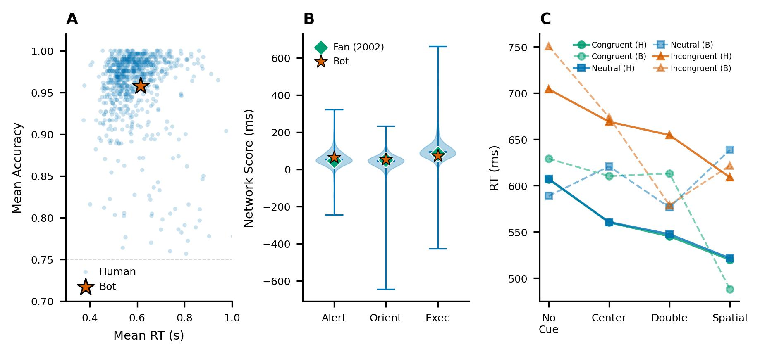

Figure 2. Detectable artifacts. (A-C) Bot position (orange line) in human distributions of QQ correlation, skewness, and lag-1 autocorrelation, with z-scores. (D) RT density distributions showing bot bimodality (primary and pixel detection failure fallback modes) vs. human unimodal right-skewed distribution.

