Hall data analysis (Aug-Oct 2019)

This report contains analysis of data obtained from the standalone solar system installed at Nyabiheke Hall for period between 1st Aug 2019 and 31st Oct 2019. There are a total of 7 CPE (6 indoor and 1 outdoor) and 4 sockets.

RQ1. How do refugees use energy and what are their energy needs, patterns of use and aspirations?

Daily profiles can vary significantly throughout the year and from weekdays to weekends. To detail these profiles, monthly data will be used to establish aggregate hourly load profiles for week and weekend days. Total energy demand profiles are to be plotted, with separate profiles being generated for socket and light usage at the hall. From these plots, we will see when energy is being used, how much is being used and what, if any, variations there are between weekdays and weekends. The graphs will show peak and low demand periods. With the graphs created for each month, we will see how these patterns of energy usage change over time.

1. Hourly energy consumption (all lights + sockets) from the hall for a week/weekend day in (month)

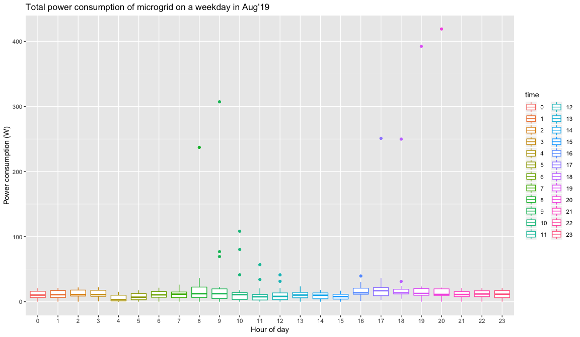 Figure 1: Total power consumption of microgrid on a week day in Aug 2019

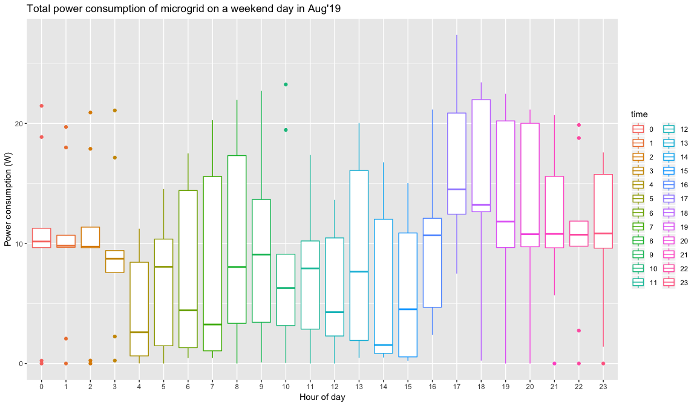 Figure 2: Total power consumption of microgrid on a weekend day in Aug 2019

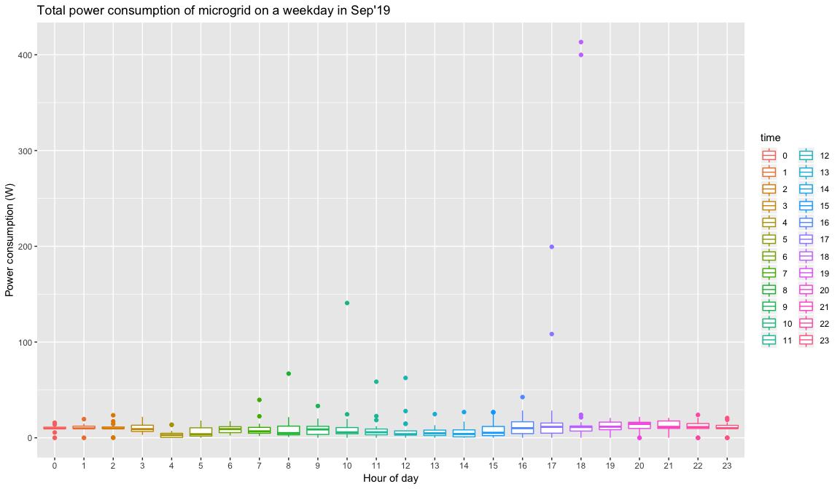 Figure 3: Total power consumption of microgrid on a week day in Sep 2019

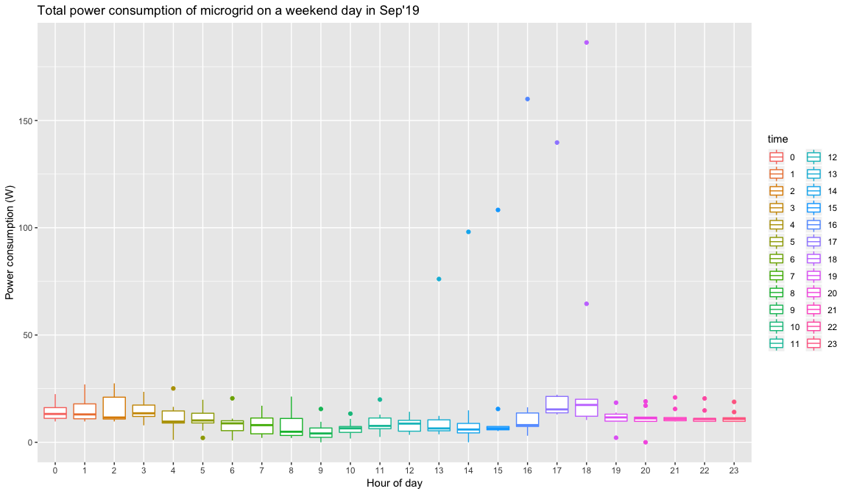 Figure 4: Total power consumption of microgrid on a weekend day in Sep 2019

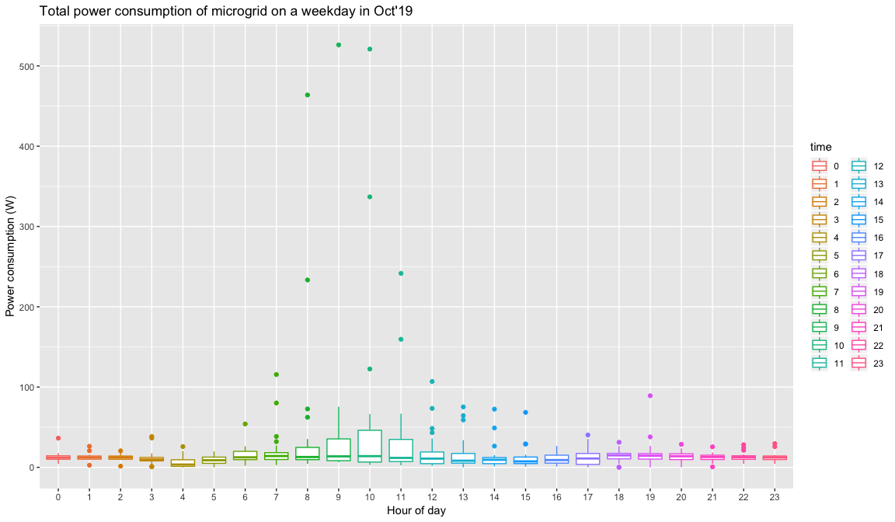 Figure 5: Total power consumption of microgrid on a week day in Oct 2019

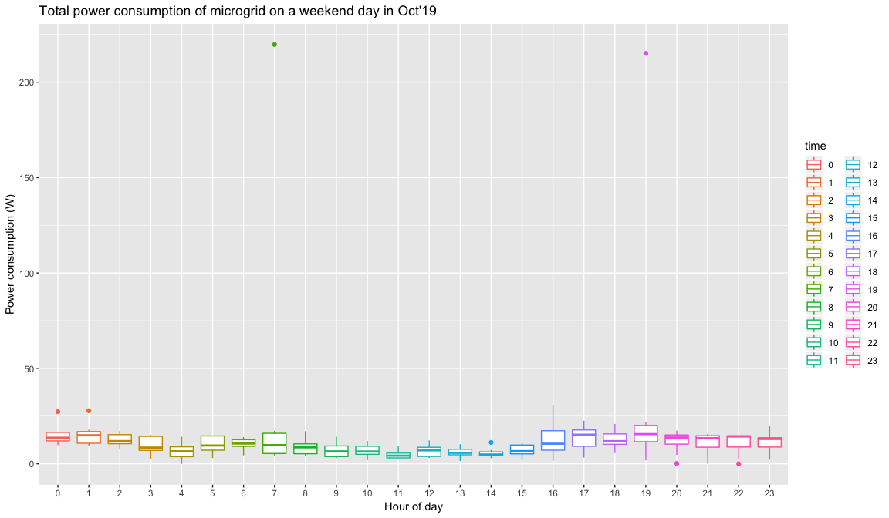 Figure 6: Total power consumption of microgrid on a weekend day in Oct 2019

1. Hourly socket consumption at the hall for a weekend/week day in (month)

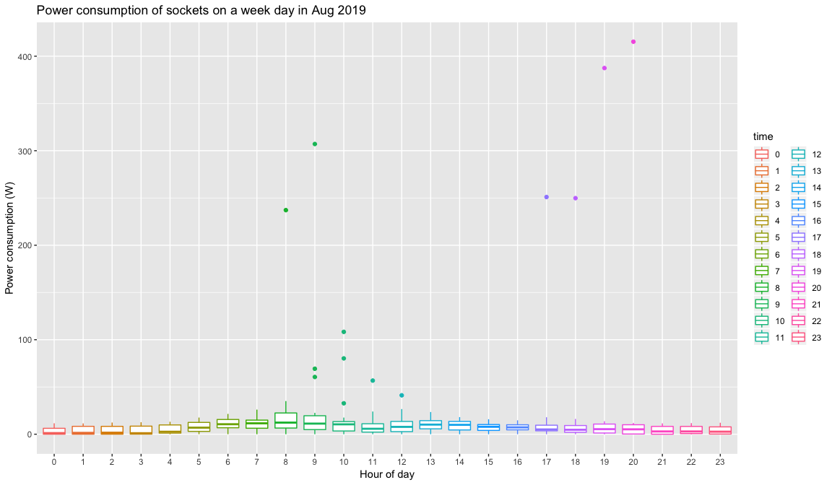 Figure 7: Power consumption of sockets on a week day in Aug 2019

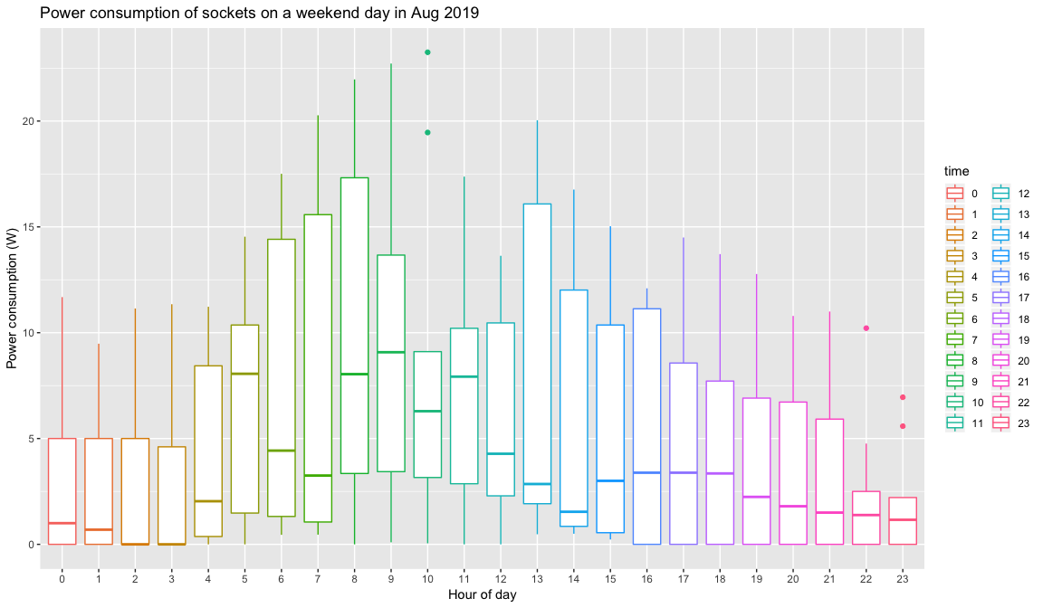 Figure 8: Power consumption of sockets on a weekend day in Aug 2019

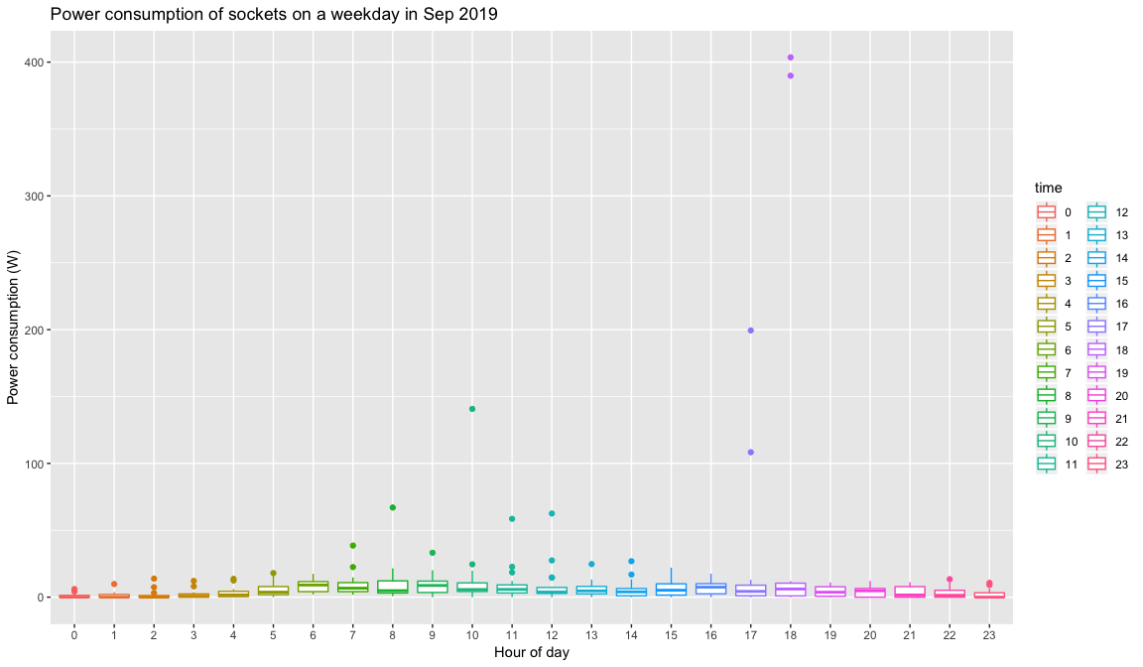 Figure 9: Power consumption of sockets on a week day in Sep 2019

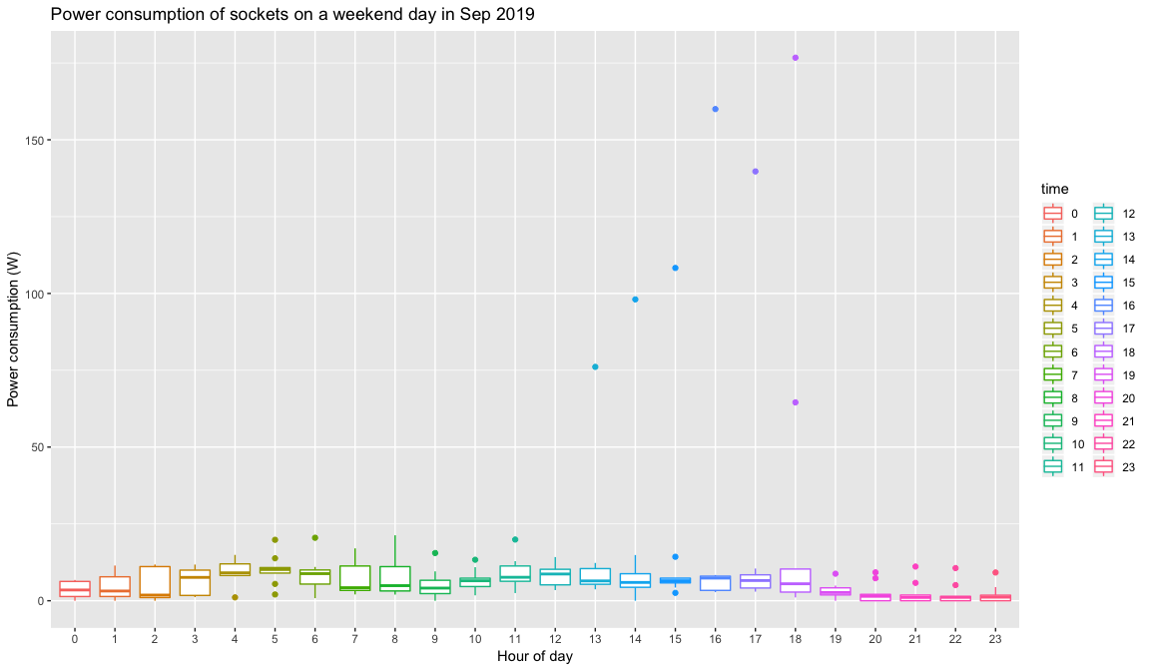 Figure 10: Power consumption of sockets on a weekend day in Sep 2019

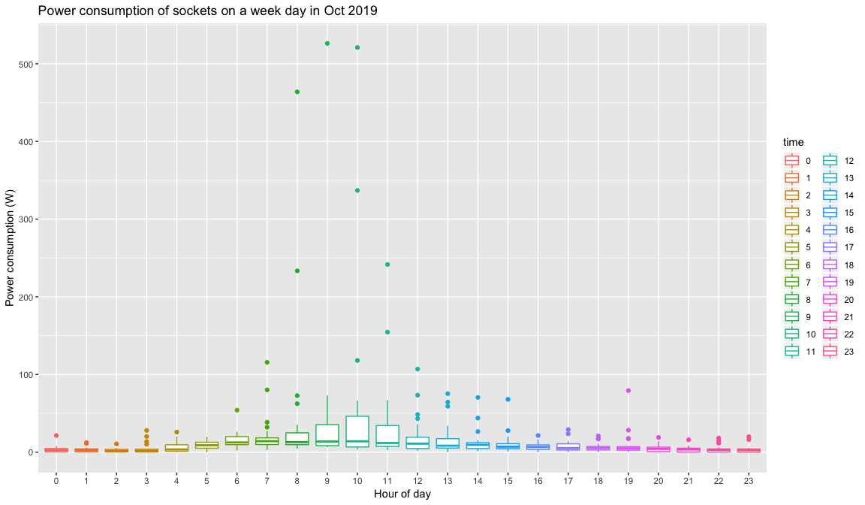 Figure 11: Power consumption of sockets on a week day in Oct 2019

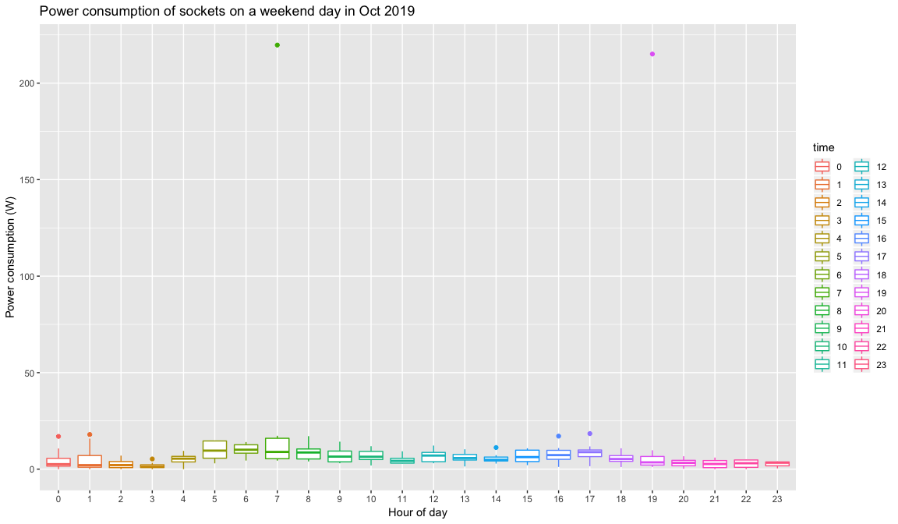 Figure 12: Power consumption of sockets on a weekend day in Oct 2019

1. Hourly indoor light consumption at the hall for a weekend/week day in (month)

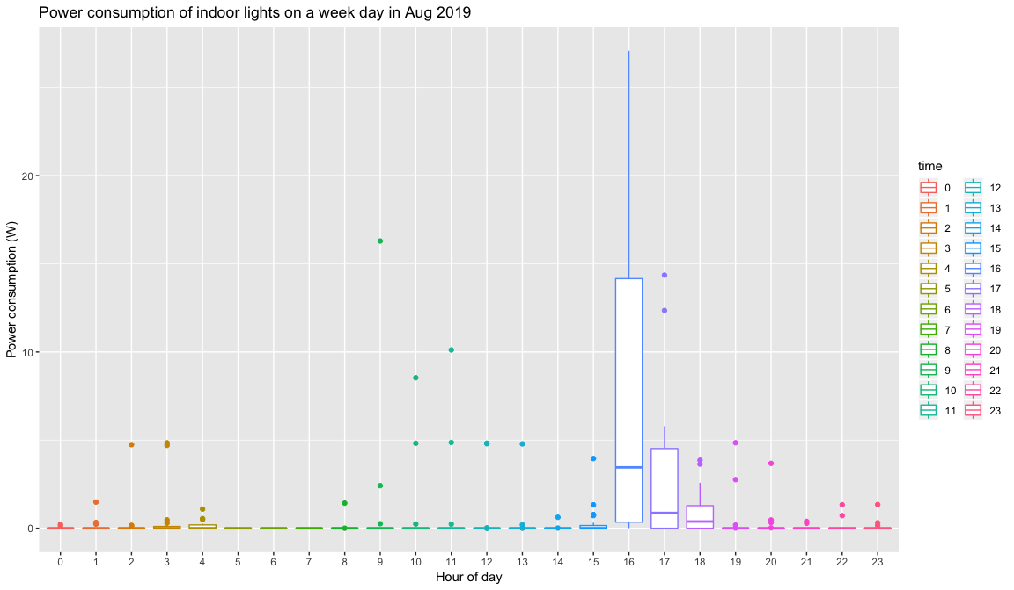 Figure 13: Power consumption of indoor lights on a week day in Aug 2019

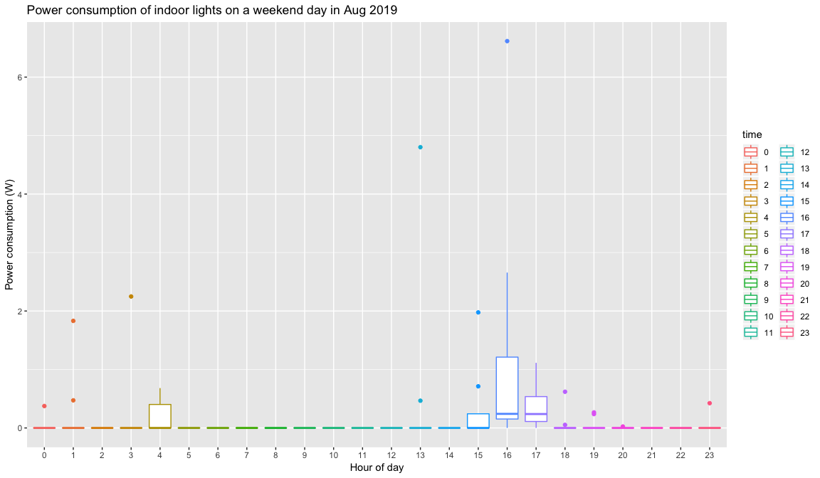 Figure 14: Power consumption of indoor lights on a weekend day in Aug 2019

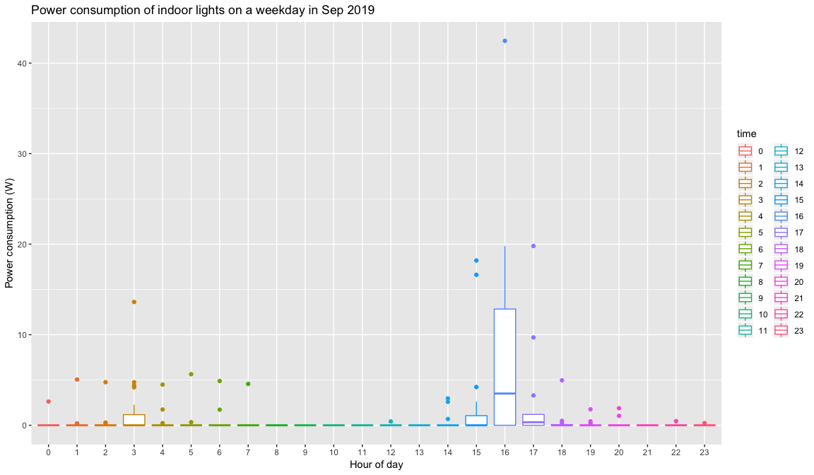 Figure 15: Power consumption of indoor lights on a week day in Sep 2019

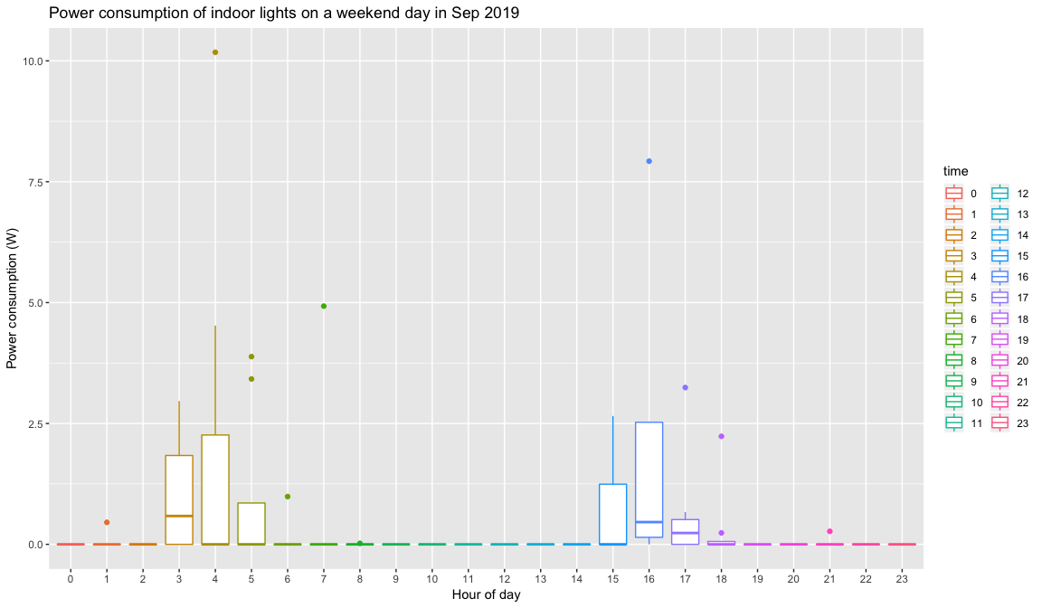 Figure 16: Power consumption of indoor lights on a weekend day in Sep 2019

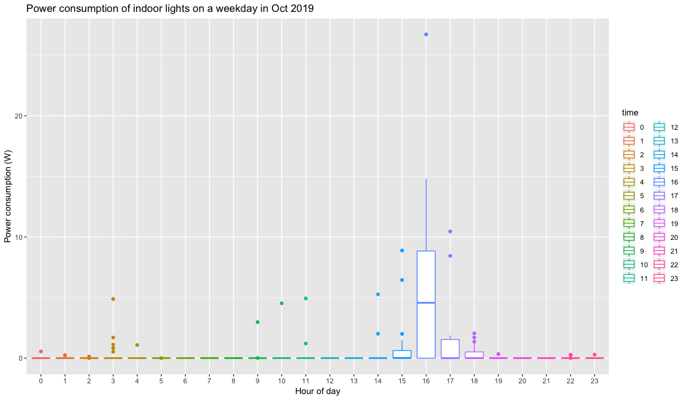 Figure 17: Power consumption of indoor lights on a week day in Oct 2019

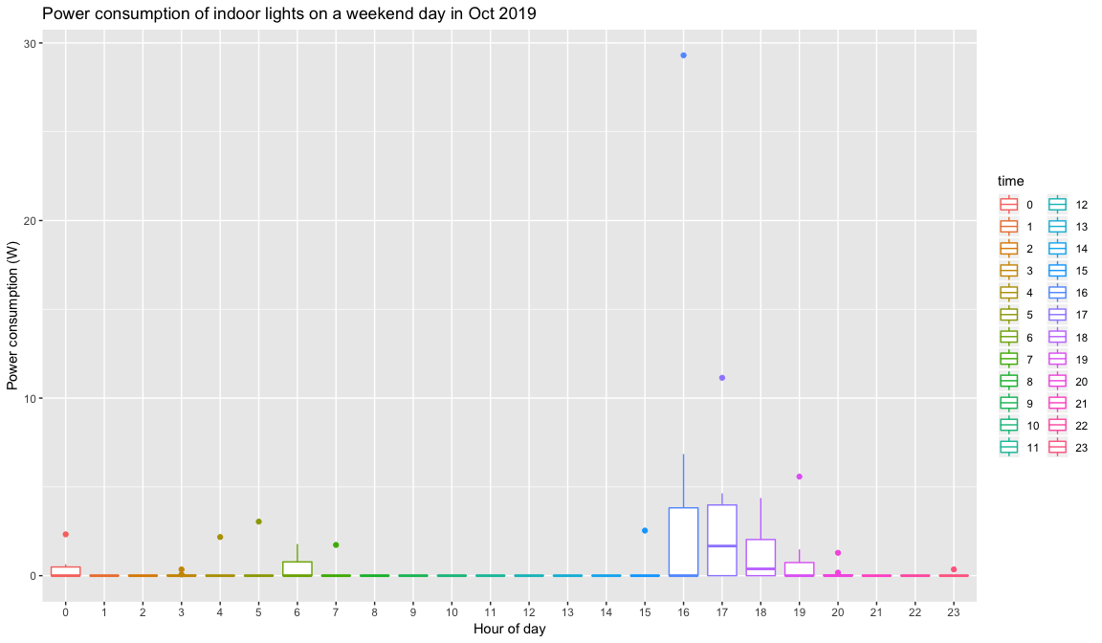 Figure 18: Power consumption of indoor lights on a weekend day in Oct 2019

1. Hourly outdoor light consumption at the hall for a weekend/week day in (month)

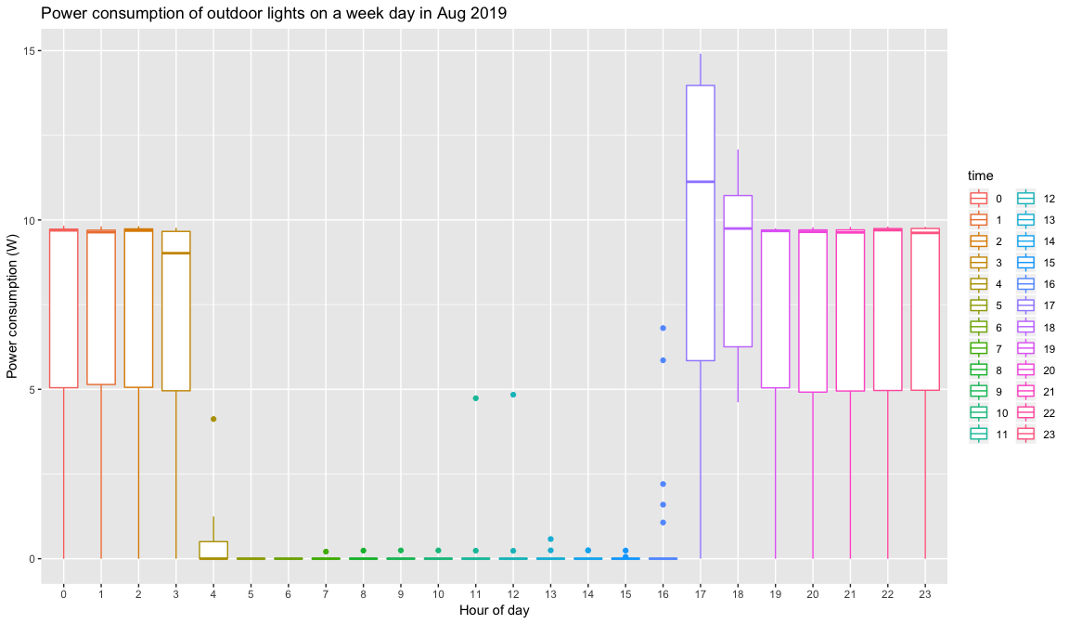 Figure 19: Power consumption of outdoor lights on a week day in Aug 2019

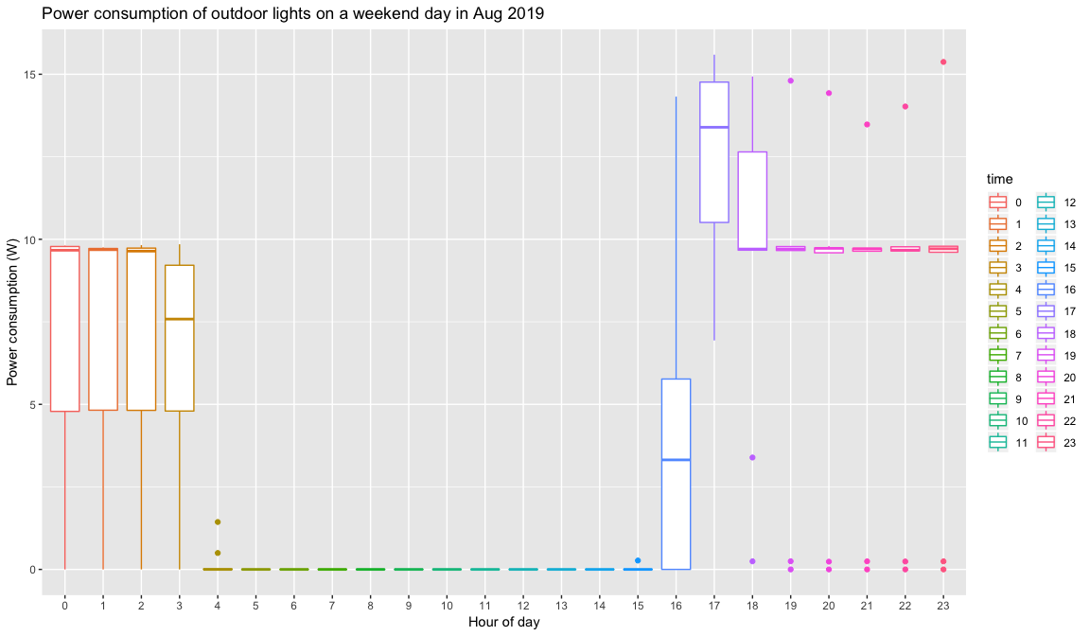 Figure 20: Power consumption of outdoor lights on a weekend day in Aug 2019

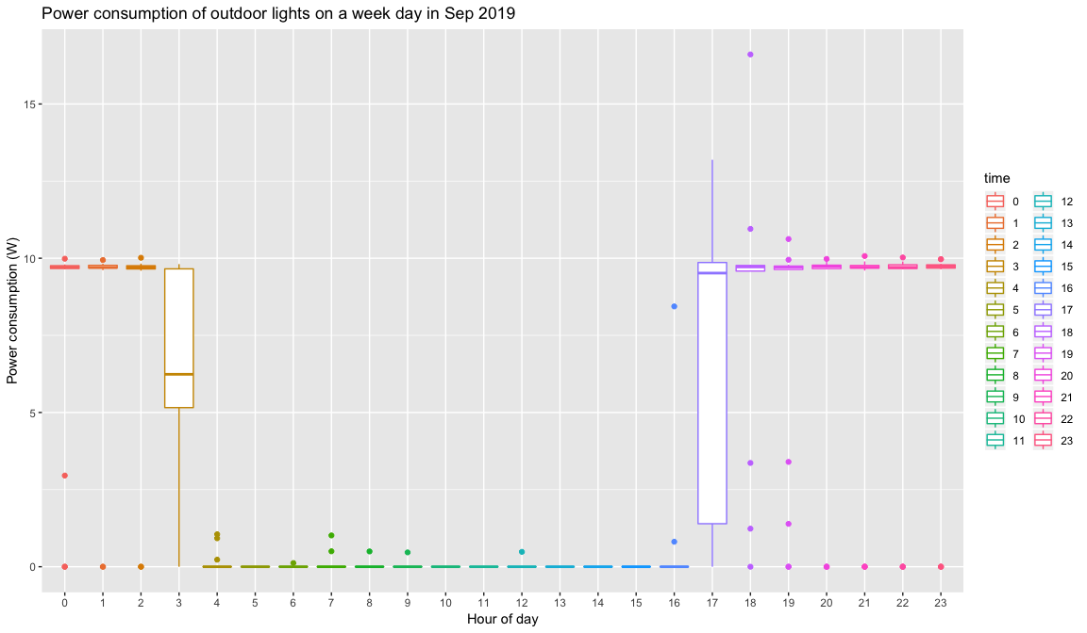 Figure 21: Power consumption of outdoor lights on a week day in Sep 2019

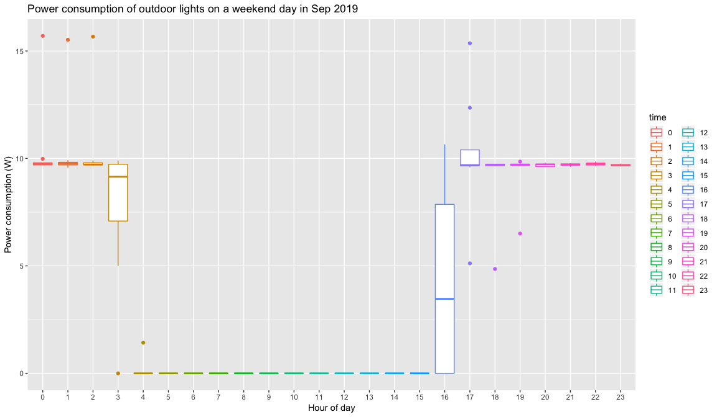 Figure 22: Power consumption of outdoor lights on a weekend day in Sep 2019

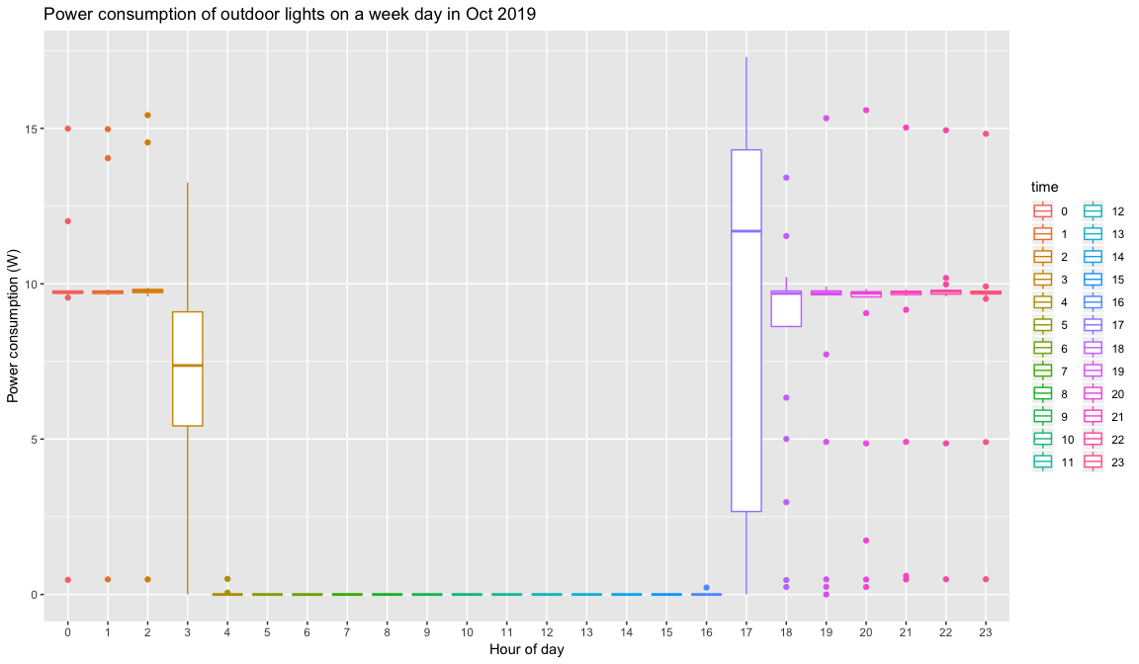 Figure 23: Power consumption of outdoor lights on a week day in Oct 2019

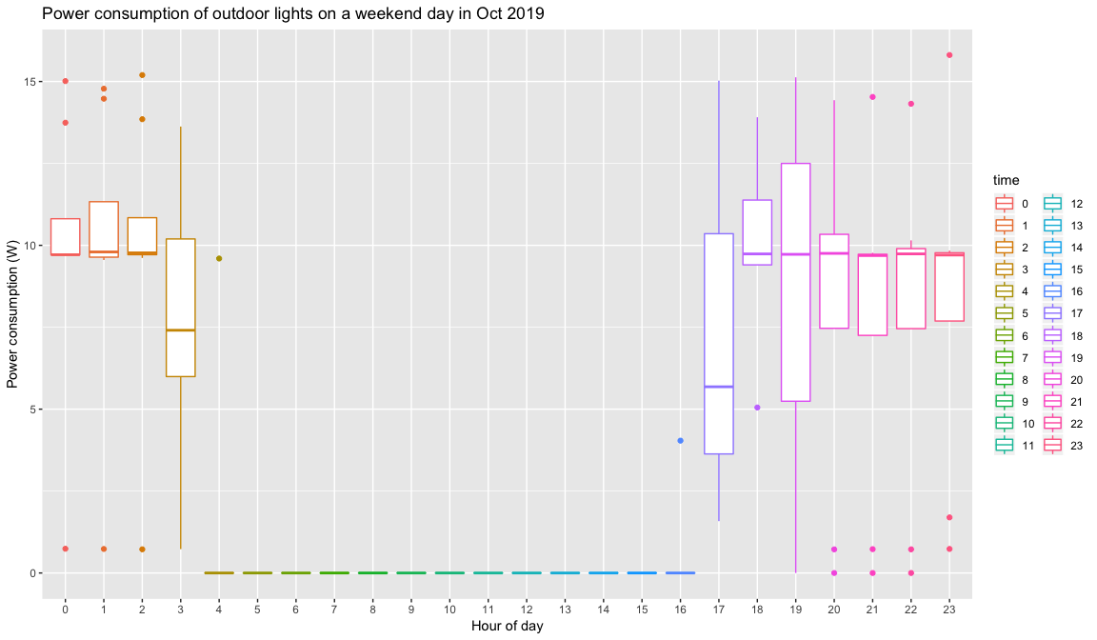 Figure 24: Power consumption of outdoor lights on a weekend day in Oct 2019

RQ2. Does energy availability through a PV system increase energy demand over time?

To see how total energy consumption changes over time, daily consumption since the commissioning of the hall installation is plotted. Using this plot, we will be able to see if there has been a growth in energy usage at the hall and how much it has changed over time. Additional plots are created to show the individual socket and light make-up of the energy usage on a daily and monthly basis. By creating monthly plots for the individual sockets and lights we will be able to determine where any changes in energy usage are occurring.

1. Daily total energy consumption of Hall per month and total energy consumption since commissioning. The monthly daily consumption average is also shown.

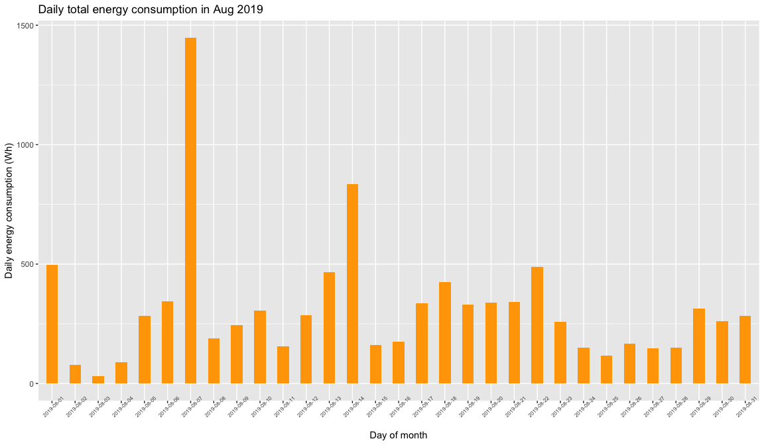 Figure 25: Daily total energy consumption (lights + sockets) in Aug 2019

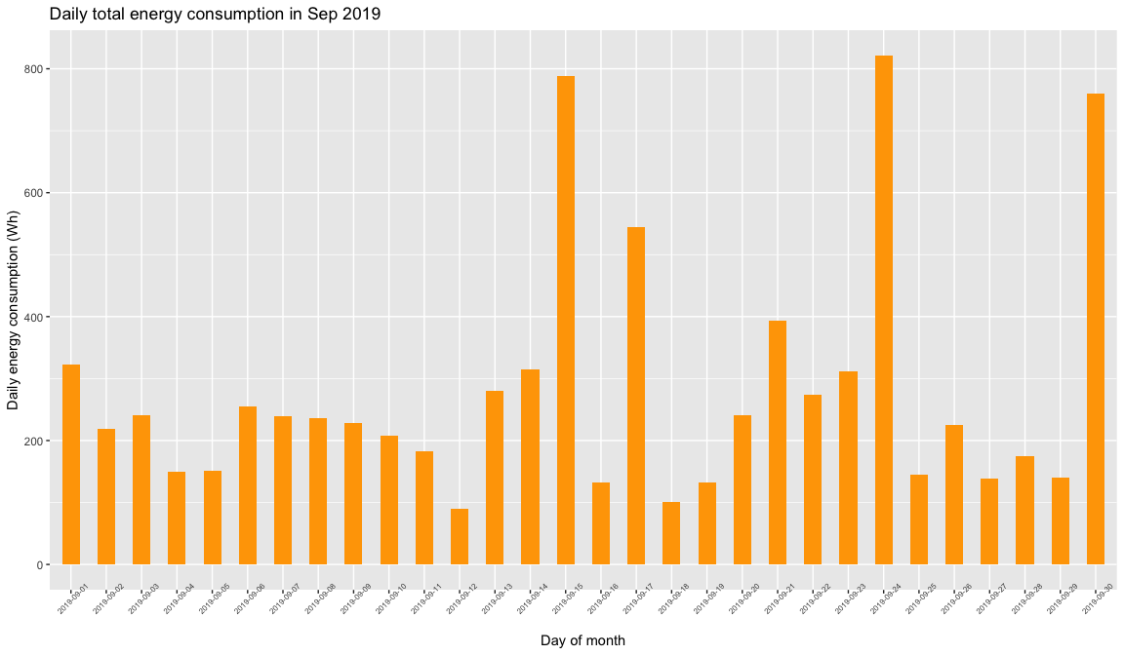 Figure 26: Daily total energy consumption (lights + sockets) in Sep 2019

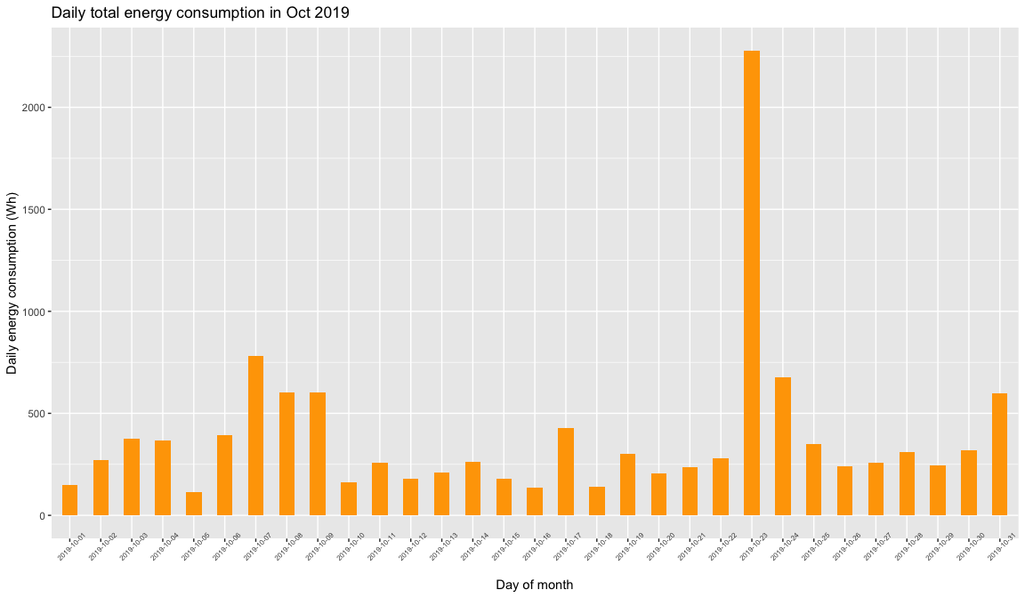 Figure 27: Daily total energy consumption (lights + sockets) in Oct 2019

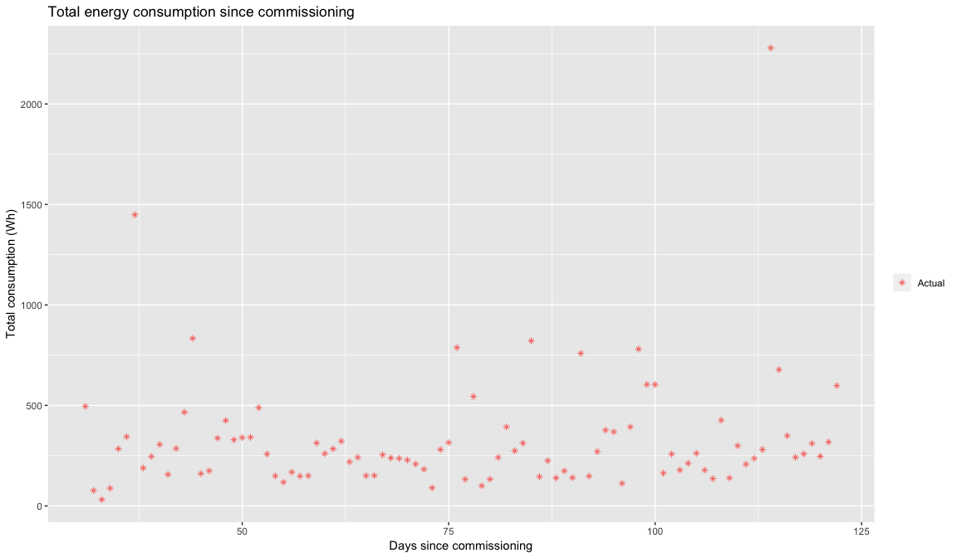 Figure 28: Daily consumption (lights + sockets) since commissioning

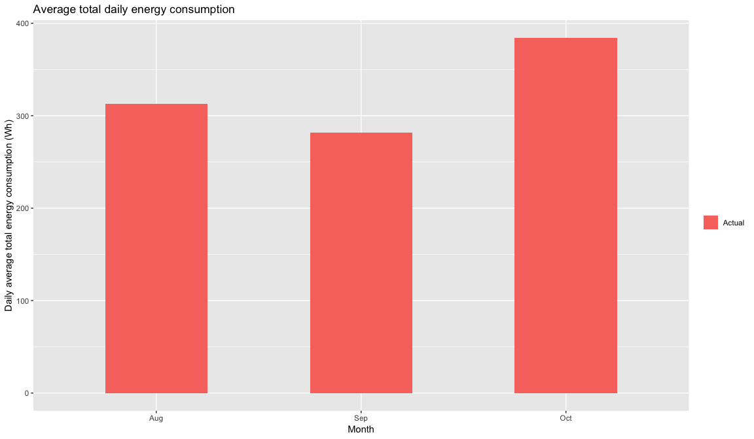 Figure 29: Monthly daily consumption average at Nyabiheke Hall in 2019

1. Daily total user consumption loads for the hall in (month).

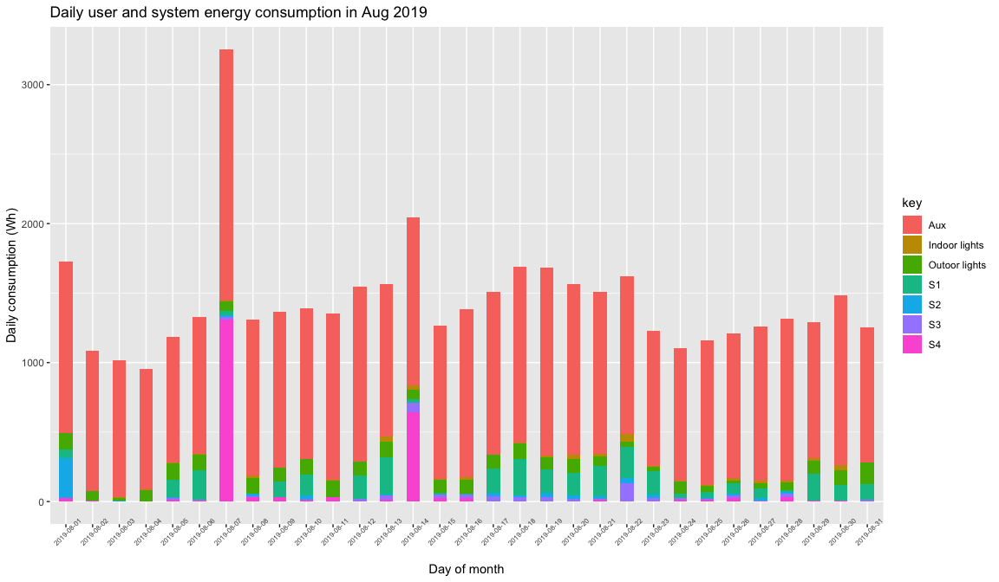 Figure 30: Daily user and system energy consumption in Aug 2019

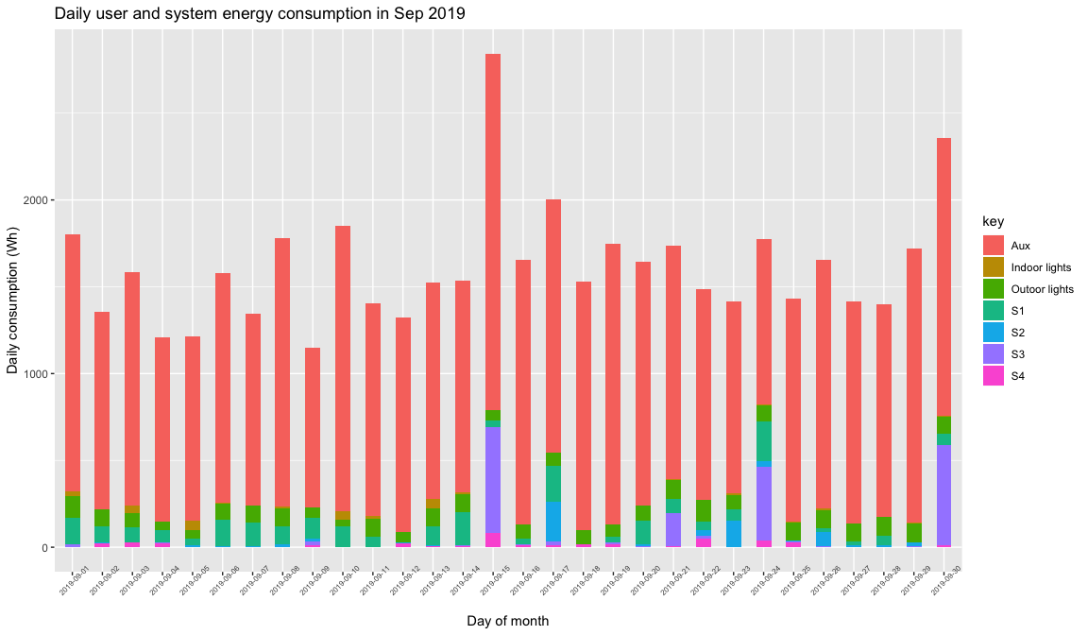 Figure 31: Daily user and system energy consumption in Sep 2019

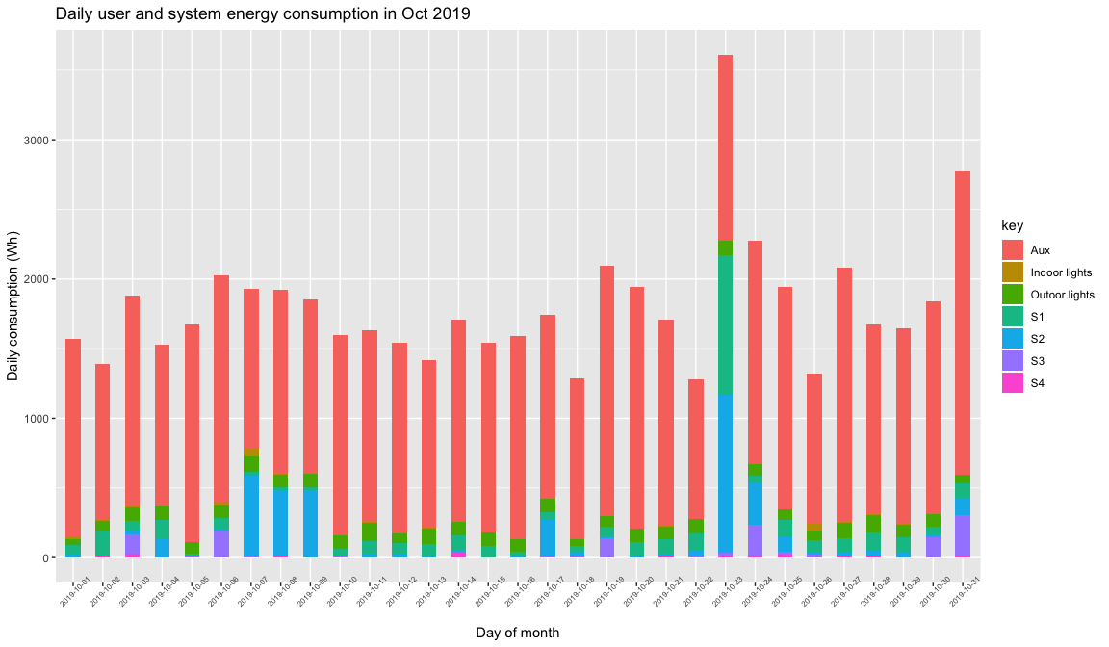 Figure 32: Daily user and system energy consumption in Oct 2019

1. Monthly energy consumption profile for the hall users. 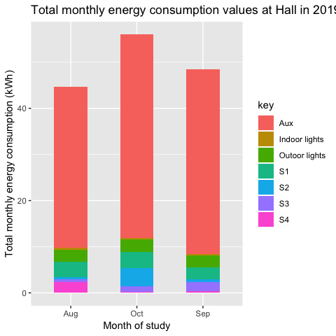 Figure 33: Total monthly energy consumption at Nyabiheke hall.

RQ3. How valid and accurate were our assumptions and simulations to design and size the system using predicted energy demand profiles and meteorological conditions?

To better understand any under and over usage predictions, the distribution of errors in terms of watthours is to be plotted. Determining the occurrence of under and over predictions at the hall enables designers to evaluate the impact of increasing or decreasing system capacity. For example, if a designer was to reduce system capacity due to surplus solar energy going to waste, the number of occurrences of under predictions would give an indication of likely capacity shortages. The plot will show us the skew towards under or over predictions and the scale of the errors.

To investigate when these differences in energy usage are occurring, an actual and predicted typical day at the hall for each month is to be created. A typical day, for a given month, for the generation and load profiles at the hall enables us to see how total system consumption varies throughout the day and when energy is delivery by the PV panels or consumed from the battery. These graphs also show when the battery is being charged and when surplus yield from the PV panels results in capture losses. Differences with predicted values provide an indication of the appropriateness of the assumed load profiles for the hall; these assumed load profiles will also be evaluated in comparison to the results obtained in relation to plots in RQ1.

The appropriateness of the design in terms capture losses in comparison to simulated values will also be evaluated. By creating graphs for an entire year for capture losses, we will see how the surplus potential energy from PV panels going to waste changes over time because of variations in energy consumption.

1. Distribution of energy-use over and under predictions at the hall
2. Actual and predicted typical day power profile at the hall in (month)

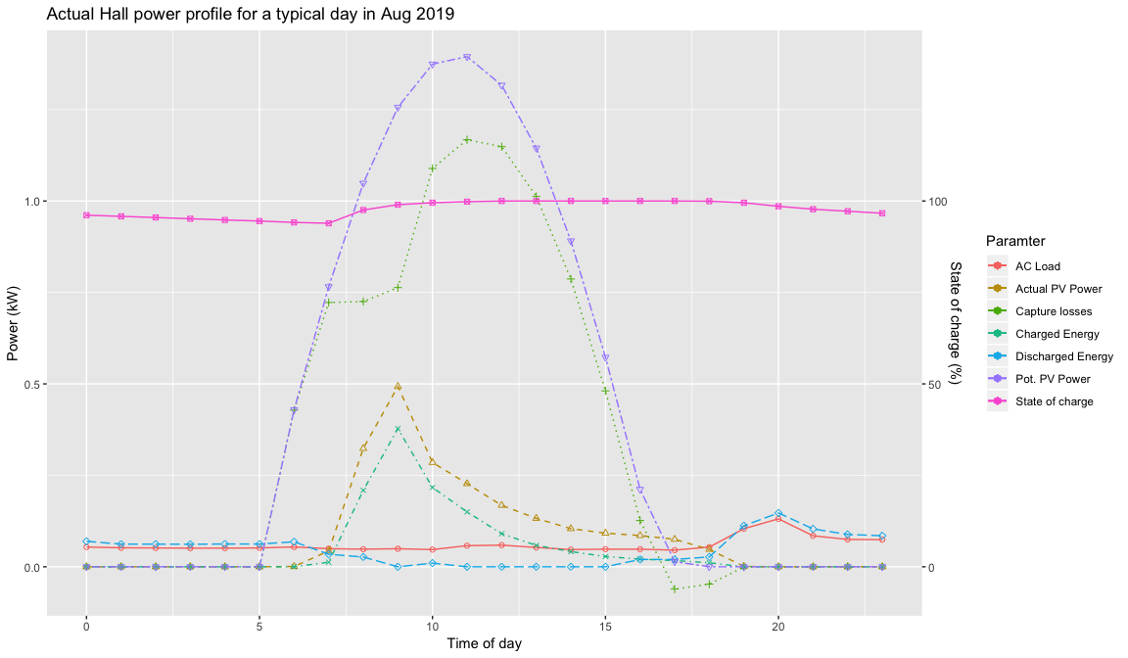 Figure 34: Actual Hall power profile for a typical day in Aug 2019. Battery state of charge is shown on the secondary axis.

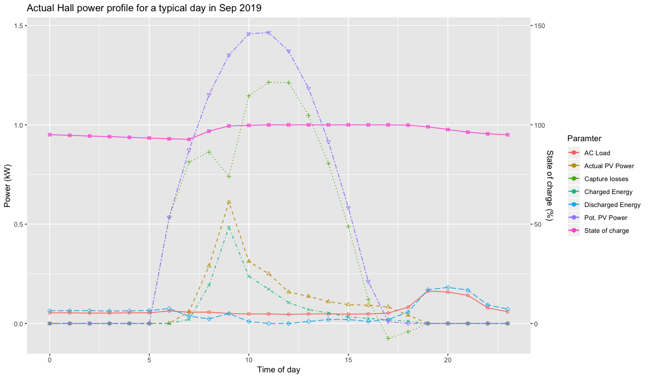 Figure 35: Actual Hall power profile for a typical day in Sep 2019. Battery state of charge is shown on the secondary axis.

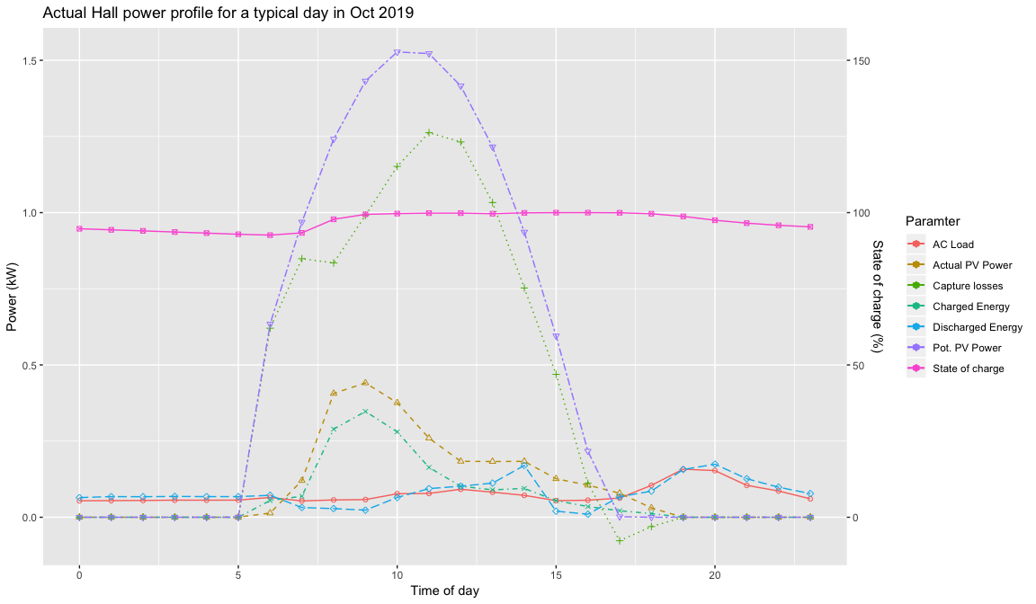 Figure 36: Actual Hall power profile for a typical day in Oct 2019. Battery state of charge is shown on the secondary axis.

1. Box plot of actual and predicted monthly capture loss values 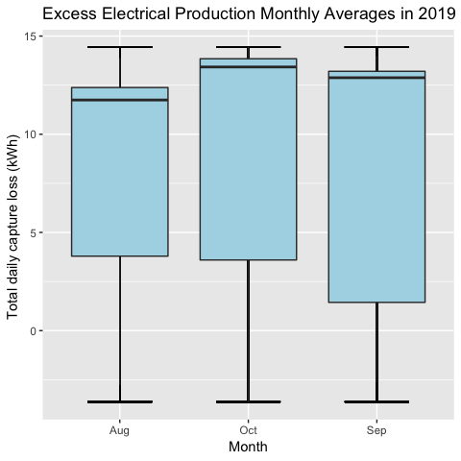 Figure 37: Monthly capture losses for the hall.

To investigate further the potential PV power that is not utilised at the hall, the estimated monthly capture losses are shown in comparison to the utilised PV power. The ratio of utilised PV power to potential PV power is known as the performance ratio, and we will want to see how this changes with energy demands at the hall. The production factor is particularly important for standalone PV-battery systems, where surplus energy from PV panels cannot be exported to a grid network. The production factor is the ratio of actual PV yield to potential PV power. The system’s overall efficiency is the ratio of the consumed AD load to the in-plane irradiance on the PV array.

1. Monthly utilised PV yield, PV capture losses and system losses

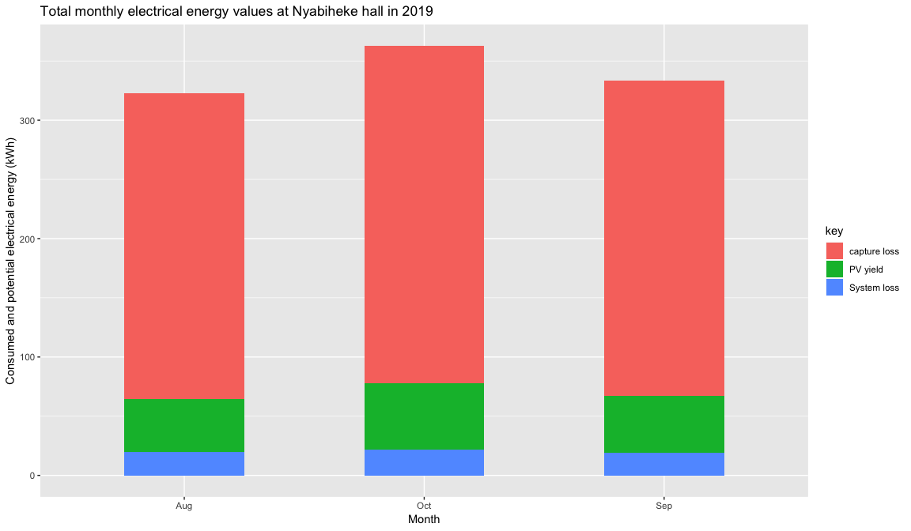 Figure 38: Monthly utilised PV yield, PV capture losses and system losses.

1. System performance ratio, production factor and overall system efficiency for each month