Hall data analysis – Missing data – 19th July 2019 to 31st Dec 2019 (n=166 days)

1. The data is analysed to assess the quality of data collection by obtaining the missing hours of data collection per day for each of the above variables. The below plots (fig. 1) show the total number of hours for which CPE and sockets data is obtained for each variable per day i.e. 24 hours period, for each month.

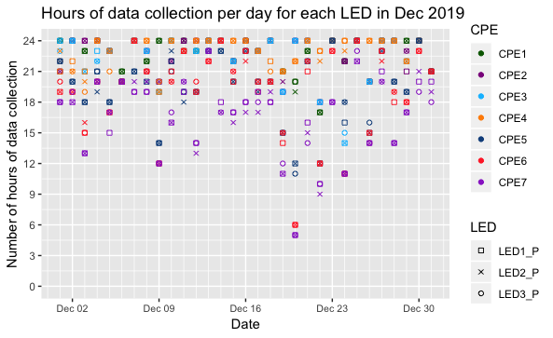

Fig. 1: Total hours of data collection per day for each CPE LED and socket for each month – Jul-Dec 2019. The figure shows gaps in data owing to missing hourly mean values for different parameters.

1. The data is also analysed to assess the quality of data collection by obtaining the last hour of data collection per day for each of the above variables. The below plots (fig. 2) show the last hour at which CPE and sockets data is obtained for each variable per day i.e. 24 hours period, for each month.

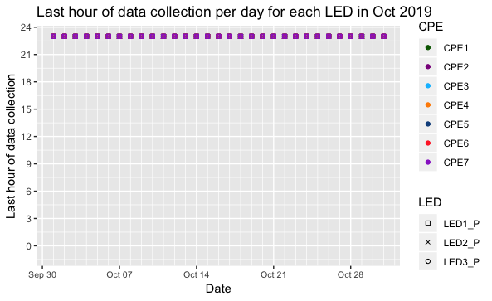

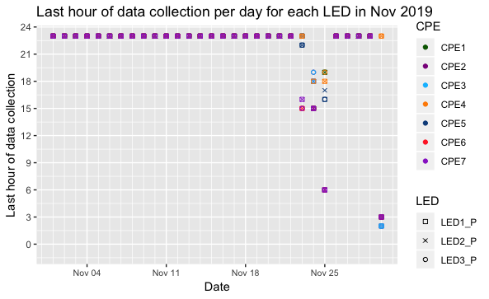

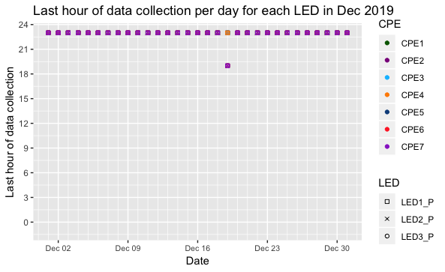

Fig. 2: The last hour of data collection per day for each CPE LED and socket for each month – Jul-Dec 2019.

1. Summary of missing data for the socket parameters - Total missing hours of data across a total period of study is 166 days (19th July to 31st Dec). These values include the days for which the system was down.
   1. Voltage - 653 hours over 75 days
   2. Current - 657 over 75 hours
   3. PF - 657 hours over 76 days
   4. VA - 661 hours over 79 days
   5. LVL - 652 hours over 78 days
   6. Energy session - 659 hours over 77 days

Of these, 70 days are overlapping across all variables i.e. data is missing for same 70 days for all variables. Furthermore, the hours of missing data are roughly the same.