Hall data analysis (Aug-Oct 2019)

This report contains analysis of data obtained from the standalone solar system installed at Nyabiheke Hall for period between 1st Aug 2019 and 31st Oct 2019. The system consists of 7 CPE (6 indoor and 1 outdoor lights) and 4 sockets.

Data exploration

1. LED[1,2

The analysis is carried out to answer the following 3 research questions.

1. RQ1. How do refugees use energy and what are their energy needs, patterns of use and aspirations?

Daily profiles can vary significantly throughout the year and from weekdays to weekends. To detail these profiles, monthly data is used to establish aggregate hourly load profiles for week and weekend days. Total energy demand profiles are then plotted, with separate profiles being generated for socket and light usage at the hall. From these plots, we will see when energy is being used, how much is being used and what, if any, variations there are between weekdays and weekends. The graphs show peak and low demand periods. With the graphs created for each month, we see how these patterns of energy usage change over time.

1. Hourly total (lights and sockets), sockets, indoor lights and outdoor lights power consumption from the hall for weekdays in Aug 2019

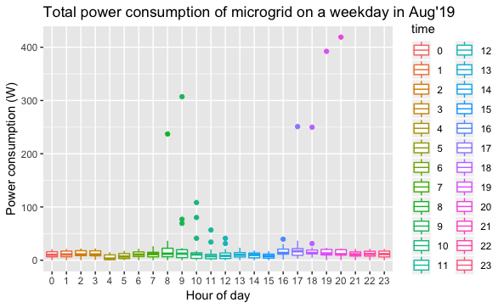

Fig. 1: Hourly total power consumption of the hall on weekdays in Aug 2019

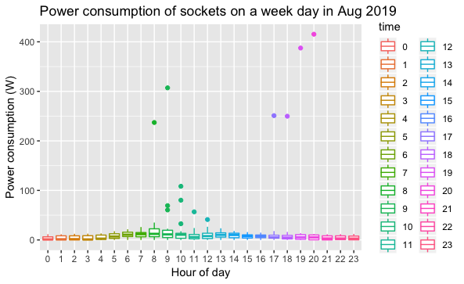

Fig. 2: Hourly sockets power consumption on weekdays in Aug 2019

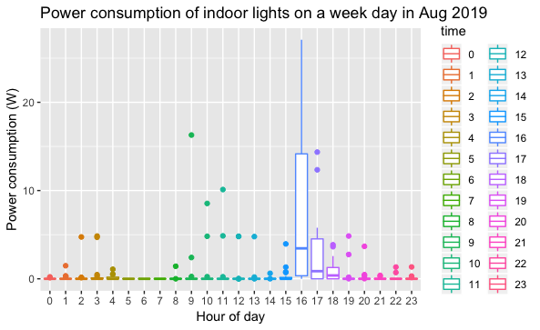

Fig. 3: Hourly indoor lights power consumption on weekdays in Aug 2019

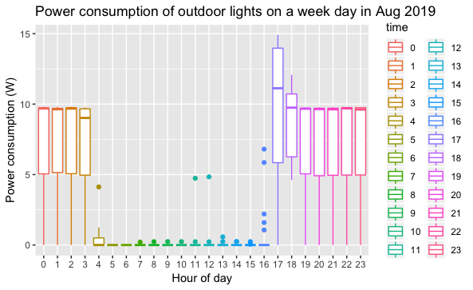

Fig. 4: Hourly outdoor lights power consumption on weekdays in Aug 2019

1. Hourly total (lights and sockets), sockets, indoor lights and outdoor lights power consumption from the hall for weekend days in Aug 2019

Fig. 5: Hourly total power consumption of the hall on weekend days in Aug 2019

Fig. 6: Hourly sockets power consumption on weekend days in Aug 2019

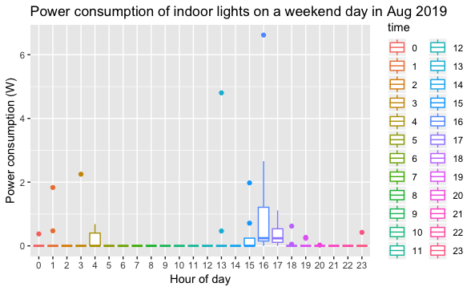

Fig. 7: Hourly indoor lights power consumption on weekend days in Aug 2019

Fig. 8: Hourly outdoor lights power consumption on weekend days in Aug 2019

1. Hourly total (lights and sockets), sockets, indoor lights and outdoor lights power consumption from the hall for weekdays in Sep 2019

Fig. 9: Hourly total power consumption of the hall on weekdays in Sep 2019

Fig. 10: Hourly sockets power consumption on weekdays in Sep 2019

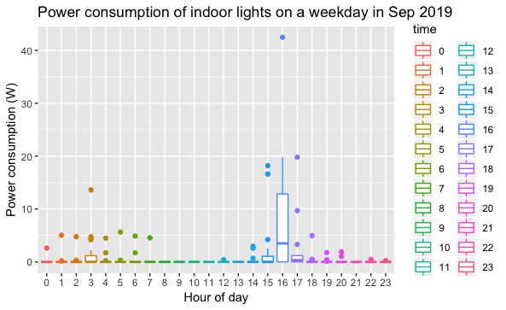

Fig. 11: Hourly indoor lights power consumption on weekdays in Sep 2019

Fig. 12: Hourly outdoor lights power consumption on weekdays in Sep 2019

1. Hourly total (lights and sockets), sockets, indoor lights and outdoor lights power consumption from the hall for weekend days in Sep 2019

Fig. 13: Hourly total power consumption of the hall on weekend days in Sep 2019

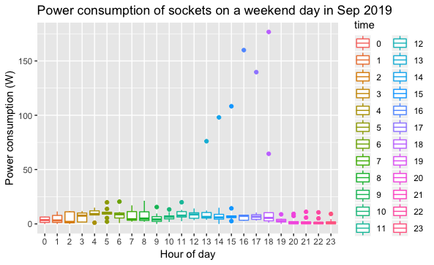

Fig. 14: Hourly sockets power consumption on weekend days in Sep 2019

Fig. 15: Hourly indoor lights power consumption on weekend days in Sep 2019

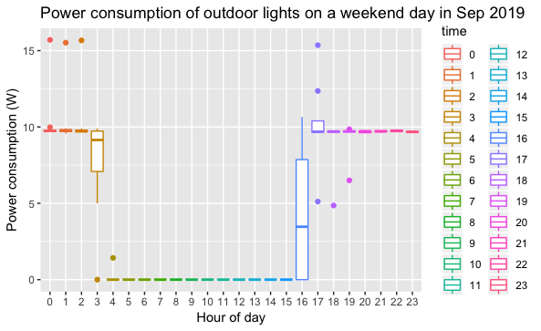

Fig. 16: Hourly outdoor lights power consumption on weekend days in Sep 2019

1. Hourly total (lights and sockets), sockets, indoor lights and outdoor lights power consumption from the hall for weekdays in Oct 2019

Fig. 17: Hourly total power consumption of the hall on weekdays in Oct 2019

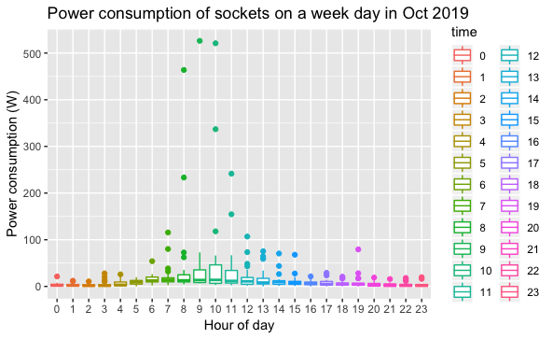

Fig. 18: Hourly sockets power consumption on weekdays in Oct 2019

Fig. 19: Hourly indoor lights power consumption on weekdays in Oct 2019

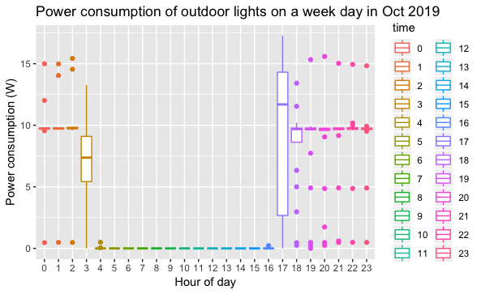

Fig. 20: Hourly outdoor lights power consumption on weekdays in Oct 2019

1. Hourly total (lights and sockets), sockets, indoor lights and outdoor lights power consumption from the hall for weekend days in Sep 2019

Fig. 21: Hourly total power consumption of the hall on weekend days in Oct 2019

Fig. 22: Hourly sockets power consumption on weekend days in Oct 2019

Fig. 23: Hourly indoor lights power consumption on weekend days in Oct 2019

Fig. 24: Hourly outdoor lights power consumption on weekend days in Oct 2019

1. RQ2. Does energy availability through a PV system increase energy demand over time?

To see how total energy consumption changes over time, daily total energy consumption of hall per month and total energy consumption since is plotted. Using these plot, we will be able to see if there has been a growth in energy usage at the hall and how much it has changed over time.

Fig. 25: Daily total energy consumption of the hall in Aug 2019

Fig. 26: Daily total energy consumption of the hall in Sep 2019

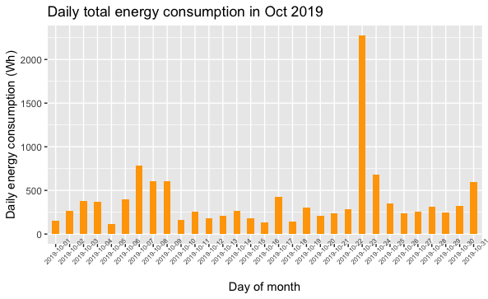

Fig. 27: Daily total energy consumption of the hall in Oct 2019

Fig. 28: Total energy consumption of the hall since commissioning (July 1, 2019)

The average total daily consumption for each month is also shown in fig. 30.

Fig. 29: Average total daily consumption of the hall.

Further analysis is performed to evaluate the individual socket and light make-up of the energy usage on a daily and monthly basis. By creating monthly plots for the individual sockets and lights we determine where any changes in energy usage are occurring.