Plot 1 – typical user load and AC consumption at the Hall, nurseries and playground from July to Dec 2019

Plot 2 – Typical day at Hall and micro-grid – monthly, 3-monthly and 6-monthly

Typical day plots for the Micro-grid

Plot 3 – Daily energy consumption using AC load at Hall and micro-grid

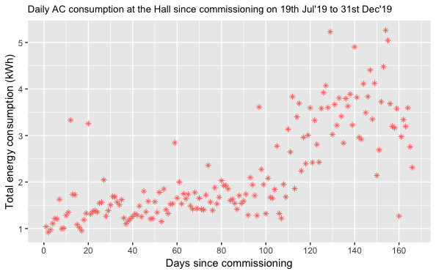

Plot 4 – Daily average yield, capture loss and system loss at Hall and micro-grid

