Nepal SL data analysis

Data handling

1. The following variables have been extracted system data
   1. PV power (W)
   2. Battery power (W)
   3. PV DC-coupled power (W)
   4. Battery state of charge (%)
   5. Discharged energy (kWh)
   6. Charged energy (kWh)
2. For each of the variables, hourly values were extracted as follows
   1. PV power (Wh) – hourly mean from instantaneous values
   2. Battery power (Wh) - hourly mean from instantaneous values
   3. PV DC-coupled power (Wh) - hourly mean from instantaneous values
   4. Battery state of charge (%) – last recorded value per hour
   5. Discharged energy (Wh) – hourly values are obtained by a) obtaining the last recorded value per hour b) getting the difference in values per hour and converting kW to W
   6. Charged energy (Wh) – hourly values are obtained by a) obtaining the last recorded value per hour b) getting the difference in values per hour and converting kW to W
3. Next, the data is analysed to assess system and socket load and efficiency of system as outlined in the template.

**How has the use of free socket power at streetlights changed over time and has it led to an increase and diversification of communal activities?**

* 1. Hourly mean system and socket load at SL1 on weekdays and weekend days in Oct’19

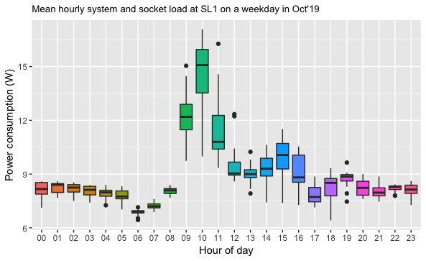

* 1. Typical day system and socket load at SL1 on weekdays and weekend days in Oct’19

* 1. Daily system and socket load since commissioning

* 1. Streetlight total socket consumption values per streetlight in (month).

**Does free AC power at solar streetlights reduce capture losses and improve standalone streetlight system performance?**

1. Typical day power profile for an advanced solar streetlight in (month).

1. Estimated capture losses and percentage of surplus used by external devices

x----------------x-----------------x-------------------x-----------x-----------------x-----------------x-------------x

Analysing the data for SL3 – Oct 2019

1. Missing data – number of hours of missing data in Oct 2019

1. Hourly mean system and socket load at SL3 on weekdays and weekend days in Oct’19

1. Typical day system and socket load at SL3 on weekdays and weekend days in Oct’19

1. Daily system and socket load since commissioning

1. Streetlight total socket consumption values per streetlight in (month) – note that the baseline power consumption (i.e. system load) varies with streetlights. For SL3, system load of 3.5W is considered on an avg per hour for the 24 hour period. For SL1, the system load was 7.5W on an avg per hour.

1. Typical day power profile for an advanced solar streetlight in (month).

1. Estimated capture losses and percentage of surplus used by external devices

