Nepal SL1 full data analysis – July to Dec 2019

1. Missing data for SL1

Fig. 1: Missing data for Nepal SL1. The data has been analysed to extract hourly mean values for each variable per day from 1st July 2019 to 31st Jan 2020. As can be seen in the above plot, the data yield is extremely high, with 2 days of partially missing data for a few variable(s). The value of PV power is, however, missing for Sep to Nov months in 2019. This is because these values are missing from the SD card data file. To replace the missing values, the PV current and voltage values are obtained from the files and actual PV power is calculated.

1. Data pre-processing/preparation – The data is available to download at any given frequency from the Victron portal. On an average, four readings are collected per hour for each variable. For analysis, the data from July to Oct was downloaded and stitched together with the SD card data for days when the system was offline. Data from Nov to Jan was downloaded from the Victron portal and stitched together with the existing dataset. Couple of issues needed to be resolved while preparing the data
   1. Data files are in different format – csv, xls and xlsx, with column headers spreading across different rows.
   2. Data for some variables is recorded under different columns if ID of the system changes after power on/off. For instance, the data for state of charge, charged and discharged energy from battery monitor is stored under different columns with names Battery Monitor [ID] <VAR> as value of ID of the same battery monitor is recorded differently if the system powers on or off. The data from different columns is transposed and stitched to the respective columns.
   3. Data in different files (SD card and Victron) are stored with timestamp belonging to various time zones – India/Mauritius, Asia (Kathmandu), Europe/Berlin. While stitching data, care needs to be taken to stitch the data with correct changes in time reflected.
   4. Data from SD card files does not contain the same columns as the files obtained from the Victron portal. For instance, the Solar charger PV power value is missing in the SD card data. To obtain these values, the PV current and voltage values are obtained from the SD card data and multiplied to obtain the PV power – labelled as actual power in fig. 1.

From the data, the above 8 variables were extracted, and hourly values were calculated for each as explained below.

* Battery power (W) – mean hourly values are calculated (in Wh)
* PV power (W) – mean hourly values are calculated (in Wh)
* PV-DC coupled power (W) – mean hourly values are calculated (in Wh)
* State of charge (%) – last recorded value per hour is calculated (%)
* Charged energy (kWh) – this is a cumulative value. The last recorded value is noted and difference in value per hour is calculated and multiplied by 1000 (Wh).
* Discharged energy (kWh) – this is a cumulative value. The last recorded value is noted and difference in value per hour is calculated and multiplied by 1000 (Wh).
* PV current (Amps) – mean hourly values are calculated (in Amps)
* PV voltage (V) – mean hourly values are calculated (in Volts)

The value for Potential PV power is obtained from the Solcast weather data. The data is recorded for hourly values in kW\*m2. The raw value is multiplied by area of the panel, panel efficiency and 1000W to obtain value in Wh.

1. Hourly mean system and socket load at SL1 on weekdays and weekend days per month – The combined system and socket load is calculated as below
   1. System and socket load = -1\*(Battery power – PV-DC coupled power) (in Wh)

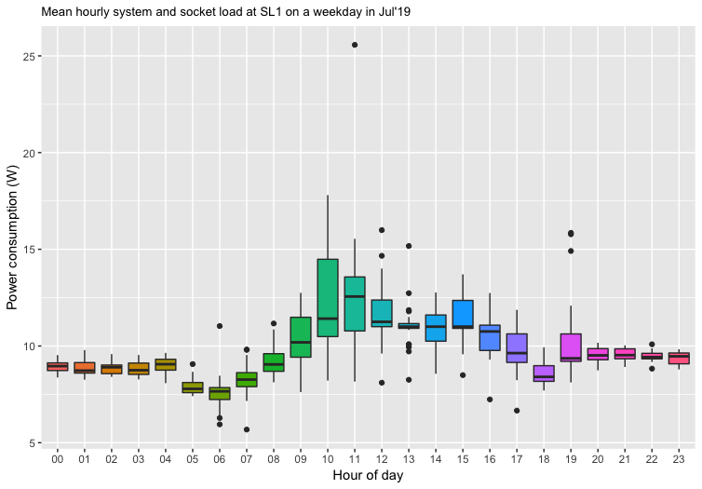

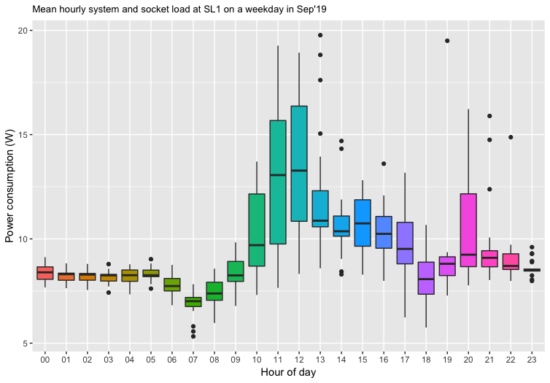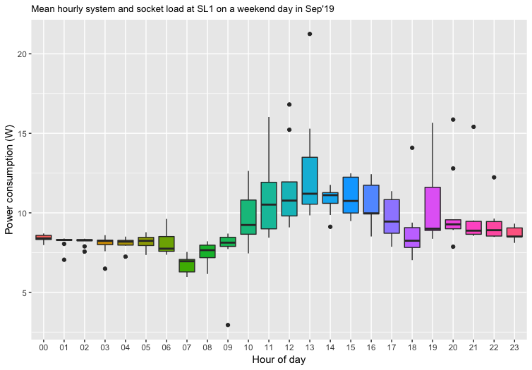

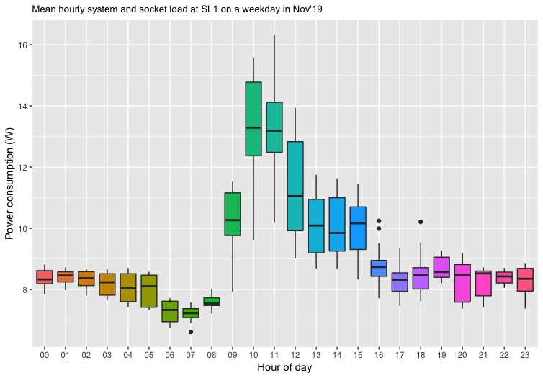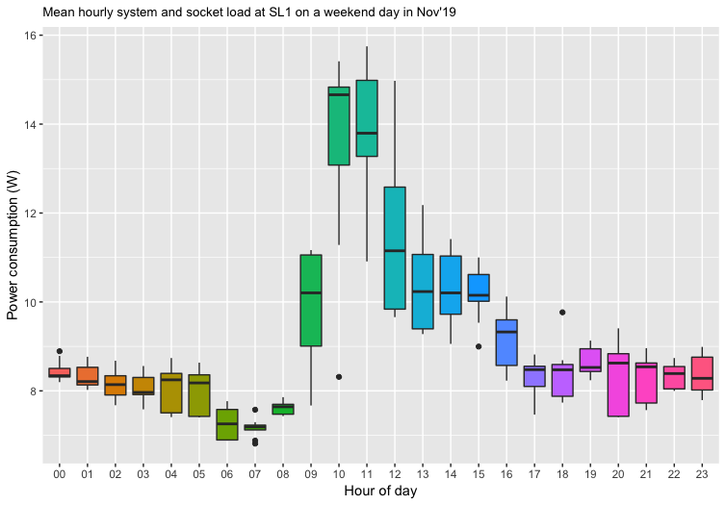

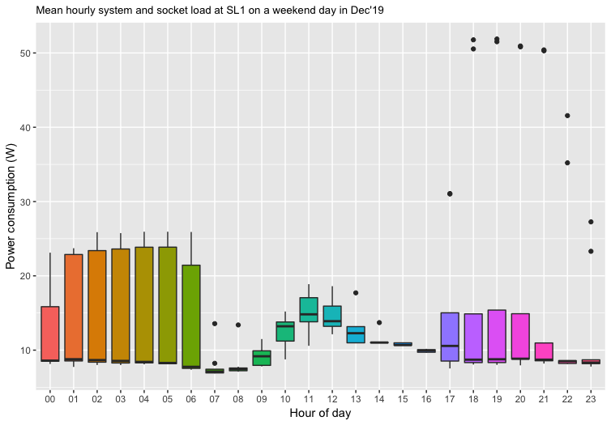

Fig. 2: The above plots show the system and socket power consumption at SL1 per hour during weekdays and weekend days (Sat and Sun) in each month between July 2019 to Jan 2020. As can be seen from the above plots, a system load is incurred throughout the day and the power consumption of system varies between 7-8Wh depending on time of day (if light is on or off). A change in the system power consumption is seen in Dec-Jan as the baseline value increases during evening and morning hours. During day time, the power consumption of sockets and system remains ~20Wh for all months. The change in power consumption during the day follows the same trend across all months with the value peaking between 11am to 12 noon.

1. Typical day system and socket load at SL1 on weekdays and weekend days per month

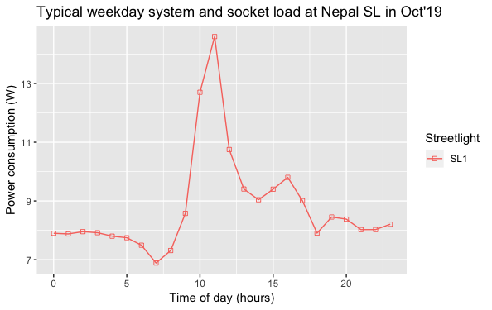

Fig. 3: Typical day profile of system and socket load at Nepal streetlights for weekdays and weekend days each month from July 2019 to Jan 2020. A typical day profile is calculated as the mean of hourly values across all days. That is, a mean typical weekday in Jul is calculated as the mean of hourly mean values of socket and system load (e.g. 1am to 2am) for all weekdays in Jul. As can be seen from the above plots, the typical profile varies across all months showing change in usage patterns. The change in system load during Dec and Jan months is also reflected. Moreover, typical profiles across weekdays and weekends show little variation for a given month.

1. Daily system and socket load since commissioning

Fig. 4: Daily total system and socket consumption at Nepal SL1 since commissioning of light on 1st July 2019. As expected from fig 2 and 3, a significant increase in energy consumption is noted on day 180 (27th of Dec 2019). This increase in consumption, however, may be due to increase in system load only.

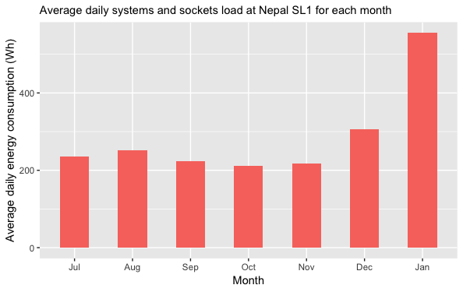

Fig. 5: Average daily systems and socket load at SL1. As can be seen from the above plot, little or no variation is seen in the daily consumption across all months between July to Nov. An increase in value is noted for Dec and Jan.

1. Total socket consumption at SL1 values per streetlight per month – To calculate the socket load, the system load needs to be removed from the total consumption value. The system load data is not available separately but is inferred by looking at the box plots in fig. 1. As the system load changes with time of day (day and night depending on lights on or off), a mean value for the day is calculated. Furthermore, the value of system load is calculated for each month owing to variation in data as seen above. The following values of system load have been used for each month. The value is multiplied by 24 to remove the total system load for a day from the total consumption.
   1. July 2019
   2. Aug 2019
   3. Sep 2019
   4. Oct 2019
   5. Nov 2019
   6. Dec 2019
   7. Jan 2020

Fig. 6: Estimated socket consumption at Nepal SL1 per month. The socket load is calculated by subtracting the estimated system load from combined socket and system load values per day. The system values (baseline value) varies across time of day (day and night) as well as across months of study, with a significant rise in value from late Dec 2019. Since the transition of values takes place in Dec, some of the socket load values are negative. Moreover, an increase in socket load is observed in Jan 2020.

1. Typical day power profile for SL1 per month – a typical day of energy consumption in a month is calculated by taking the mean hourly value across all days. E.g. a typical day value between 1am to 2am is calculated by taking mean of values for the given hour for all days in a month.

Fig. 7: Typical day values for all variables in a month for Nepal SL1. The state of charge value is also shown on the secondary Y-axis. The capture loss is calculated as the difference of potential PV power (predicted PV power that can be harnessed at a given hour) and actual PV power (actual PV power that is output of the PV panel in a given hour). Note that since the potential PV power values have certain inaccuracies, the capture loss for certain hours is negative. These values have been replaced with 0 to indicate no capture loss for those hours.

1. Estimated capture losses and percentage of surplus used by external devices –
   1. Daily capture loss = Daily Pot. PV power – Daily Actual PV power
   2. Daily surplus = 1 – daily capture loss / (daily capture loss + daily system-socket load)

Fig. 8: Capture loss and system and socket load at SL1 since commissioning of light on 1st July 2019 until Dec 2019. The surplus energy (%) is also shown on secondary Y-axis. The surplus energy shows the % of energy harnessed by the PV power that is used by sockets and would have otherwise been wasted if no sockets were installed. As seen from the above plot, the system and socket load has roughly been constant throughout the period of study, with slight increase in value starting Dec 2019. Majority of the surplus energy usage is <=25%. As expected, the surplus is 100% on days where the capture loss is zero (a negative value of loss is replaced with zero).