- Yield for data – yield for each day has been calculated as the % hours for which data is available per day. The data has been cleaned to remove socket load values that are NA or negative.

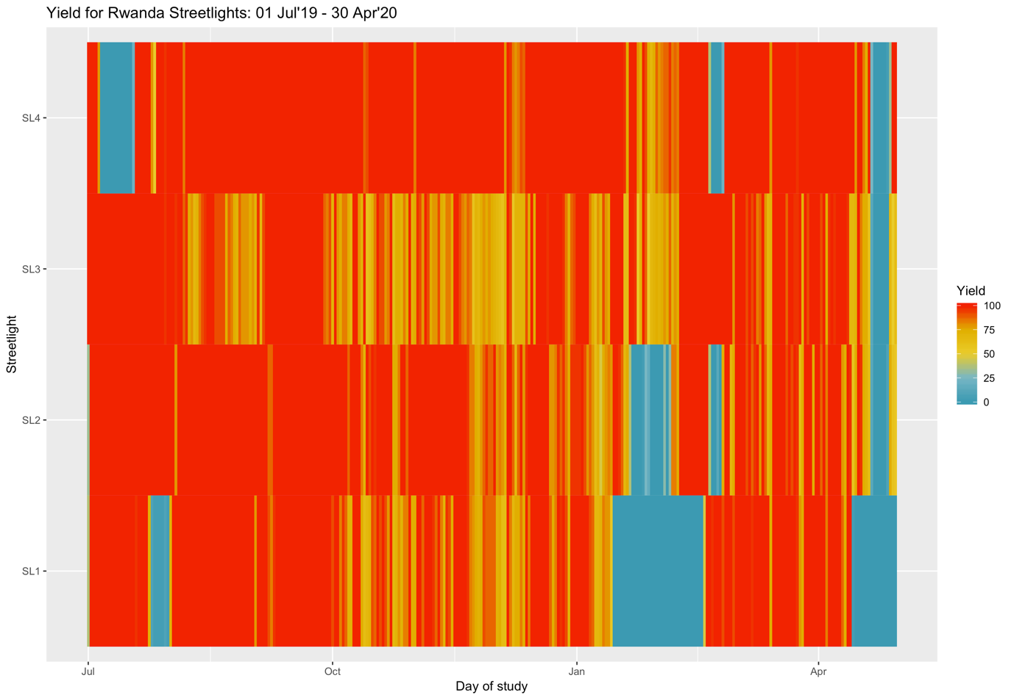
Fig. 1: Yield for all SL

- Mean hourly system and socket load – during the entire and during day-time hours. Values where the load is NA or negative have been removed.
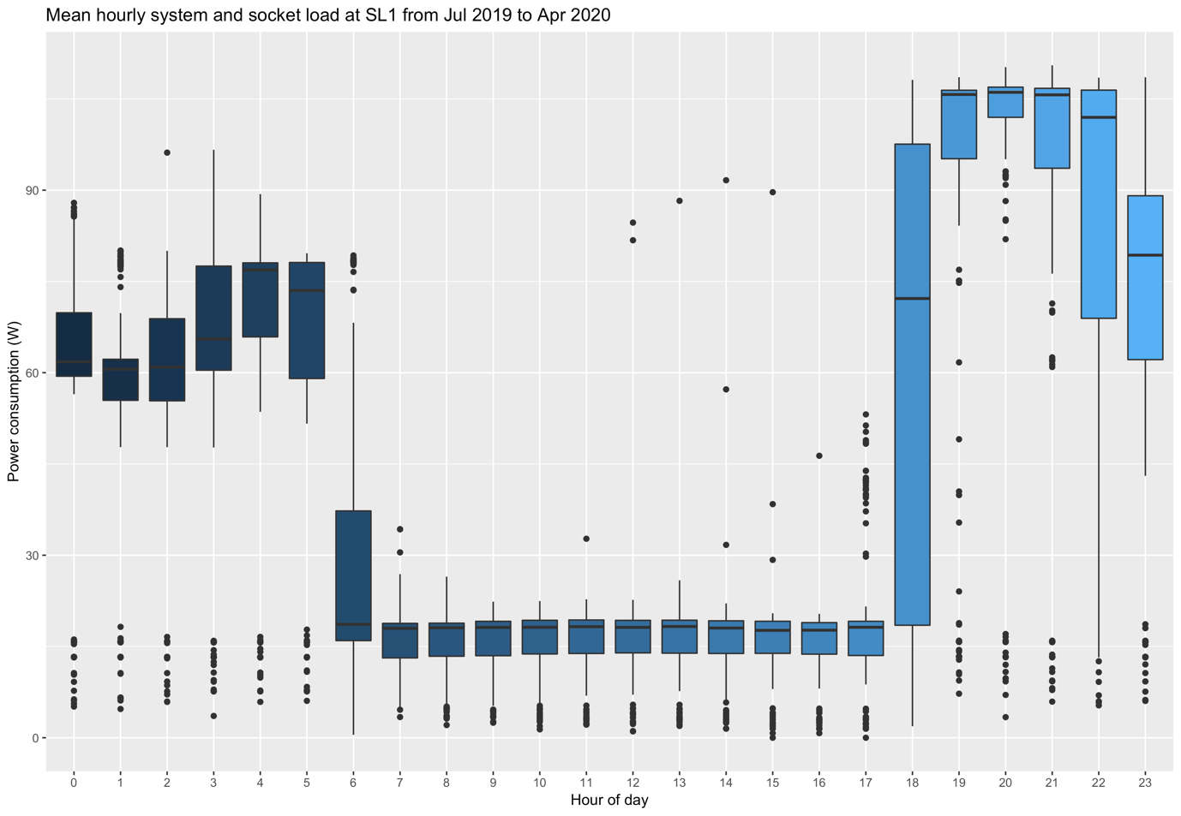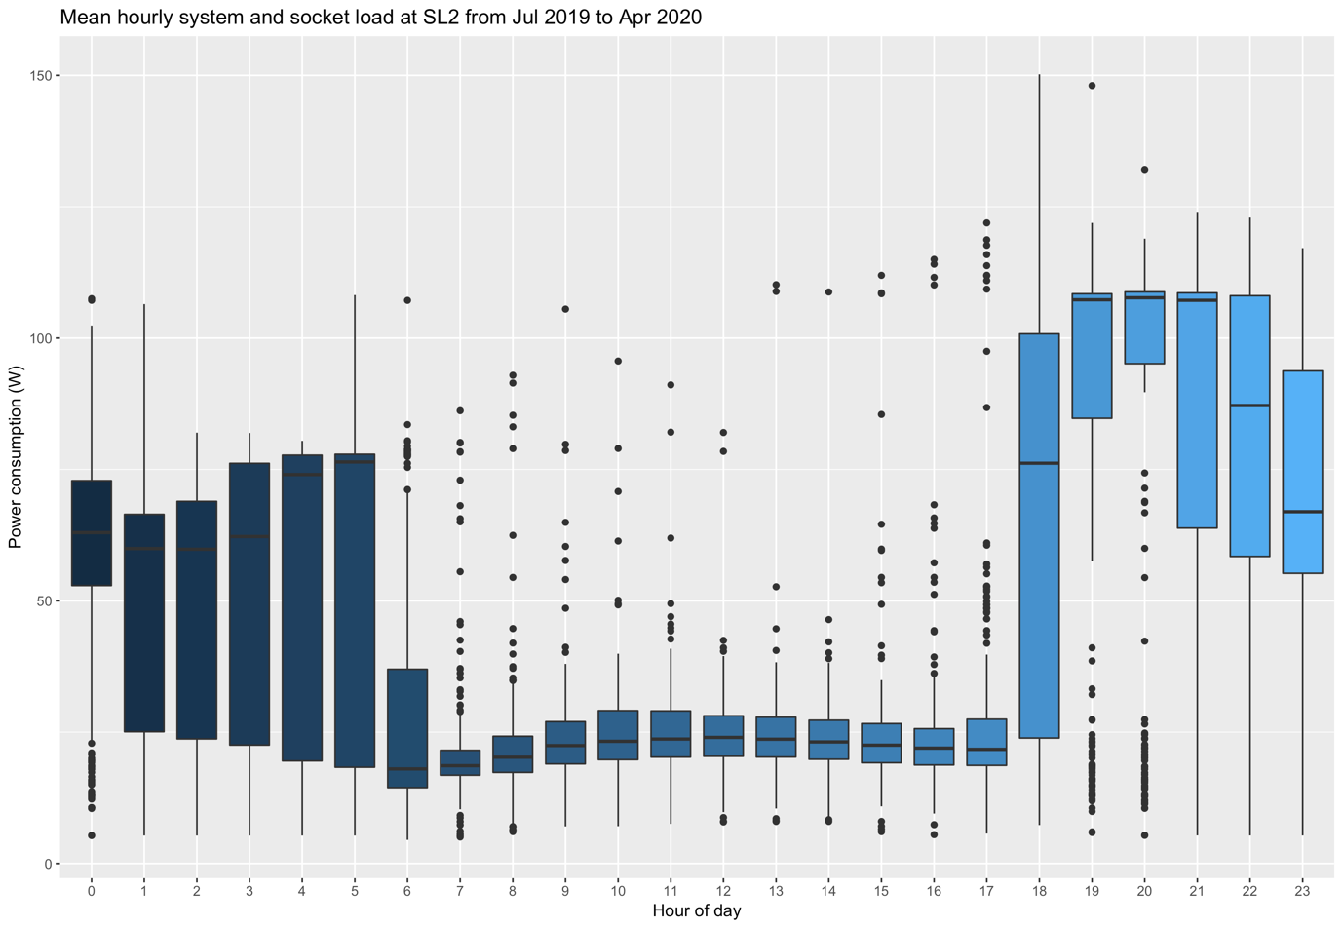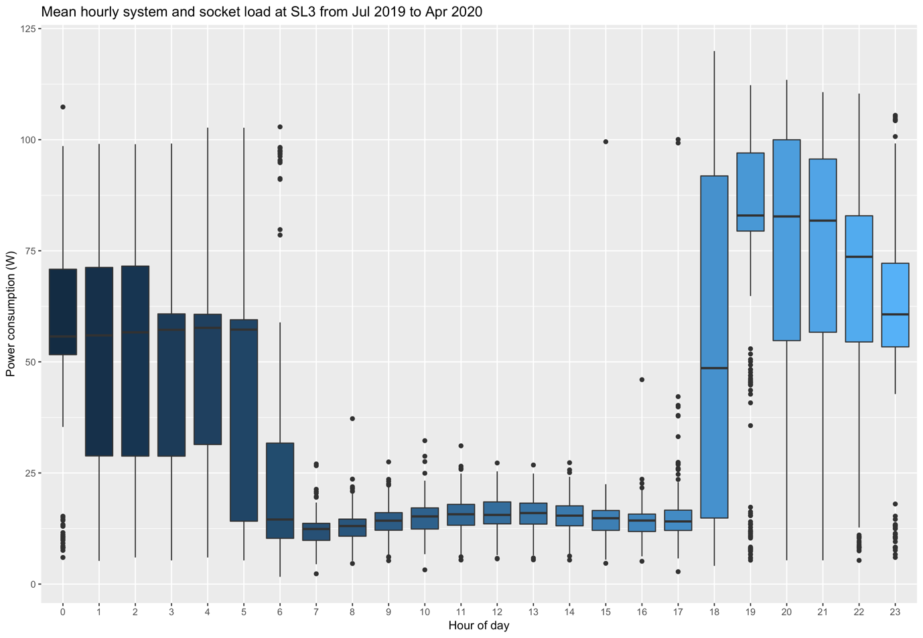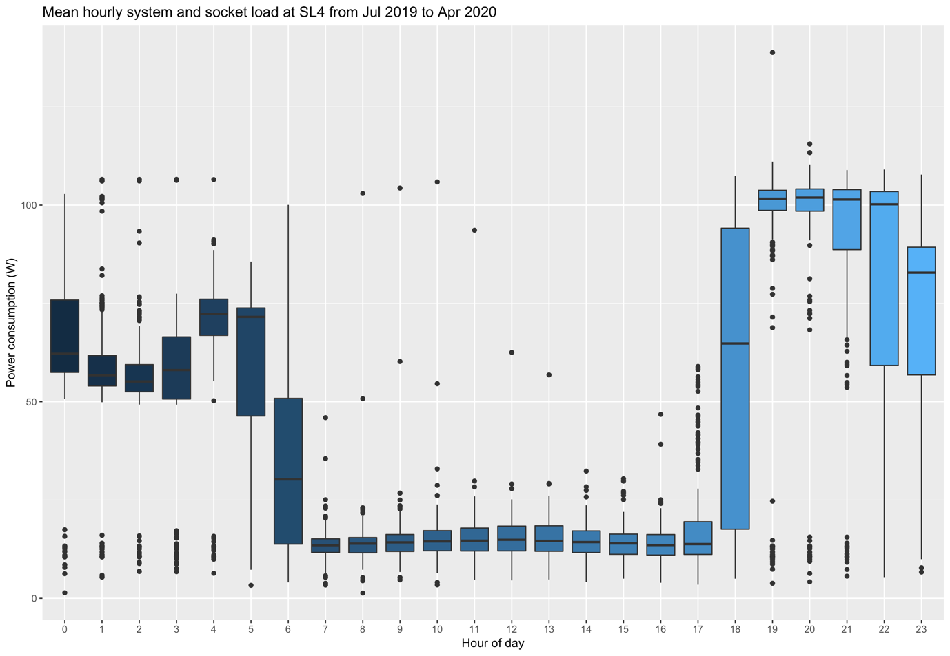
Fig. 2a: Mean hourly system and socket load during the entire day for all SL

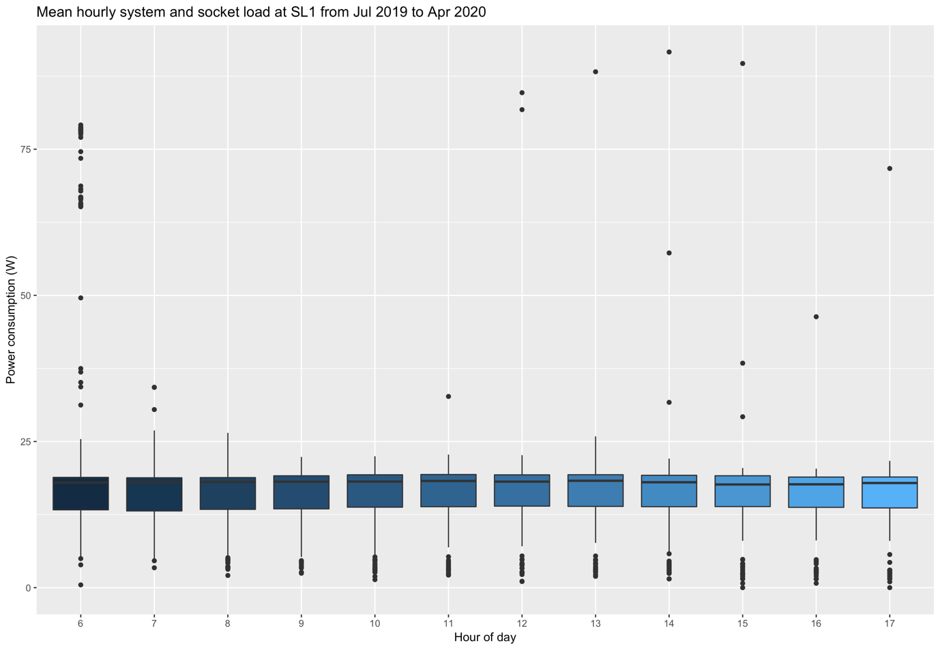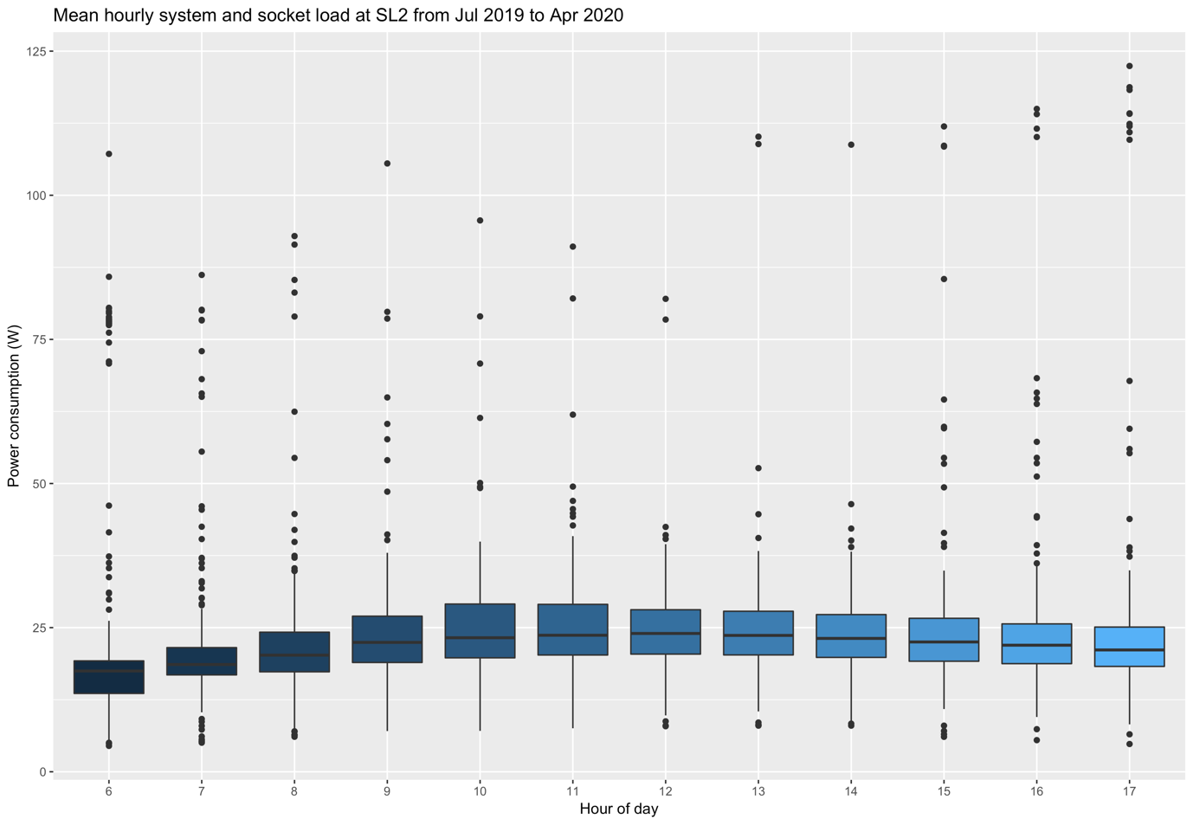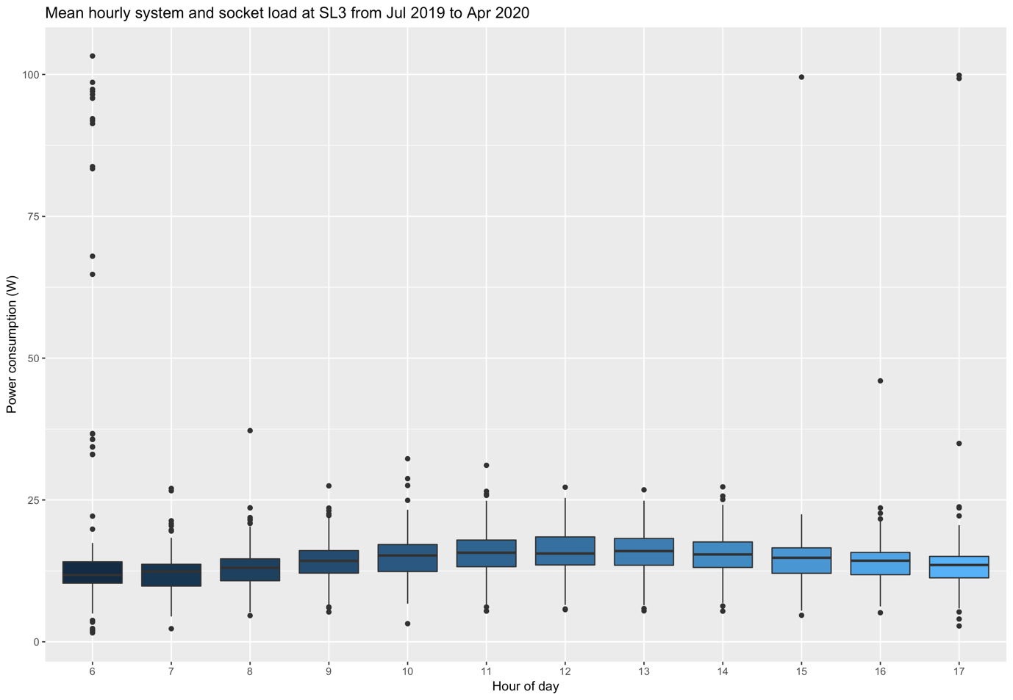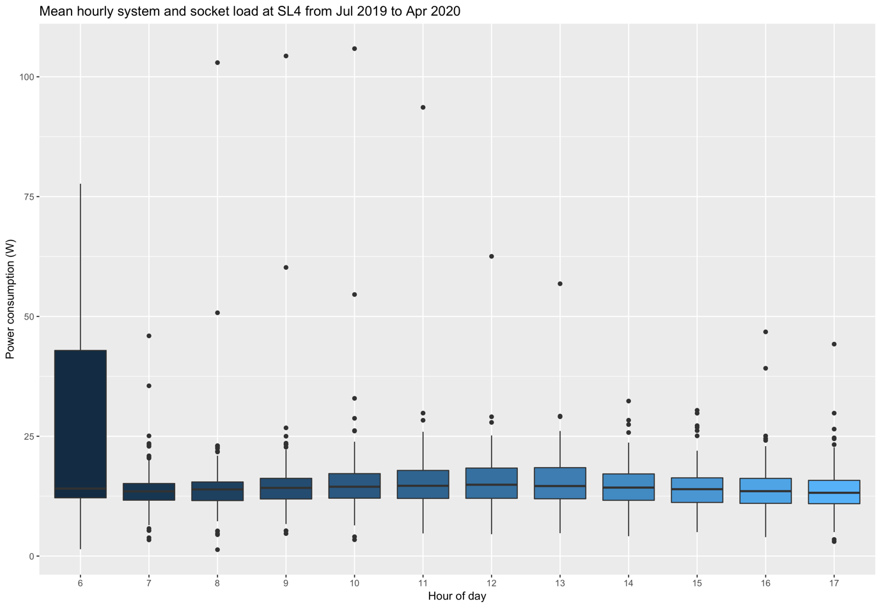
Fig. 2b: Mean hourly system and socket load during day time for all SL

- Mean hourly AC consumption using all available data

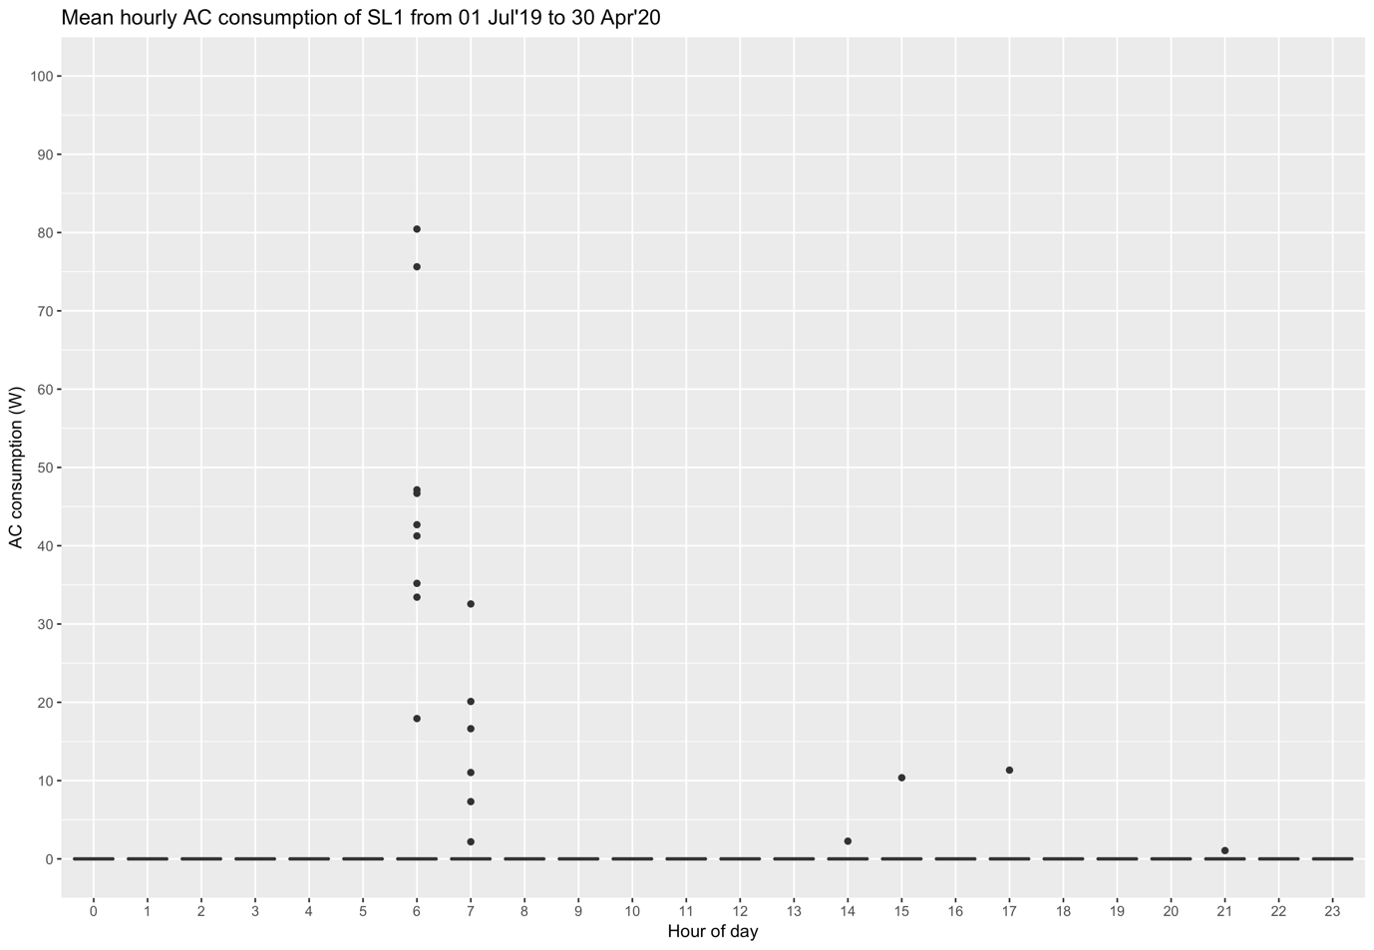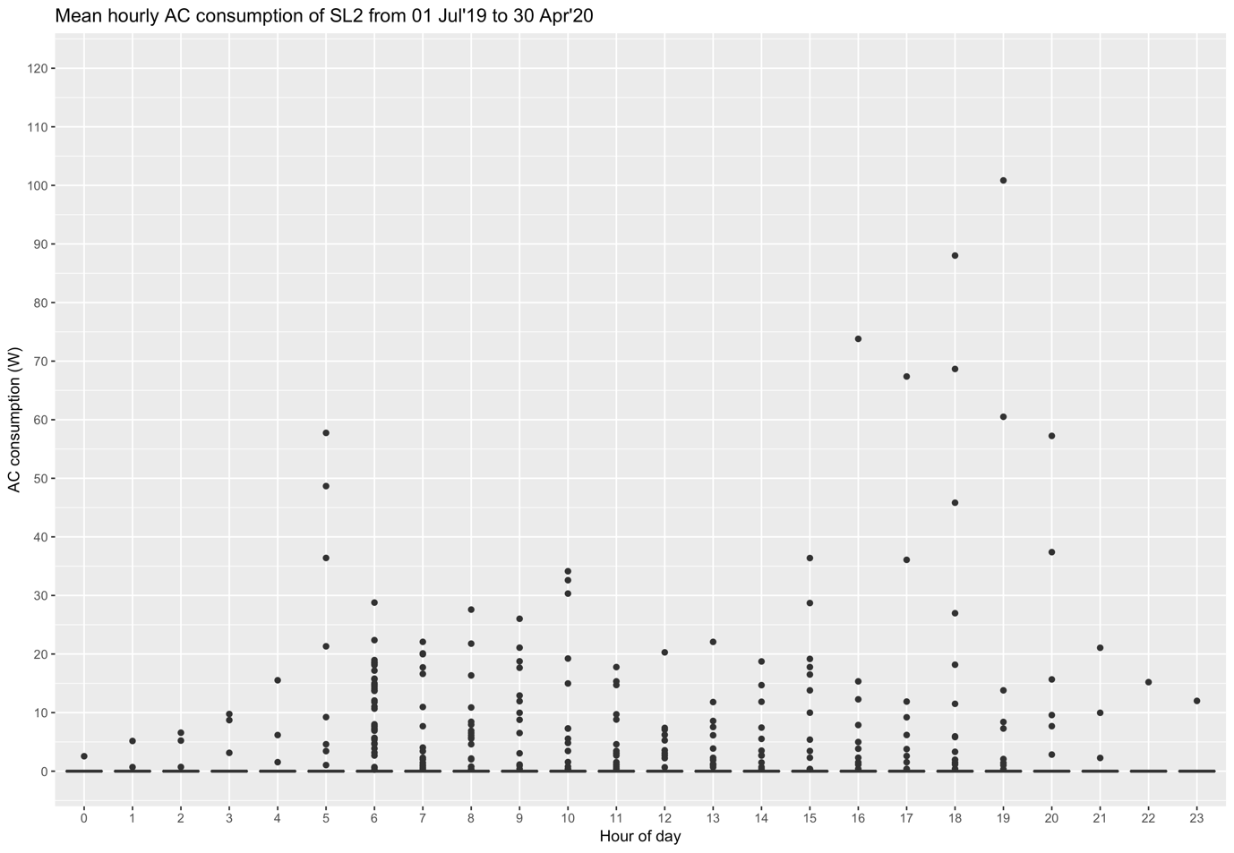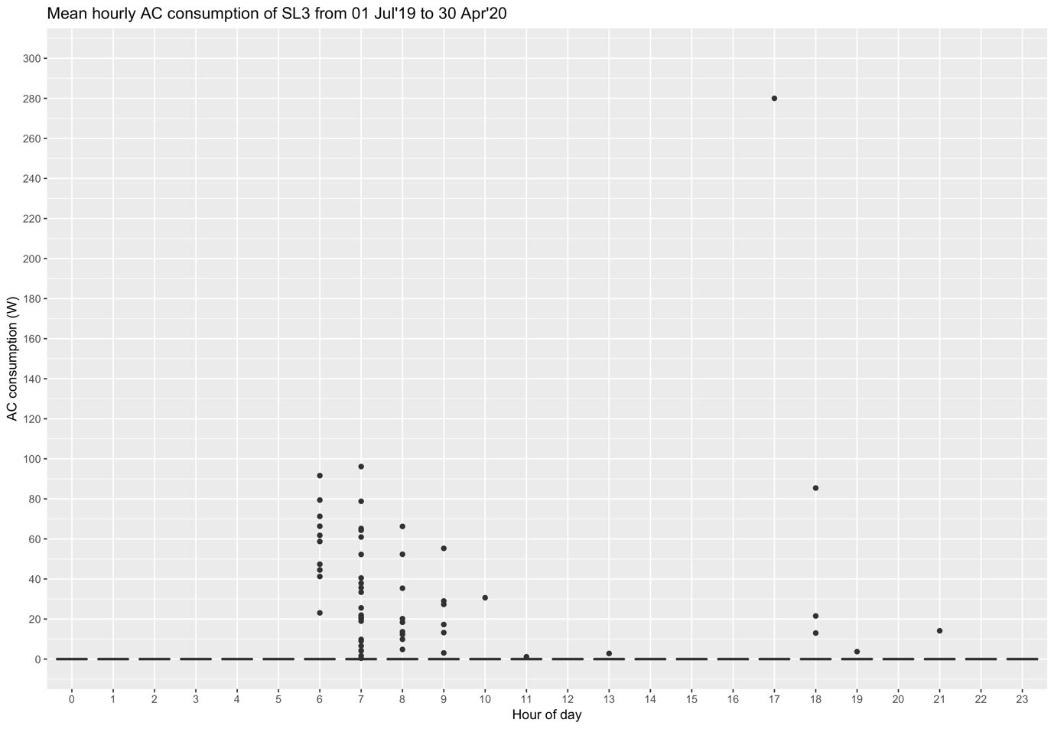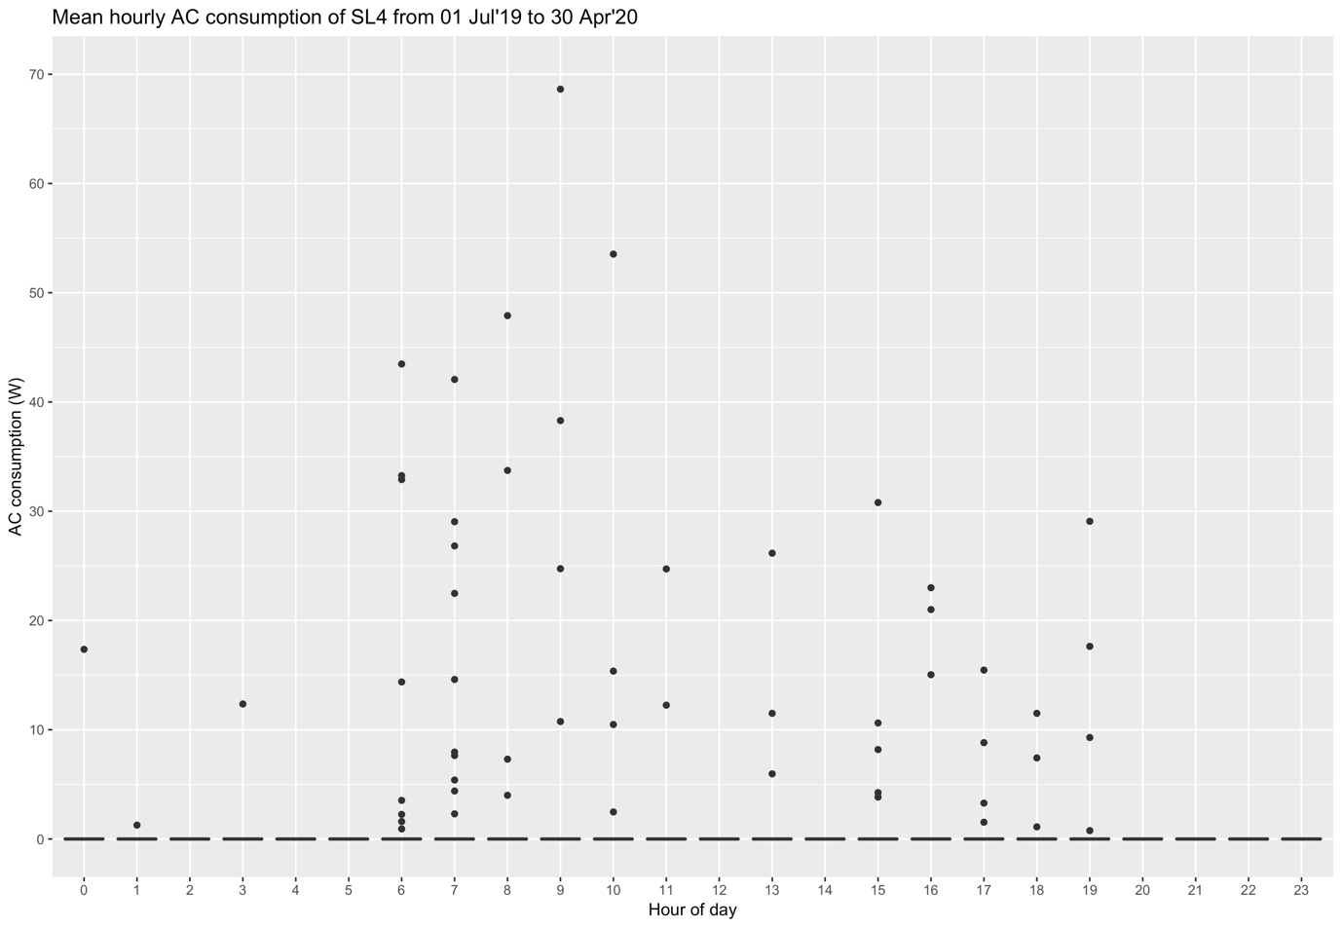
Fig. 3: Mean hourly AC consumption for all SL

- Daily AC consumption since commissioning using all data available and only for full data days

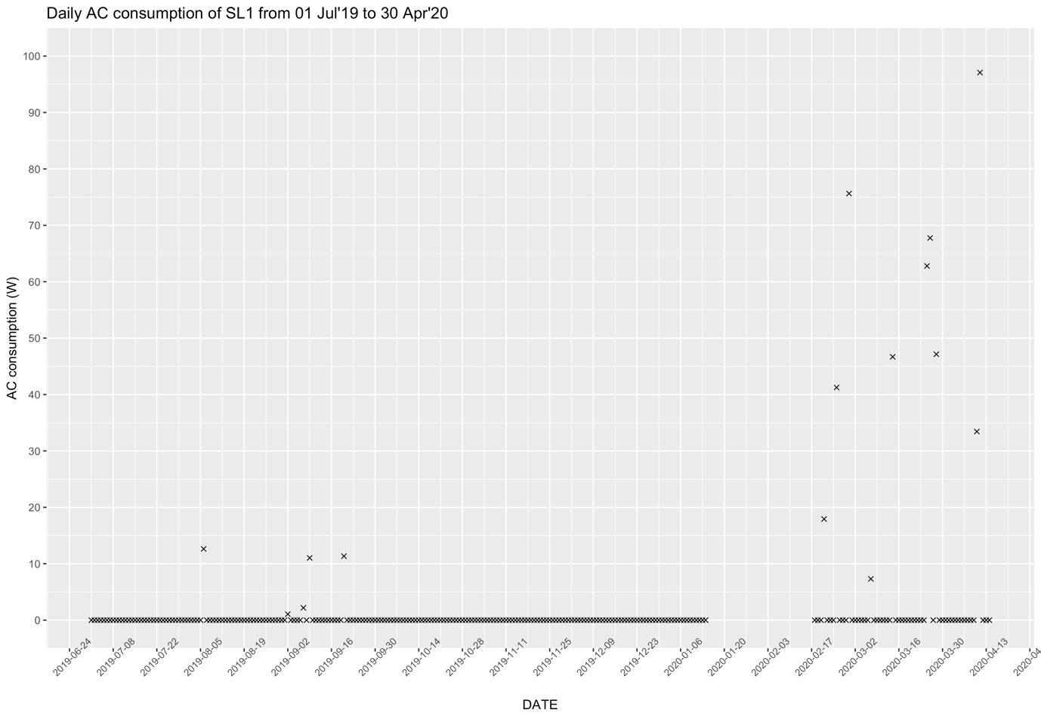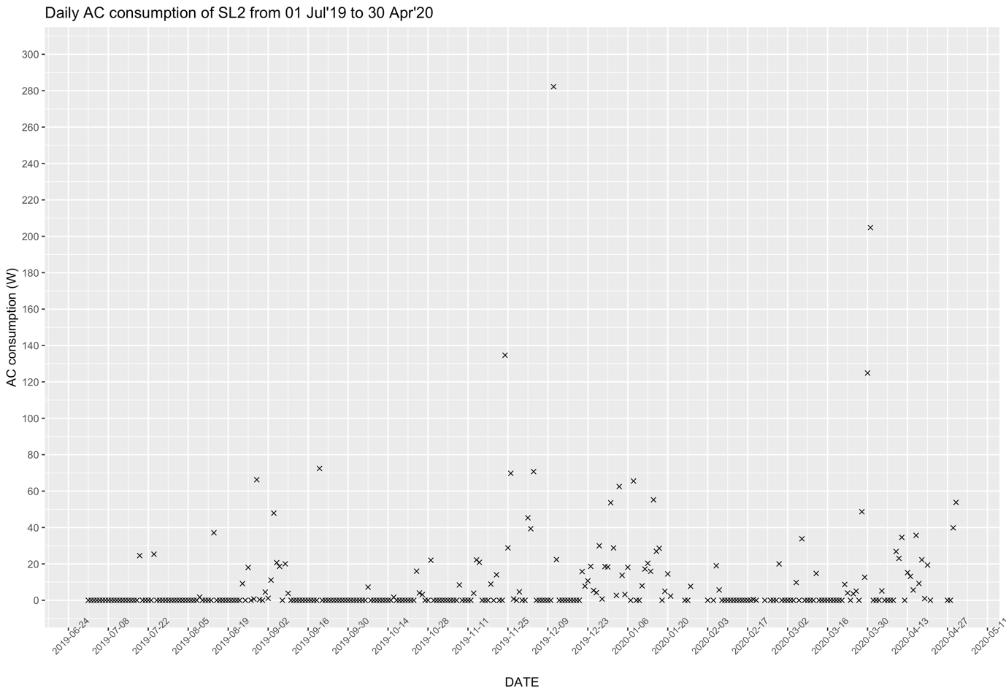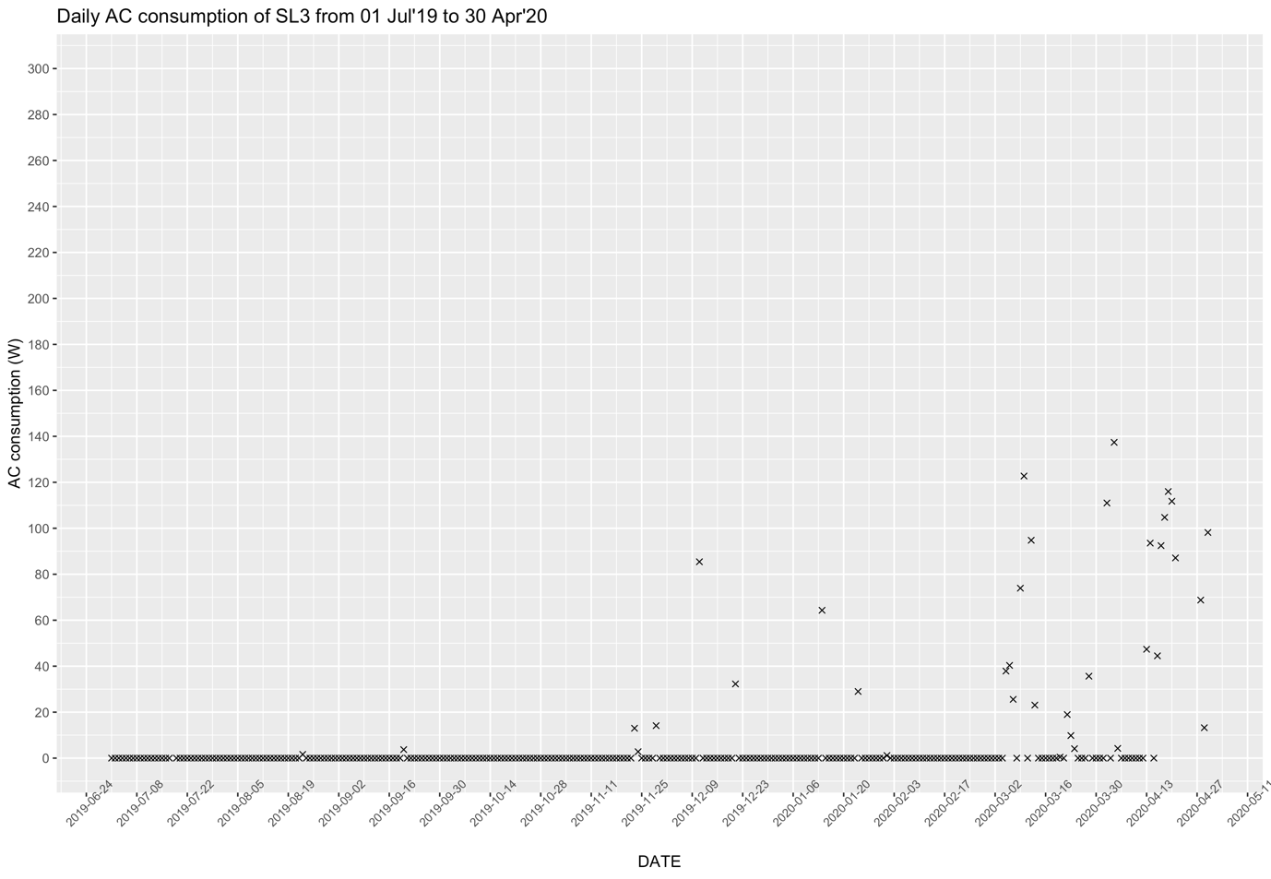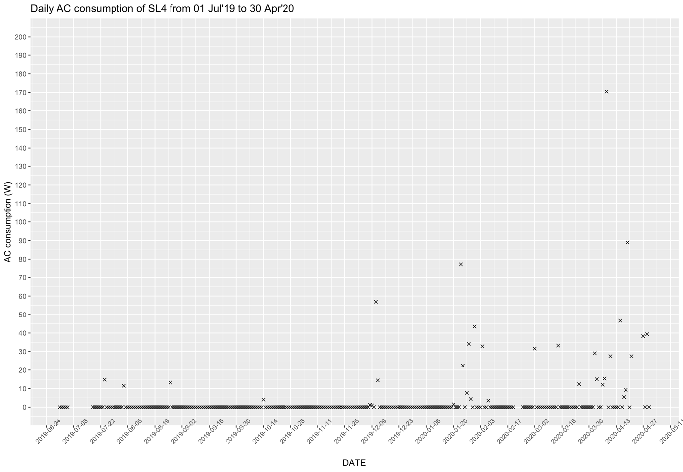
Fig. 4a: Daily AC consumption since commissioning for each SL using all data available

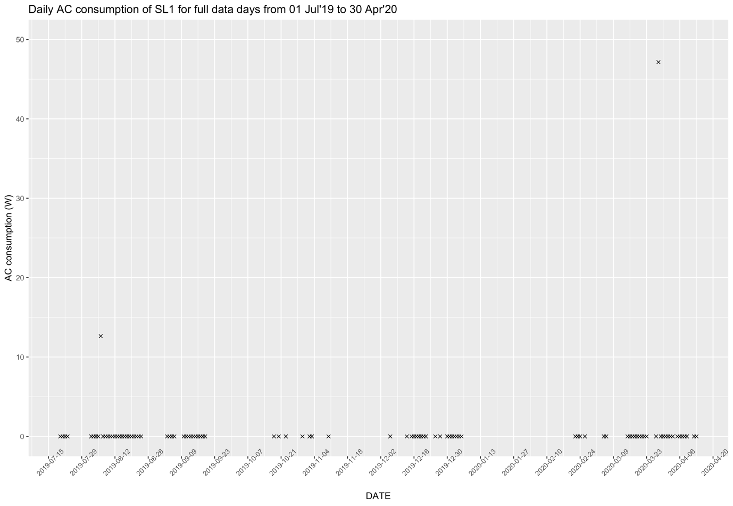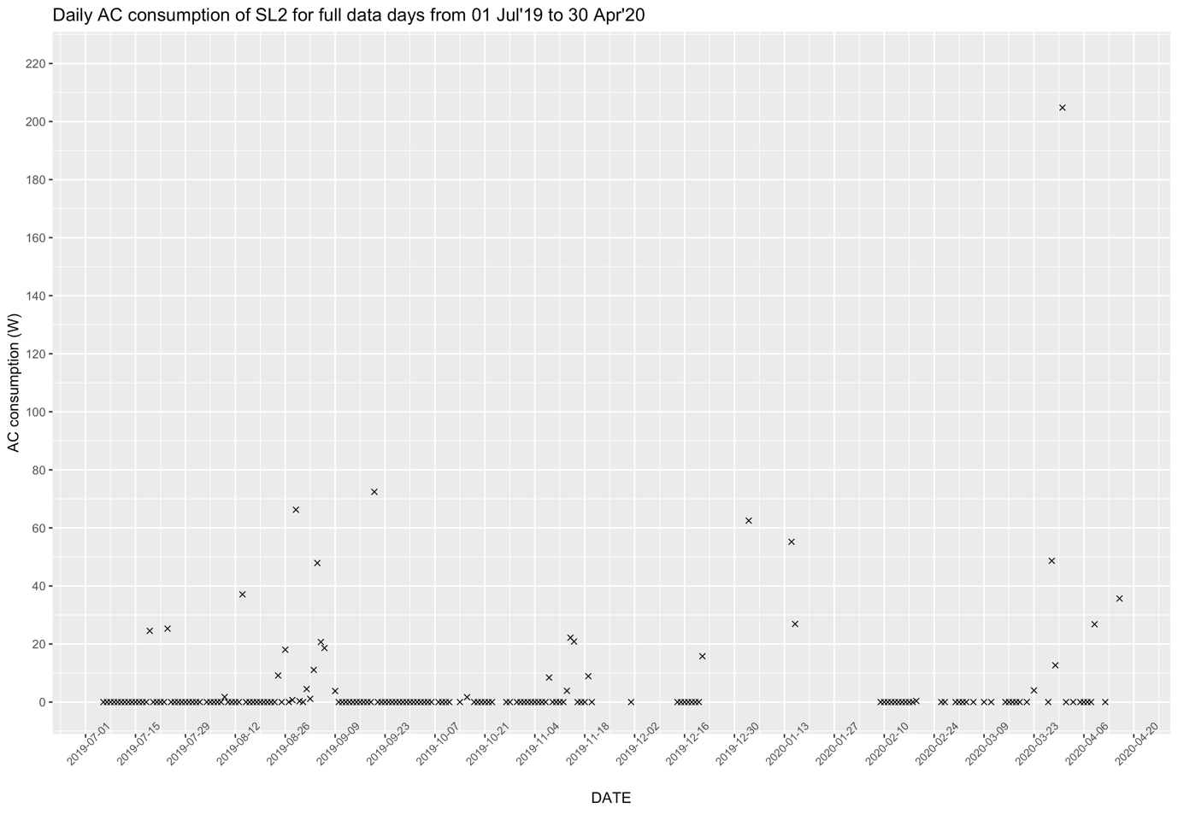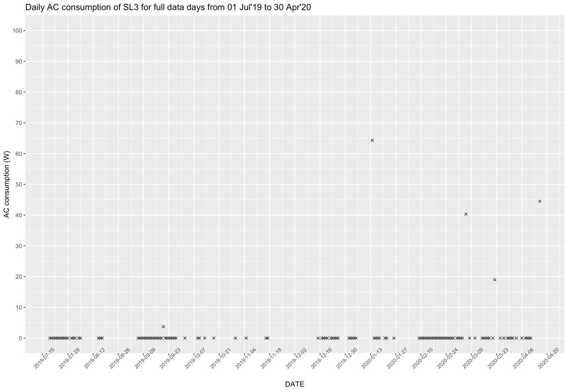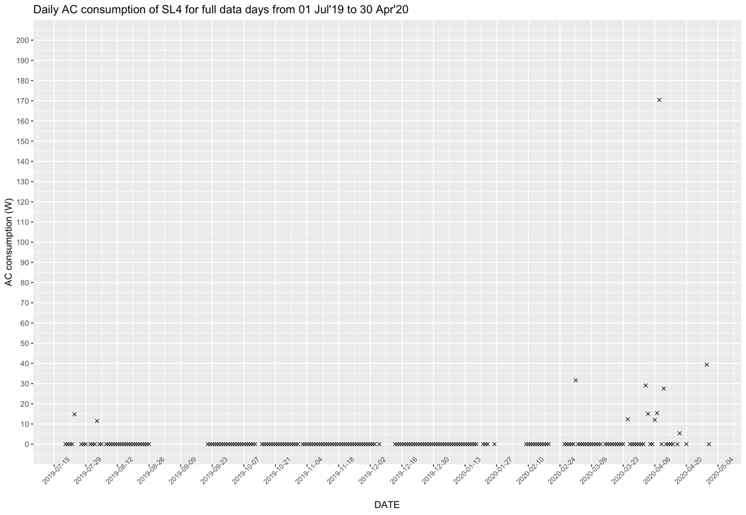
Fig. 4b: Daily AC consumption since commissioning for each SL on full data days

- Daily average for Capture loss, Total Load, System loss for each month for full data days – full data days are those where data is available for all 24 hours. Daily values are calculated for Battery Power, Solar Charger Battery Power, Actual PV power and Potential PV power on full data days. Next, the total load per day is calculated as
+Solar Charger Battery Power – (Positive Battery Power – Negative Battery Power). The system loss is then calculated as Actual PV power – abs(Total load).

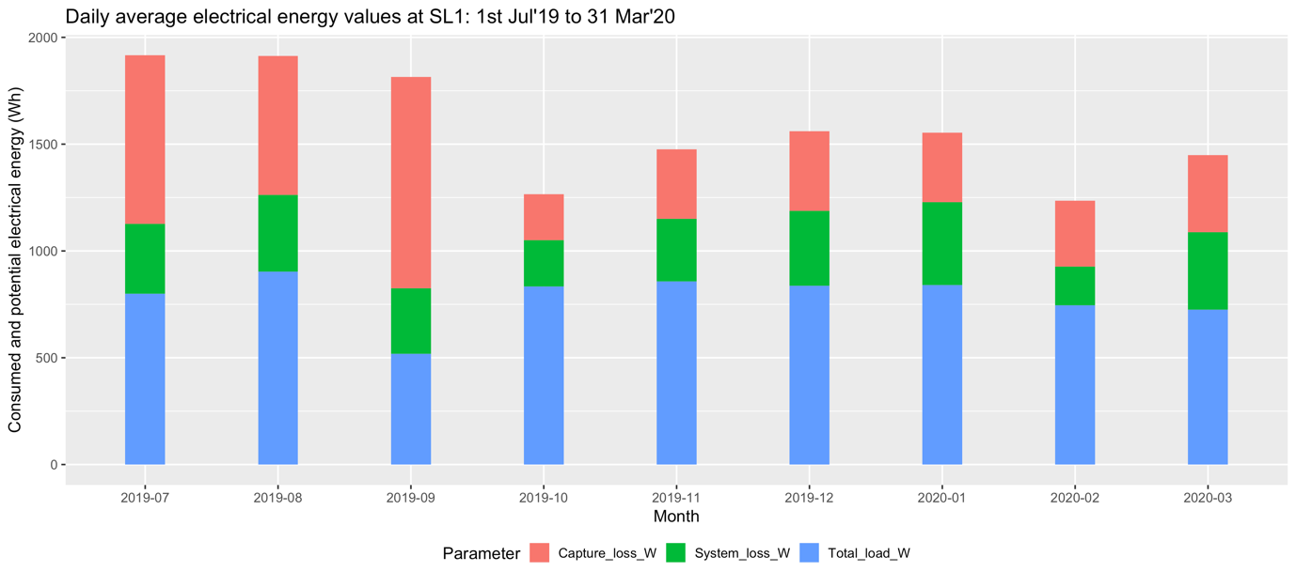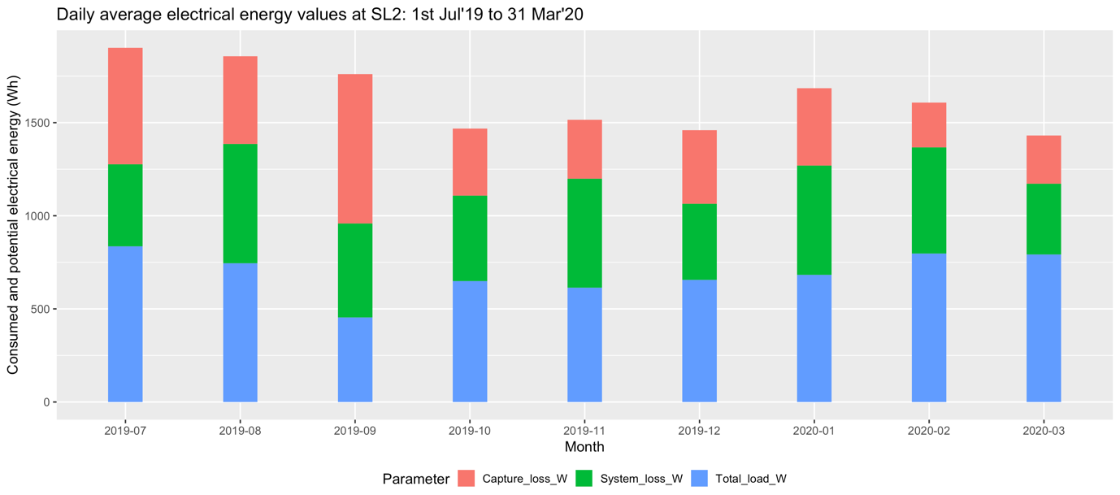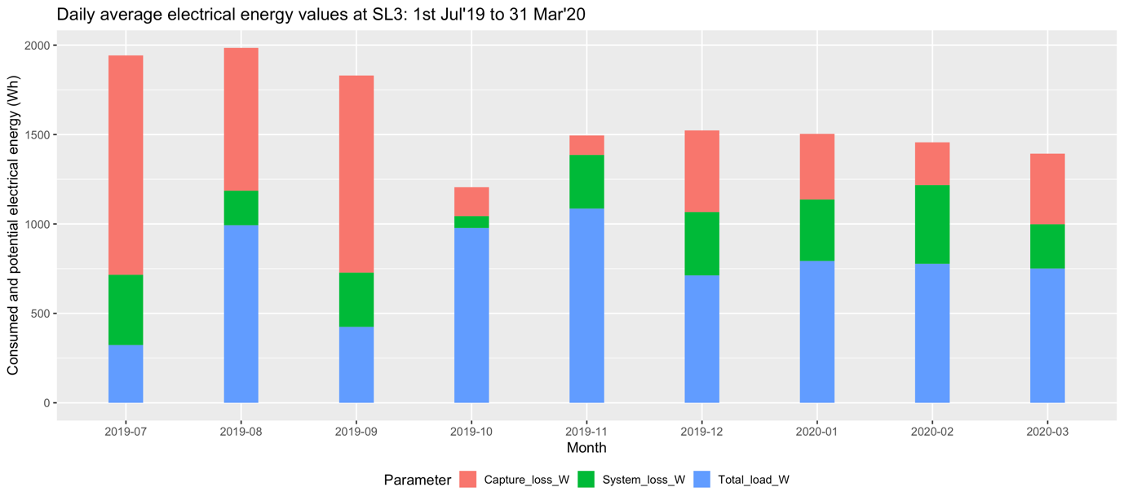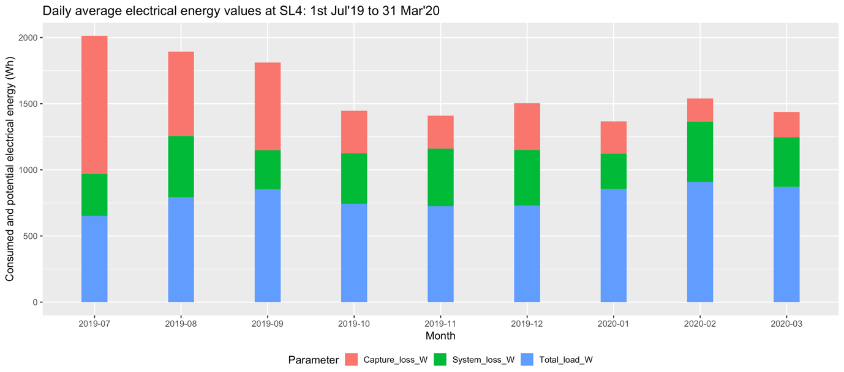

Fig. 5a: Daily average for electrical energy values at Rwanda SL on full data days. Total load is calculated as +Solar Charger Battery Power – (Positive Battery Power – Negative Battery Power)

The total load may be calculated as +Solar Charger Battery Power – (Positive Battery Power + Negative Battery Power). Following plots are then reflected.

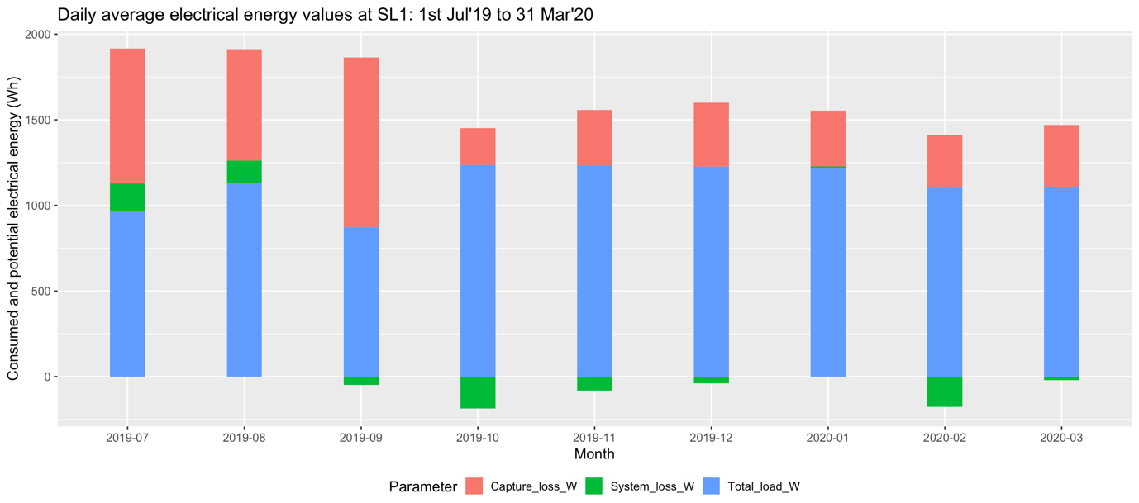
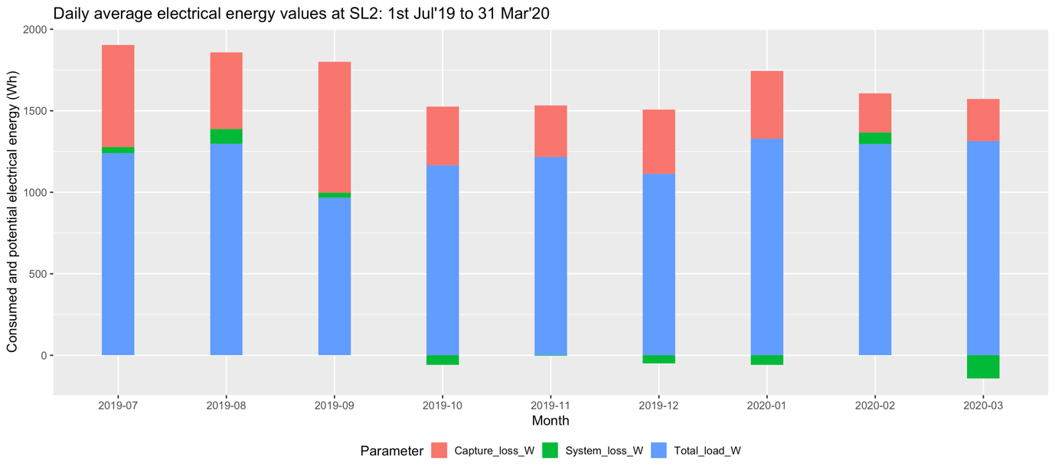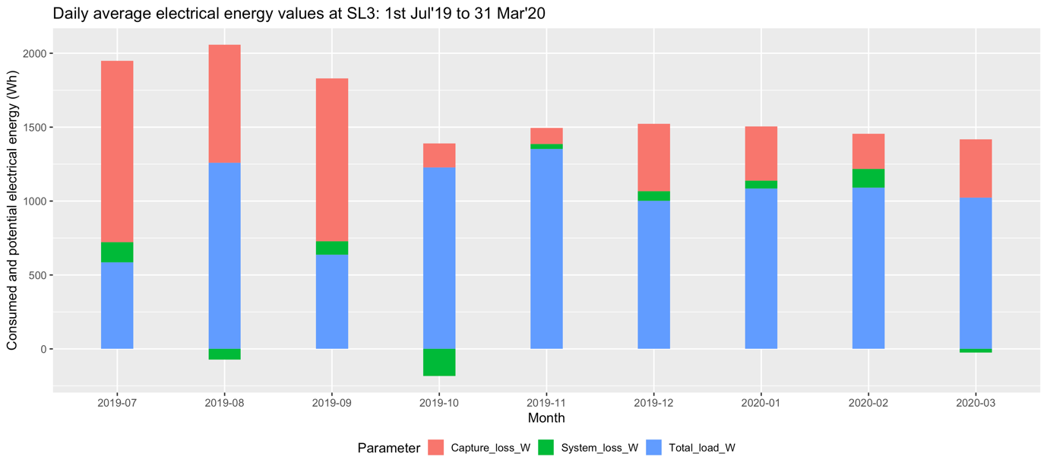
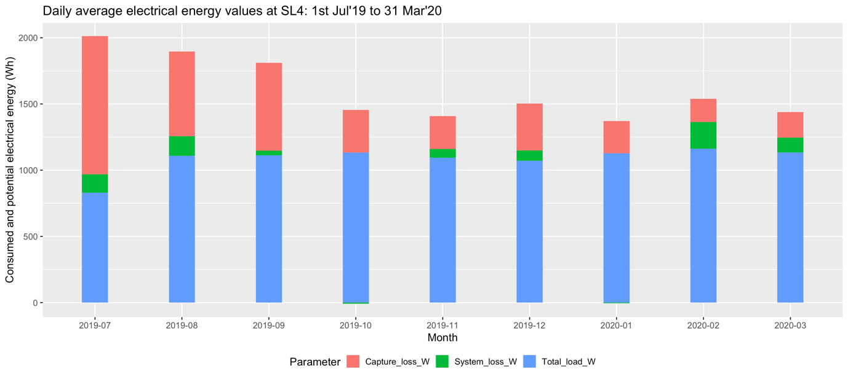
Fig. 5b: Daily average for electrical energy values at Rwanda SL on full data days. Total load is calculated as +Solar Charger Battery Power – (Positive Battery Power + Negative Battery Power)

- System and socket load during daytime for days where all daytime hours data is available (between 6:30am to 5:30pm)

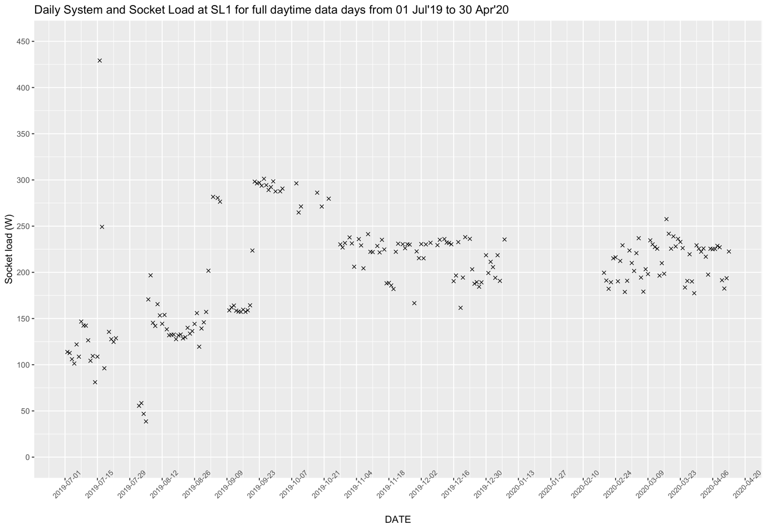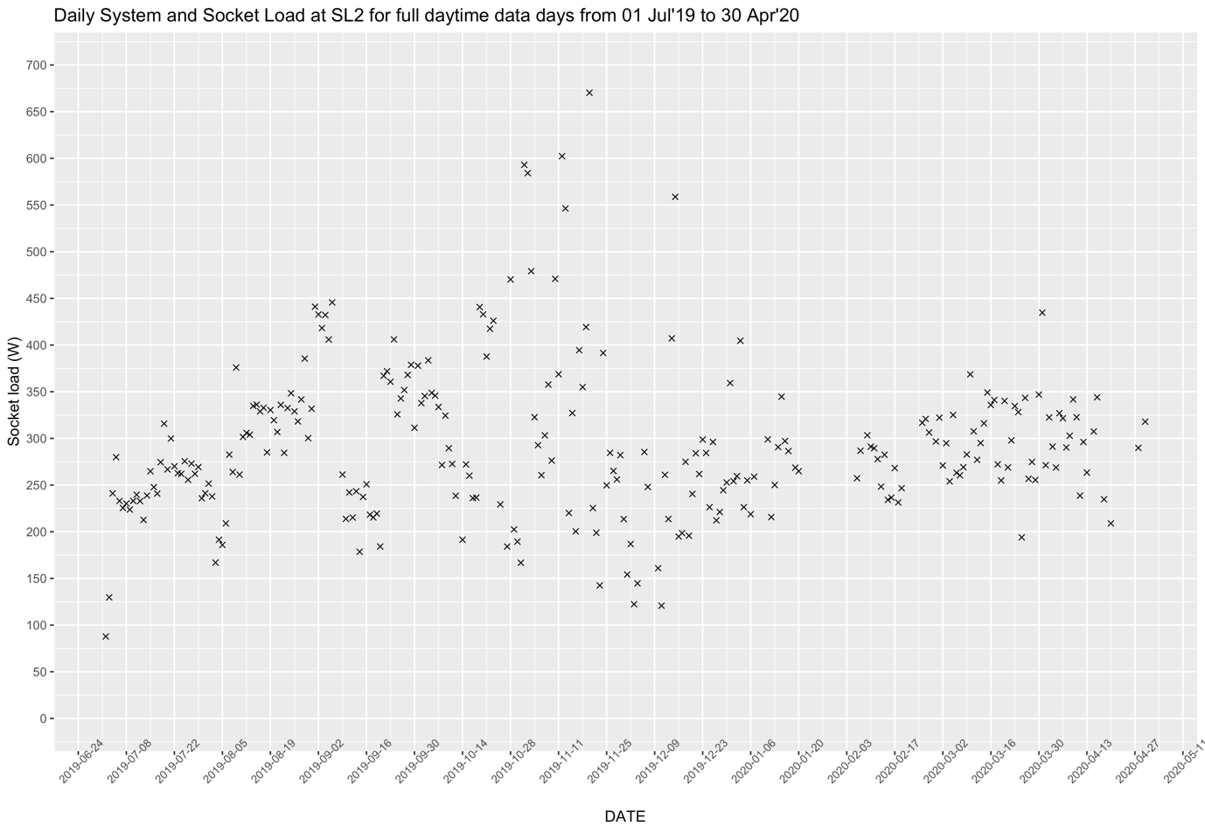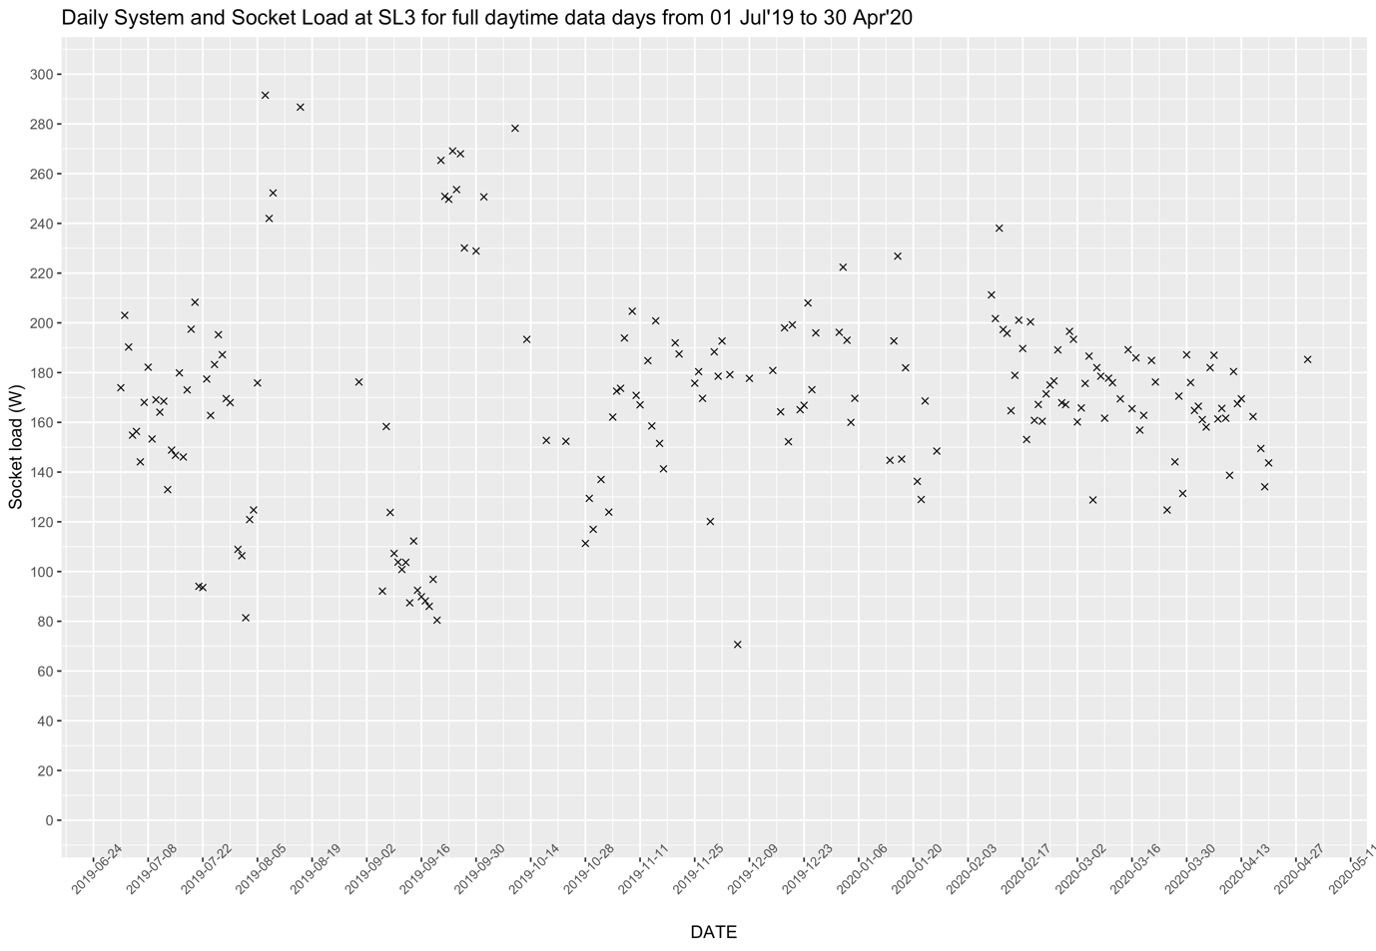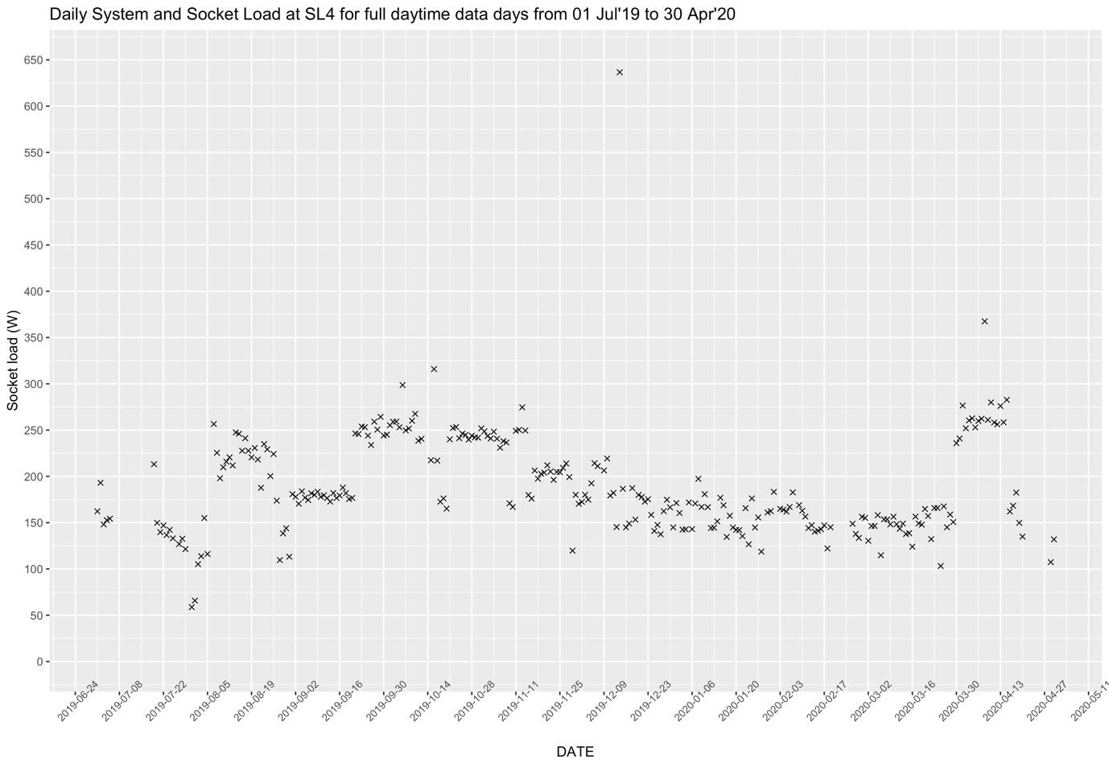
Fig. 6: Daily system and socket load for days where daytime data is available for all 12 hours

