|  |  |
| --- | --- |
| **ECEN 4610** | **Capstone Fall 2014** |
| The League of Extraordinary Engineers Team  Level 2 Functional Decompositions | |

**1.1 Functional Decomposition Level 2 - Vehicle System**

**Charge Plates - Vehicle**

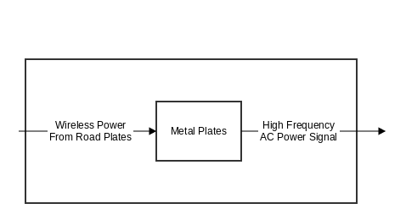

|  |  |
| --- | --- |
| Module | Metal Plates |
| Inputs | Wireless power from road plates |
| Outputs | High frequency AC power signal |
| Functionality | Receives wireless power from road charge plates |
| Testability | Transmit power from another charge plate, and measure received power signal. |

**Power Converter - Vehicle**

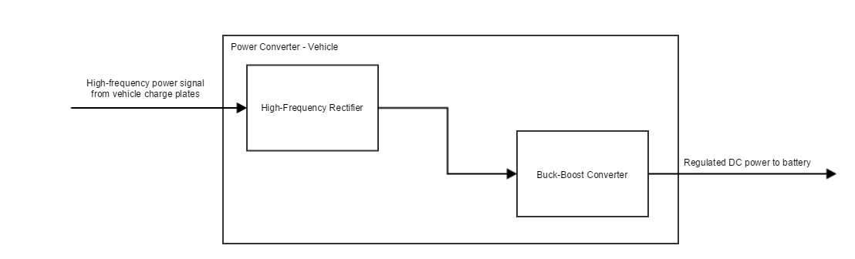

|  |  |
| --- | --- |
| Module | High-Frequency Rectifier |
| Inputs | High frequency power signal from the vehicle charge plates |
| Outputs | DC power to vehicle buck-boost converter |
| Functionality | Converts the high frequency AC power signal to a DC power signal |
| Testability | Input a high frequency AC power signal, and measure the output signal to ensure that it is DC |

|  |  |
| --- | --- |
| Module | Buck Boost converter |
| Inputs | DC power from high-frequency rectifier |
| Outputs | Regulated DC power to battery |
| Functionality | Converts the DC power signal from the high-frequency rectifier to the appropriate voltage level for charging the vehicle battery |
| Testability | Sweep the voltage range for the input and confirm output voltage range can charge the battery |

**Charge controller - Vehicle**

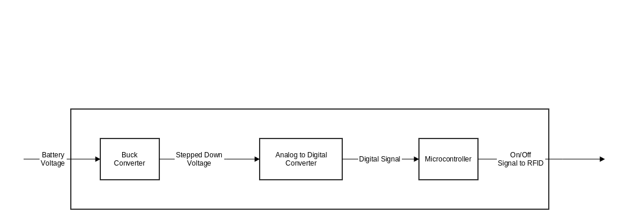

|  |  |
| --- | --- |
| Module | Microcontroller |
| Inputs | Data that indicates vehicle’s battery level |
| Outputs | Voltage to control RFID tag |
| Functionality | Turns the RFID tag on or off based on whether the car battery is fully charged. |
| Testability | See if a full battery signal results in the RFID tag being turned off, and if an uncharged battery turns the RFID tag on. |

|  |  |
| --- | --- |
| Module | Buck Converter |
| Inputs | High voltage signal from battery |
| Outputs | Low voltage signal for input into analog to digital converter. |
| Functionality | Steps down the voltage level of the battery so that it can be an input into the analog to digital converter. |
| Testability | Sweep the input of the buck converter from lowest possible voltage to battery’s max voltage and see if all output signals have a lower output voltage. |

|  |  |
| --- | --- |
| Module | Analog to Digital converter |
| Inputs | The scaled down analog signal from the buck converter. |
| Outputs | A digital signal indicating battery charge to the microcontroller |
| Functionality | Converts the analog signal from the buck converter into a digital output so that the microcontroller can analyze the signal. |
| Testability | Sweep the input of Analog to digital converter from the minimum value of the buck converter output to the maximum value of the buck converter output and see if the digital signal has appropriate resolution. |

**RFID Tag - Vehicle**

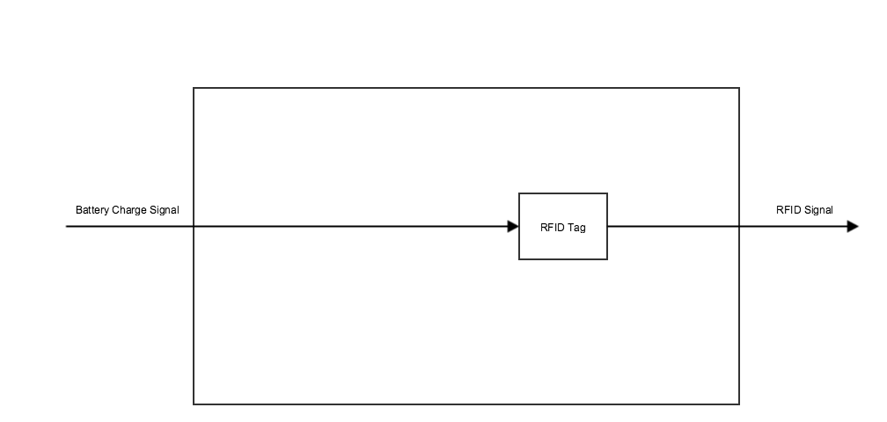

|  |  |
| --- | --- |
| Module | RFID Tag |
| Inputs | Battery charge level |
| Outputs | RFID signaling desired charge behavior |
| Functionality | Transmits an RFID signal when the vehicle battery needs charging |
| Testability | Give the RFID tag a digital battery voltage level, and measure the resulting output signal with an RFID reader. |

**1.2 Functional Decomposition Level 2 – Road System**

**Charging Pads - Road**

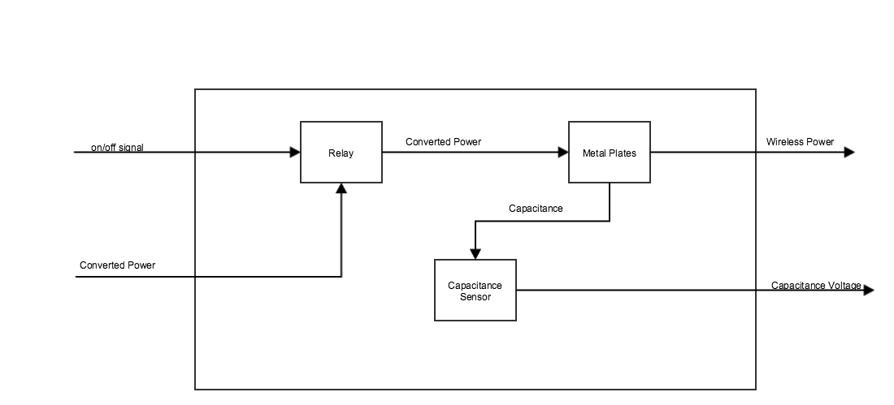

|  |  |
| --- | --- |
| Module | Metal Plates |
| Inputs | Scaled AC voltage from the relay |
| Outputs | Wireless power to vehicle charge plates |
| Functionality | When the controller desires the plates to be on, the road plates provide two phase-shifted signals to the vehicle plates. |
| Testability | Provide an AC voltage signal and measure transmitted signals using a matching set of vehicle plates and an oscilloscope. |

|  |  |
| --- | --- |
| Module | Relay |
| Inputs | On/off signal, scaled voltage from the frequency converter |
| Outputs | Scaled AC voltage to road plates |
| Functionality | When the relay is turned on by the control logic, the scaled AC voltage passes through; otherwise, the plates will remain unpowered. |
| Testability | Use an oscilloscope to measure the power transmitted when the relay is on, and when it is off. |

|  |  |
| --- | --- |
| Module | Capacitance Sensor |
| Inputs | Capacitance from the Road Capacitive Plates |
| Outputs | A digital level to determine if the plates need to be on or off. |
| Functionality | Determines the capacitance of each individual plate in order to turn the plates on or off based on if the vehicle is above the plate or not. |
| Testability | To test, put different capacitances as the input to the circuit and see if the output value is correct for that capacitance. |

**Energy Meter -Road**

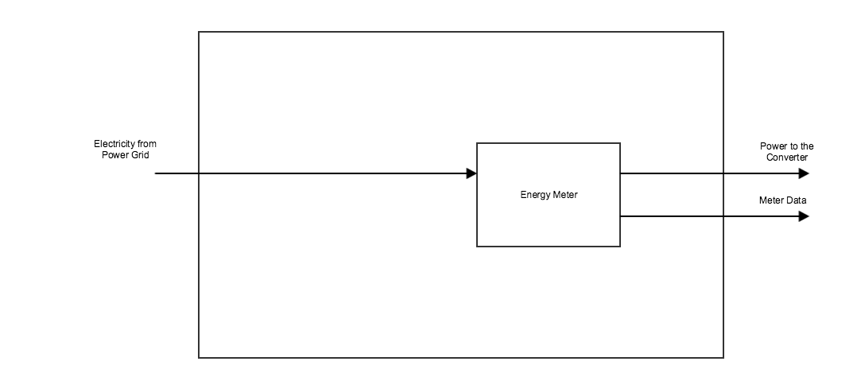

|  |  |
| --- | --- |
| Module | Energy Meter |
| Inputs | Mains electric power from the power grid |
| Outputs | Data about power usage to road microcomputer, power to the frequency converter |
| Functionality | Measures how much energy is being used. |
| Testability | Put a load on the end of the circuit that has a known power consumption rate, and make sure the energy meter’s measurement matches the known power consumption. |

**Frequency Converter - Road**

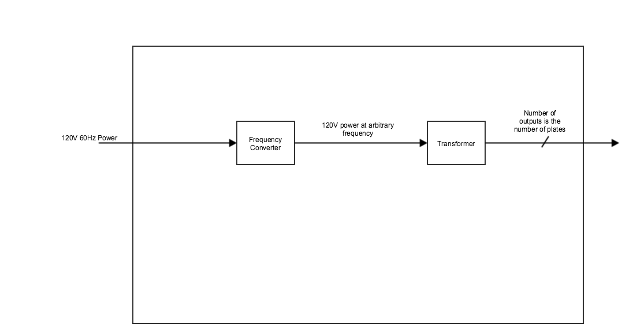

|  |  |
| --- | --- |
| Module | Frequency Converter |
| Inputs | 60Hz power from the meter |
| Outputs | Power to the transformer at arbitrary frequency |
| Functionality | Converts 60Hz signal to a signal on the order of megahertz |
| Testability | Measure output frequency given appropriate input frequency, using an oscilloscope |

|  |  |
| --- | --- |
| Module | Transformer |
| Inputs | 120V power from the Frequency Converter |
| Outputs | Power to all of the plates |
| Functionality | Converts the RMS Voltage of an input power source to one that is more efficient for transmitting wireless power. |
| Testability | Measure output voltage given input voltage, using an oscilloscope |

**RFID Reader - Road**

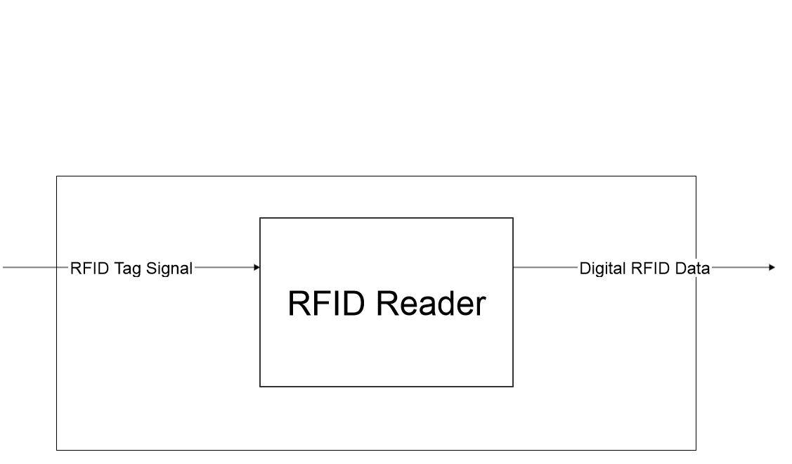

|  |  |
| --- | --- |
| Module | RFID Reader |
| Inputs | RFID tag signal |
| Outputs | Digital RFID data |
| Functionality | Reads the RFID tag and transmits the Identification Number of the vehicle with information requesting power to the on/off block |
| Testability | Have the RFID reader scan the RFID tag for two cases. The first case is when the vehicle wants power, and the second case is when the vehicle does not want power. |

**Microcomputer - Road**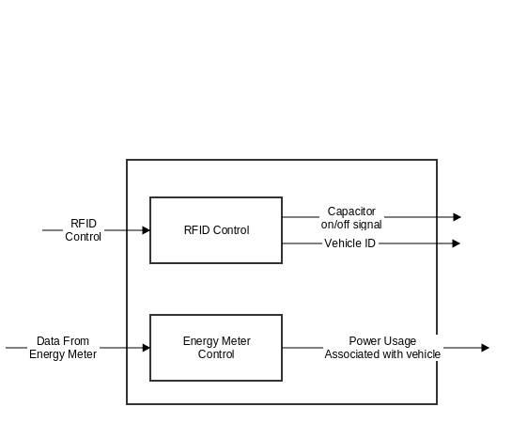

|  |  |
| --- | --- |
| Module | RFID Control |
| Inputs | RFID Reader Data |
| Outputs | On/Off signal to Road Capacitive Plates and Identification of Vehicle to Metering System |
| Functionality | The purpose of this block is to read in the RFID Data and process it to see if the vehicle passing by needs to be charged. It also processes the vehicle ID to send to the metering system. |
| Testability | Send an RFID reader signal and verify if it accurately outputs both the correct on/off signal and vehicle identification information. |

|  |  |
| --- | --- |
| Module | Energy Meter Control |
| Inputs | Data from energy meter |
| Outputs | Power usage associated with vehicle |
| Functionality | Tracks the power usage for each vehicle |
| Testability | Input synthetic data and verify output |