**Capacitive Charging of Electric Vehicles**

**Requirements Specification**



**Created 9/11/14**

**League of Extraordinary Engineers Team:**

**Vince Coghlan**

**Conrad Huegen**

**James Pentz**

**Zachary Vogel**

**Sean Wilson**

Table of Contents

1. Introduction
   1. Purpose
   2. Scope
   3. Definitions, Acronyms, and Abbreviations
   4. References
   5. Overview
2. Overall Description
   1. Product Perspective
   2. Product Functions
   3. User Characteristics
   4. Constraints
   5. Assumptions and Dependencies
3. Specific Requirements
4. Use Cases

**1. INTRODUCTION**

**1.1 Purpose**

The purpose of this document is to define requirements for a wirelessly charging road for electric vehicles and to define requirements for a scale model of said wirelessly charging road.

**1.2 Scope**

This document describes hardware and software requirements specification for a scale model of a wirelessly charging road for electric vehicles as well as a full size model of the same system.

**1.3 Definitions, acronyms, and abbreviations**

1.3.1 Vehicle or Ground Vehicle - An automobile or model of an automobile which carries a power source and is capable of transportation while in contact with a road [1.3.2]. The scaled model [1.3.3] and industry model [1.3.4] are examples of vehicles.

1.3.2 Road - The surface of the ground which is contacted by a vehicle [1.3.1]. Usually, road refers to an asphalt or concrete surface. However, road may also refer to any other surface capable of supporting either the scaled model [1.3.3] or industry model [1.3.4].

1.3.3 Scaled Model - A radio controlled (RC) vehicle that is charged with charge pads [1.3.5], and that carries an onboard system [1.3.6]. The scaled model is smaller in dimension than a typical four-door sedan, and the scaled model is not intended to carry a driver [1.3.7]. Also, the scaled model is meant to demonstrate the feasibility of an industry model [1.3.4]. The scaled model system will be designed such that power and dimension characteristics may be adjusted to an industry model, under appropriate scaling, as calculated using mathematical models.

1.3.4 Industry Model - A theoretical full-size electric or hybrid vehicle capable of using an onboard system [1.3.6] in conjunction with charge pads [1.3.5], for wireless charging of that vehicle’s power source. The industry model can carry and be operated by a human driver [1.3.7]. The industry model is primarily intended to be operated in a densely populated area like a city. Industry model vehicles are charged wirelessly with power sourced from charge pads.

1.3.5 Charge Pad - The device that, when placed at or below the surface of a road, emits energy to charge vehicles, such as a scaled model [1.3.3] or an industry model [1.3.4].

1.3.6 Onboard System - The electrical system which is carried aboard the scaled model [1.3.3] and which receives power from charge pads [1.3.5]. This may also refer to the theoretical system which is carried aboard the industry model [1.3.4].

1.3.7 Driver - A human who may operate and be transported by a vehicle.

1.3.8 SAR - Specific absorption rate

Remark: All terms not defined here are meant to be interpreted according to their standard English dictionary definitions.

**1.4 References**

1.4.1 *Efficient In-Motion Capacitive Wireless Power Transfer System for Electric Vehicles*, K. Afridi and Z. Popovic

1.4.2 http://transition.fcc.gov/Bureaus/Engineering_Technology/Documents/bulletins/

oet56/oet56e4.pdf

**1.5 Overview**

The main limiting factor in the widespread adoption of electric vehicles is the low driving range made available by the vehicles, often below 100 miles. Many consumers are worried they won’t be able to travel to work and back with the batteries in current electric vehicles. By charging these electric vehicles during their use it is possible to dramatically increase the range possible.

This product could have wide ranging impacts within the country. If installed in the United States road system it would vastly improve the range of wireless vehicles encouraging consumers to reduce their impact on the environment and lower their transportation costs.

**2. Overall Description**

**2.1 Product Perspective**

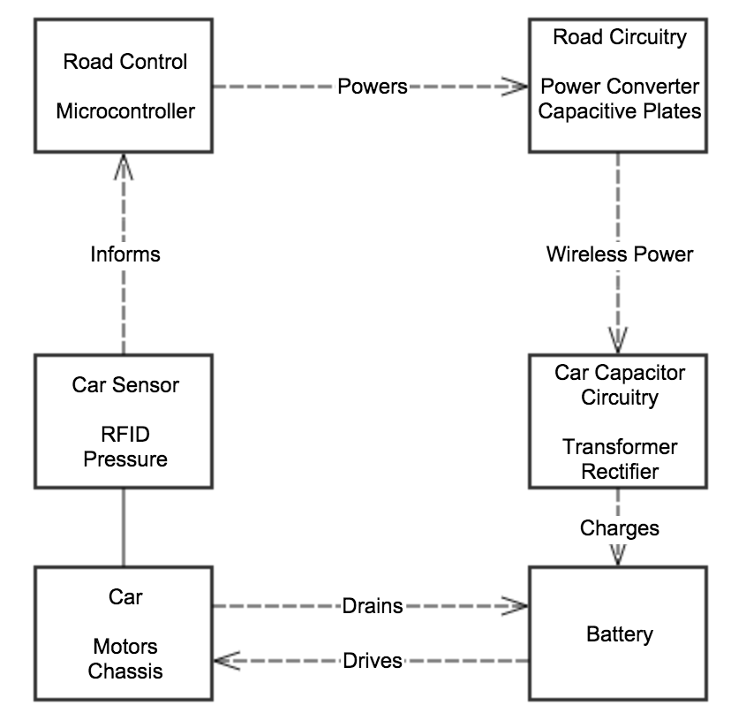

**2.2 Product Functions**

**High Priority:**

* Wirelessly charge a stationary RC vehicle using capacitive plates located under the vehicle.

**Medium Priority:**

* Wirelessly charge a moving vehicle.
* Correctly detect the location of the vehicle and direct power.

**Low Priority:**

* Optimize power delivery to the correct location.
* Monitor multiple vehicles.
* Develop a scaled product.

**2.3 User Characteristics and Larger System Characteristics**

2.3.1 The driver is expected to be licensed to drive an industry model vehicle.

2.3.2 The driver is expected to be physically capable of operating a vehicle, as required legally to obtain and keep a driver’s license.

2.3.3 The charge pads operate at or below the surface level of roads and emit power to charge ground vehicles.

2.3.4 The ground vehicles receive power through an onboard system when driving above a charge pad.

2.3.5 Ground vehicles must be hybrid or completely electrically powered, and the vehicles must be equipped with a compatible onboard system.

**2.4 Design Constraints**

2.4.1 The operating frequency of the charging pad system is within an industrial, scientific, and medical (ISM) band.

2.4.2 The onboard system can interface with a target vehicle’s power supply system or battery.

2.4.3 The charging pads are compatible with a road and scaled model so that the scaled model is capable of driving directly over the charging pads without needing to decrease speed of travel.

2.4.4 The peak power absorption of a human driver operating an industry model vehicle must be within FCC radio frequency (RF) absorption rate regulations.

**2.5 Assumptions and Dependencies**

2.5.1 No team personnel changes will occur during the project development process.

2.5.2 Funding and resources for required parts needed to develop the system will be provided by Professor Zoya Popovic and by a UROP grant.

2.5.3 All required electronic components beyond those specially designed for our system will be available for purchase online and will be delivered within a maximum of one month after placing an order.

2.5.4 Workspace and basic tools for electronics development will be available for use in the CU Boulder ECEE department Senior Projects Laboratory.

**3. Specific Requirements**

|  |  |  |
| --- | --- | --- |
| **Marketing Requirements** | **Engineering Requirements** | **Justification** |
| 6 | Reduce net discharge rate of vehicle battery by X% per minute | The system decreases the amount of time that has to be spent manually recharging |
| 1 | Maintain human driver SAR below ~4W/kg at all times while driving | The system does not endanger users |
| 2 | Charging pad recognizes if compatible vehicle is above it in X seconds | The system recognizes vehicles quickly to maximize charging time and reduce energy waste |
| 7 | Use frequencies in ISM band for power transfer | The system does not interfere with communication or other sensitive equipment |
| 3, 4 | Onboard system is less than 20% of total industry model vehicle weight | This system does not decrease mileage or range of vehicle, as this would defeat the purpose of charging a vehicle on the road |
| 5 | The scale model includes a road surface above the charge pads or the charge pads are less wide than the width of the vehicle wheelbase. | Scale model accurately represents industry model to verify feasibility of product |

|  |
| --- |
| **Marketing Requirements**   1. The industry model does not expose vehicle drivers or passengers to a lethal amount of electromagnetic radiation. 2. The system detects when a vehicle with an onboard system is above a charge pad. 3. The onboard system does not interfere with vehicle functionality. 4. The onboard system fits and operates in a vehicle. 5. The charge pad fits in or on the road and allows vehicles to drive over it without making contact. 6. The charge pad decreases the net battery discharge rate while vehicle is above the charge pad. 7. The charge pad and onboard system transmit and receive energy in an ISM band. |

**4. Use Cases**

**Use Case UC1:** Wirelessly Charge Compatible Vehicle

**Scope:** Wireless, Capacitive-Plate, Sub-Road, Vehicle Charging System

**Level:** User Goal

**Primary Actor:** Vehicle Owner

**Stakeholders:**

Driver - Wants a safe and convenient method of transportation

Vehicle Owner - Wants a cheap, fast, and easy method of powering a vehicle

Power Company - Wants to efficiently transmit power to electric vehicles

Department of Transportation - Wants to easily maintain a safe transportation system.

Vehicle Manufacturer - Cheaply adapt existing cars to receive power.

**Preconditions:**

Car must be on power enabled road.

Power is running through road plates.

**Success Guarantees**: The charge pad will decrease the net battery discharge rate while vehicle is above the charge pad.

**Main Success Scenario:**

vehicle enters road segment

battery begins to discharge more slowly

**Extensions:** Vehicle must be able to decrease net discharge rate while stationary and/or off.

**Open Issues:**

How do we determine how much power we would need to transfer?

How can this be done efficiently?

Is this safe?

**Use Case UC2:** Detect Vehicle as it Drives over Surface

Scope: Wireless detection system to recognize electric vehicles

Level: User Goal

Primary Actor: Power Company

Stakeholders:

Driver - Doesn’t want to be affected by his vehicle charging

Power Company - Doesn’t want to waste energy not charging an electric and wants to be able to charge money for the electricity used to charge electric vehicles

Department of Transportation - Wants to be able to record usage statistics for this road system

Vehicle Manufacturer - Want to enable their customers to use this product effectively

Preconditions:

Vehicle must be on power enabled road.

Identification chip is present in vehicle

Success Guarantees: The charge pad will allow for detection of vehicle and vehicle owner to charge for the cost of charging.

Main Success Scenario:

vehicle enters road segment

road identifies vehicle as compatible and finds vehicle ID which associates vehicle with a power company.

company can then charge vehicle owner for the cost of their electricity usage

Extensions: Road must be able to detect vehicle power usage and transmit usage to the power company associated with that vehicle.

Open Issues:

How will the association with a vehicle ID, owner, and power company work?

What technology will be used to identify the vehicle?

How will a standard be developed between car manufacturers?