|  |  |
| --- | --- |
| **ECEN 4610** | **Capstone Fall 2014** |
| The League of Extraordinary Engineers Team  Responsibilities and System Diagram | |

|  |  |  |  |
| --- | --- | --- | --- |
| **Responsibilities** | **Roles** | **Hardware** | **Software** |
| Trigger capacitor plates for power transmission when vehicle is above plates | Control Subsystem | Microcontroller and decoder | Plate control logic |
| Identify vehicle and determine if vehicle is suitable for charging | RFID Subsystem | RFID reader | RFID control logic |
| Transmit power through charge plates | Road Power Subsystem | High-frequency inverter, capacitive plates | - |
| Receive power through vehicle plates | Vehicle Power Subsystem | Power rectifier and converter, vehicle plates | - |

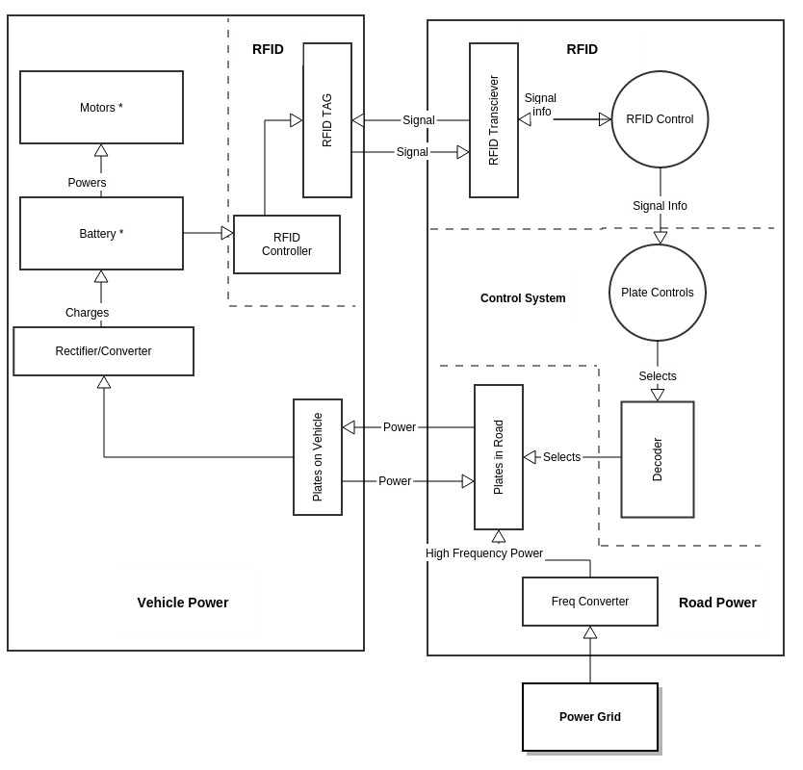

**Fig. 1: System Diagram**

Note: * indicates a component that is not a part of the system we are developing