|  |  |
| --- | --- |
| **ECEN 4610** | **Capstone Fall 2014** |
| The League of Extraordinary Engineers Team  Responsibilities and System Diagram | |

|  |  |  |  |
| --- | --- | --- | --- |
| **Responsibilities** | **Roles** | **Hardware** | **Software** |
| Trigger capacitor plates for power transmission when vehicle is above plates | Control Subsystem | Microcontroller and decoder | Plate control logic |
| Identify vehicle and determine if vehicle is suitable for charging | RFID Subsystem | RFID reader | RFID control logic |
| Transmit power through charge plates | Road Power Subsystem | High-frequency inverter, capacitive plates | - |
| Receive power through vehicle plates | Vehicle Power Subsystem | Power rectifier and converter, vehicle plates | - |

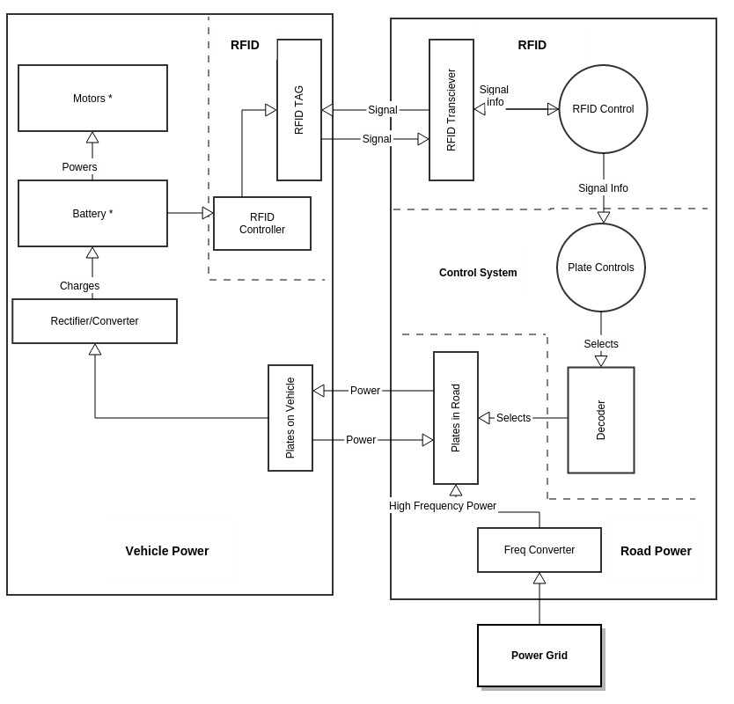

**Fig. 1: System Diagram**

Note: * indicates a component that is not a part of the system we are developing

|  |  |
| --- | --- |
| **ECEN 4610** | **Capstone Fall 2014** |
| The League of Extraordinary Engineers Team  Level 0 Functional Decompositions | |

**1.1 Functional Decomposition Level 0 - Vehicle System**

|  |  |
| --- | --- |
| **Module** | Onboard Vehicle Power System |
| **Inputs** | Wireless energy from charging pads  Battery voltage levels |
| **Outputs** | RFID signal  DC power to battery |
| **Functionality** | The onboard system takes in battery voltage levels to determine if the battery needs to acquire power from the road. Based on this information, different codes are transmitted by the vehicle RFID tag in order to request power when needed. The onboard system then receives power transmitted by the charge pads in the Road Surface Power System. Finally, the onboard vehicle power system outputs the received power to the vehicle battery for charging. |

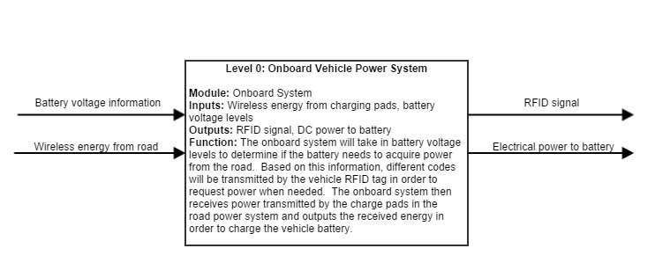

**Fig. 2: Level 0 Functional Decomposition for Onboard Vehicle Power System**

**1.2 Functional Decomposition Level 0 – Road System**

|  |  |
| --- | --- |
| **Module** | Road Surface Power System |
| **Inputs** | RFID signal  60Hz/120V electrical power |
| **Outputs** | ISM-band wireless power  Power metering information |
| **Functionality** | The road surface power system is powered by mains power from the electrical grid. An RFID reader and control subsystem determines if power should be transmitted based on the input RFID signal. Additionally, based on RFID readings, only the road-surface level charge pads nearest the vehicle enter transmit mode, outputting wireless power in an ISM band. The road system also meters power used by each vehicle and stores the information in a database to be accessed on the web by users (vehicle drivers) or power companies. |

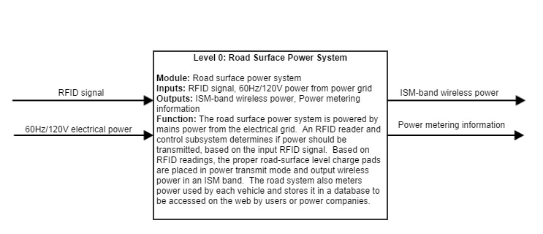

**Fig. 3: Level 0 Functional Decomposition for Road Surface Power System**

|  |  |
| --- | --- |
| **ECEN 4610** | **Capstone Fall 2014** |
| The League of Extraordinary Engineers Team  Level 1 Functional Decompositions | |

**2.1 Functional Decomposition Level 1 - Vehicle System**

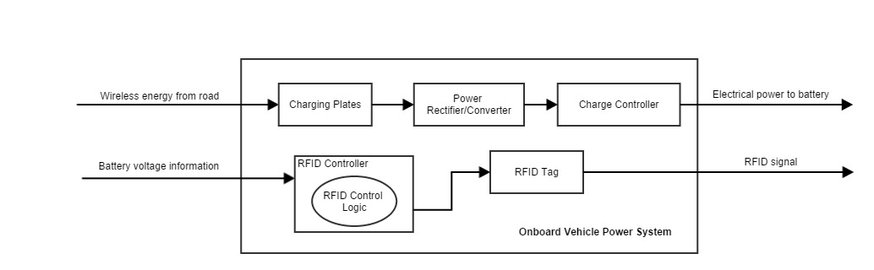

**Fig. 4: Level 1 Functional Decomposition for Onboard Vehicle Power System**

|  |  |
| --- | --- |
| **Module** | Vehicle Capacitive Plate Module |
| **Inputs** | Wireless power from road capacitive plates |
| **Outputs** | Power over a wire to the Rectifier-Converter Module |
| **Functionality** | Receives power through capacitive coupling with the road Capacitive Plates Module and feeds AC power to the Power Rectifier/Converter Module |

|  |  |
| --- | --- |
| **Module** | Rectifier-Converter Module |
| **Inputs** | Electrical power from vehicle Capacitive Plate Module |
| **Outputs** | Rectified electrical power to vehicle Charge Controller |
| **Functionality** | Converts electrical power from the capacitive plates to a current and voltage that can be used by the charge controller |

|  |  |
| --- | --- |
| **Module** | RFID Controller |
| **Inputs** | Battery state information |
| **Outputs** | Control to the Active RFID Tag in the vehicle |
| **Functionality** | Sends data to the RFID Tag in the vehicle. These data determine if the vehicle needs power from the road. |

|  |  |
| --- | --- |
| **Module** | Vehicle RFID Tag |
| **Inputs** | Data from RFID Controller |
| **Outputs** | Wireless signal to the road RFID Reader |
| **Functionality** | Transmits the data from the RFID Controller to the RFID Reader in the road. |

|  |  |
| --- | --- |
| **Module** | Charge Controller |
| **Inputs** | Electrical power from the Rectifier-Converter Module |
| **Outputs** | Electrical power to the battery |
| **Functionality** | Charge the vehicle battery. |

**2.2 Functional Decomposition Level 1 - Road System**

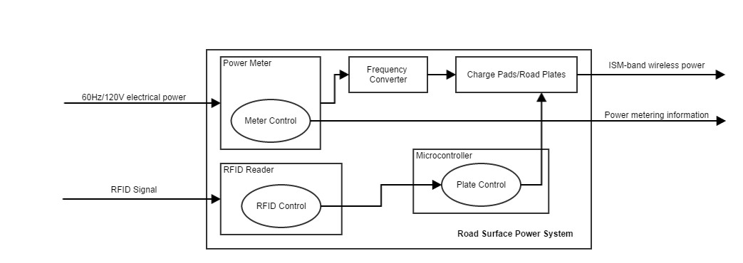

**Fig. 5: Level 1 Functional Decomposition for Road System**

|  |  |
| --- | --- |
| **Module** | Power Meter |
| **Inputs** | Mains power from the power grid and data from RFID Reader |
| **Outputs** | AC mains electrical power to the Frequency Converter and meter information to a database |
| **Functionality** | Reads the amount of power going into the system from the power grid and provides information associating each vehicle with its power usage. This allows power companies to bill the corresponding users (vehicle drivers) for their power consumption. |

|  |  |
| --- | --- |
| **Module** | Frequency Converter |
| **Inputs** | 120V 60Hz AC power from the power meter |
| **Outputs** | Frequency converted signal to Capacitive Road Plates |
| **Functionality** | Changes the frequency from 60Hz to an ISM transmission frequency. |

|  |  |
| --- | --- |
| **Module** | Capacitive Road Plates |
| **Inputs** | Frequency converted power source  Control signals from plate Control Module |
| **Outputs** | Wireless ISM-band frequency converted power signal and metering information |
| **Functionality** | Enables conversion from a wired power signal to a wirelessly transmitted power signal. There are multiple of these modules that are individually activated or deactivated by the Control Module. |

|  |  |
| --- | --- |
| **Module** | RFID Reader |
| **Inputs** | RFID signal from RFID Tag in vehicle |
| **Outputs** | Data to Control Module in road and data to Metering Module |
| **Functionality** | Reads vehicle RFID tag and sends identification information to Control Module and Metering Module |

|  |  |
| --- | --- |
| **Module** | Control Module |
| **Inputs** | RFID Reader data |
| **Outputs** | On/Off selection signal to control Capacitive Road Plates |
| **Functionality** | This module controls the Capacitive Road Plates. It first determines which individual capacitive plates to activate based on RFID data from the RFID Reader, then activates the correct plates. |