# Helm chart for installing Tekton pipelines

**This Helm chart is still in development**

Copyright [2024] [Cogito Group Ltd]

[Cogito Group’s](https://cogitogroup.co.uk) Tekton Helm chart to install CI/CD pipelines on Kubernetes with **one** command.

This repository contains a Helm chart and examples for installing Tekton pipelines on Kubernetes. The chart does not install the Tekton CRDs, you must install these separately, the chart is designed to be both platform and Kubernetes distribution agnostic.

Source repository https://github.com/cogitogroupltd/tekton-helm-chart

* 1. Summary
  2. Examples
  + 2.1. Simple Kaniko Pipeline Example
  + 2.2. Simple Buildah Pipeline Example
  + 2.3. Simple Docker-in-docker Pipeline Example (not recommended)
  1. Todo
  2. Troubleshooting

## 1. Summary

**This project is in development and should not be used in production**

### 1.1. Features

* Helm chart to deploy Tekton pipelines and all dependencies except Tekton Custom Resource Definitions
* Simplifies developer experience with automated Tekton resource linking
* Declarative and immutable pipelines
* Least-privilege with isolated permissions for each task run
* Create/Delete Github webhooks from inside Tekton
* Trigger pipelines from CronJob or Github webhook events

### 1.2. Successfully tested on

* CPU Architectures; arm64 (MacM1, MacM2), amd64
* AWS EKS version == v1.30
* OpenShift ROSA (OKD4) v1.28 - v1.30
* Openshift OKD3 - v1.28 - v1.30
* Kind [download](https://kind.sigs.k8s.io/) version == v1.29, v1.30
* Microk8s version == v1.30
* Rancher K3s == v1.30
* Azure AKS == 1.30
* Google Kubernetes Engine (GKE)

### 1.3. Prerequisties

Before deploying the Helm chart the below steps are required:

* Kubernetes cluster >= v1.28, see [kind.md](./docs/kind.md).
* Kubectl > v1.25 <https://kubernetes.io/docs/tasks/tools/>. Only required to execute a pipelineRun. See [Pre Requisities](./docs/prereqs.md) for an example install script
* Helm > v3.0 <https://helm.sh/docs/intro/install/>. Required to deploy the Tekton pipelines in this Helm chart. See [Pre Requisities](./docs/prereqs.md) for an example install script
* Install Tekton, see [Installing Tekton](./docs/installing_tekton.md). Required dependency to deploy the Tekton pipelines in this Helm chart.
* SSH RSA Keypair linked with Github with **no passphrase**, see [Generate RSA](./docs/generate_rsa.md) for how to generate. If you already have one then great, this will be required for all examples.
* AWS CLI > v2.0 - Required to deploy the Tekton pipelines in this Helm chart.
* DockerHub username and password - required for examples using Dockerhub

## 2. Examples

helm repo add tekton https://cogitogroupltd.github.io/tekton-helm-chart  
helm repo update tekton

Listed below are a series of examples of how to use the Helm chart to achieve common DevOps tasks.

### 2.1. Simple Kaniko Pipeline Example

[Kaniko](https://github.com/GoogleContainerTools/kaniko) operates without needing a Docker daemon, builds container images without requiring root privileges and more resource-efficient for building images in Kubernetes as it doesn’t require a daemon and operates as a single container process.

See example [README.md](./examples/kaniko-build-deploy/README.md)

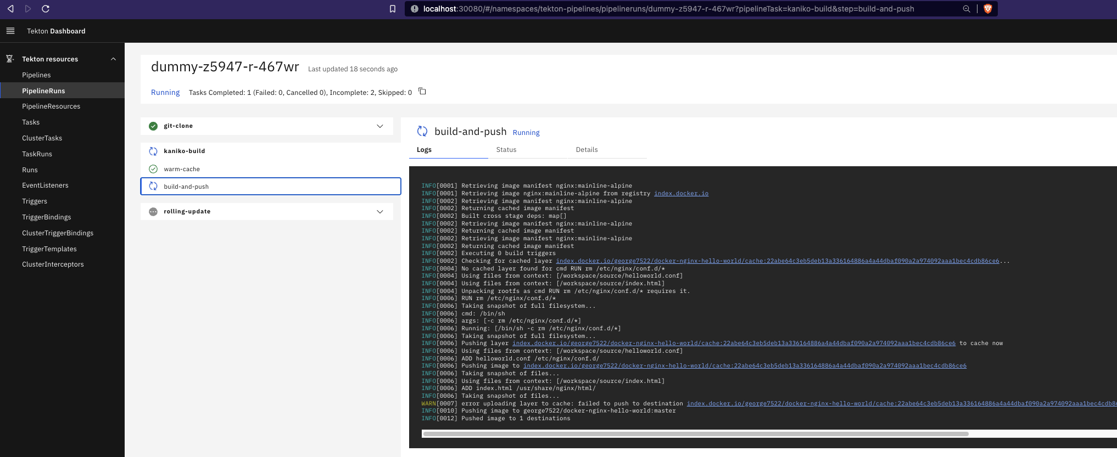

### 2.2. Simple Buildah Pipeline Example

[Buildah](https://buildah.io/) is designed to be lightweight and operates without a long-running daemon, unlike Docker. This can be beneficial when running inside a container on Kubernetes, where you may want a more streamlined and efficient toolchain. Buildah allows for more granular control over the image creation process and builds images without requiring root privileges or the Docker daemon.

See example [README.md](./examples/buildah-build-deploy/README.md)

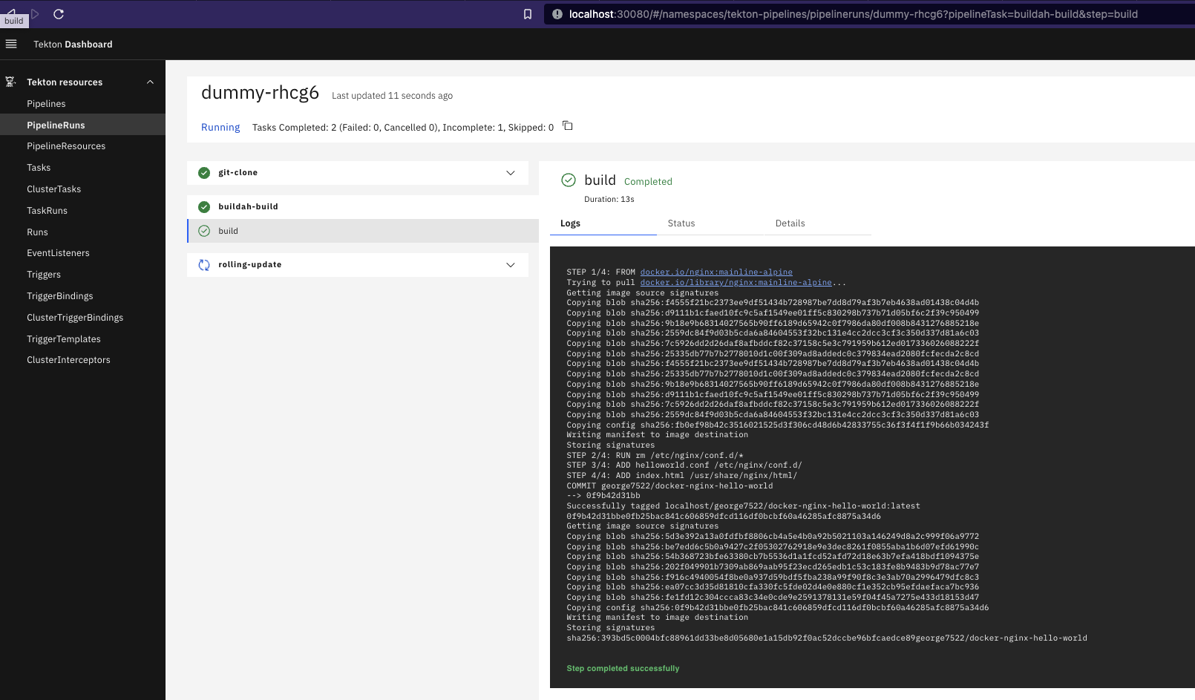

### 2.3. Simple Docker-in-docker Pipeline Example (not recommended)

This is for just for fun. Running docker-in-docker is not recommended due to security vulnerabilities and the Docker daemon is now deprecated on Kubernetes. Here we mount the docker.sock and local docker image cache into the Kubernetes hosted docker container, to build source code using native docker commands.

See example [README.md](./examples/dind-ecr-build-deploy/README.md)

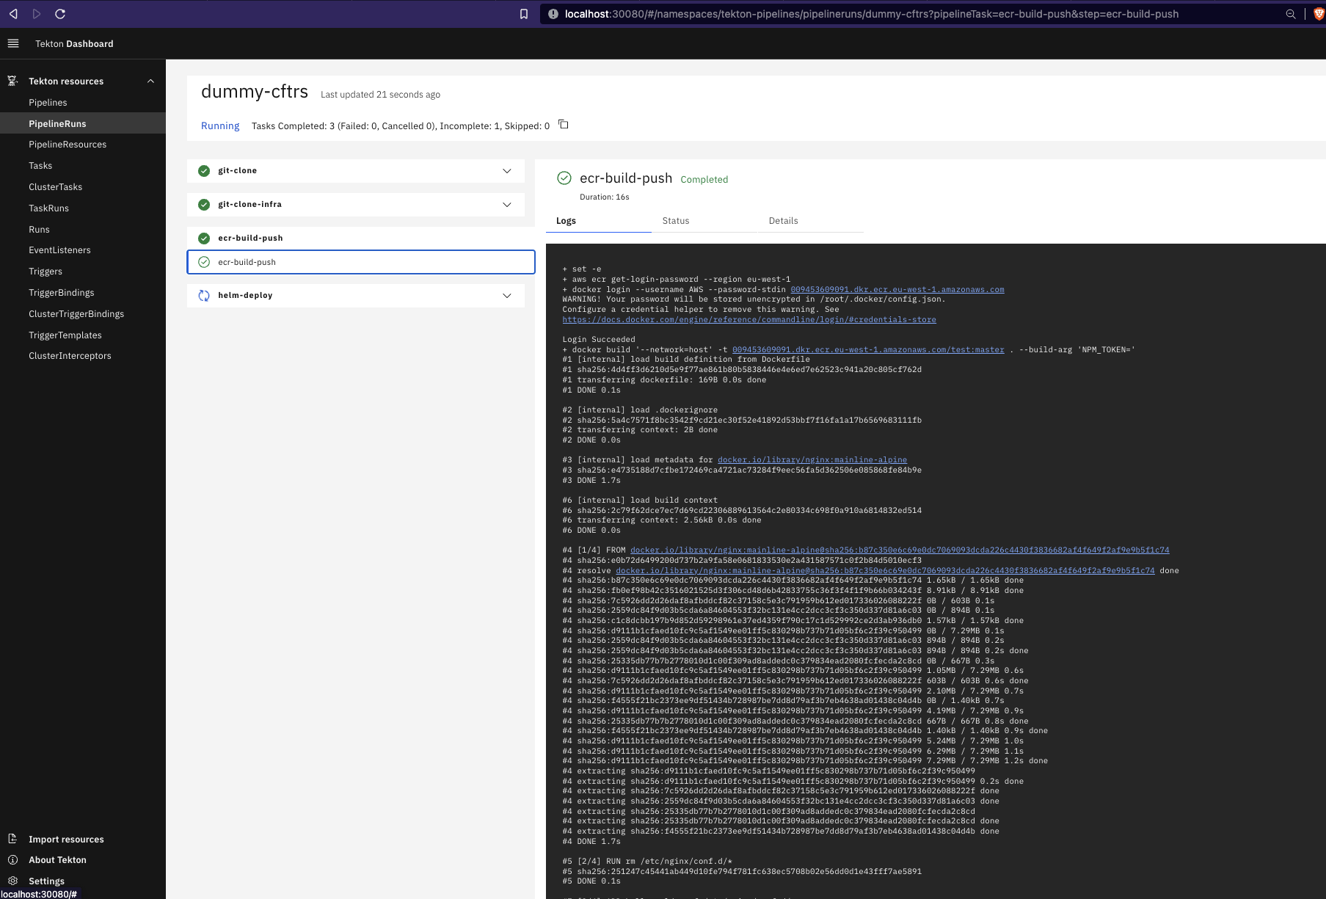

## 3. Todo

* Allow multiple installations of helm chart into same cluster; currently conflicts when ClusteRoles and ClusterRoleBindings are not unique
* Helm not correctly reconciling Task definition updates, despite
* Remove hard coding in triggerTemplate by moving all built-in tasks to use an array same as calling a global custom task
* Add docs on taskPodTemplate vs podTemplate whereby a taskPodTemplate overrides the podTemplate
* Examples - Incorporate usage of eks.role.arn annotations to demonstrate easy utilisation of lease privilege
* Allow multiple installations of helm chart into same namespace; currently conflicts when task names are not unique
* Move resource defs from eventListener
* Remove dependency on cluster-admin ClusterRole by creating a new tekton-cluster-admin ClusterRole
* Documentation for Windows
* Auto generate dynamic _taskRun.yaml for custom-task in helm output via Notes.txt
* Auto generate a dynamic _pipelineRun.yaml for each pipeline in helm output via Notes.txt
* Add taskcall[0].steps to override taskdefinition[0].steps so that a developer can use the same task but have the steps overridden. This fix requires dynamic task creation in the background and hence post-pended GUID mapping.

More feature requests? Please raise a github [issue](https://github.com/cogitogroupltd/tekton-helm-chart/issues)

## 4. Troubleshooting

See [FAQ.md](./docs/FAQ.md) or our [blog](https://cogitogroup.co.uk/blog)