Evidence for the use of verb telicity in sentence comprehension

Erin O’Bryan
University of Arizona
erinobryan@gmail.com

Raffaella Folli
University of Ulster
r.folli@ulster.ac.uk

Heidi Harley
University of Arizona
hharley@email.arizona.edu

Thomas G. Bever
University of Arizona
tgb@email.arizona.edu

Introduction

This chapter presents evidence that event structure information is accessed by the processor during on-line comprehension. We investigate the predictive power of two verb classifications proposed in linguistic research, one based on verb argument structure and the other one based on verb event structure. In psycholinguistic research, the value of the former for predicting difficulty in the comprehension of reduced relative clauses has been established (MacDonald 1994). In this chapter, we investigate whether the latter, event structure, is also an influential factor in comprehension.

1.1 Argument structure

Verbs can be categorized based on the number of arguments that they allow or require. Since Perlmutter (1978), verbs have been recognized as falling into at least three classes: transitives, with both an internal and an external argument, unergative intransitives, with only one external argument, and unaccusative intransitives, with only one internal argument. In (1), the transitive form of the verb break occurs with two participants: John, the external argument and causer or agent of the verbal action, and the vase, the internal argument and theme.

(1) Transitive verb: break_{[2 args]}: John broke the vase.
(2) Unergative verb: run_{[1 arg]}: John ran.
(3) Unaccusative verb: break_{[1 arg]}: The vase broke.

In (2), the intransitive unergative verb run occurs with one participant, John, the external argument, which has the role of agent. In (3), the intransitive unaccusative variant of break occurs with one participant, the internal argument and theme. Much syntactic evidence is available showing a strong correlation between the semantic properties of arguments, (i.e. their being interpreted as agents or themes) and their syntactic position (Burzio 1981, Levin and Rappaport-Hovav 1995, among others). In (3) the only argument of the verb, the vase, is generated in the underlying direct object position because it bears the theme role with respect to the action.
In the Principles and Parameters framework (Chomsky and Lasnik 1993), the theme argument of an unaccusative verb, like break in (3), is generated in the underlying direct object position and is thus fundamentally both a semantic and syntactic object. Only secondarily does it acquire the status of subject. In other words, it is a derived subject, like the subject of a passive verb. With unergative verbs, like run in (2), the single agent argument is both a semantic and structural subject. The lexical semantics of any given verb thus correlates with the syntactic structure in which it appears. The event structure of verbs, which we review in the next section, has been shown to have syntactic reflexes intimately connected with underlying direct objects.

1.2 Event structure and telicity

Aristotle first noticed that verbs can be divided into states and events and that only a subset of eventive verbs include in their meaning the idea of an endpoint. Since Vendler’s (1967) reanalysis of Aristotle’s distinction, the linguistic literature on verbs has made extensive use of a classification of verbal predicates based on aspectual information. The event denoted by a verb may entail the existence of a process, may entail an endpoint, may be homogenous or have distinct stages of completion, and may be punctual or non-punctual. In Vendler’s schema, verbs divide into four classes, including states and three types of events:

(3) a. Activities: (e.g., applaud) events that go on for a time, with homogenous sub-parts and without a necessary endpoint. They are atelic.
b. Accomplishments: (e.g., write the book) events that have a process portion which proceeds via distinct stages to a logically necessary endpoint. They often involve a transition, followed by a resultant state. They are telic.
c. Achievements: (e.g., stop or trip) change-of-state events that culminate at the moment they occur and lack a preceding process. They are telic.

Vendler established these classifications by observing whether or not a verb’s meaning was congruent with certain types of temporal modification. One test he used was modification by the adverbials for an hour/in an hour/at 2 o’clock.

(4) a. Mary pushed the cart (#in/for an hour)(#at 2 o’clock). activity (atelic)
b. Mary wrote the book (in/#for an hour)(#at 2 o’clock). accomplishment (telic)
c. Mary crossed the finish line (in/#for an hour)(at 2 o’clock). achievement (telic)

These tests are based on the fact that adverbials like for an hour modify atelic events, whereas in an hour modifies telic events. If the activity can extend for some time period such as for an hour without any endpoint being specified, then this implies homogeneity and atelicity. In contrast, if the event denoted by the verb can be completed in some delineated time period such as in an hour, then the verb's meaning implies completion, and thus heterogeneity, an endpoint, and telicity. The third test, at 2 o'clock, distinguishes between telic events which unfold over an extended period, called “accomplishments” and telic events which occur at a single moment, called “achievements”.
When a verb is composed with an adverbial that is incongruent with its telicity specification, additional interpretive effects appear. For example, if a telic verb is composed with an atelic modifier such as for an hour, it may be interpreted as iterated or incomplete (consider, for example, Mary crossed the finish line for an hour, or Mary wrote the book for an hour). When an atelic verb is modified by in an hour, the event is interpreted as peculiarly habitual or having some unspecified conventional extent in the context (consider, Mary pushed the cart in an hour). These additional interpretive effects are referred to as “aspectual coercion” (see e.g. Piñango, Zurif, and Jackendoff 1999).
Theoretical linguistic work has argued that event structure has implications for syntactic structure. It has been observed that telic events always have objects in their syntactic structure, sometimes only underlyingly (Tenny 1992). For example, a verb like write shows the relationship between transitivity and telicity because it can occur with or without an object and exhibits a corresponding change in its event structure:

(5) a. John wrote (for an hour).
b. John wrote a letter (in an hour).

In (5)a, the verb indicates an atelic event, describing a process without a known endpoint. Adding an object, as in (5)b, creates a shift to a telic interpretation, in which the final state of written-ness of the letter is the endpoint of an accomplishment event. The presence or absence of the object, then, correlates with the presence or absence of the endpoint sub-part of the overall event, i.e., with the telicity of the event.
The question of how to represent the connection between telic events and syntactic objects has been the focus of much work on the lexicon-syntax interface. The observation that events have complex internal structure has caused many to propose that complex event structure is linked in the syntax to a complex phrase structure (Pustejovsky 1988, Borer 1994, among others). As noted above, the semantic aspectual information associated with each event type can be characterized as made up of specific sub-parts, such as process, endpoint, and result state. The proposal is that each sub-part of the event is represented in the syntax by a specific piece of phrase structure. For example, an endpoint sub-part in the aspectual semantics of a verb will be represented in the syntax by a particular functional projection. Verbs denoting different types of events, then, will be associated with different syntactic structures.
The syntactic structure related to the sub-events associated with a particular verb is the event structure of that verb. In this perspective, each argument of a verb occupies a given position associated with a sub-part of the event in the syntactic structure. The interpretation of the argument itself is determined by the aspectual properties associated with that projection.
The correlation between event endpoints and syntactic objects follows from the fact that the endpoint functional projection is lower in the syntactic structure than the base position of the external argument. The event in John broke the vase is telic because it implies that the theme the vase reaches a final change of state. In the event structure analysis, the vase undergoes movement to occupy the specifier position of the telic functional projection, labeled TelicP in (6).

(6)

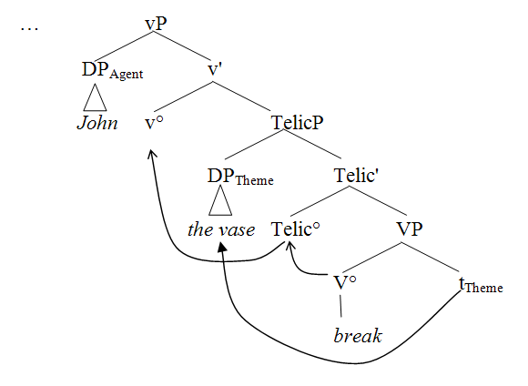

Because the telic functional projection is situated lower than the position of the external argument John, only internal arguments (like the vase) are available to fill its specifier. Hence only internal arguments may affect the telicity of a verbal predicate.

1.3 Telicity is not reducible to transitivity

From the discussion above, it might appear that that transitivity and telicity are indistinguishable, in that both involve the presence of a syntactic object. This is not the case, however. Although telicity requires the presence of a syntactic object, the converse is not true. There are transitive verbs with syntactic objects that are not telic, for example, (7) and (8).

(7) John pushed the cart (for an hour/#in an hour). (ATELIC, TRANSITIVE)
(8) John drove the bus (for an hour/#in an hour). (ATELIC, TRANSITIVE)

An intransitive verb may project an underlying object if the verb is unaccusative, as described in section 1.1. Thus, there are also telic verbs which are intransitive. Above, we introduced unaccusativity using an example verb (break) which alternates between transitive and unaccusative uses. There are also purely unaccusative verbs, which have no transitive variant, such as arrive. Examples of such telic intransitive verbs are shown in (9) and (10):

(9) a. John arrived (in an hour/#for an hour/at 2 o’clock). (TELIC, INTRANSITIVE)
b. *John arrived Mary.
(10) a. John died (in an hour/#for an hour/at 2 o’clock). (TELIC, INTRANSITIVE)
b. *John died Mary.

When a transitive verb is not telic, the object does not occupy the specifier of the telic functional projection. In telic verbs which are not transitive, the specifier of the telic functional projection is occupied at some point by the single theme argument, which later becomes a derived subject. Because the telic functional projection is below the position of the external argument, intransitive telic verbs are necessarily unaccusative. The agentive subject of an unergative intransitive verb like whistle, on the other hand, initially occupies the higher external-argument projection, and can never appear in the specifier of the lower telic functional projection.
These syntactic consequences of telicity led us to investigate the question of whether the processing system makes use of verb event structure information during on-line sentence comprehension. The independence of telicity and transitivity allows us to ask if each of these two factors independently affects processing. We investigated these questions using the main clause versus reduced relative ambiguity.

1.4 Investigating the comprehension of structurally ambiguous sentences

The comprehension of reduced relative clauses has been used to examine which factors are immediately relevant to the comprehension process (Bever 1970, et seq.). The reduced relative clause sentence (11)a has the same beginning as the simple sentence in (11b). (11)c is the unambiguous version of (11)a.

(11) a. The actress tripped by the writer was eccentric.
b. The actress tripped the writer.
c. The actress who was tripped by the writer was eccentric.

If, during the comprehension of (11)a, the sentence processing system interprets the initial noun phrase the actress as the subject and agent of the verb tripped, as in (11b), this simple main clause interpretation must be reversed later in the sentence. The preposition by, in conjunction with the past tense morpheme on the verb tripped, is the first possible cue that the sentence could have a reduced relative structure. When the processor reaches the actual main verb was, the actress must be treated as the object of tripped. The degree of comprehension difficulty in reduced relative clause sentences is a result of the processor’s degree of commitment to the main clause interpretation. The unreduced relative clause version of the same sentence, (11)c, serves as a baseline measure of sentence difficulty, because it is unambiguous. Thus, the reduced relative effect can be measured as the processing time for (11)a minus the processing time for (11)c in the ambiguous and disambiguating regions of the sentence (…tripped by the writer was eccentric). The degree to which a factor affects commitment to the main clause interpretation can be determined by how much it affects the size of the reduced relative effect.

1.5 Argument structure and the reduced relative effect: MacDonald’s study

Previous research (MacDonald 1994) has shown that the reduced relative effect is affected by the argument structure of the verb, as predicted by Pritchett (1992). In a reduced relative clause sentence, the initial verb must receive a transitive reading when the initial noun phrase is eventually interpreted as the direct object. Verbs may differ in the degree to which they promote a reduced relative reading in English because transitive verbs can be either obligatorily transitive, such as capture, or optionally transitive, such as fight. In a self-paced reading experiment, MacDonald found that less processing difficulty occurred in reduced relatives with obligatorily transitive verbs as in (12)a than with optionally transitive verbs as in (12)b. This effect was found on the main verb, e.g. was.

(12) a. The ruthless dictator captured in the coup was hated throughout the country.
b. The ruthless dictator fought in the coup was hated throughout the country.

This result suggests that the information that a verb requires an object may lead the comprehension system to be less committed to a main clause reading of the initial portion of the sentence. One possible explanation is that if the processor accesses the information that a verb requires an object, it leaves open the possibility that the initial noun phrase might be the needed object. For example, in (12)a the verb capture is stored with the information that it requires a direct object. This information may influence the processor to leave open the possibility that the ruthless dictator is the direct object in a reduced relative construction. Thus, in this case, the processor would not immediately commit to the analysis of the ruthless dictator as the subject of a main clause. The reduction in the reduced relative effect associated with obligatorily transitive verbs has been found in several subsequent studies (Townsend and Bever 2001: 264-272).

1.6 Stevenson and Merlo (1997)

Stevenson and Merlo (1997) found that different argument structures result in significantly different acceptability judgements of reduced relative clauses within the class of optionally transitive verbs. Optionally transitive verbs can be sorted into unergative or unaccusative groups based on their intransitive form. Reduced relatives formed on unergative optionally transitive verbs such as race are less acceptable than reduced relatives formed on unaccusative optionally transitive verbs such as melt. Stevenson and Merlo argue that this difference is the result of the different syntactic structures associated with the two classes of verbs, the former having an underlying subject and the latter an underlying object argument. In other words, they find argument structure effects in reduced relatives that are independent of obligatory transitivity. Given the connection between telicity and the underlying object position, it is possible that these effects may reflect the structural properties of telic predicates.

1.7 Telicity and the reduced relative effect: The Event Structure Processing hypothesis

The previous sections briefly reviewed the syntax-semantics literature concerning the connection between a verb’s argument structure and its event structure. We reviewed the hypothesis that telic events are associated with a syntactic structure with a particular functional projection, representing the endpoint of the event. The effect of this superstructure is that telic events must represent an underlying direct object syntactically, filling the specifier of the telic functional projection. This raises the question of whether verb event structure influences on-line structural ambiguity resolution (see Sanz 2000 and Townsend and Bever 2001:272).
Because many transitive verbs are also telic, the possibility that event structure influences on-line resolution represents a potential confound in MacDonald’s findings. Most of MacDonald’s (1994) optionally transitive verbs were atelic (fifteen atelic verbs versus three telic verbs), and most of her obligatorily transitive verbs were telic (fifteen telic verbs versus three atelic verbs). Thus, MacDonald’s finding could be due to telicity rather than transitivity. Since telic verbs must have internal arguments, we predict less processing difficulty in reduced relatives with telic verbs such as (13)c and (13)d than in those with atelic verbs such as (13)a and (13)b.

(13) a. Atelic, optionally transitive: The actress sketched by the writer left in a hurry.
b. Atelic, obligatorily transitive: The actress escorted by the writer left in a hurry.
c. Telic, optionally transitive: The actress tripped by the writer left in a hurry.
d. Telic, obligatorily transitive: The actress noticed by the writer left in a hurry.

Both telic and atelic verbs can be obligatorily transitive or optionally transitive, as shown in (13). This allows us to tease apart the relative effects of telicity and transitivity.
The hypothesis of the current research is that event structure is not simply a by-product of argument structure, but rather is an independent semantic feature of the verb, with independent consequences for syntactic structure. We will refer to this hypothesis as the Event Structure Processing hypothesis. The endpoint part of a predicate’s meaning entails having a theme argument filling the specifier position of the telic functional projection. This information is represented in the verb’s lexical entry. We hypothesize that it is used immediately by the processor in on-line comprehension.
Our goal in this chapter is to determine whether telicity has an effect on comprehension that is not reducible to transitivity. We will present results from four different comprehension experiments, including prior and current studies, designed specifically to investigate this question. First, we review prior experiments bearing on the hypothesis.

2.0 Prior experiments bearing on the hypothesis

2.1 Self-paced reading results

As a preliminary test of the Event Structure Processing hypothesis, O’Bryan (2003) conducted a post-hoc analysis of two prior published self-paced reading experiments on the reduced relative effect (McRae, Spivey-Knowlton, and Tanenhaus 1998, Tabossi, Spivey-Knowlton, McRae, and Tanenhaus 1994). The post-hoc analysis involved categorizing the verbs from the prior studies and reanalyzing reading times in order to examine the effects of telicity and obligatory transitivity. The experimental task in both prior studies was self-paced reading in moving window format, with two words presented at a time. The embedded verb always occurred in the same region with the preposition by as shown in (14)a.

(14) a. The trainee / taught by / the specialists / was better / skilled than / the others.
b. The trainee / who was / taught by / the specialists / was better / skilled than / the others.

The unambiguous control sentences, such as (14)b, were the same as the experimental sentences except for the insertion of who was. The two experiments used each verb only once. Thus, the number of items in each experiment was equivalent to the number of unique verbs. Combining across both studies, there were a total of 71 items and 72 native English-speaking participants.
For the post-hoc analysis, the verbs were categorized as obligatorily or optionally transitive based on the results of a questionnaire administered to eight monolingual English speakers. The verbs were categorized as telic or atelic by three judges, and the categorizations were then confirmed using an in an hour versus for an hour forced choice task administered to 24 native English speakers.
Table 1 shows the mean self-paced reading times in both studies combined for each of the verb types in each of the sentence regions.

Table 1 goes about here.

In the mean reading times, each item from the two studies is represented equally.
A repeated measures ANOVA on all items from both studies was conducted for each sentence region. The independent variables were telicity (telic versus atelic) and transitivity (obligatory versus optional). The dependent variable was the reduced relative effect (RRE), measured as mean reading time for the ambiguous sentence minus the corresponding unambiguous sentence in each region. On the verb-ed by region, the RRE was significantly smaller when the embedded verb was telic rather than atelic, F=5.74, p<.05. There was a trend towards a smaller RRE when the embedded verb was optionally rather than obligatorily transitive, F=3.98, p=.05. The interaction between telicity and transitivity was not significant on this region, F=1.47, p>.10. There were no significant effects of telicity, transitivity, or the interaction between the two on the noun phrase or main verb regions. On the main verb region, there was a trend towards a smaller RRE when the embedded verb was telic rather than atelic, F=3.08, p=.08. The numerical difference between the transitivity conditions on the main verb region was in the same direction as the transitivity differences reported by MacDonald (1994). All statistical analyses were conducted by item. By participant analyses were not possible because telicity and transitivity were not planned factors in the original experiments.
The post-hoc reanalysis showed that verb telicity had a statistically significant effect on the amount of processing difficulty that arose in the earliest possible disambiguation region, the verb-ed by region. The reduced relative effect was significantly smaller when the embedded verb was telic than when it was atelic.
The results provided preliminary evidence for the relevance of telicity to on-line sentence comprehension. This finding is consistent with our hypothesis that the verb contributes information about its event structure, which is used without delay in resolving structural ambiguity. These initial results provided the motivation for additional balanced, controlled experiments.

2.2 Auditory sentence comprehension results

O’Bryan, Folli, Harley, and Bever (in preparation) found additional evidence supporting the Event Structure Processing hypothesis in an auditory sentence comprehension experiment. The experiment used 24 sets of reduced relative clause sentences such as those shown in (15).

(15) a. Atelic, optionally transitive: The actress sketched by the writer left in a hurry.
b. Atelic, obligatorily transitive: The actress escorted by the writer left in a hurry.
c. Telic, optionally transitive: The actress tripped by the writer left in a hurry.
d. Telic, obligatorily transitive: The actress noticed by the writer left in a hurry.

The corresponding control sentences were structurally unambiguous due to insertion of that was, as shown in (16).

(16) The actress that was sketched by the writer left in a hurry.

Each set of experimental sentences differed only in the telicity and transitivity of the embedded verb. The verb type included in each condition was kept as homogenous as possible. Verbs in the telic optionally transitive condition were necessarily unaccusative and could undergo the causative alternation. Verbs in the obligatorily transitive telic condition, e.g., notice, could not undergo the causative alternation; this fact is critical for separating telicity from the causative alternation. Verbs in the atelic optionally transitive condition, e.g., sketched, were object drop verbs. Stative predicates were avoided in all conditions.
The auditory sentence comprehension experiment tested the Event Structure Processing hypothesis using the speaker change monitoring task. Forty-four native English-speaking participants heard the spoken sentences and indicated whether they heard a word or part of a word spoken by a different speaker than the rest of the sentence. The rationale for the task is that listeners will have more difficulty detecting the speaker change when sentence factors impose a greater processing load (Townsend and Bever 1991). In the experimental sentences, the speaker change always occurred on the first syllable of the noun in the by-phrase, e.g. writer in (15). The dependent variable was the reduced relative effect, measured as the percentage of speaker change detection errors for the ambiguous sentence minus for the corresponding unambiguous sentence.
The results, shown in Table 2, followed the same pattern found in the self-paced reading data: significantly less processing difficulty occurred when the embedded verb was telic than when it was atelic, F1=6.18, p<.05, F2=4.82, p<.05.

Table 2 goes about here.

Effect size was measured using Cohen’s f as .24 for the by-participants analysis and .21 for the by-items analysis, indicating a medium effect size (Cohen 1988). There was not a significant main effect of transitivity or a significant interaction between telicity and transitivity, all ps > .10. Since the speaker change syllable occurred on the noun in the by-phrase, this result is consistent with the self-paced reading results.
The auditory sentence comprehension results provided further support for the Event Structure Processing hypothesis. However, a limitation of the study was that it only allowed examination of effects on the noun in the by-phrase. Thus, an experimental task that would be sensitive to processing effects throughout the sentence was needed.

2.3 Eye tracking during reading results

O’Bryan et al (in preparation) further tested the Event Structure Processing hypothesis in an experiment that measured readers’ eye fixations during sentence reading. The materials were 24 sets of sentences like those used in the speaker change monitoring experiment, shown in (15). Forty monolingual English-speaking participants read the sentences silently while their eye fixations were measured. They answered 16 yes/no questions during the experiment to ensure comprehension of the sentences.
The hatchmarks in (17) show the boundaries of the zones that were defined for analysis of the eye fixations.

(17) 1 2 3 4 5 6
a. The actress # # tripped # by the writer # left # in a hurry.
b. The actress # that was # tripped # by the writer # left # in a hurry.

Note that the critical regions for examining processing effects are zones 4 through 6, which are exactly the same in the ambiguous experimental sentence (17)a as in the unambiguous control sentence (17)b.
The dependent variable, as in the self-paced reading and speaker change monitoring studies, was the reduced relative effect, used as an indicator of processing difficulty resulting from the syntactic ambiguity. Processing difficulty was measured as the eye fixation time in each zone, measured as “go past” time per word. “Go past” time is defined as “the sum of all fixations in a region until the eye exits to the right only” (Barker and Bolger 2005). Trials with no fixations in a region were discarded from the analysis.

Figure 1 goes about here

The results are shown in Figure 1. The x axis in Figure 1 shows each sentence zone, and the y axis shows the amount of processing difficulty, measured as the reduced relative effect. The results indicate that the differences between the experimental conditions were greatest on the main verb, such as left in (17). In this zone, significantly less processing difficulty was found when the embedded verb was telic than when it was atelic, F1=5.257, p<.05; F2=4.126, p=.05; Cohen’s f=.23. Significantly less processing difficulty was found in the obligatorily transitive conditions compared to the optionally transitive conditions, F1=5.019, p<.05, F2=4.230, p=.05; Cohen's f=.28. There was not a significant interaction between telicity and transitivity, F1=1.058, p>.10, F2<1. A planned contrast analysis revealed a significantly smaller reduced relative effect in the obligatorily transitive telic condition compared to the obligatorily transitive atelic condition, F=6.263, p<.05.
Neither transitivity, telicity, nor the interaction between the two significantly affected the size of the reduced relative effect in region 4 (the by-phrase) or region 6 (the adverbial following the main verb), all ps>.10.
The eye tracking experiment revealed the same pattern of results found in the speaker change monitoring experiment and the self-paced reading reanalysis: less processing difficulty occurred in the disambiguating region of reduced relative clause sentences when the embedded verb was telic compared to atelic. The results also replicated the pattern of results that MacDonald (1994) found for the effect of obligatory transitivity. The planned contrast analysis yielded a result that is important for supporting the Event Structure Processing hypothesis: telicity significantly lessens the reduced relative effect, even for obligatory transitive verbs, which are not unaccusative and do not undergo the causative alternation. Thus, all of the results have supported the hypothesis that event structure, specifically verb telicity, is used during on-line sentence comprehension.
Here we return to the question of whether telicity was a confound in MacDonald’s (1994) experiment. The self-paced reading and eye tracking experiments replicated her finding that obligatory transitivity affects on-line comprehension. However, we also found that telicity had a significant main effect. These effects showed up in the same zone (main verb) in the eye fixation data, but there was no interaction between telicity and transitivity. These results increased our motivation to be more precise about where the telicity and transitivity effects arise in the disambiguating region. Such precision would require a measure that allows examination of the effects as each word is integrated into the sentence. The word maze (Freedman and Forster 1985, Nicol, Forster, and Veres 1997) is the appropriate task for this purpose.

3.0 The word maze experiment

In the word maze task, the participant sees a word on the screen followed by a sequence of word pairs. For each pair of words, the participant is asked to choose the word that can follow the previous word(s) in a sentence as shown in Figure 2. The word maze task forces incremental parsing. Thus, the task is well suited for our purpose: it provides a measure of the difficulty of integrating each new word into the sentence as it is processed.

Figure 2 goes about here

The purpose of the word maze experiment is to investigate how telicity and transitivity each affect incremental processing of the structurally ambiguous sentence. Note that the task is not the same as normal reading or listening comprehension. Rather, the task provides insight into the kinds of information that are available from each word in the linguistic input and how this information can affect the interpretation of the sentence as it is built.

3.1 Methods

The word maze experiment used the experimental sentences from O’Bryan et al’s (in preparation) speaker change monitoring and eye tracking studies, with a few changes in the particular verbs used. There were 24 sets of 8 experimental sentences. The verbs were controlled for lexical frequency using the Kucera Francis database. An ANOVA on verb frequency counts showed no significant difference in the lexical frequencies between the verbs in the four different verb type categories. The participants in the study were 56 monolingual English speakers.
Construction of the maze task stimuli required the use of non-continuation words, which served as the incorrect choices at each point in the sentences. For example, were, them, and clock are the non-continuation words in Figure 2. The non-continuation words were incorrect choices because they resulted in an ungrammatical sentence fragment, not just an implausible sentence fragment.
The design of the experiment was the same as in the speaker change monitoring and eye tracking experiments. The participants were not asked to answer comprehension questions or to paraphrase the sentences, because successfully navigating through the word maze requires the participant to comprehend the sentence. We collected reaction times and errors for each choice throughout the sentence. The dependent variable was the reduced relative effect in milliseconds.
The predictions of the word maze experiment were the same as in the prior experiments, except that we expected that the time course of the effects would be different due to the nature of the task. As before, we predicted that less processing difficulty would occur in reduced relative sentences when the initial verb was telic compared to atelic. We also predicted that less processing difficulty would occur when the initial verb was obligatorily transitive compared to optionally transitive.

3.2 Results

The results of the word maze are shown in Figure 3. The y axis indicates the size of the reduced relative effect in milliseconds. The x axis depicts the words in the target sentence.

Figure 3 goes about here.

Figure 4 shows the same data presented differently. The x axis still reflects the words in the sentence, but the y axis shows how much the results went in the predicted direction. Dark bars show the difference between the atelic and telic conditions. Light bars show the difference between the optionally transitive and obligatorily transitive conditions.

Figure 4 goes about here.

The analysis of variance results are presented in Table 3.

Table 3 goes about here.

The effects of telicity and transitivity on the reduced relative effect throughout the critical regions (by through the “next word” region, which is one word following the main verb) were negatively correlated at -.98.

3.3 Discussion of Word Maze Results

The results show that telicity had a significant effect on the amount of processing difficulty that occurred on the early disambiguation region (the word by). As in the three prior experiments, the reduced relative effect (RRE) was smaller when the embedded verb was telic compared to when it was atelic. Thus, the word maze results further support the Event Structure Processing hypothesis.
The word maze results also show that transitivity had a significant effect on the RRE. On the noun in the by-phrase and on the main verb (but not on the earlier by region), the transitivity effect was significant in the predicted direction. That is, the RRE was significantly smaller when the embedded verb was obligatorily transitive compared to when it was optionally transitive. As noted above, MacDonald (1994) found the same pattern of results in a self-paced reading experiment. One difference between MacDonald’s study and the current studies is that her reduced relative clause sentences used prepositional phrases such as in the coup in (18) instead of by-phrases.

(18) The ruthless dictator fought in the coup was hated throughout the country.

In the word maze on the early disambiguation (by) region, the transitivity effect was significant in the opposite direction from the effect on the main verb. MacDonald’s (1994) Experiment 1A also found the same pattern: the obligatorily transitive condition resulted in a larger RRE than the optionally transitive condition on the prepositional phrase preceding the main verb. MacDonald reports but does not explain this result, because it is not the focus of her paper. The difficulty that subjects have in the obligatorily transitive condition in this early region is understandable, because an obligatorily transitive verb requires a direct object which must immediately follow the verb in any active sentence. For example, consider the obligatory transitive verb capture. In the sentence The ruthless dictator captured in the coup…, when the preposition in is encountered, it becomes clear that the sentence cannot be a grammatical simple main clause. In other words, in the reduced relative, the preposition following the verb signals the processor that the required direct object is absent from the surface direct object position. Thus, anything other than a noun phrase in this position, such as by, a preposition, or an adverbial, should result in processing difficulty.
Less processing difficulty occurs in the optionally transitive condition prior to the main verb, because a simple main clause interpretation can be maintained. Consider the optionally transitive condition sentence in (18) until the main verb disambiguation point (indicated by the pipe ‘|’): The ruthless dictator fought in the coup | was hated throughout the country. This sentence beginning could have a simple main clause structure with the ruthless dictator as the subject, since fought requires no direct object. When the main verb was occurs following coup, processing difficulty will ensue, especially because there was not a cue that a reduced relative structure should be posited earlier in the sentence. Thus, the optionally transitive condition has a small RRE prior to the main verb and a very large RRE on the main verb. This pattern of results was found in the word maze experiment as well as in MacDonald’s experiment 1A.
The word maze results did show an interaction between telicity and transitivity on by. In order to understand this, it is important to note that the two factors, each with two levels, make 4 verb conditions. The interaction indicates that one of these 4 verb conditions has the smallest RRE of all: the optionally transitive telic condition. However, even with the interaction taken into account, telicity and transitivity have significant main effects on the RREs in the word maze.
The condition with the smallest RREs on by, the optionally transitive telic condition, is the condition in which the verbs are unaccusative in their intransitive usage. This finding is consistent with Stevenson and Merlo’s (1997) claim that reduced relatives with unaccusative embedded verbs are easier to understand than those with unergative embedded verbs. Unaccusatives that can occur in reduced relative clause sentences also undergo the causative alternation as shown in (19).

(19) a. The writer tripped the actress.
b. The actress tripped.

This finding raises the question of whether the relevant factor in on-line comprehension is telicity, unaccusativity, or the causative alternation. If unaccusativity or the causative alternation were the relevant factor, the difference between the telic and atelic condition should be found only for optionally transitive verbs. The speaker change monitoring and eye tracking results revealed a significant difference between the telic and atelic conditions for obligatorily transitive verbs, which are neither unaccusative or unergative and do not undergo the causative alternation. Thus, our results support the claim that telicity is the relevant factor rather than unaccusativity or the causative alternation.
In order to understand the word maze results, it is important to notice a general pattern that occurs in all four verb conditions. When a lot of processing difficulty occurs on the early region, less processing difficulty occurs on the main verb. Conversely, when very little processing difficulty occurs on the early by region, a lot of processing difficulty occurs on the main verb. Processing difficulty on the early region suggests that the processor may have disambiguated the sentence as a reduced relative. If this is the case, there will be less processing difficulty on the main verb, presumably because the processor has already determined that the structure is a reduced relative. Little or no processing difficulty on the early by region indicates that disambiguation has not occurred and a simple main clause analysis is still being considered. When this is the case, there will be a great deal of processing difficulty at the disambiguation point, on the noun in the by-phrase or on the main verb region. Because of this pattern in the word maze data, the interaction between telicity and transitivity on the main verb is probably due to the interaction on by. The optionally transitive telic condition has the smallest RRE on by and the largest RRE on the main verb.
The pattern just described explains why a negative correlation in the early disambiguation region would lead to the continuation of the negative correlation later in the sentence on the main verb. However, it doesn’t explain why a negative correlation exists in the early disambiguation region. It would have been possible for telicity and transitivity to pattern together, yielding a very positive correlation, but they do not.
The negative correlation between the telicity and transitivity effects throughout the word maze sentence regions depends on the subtraction of the telicity and transitivity conditions. The telicity effect is computed as the atelic condition minus the telic condition, and the transitivity effect is computed as the optionally transitive condition minus the obligatorily transitive condition. The subtractions are done in this way because of a similarity between the telic verb condition and the obligatorily transitive verb condition: both require an object. The difference between them is that telicity involves requiring an underlying direct object (internal argument and theme), while obligatory transitivity involves requiring a surface direct object. Thus, the negative correlation in the early disambiguation region can be understood as follows: in the reduced relative clause sentence, integration of the preposition by is facilitated by the verb’s requiring an underlying direct object (i.e., being telic), and it is inhibited by the verb’s requiring a surface direct object (i.e., being obligatorily transitive).

4.0 General Discussion and Conclusions

Our experimental findings provide support for the Event Structure Processing hypothesis, namely, that the processor accesses information about verb telicity and uses it during on-line comprehension. The hypothesis was supported by evidence from four different experimental tasks: self-paced reading, speaker change monitoring, eye tracking during reading, and the word maze. All of the experiments found the same pattern of results: less processing difficulty occurred in the disambiguating region of reduced relative clause sentences when the embedded verb was inherently telic compared to when it was atelic. The results also indicate that this effect of telicity is distinctly different than the effects of obligatory transitivity.

4.1 The time course of the effects

The effect of telicity showed up in different regions of the sentences in the different experimental tasks. In the speaker change monitoring experiment, the effect is linked to the noun in the by-phrase because that is where the speaker change was located in the stimuli. Consequently, this task does not allow inferences to be made concerning the time course of the effect of telicity. All we can be sure of is that telicity has a facilitating effect on reduced relative comprehension at that point in the auditorily-presented sentence.
In the eye-tracking experiment, our results showed an effect of telicity appearing on the main verb only. No significant effects of telicity or transitivity were found on the by-phrase. The effect on the main verb during natural reading in the eye-tracking experiment is consistent with the notion that the main verb is the most salient disambiguator. In a reduced relative, the processing load increases sharply at the disambiguation point, and consequently reading times are longest at this point. The facilitating effect of telicity thus shows up as reduced eye fixation times at the disambiguating main verb.
In the self-paced reading reanalysis, the facilitating effect of telicity appeared much earlier in the sentence, on the verb-ed by region, suggesting that a cue to the complex structure is available to the processor at that point in the sentence, presumably the word by itself. There are a few reasons why this cue might be more likely to have an immediate effect on the processor in self-paced reading than during eye-tracking. In self-paced reading, the sentence is artificially chunked, and the reader presses a button to progress through the sentence. Once the button has been pressed for the next chunk, the previous chunk disappears and is no longer available to the reader. The inability to look back encourages the reader to make maximum use of available cues in each chunk as it occurs. In contrast, during eye-tracking, the sentence remains available on the screen, as during normal reading, and backtracking is possible. Consequently less salient cues to complexity may be safely left for later consideration. Finally, the need for button-pressing during self-paced reading gives the processor additional time to work between the appearance of chunks of text, while the button-press is occurring, which amplifies the effect of early cues to complexity.

4.2 Telicity and transitivity are independent

In section 1.5, we described MacDonald (1994)'s findings which showed a significant reduction of the reduced relative effect for obligatorily transitive main verbs. This result was further supported by Townsend and Bever (2001:264-272), who attribute transitive verbs’ facilitating effect on reduced relative comprehension to their object-seeking character. If telic verbs and transitive verbs are both object-seeking, then one might expect that they should show the same facilitating effect on the resolution of reduced relative clauses.
Some approaches to event structure in the syntactic literature would lead to this expectation as well. Borer (2005), for example, proposes that argument structure is derived from event structure information. Under this view, no information regarding the number of arguments is represented in the lexical entry of the verb. If argument structure is derived from event structure, or vice versa, transitivity and telicity should be indistinguishable in their effects on processing.
Our results, however, show that this is not the case. The word maze results show that telicity and transitivity had distinctly different effects on processing throughout the disambiguating region. Both the speaker change monitoring and eye tracking experiments found a significant difference between telic and atelic obligatorily transitive verbs. Each of these results show the effect of telicity to be independent of transitivity.
In the resolution of a reduced relative clause sentence, the processor must posit the presence of a theme argument or underlying object, which is subsequently displaced by movement. We propose that verb telicity gives the processor a head start in this process of resolution, as it forces the processor to introduce an underlying object position so that the specifier of TelicP may be filled, regardless of the verb’s transitivity. Verb telicity can be thought of as a lexical semantic feature on the verb which requires the presence of a particular syntactic structure (Folli 2001, Folli and Ramchand 2005, among others). The event structure properties of a telic verb, in other words, are a cue to the processor to project a syntactic frame containing an underlying object and a TelicP.

4.3 Incorporating telicity into current processing models

We now turn to the kind of comprehension model supported by our findings. Our results support a model in which telicity information facilitates the resolution of the syntactic ambiguity in reduced relative clauses. This requires consideration of models which can incorporate information like event structure into ongoing processing. In the case of reduced relatives, there are three kinds of factors that may govern the strength of the reduced relative effect: (1) factors that affect the commitment to the main clause reading; (2) factors that affect the behavioral or computational difficulty of noticing the ambiguity; (3) factors that affect the difficulty of recovering from the misanalysis (for extensive discussion of the possibilities for integrating telicity into several different kinds of processing models, see O’Bryan, 2003). Processing models differ with regard to these factors.
Consider first, models which explain the effects as a function of the likelihood of the main clause analysis. Some of these models already incorporate transitivity as a factor in on-line processing of reduced relatives. In particular, constraint-based models like that of McRae, Spivey-Knowlton, and Tanenhaus (1998) have explicitly incorporated the facilitating effect of transitivity. It is straightforward to include telicity as an additional constraint in such a model. Telicity and transitivity would then be independent factors that would facilitate the resolution of ambiguity. Such a model predicts that when both factors are present, the greatest facilitating effect should be found, and when both are absent, the greatest reduced relative effect should be found. This is precisely what we see on the main verb in the eye-tracking study, where the reduced relative effect is largest in the atelic optionally transitive condition, and smallest in the telic obligatorily transitive condition (see figure 1 in section 2.3).
In such models, the reduced relative effect in a reduced relative clause is attributed to the difference in activation strength of two competing structural analyses of the ambiguous string: a strong main clause analysis versus a weak reduced relative analysis (Seidenberg and MacDonald 1999). As new words are integrated into the string, the activations of the two analyses change. Telicity information is available as soon as the embedded verb is encountered, as it is represented in the verb's lexical entry. We might therefore expect this information to have a facilitating effect at the earliest possible disambiguation point, namely at the word by. Although our results do show an early effect of telicity in the self-paced reading task, no such early effect occurs in the eye-tracking study. Furthermore, such models always raise two related questions: (a) what is the basis for the acquisition of such constraints? In this case, how does the child learn to incorporate the statistical effect of telicity in the embedded verb? (b) what is the computational mechanism that causally links telicity to a reduction in the reduced relative effect in particular? Constraint based models can capture the facts but require further explanation of how the constraints are learned and why the constraints have the effects that they do.
A relevant hypothesis concerning reduced relative clause processing that we have not yet discussed is that of McKoon and Ratcliff (2003). They claim that the meaning of the reduced relative construction is incompatible with some verbs. They assert that the reduced relative structure indicates “participation in an event caused by some force or entity external to itself”. They further claim that events that are internally caused by the head noun phrase are incompatible with the meaning of the reduced relative construction. They consider internally caused events to be compatible with the corresponding unreduced relative clauses because they have a distinct, bi-eventive meaning. They claim that The horse raced past the barn fell is ungrammatical because whenever someone races a horse, the horse must internally cause the racing event. Their account also predicts that The horse raced by the new jockey fell is ungrammatical. This false prediction leads us to doubt that their account could be accurate. In any event, McKoon and Ratcliff’s account does not explain our findings. Consider the reduced relative clause sentences from the speaker change monitoring, eye tracking, and word maze experiments, repeated in (20) for convenience.

(20) a. Atelic, optionally transitive: The actress sketched by the writer left in a hurry.
b. Atelic, obligatorily transitive: The actress escorted by the writer left in a hurry.
c. Telic, optionally transitive: The actress tripped by the writer left in a hurry.
d. Telic, obligatorily transitive: The actress noticed by the writer left in a hurry.

Only one of our conditions could be considered to include an event internally caused by the head noun phrase: the optionally transitive telic condition, (20)c. McKoon and Ratcliff’s account would then predict that (20)c is ungrammatical and thus should show the greatest reduced relative effect. This prediction was not borne out. In fact, the eye tracking and word maze experiments showed that (20)c had the smallest reduced relative effect. If none of our verb conditions are considered to involve internal causation, McKoon and Ratcliff’s account does not explain why significantly less processing difficulty occurred in the telic conditions.
Let us now consider how a structurally-based model could approach the facilitating effect of telicity in terms of the ease of recovering from the main clause analysis. In such models, the reduced relative effect is attributed to the processing cost associated with revising the structural analysis. In this case, the independent facilitating effect of telicity could only be accounted for if its structural representation is distinct from the structural representation of simple transitivity. One example of a processing model which proposes an important role for lexically-projected syntactic structure is Stevenson and Merlo (1997)'s Competitive Attachment model. In such a model, distinct and competing structural analyses are ordered in terms of their computational complexity. The effect of telicity could be accounted for by assuming the lexical projection of distinct object positions in telic and atelic obligatorily transitive verbs and consequent differences in the ease of re-assigning the correct structure to the initially incorrect analysis.
If the facilitating effect of telicity is indeed structural, it must be the case that a smaller amount of reanalysis is necessary to switch to a reduced relative clause structure from an erroneous main clause analysis of a telic verb than from a main clause analysis of an atelic verb. In other words, there must be some respect in which the structural analysis of a clause containing a telic main verb shares unique structural similarities with the analysis of a reduced relative clause.
In recent syntactic theory, the Spec-TelicP position has structural and semantic properties which are closely related to the properties of resultative participles: the preterit participles used in passives and perfects in English. The subject of the reduced relative is ascribed the property of having undergone the action described by the verb; this is the characteristic meaning of such participles (Embick 2004, Kratzer 2005, among others). The passive participle in a reduced relative is thus a subtype of resultative participle. A tree representing this general idea is presented in (21).

(21)
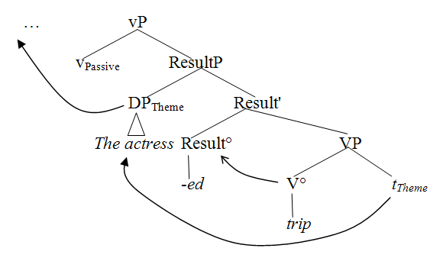

Similarly, with telic verbs, the underlying object in Spec-TelicP is an inner subject (Hale and Keyser 1993), entering into a predication relation with the verbal head lower in the tree. Telicity involves a transition into an end state, and the verb provides the specification of what that end state is. Hence, telic verbs structurally represent a resultant state in very much the same way that a resultative participle does.

(22)
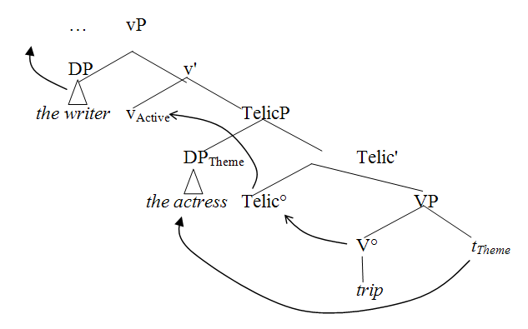

Notice that the TelicP portion of the tree in (22) is structurally identical with the ResultP portion of the tree in (21), and indeed its semantic interpretation is very similar.
With atelic transitive verbs, on the other hand, the object does not move into Spec-TelicP and this special result-state predication relation is not established. This is illustrated in (23).

(23)
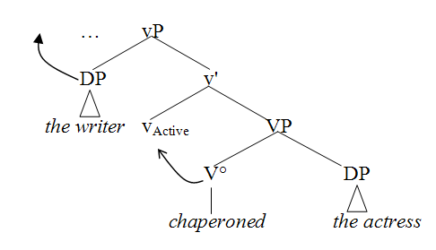

As a result, reanalysis to a resultative participle requires a greater structural adjustment when the predicate is atelic, involving the addition of a ResultP to the structure.
If we now introduce this structural distinction into Stevenson and Merlo’s model, we can consider the different reanalysis steps that would be involved in switching from a main clause analysis to a reduced relative analysis at a given disambiguation point. Consider first the main clause analysis of a telic verb at the point The actress tripped… The presence of a telic feature on the verb trip will motivate the processor to introduce a TelicP into the derivation, with a place-holder waiting for the object to occupy its specifier. The structure at this point is represented in (24).

(24)
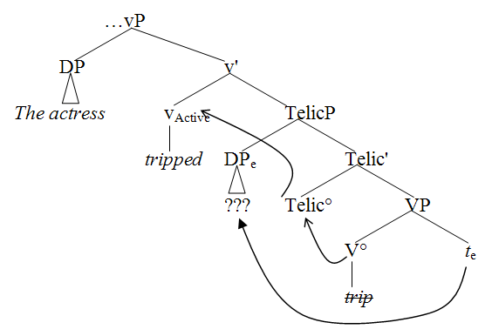

When the processor needs to reanalyze this structure as a reduced relative tree like that in (21), due to encountering a disambiguation cue that rules out the main clause analysis, the only structural adjustment required is the replacement of the placeholder DP (indicated with ??? in (24)) with the erstwhile subject DP the actress, accompanied by a featural adjustment to v° from Active to Passive.
In contrast, when the processor has developed a main clause analysis of an atelic transitive verb, as in The actress chaperoned… , the structure at that point is as represented in (25), with an object placeholder occupying the sister-to-V position.

(25)
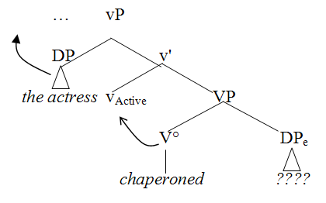

At the disambiguation point, the change to the reduced relative structure in (21) will require the projection of an additional functional projection, ResultP, and corresponding movement from the sister-of-V° to spec-ResultP projection, along with reanalysis of the position of the actress and the features of the v°. This is clearly a more taxing process.
In other words, current syntactic theory provides structures for telic and atelic transitive predicates and resultative participles which provide the basis for a structural reanalysis that predicts the facilitating role of telicity in on-line processing of ambiguous obligatorily transitive sentences. Without such a structural distinction, however, such syntactically-driven models will erroneously predict that the two types of transitive verbs should behave identically at reanalysis.
Our data do not unambiguously choose between these explanations. Furthermore, the wide range of studies of reduced relative constructions suggest that both structural and probabilistic processes may be involved. Superficial features of the reduced relative verb sequence that correlate with a simple declarative sentence have been found to increase the strength of the reduced relative effect (e.g. McRae, Spivey-Knowlton, and Tanenhaus 1998, among others). The structural differences between the erroneous main clause analysis and the correct analysis may also affect the overall difficulty (e.g. Stevenson 1994, Frazier and Clifton 1996, among others). This invites consideration of models that explicitly integrate the operation of immediately available pattern completion constraints with the assignment of syntactic derivations.
One such model is the analysis by synthesis framework (Townsend and Bever 2001). In such a model, comprehension involves the formation of meaning representations based on both probabilistic information and structural derivation. The model predicts that the initial comprehension of sentences is based on pattern recognition, reflecting statistically and informationally dominant patterns, without the benefit of a complete or correct derivational syntax. In this model, semantic event structure information carried by individual verbs contributes directly to the initial meaning representation, as suggested by our results. The model then involves an almost parallel assignment of derivational structure, followed by a comparison of the probabilistic and structural analyses. The contribution of such a model is that it provides an architecture for integrating pattern-based analysis, derivation-based analysis, and reconciliation of the two kinds of information.
At a more general level, our findings are relevant to the longstanding debate about the interaction of syntax and grammatically encoded semantics, and its relevance for sentence comprehension. Telicity, and more generally, event structure, is an intrinsic lexical and categorical semantic property of verbs, but as we have seen, it has strong syntactic reflexes and lends itself to a structural characterization. We have shown that on-line sentence comprehension is sensitive to this factor. Because of its position at the cusp of the syntax-semantics interface, event structure will prove to be a fruitful testing ground for experimental investigation of the role that syntactic computations and semantic categories play in on-line comprehension.

Acknowledgements
This project was supported by the University of Arizona Cognitive Science Program, by NSF Grant No. 0132380 to O’Bryan and Bever, by a British Academy Postdoctoral Fellowship, and by the University of Ulster. We are grateful to Selene Gardner, Roeland Hancock, Benjamin Jones, Andria Ligas, and Hollis Weidenbacher for assistance with the preparation and running of the experiments and to Jason Barker, Ken Forster, Ken McRae, Wayne Murray, Christopher Nicholas, Peter Richtsmeier, and David Townsend for suggestions and advice. Finally, we wish to thank Ken McRae for providing the raw data from his study for the post-hoc reanalysis.

References

Barker, J. and Bolger, P. (2005). Manual for eye tracking hardware and software: Eyesamv.exe and accompanying files. Unpublished manuscript.
Bever, T. G. (1970). The cognitive basis for linguistic structures. In J. R. Hayes (ed.) Cognition and the Development of Language, pp. 279-362. New York: Wiley
Borer, H. (1994). The projection of arguments. In E. Benedicto and J. Runner (eds.), University of Massachusetts Occasional Papers in Linguistics, 17. Amherst, MA: GLSA.
Borer, H. (2005). Structuring Sense, Vol. II: The normal course of events. Oxford: OUP.
Burzio, L. (1981). Intransitive verbs and Italian auxiliaries. Doctoral dissertation. MIT.
Chomsky, N. and Lasnik, H. (1993) The theory of principles and parameters. In J. Jacobs, A. von Stechow, W. Sternefeld, and T. Vennemann (eds.), Syntax: An International Handbook of Contemporary Research, pp. 506-69. Berlin: Walter de Gruyter.
Cohen, J. (1988). Statistical Power Analysis for the Behavioral Sciences (2nd ed.). New York: Academic Press.
Embick, D. (2004) On the structure of resultative participles in English, Linguistic Inquiry, 35, 355-392.
Folli, R. (2001). Constructing telicity in English and Italian. Doctoral dissertation. University of Oxford, Oxford, England.
Folli, R. and Ramchand, G. (2005). Prepositions and results in Italian and English: An analysis from event decomposition. In H. Verkuyl, A. van Hout, and H. deSwart (eds.), Perspectives on Aspect, pp. 81-105. Dordrecht: Springer.
Frazier, L. (1979). On Comprehending Sentences: Syntactic Parsing Strategies. Doctoral dissertation. Bloomington, IN: Indiana University Linguistics Club.
Frazier, L. and Clifton, C. (1996). Construal. Cambridge, MA: MIT Press.
Freedman, S. E. and Forster, K. I. (1985). The psychological status of overgenerated sentences. Cognition, 19, 101-131.
Hale, K. and S. J. Keyser. (1993) On argument structure and the lexical expression of syntactic relations. In K. Hale and S. J. Keyser (eds.), The View From Building 20. Cambridge: MIT Press.
Harley, H. (2005). How do verbs get their names? Denominal verbs, Manner Incorporation and the ontology of verb roots in English. In N. Erteschik-Shir and T. Rapoport, (eds.), The Syntax of Aspect, 42-64. Oxford: Oxford University Press.
Kratzer, A. (2005). Building Resultatives. In C. Maienborn and A. Wöllstein-Leisten (eds.), Events in Syntax, Semantics, and Discourse, (pp. 177-212). Tübingen: Niemeyer.
Levin, B. and Rappaport-Hovav, M. (1995). Unaccusativity: At the Syntax-Lexical Semantic Interface. Cambridge, MA: MIT Press.
MacDonald, M. C. (1994). Probabilistic constraints and syntactic ambiguity resolution. Language and Cognitive Processes, 9, 157-201.
McKoon, G. and Ratcliff, R. (2003). Meaning through syntax: Language comprehension and the reduced relative clause construction. Psychological Review, 110, 490-525.
McRae, K., Spivey-Knowlton, M. J., and Tanenhaus, M. K. (1998). Modeling the influence of thematic fit (and other constraints) in on-line sentence comprehension. Journal of Memory and Language, 38, 283-312.
Nicol, J. L., Forster, K. I., and Veres, C. (1997). Subject-verb agreement processes in comprehension. Journal of Memory and Language, 36, 569-587.
O’Bryan, E. (2003). Event structure in language comprehension. Doctoral dissertation, University of Arizona, Tucson.
O’Bryan, E., Folli, R., Harley, H., and Bever, T. G. (In preparation). Event structure affects on-line sentence comprehension.
Perlmutter, D. (1978). Impersonal passives and the Unaccusative Hypothesis. Proceedings of BLS, 4, 157-189. University of California, Berkeley.
Piñango, M. M., Zurif, E., and Jackendoff, R. (1999). Real-time processing implications of enriched composition at the syntax-semantic interface. Journal of Psycholinguistic Research, 28, 395-414.
Pritchett, B. L. (1992). Grammatical Competence and Parsing Performance. Chicago, IL: University of Chicago Press.
Pustejovsky, J. (1988). The Geometry of Events. In C. Tenny (ed.), Studies in Generative Approaches to Aspect (pp. 19-39). MIT Lexicon Project Working Papers, 24.
Sanz, M. (2000). Events and Predication: A New Approach to Syntactic Processing in English and Spanish. Philadelphia, PA: John Benjamins.
Seidenberg, M. S. and MacDonald, M. C. (1999). A probabilistic constraints approach to language acquisition and processing. Cognitive Science, 23, 569-588.
Stevenson, S. (1994). Competition and recency in a hybrid network model of syntactic disambiguation. Journal of Psycholinguistic Research, 23, 295-322.
Stevenson, S., and Merlo, P. (1997). Lexical structure and parsing complexity. Language and Cognitive Processes, 12, 349-399.
Tabossi, P., Spivey-Knowlton, M. J., McRae, K., and Tanenhaus, M. K. (1994). Semantic effects on syntactic ambiguity resolution: Evidence for a constraint-based resolution process. In C. Umilta and M. Moscovitch (eds.), Attention and Performance XV: Conscious and Unconscious Information Processing (pp. 589-616). Cambridge, MA: MIT Press.
Tenny, C. (1992). The Aspectual Interface hypothesis. In I. A. Sag and A. Szabolcsi (eds.), Lexical Matters. Stanford, CA: CSLI.
Townsend, D. J. and Bever, T. G. (1991). The use of higher-level constraints in monitoring for a speaker demonstrates functionally distinct levels of representation in discourse comprehension. Language and Cognitive Processes, 6, 49-77.
Townsend, D. J. and Bever, T. G. (2001). Sentence Comprehension: The Integration of Habits and Rules. Cambridge, MA: MIT Press.
Vendler, Z. (1967). Linguistics in Philosophy. Ithaca, NY: Cornell University Press.

Table 1. Mean self-paced reading times in post-hoc reanalyses of two prior studies

Trans | Tel | N | Example | Reduction | verb-ed by | the N | main verb
Oblig Trans | Atelic | 17 | The N escorted  by the N mainV… | Reduced | 541.09 | 592.47 | 596.94
 |  |  |  | Unreduced | 504.32 | 546.76 | 552.59
 |  |  |  | RRE | 36.76 | 45.71 | 44.35
Oblig Trans | Telic | 32 | The N noticed  by the N mainV… | Reduced | 501.73 | 547.36 | 554.52
 |  |  |  | Unreduced | 485.23 | 550.27 | 525.23
 |  |  |  | RRE | 16.50 | -2.91 | 29.28
Option Trans | Atelic | 12 | The N sketched by the N mainV… | Reduced | 561.67 | 586.17 | 620.04
 |  |  |  | Unreduced | 461.58 | 539.25 | 510.71
 |  |  |  | RRE | 100.08 | 46.92 | 109.33
Option Trans | Telic | 10 | The N tripped  by the N mainV… | Reduced | 489.80 | 530.50 | 551.20
 |  |  |  | Unreduced | 460.70 | 470.45 | 521.50
 |  |  |  | RRE | 29.10 | 60.05 | 29.70

Table 2. Mean speaker change detection errors for the 4 verb types

Transitivity | Telicity | Example | Reduction | % Detection Errors
Obligatorily Transitive | Atelic | The N escorted  by the N mainV… | Reduced | 7.80%
Obligatorily Transitive | Atelic | The N escorted  by the N mainV… | Unreduced | 2.10%
Obligatorily Transitive | Atelic | The N escorted  by the N mainV… | RRE | 5.70%
Obligatorily Transitive | Telic | The N noticed  by the N mainV… | Reduced | 2.80%
Obligatorily Transitive | Telic | The N noticed  by the N mainV… | Unreduced | 4.30%
Obligatorily Transitive | Telic | The N noticed  by the N mainV… | RRE | -1.50%
Optionally Transitive | Atelic | The N sketched by the N mainV… | Reduced | 3.50%
Optionally Transitive | Atelic | The N sketched by the N mainV… | Unreduced | 2.80%
Optionally Transitive | Atelic | The N sketched by the N mainV… | RRE | 0.70%
Optionally Transitive | Telic | The N tripped  by the N mainV… | Reduced | 1.40%
Optionally Transitive | Telic | The N tripped  by the N mainV… | Unreduced | 2.80%
Optionally Transitive | Telic | The N tripped  by the N mainV… | RRE | -1.40%

Table 3. Word Maze ANOVA results

 | Sentence Regions
 | embedded verb |  | by |  | the |  | noun |  | main verb
Factor(s) | F | p | F | p | F | p | F | p | F | p
Telicity | 1.9 | n.s.ª | 4.9 | <.05 | <1 | n.s. | 3.3 | .08 | 2.9 | n.s.
Transitivity | 3.5 | .07 | 4.4 | <.05 | 2.4 | n.s. | 19.5 | <.01 | 9.2 | <.01
Telicity X Transitivity | 4.1 | <.05 | 4.6 | <.05 | <1 | n.s. | <1 | n.s. | 5.8 | <.05
ª n.s. = “not significant”

Figure 1. Processing difficulty measured as eye fixation times per word in each sentence zone

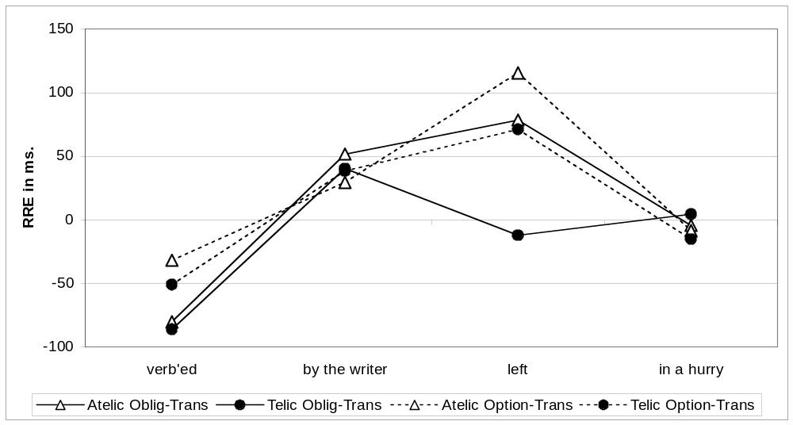

Figure 2. The word maze task (Freedman and Forster 1985)

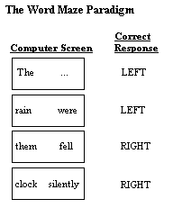

Figure 3. Word Maze Results

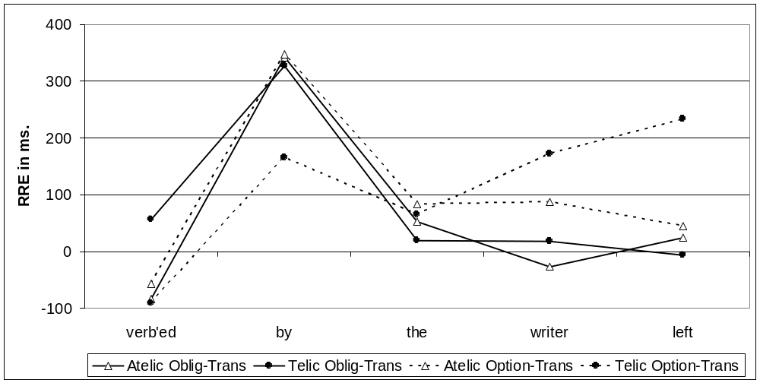

Figure 4. Effects of telicity and transitivity in the word maze

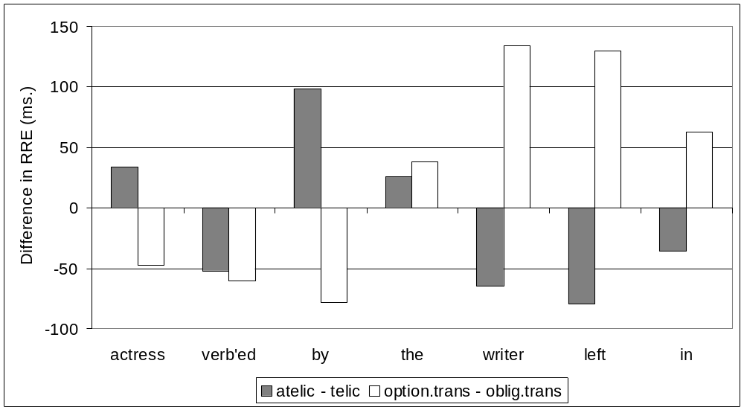

The # symbol indicates semantic infelicity.
Harley (2005) argues that in fact the predication relation (a small clause) is the key factor in producing a telic or resultative interpretation in these sentences, and that dedicated functional projections such as TelicP and ResultP are not required or motivated. On this approach, the structural characteristic held in common by telic predicates and the resultative participles would be the inner subject structural relation associated with the predication represented in each.
In an optionally transitive verb, however, the object placeholder will not be posited by the processor, requiring an even greater amount of restructuring to recover from the main clause analysis. Consequently, the facilitating effect of transitivity is still accounted for.

