

COGNISYNC
Incubation Centre SVIT, Rajanukunte, Bengaluru 560064
Email: cognisync.tech@gmail.com Contact no: +91 7019458378

"We started with nothing but a framework and a dream, and the journey of thousand miles began with that single step. Today, this achievement confirms the path was right and proves, unequivocally, that the dream was valid."

Cognisync is reaching heights

- SJCIT - 3rd place at 24 hours NATIONAL LEVEL HACKATHON

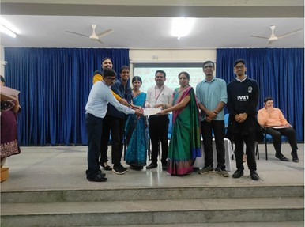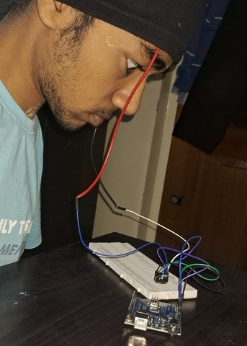

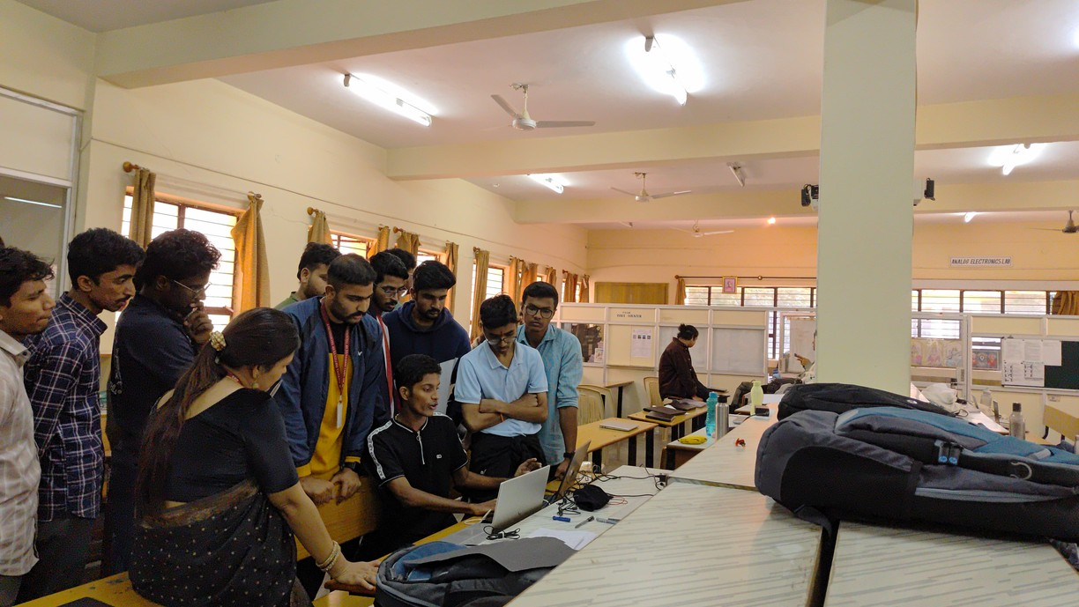

- IMTEX, Bengaluru

Our prototype was presented at INTERNATIONAL MACHINE TOOLS EXHIBITION (IMTEX) at BIEC.
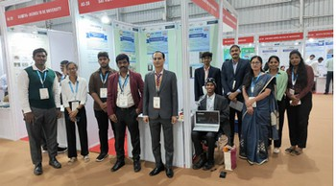
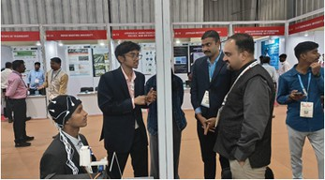
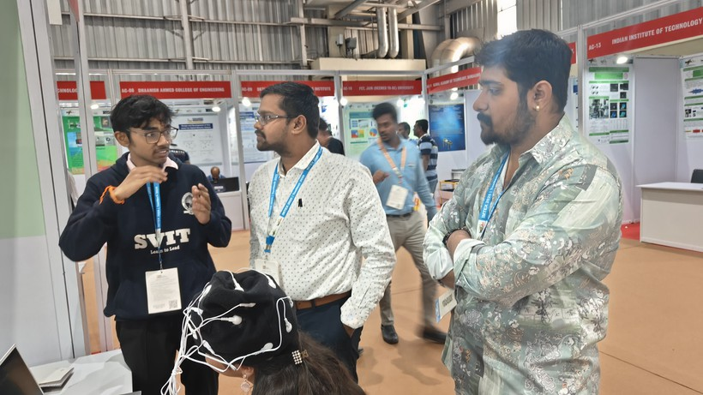
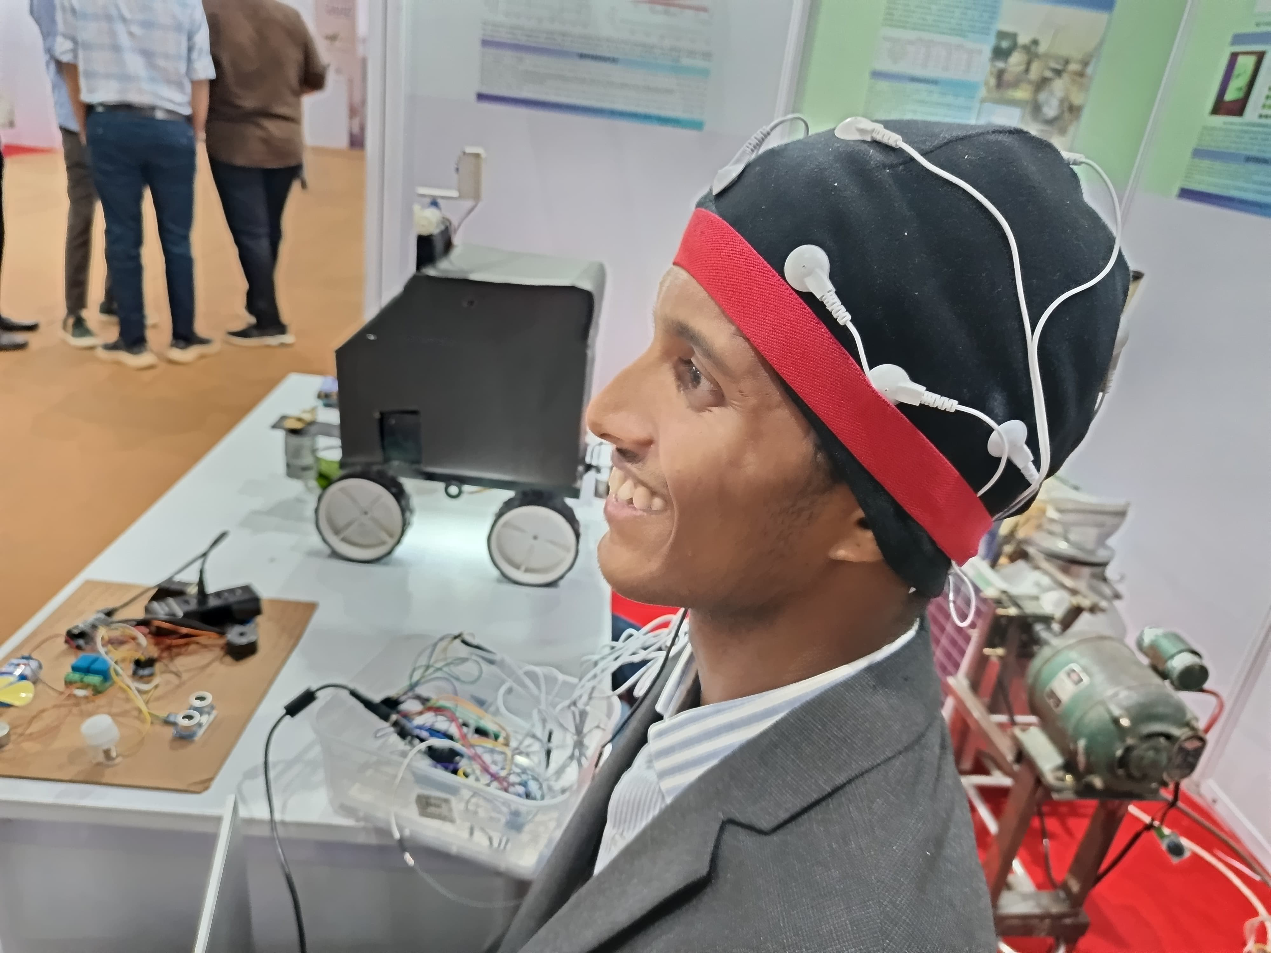

- National Level Hackathon, SRMIT, Delhi, 2025 – Was awarded 5th place for idea and pitch
Was awarded the title of EFFICIENT HARDWARE RESOURCE MANAGEMENT PROJECT
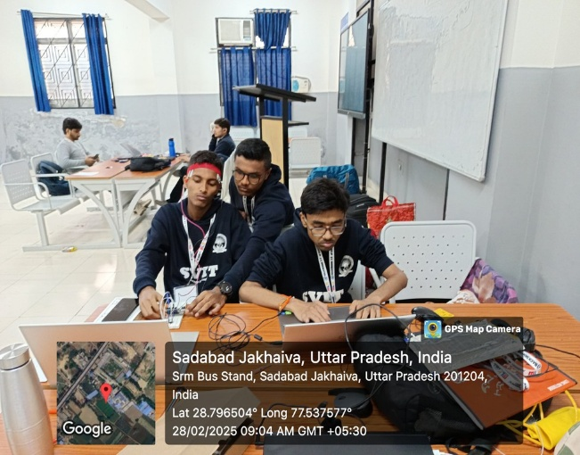
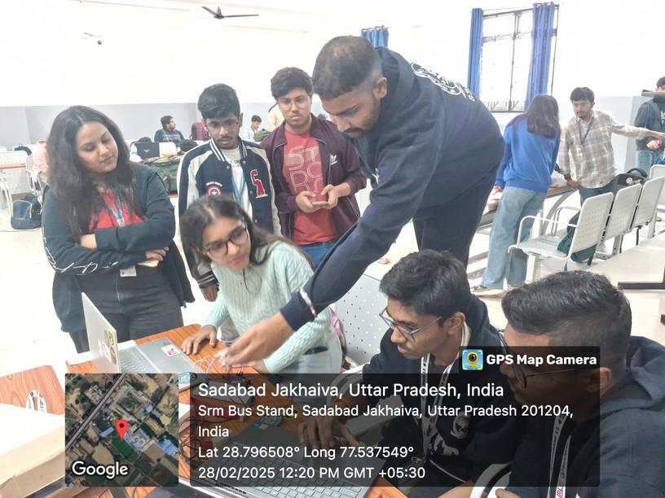

- MVIT Hackathon – Our team was awarded the 3rd place
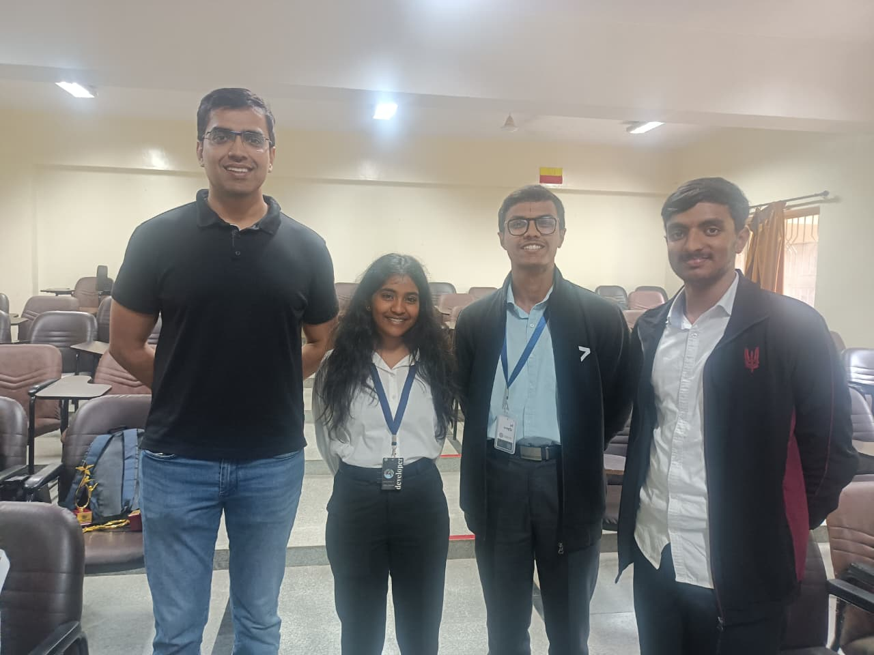
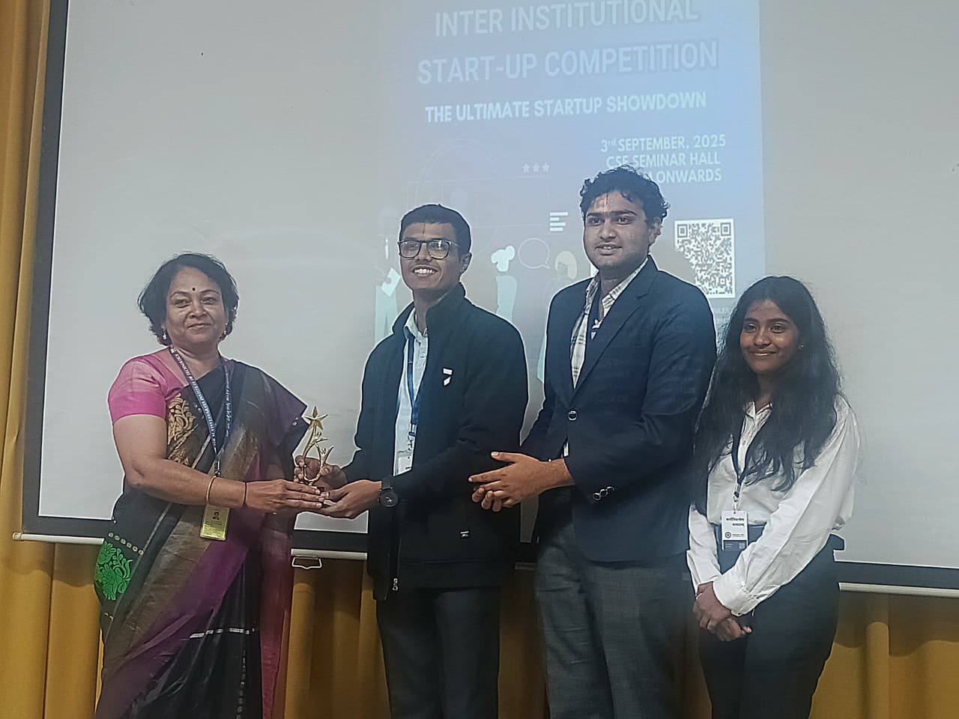

- Adichunchanagiri Institute of Technology, Chikamagaluru – Our team was awarded the 1st place in the hackathon organized by AIT.

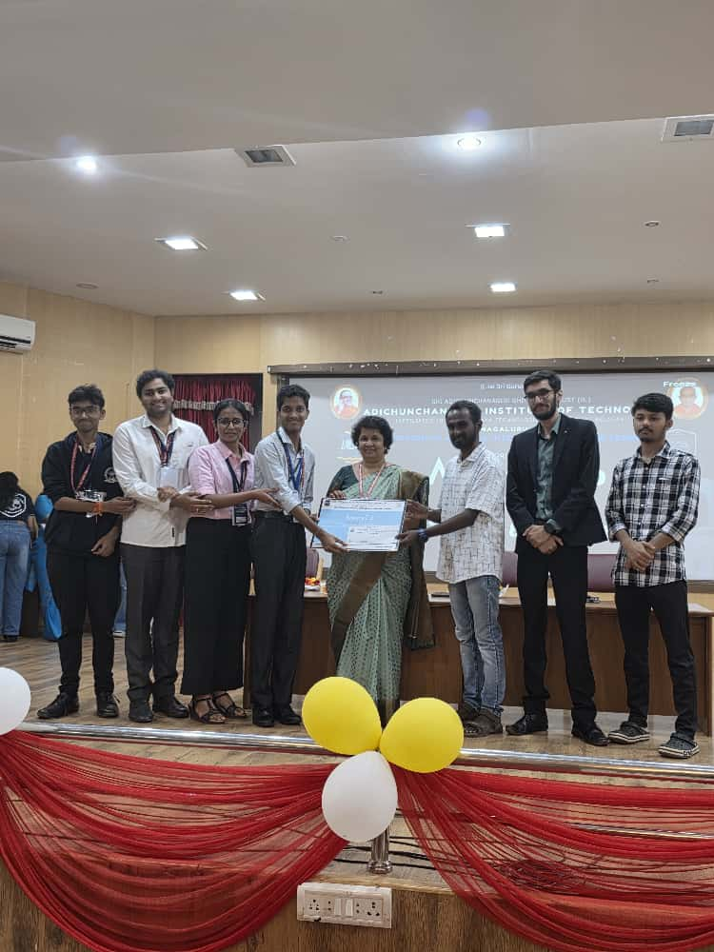

- Validation with EEG professional expert in Bangalore Neural Centre(BNC) - Dr. Murthy

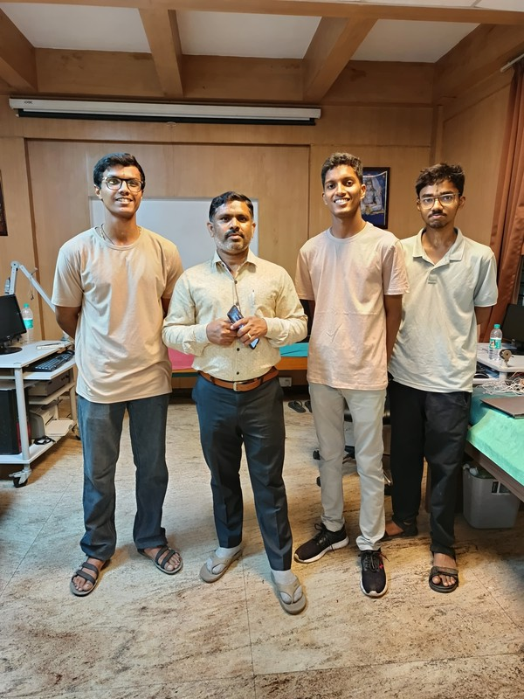

- Validation in Spandanna Hospital (Rajajinagar)

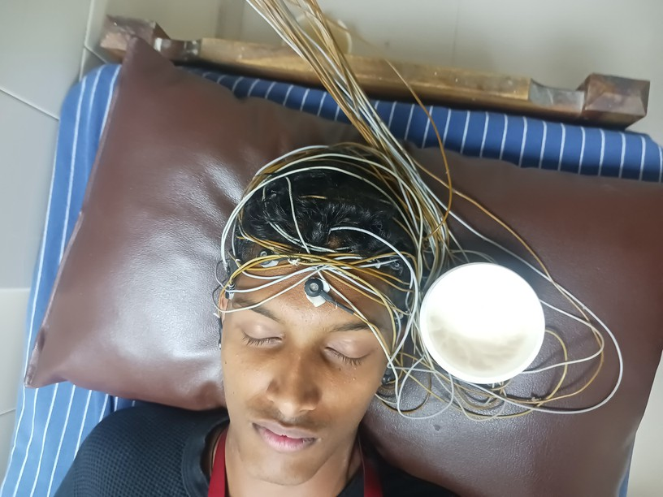
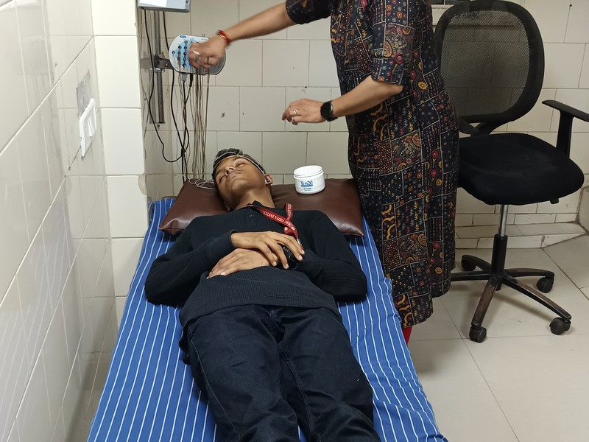

- Startup Saga– We were awarded the first prize at Startup Saga organized by VTU Belagavi

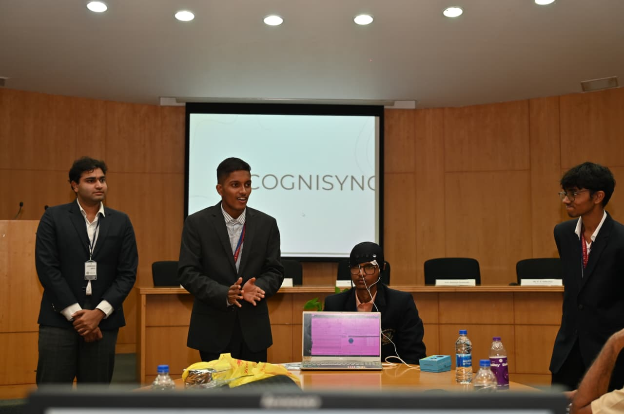
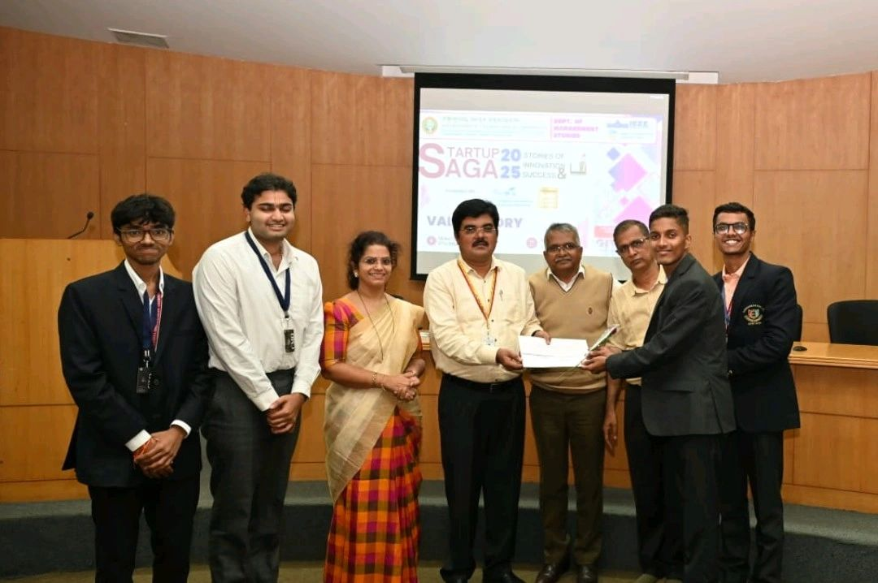

- SVIT Hackathon – Secured 2nd place in the hackathon organized by SVIT

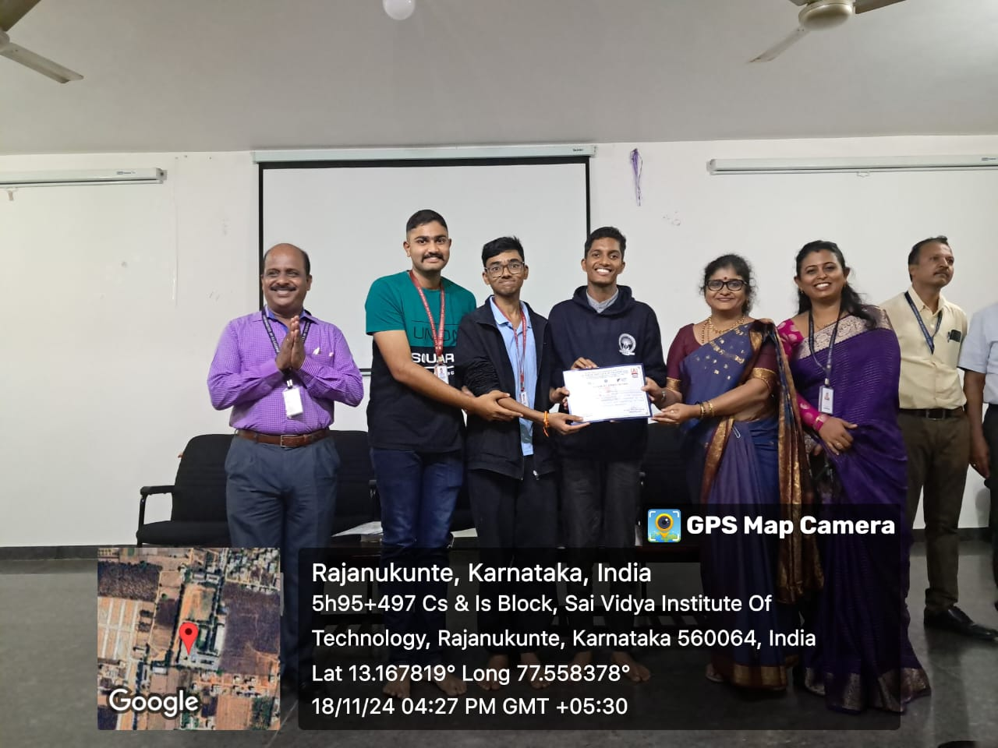

- Finalist in App development (Swift) organised by Kanini.
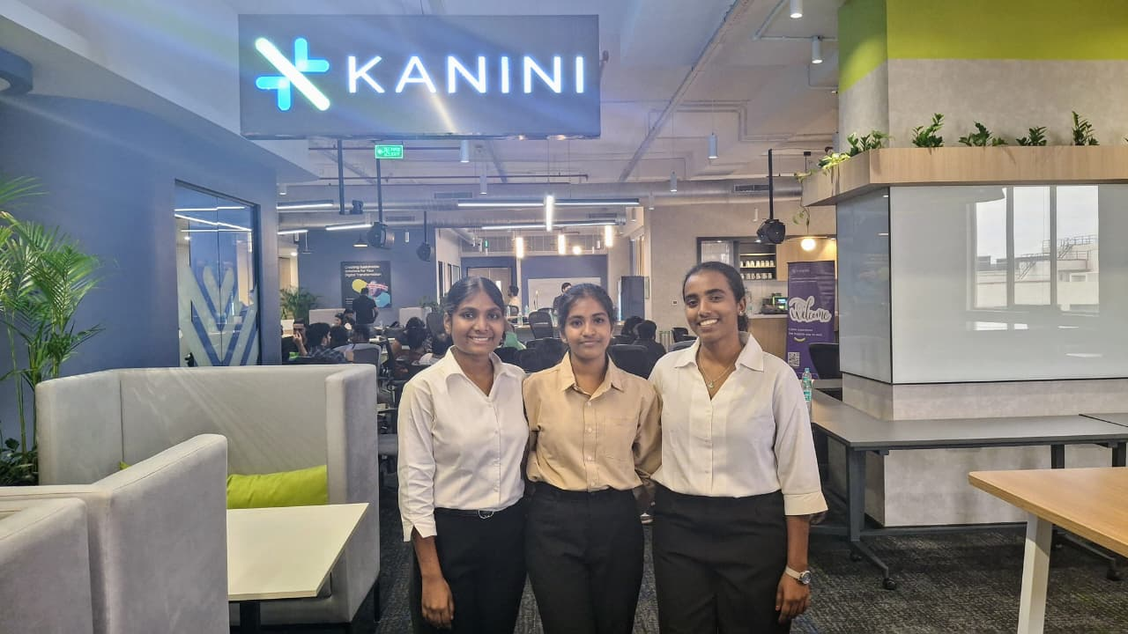
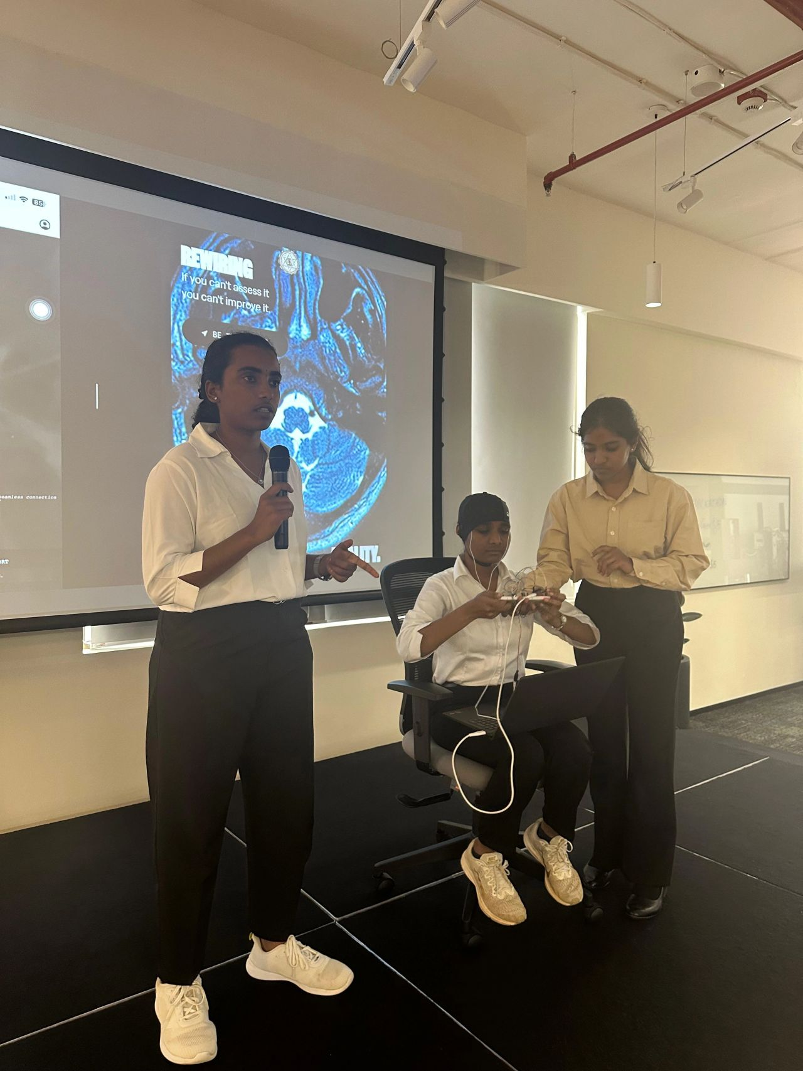

- VTU Exhibition held at Nagarbhavi
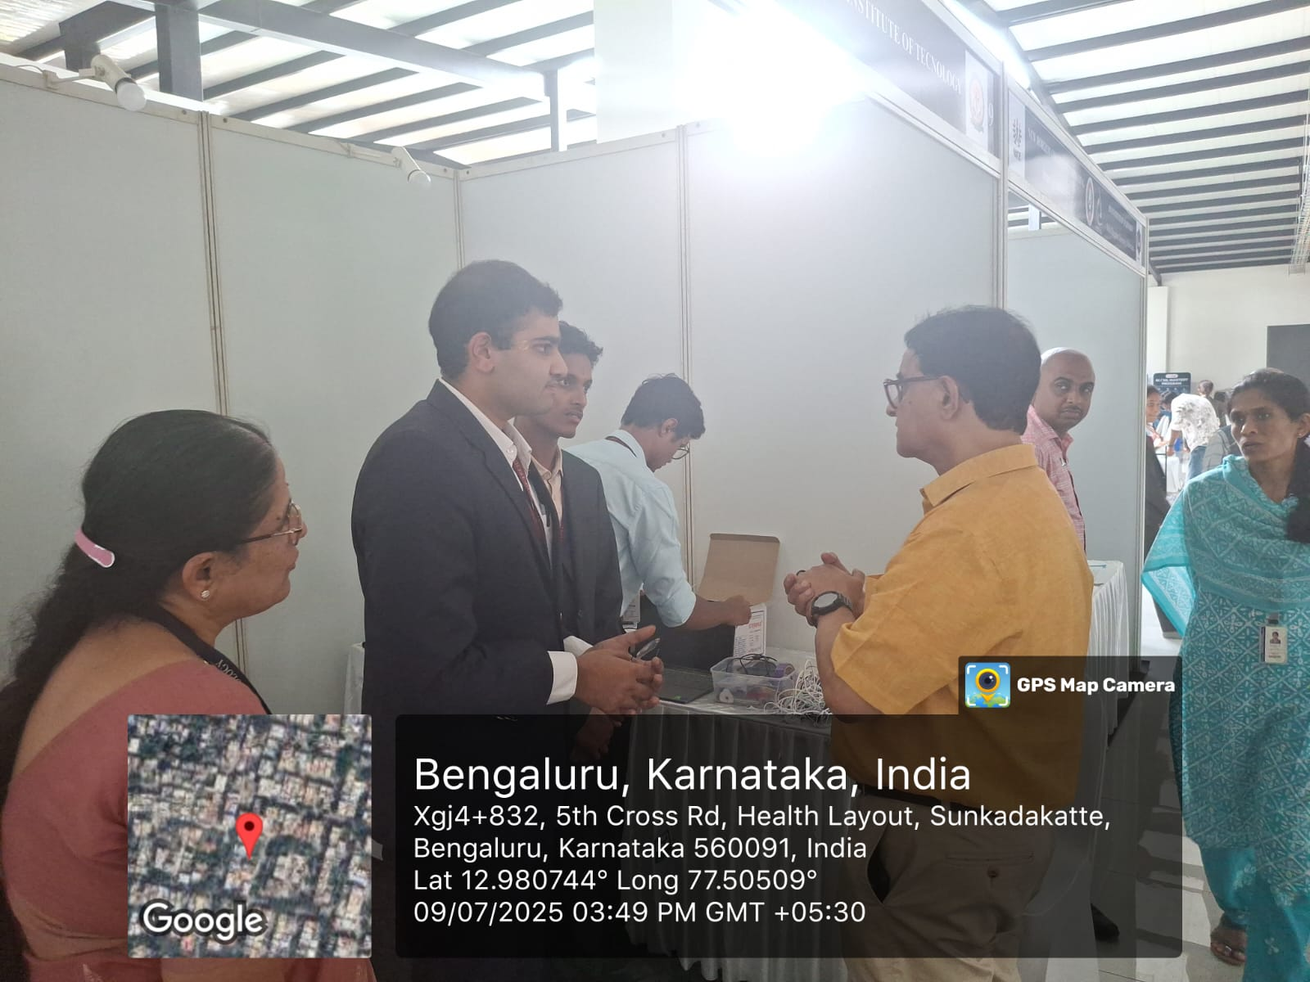

- We are happy to have Mr. Anuraag Vibhuthi, Deputy Director, TCOE as our advisory



