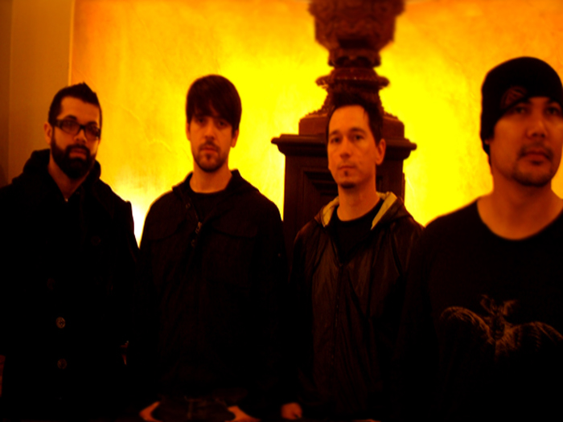

At the end of 2008 four long time friends came together to vent frustrations, share ideas, try and step outside themselves to make music. Secluded in a small room with minimal equipment and a computer Sleepnoise recorded their debut EP White Empty Rooms. The members of Sleepnoise came from influential California Central Valley bands such as Pome (Velvet Hammer Music Management), Simon Says (Hollywood Records), Key to Arson (Spunout Records), and Cleanse. Collectively they have years of experience and have toured the world sharing the stage with a wide range of national acts including: Deftones, System of a Down, Incubus, Papa Roach, and Far. Everyone in the band has played pro venues to large audiences ranging from Woodstock 1999 to XFest 2008. Sleepnoise plans to continue writing new music and playing out as much as possible, adding to its fast growing fan base and bringing solid melodic rock back to the masses.

**Sound:**

Dark and driving, melodic and emotive, spiraling notes and atmospheric plunges, perfectly blended with sharp hooks.

**Sleepnoise is: Booking and Press Requests:**

Mike Arrieta – Bass Danny Schreiber

Dave Maritch – Drums [cognitronic@gmail.com](mailto:cognitronic@gmail.com)

Joe Gonzalez – Guitar

Danny Schreiber – Vocals

**Websites:**

<http://www.myspace.com/sleepnoise>

<http://www.sonicbids.com/sleepnoise>

<http://www.reverbnation.com/sleepnoise>