**INSTALLATION STEPS**

yum install wget unzip tree git -y

yum install java -y

To install jenkins, we have add the package to repo and then install it.

wget -O /etc/yum.repos.d/jenkins.repo <https://pkg.jenkins.io/redhat/jenkins.repo>

rpm --import <https://pkg.jenkins.io/redhat/jenkins.io.key>

yum install jenkins -y

service jenkins start

* browse url with public ip with port number 8080

<http://54.243.5.107:8080/>

You can see the jenkins page first time login as below

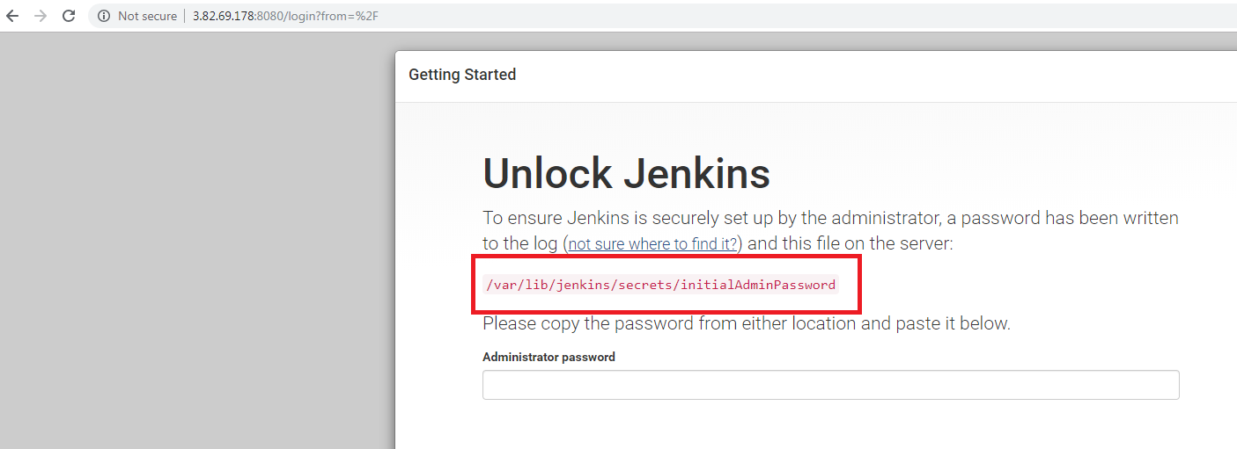

Copy the initial admin password from

[root@ip-172-31-86-155 opt]# cat /var/lib/jenkins/secrets/initialAdminPassword

f735142601ba4d71bd32692c4d08946c

And paste on the UI at prompting place

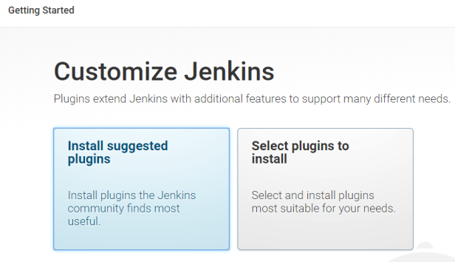

Click on install suggested plugins

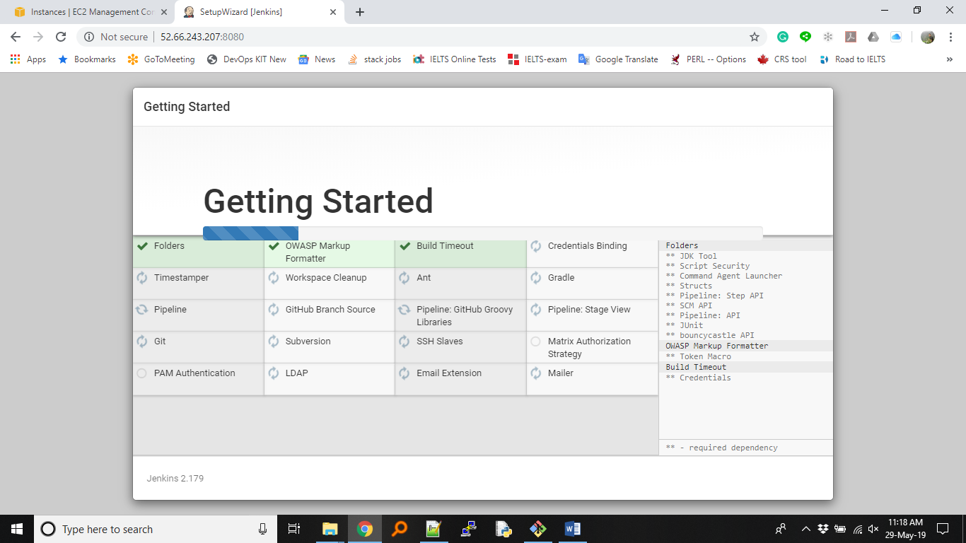

So now, you are able to see the getting started page.

To check the Jenkins server running or not

**[root@ip-172-31-86-155 opt]# service jenkins status**

or

**ps -ef | grep jenkins**

[root@jenkinserver ~]# ps -ef |grep jenkins

jenkins 4119 1 10 01:55 ? 00:00:36 /etc/alternatives/java -Dcom.sun.akuma.Daemon=daemonized -Djava.awt.headless=true -DJENKINS_HOME=/var/lib/jenk

ins -jar /usr/lib/jenkins/jenkins.war --logfile=/var/log/jenkins/jenkins.log --webroot=/var/cache/jenkins/war --daemon --httpPort=8080 --debug=5 --handlerCoun

tMax=100 --handlerCountMaxIdle=20

root 4256 4221 0 02:01 pts/0 00:00:00 grep --color=auto jenkins

[root@jenkinserver ~]#

**Exercise 1**

Please create new jobs to get started as demo_job1

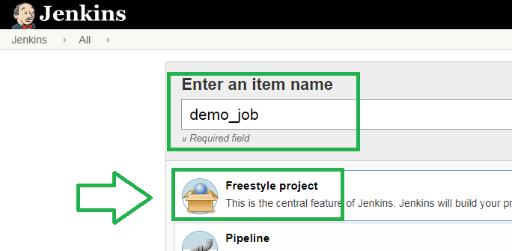

Click on Build tab

select the option “Execute shell”

write the below content in the box and save

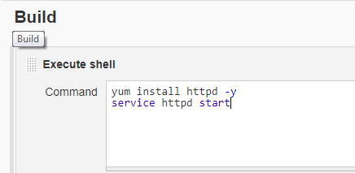

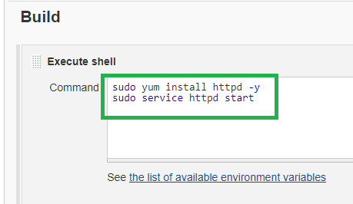

It will fail even we use sudo command, because, all process running by jenkins user

So, add the jenkins user in sudoers file at bottom as below to execute commands as a root user.

[root@ip-172-31-86-155 opt]# vi /etc/sudoers

#includedir /etc/sudoers.d

ec2-user ALL=(ALL) NOPASSWD: ALL

jenkins ALL=(ALL) NOPASSWD: ALL

Then build the job now, it will be successful

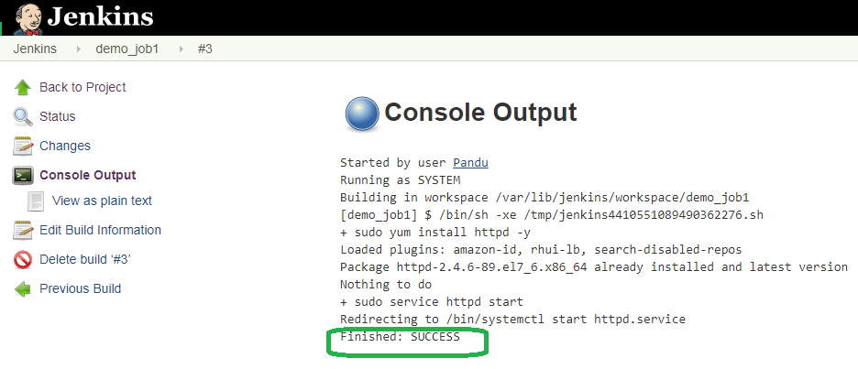

Browse the URL with public IP and will get http Apache test page

http://13.233.199.99

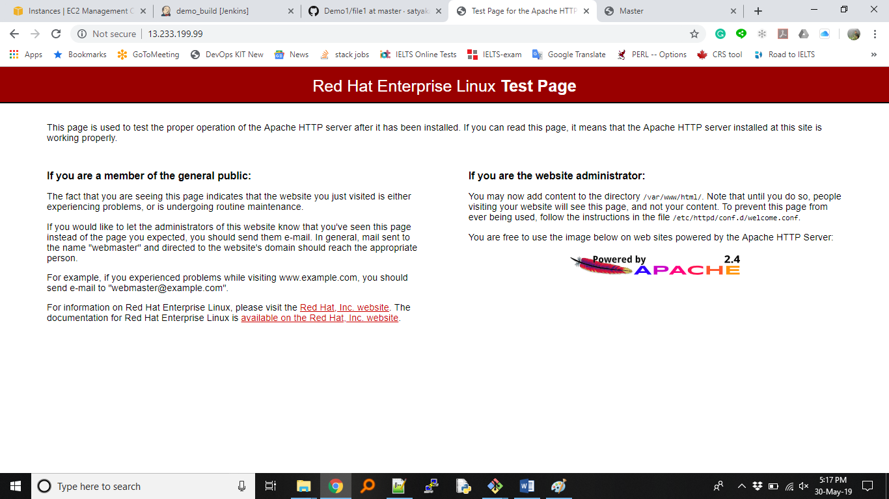

**Exercise 2**

Now, we will try to do activity remote machine using ssh or executing commands on remote machine.

**Step1:** Create another RHEL machine

**Step2:** Install SSH plugins in jenkins server, show that it can talk with remote machine

Jenkins-->Manage Jenkins--> Manage Plugins-->click on "Available” tab

In filter engine search respective plugin example: SSH

Select the “SSH” plugin -> Click on “Install without restart”

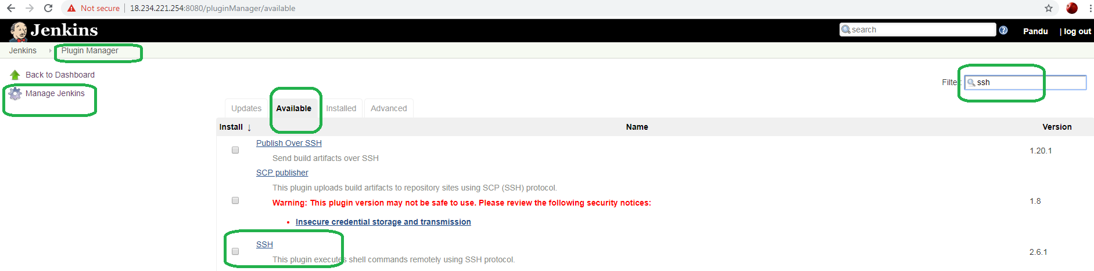

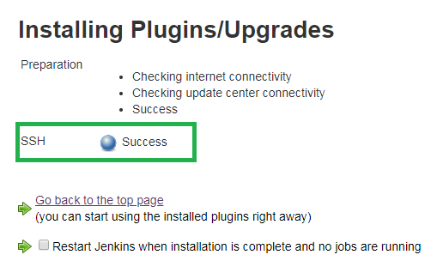

**Step3:** To access remote machine and execute commands on remote machine, need to be setting up credentials in jenkins server.

Jenkins-->Credentials-->global--> Add Credentials

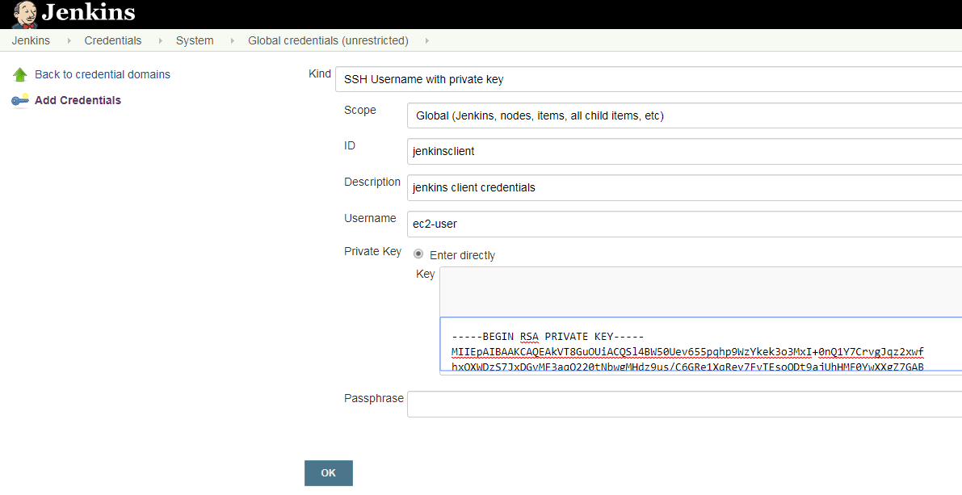

In the Private key box space, paste the pem file contents (Ex: Mumbai23May.pem).

Open the pem file in a notepad, select all the lines(Ctrl+a), copy it then paste it in that Private key box space.

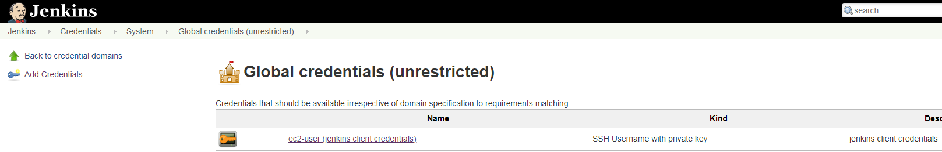

**Step4:** Adding SSH sites,

Jenkins-->Manage Jenkins--> Configure System

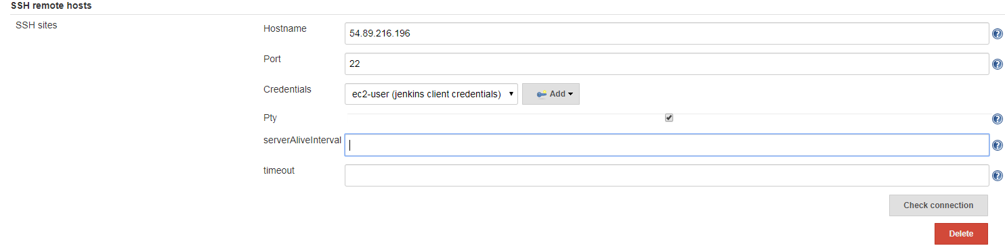

Hostname: 54.89.216.196 (Private IP of newly created remote machine)

Port: 22

Credentials: ec2-user (Jenkins client credentials)

Click on Check connection -> you will see Successful connection

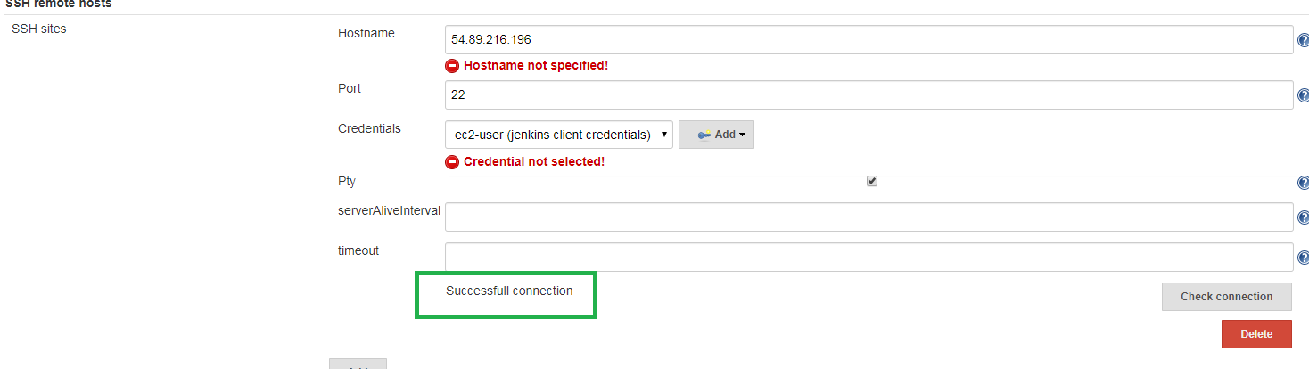

click on the "save" button at the bottom.

**Step5:**

Create a job to execute on remote machine.

Jenkins-->New item-->Freestyle project

Create new job as remote_job1

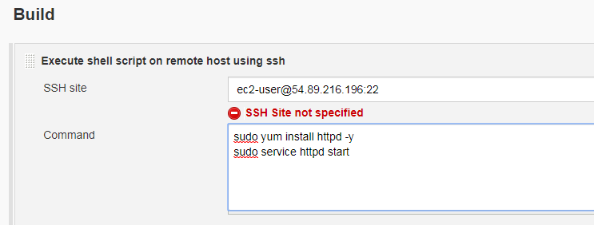

**Save => Build Now.**

It should be successful.

To Verify, go to browser, put the public IP of remote machine in the URL.

It will display http apache page.

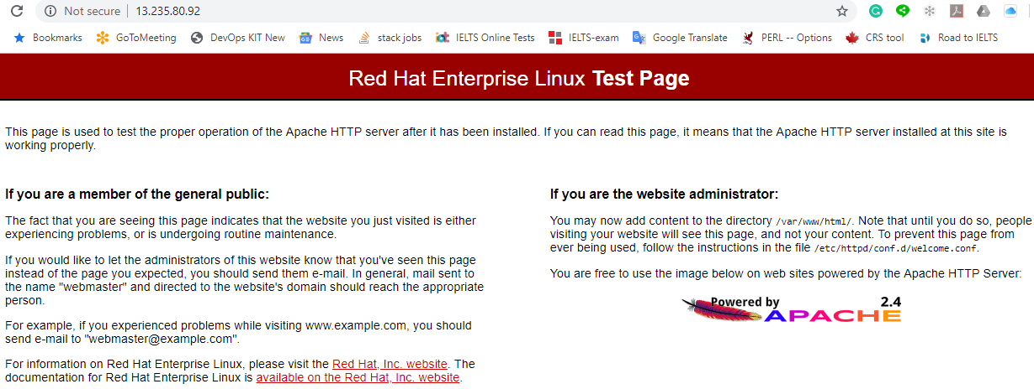

**Step6:**

Now, try to create index file in remote machine location with some content

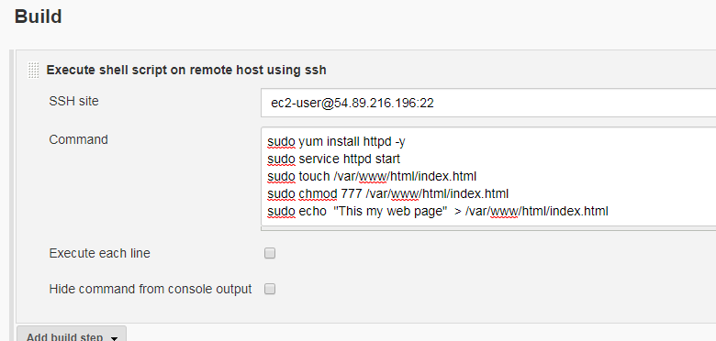

Save and Build it again. It should be successful.

Browse in the URL and check again.

**Exercise 3**

Download and configure the benefits.war

Command:

sudo yum install tomcat wget -y

sudo service tomcat start

sudo wget https://www.oracle.com/webfolder/technetwork/tutorials/obe/fmw/wls/12c/03-DeployApps/files/benefits.war -P /usr/share/tomcat/webapps

Save -> Build now -> we can monitor the console output -> We can see the build is Success

Now open the browser and check the benefits war file (Class3 note)

**http://13.233.199.99:8080/benefits/**

**================Master & Slave setup===============================**

**Jenkins** 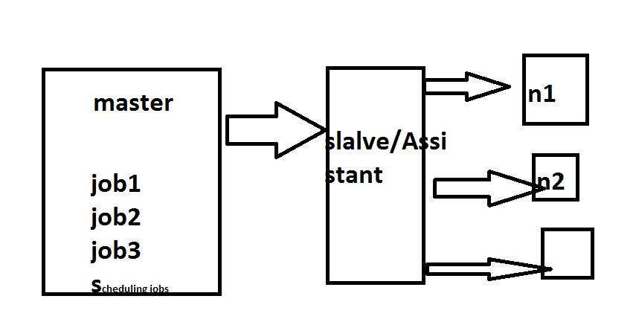

**Create one RHEL machine for slave setup (you better use same credentials else you need to add slave credentials .)**

**Set Credentials for slave machine in jenkins:**

**setting up slave:**

**Jenkins-->**[Manage Jenkins](http://52.87.164.67:8080/manage)-->manage node

[Select Manage Nodes](http://52.87.164.67:8080/computer)

[Add, remove, control and monitor the various nodes that Jenkins runs jobs on.](http://52.87.164.67:8080/computer)

create new node---> provide node name and select option Permanent

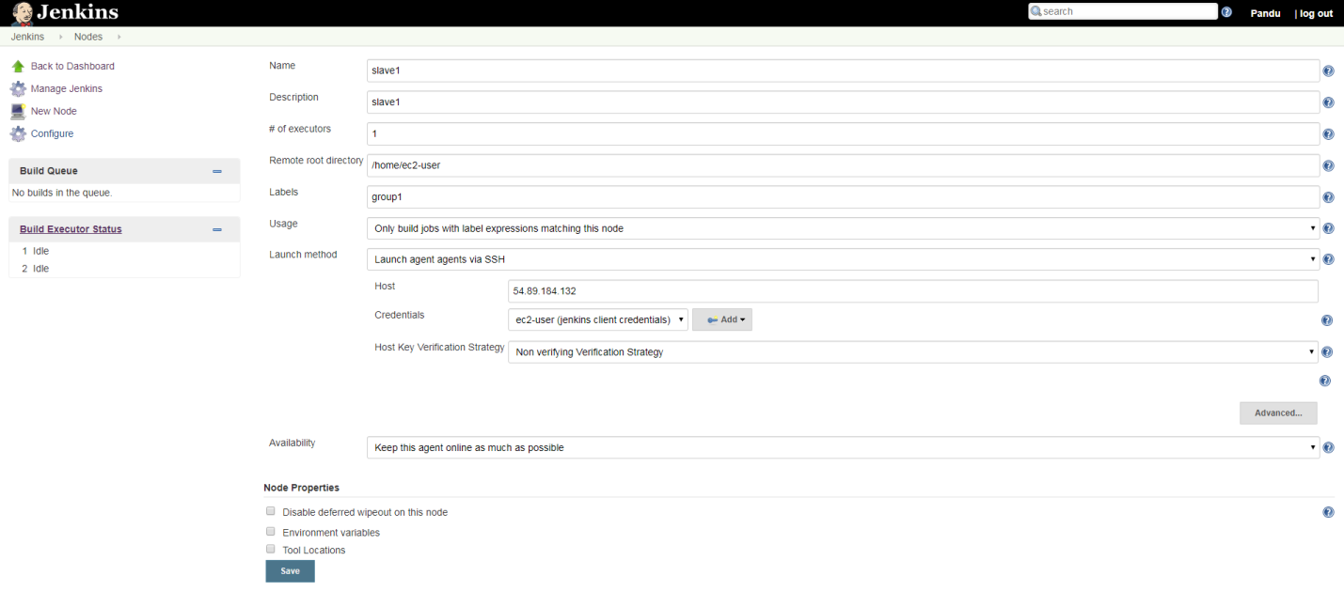

Provide the details properly

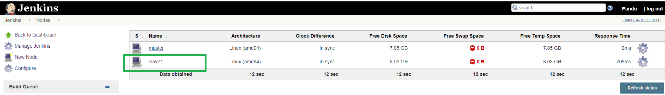

Now, create job

jenkins--> New Item-->Free style job--> provide name "slavejob1" and click on ok

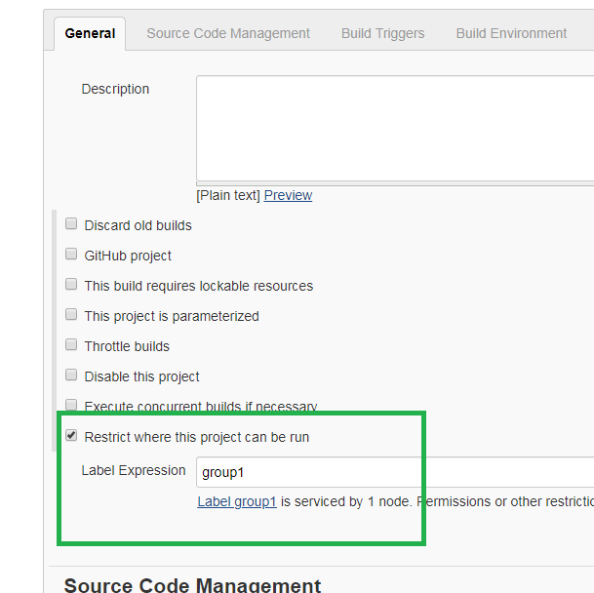

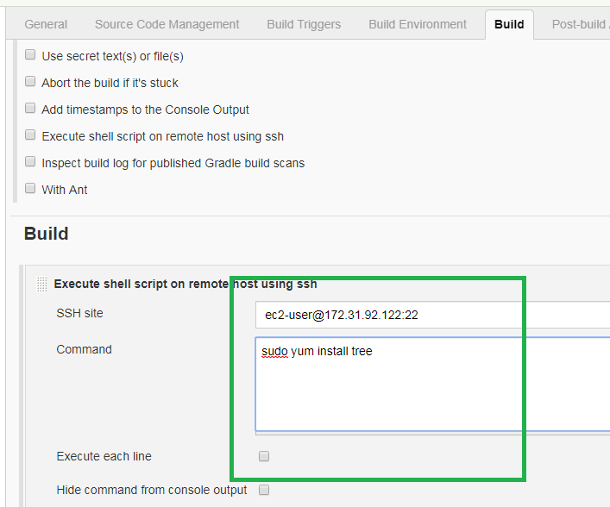

save and Build it after writing script on build page

So far we did ran job on slave machine with single job.

**=========Parameterized Tasks=================================**

**Tasks1:**

Step1: Create new job "demo_job5"

**In General section**, select option "This project is parameterized"

Select "Add Parameter" option as "string parameter"

provide name and description

Example:

Name pkg_name

Description "please provide the package you install"

Select "Trim the string"

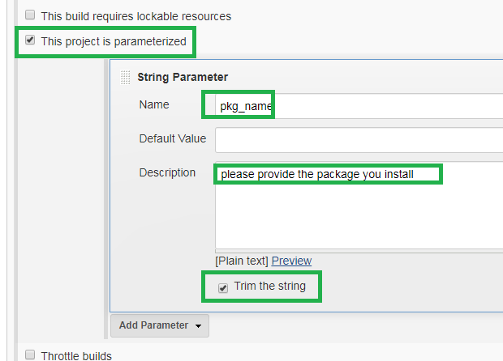

Now, go to Build tab:"

select "Execute Shell"

provide command " sudo yum install $pkg_name -y

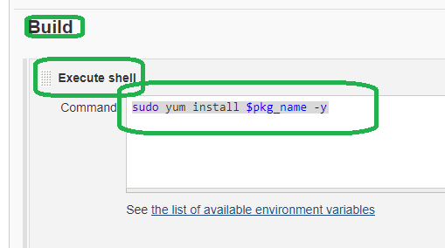

Save and build.

[Build with Parameters](http://18.212.167.139:8080/job/demo_job6/build?delay=0sec)==>the job should run successfully

**Tasks2:**

Step1: Create new job "demo_job5"

**In General section**, select option "This project is parameterized"

Select "Add Parameter" option as "choice Parameter"

Provide details as below

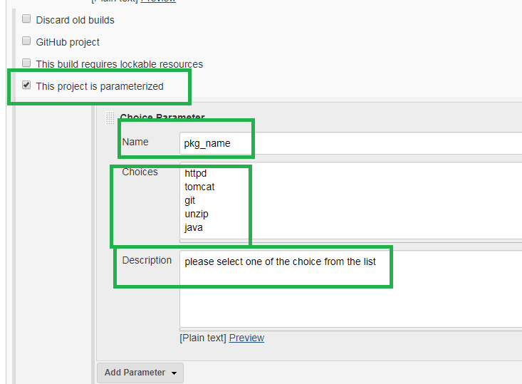

**In Build section:**

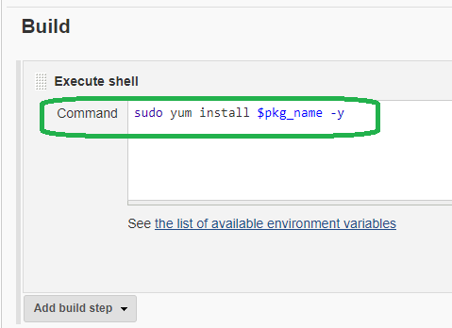

Save and build.

[Build with Parameters](http://18.212.167.139:8080/job/demo_job6/build?delay=0sec)==>the job should run successfully

**Assignment:**

How to restore jenkins

1. Take backup of jenkins folder

=> **cp /var/lib/jenkins /tmp/jenkins_ddmmyy**

1. Stop jenkins

=> **service jenkins stop**

1. Uninstall jenkins

=> **yum remove jenkins**

1. Delete jenkins directory

=> **rm –rf /var/lib/jenkins**

1. Install jenkins in Remote host/another machine

=> commands have been written on the starting of this document.

1. Copy the jenkins directory from host to remote host

* scp **/tmp/jenkins_ddmmyy ec2_user@RemoteHost_publicIP**

1. Open the jenkins page in web browser.

publicIP:8080

**5th Day**

**===========CI/CD Pipeline==============**

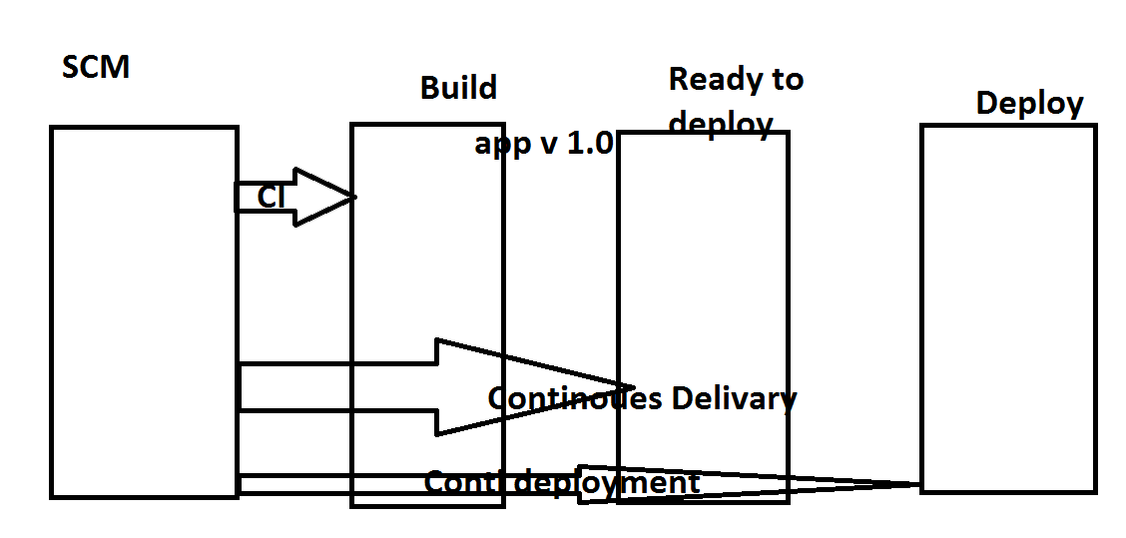

CI/CD pipe line:

We can create pipeline job in two ways:

pipeline code

build pipeline.

pipeline code: It uses Grove language

we need to write code in grovee langauage and in stages mode

Exercise1:

Jenkins-->New item--slect pipeline and name something as pipelinejob2

Build pipeine plugin

**using build pipeine plugin**

**Step1:**

jenkins--->manage jenikins-->mange plugins---> serach build pipeline

Select Build Pipeline

install without restart

Create multiple jobs(3 now) like as below

job1: echo "continuous integration getting done"

job2: echo "continuous delivery getting done"

job3: echo "continuous deployment getting done"

go to each job "configure" and Configure each job should trigger one after another job

then run the job. It will run successfully all jobs

Exercise:

configuring build periodically and check once it is running or not periodically

**Github webhooking:**

Login into github with your login credentials

Create one repo as demo_repo1

Create one file as file2in above repo and commit it

step1: Go to repo on your github--> settings(top right)-->webhooks(left side)-->addwebhook-->provide jenkins server url and select application/json, select everything option

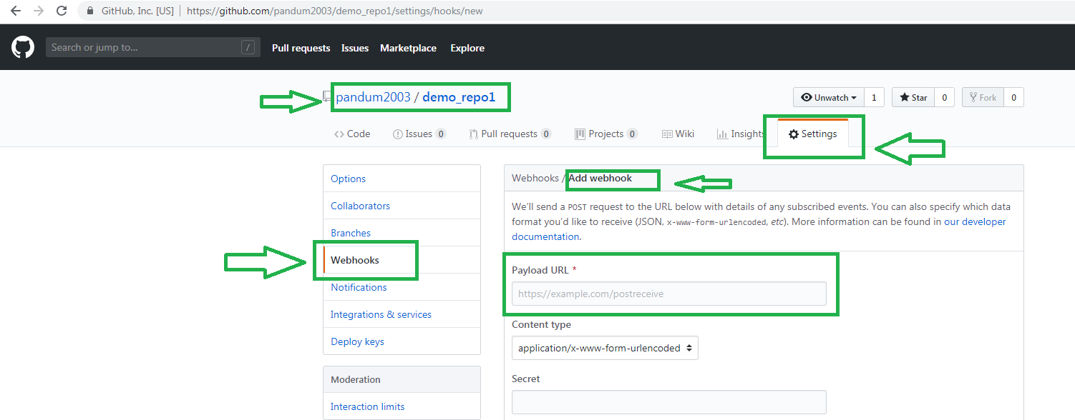

Note: In Payload URL don’t forget to add “github-webhook/” after the Jenkins URL.

Ex:

<http://13.233.155.148:8080/github-webhook/>

Which event

Send me everything

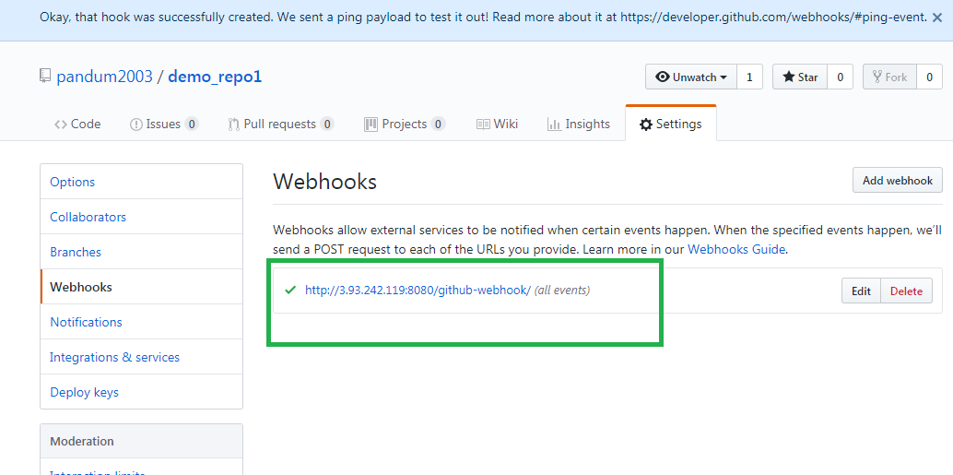

**Step2:**

Creating credentials from github

Go to jenkins console--Credentials--->global-->add credentials

**step3:**

Create job to use with github-webhook

Create a new job

jenkins-->new-item--><name as: webhook_demo>

Provide gthub details URL and credentials

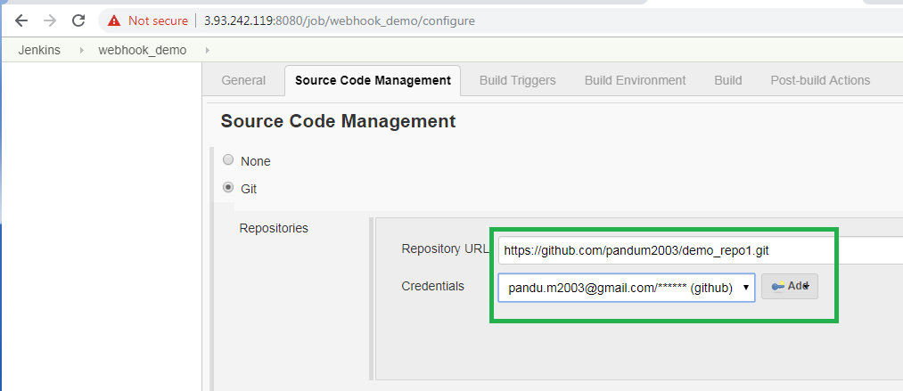

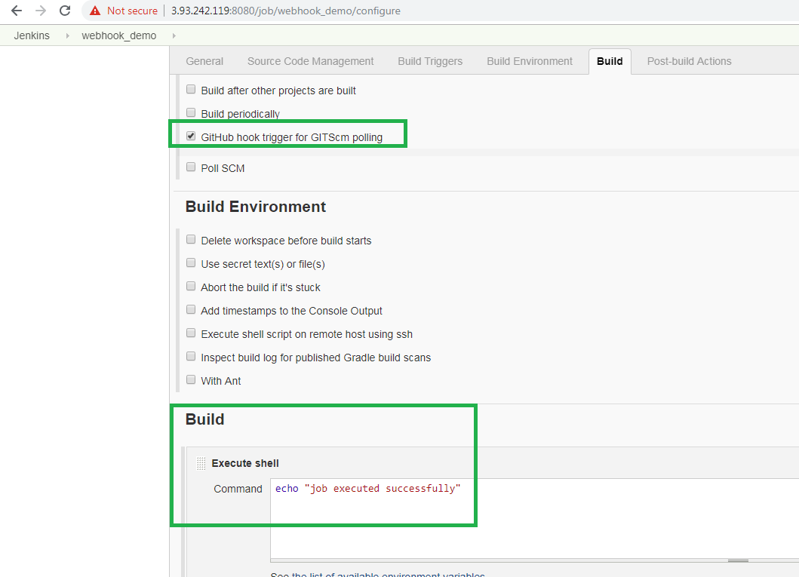

Save the configuration

Now, change the gothub repo file . Once you modify the file, build will trigger automatically on jenkins.