 Cognizone
COGNIZONE / SPEC
Test Document: All Formatting Features
Second title line
Cover summary paragraph.
ID | TEST-001
TYPE | spec
STATUS | draft
VERSION | 1.2
DATE | 2026-03-12
AUTHOR | Cognizone
CLIENT | ERA — European Union Agency for Railways
PROJECT | REG+
Cognizone BV · Avenue Arnaud Fraiteur 15-23, 1050 Ixelles, Belgium · BE 0634.615.174
2026-03-12 · Confidential

CONTENTS
CHAPTER 01 Status –
CHAPTER 02 Simple Paragraphs –
CHAPTER 03 Code Blocks –
CHAPTER 04 Tables –
4.1 Simple Table –
4.2 Table With Inline Formatting –
CHAPTER 05 Lists –
5.1 Unordered List –
5.2 Ordered List –
5.3 Mixed Nesting –
CHAPTER 06 Blockquotes –
CHAPTER 07 Images –
CHAPTER 08 Mermaid Diagrams –
8.1 Flowchart –
8.2 Sequence Diagram –
8.3 Sized Diagram –
CHAPTER 09 Horizontal Rules –
CHAPTER 10 Headings Hierarchy –
10.1 Third-Level Heading H3 –
10.1.1 Fourth-Level Heading H4 –
10.2 Another H3 –
CHAPTER 11 Edge Cases –
11.1 Empty Table Cells –
11.2 Long Content –
11.3 Adjacent Lists –
11.4 Special Characters –
CHAPTER 12 Summary –

CHAPTER 01

Status
Draft — created to verify all rendering features across PDF and DOCX output.
CHAPTER 02

Simple Paragraphs
This is a regular paragraph with bold text, italic text, and bold italic text combined. It also includes inline code and a hyperlink to verify inline formatting.
Here is a second paragraph to verify spacing between paragraphs. It contains a LongCodeSpanThatMightBeInteresting to test inline code styling.
CHAPTER 03

Code Blocks
Fenced code block with a language tag:
function greet(name) {
const message = `Hello, ${name}!`;
console.log(message);
return message;
}

// Call it
greet('Cognizone');

Fenced code block without a language:
No language specified here.
Just plain preformatted text.
With some indentation.

Code with angle brackets and ampersands (must not be dropped as HTML):
PREFIX eurio: <http://data.europa.eu/s66#>
SELECT ?s WHERE { ?s a <http://ex/#Thing> . FILTER(?a > 1 && ?b < 2) }

Inline code with brackets: <html> & a < b.
CHAPTER 04

Tables

4.1 Simple Table
Column A | Column B | Column C
Row 1 A | Row 1 B | Row 1 C
Row 2 A | Row 2 B | Row 2 C
Row 3 A | Row 3 B | Row 3 C
Row 4 A | Row 4 B | Row 4 C
Row 5 A | Row 5 B | Row 5 C

4.2 Table With Inline Formatting
Feature | Status | Notes
Bold header | done | Uses italic note
Links | done | See cogni.zone
Mixed | pending | Has bold, italic, and code

CHAPTER 05

Lists

5.1 Unordered List
- First item
- Second item with bold
- Third item with code
  - Nested item one
  - Nested item two
    - Deeply nested item
- Fourth item

5.2 Ordered List
- First step
- Second step with emphasis
- Third step
  - Sub-step A
  - Sub-step B
    - Sub-sub-step
- Fourth step

5.3 Mixed Nesting
- Unordered parent
  - Ordered child one
  - Ordered child two
- Another unordered
  - Bullet child
    - Ordered grandchild
CHAPTER 06

Blockquotes
This is a simple blockquote to verify italic styling and the green left border.

Multi-line blockquote that spans more than one line to verify that longer
content wraps properly and maintains consistent styling throughout.

Sources:
- Quoted list item one
- Quoted list item two

CHAPTER 07

Images
An inline image reference:

Resized via HTML tag (100x21):
CHAPTER 08

Mermaid Diagrams

8.1 Flowchart
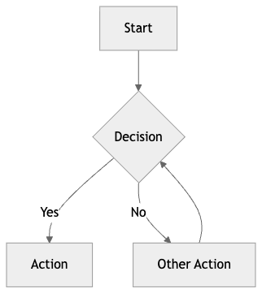

8.2 Sequence Diagram
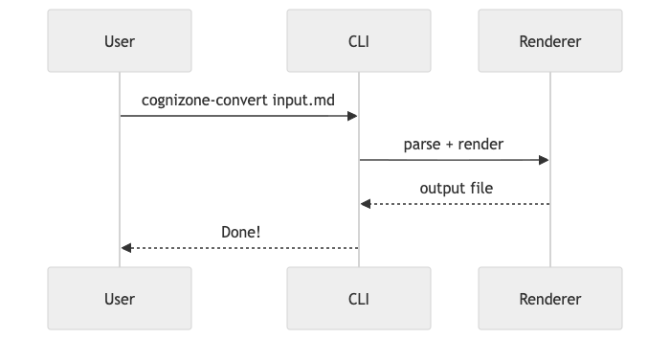

8.3 Sized Diagram
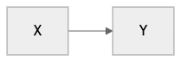
CHAPTER 09

Horizontal Rules
Content above the rule.

Content below the rule.
CHAPTER 10

Headings Hierarchy

10.1 Third-Level Heading (H3)
Content under H3 to verify green color and section numbering.

10.1.1 Fourth-Level Heading (H4)
Content under H4 to verify dark2 color and deeper numbering (e.g. 7.1.1).

10.2 Another H3
Back to H3 to verify counter resets properly.
CHAPTER 11

Edge Cases

11.1 Empty Table Cells
Has Content | Empty | Also Empty
Yes
 | Yes

11.2 Long Content
This paragraph contains a very long inline code span: this-is-a-really-long-code-span-that-might-cause-wrapping-issues-in-both-pdf-and-docx-output-formats to verify how both renderers handle overflow.

11.3 Adjacent Lists
First list:
- Alpha
- Beta
Second list immediately after:
- Gamma
- Delta

11.4 Special Characters
Ampersand & angle brackets < > and quotes "double" 'single' plus an em dash — and ellipsis... should all render correctly.
CHAPTER 12

Summary
This document exercises:
- All heading levels (H2, H3, H4)
- Section numbering
- Paragraphs with inline formatting (bold, italic, bold+italic, code, links)
- Fenced code blocks (with and without language)
- Tables (simple, with formatting, with empty cells)
- Lists (ordered, unordered, nested, mixed)
- Blockquotes
- Horizontal rules
- Special characters
- Cover page with all frontmatter fields
- Table of contents generation
- Headers and footers

