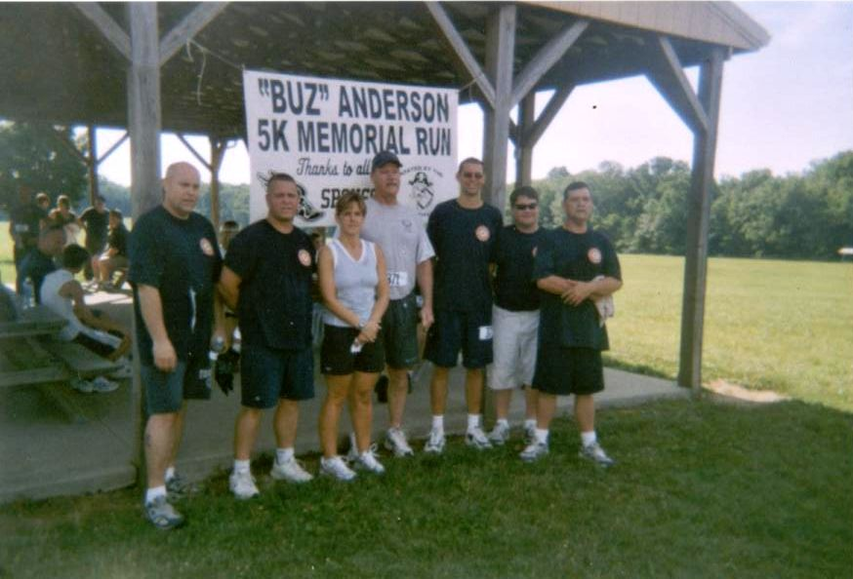
The Al “Buz” Anderson

Black River
2016
Fullbackers
Fallen Fullbackers Memorial
5K RUN
1 Mile Run/Walk
Firestone Park
Spencer, Ohio

Information
Date: Saturday, June 25, 2016
Time: 8:30am
Entry Fee: $16 pre-registration, $20 day of race
Pre-registration accepted until June 18, 2016
Registration: 7:30 day of race at Firestone Park

Firestone Park Route 301 South through Spencer .5miles

In consideration of accepting this entry, I hereby for myself, heirs, executors and administrators, waive and release any and all rights and claims for damages I may have against the Village and Township of Spencer, the Fullbackers Club, and the Black River Local Schools, their representatives and successors and assigns for any and all injuries suffered by me in this event. I further attest and certify that I am physically fit and am sufficiently trained for the competition in this event.

Signature

Parent or Guardian Signature (If under 18)

_________________________________________________________
Awards
1 Mile Walk: 1st and 2nd male and female finishers.
5K: 1st, 2nd, and 3rd male and female finishers in each age division.
14 & under, 15-19, 20-24, 25-29, 30-34, 35-39, 40-44,
45-49, 50-54, 55-59, 60-64, 65+

*Send Check or Money Order and Registration to:

Black River Fullbackers
PO Box 202
Spencer, OH 44275

Name: ______________________________ Age: _________

Street Address: __________________________________________

City, State, Zip: __________________________________________

Phone: __________________________________________________

Shirt Size: Small Medium Large XL (Circle One)

Male: _____ Female: _____

I am competing in the: 5k run _____ 1 mile walk _____

