**The Al “Buz” Anderson** 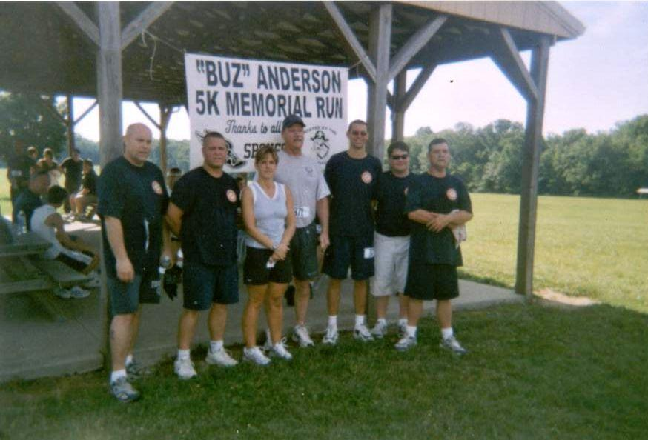

**Fallen Fullbackers Memorial**

**5K RUN**

**1 Mile Run/Walk**

**Firestone Park**

**Spencer, Ohio**

**Information**

Date: Saturday, June 30, 2018

Time: 8:30am

Entry Fee: $16 pre-registration, $20 day of race

Pre-registration accepted until June 24, 2018

Registration: 7:30 day of race at Firestone Park

**Firestone Park Route 301 South through Spencer .5miles**

**In consideration of accepting this entry, I hereby for myself, heirs, executors and administrators, waive and release any and all rights and claims for damages I may have against the Village and Township of Spencer, the Fullbackers Club, and the Black River Local Schools, their representatives and successors and assigns for any and all injuries suffered by me in this event. I further attest and certify that I am physically fit and am sufficiently trained for the competition in this event.**

**Signature**

**Parent or Guardian Signature (If under 18)**

_________________________________________________________

**Awards**

**1 Mile Walk:** 1st and 2nd male and female finishers.

**5K:** 1st, 2nd, and 3rd male and female finishers in each age division.

14 & under, 15-19, 20-24, 25-29, 30-34, 35-39, 40-44,

45-49, 50-54, 55-59, 60-64, 65+

*Send Check or Money Order and Registration to:

**Black River Fullbackers**

**PO Box 202**

**Spencer, OH 44275**

**Name: ______________________________ Age: _________**

**Street Address: __________________________________________**

**City, State, Zip: __________________________________________**

**Phone: __________________________________________________**

**Shirt Size: Small Medium Large XL (Circle One)**

**Male: _____ Female: _____**

**I am competing in the: 5k run _____ 1 mile walk _____**