**Supplementary Information for**

**Qualitative translation of relations from BioPAX to SBML qual**

Finja Büchel1, Clemens Wrzodek1, Florian Mittag1, Andreas Dräger1, Johannes Eichner1,

Nicolas Rodriguez2, Nicolas Le Novère2, and Andreas Zell1

1 Center for Bioinformatics Tuebingen (ZBIT), University of Tuebingen, Tübingen, Germany

2 Computational Systems Neurobiology Group, European Bioinformatics Institute, Hinxton,United Kingdom

**Detailed description of the conversion of the BioPAX Control element**

A Control element consists of zero or more Controller elements and of zero or one Controlled elements. Depending on these enclosed elements a Control element can be translated into a SBML transition or reaction.

If the Controller or the Controlled element is a Pathway element, the Interaction is always converted to a transition, because it is biologically not possible to create a reaction with a whole pathway as a reactant or product. A Control entity is translated into a transition if the Controlled element is translated into a transition, too. For instance, the conversion of a Modulation, consisting of a PhysicalEntity as Controller and a BiochemicalReaction as Controlled, is translated into a reaction. An example is shown in Figure S1, which shows the ceramide signaling pathway, where the biochemical reaction from sphingomyelin to ceramide (the Controlled element) is positively modulated from SMPD1+ (the Controller). This modulation will be converted into a reaction where SMPD1+ is modeled as an enzyme of the reaction. But if the Controlled element is a GeneticInteraction, the Modulation is converted into a transition. A detailed overview of the conversion of the Control elements is shown in Table 2. The sign attribute of the input element describes the relationship between input and output and is determined depending on the ControlType attribute. This attribute is assigned to nearly all Control elements. If the ControlType is activating, sign is set to *active*; if it is inhibiting sign is set to *negative*; if it is both, sign is set to *dual*; otherwise sign is set to *unknown*.

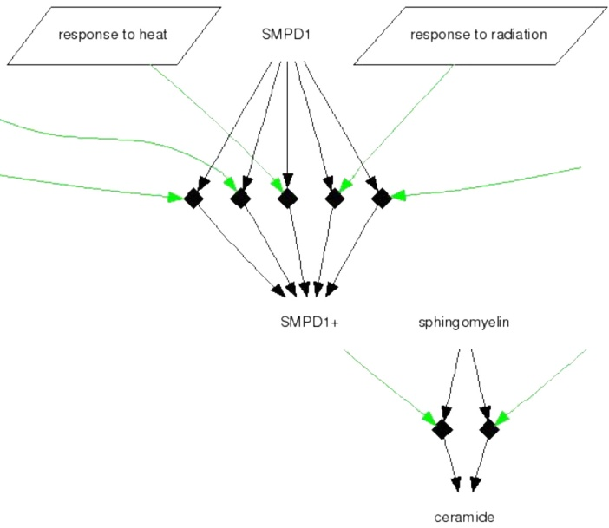

Fig. S1. Part of the ceramide signaling pathway imported from BioCarta into the Pathway Interaction Database (PID). Modifications are drawn with black diamonds. The entities with a black arrow to the diamond describe the modulation inputs and the entities with an black arrow out of the diamond the modulation output. The green arrows symbolize positive regulators and the round rectangles complexes. Pathways are visualized with a trapezium. The ceramide signaling pathway is one pathway example for providing information which could not be translated to SBML before the creation of the Qualitative Models extension (qual). With qual, it is possible to translate reactions and relations, and to include them in one model. Even pathway-reaction modulations, like the ‘response to heat’ pathway that positively stimulates the reaction from SMPD1 to SMPD1+, can be described. (Figure by courtesy of the National Cancer Institute – http://www.cancer.gov).