Task Instructions & Answer Key
BEJohn
15may09

The prose and pictures from the Task Instructions follows, with the CogTool elements after each instruction in highlighted Helvetica font.

For all tasks, assume:
- The hand starts on the mouse
This means that at the start of every demonstration, the hand needs to be set to the mouse instead of the keyboard. Your scripts should never include a Home to Mouse in the beginning of the task.
- The roommates are going to follow the link to see the page, so it doesn’t matter if the link is just a URL or a page title.
This means that you should not do anything to make the communications precisely alike. It’s OK that the Google Notebook has the page title as well as the link.
- All screens load immediately unless otherwise noted.
This means that there should be no “wait” on any transitions except the ones specifically mentioned below.
- The start screen is the Craigslist listing of the couch she wants to share (we have put this image as the first image of each of the folders).
This means that the start screen for each script should be the Craigslist screen.
- Any necessary sharing has already been set up (i.e., Gmail group, Google Notebook sharing, Wetpaint permissions), so all we are modeling here is how long it takes to share a single link with a comment.
This means that there should be no script steps that set up sharing. The scripts should be only the steps in the instructions below.

Table of Contents:
Page 2: Use Google Notebook share a link and a comment.
Page 7: Use GMail to share a link and a comment.
Page 18: Use Wetpaint wiki to share a link and a comment.

Use Google Notebook share a link and a comment.
Start at the following screen, file name: GoogleNotebook_01.JPG

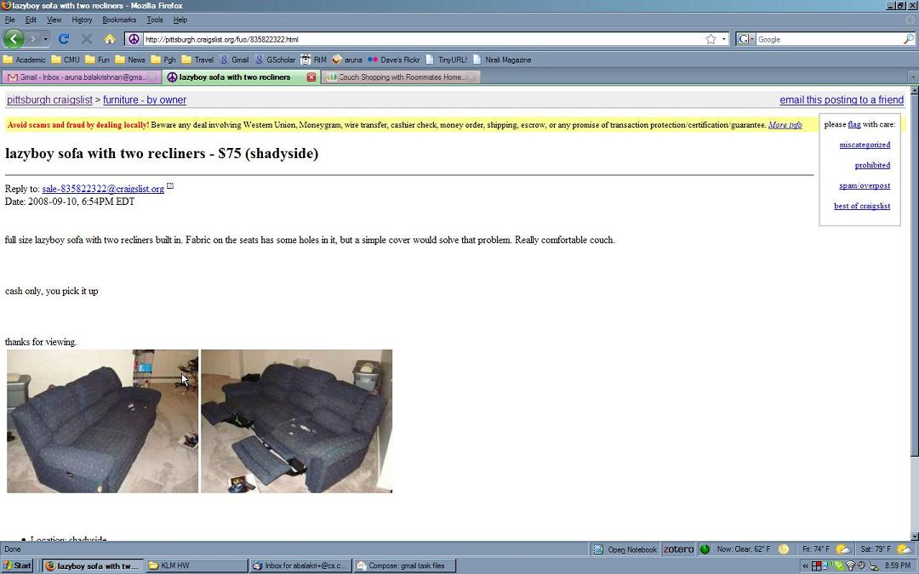

Highlight the title of this post, “lazyboy sofa with two recliners - $75 (shadyside)” by triple-clicking anywhere in that title.

In the Google Notebook design, there is a frame GoogleNotebook_01, with one widget in it
- A Text widget on top of the title “lazyboy sofa with two recliners - $75 (shadyside)”.
This is a text widget, as opposed to a Text Box widget, because the user is going to highlight the text. See the section “Working with Textboxes and Text” for more suggestions on other ways to model highlighting.
The transitions associated with this frame are:
- A left triple-click transition to GoogleNotebook_02.

File name: GoogleNotebook_02.JPG

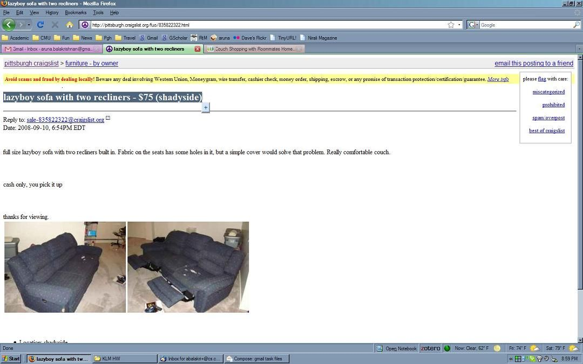

Click on the plus sign that appears to the right of the highlighted title.

In the Google Notebook design, there is a frame GoogleNotebook_02, with one widget in it
- A Button widget the size of the plus-sign button that appears when the title is highlighted.

The transition associated with this frame is:
- A left-click transition from the plus sign Button widget to GoogleNotebook_03.

File name: GoogleNotebook_03.JPG

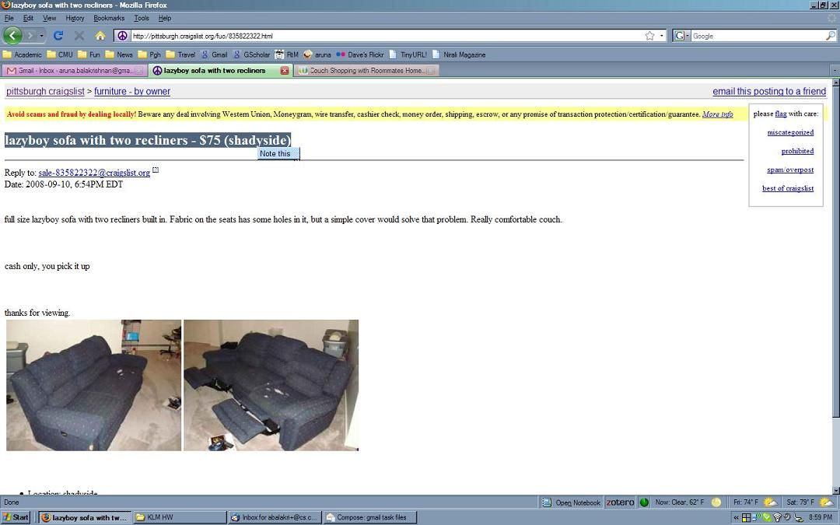

Click on the “Note this” that appears in place of the plus sign.
After 1.25 seconds, the Google Notebook appears at the bottom right of the screen.

In the Google Notebook design, there is a frame GoogleNotebook_03, with one widget in it
- A Button widget the size of the “Note this” button that appears when plus sign button is clicked.

The transition associated with this frame is:
- A left-click transition on the Note This Button widget to GoogleNotebook_04m, with a 1.25 second system wait.

File name: GoogleNotebook_04.JPG

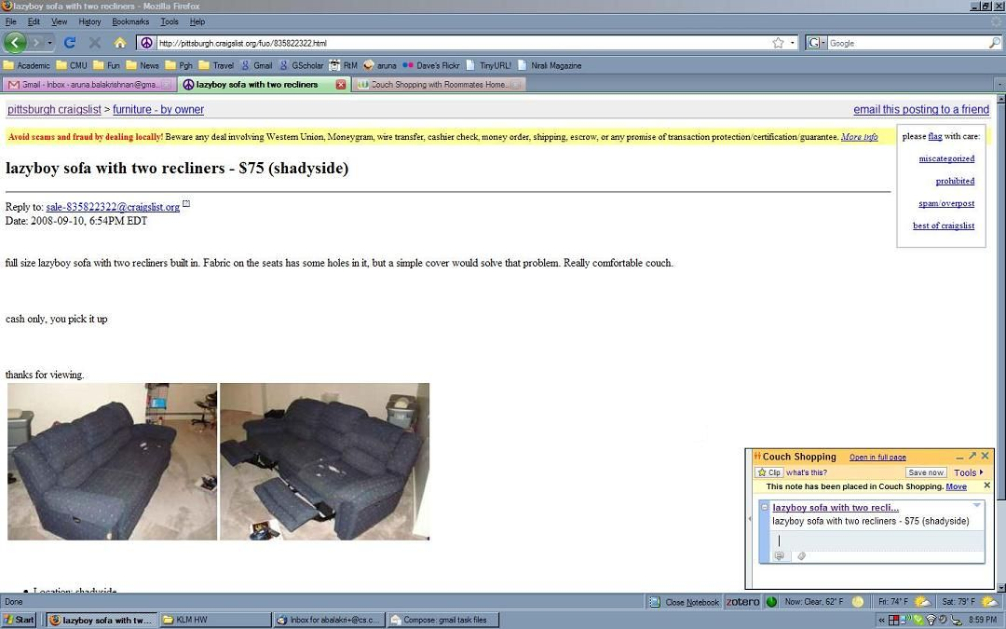
The cursor is already in the comment field below the link.
Type “I like the color and price.”
Click on “Save now”

In the Google Notebook design, there is a frame GoogleNotebook_04, with one widget in it
- A Button widget the size of the “Save now” button.

The transitions associated with this frame are:
- A typing self-transition from the keyboard: I like the color and price.
“I like the color and price.” is the message to the roommates, not a command, so the Command checkbox in the transition properties should not be checked.
- A left-click transition from the Save now Button widget to GoogleNotebook_05.

File name: GoogleNotebook_05.JPG

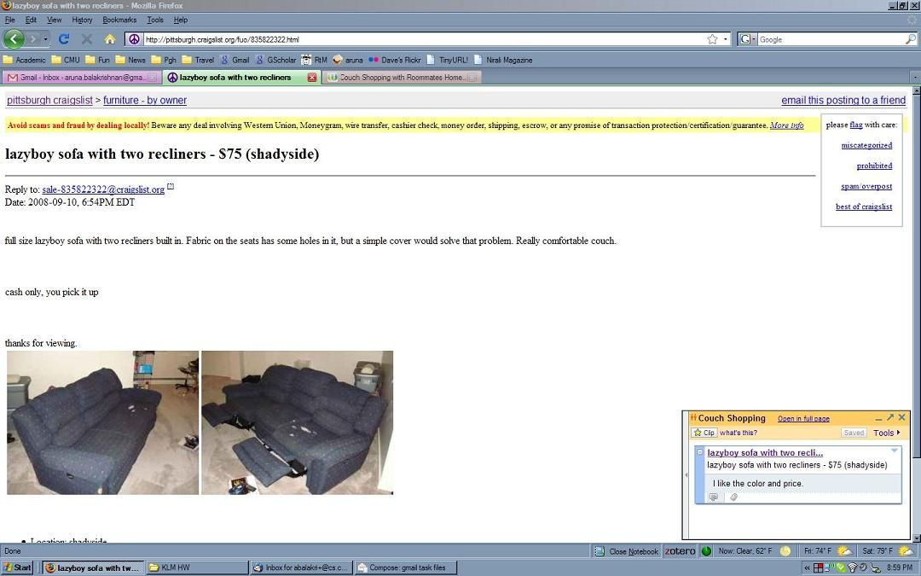

Look at “Saved”, which has changed from “Save now” which indicates that the link and comment have been saved.

In the Google Notebook design, there is a frame GoogleNotebook_05, with one widget in it
- A Non-interactive widget the size of the “Save now” button.
The Non-interactive widget is the best choice for this widget because you can’t interact with it in this frame. We also accepted this being a Button widget because it still looks like a button and this choice does not change the predicted time.

There are no transitions associated with this frame. It is the end of the task.

This is the end of the task using Google Notebook.

Use Gmail to share a link and a comment.
Start at the following screen, file name: Gmail_01.JPG

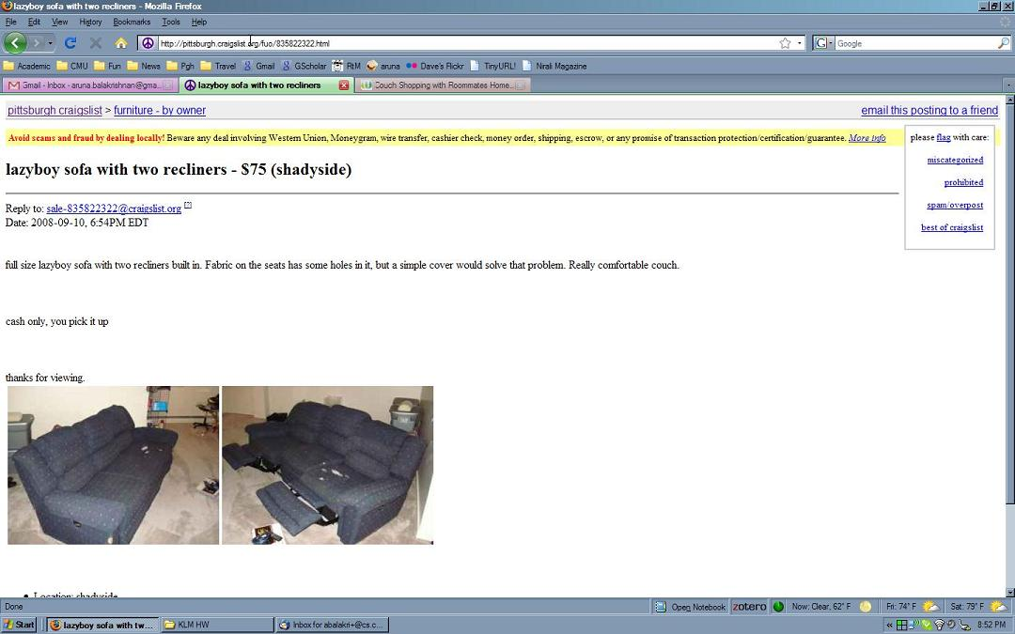

Click on the URL to highlight it.
Type Ctrl-C, to copy the highlighted URL.
Click on the Gmail tab to switch to Gmail.
After 0.5 seconds, the next page appears on the screen.

In the Gmail design, there is a frame Gmail_01, with two widgets in it
- A Text widget the size of the URL field. It is a Text widget because the user’s intention is to copy the text and the CogTool User Guide says to use a Text widget “… for any text that can be selected and copied, deleted, pasted over, or typed over. It can be the text in a text box, the text someone is editing in a word processor, text on the web you want to copy, etc.” Since the user is selecting the text to copy it, the Text widget is used instead of the Text Box widget.
  - It is important to use the correct widget because Text and Text Box widgets produce different predictions (see the Appendix on where CogTool places Think operators to see the difference.)
  - This widget is the size of the entire URL field because a user can click anywhere in the field and have the URL highlight in the browser in the image. Remember in lecture I told you that the quickest way to lose credibility with a development team is to not know how the application actually works, so it is most correct to make the widget the size of the field instead of only the URL.
- A Button widget the size of the Gmail tab except for the area covered by the close box. It is a Button widget because the CogTool User Guide says to use a Button widget for “…tabs in Firefox (two of which are shown)”. It is the size of the Gmail tab EXCEPT for the area covered by the close box because if a use clicks in the close box, it closes the tab instead of going to Gmail.
The transitions associated with this frame are:
- A left-click self transition from the Text widget.
- A typing self-transition from the keyboard: ctrl-c.
Although it is possible to make the transition from the URL field Text widget, it makes more sense to make the transition go from the keyboard because users type with their hands on the keyboard, not on the screen where the widget is.
- A left-click transition to Gmail_02 from the Gmail tab Button widget, with 0.5 seconds wait time on it.
File name: Gmail_02.JPG

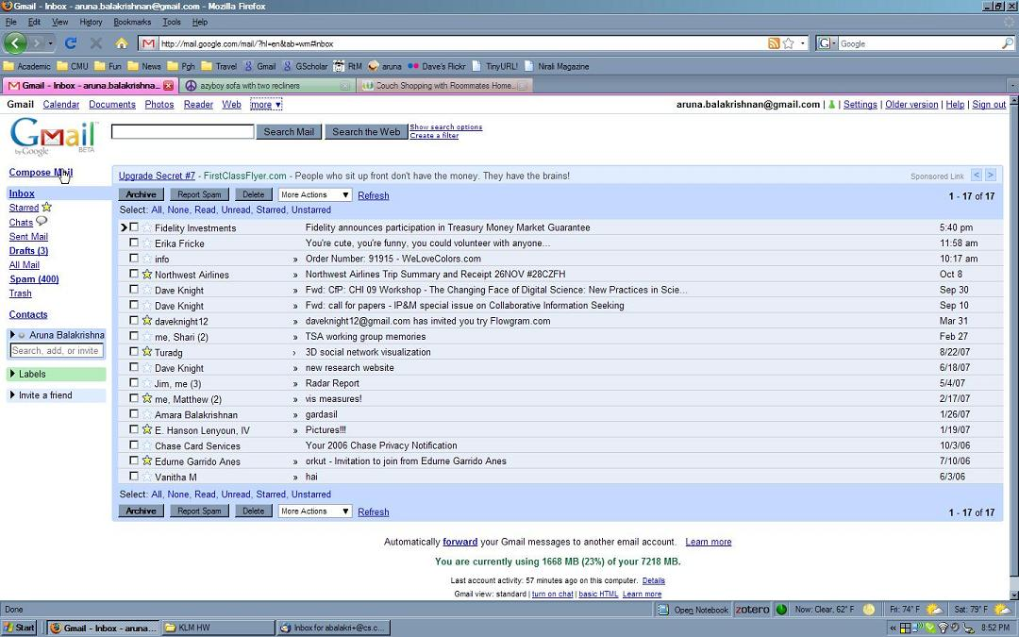

Click on Compose Mail.

In the Gmail design, there is a frame Gmail_02, with one widget in it
- A Link widget the size of the Compose Mail link.

The transitions associated with this frame are:
- A left-click transition from the Compose Mail Link widget to Gmail_03.
File name: Gmail_03.JPG

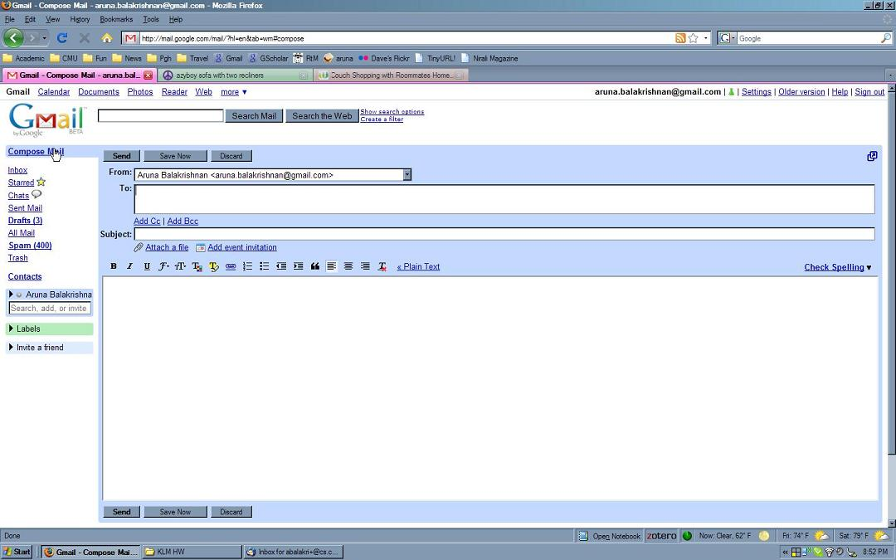

The cursor is already blinking in the To: field.

This means that you cannot have a step that clicks in the To: field in your demonstration and still be modeling the procedure we instructed you to model. Of course a user could click on the filed and still do the task correctly, but this would be a different demonstration than we asked you to model.

Type “roo” to get the Roommates group to appear (see next image).
NOTE: When the “r” is typed, a list of contacts starting with “r” appears.
When the first “o” is typed, a list of contacts starting with “ro” appears.
When the second “o” is typed, the list of contacts starting with “roo” appears; it contains only “Roomates (group)”, as seen in the next image.
This NOTE was just to explain to people who had never seen an auto-completion interface work, the list items that would appear and disappear as the user typed “roo”. There was no need for you to create new frames or have intermediate typing transitions (e.g., type “r”; type “o”; type “o”).

In the Gmail design, there is a frame Gmail_04, with no widgets in it
The transition associated with this frame is:
- A typing transition from the keyboard to Gmail_05: “roo”. Since “roo” is part of the “roommates” group address it is not a command, so the command checkbox on this transition cannot be checked.
File name: Gmail_04.JPG

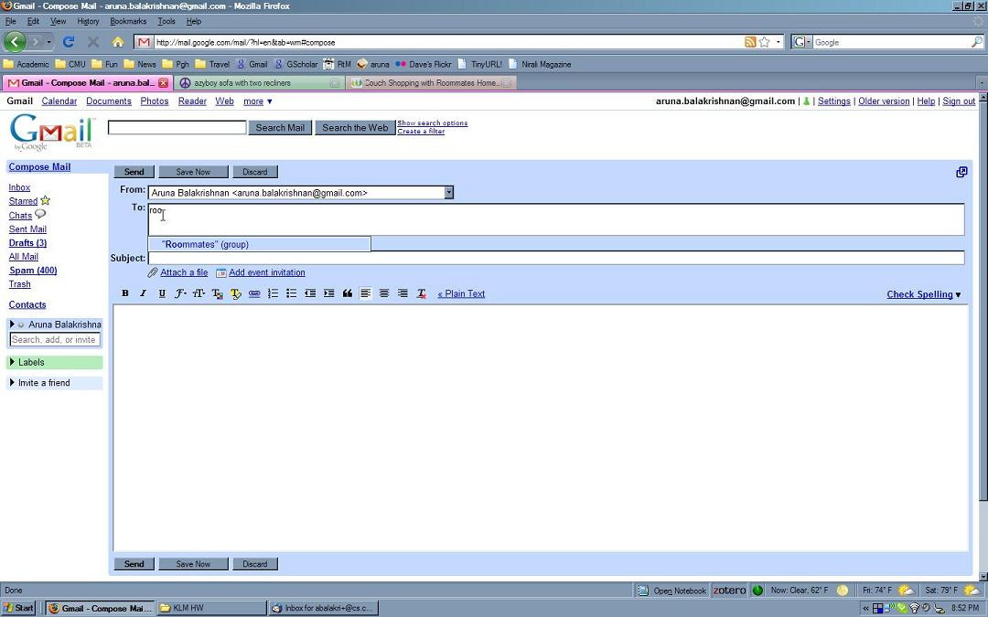

Click on the “Roommates”(group).

In the Gmail design, there is a frame Gmail_04, with one widget in it
A List Box Item widget the size of the “Roommates” (group) entire box.
It is the size of the entire box, because you can click in any part of the box to select the Roommates (group).
a. A List Box Item widget is appropriate because that is the closest widget, given the types of widgets CogTool provides. See Appendix B.
b. A List Box Item widget is used “when there is a visible list of items, from which one or more can be selected, that does not have to be pulled down or popped up.” The advice probably should say “does not have to be pulled down or popped up with a mouse click” (and I will change it in the manual). This list came up through typing, so it fits in the definition.
Another type you might have considered is some type of Pull-Down List Widget but I don’t think that is as good a choice because the operation of a Pull-down list logically requires two clicks – one to pull down the list (on a Pull-down list header widget) and one to select the new item (a Pull-down list item widget). It is odd to call the “Roommates (group)” thing the Pull-down list header and then click on it because it is already in the header position. So odd, in fact, that CogTool will not let you transition from a standard Pull-down List header widget to another frame. So you would have to use a Custom Pull-down List Header widget. You can’t call it a Pull-down list item widget because you can’t get to a Pull-down list item until its header is clicked (and there it no header). So in my opinion this choice poses more problems making a sensible model than the List Box Item Widget.
A third type of widget that may be possible is the context menu. Appendix B says a context menu should be used “for a menu that is accessible by right-click (PC) or CTRL-click (Mac).” This interaction doesn’t have any clicking involved for bringing up the list, so I don’t think this is an appropriate widget.
If you read the Appendix about where Think operators are placed, or tried out these different widgets, you would find that the List box item widget and the pull-down list header or list item widgets do not get Think operators in front of them “because these widgets typically select arguments, not commands”. Just as you should have reasoned that “roo” was not a command, you should have been drawn to widgets that CogTool thinks pick arguments. But a context menu item does get a Think operator, “because, although the target may be either a command or an argument, the act of bringing up a context menu signals the intention to invoke command”. This statement should have warned you against using a context menu (as well as the fact that you have to click on it according to the widget-choice table in Appendix B). So it does matter which widget you pick for the accuracy of your predictions.
- The transitions associated with this frame are:
- A left-click transition from the List Box Item widget to Gmail_05.

File name: Gmail_05.JPG

NOTE: we have Xed out the roommates’ email addresses.
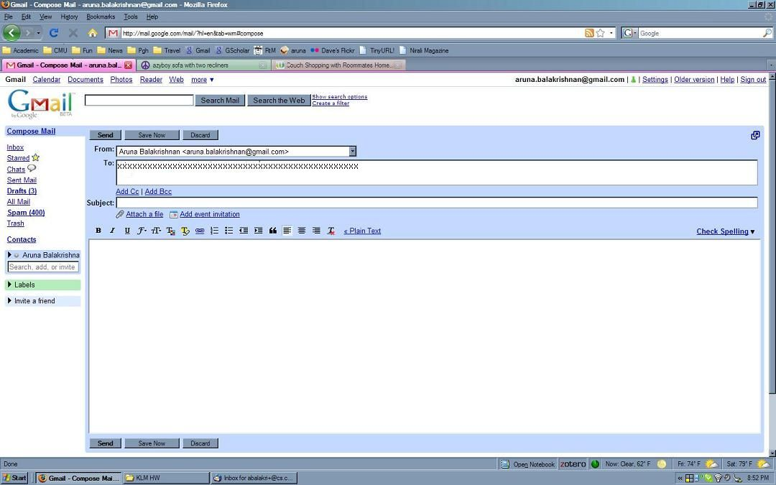
Click in the Subject: field.
Type “couch I found”
Click in the main message area to put the cursor in that area.

In the Gmail design, there is a frame Gmail_05, with two widgets in it
- A Text Box widget the size of the Subject field.
This is a Text Box widget because in the “Working with Textboxes and Text Widgets” section of the User Guide it says “If your prototype will only need to mock-up … clicking and typing into an empty box, then a Text Box Widget is all you need.” (It also goes on to explain the reasons why.) Clicking and typing into an empty box is all you need to do in the Subject field, so a Text Box widget is what you need.
a. This is not a text widget, because you are not editing this text than to enter some into an empty box. Text widgets are only for more complex editing (e.g., highlighting, copying, inserting, etc.)
b. The widget must be the size of the whole field because you can click on any part of the field to put the cursor in it.
- A Text Box widget the size of the message area.
Again, in this frame, all you need to do is click on it to set the cursor position (and even in the next frame, all you need to do is type into the empty box), so it should be a Text Box widget.
It must be the size of the whole message area because you can click on any part of the message area to put the cursor at the top left of it.
The transitions associated with this frame are:
- A left-click self-transition from the Subject Text Box widget.
- A typing self-transition from the keyboard: couch I found.
Since “couch I found” is not a command, the command checkbox should not be checked on this transition.
Although it is possible to make the transition from the Subject Text Box widget, it makes more sense to make the transition go from the keyboard because users type with their hands on the keyboard, not on the screen where the widget is.
- A left-click transition to Gmail_06 from the Message Text Box widget.

File name: Gmail_06.JPG

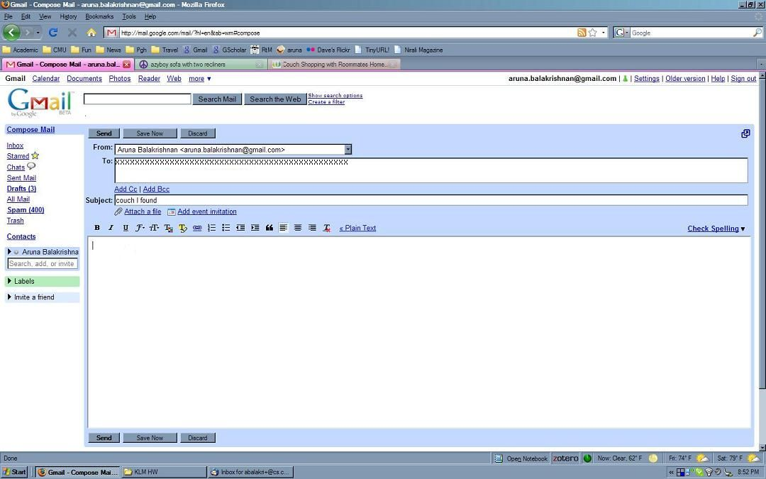

Type CNTRL-v to paste the link.
Type ENTER to move to the next line.
Type “I like the color and price.” to add the comment.

In the Gmail design, there is a frame Gmail_06, with no widgets in it
The transition associated with this frame is:
- A typing transition from the keyboard to Gmail_07: †v¶I like the color and price.
CogTool figures out which of these are commands and which aren’t automatically, so the command checkbox on this transition need not be checked.
The easiest way to do this is just to put all of these characters in one keyboard transition, but it is just as correct to make it three transitions: two self-transitions for †v and ¶ and a transition to the next frame with “I like the color and price.”

File name: Gmail_07.JPG

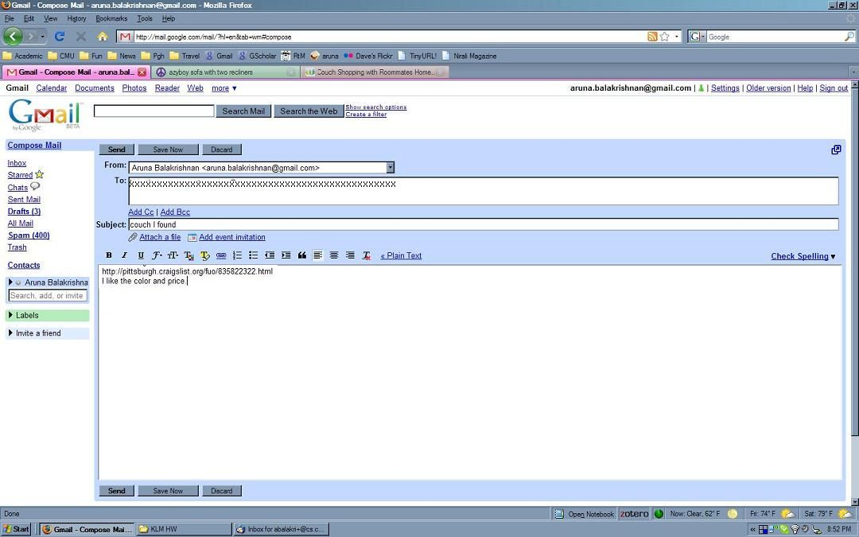

Click on SEND to send the email.
After 1.25 seconds, the next screen appears.

In the Gmail design, there is a frame Gmail_07, with one widget in it
- A Button widget the size of the Send button.
The transitions associated with this frame are:
- A left-click transition from the Send Button widget to Gmail_08, with a system wait time of 1.25 seconds.

File name: Gmail_08.JPG

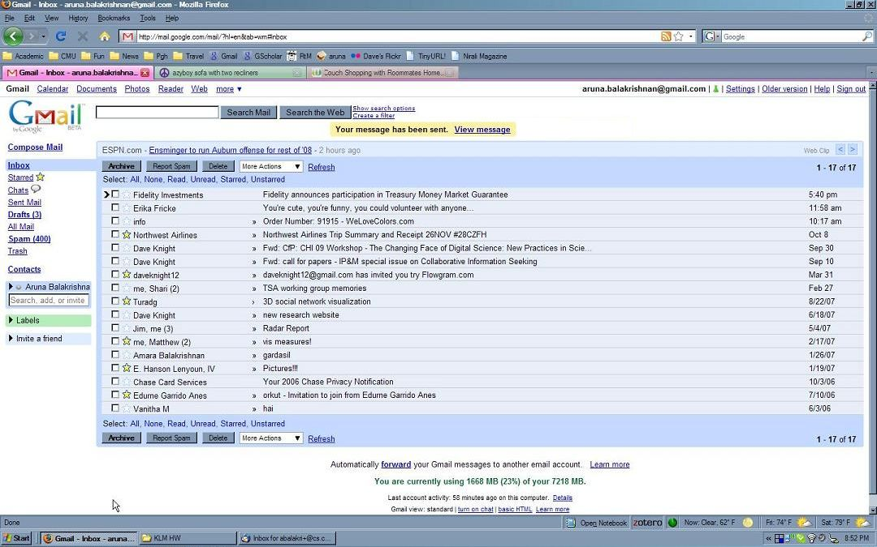

Look at the yellow confirmation message to make sure the email was sent.

In the Gmail design, there is a frame Gmail_08, with one widget in it
- A Non-Interactive widget the size of “Your message has been sent.” (We are also accepting a non-interactive or link widget the size of “Your message has been sent. View message”.)
There are no transitions associated with this frame.

This is the end of the task using Gmail.

Use Wetpaint to share a link and a comment.
Start at the following screen, file name: wetpaint_01.JPG

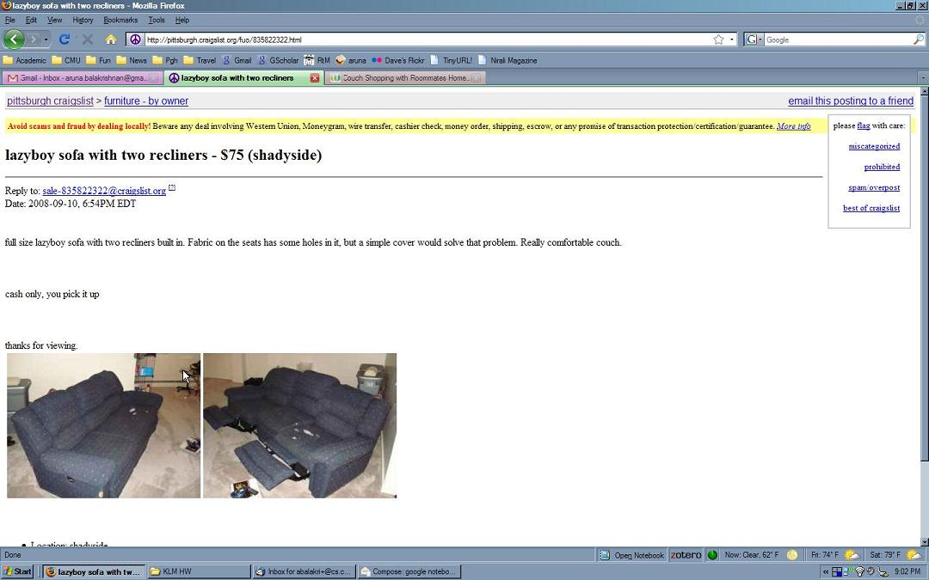

Click on the URL to highlight it.
Type Ctrl-C, to copy the highlighted URL.
Click on the “Couch Shopping with Roommates Home” tab to switch to Wetpaint.

In the Wetpaint design, there is a frame wetpaint_01, with two widgets in it
- A Text widget the size of the URL field. It is a Text widget because the user’s intention is to copy the text and the CogTool User Guide says to use a Text widget “… for any text that can be selected and copied, deleted, pasted over, or typed over. It can be the text in a text box, the text someone is editing in a word processor, text on the web you want to copy, etc.” Since the user is selecting the text to copy it, the Text widget is used instead of the Text Box widget.
It is important to use the correct widget because Text and Text Box widgets produce different predictions (see the Appendix on where CogTool places Think operators to see the difference.)
This widget is the size of the entire URL field because a user can click anywhere in the field and have the URL highlight in the browser in the image. Remember in lecture I told you that the quickest way to lose credibility with a development team is to not know how the application actually works, so it is most correct to make the widget the size of the field instead of only the URL.
- A Button widget the size of the Wetpaint tab except for the area covered by the close box. It is a Button widget because the CogTool User Guide says to use a Button widget for “…tabs in Firefox (two of which are shown)”. It is the size of the Wetpaint tab EXCEPT for the area covered by the close box because if a user clicks in the close box, it closes the tab instead of going to Wetpaint.

The transitions associated with this frame are:
- A left-click self transition from the Text widget.
- A typing self-transition from the keyboard: ctrl-c.
Although it is possible to make the transition from the URL field Text widget, it makes more sense to make the transition go from the keyboard because users type with their hands on the keyboard, not on the screen where the widget is.
- A left-click transition to wetpaint_02 from the Wetpaint tab Button widget (with no wait time on it because Wetpaint was faster to load than Gmail when we measured it).

File name: wetpaint_02.JPG

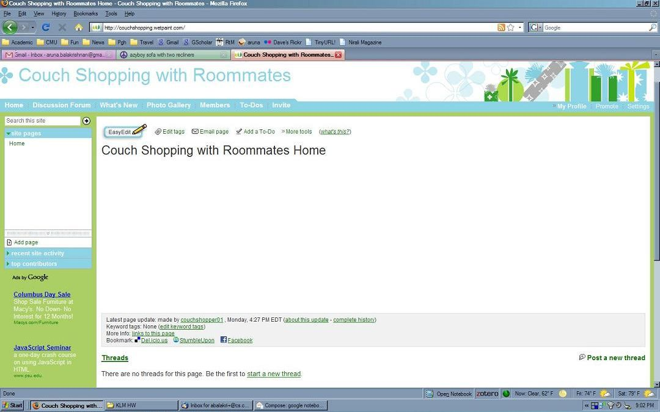

Click EasyEdit.
After 2.00 seconds, the editing page loads (see next image).

In the Wetpaint design, there is a frame wetpaint_02, with one widget in it
- A Button widget the size of the EasyEdit button.

The transitions associated with this frame are:
- A left-click transition from the EasyEdit Button widget to wetpaint_03, with a 2.00 second system wait.

File name: wetpaint_03.JPG

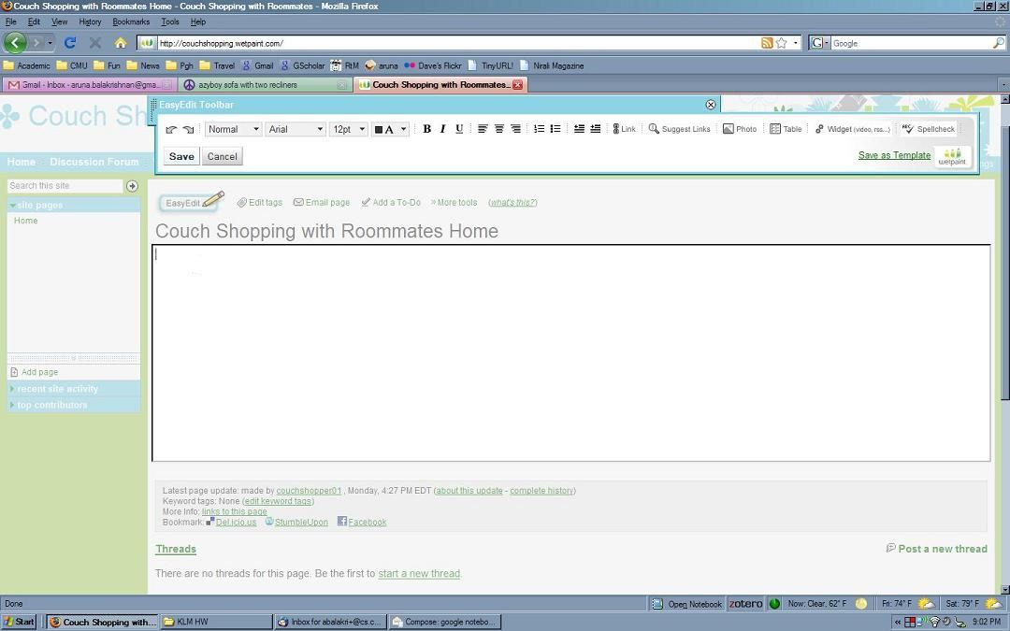

The cursor is already in the main editing area.
Type CNTRL-v to paste the link.

In the Wetpaint design, there is a frame wetpaint_03, with no widgets in it
The transition associated with this frame is:
- A typing transition from the keyboard to wetpaint_04: †v
CogTool figures out that this is a command, so the command checkbox on this transition need not be checked.
File name: wetpaint_04.JPG

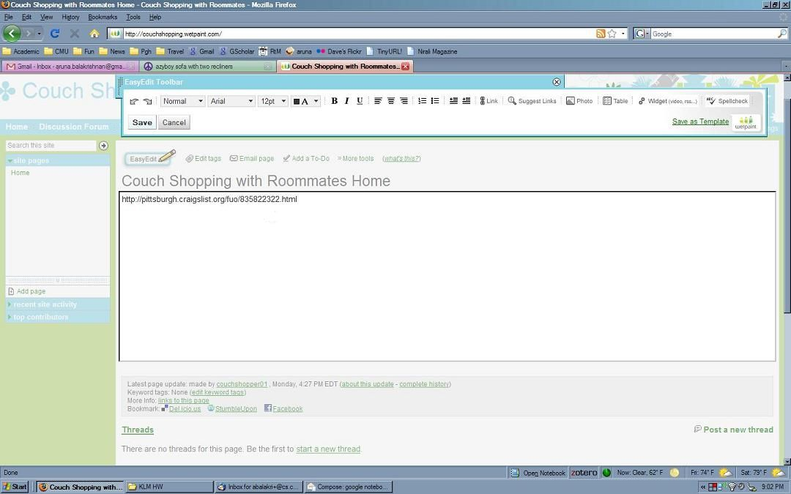

The link pasted in as text, not as a link. To change it to a link, do the following.
Double-click on the text of the link just pasted, to highlight the entire link.

In the Wetpaint design, there is a frame wetpaint_04, with one widget in it
- A Text widget the size of the URL. In Wetpaint, you have to click on the text itself, not in the blank space to the right of the text, so this widget has to be the size of the URL only.
It is a Text widget because the user’s intention is to highlight the text and the CogTool User Guide says to use a Text widget “… for any text that can be selected and copied, deleted, pasted over, or typed over. It can be the text in a text box, the text someone is editing in a word processor, text on the web you want to copy, etc.” Since the user is selecting the text to highlight it and change it into an active link (which can be considered a form of editing) the Text widget is used instead of the Text Box widget.

The transitions associated with this frame are:
- A left-double-click transition from the URL Text widget to wetpaint_05.

File name: wetpaint_05.JPG

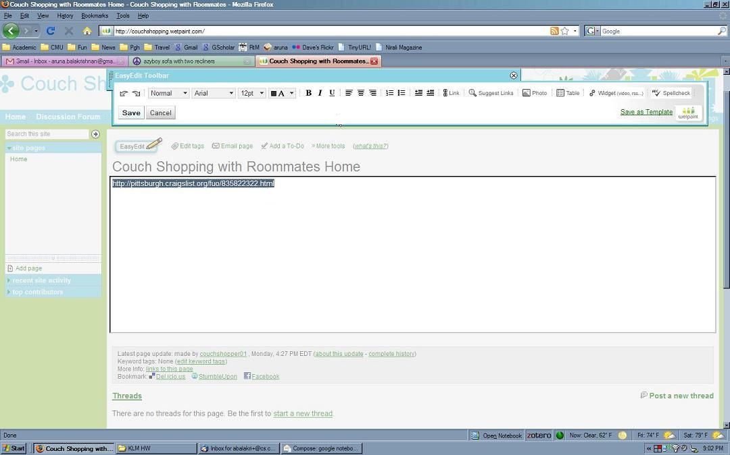

Click Link.

In the Wetpaint design, there is a frame wetpaint_05, with one widget in it
- A Button widget the size of the Link button.

The transitions associated with this frame are:
- A left-click transition from the Link Button widget to wetpaint_06.

File name: wetpaint_06.JPG

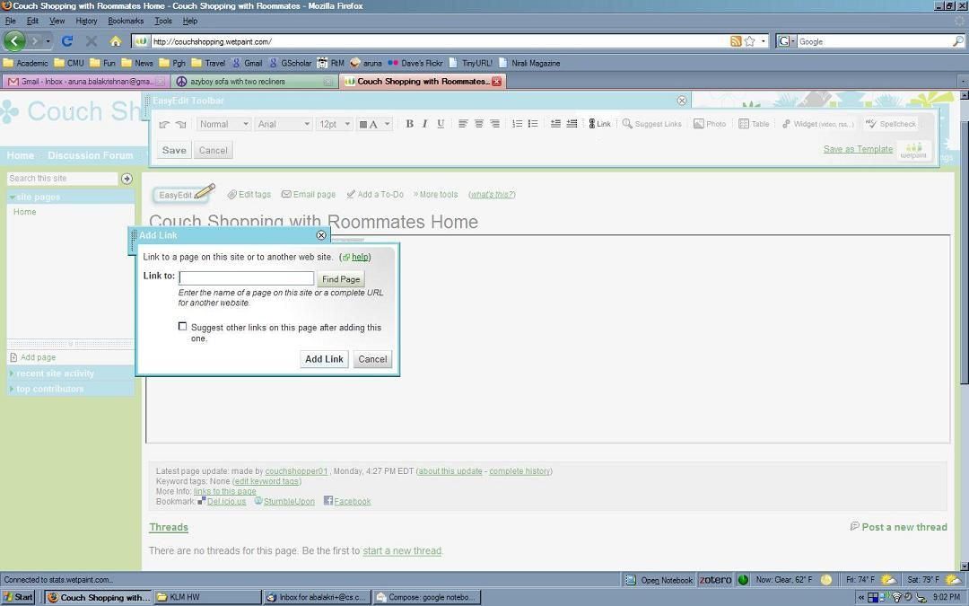

The cursor is already blinking in the Link to: field.
CNTRL-v to paste the link into the field.

In the Wetpaint design, there is a frame wetpaint_06, with no widgets in it
The transition associated with this frame is:
- A typing transition from the keyboard to wetpaint_07: †v
CogTool figures out that this is a command, so the command checkbox on this transition need not be checked.

File name: wetpaint_07.JPG

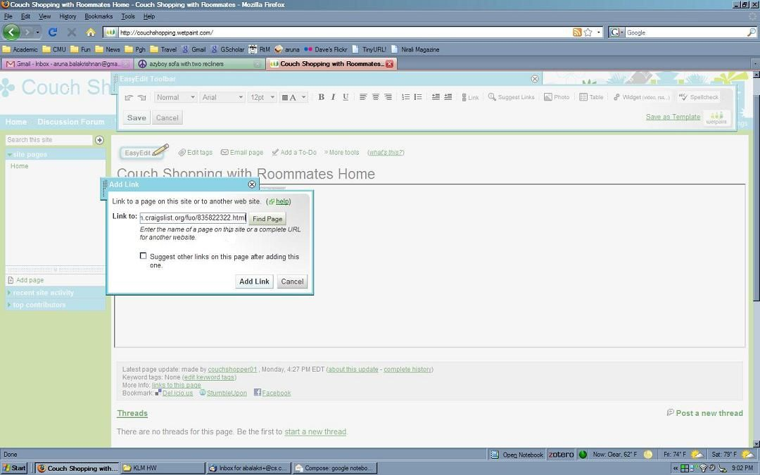

Click “Add Link”.

In the Wetpaint design, there is a frame wetpaint_07, with one widget in it
- A Button widget the size of the Add Link button.

The transitions associated with this frame are:
- A left-click transition from the Add Link Button widget to wetpaint_8.

File name: wetpaint_08.JPG

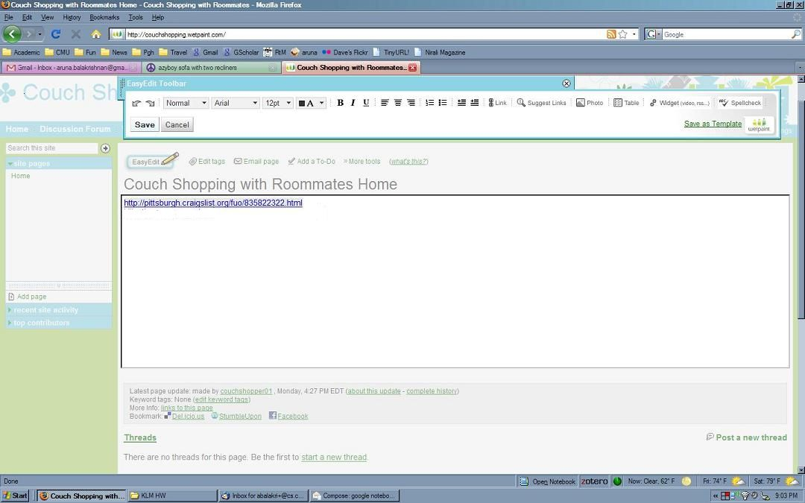

Type the right-arrow key to make the cursor move to the end of hyperlink.
Type ENTER to move the cursor to a new line.
Type “I like the color and price.” to add the comment.

In the Wetpaint design, there is a frame wetpaint_08, with no widgets in it.

The transitions associated with this frame are:
- A typing transition from the keyboard: →¶I like the color and price.
This transition goes to wetpaint_09.

File name: wetpaint_09.JPG

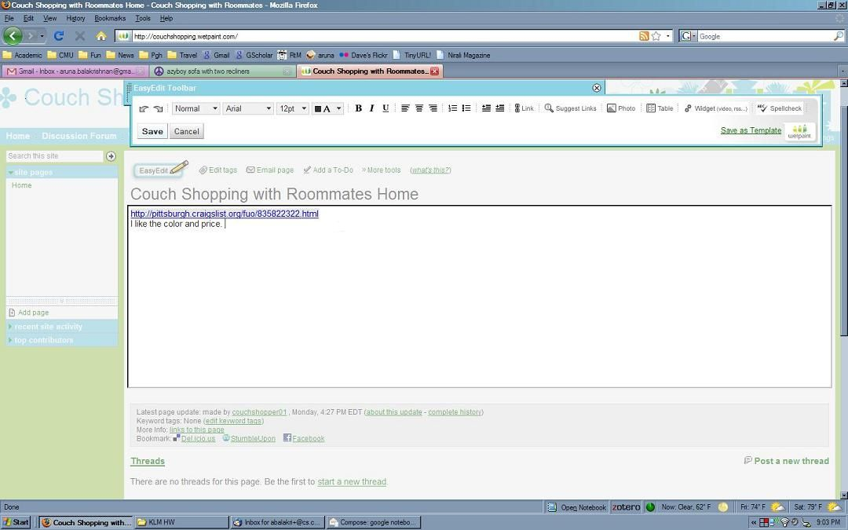

Click on “Save”.
After 0.75 seconds, the EditNote dialog pops up (see next image).

In the Wetpaint design, there is a frame wetpaint_09, with one widget in it
- A Button widget the size of the Save button.

The transitions associated with this frame are:
- A left-click transition from the Save Button widget to wetpaint_10, with a 0.75 second system wait.

File name: wetpaint_10.JPG

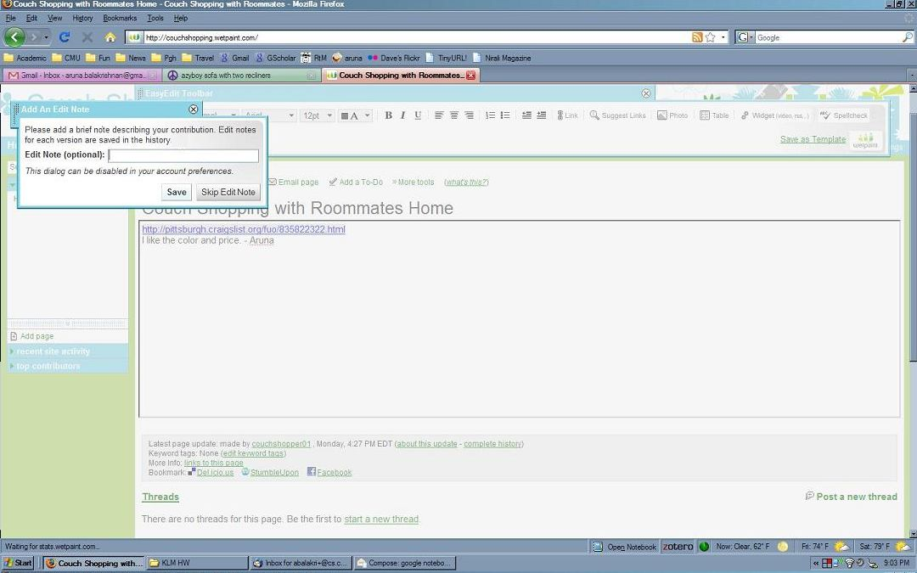

Click “Skip Edit Note”
After 1.00 seconds, the next screen appears.

In the Wetpaint design, there is a frame wetpaint_10, with one widget in it
- A Button widget the size of the Skip Edit Note button.

The transitions associated with this frame are:
- A left-click transition from the Skip Edit Note Button widget to wetpaint_11, with a 1.00 second system wait.

File name: wetpaint_11.JPG

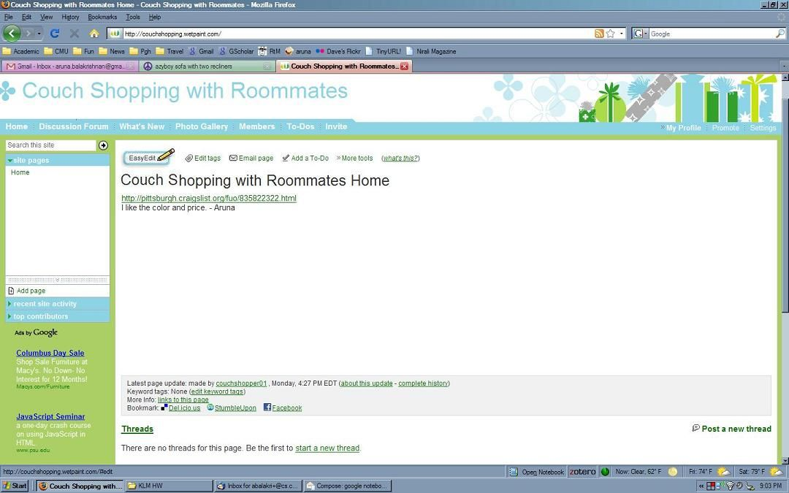

Look at the post to make sure it is correct.

In the Wetpaint design, there is a frame Gmail_11, with one widget in it
- A Non-Interactive widget the size of the URL and the comment. (We are also accepting a Text widget.)
This can be a Non-interactive widget because the user is not going to interact with it, or a Text widget because the user could select it if he or she so needed to.

There are no transitions associated with this frame.

This is the end of the task using Wetpaint.

