Task Instructions
Three ways for roommates collaboratively shopping for a couch to share a link and comment on a specific couch found on craigslist.
Bonnie E. John, 3nov2008

The following are the task instructions for sharing a link using Google Docs.

Assume:
- The hand starts on the mouse
- The roommates are going to follow the link to see the page, so it doesn’t matter if the link is just a URL or a page title.
- All screens load immediately unless otherwise noted.
- The start screen is the craigslist listing of the couch she wants to share.
- Any necessary sharing has already been set up (i.e., GoogleDocs sharing), so all we are modeling here is how long it takes to share a single link with a comment.

Use Gmail to share a link and a comment.

Start at the following screen, file name: Gmail_01.JPG

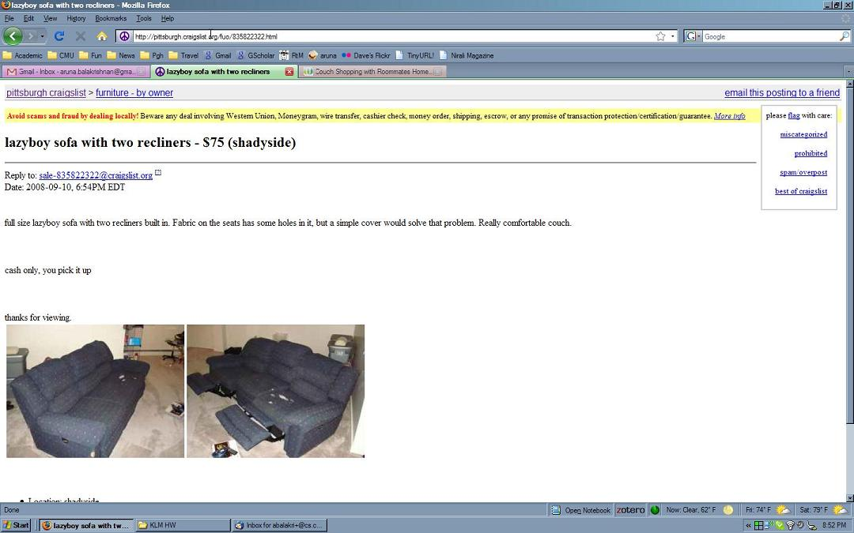

Click on the URL to highlight it.
Type Ctrl-C, to copy the highlighted URL.
Click on the Gmail tab to switch to Gmail.
After 0.5 seconds, the next page appears on the screen.

File name: Gmail_02.JPG

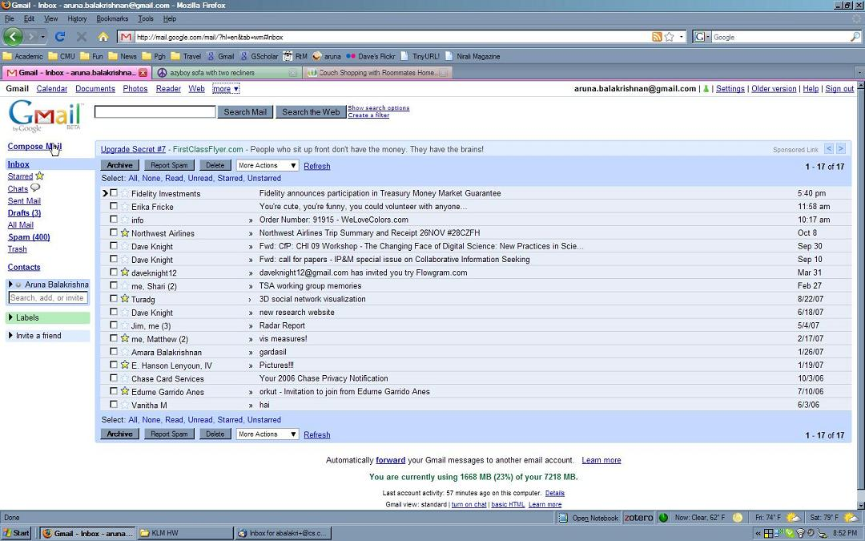

Click on Compose Mail.

File name: Gmail_03.JPG

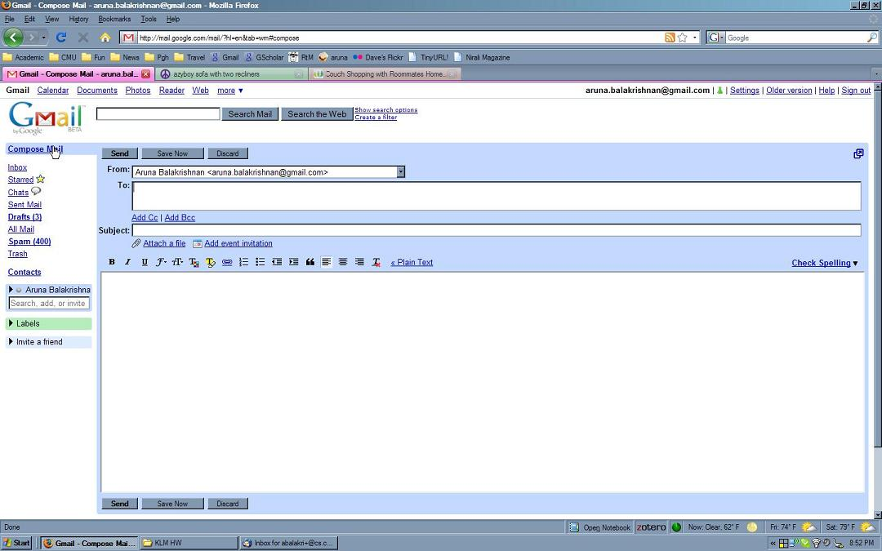

The cursor is already blinking in the To: field.
Type “roo” to get the Roommates group to appear (see next image).
NOTE: When the “r” is typed, a list of contacts starting with “r” appears.
When the first “o” is typed, a list of contacts starting with “ro” appears.
When the second “o” is typed, the list of contacts starting with “roo” appears; it contains only “Roomates (group)”, as seen in the next image.
File name: Gmail_04.JPG

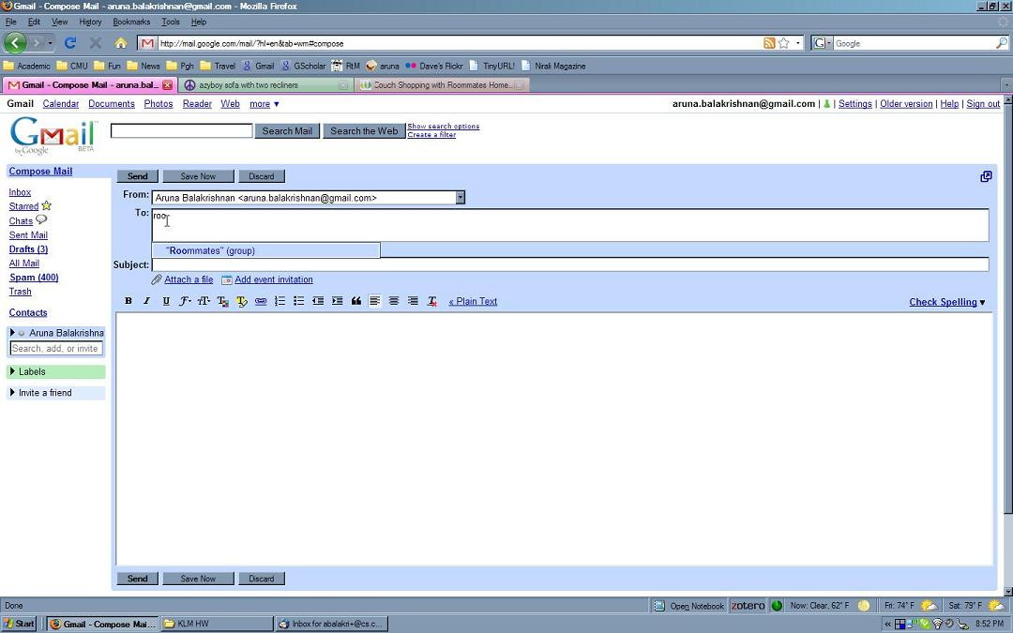

Click on the “Roommates”(group).
File name: Gmail_05.JPG

NOTE: we have Xed out the roommates’ email addresses.
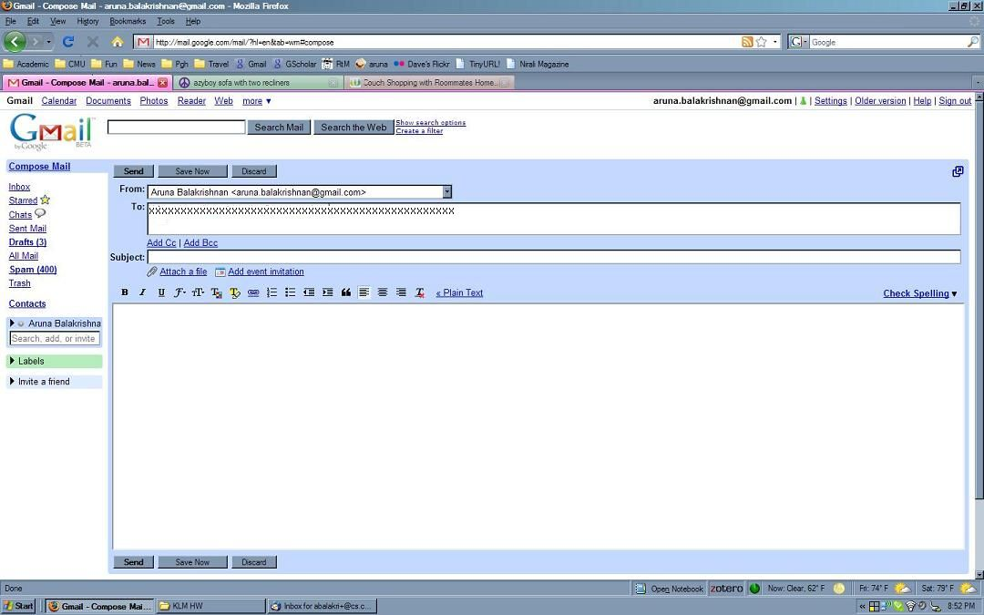
Click in the Subject: field.
Type “couch I found”
Click in the main message area to put the cursor in that area.

File name: Gmail_06.JPG

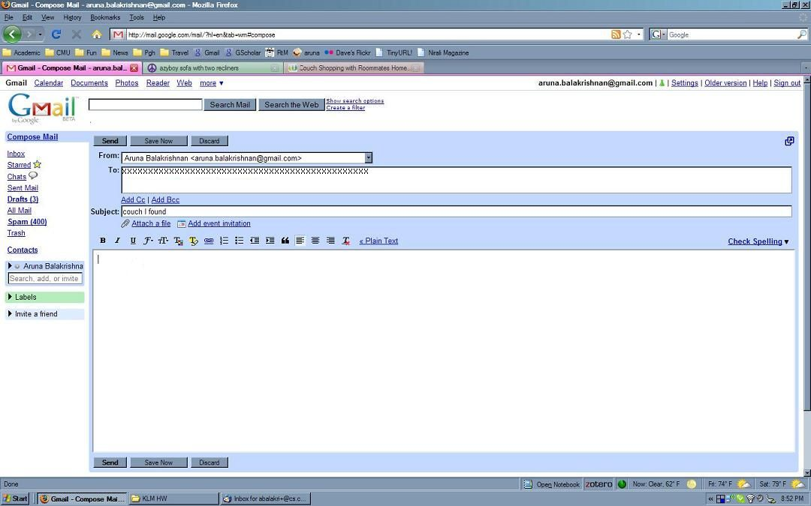

Type CNTRL-v to paste the link.
Type ENTER to move to the next line.
Type “I like the color and price.” to add the comment.
File name: Gmail_07.JPG

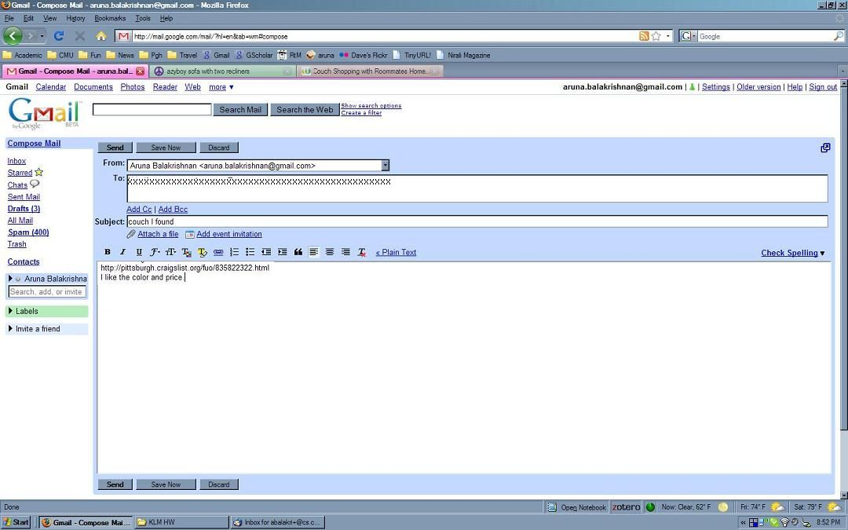

Click on SEND to send the email.
After 1.25 seconds, the next screen appears.
File name: Gmail_08.JPG

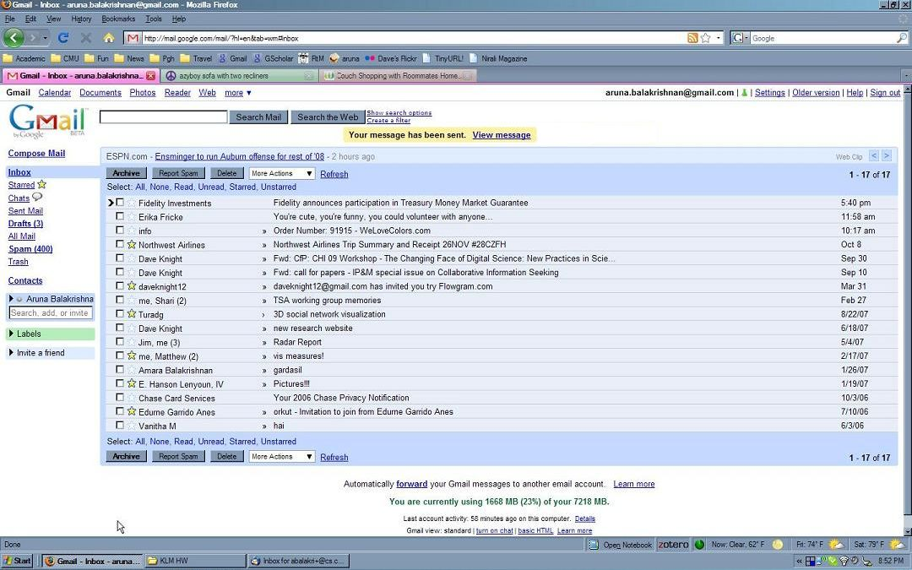

Look at the yellow confirmation message to make sure the email was sent.

This is the end of the task using Gmail.

Use Google Notebook share a link and a comment.
Start at the following screen, file name: GoogleNotebook_01.JPG

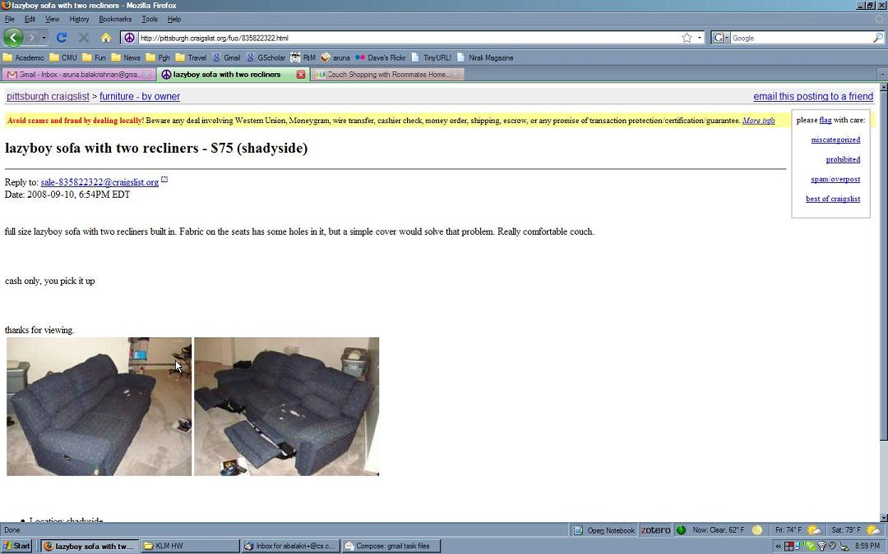

Highlight the title of this post, “lazyboy sofa with two recliners - $75 (shadyside)” by dragging from the left of the title to the right of the title.
File name: GoogleNotebook_02.JPG

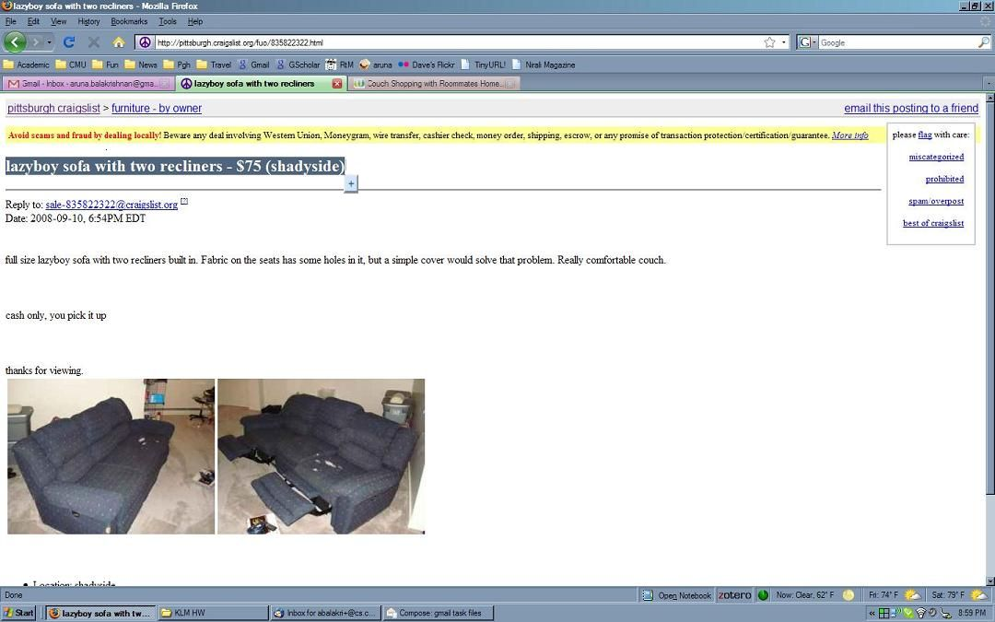

Click on the plus sign that appears to the right of the highlighted title.
File name: GoogleNotebook_03.JPG

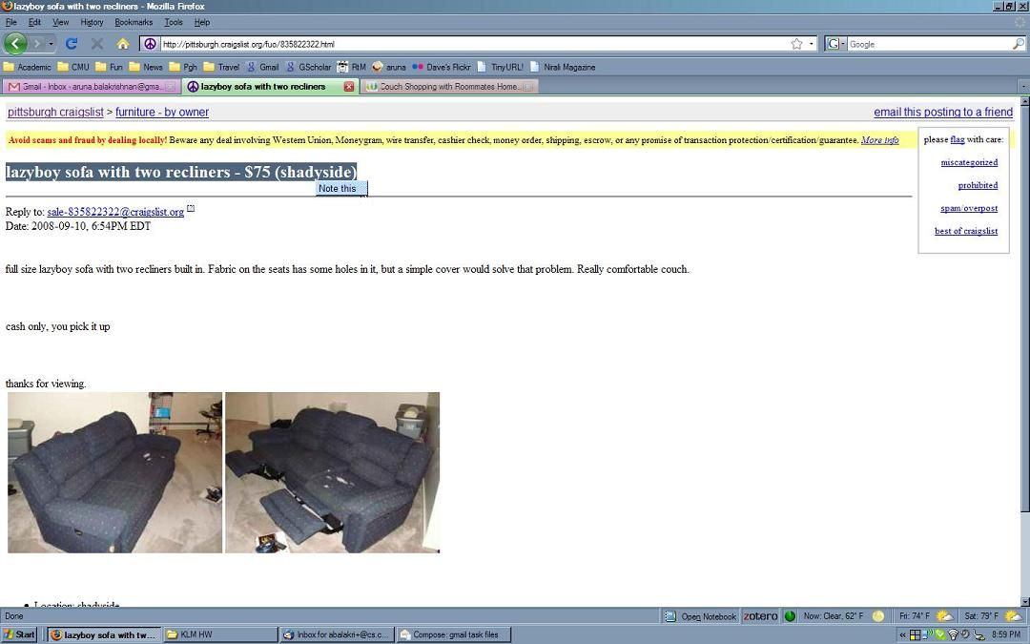

Click on the “Note this” that appears in place of the plus sign.
After 1.25 seconds, the Google Notebook appears at the bottom right of the screen.
File name: GoogleNotebook_04.JPG

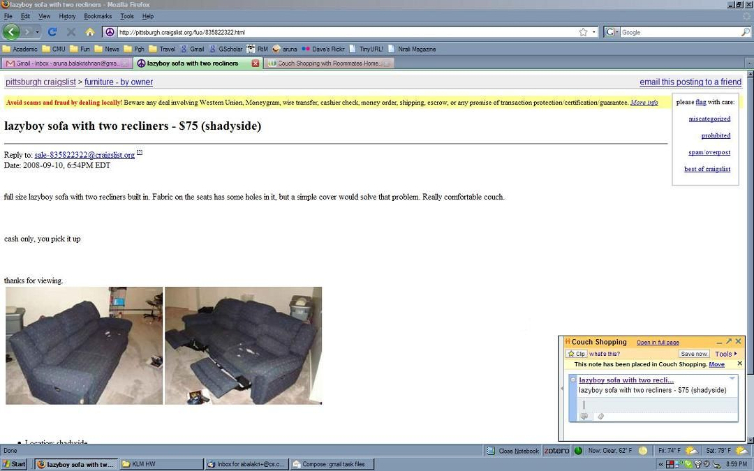
The cursor is already in the comment field below the link.
Type “I like the color and price.”
Click on “Save now”
File name: GoogleNotebook_05.JPG

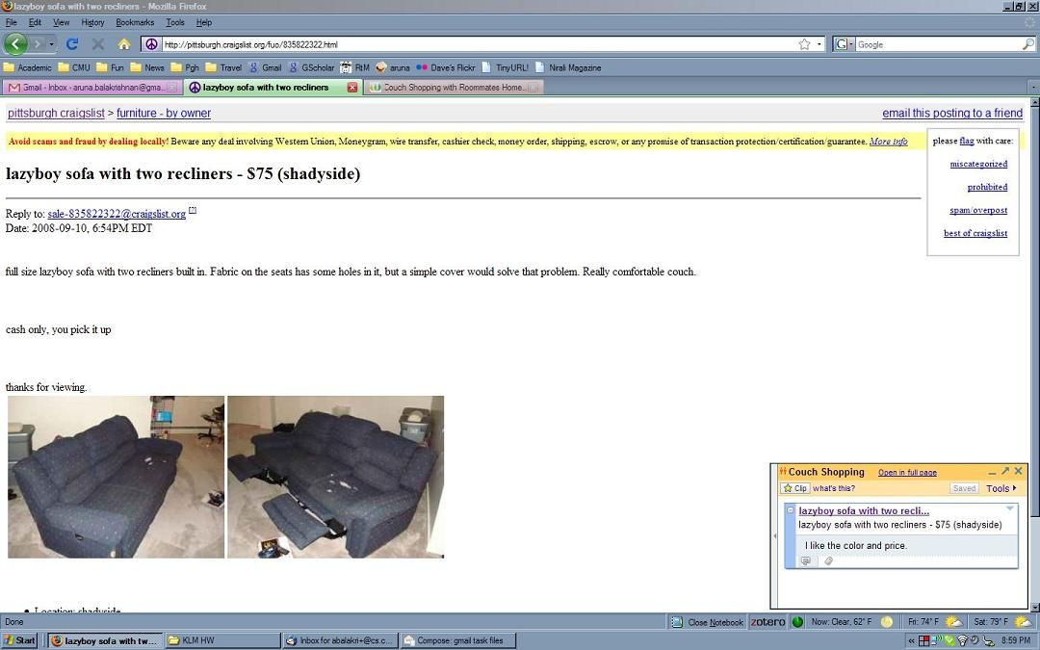

Look at “Saved”, which has changed from “Save now” which indicates that the link and comment have been saved.

This is the end of the task using Google Notebook.
Use Wetpaint to share a link and a comment.
Start at the following screen, file name: Wetpaint_01.JPG

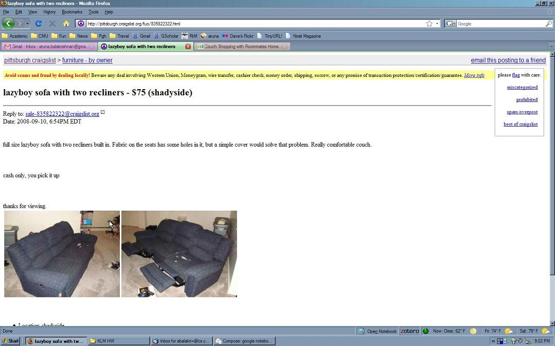

Click on the URL to highlight it.
Type Ctrl-C, to copy the highlighted URL.
Click on the “Couch Shopping with Roommates Home” tab to switch to Wetpaint.
File name: Wetpaint_02.JPG

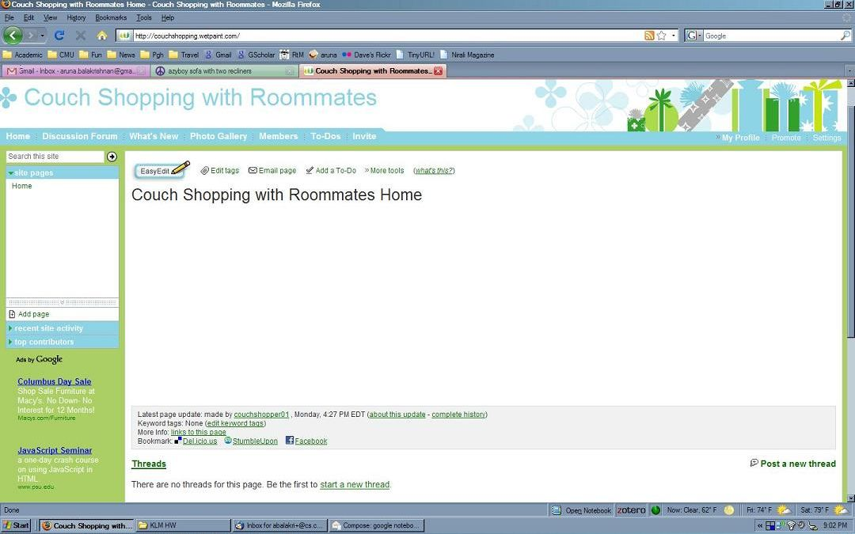

Click EasyEdit.
After 2.00 seconds, the editing page loads (see next image).
File name: Wetpaint_03.JPG

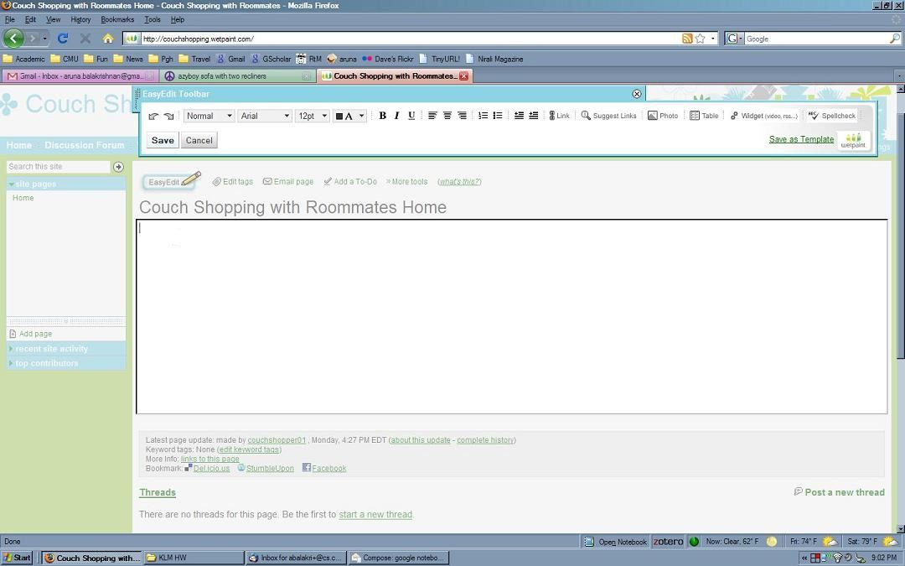

The cursor is already in the main editing area.
Type CNTRL-v to paste the link.

File name: Wetpaint_04.JPG

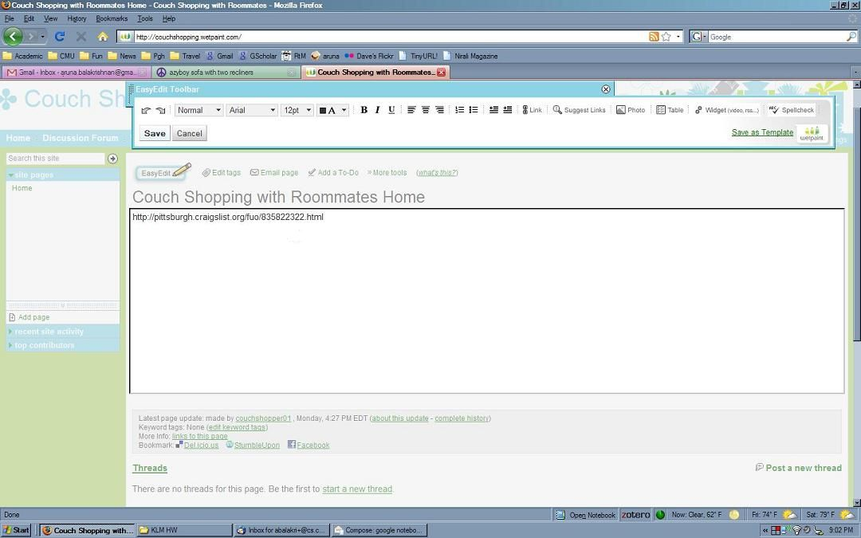

The link pasted in as text, not as a link. To change it to a link, do the following.
Double-click on the text of the link just pasted, to highlight the entire link.
File name: Wetpaint_05.JPG

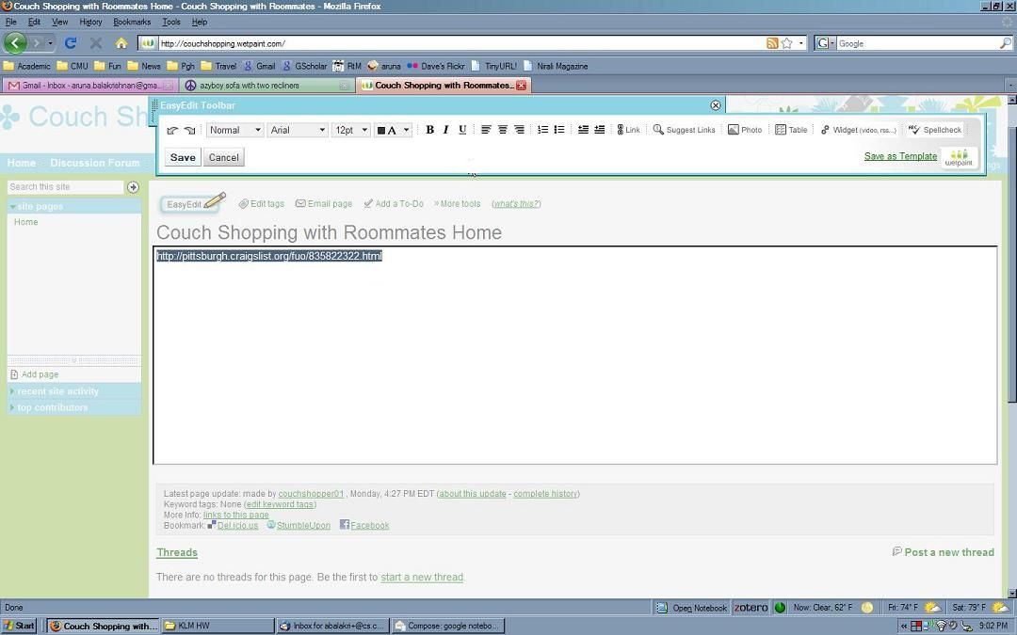

Click Link.
File name: Wetpaint_06.JPG

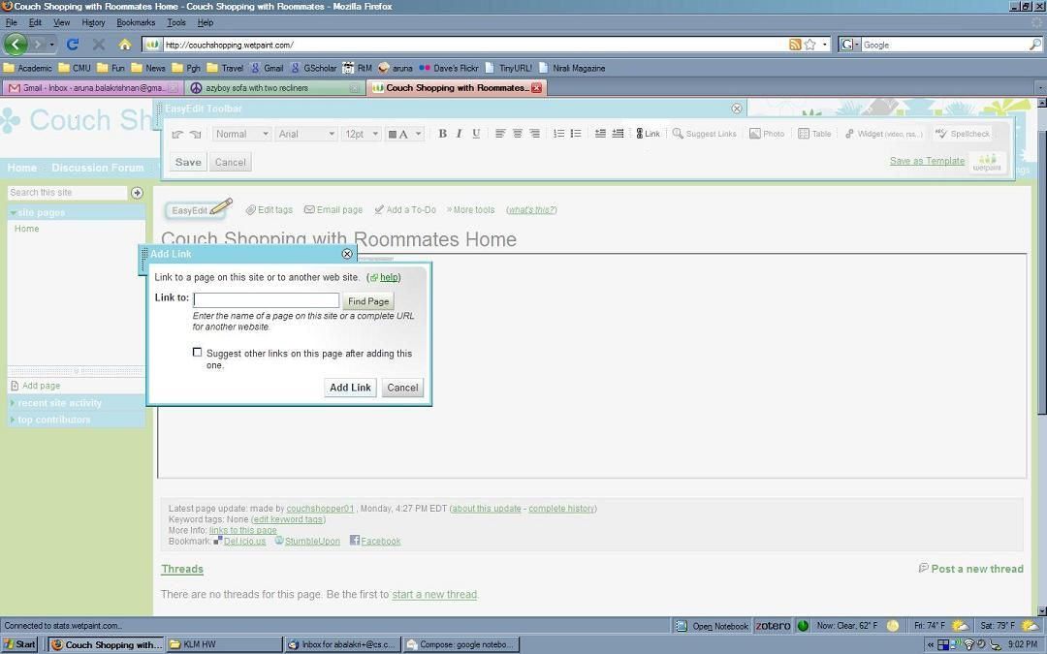

The cursor is already blinking in the Link to: field.
CNTRL-v to paste the link into the field.
File name: Wetpaint_07.JPG

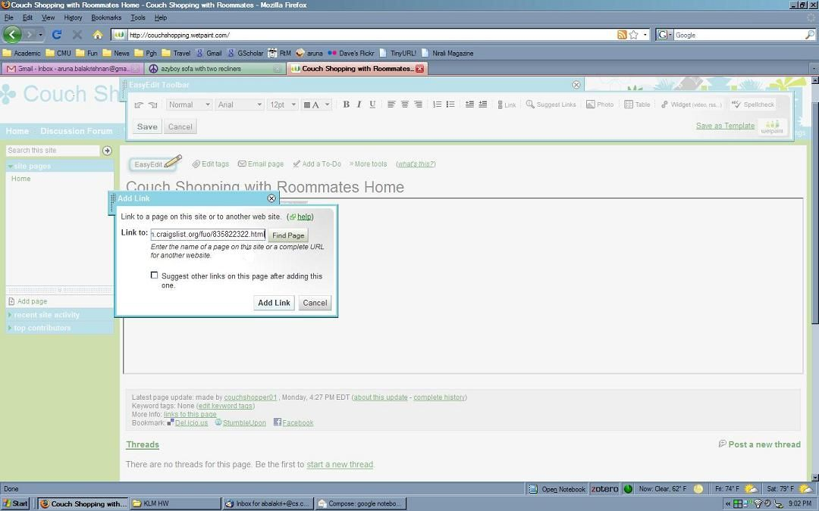

Click “Add Link”.
File name: Wetpaint_08.JPG

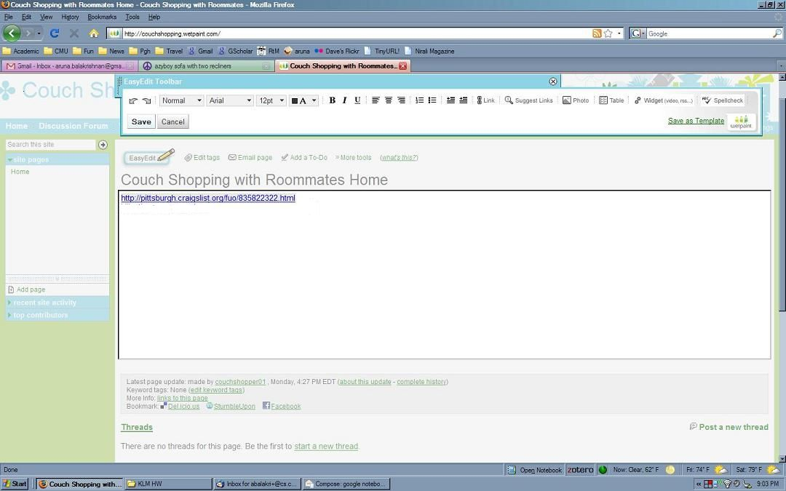

Type the right-arrow key to make the cursor move to the end of hyperlink.
Type ENTER to move the cursor to a new line.
Type “I like the color and price.” to add the comment.
File name: Wetpaint_09.JPG

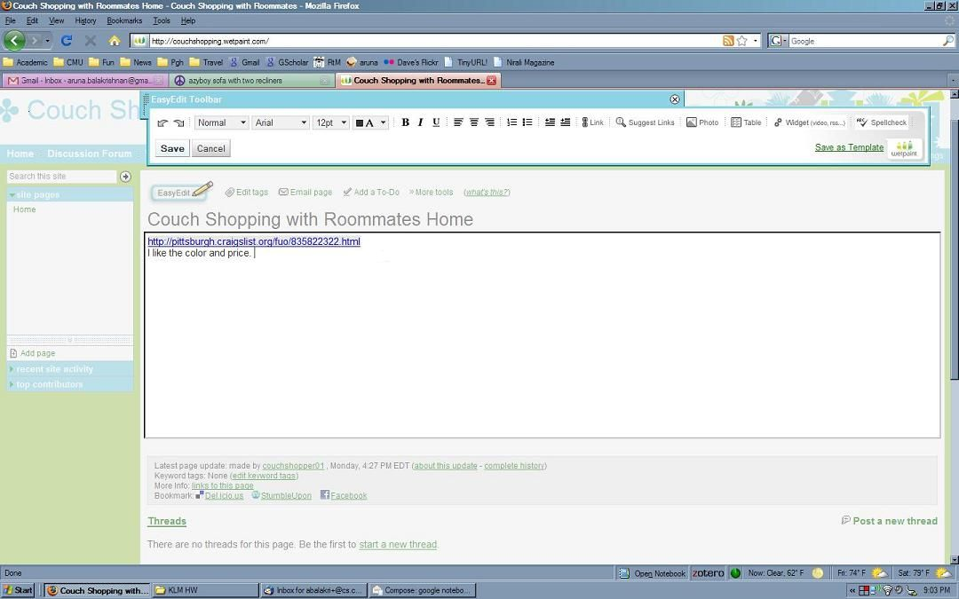

Click on “Save”.
After 0.75 seconds, the EditNote dialog pops up (see next image).
File name: Wetpaint_10.JPG

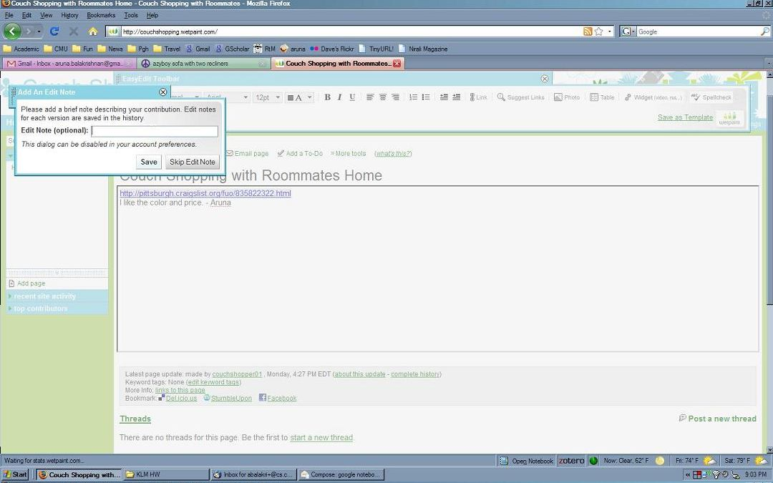

Click “Skip Edit Note”
After 1.00 seconds, the next screen appears.
File name: Wetpaint_11.JPG

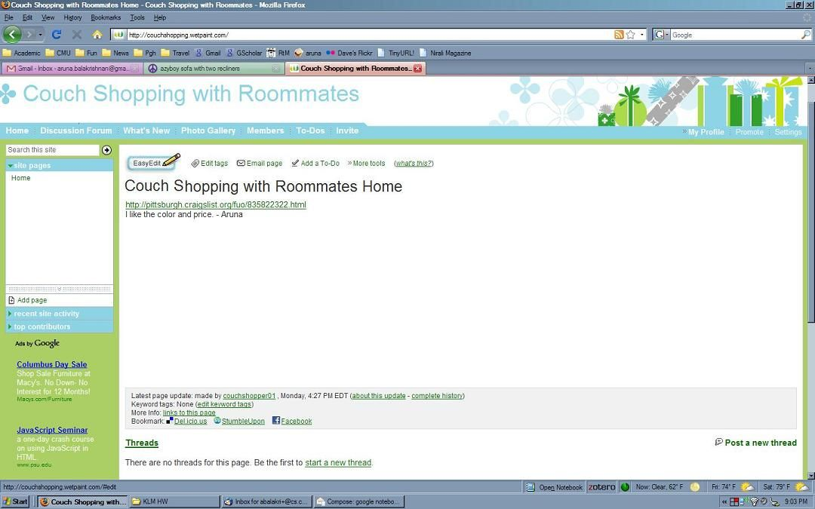

Look at the post to make sure it is correct.

This is the end of the task using Wetpaint.

