Requirements document for new version of CogTool
Bonnie John, Gus Prevas, Peter Centgraf, Alex Eiser
15sept04 – added to by Bonnie, Gus, Alex
14sept04 – added to by Gus and Peter
14sept04 - begun

This document originally started from Gus Prevas’s email of 14sep04, then modified with all of us in the room.)

mock-up creation
these relate to the Dreamweaver replacement component
this function could be accessed by double-clicking the title of a design in the grid view, via the contextual menu on the design, or via a menu item (e.g Design->Edit Mockup…) while a design or grid cell is selected
(What’s a grid view? Is this more detailed than we care about at this point? Not that I want to lose the ideas, but I don’t know how much I should work to understand them.)

-structural view of mock-up
Viewing the linking of hotspots to pages that they link to, in a visual map of the mock-up (like the Denim map view)

-create hotspots by drawing rectangles, specify hotspot type
the types of hotspots will be the specialized widgets, like drop-down menus, things that work with a double-click, etc.
The detailed design of this is still to come (e.g., toolbars, etc.)

-link hotspots to states by drag-and-drop/drawing lines
Denim-like interaction for linking hotspots to pages

-support user input that is not clicking on a widget (keystrokes, keyboard shortcuts, voice input) – including some way to represent in structural view
The detailed design of this is still to come.

–default widget images for hotspots, or "grab" background image under the hotspot
Divorces the mockup from having to have an image.
Make sure that widgets can have labels
The widgets should be resizable.
Make sure they can be placed anywhere on the canvas, through dragging, and have they stay put.

-export to HTML
vanilla html that works on lots of browsers, doesn’t require applets or java-script code, or any of that.
Think about exporting to PowerPoint, Visio, possibly others (quite possibly not possible)

Drag and Drop Support
Allow images to be dragged from the file system to create new states
Also support pasting of image data from graphics programs, if possible

Resizing
Support resizing by zoom-in/-out, by-percentage, and by dragging a corner
By-percentage is important to help keep all images in a mockup at a consistent size – this should also be available as an aggregate command.

Widgets we want to support (list not complete)

Text entry (including tabbing between them)
Must have some way to mock-up multiple text fields in an interface that allows demonstrating entering text. Some possibilities include having a text-box widget.

Buttons that you use a mouse on, both double click and single click, multiple key click and right click

Buttons that you use a finger on. Like a car radio

Other things you can click on (like the text in this word processor)

Pull-down menus, with submenus (possibly other types of menus)

Other possible widgets specific to sponsors (e.g., GM, Boeing, NASA, ONR)

Task demonstration
this function could be accessed by clicking on a “?” grid cell, via a contextual menu on a cell, or via a menu item (Task->Demonstrate Task…) while a cell is selected

-single-state view (rather than structural view used for creating the mock-up)
web browser-like view that shows one state at a time, responds to clicks and keystrokes and advances to the appropriate state
we could make this available outside of recording as well, possibly have a “record button” in this view that starts/stops recording
Bonnie believes that this view will help the modeler remember to demonstrate steps for all parts of the task better than the structural will.

-maintain a list of steps
each time the user performs an action while recording, the action is added to the list
Possibly in simplified English sentences, i.e. "Double-click on the 'databases' menu item")
Possible implementation: table-formatted list of actions (including action type, item acted upon, and result) alongside mockup
Possibly include pictures as well as the steps in words, and do automatic documentation of these procedures in a format that the Tech Writing people in English say is good (or we can find in some literature somewhere).

Do not preclude future interactive views of the demonstrations that may include branching and selection rules
E.g., the state transition diagram that the Behavior Recorder uses, possibly with thumbnails instead of nodes. Must be interactive to allow modeler to start a new branch from any node. This is not planned for the next year, but we don’t want to do anything that would preclude it without thinking hard about that decision.

Support Undo
the last action can always be undone, which may return the view to the previous state
possibly allow other previous actions to be deleted from the middle of the sequence where this doesn’t interfere with the state transitions, although we’d have to indicate visually where this is possible (pjc: I disagree – tracking dependencies may be too confusing/invisible for users.)
allow “rewind” to a specific point in the sequence
BEJ: the details of undoing and deleting from the middle of the sequence of steps are to be worked out and user tested later.

Store meta-data
Give tasks names and simple textual notes to describe them
Editing a sequence
automatically re-runs models
Numbers displayed in chart should always stay in sync with most recent demonstrated sequence

Automatic exploration of parameters

M placement

In driving, pops

Other parameters (e.g., typing speed, reading speed, etc.)

Results view
this would be the main view for a project file (described below)
we should expect to handle up to 30 or so tasks (max 100+), up to 10 design variations (max 20+), and up to 5 projects (max 10+) simultaneously with good performance

-table of tasks vs. designs
as per our previous discussions – tasks along the left side, designs along the top
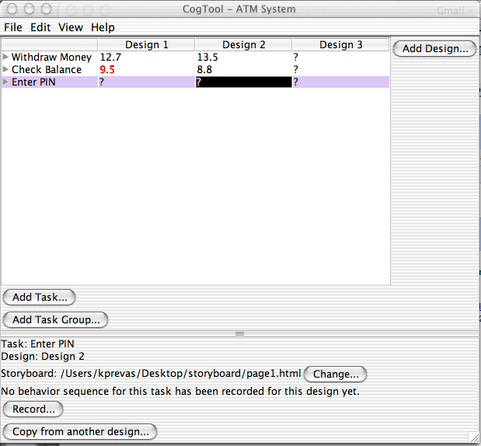

-add design: adds new column (see mock-up creation)
asks for name, possibly opens mock-up creation mode
allow user to duplicate existing design instead

-add task: adds new row
asks for name, no further interaction required – behavior sequences will be copied/recorded as below

-run models automatically in background for cells with recorded behavior sequence
ACT-R will be running in the background, so we can queue up models in a background thread to run without the need for user interaction
This should be pretty fast since we’re not waiting for Netscape

-task times displayed in cells when possible; if no behavior sequence has been recorded for a cell, "?" displayed
for any task/design combination with a working recorded behavior sequence, we display the total task time
otherwise (no sequence recorded or mock-up was changed so that the recorded sequence is broken) indicate that no current results are available (e.g. display “?”)

Display ‘X’ or or “n/a” blank for cells where a task is n/a
Allows user to specify that a particular task (e.g. one GOMS-style method) cannot be used on a particular design
Reduces visual clutter and gives “?” special significance as a problem requiring attention

-click on "?" cell to record behavior sequence
more precisely, when a “?” cell is selected, tell the user what’s preventing the model from being run, and present options for recording a sequence or fixing the mockup (which would be presented for non-? cells as well)

-allow user to copy behavior sequence from one design to another when possible
if two designs are isomorphic as far as hotspot names and behavior sequence (i.e. layout changes only), we provide an easy way to copy behavior sequences from one to the other

grouping structure in task list
e.g. several methods for achieving a goal, several variations of a benchmark
ungrouped tasks should also be possible
design choice: one or multiple levels of hierarchy?

Support collecting/reporting summary statistics
Weighted averages for comparing benchmark tasks across designs (http://www.taskz.com/mayhew_keystroke_indepth.php)
Fastest-/slowest-in-group highlighted in color?
Safest/least-safe by lane deviation and/or reaction time across variations and across designs
Improvement/no improvement, with respect to a specified baseline column etc. (like in the GM report in aug04)

Entry of human subject data for comparison
assist in comparing known data for some designs to simulated data for others
Both for total task times and for timeline as well.

Timeline Visualization

-expand cells(rows?) into timeline view
vertical timeline appears beneath expanded rows showing a detailed visual representation of the model run (pjc: perhaps this should be in a separate window or panel rather than the main grid)

-provide levels of granularity in timeline view (operator-level, action-level)
action-level will show elements in the timeline at the level of “click this button”, “type this string into this textbox”
operator-level will show elements at the KLM level, grouped by color according to the action-level elements

-allow creation of new task from selected segment of timeline view
user can select one or more (contiguous) actions on the timeline
selection occurs at the action level, even if operator-level is visible
selected actions can be “broken out” into a new task

-display state associated with a point on the timeline (double-click?)
some form of interaction with the timeline that will display the interface state at that point in time in the single-state view, as above

driving

allow driving and stand-alone to co-exist
support stand-alone-only projects and the ability to add driving-specific commands later
sequences for driving are always also stand-alone sequences – special commands for driving should be ignored when running stand-alone
driving versions may exist or not on a task-by-task basis – show when sequences include driving meta-data
allow (many) multiple variations of driving commands for a single task (perhaps grouping support would be sufficient for this). So far we’ve needed to do this with “monitor driving” (pops in attention).

-run driving models automatically in background, if fast enough
as above; we may want to give the user the option of how many trials to run, “in the users’ language” (this might be a global or session-global preference)

-display summary statistics in table (separate table? "driving mode"?)
we need to present the summary statistics (task time, avg. deviation, brake light response) in a tabular format that makes it easy to compare but is compatible with the tasks vs. designs paradigm

-overlay lateral deviation graph on timeline; indicate glances?
We can have a line graph of lateral deviation over time, overlaid on the standard task timeline, to allow the user to match up spikes in deviation with task actions
Possibly use colored background to indicate when the model is looking at the road vs. at the device, or use dashed-line alongside timeline
Show “critical periods” of unsafe behavior judged by lane deviation
safety tolerance value for lane deviation stored as a preference

-allow graphical replay of model run
save the raw data generated by each model run (pjc: perhaps only some important subset of the raw data, since a large amount is generated)
generate a graphical replay on demand within the Java application
could probably allow movie-like controls (frame-by-frame, fast forward/rewind, etc.)

??? Support variations of driving model ???
allow user to specify a customized version of the ACT-R code for special purposes, but display results together in chart as usual
perhaps include some pre-packaged variations selectable from a menu (for GM only)

Saving/Exchanging Files

Store result data to avoid re-running models
Since we control the mockups, we can assume they don’t change without our knowledge

Aggregate files into single project file
Use a single container file (in zip format) to aggregate all files for mockups (images, link info) and tasks (asb sequence files, result data)
Files could be compressed for space or uncompressed for speed (pjc: I suggest the latter)

Allow multiple projects to be open at once
Project “document” maps to a single design/task grid window
Supports multiple styles of interaction, depending on how users arrange items within projects (e.g. single master window with all designs, multiple windows with one major design iteration each, one project for benchmark tasks and another for experimentation)

Support transfer of designs between projects
Drag-and-drop and/or cut-and-paste should be available
Moves all files for design and associated tasks to a different project, creating new tasks items at destination when necessary
Supports collaboration between multiple designers

Support transfer of tasks between designs in multiple projects
Drag-and-drop and/or cut-and-paste should be available
Moves details for one or more tasks to a different project, re-running sequences when they are compatible and marking others with “?”
Supports sharing of benchmark tasks

