Importing Designs and Demonstrations into CogTool

This tutorial describes how to construct XML representations of user interface designs and demonstrations in a format that can be imported into CogTool. Importing user interfaces into CogTool allows you to take advantage of the CogTool’s access to various cognitive modeling engines without having to construct the example user interfaces by hand using CogTool’s GUI.

Basic Structure of the XML Document

To create an XML file that CogTool can import, the document must validate against the schema cogtoolimport.xsd. Each document to be read by CogTool must contain a design; documents may also contain zero or more demonstrations. Note that every user interface component referenced (e.g., frame, widget) in a demonstration must be defined in the design.

<?xml version="1.0" encoding="iso-8859-1"?>
<cogtoolimport version=”1.0”>
<design name=”...”>
...

<demonstration startFrameName=”...” taskName=”...”>
...
</demonstration>
<demonstration startFrameName=”...” taskName=”...”>
...
</demonstration>
</design>
</xs:cogtoolimport>

Example Design

The example used throughout this tutorial is an application to view the weather from the OS X 10.4 Dashboard. Below the weather report there is a single button, a small “i” in the lower right hand corner that allows the user to change the settings.

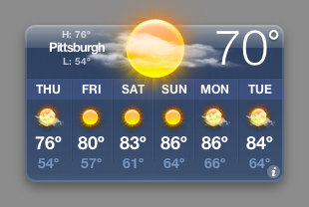  Weather | 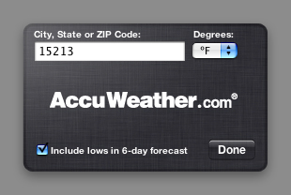  Settings

Here are the elements of the design that the user can interact with (highlighted in orange):

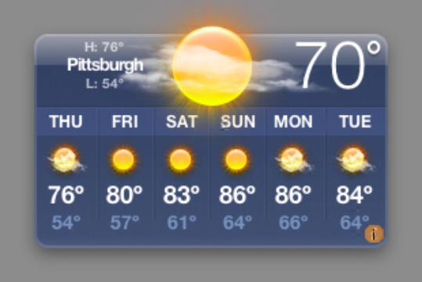  Weather | 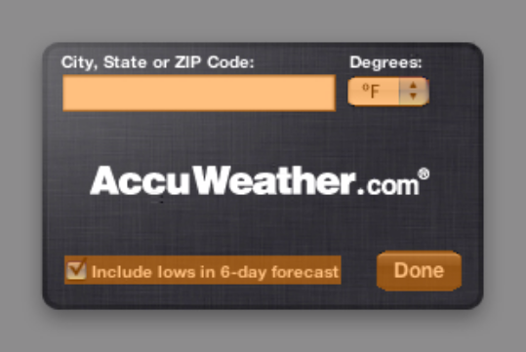  Settings

Here are the transitions in the interface (shown with arrows):

Weather | Settings

Terminology

XML documents created to be imported into CogTool use the same terminology as the CogTool user interface for creating prototype designs:

Term | Description | From the example above:
Frame | A window or physical object that contains elements with which the user can interact | Weather and  Settings windows
Widget | Specific element with which the user can interact | “i” button  “Address” TextBox  “Degrees” drop down  “Include lows” checkbox  “Done” button
Transition | A change in the user interface resulting from the user performing an action | “i” button → action → Settings  “Done” button → action → Weather
Action | A specific action performed by the user | Left mouse click

Representing a Design in XML

Here is how the example interface is represented in XML:

<design name="OS X Dashboard Weather">
<device>keyboard</device>
<device>mouse</device>
<!--Interface to display the weather -->
<frame name="Weather">
<backgroundImagePath>weather.jpg</backgroundImagePath>
<widget name="i-button" type="button" shape="ellipse">
<displayLabel>i</displayLabel>
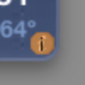
<extent x="267" y="165" width="14" height="14"/>
<transition destinationFrameName="Settings">
<action>
<mouseAction button="left" action="downUp"/>
</action>
</transition>
</widget>
</frame>
<!--Interface for changing settings -->
<frame name="Settings">
<backgroundImagePath>settings.jpg</backgroundImagePath>
<widget name="Address" type="text box">
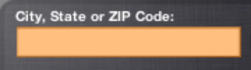
<displayLabel/>
<extent x="37" y="44" width="161" height="22"/>
<transition destinationFrameName="Settings">
<action>
<mouseAction button="left" action="double"/>
</action>
</transition>
</widget>
<widget name="Degrees"
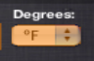
type="pull-down list"
shape="rounded rectangle">
<extent x="205" y="45" width="48" height="17"/>
</widget>
<widget name="Include Lows" type="check box">
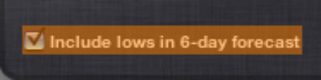
<displayLabel>Include lows in 6-day forecast</displayLabel>
<extent x="38" y="151" width="162" height="16"/>
</widget>
<widget name="Done" type="button" shape="rounded rectangle">
<displayLabel>Done</displayLabel>
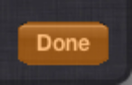
<extent x="222" y="148" width="50" height="24"/>
<transition destinationFrameName="Weather">
<action>
<mouseAction button="left" action="downUp"/>
</action>
</transition>
</widget>
<keyboardTransitions>
<transition destinationFrameName="Settings">
<action>
<keyboardAction>
<text>94035</text>
</keyboardAction>
</action>
</transition>
</keyboardTransitions>
</frame>
<!-- Demonstrations go here -->
</design>
Representing a Demonstration in XML

In this demonstration, the user changes their weather display from Pittsburgh to Mountain View:

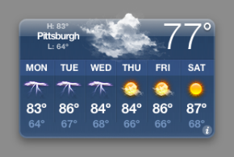  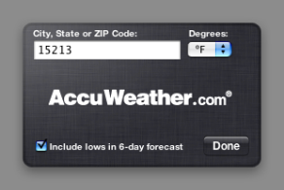  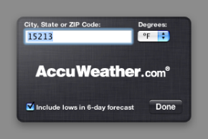  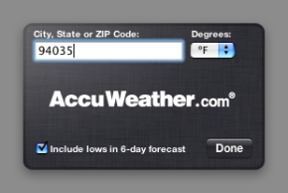  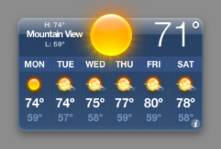 | <demonstration taskName="FindWeatherByZip" startFrameName="Weather">  <startingRightHandPosition>keyboard</startingRightHandPosition>  <startingMousePosition x="0" y="0"/>  <startingEyePosition x="0" y="0"/>  <demonstrationStep>  <actionStep targetWidgetName="i-button">  <mouseAction button="left" action="downUp"/>  </actionStep>  </demonstrationStep>  <demonstrationStep>  <actionStep targetWidgetName="Address">  <mouseAction button="left" action="double"/>  </actionStep>  </demonstrationStep>  <demonstrationStep>  <keyboardActionStep>  <text>94035</text>  </keyboardActionStep>  </demonstrationStep>  <demonstrationStep>  <actionStep targetWidgetName="Done">  <mouseAction button="left" action="downUp"/>  </actionStep>  </demonstrationStep>  </demonstration>

Further Documentation

The previous example did not show all of the types of information that can be imported into CogTool. For instance, the example did not deal with touch screen displays, voice recognition commands, or graffiti gestures. For a complete and definitive list of information that can be imported into CogTool, please view the schema cogtoolimport.xsd.

Preparing a Valid XML Document

To make sure that the XML documents you are create will import correctly into CogTool, please be sure to follow these four guidelines:

1. Verify that your XML document validates against the schema cogtoolimport.xsd. There are a variety of tools for validating XML instance documents against an XML schema. An easy to use Web based tool is available at: http://www.xmlforasp.net/SchemaValidator.aspx

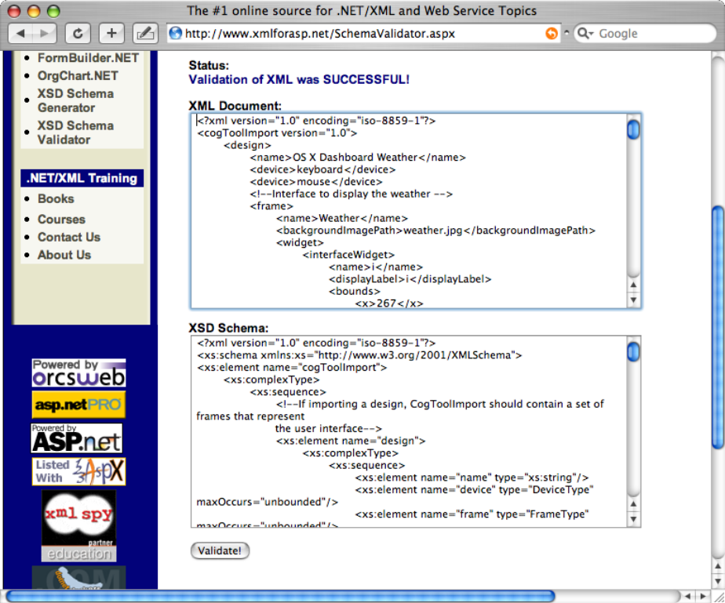

Additional guidelines that the schema validation will not check:

2. If importing a demonstration, every frame referenced in the demonstration must be defined in the preceding design.

3. Every frame must have a unique name.

4. Every widget in a particular frame must have a unique name.

