Human Performance Modeling for All:
Importing UI Prototypes into CogTool

Abstract

Copyright is held by the author/owner(s).

CHI 2010, April 10–15, 2010, Atlanta, Georgia, USA.
ACM 978-1-60558-930-5/10/04.
Brett Harris
Carnegie Mellon University
5000 Forbes Avenue
Pittsburgh, PA 15212 USA
bnh@cmu.edu

Bonnie E. John
Carnegie Mellon University
5000 Forbes Avenue
Pittsburgh, PA 15212 USA
bej@cs.cmu.edu

Jonathan Brezin
IBM T. J. Watson Research Center
P.O. Box 704
Yorktown Heights, NY 10598 USA
brezin@us.ibm.com

UI designers use a variety of prototyping tools, from paper and pencil sketching, to drag-and-drop mock-up tools (e.g., Balsamiq Mockups), to sophisticated suites of modeling tools and toolkits (e.g., iRise or dijit, the dojo GUI toolkit). Many projects would benefit from quickly analyzing prototypes at an early stage without the effort of bringing in users for empirical tests. Most analysis tools, however (e.g., AutoCWW [1], Bloodhound [2], and CogTool [4]), require prototypes to be in their own format, which forces the designer to re-do the prototypes in order to analyze them. Our work is a step toward allowing the CogTool analysis tools to import from many different prototyping tools, so designers will have a path to quick usability analysis without changing the way they currently express their preliminary designs.

Keywords
Human performance modeling, UI prototyping

ACM Classification Keywords
H.5.2 User Interfaces; D.2.2 Design Tools and Techniques.

General Terms
Human Factors

Introduction
Usability testing is an important method for creating products that are easy to use, but it is expensive and time consuming. Predictive human performance models allow a designer to estimate some usability metrics like time to complete a task, or the number of errors. CogTool [4] provides one such model, as well as a user-interface for creating prototypes.
Good as CogTool‘s mock-up capabilities are, it may not be the ideal prototyping tool for a particular project. So a designer may want the predictions CogTool can make, but for good reasons want to work out the design in another prototyping tool. It is obviously desirable to minimize the effort the designer must exert to get from their chosen design tool’s output to something CogTool can analyze. This paper reports on a general facility for importing mock-ups created by other programs into CogTool. As proof of concept, we also show how it applies to importing designs created in Balsamiq Mockups.
CogTool expresses a prototype as a storyboard, with interactive widgets placed on frames to represent the screens a user would see on a desktop, laptop, or hand-held device. An arrow drawn from a widget to a frame (a transition) represents the user’s action on the widget that would make the screen change to what is depicted in the target frame. When the designer demonstrates a task on the storyboard, CogTool produces a prediction of the time it would take a skilled user to execute that task [4]. CogTool-Explorer goes further by predicting errors made by novices using the prototype to try to accomplish a goal [5].
Prior to the work described here, CogTool allowed designers to import image files (e.g., JPEG, PNG) as background images on each frame, to place widgets on those backgrounds, and to draw in the transitions. It also allowed a limited import from HTML files, building a storyboard automatically from page images, links and their transitions. A designer could also export a CogTool design as XML and then re-import it. The XML contains all the information CogTool needs to reconstruct the storyboard and demonstrations, and allows an ordinary text editor to be used for editing large designs efficiently—e.g., using global search and replace to make wording changes. Although useful, these capabilities did not allow much re-use of mock-ups built outside of CogTool.

The proposed solution for importing from other prototyping tools
We have begun to develop a general-purpose facility in CogTool for importing mock-ups created in other prototyping tools. This solution starts from CogTool’s ability to create elements from user interaction and to import its own XML (figure 1).
CogTool’s UI is implemented in Java. It is important to understand that the Java realization of the W3C DOM that one gets from the imported XML is not CogTool’s internal representation of a project, nor is that XML CogTool’s native persistent format. As one would expect, there is a class that is responsible for transforming XML into what CogTool really wants. The first step in the solution is to abstract that class and expose the API that it uses to create the CogTool objects. The second is to integrate that cleanly into CogTool so that importing can be done easily from within CogTool itself.

Integrating with CogTool
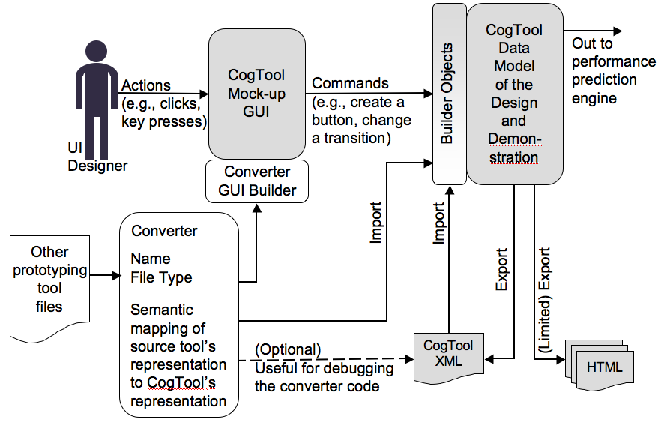
figure 1. Existing CogTool components and capabilities are shown in gray. This work will provide the Converter GUI Builder to make a useable UI for each new converter, expose CogTool’s builder objects through an API, specify the outputs of any converter, and provide documentation and examples.
Let us start with the integration step. The abstract class that defines the integration point into CogTool is called AImportConverter. It has two methods that must be implemented by a concrete importer’s subclass:
- String convertToXML(InputReader reader);
- String name();

The convert method implements the actual conversion from the given stream into CogTool’s representation and the name method specifies how to describe the source to the UI designer in the importing UI.
AImportConverter also implements a method
String[] allowedExtensions() {
return new String[] { “.xml” };
}
that allows the developer to restrict the file extensions that the converter will accept. If a converter needs to import from any file type other than .xml, its class needs to override this method. The Balsamiq converter, for example, would define .bmml as the one and only allowed file type.
For those familiar with the inner workings of Java, we note that we use the Java reflection API at runtime to invoke the methods in the converter class. The main drawback of reflection, the performance hit, is not an issue here.
We have designed the facility so that developers can create converters and make their .class files available to UI designers. The UI designers can drop these .class files into any convenient directory, and tell CogTool where to find them (figure 2). CogTool will then dynamically create appropriate menu items so a designer can import directly from the files produced by their prototyping application of choice (figure 3). While an organization that uses a particular prototyping tool could write a converter for its own use, we hope that, CogTool being open source, organizations will contribute their converters for all to use.

Writing converter files
The developer of the converter needs to know the semantics of both CogTool and the source prototyping tool, and unfortunately, the mapping between the source’s “widgets” and CogTool’s may not be straight-forward. Two good examples are the OK button at the bottom right of figure 2 and the hierarchical menu shown in figure 3. Both figures are Balsamiq mockups, The button translates easily, but the menu definitely does not.
A Balsamiq button has a size, a position on the screen, and a label, all properties that map directly to CogTool Button properties. It also has a link (signified by the blue arrow on the button) that maps directly to a CogTool transition: the link names a file that converts to a CogTool frame that is the target of the CogTool transition.
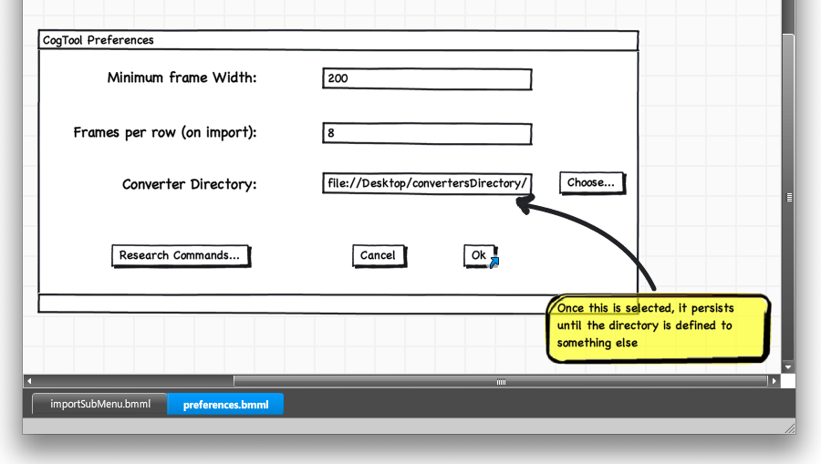
figure 2. CogTool Preferences dialog box where a designer can identify the directory containing converter files. (These designs were created in Balsamiq Mockups, to allow us to understand a prototyping tool that might be converted to CogTool.)

The hierarchical menu, on the other hand, consists of three Balsamiq widgets (a Menu Bar widget at the top and two separate Menu widgets representing the two levels of cascading menu items) which translate into a single hierarchical menu widget in CogTool. The converter must recognize that a Balsamiq Menu widget positioned below a Menu Bar widget represents the children of one of the menu bar options, determine which one, and place the items appropriately in CogTool’s Menu widget (figure 4). Likewise, the relationship of the sub-menu to the first-level menu items would have to be determined and appropriately embedded in CogTool’s hierarchical menu structure.
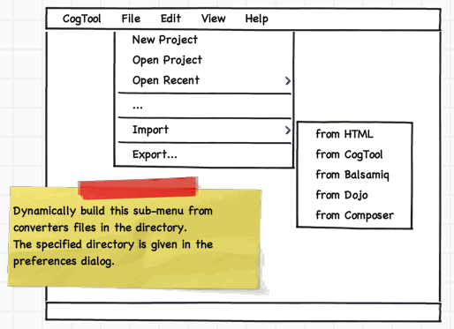
figure 3. Dynamically created Import sub-menu.
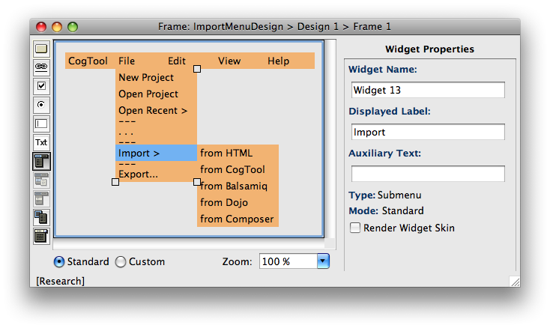
figure 4. CogTool’s equivalent of the Balsamiq menu shown in figure 3.

Using converter files: Preferences dialog
Once developers have created converters and a UI designer has placed one or more of them in a convenient directory, they must be registered with CogTool. The UI designer will use the normal CogTool Preferences dialog box (where other preferences are set) to register the converters by navigating to the directory through a standard file picker (figure 2). Once the directory is selected, the information will be kept as part of CogTool’s persistent state and will be available for future invocations of CogTool. The UI designer may choose a different directory at any time.

Using converter files: Import… Sub-Menu
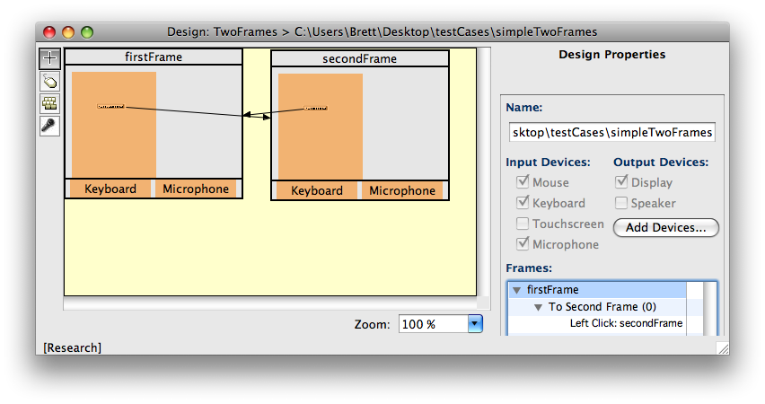
figure 6. A CogTool design window displaying two frames resulting from importing the Balsamiq frames shown in figure 5. The button widget on each frame has a link transition to the other frame.
The import sub-menu shown in figure 3 loads its menu items dynamically from the contents of the registered converter directories. The built-in “Import > from HTML” and “from CogTool” always appear, followed by items defined by the registered converters. When the UI designer selects an import command, a standard file picker dialog opens, allowing the designer to select either a directory of files (e.g., as Balsamiq requires) or a specific file to be imported into CogTool.
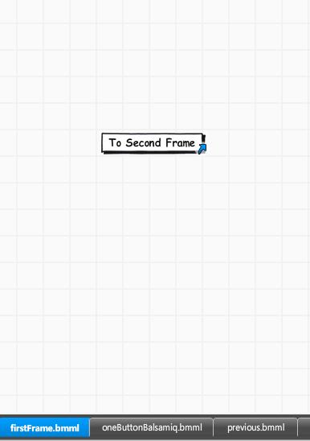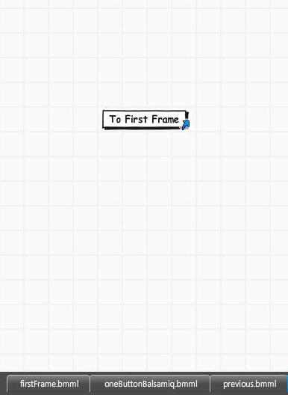
figure 5. A Balsamiq Mockup design. firstFrame.bmml (left), contains a button widget with a link transition to secondFrame.bmml (right), which contains a button widget with a link transition back to firstFrame.bmml.

SAMPLE BALSAMIQ TO COGTOOL DESIGN CONVERSION
Figure 5 is an example of a design made in Balsamiq Mockups. It has two frames (Balsamiq calls them ”mockups” and stores each in a separate file), each with a button in the middle. The button on firstFrame.bmml (left in figure 5) links to secondFrame.bmml (right in figure 5), and visa versa. Figure 6 shows the results of a successful conversion from these Balsamiq mockups to CogTool: two frames, each with a button, and transitions between them.

JUST THE BEGINNING
This work provides the framework within which converter code can be created that both imports files from prototyping tools into CogTool and dynamically generates a useable UI for designers. We will supply documentation allowing programmers to create converter code and also provide an example converter source file for Balsamiq Mockups to serve as a model for developing converters from other prototyping tools.
We plan to use this new import feature in the next year in at least two ongoing projects, importing from the ADEPT tool [3] to get predictions of airline pilot behavior in new cockpit designs, and importing from IBM and IBM-partner tools (e.g., Rational Requirements Composer, iRise, or the dijit GUI toolkit).
Programmers interested in writing converters for other prototyping tools will be able to access our code and documentation at the CogTool project website (http://cogtool.hcii.cs.cmu.edu/) and to share their converters there. We anticipate that this capability will open the door to using human performance modeling to UI designers and developers with little additional effort beyond their current prototyping activities.

Acknowledgements
We thank Don Morrison and Brad Myers (CMU) and Rachel Bellamy and Cal Swart (IBM Research) for their contributions. This research was supported in part by funds from NASA, NEC and IBM. The views and conclusions in this paper are those of the authors and should not be interpreted as representing the official policies, either expressed or implied, of NASA, NEC, IBM, or the U.S. Government.

References
- Blackmon, M. H., Kitajima, M., & Polson, P. G. (2005). Tool for accurately predicting website navigation problems, non-problems, problem severity, and effectiveness of repairs. In Proceedings of the SIGCHI Conference on Human Factors in Computing Systems. CHI '05. ACM, New York, NY, 31-40.
- Chi, E. H., Rosien, A., Supattanasiri, G., Williams, A., Royer, C., Chow, C., Robles, E., Dalal, B., Chen, J., & Cousins, S. (2003). The bloodhound project: automating discovery of web usability issues using the InfoScent simulator. In Proceedings of the SIGCHI Conference on Human Factors in Computing Systems. CHI '03. ACM, New York, NY, 505-512.
- Feary, M. (2007) Automatic Detection of Interaction Vulnerabilities in an Executable Specification. Lecture Notes in Computer Science, (4562), Berlin: Springer. 487-496
- John, B. E., Prevas, K., Salvucci, D. D., & Koedinger, K. (2004). Predictive human performance modeling made easy. In Proceedings of the SIGCHI Conference on Human Factors in Computing Systems. CHI '04. ACM, New York, NY, 455-462.
- Teo L., & John B. E. (2008). Towards a Tool for Predicting Goal-directed Exploratory Behavior. In Proceedings of the Human Factors and Ergonomics Society 52nd Annual Meeting, HFES, Santa Monica, CA, 950-954

http://www.balsamiq.com/products/mockups
http://www.irise.com/
http://dojotoolkit.org/projects/dijit
http://www-01.ibm.com/software/awdtools/rrc/

