Multi-Purpose Prototypes for Assessing User Interfaces in Pervasive Computing Systems

Bonnie E. John, Carnegie Mellon University
Dario D. Salvucci, Drexel University

In the realm of pervasive computing systems, prototypes serve a number of uses and have different requirements related to those uses. Some prototypes are built to test the physical form of a pervasive computer system — for example, will this wearable computer be light enough for eight hours of maintenance work, or small enough to allow a maintenance worker to crawl through a narrow passage inside a machine? The essential features of a prototype for this purpose are form-factor and weight, but this type of prototype need not be functional in any interactive way. Other prototypes are built to demonstrate that the proposed technical solution can function at all — for instance, can a signal get from A to B in sufficient time and with sufficient strength to fulfill the functional needs of the envisioned system? These prototypes need to be narrowly functional, perhaps only sending a signal in a full round trip, but not broadly functional, and they need not simulate the expected user interface for the system. On the other hand, prototypes for user interfaces (UIs) of pervasive systems are often built to serve one of three purposes: (1) to communicate design ideas to the development team, management, and/or customers; (2) to provide a basis for user studies, often with novice users, to identify usability problems with the design; and (3) to get information about projected performance by skilled users. When deciding when to build and test prototypes, the balance between the costs and benefits of development tilts in favor of prototypes that are easy to build and fulfill multiple purposes.
We have developed a tool called CogTool that enables very low-cost, rapid construction of interactive prototypes that serve all three UI purposes described above [1]. The core prototyping technique employed by CogTool is storyboarding — specifically, interactive storyboarding using HTML (HyperText Markup Language), a language most commonly known as a framework for pages in the World Wide Web. CogTool does not cover the entire expanse of possible pervasive systems. Instead, it focuses on systems that involve deliberate commands invoked by some motor action on the part of the user — a significant subset of pervasive systems including PDAs, cell phones, handheld terminals (e.g., those used by rental car return personnel), in-vehicle driver information systems, and certain wearable computers that run desktop- or PDA-like applications.

Multiple uses for HTML prototypes
A UI prototype can serve as a medium to communicate design ideas to team members not directly involved in design. Team members from software development, management, marketing, sales, technical writing, etc. can all get a feel for the overall design through a storyboard-like prototype. One purpose of such a prototype is to create shared understanding and get “buy-in” for the direction of the design from the various team members. A second purpose is to provide formative information about the user interface — that is, to identify usability problems early in the development process so improvements can be made before substantial coding time is invested. A third purpose is to provide summative information — that is, how much better the new system will be than the current system serving the same goal. For example, some pervasive computing systems replace paper-based systems, such as a wearable computer replacing a paper checklist or paper manuals, a PDA replacing a paper calendar and notepad, or an in-vehicle navigation system replacing maps. Often, the new system will be more expensive per unit than paper and a return on investment analysis is useful to convince management or consumers to invest in the product. Thus, estimates of measures like task performance time for skilled users are valuable to some projects. Each of these purposes delivers different information to the development team and puts different requirements on the prototype, as shown in Table 1.

Table 1. Different purposes of a prototype have different requirements and produce different results. White boxes indicate that a function is required to satisfy a particular purpose, light gray boxes are optional (see prose), and dark gray boxes can be ignored for the purpose named in the column heading.
Purpose of  the prototype | Communicating design ideas | User testing | Predictive human performance modeling
Requirements on the Prototype
Information navigation | Yes | Yes | Yes
Correct procedures | Yes | It depends | Yes
Best-guess labels/commands | It depends | Yes | No
Best-guess visuals | It depends | Yes | No
Size and layout of controls | It depends | Yes | Yes
Best-guess response time | No | No | Yes
Interactivity | No | It helps a lot | It depends
Products of the Prototype
 | Team understanding | Usability problems of novices | Performance time of skilled users
 | Team buy-in | Ideas for revised design | Bottlenecks in performance

Communicating design ideas
Communicating design ideas to people not directly involved in the design process requires that a prototype convey the general feeling of the planned interface. The prototype might be as simple as a series of drawings of the different system states (e.g., screens) that a designer presents to the rest of the group. It is necessary to convey how the user would access information and perform tasks on the system so the team can see the envisioned interaction techniques, accessibility of information, and what it would feel like to perform some tasks. Since designers often present their work to others in person, it is not necessary for the storyboard to be interactive or for all button and link labels to be drafted; interaction and command responses can be described rather than fully specified. Typically, it is also not necessary to provide information about projected system response time for user actions, because such lower-level information would not communicate well during a presentation and would usually be too fast in the context of a presentation. However, one critical aspect of the prototype is its visual look-and-feel: the closer the storyboard’s visuals are to the final system, the easier it will be for the audience to imagine a user’s interaction with the system.
With the advent of what-you-see-is-what-you-get (WYSIWYG) HTML editing tools, many designers already develop and present their prototypes in HTML. Because arbitrary images can be incorporated into HTML, the technology is expressive enough to create storyboard prototypes that communicate design ideas at whatever detail is desired (e.g., hand-drawn sketches or photographs of real devices or components). HTML also allows for simple interactivity with link transitions and basic components (e.g., pull-down menus and text boxes), and annotations explaining visuals, labels, procedures and design rationale, as illustrated in Figure 1. Such prototypes can also serve as a form of interface requirements from which code can be written. HTML storyboards are easy to share over the web (which sometimes unintentionally gives them “legs” as they are passed around and appear in places the original designers did not intend). Overall, HTML storyboards are efficient and sufficient representations to produce shared understanding and buy-in within an organization.

User testing
User testing places different requirements on prototypes. As above, the anticipated information navigation must be built into the prototype because navigation schemes are easily and usefully tested by asking users to think aloud as they perform tasks. The design team does not necessarily have to specify correct or optimal procedures for doing each task, because the user test often aims to determine whether a novice user can discover a correct path to accomplish each task. (However if the user test includes assessing the effectiveness of training materials, correct procedures are usually written into those training documents and are thus a requirement for such user tests.) The designers must provide the prototype with their best guesses at button and/or link labels, command names, and icons because user tests are excellent at uncovering ambiguities in such items. Although user testing can be done with non-interactive systems like paper prototypes, tests are much easier to administer, and the user’s experience is much closer to actual use, if the system is at least minimally interactive. However, since thinking aloud while doing a task slows performance, timing measures are unreliable in user tests and are therefore typically not recorded. Therefore, it is not necessary for the prototype to provide realistic system response time.
HTML prototypes are well suited for user testing purposes. They can be built with realistic information navigation, labels, commands, buttons, controls and visuals. Interactivity can be simulated by using links that take the user to another page in response to a user’s action. Unrealistic system response time incurred by the browser is not a problem, as argued above. Many usability problems in a pervasive computer system can be discovered even if the prototype is displayed on a desktop browser and operated with a mouse. In some cases, the form factor of the pervasive system can be approximated with the HTML prototype. For example, designing the HTML so that it displays well on Pocket IE allows a designer to deliver a prototype on a PDA. In our lab, we have positioned a touch-screen on the dashboard of a driving simulator and thereby prototyped in-vehicle navigation systems in HTML. Thus, clever prototyping with HTML storyboards often suffice for the purpose of user testing pervasive computer systems.

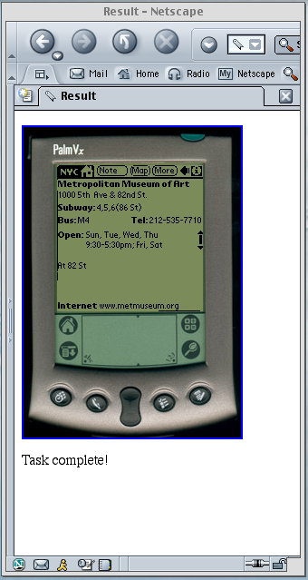
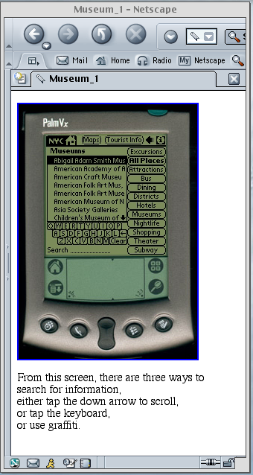
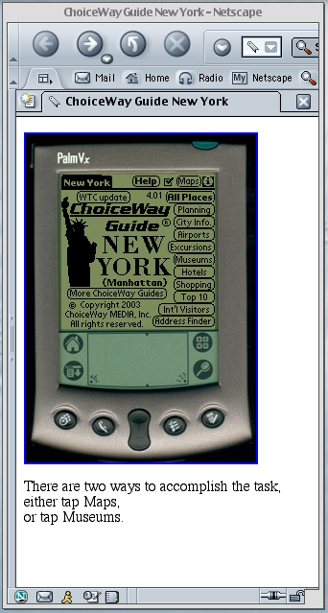
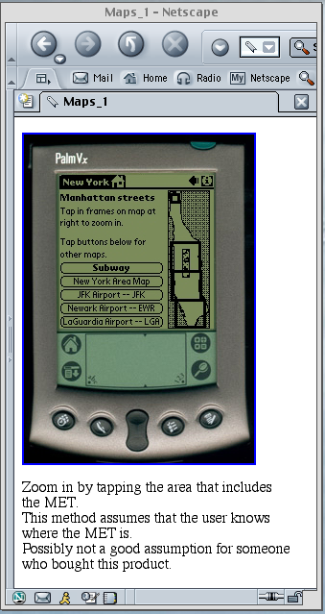
Several steps later
Several steps later
Step 1 in the Maps method
Step 1 in the Graffiti method

Figure 1: Parts of an HTML storyboard of an information finding task on a Palm PDA, annotated with user procedures and design rationale, shown within a browser.

Predictive human performance modeling
A third use of prototyping is to obtain information about the performance of skilled users. This can be done empirically but is very expensive, since measuring skilled performance would require that users interact with a robust prototype for hours, days, or even for weeks on end. However, performance time of skilled users can be obtained analytically by using predictive models of human behavior. Such models have been a centerpiece of applied cognitive psychology in HCI for two decades. The Model Human Processor (MHP), Keystroke-Level Models (KLMs) and GOMS (Goals, Operators, Methods, and Selection Rules) were introduced and validated in the early 1980s [2]. Since this time, other cognitive architectures — unified psychological theories and computational frameworks — have been developed to model human performance at many levels. For example, ACT-R [3] and similar cognitive architectures have been used to simulate behavior in a number of complex dynamic domains including air-traffic control [4] and driving [5].
Predictive human behavior modeling has historically been done in three ways: (1) manually by a human analyst, (2) computationally via “faked” interaction with a skeletal prototype, and (3) computationally via “real” interaction with an implemented prototype. In the most basic frameworks (e.g., MHP, KLM), a skilled analyst lists by hand all the actions required by the human and the estimated system response time of the system in response to those actions. The analyst then adds up the time to perform each listed operator. When a computational cognitive architecture is used (e.g., ACT-R, some versions of GOMS, etc.), the analyst can fake the interaction with a prototype simply by programming the cognitive architecture to wait a certain amount of time for each manual or perceptual action; the duration of the wait would correspond to previously established estimates taken from the psychology literature. Finally, the modeler may choose to exploit the computational cognitive architecture by connecting the model to some functional prototype so that the human simulation and the system simulation (prototype) can work in concert to generate predictions of skilled human performance.
In all these ways of doing predictive human behavior modeling, the prototype that the human analyst works from (in 1 and 2) or that the cognitive architecture connects to (in 3) must have the information navigation specified or the analysis cannot proceed. The procedures for tasks must be known by the analyst and programmed into the cognitive architecture as “task knowledge” to simulate a user who knows how to use the system. Labels and visuals need not be well worked out because skilled users would have learned even the most unintuitive terms or icons, and cognitive architectures typically function as well with a generic label (e.g., “Label 1”) as they do with a semantic label for a button or link. However, skilled performance time is dependent on the size and position of controls, so these must be specified in the prototype. In all cases, an estimate of expected system response time is needed to make accurate predictions, and an interactive prototype is needed only when it is connected to a cognitive architecture.
HTML storyboards supply the requirements of prototypes for predicting human performance in all the ways described above. They depict the interface sufficiently to give information navigation, correct procedures, and size and layout of controls. They usually depict best-guess labels, commands and visuals, which are not needed by human performance models but also do not get in the way. As we describe next, we have adapted ACT-R to interact with an HTML prototype through a web browser and have created a mechanism for specifying estimated system response time that is independent from the actual response time of the browser or the speed of the cognitive model. Thus, HTML storyboards can fulfill the requirements to predict skilled human performance as well as those related to communicating design ideas and user testing. Therefore, building HTML storyboards as prototypes fulfills multiple purposes for sharing and evaluating proposed user interfaces for a large subset of interactive pervasive systems.

CogTool
CogTool is a new human performance modeling system created to make this technique more accessible and affordable for computer system designers [1]. Based on a human information processing theory of human behavior, the underlying psychological theory was decades in the making, drawing from scores of results in the psychological literature and validated through HCI research and real-world use over the last 20 years [7]. In recent years, we have undertaken user-centered design of CogTool to understand the knowledge and skills of UI designers, understand their workflow and workplace influences, uncover common error patterns, and user test iterations to improve the design. The result is a tool that is produces keystroke-level predictions of human performance models from demonstration of tasks on an HTML prototype. These predictions are as accurate as can be expected from the underlying theory (typically regarded as producing skilled performance time estimates within 20% of the actual performance) with an order of magnitude less effort than when done by hand. This paper extends the previous work by demonstrating CogTool’s application to pervasive computing devices.

Underlying cognitive theory
CogTool is based on the Keystroke-Level Model (KLM) version of a human information processing (HIP) theory of human behavior proposed by Card, Moran and Newell in the early 1980s [2]. A HIP model (Figure 2) has a perception module that takes information from the world (i.e., the prototype) and passes it through to a cognitive module. The cognitive module processes that information, possibly combining it with information from other sources (e.g., a long term memory not shown), and sends commands to a motor module. The motor module takes action in the world by manipulating the prototype.

Figure 2: Information-processing block diagram with KLM operators.
The HIP theory underlying CogTool is specific to skilled human behavior with computer-based tasks, where certain time parameters apply. Perception takes on the order of hundreds of milliseconds because signals in computer-based tasks are assumed to be relatively easy to perceive (e.g., perception would take longer if the tasks took place in extremely low light for visual signals, or in high noise for auditory signals). The motor module in KLMs for desktop applications included operators for pressing keys (K), pointing (P), and homing between the keyboard and the mouse (not relevant to many pervasive computing systems, so not shown). To extend to PDAs, we have added a Graffiti motor operator (G). The duration of motor operators are set from psychology literature, with K dependent on a person’s typing speed, P related by Fitts’s Law to the distance moved and the size of the target, and G empirically determined in an experiment using a Palm PDA [8]. On a desktop, point-and-click was modeled by a K following each P to a target; for pervasive systems this K is unnecessary because the original formulation of Fitts’s Law included physical contact with the target [9], analogous to pressing a button or tapping with a stylus. KLM has one “mental operator,” M, that represents a composite of all unobservable activities including cognitive and perceptual activities like comprehension of perceptual input, recognition of the situation, recall of commands, decisions, etc. Card, Moran and Newell empirically estimated M to be 1350 msec. In CogTool, we estimate M to be 1200 msec to accommodate the ACT-R architecture, which would normally require a 150 msec look-at operator with typical mental operations.
KLM makes approximate predictions of human behavior by assuming that a skilled person will execute each operator necessary to complete a given task sequentially, and all times are added together to get an estimate of total task time. Predicting the sequence of motor operators is straightforward, only requiring that an analyst know the task and system sufficiently well to list the necessary operators to perform the task successfully. Including mental operators is more difficult. Card, Moran and Newell, working with command-based desktop interfaces, defined five rules for placing Ms in a KLM that were dependent on distinctions such as commands, arguments, and “cognitive units.” CogTool has updated and automated the placement of M operators by tying them to specific types of widgets found in modern interfaces. If the system being modeled has system response time that makes a user wait (which in practice means that it exceeds the duration of an M), then the KLM includes the waiting time in the total task time.
In the past two decades, while developers were using KLM pragmatically in HCI, cognitive psychologists were developing computational cognitive architectures with more sophisticated explanations of the details of human performance. ACT-R incorporates significantly more detailed theoretical accounts of human cognition, perception, and performance than a typical KLM. For instance, the ACT-R computational engine includes a theory of eye movements and visual attention, a theory of motor preparation and execution, and a theory of which operations can proceed in parallel with other operations. In 2003, Salvucci and Lee [10] implemented a KLM-like modeling language, ACT-Simple, that compiles into ACT-R commands. We chose to build CogTool on top of ACT-Simple to marry the simplicity of KLM with the predictive power of the ACT-R computational engine. We added the ability for ACT-R to interact directly with HTML storyboard prototypes, “seeing” the widgets on the HTML page and operating those widgets with ACT-R’s “hands”.
Most work with KLM assumes that the user is currently engaged in only one task. However, we have been researching how to combine separately-developed models of single tasks to predict the multitasking behavior that results from performing both tasks together. Building on experience developing multi-tasking models of driving and driver distraction solely in the ACT-R architecture [5], we have incorporated an ACT-R model of driver behavior into CogTool [11]. Prototypes of secondary tasks like dialing a cell phone or finding the nearest gas station with an in-vehicle navigation system can be built with CogTool and integrated with the driving model. Although theories of how people switch between tasks are still evolving, the driving model in CogTool approximates human behavior by switching to the secondary task when its driving is “safe” (i.e., the vehicle is stable and near the lane center). At the present time, the analyst must instruct CogTool when to switch back to driving from the secondary task, such as after a few button presses, at the end of a subtask, or only at the end of the entire task; task switching strategies can have a large impact on driving performance. The integration with driving extends CogTool conceptually into a much broader array of interfaces and devices that are used in the context of real-world multitasking, like many of today’s pervasive systems.

How designers use CogTool
The most important aspect of CogTool is that, even with as rigorous an underlying theory as ACT-R, designers need not have any experience with or knowledge of human performance modeling whatsoever — the details of the theory and models are hidden from the designer. Instead, CogTool provides a simple interface through which to build interfaces, specify common tasks on the interface, and then automatically predict and analyze the behavioral results of skilled users, with models in the background serving the role of simulated users.
A designer begins by using CogTool to build an HTML storyboard prototype of the proposed interface. CogTool adds a palette to Dreamweaver®, that produces HTML and Javascript that can communicate with CogTool while building a task model, and communicate with ACT-R when a model is run. This palette contains many familiar UI widgets for desktop applications like buttons, checkboxes, links, textboxes, etc. It also contains tools more suited for prototyping pervasive computer systems, like images, hotspots to place on those images, and a Graffiti area. Other tools in the palette give the designer the ability to express non-manual actions in a task. The tool that looks like a steering wheel tells the model to switch back to driving from a secondary task. The eye tool tells the model to look at a hotspot to gather information but not touch it. The stopwatch inserts system response time delay before the HTML storyboard page loads. The microphone and speaker tools allow the model to speak to the storyboard and listen to it, respectively, thereby prototyping auditory interfaces.
After the designer has created the HTML prototype, s/he demonstrates the desired tasks by clicking on the widgets in the storyboard. Behind the scenes, CogTool’s Behavior Recorder [12] records all interactions with the HTML prototype and stores these events. (Note that the designer’s actions are not a timed during these demonstrations; she could click on one widget, have a cup of coffee, then click on the next widget, and the resulting model of skilled performance would be the same as if no coffee had been sought.) The designer then tells CogTool whether the prototype is of a mouse-based desktop system or a system that uses a stylus (or finger) as its primary mode of interaction. For standard desktop systems, CogTool translates the demonstrated clicks to mouse and keyboard actions, but for more general pervasive systems the clicks are interpreted as taps with a stylus, Graffiti strokes, or physical depressions of a button or similar component (e.g., on a phone or navigation device). CogTool also places mental operators according to rules derived from Card, Moran and Newell’s results, but updated to apply to the widgets in the CogTool palette. The end result of the demonstration is a model expressed in ACT-R. When run, ACT-R interacts directly with the HTML prototype, “seeing” the widgets on the page and “pressing” them, thereby operating the prototype and producing a trace of skilled user behavior with quantitative predictions of performance time.
If the designer wishes to evaluate use of the interface while driving, s/he selects the Driving + Task Model option in the Model Launcher. A window opens that shows a road from the viewpoint of a driver and places a wire frame of interface on the dashboard (Figure 3). The model drives the car down the road and performs the secondary task, switching tasks as described in the previous section. This results in predictions of performance measures typical of empirical studies of driver distraction — for example, vehicle lateral deviation from lane center and brake response delay from the onset of an external event (e.g., lead-car braking). Obtaining such results from CogTool requires no additional effort on the part of the designer, except that it is sometimes useful to designate different reasonable points at which the driver switches between interface use and driving to explore the boundaries of safe and reckless attention to the road.

Experiences in pervasive computing tasks
We have used CogTool as a prototyping and evaluation tool in a variety of pervasive computing tasks. Twenty-seven undergraduate and masters students in Carnegie Mellon’s HCI Methods class in Fall 2004 used CogTool to model different methods of entering a new appointment into a PDA calendar. Masters students in a Spring 2004 cognitive modeling class used CogTool to model common tasks on a Palm PDA and on an in-vehicle navigation device. One student created over 300 models to explore strategies for error detection and correction in cell phone SMS-like text-entry using both multi-tap and T9. One software engineering researcher used CogTool to predict the skilled use of a Palm application to find information about the Metropolitan Museum of Art (Figure 1) and checked her predictions with a user study [13]. In her study, people were trained to access the requested information using one of four methods: map navigation, query by a soft keyboard, query by Graffiti, and locating the museum in a scrollable list. A prototype of the interface was quickly generated with the CogTool and each of the four tasks was demonstrated in the system to produce predicted performance results. Comparing the predictions to the results of human users, CogTool performance corresponds extremely well with human performance, with an average absolute error of less than 8%.
Finally, we used CogTool to replicate earlier results that predicted driver distraction with cell-phone dialing models written by expert ACT-R modelers [10]. We created mock-ups of a simple cell phone and demonstrated a 7-digit dialing task, with the assumption that drivers switched back to driving between the 3- and 4-digit blocks of the full number. Simply by asking CogTool to run this as a secondary task while driving, we could simulate this behavior and gather performance measures of the interactive effects of dialing and driving. Figure 4 shows that the tool’s predictions match well with the human data: first, driving slightly increases the total time needed to complete dialing, and second, dialing significantly affects the lateral deviation of the vehicle (i.e., distance from lane center as a measure of steering accuracy). CogTool thus produced the earlier expert findings with only minutes of prototyping and simulation, hiding the details of the complex models from the designer and simply presenting the final measures for analysis.

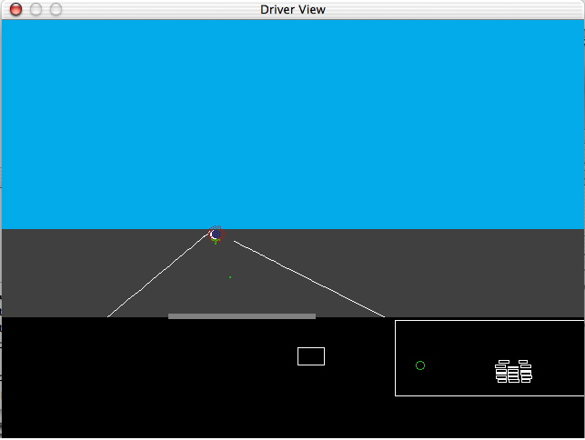
Wireframe of the device.
ACT-R’s eyes will look at it and its right hand will move to it when doing the secondary task.
Position of ACT-R’s right hand when it is on the wheel
The far point where
ACT-R’s glance resides when it monitors driving.
ACT-R’s hand in transit to the cell phone

Figure 3. Operation and results of a model of driving a cell phone while driving (adapted from [11]).

Conclusions
CogTool offers great potential for serving three major purposes of UI prototyping in pervasive systems. CogTool’s HTML prototypes can communicate design ideas between team members, serve as the basis for user tests with novice, and interact with cognitive models to predict skilled user performance. Because the modeling process has been simplified from a programming task, painstakingly specifying human behavior at the level of eye and finger movements, to one of simply demonstrating a task, we believe that human performance modeling will be more accessible to pervasive and interactive system designers than it has been in the two decades since its introduction as a UI evaluation method. Because ACT-R already includes several modalities (e.g., both vision and audition, both manual and speech acts) and is relatively easy to extend, we believe that CogTool will grow as a modeling tool for pervasive computing systems as well as the traditional desktop systems. We invite you to try CogTool, documentation and download available at http://www.cs.cmu.edu/~bej/cogtool/. We look forward to hearing about your experiences and improving CogTool to meet your needs.

Acknowledgements
We thank Peter Centgraf, Alex Eiser, Mike Horowitz and Gus Prevas for their work on CogTool, Lu Luo for her Palm PDA model and data, and the students in HCI Methods and Cognitive Modeling for HCI at CMU for their efforts using CogTool for modeling assignments.
Bonnie John was supported by Office of Naval Research grant N00014-03-1-0086; Dario Salvucci by Office of Naval Research grant N00014-03-1-0036. The views and conclusions contained in this document are those of the authors and should not be interpreted as representing the official policies, either expressed or implied, of the Office of Naval Research or the U. S. Government.
References
[1] John, B. E., Prevas, K., Salvucci, D. D., & Koedinger, K. (2004). Predictive human performance modeling made easy. In Human Factors in Computing Systems: CHI 2004 Conference Proceedings (pp. 455-462). New York: ACM Press.
[2] Card, S., Moran, T., & Newell, A. (1983). The psychology of human-computer interaction. Hillsdale, NJ: Lawrence Erlbaum Associates.
[3] Anderson, J. R., Bothell, D., Byrne, M. D., Douglass, S., Lebiere, C., & Qin, Y. (2004). An integrated theory of the mind. Psychological Review, 111, 1036-1060.
[4] Taatgen, N. A., & Lee, F. J. (2003). Production compilation: A simple mechanism to model complex skill acquisition. Human Factors, 45, 61-76.
[5] Salvucci, D. D. (2001). Predicting the effects of in-car interface use on driver performance: An integrated model approach. International Journal of Human-Computer Studies, 55, 85-107.
[6] Blackmon, M. H., Kitajima, M., & Polson, P. G. (2005) Tool for accurately predicting website navigation problems, non-problems, problem severity, and effectiveness of repairs. In Human Factors in Computing Systems: CHI 2005 Conference Proceedings (pp. 31-40). New York: ACM Press.
[7] John, B. E., & Kieras, D. E. (1996). Using GOMS for user interface design and evaluation: Which technique? ACM Transactions on Computer-Human Interaction, 3, 287-319.
[8] Fleetwood, M.D., Byrne, M. D., Centgraf, P., Dudziak, K., Lin, B., & Mogilev, D. (2002) An evaluation of text entry in Palm OS-Graffiti and the virtual keyboard. Proceedings of the Human Factors and Ergonomics Society 46th Annual Meeting. Santa Monica, CA, 2002.
[9] Fitts. P. M. (1954). The information capacity of the human motor system in controlling aplitude of movement. Journal of Experimental Psychology 47, 381-391.
[10] Salvucci, D. D., & Lee, F. J. (2003). Simple cognitive modeling in a complex cognitive architecture. In Human Factors in Computing Systems: CHI 2003 Conference Proceedings (pp. 265-272). New York: ACM Press.
[11] John, B. E., Salvucci, D. D., Centgraf, P., & Prevas, K. (2004). Integrating models and tools in the context of driving and in-vehicle devices. In Proceedings of the Sixth International Conference on Cognitive Modeling (pp. 130-135). Mahwah, NJ: Lawrence Erlbaum Associates.
[12] Koedinger, K. R., Aleven, V., and Heffernan, N. (2003). Toward a rapid development environment for Cognitive Tutors. Artificial Intelligence in Education: Shaping the Future of Learning through Intelligent Technologies, Proceedings of AI-ED 2003, IOS Press, 455-457.
[13] Luo, L., & John, B. E. (2005). Predicting task execution time on handheld devices using the keystroke-level model. In Human Factors in Computing Systems: CHI 2005 Conference Proceedings (pp. 1605-1608). New York: ACM Press.

Some computational cognitive models predict the behavior of users when confronted with semantic labels for buttons, menu items, or links, e.g., CoLiDeS [6].

