Printed Circuit Board Design 101 Using Eagle CAD

Pre-Class Preparation

Hey Everyone !
I’m looking forward to seeing you at Printed Circuit Board Design 101 Using Eagle CAD.
Before you arrive, there’s a few chores you must perform:

INSTALL /VERIFY EAGLE CAD
We will be using freeware version 7.2 or later.. If you have anything newer than 7.0 you should be OK.
[ ] Download from https://cadsoft.io/ appropriate version for your OS

[ ] Install and Startup Eagle:
[ ] Run as Freeware ? YES

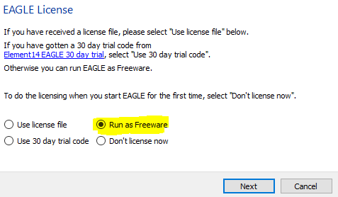

[ ] Create $HOME/eagle directory ? YES

[ ] Startup Eagle The Eagle Control Panel Should Come Up:

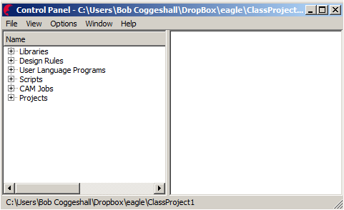

[ ] From the menu selection Options->Directories
[ ] Replace highlighted items with wherever your preference is for where to put things. (UNIX AND MAC: REPLACE ; with : and \ with / )
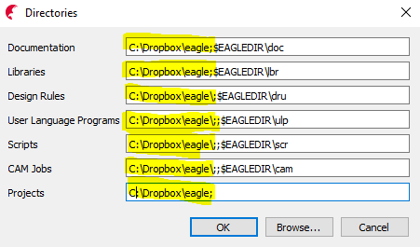

DOWNLOAD AND INSTALL FILES WE WILL USE IN CLASS

https://github.com/cogwheelcircuitworks/IntroToEagleCAD

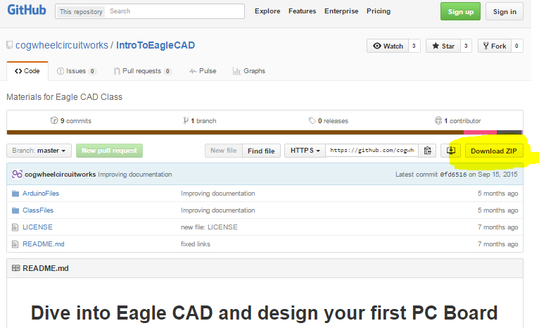

[ ] place in same location under the same directory that you set in Eagle CAD above.

You should now see all of this in the Eagle Control Panel Browser:

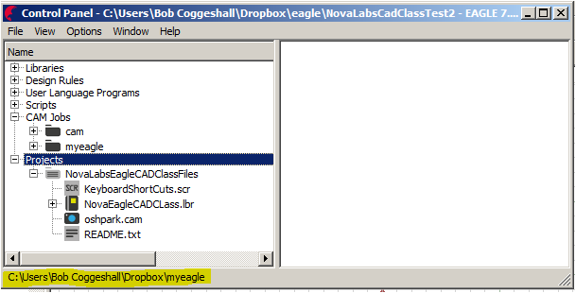

CREATE A LOGIN ON OSHPARK
[ ] Create A Login/PW on www.oshpark.com Have login / password ready for use in class

THANKS ! SEE YOU IN CLASS !

