Nova SMT Practice Board
Revision X
9/22/2015
Errata

The following modifications must be performed:
- Jumper Anode of LED 15 to Anode of LED16
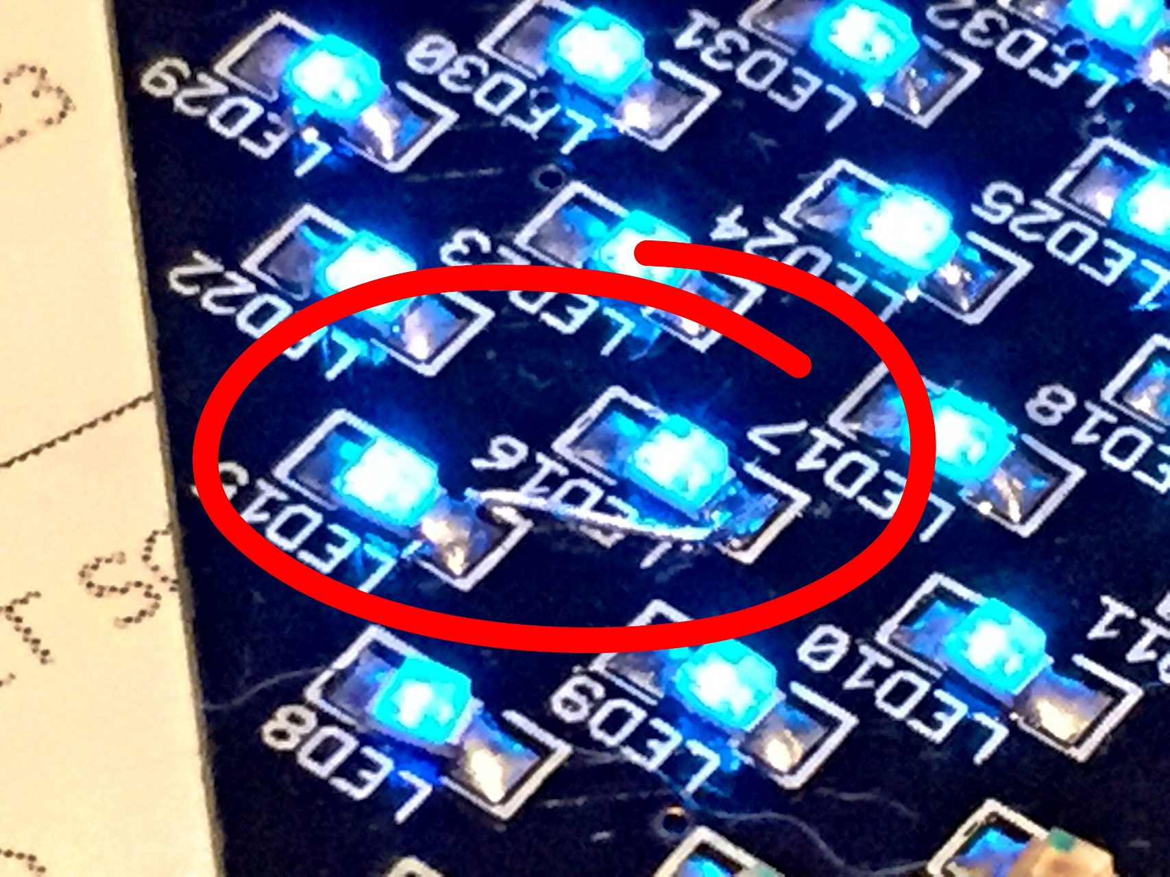

- Add high-side switch to Column Drivers; Rotate R1-R5 90degrees, add AWG30 wire-wrap wire to open end, attach drain of N-CH MOSFET to this common wire, Attach Source to VCC, Attach Gate to SCK of ‘ATTiny.
