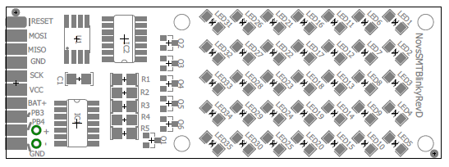
Nova SMT Blinky
Revision D
https://github.com/cogwheelcircuitworks/NovaSMTBlinky

Nova SMT Blinky is a 5x7 LED dot-matrix display board. It is used in kit form to teach surface-mount soldering classes. There is an assembled version as well.
Nova SMT Blinky uses an Microchip ATtiny 85 Processor. It can operate from 3 1.5V batteries or a 5 volt supply. It can be driven with either 5V or 3.3V sytems.
Nova SMT Blinky comes with firmware which allows it to be used as a smart display peripheral with a host system. There is a bar-graph mode. There are two dot-matrix character sets – 5x7 for one character, or 3x5 to display two characters side-side. There is also a raw mode where each individual led can be accessed.
Demo Mode
When supplied just power, Nova SMT Blinky will come up in 'demo' mode, showing off its various capabilities and special effects.
Driver Library
An Arduino-compatible library is available which can be used drive Nova SMT Blinky as a display peripheral
Source Code & Schematics
For people who would like to program Nova SMT Blinky directly, source code is included, which can be loaded into the Arduino IDE along with 3rd party support for AtTiny. New firmware can be flashed using a Tiny AVR Programmer available from SparkFun. Schematics and Eagle CAD files are also included.

Using Blinky Stand-Alone
Nova SMT Blinky has a demo mode which is fun all by itself. Simply attach a 5V supply to the VCC pin along with a ground connection to GND. When it powers-up, it looks to see if the MOSI pin is being pulled down to ground. If it is pulled high or disconnected, demo mode will commence.

Using Blinky as a Peripheral
There is an arduino-compatible driver located under software/libraries/NovaDotMatrixDriver/, in the github repository. Copy this to your Arduino IDE's libraries folder and restart the Arduino IDE. You will then be able to navigate to File -> Examples -> NovaDotMatrixDriver and load the example sketch.

At the top of the setup() function, note the pin assignments for clk_pin and data_pin. Attach clk_pin to to Nova SMT Blinky's SCK pin. Attach data_pin to the MOSI pin, along with 5V and GND. When the example sketch is started and Nova SMT Blinky reset, the sketch will run through various demonstrations.
The sketch uses 'bit-bang' mode, so you should be able to use Nova SMT Blinky with any digitial pins of any Arduino-compatible processor.

Hacking on Blinky Software
Source code to Nova SMT Blinky is available under /software/libraries/NovaDotMatrix/ in the github repository. You will need a SparkFun TinyAVR Programmer. You will also need to install support for the Attiny into your Arduino IDE. Sparkfun has an excellent tutorial covering everything. Google /SparkFun Tiny AVR Programmer tutorial/ to access it.
Here is the hookup diagram:
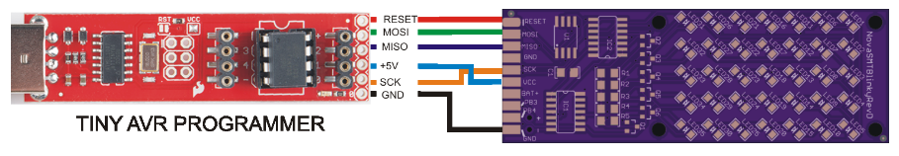

Hardware Hacking
Schematics, board layout and Eagle CAD files are located in NovaSMTBlinky/hardware/RevD/ in the gitbhub repository.

