Replicator User Manual

Code Replicator is a general purpose interactive programmer's tool
for creating large blocks of similar code from list(s) of variables.
It saves programmers from boring and repetitive tasks and it is faster than manual typing.
This program is free and open-source, and allowed for commercial use.

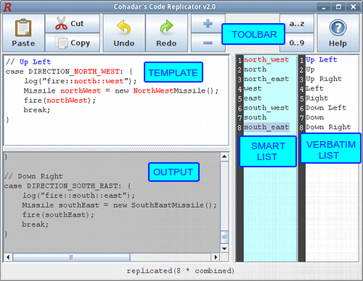
Code Replicator consists of five regions:
- TOOLBAR – contains replicator commands for text and list manipulation
- SMART_LIST – contains list of smart variables in c_lower case
- VERBATIM_LIST – contains literal text lines (any character allowed)
- TEMPLATE – contains text to be replicated
- OUTPUT – contains replicated text

How it works
First variable in smart list and first variable in verbatim list behave as arguments of template. Program colors them in red and blue respectfully.
In the picture above smart argument is north_west
and verbatim argument is Up Left
Smart argument can match entries in template of any case with any separator. Notice how in the picture above it detects all of these:
northWest, NorthWest, NORTH_WEST, north::west
Verbatim argument can match only exact literal strings:
''Up Left'' can match only ''Up Left'', it cannot match ''up left'' or ''UP_LEFT''

The text of template is copied to output M times.
M = Min(Size(SMART_LIST), Size(VERBATIM_LIST)).
In each iteration smart argument replaces all his matches in template by a variable from smart list while preserving case and separator used in template.
At the same time verbatim argument is simply replaced verbatim by arguments from verbatim list.
Output text is generated on any text change in template or any of lists.
Simple left-click on output area copies all output text to clipboard.

Conventions
Entries in smart list must be in lower case separated by underscores.
If they are not they will be automatically converted by replicator.
If you enter ''HelloWorld'' inside smart list it will be converted to ''hello_world''
If your smart list has no names combined from two or more other names you don't have to use underscores, you can simply write all in lowercase.
But if you have underscores in your list than first entry (smart argument) must have underscore so it can detect separators in template.
You don't have to use two lists all the time, if one of the lists is empty only the other one will be used in replication.
To get a better technical background for this application and it's potential uses please read case-inference.pdf

Code, sources and documents for Code Replicator can be downloaded from:
http://codereplicator.sourceforge.net/

