Report Delivery Instructions

Assume we have a third-party reporting application outputting numerous reports meant for clients. Update C# service application that collects these reports and moves them to various destinations grouped by clients. The C# application will read an XML configuration file like the one below and is mocked up in the project (MockPackageConfigReader)

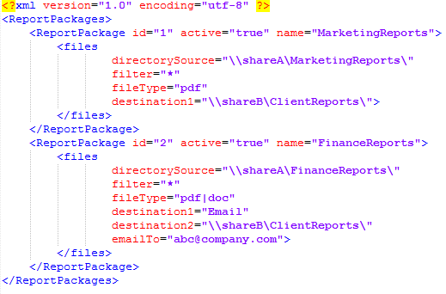

1. Read all files from the source with the specified filter and filetype (implement SampleFileReader)
2. To group the reports by client, retrieve the client-account mapping from Client repository
3. Assume files from all source directories will have the following naming conventions (AccountCode+ReportDate+FileExtenstion),

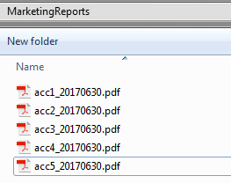

1. Create the following folder structure with year/month/clientcode and copy the reports to their respective client folders by implementing DeliverReports in ReportDeliveryService

