Chris Cohen
CS426 – Spring 2021
SETUP TASK 4 (10 points)

1. Output of ‘dig ns.cohen50.com’ – proof that our local dns server forwards this request to the attacker VM. As you can see, the answer section gies us the IP of 10.0.2.8, which is the IP of the attacker VM.

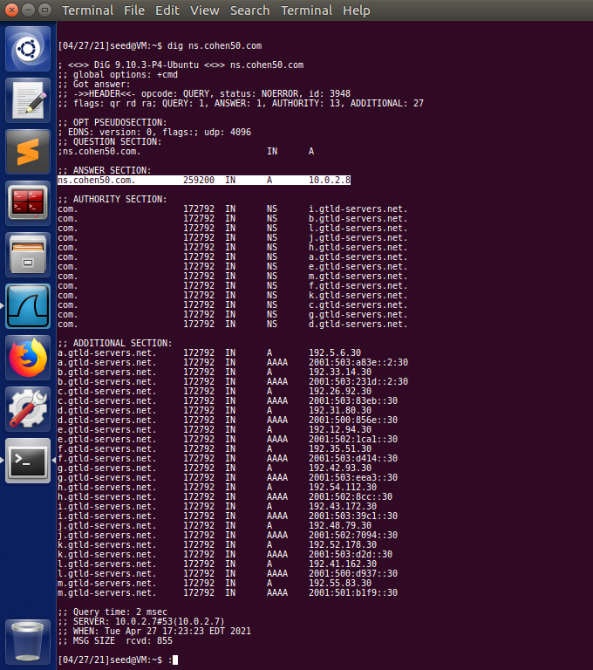

2. The output of ‘dig www.example.com’ vs ‘dig @ns.cohen50.com www.example.com’. When we don’t use our local nameserver (ns.cohen50.com), the request is successful, and gives us the expected IP of 93.184.216.34 in the answer section. If we use our nameserver, though, the dig request returns the falsified IP of 1.2.3.5 in the answer section.

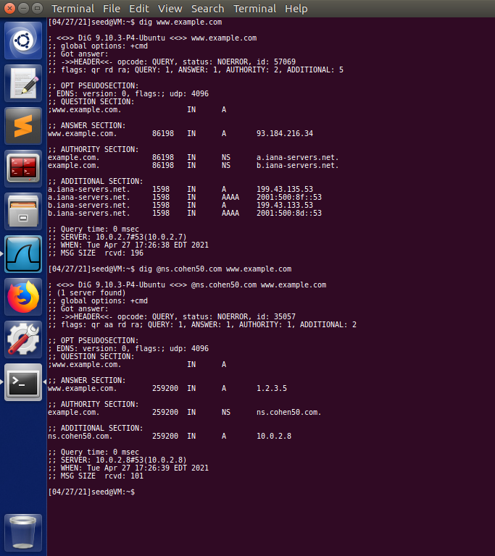

ATTACK TASK 4 (15 points)

1. Proof that I’ve made a program to construct a DNS request. As you can see, after running my attacktask4.py program, a DNS request is sent from 10.0.2.8 (attacker VM) to 10.0.2.7 (local DNS server). The DNS server then responds immediately afterwards. We know that the request packet is correctly formed because Wireshark labels it as “standard query”, and also that the local DNS server gives us a valid response.

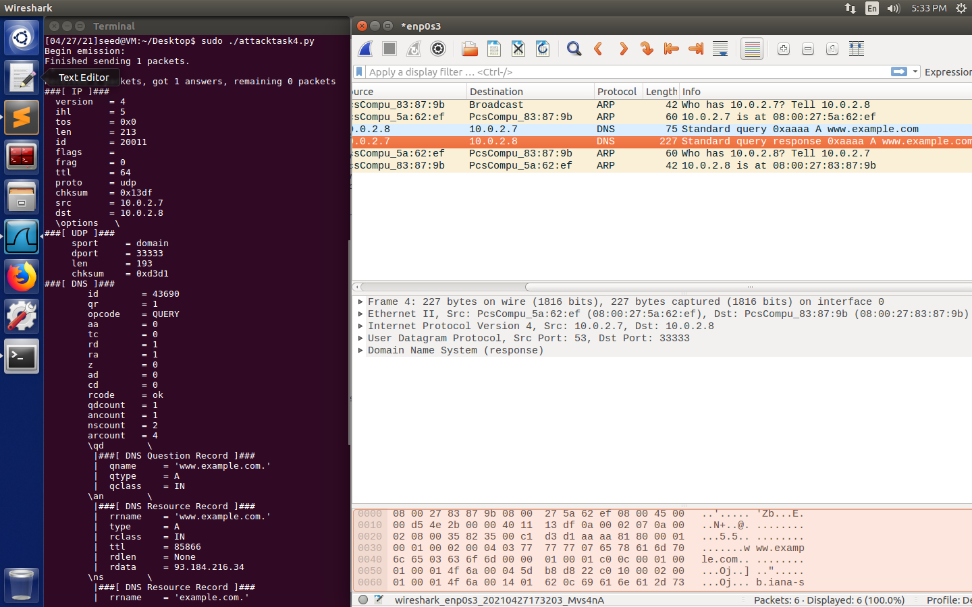

ATTACK TASK 5 (20 points)

1. Proof that I’ve made a program to forge DNS replies. As you can see, when I ran my attacktask5.py program, it forged a reply to make it look like one of the IPs of the nameservers for www.example.com (199.43.133.53) responded to a DNS query with our falsified nameserver. In my code, I had to fill in some values to make this work. The ‘name’ field had to be the domain name that the user queried (in this hypothetical case, it was www.example.com). The ‘domain’ field must be the root domain of the website (in our case, just example.com). The ‘ns’ field had to be our falsified nameserver, pointing to the attacker VM rather than the real nameserver. In our case it is ‘ns.cohen50.com’. Then, for the IP layer, I had to make the destination IP that of the local DNS server so that, in the future, the local DNS server hopefully caches that reply. The source IP had to be that of the known official nameserver, as I mentioned earlier. Lastly, for UDP, the source port had to be 53, which is the typical DNS port. The destination port is hardcoded to 33333, which we made static during our setup process.

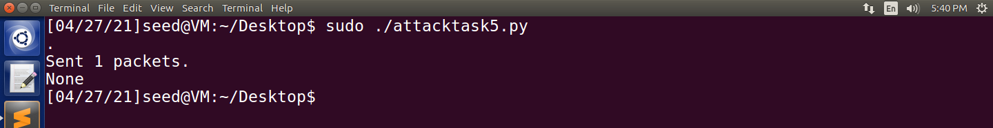

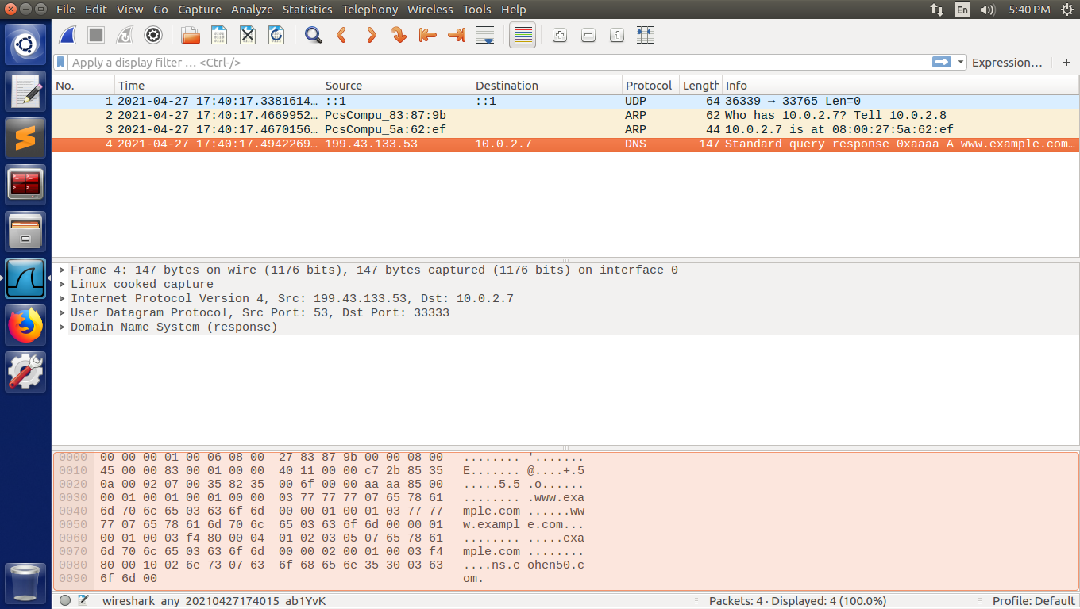

ATTACK TASK 6 & 7 (40 points)

1. Proof that the attack poisons the local DNS cache (our falsified nameserver is stored in local DNS server’s cache).
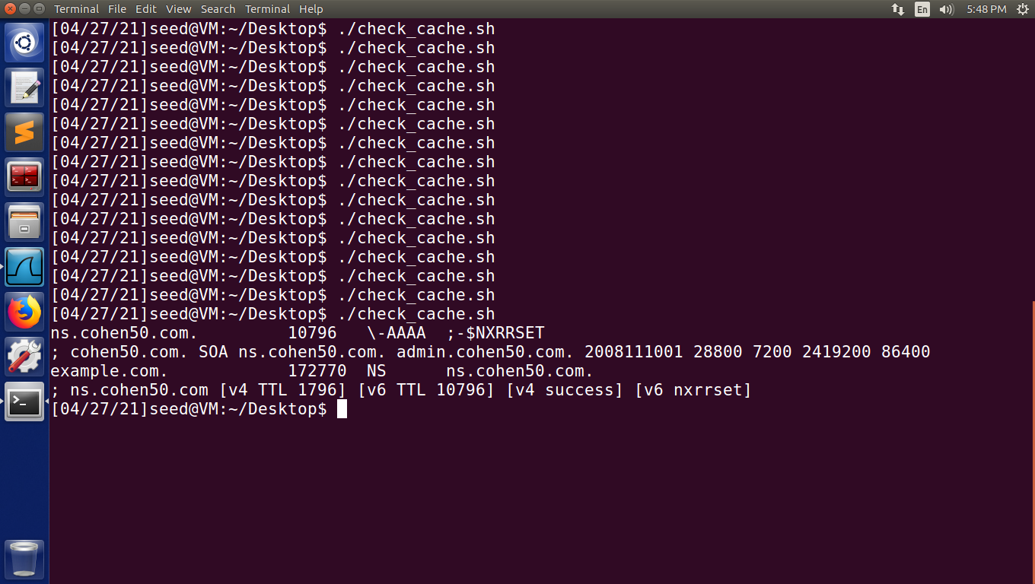
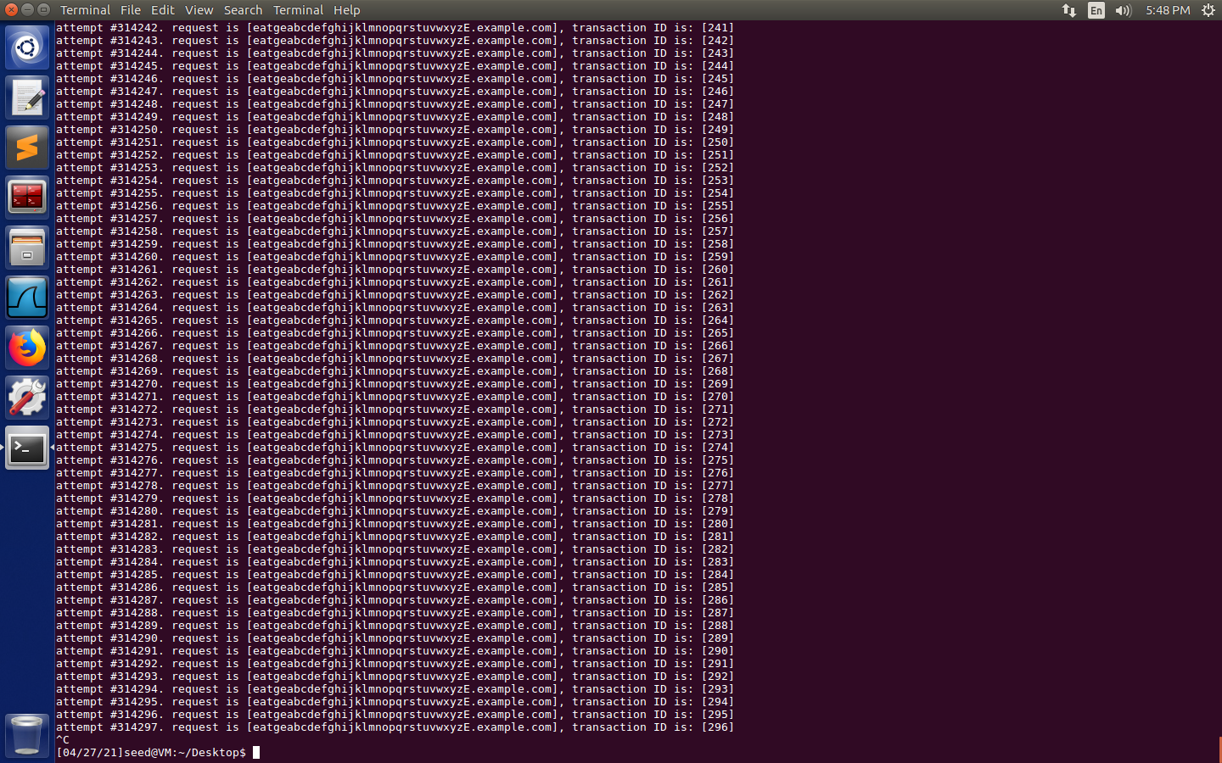
2. Proof that our User VM always uses the malicious nameserver ns.cohen50.com.
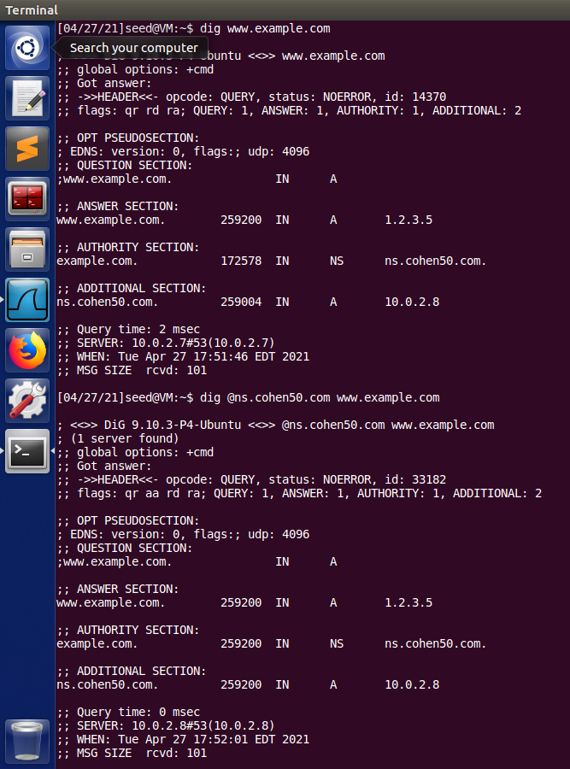

3. Explanation of attack.c code and why this attack works:

First, I send a DNS request for a random subdomain that has likely never been queried before, so the local DNS server must reach out to the authoritative nameserver to find the IP. Using bless, I found specific offsets that I needed to modify the subdomain in my request template. To modify the subdomain in the question field, I just needed to memcpy the new subdomain to an offset of 41. The same method is used to modify the transaction ID field (offset of 28). Then, the request is sent.

For every DNS request sent by the attacker VM, 500 attempts are made to spoof the reply. I sent a fake reply with source IPs from both known authoritative nameservers (199.43.135.53 and 199.43.133.53). Then, in similar fashion to the request packet, I modify fields. I modify the source IP address of the fake response packet by inserting it into an offset of 12. I modify the subdomain in the question and answer fields with offsets of 41 and 64, respectively. Lastly, I modify the transaction ID (our guess) with an offset of 28. Then, the packet is sent to our local DNS server. If our guessed transaction ID matches a request that is waiting for a response, the DNS cache is poisoned.

When we guess the transaction ID correctly, the local DNS server caches our falsified entry. It changes the nameserver for example.com to ns.cohen50.com, and since we’ve set up forwarding for that nameserver to our attacker VM, all requests are routed to the attacker VM.

Below is a screenshot that verifies our result. In the terminal to the left, I ran ‘dig www.example.com’. I highlighted the response from our local DNS server (10.0.2.7), which gives us the IP 1.2.3.5, authoritative nameserver of ns.cohen50.com (and corresponding IP 10.0.2.8!). Clearly, the cache has been poisoned.


