Assessing the Impact of Monetary and Macroprudential Policies on Israel's Housing Market: A DSGE Model Approach
Alex Ilek , Nimrod Cohen and Yaakov Chen-Zion
March 10, 2026
Abstract
We develop and calibrate a dynamic stochastic general equilibrium (DSGE) model tailored to the Israeli economy, incorporating key features of its housing market—both ownership and rental segments—and household heterogeneity. The model is used to analyze the effects of monetary and macroprudential policies, as well as their interaction, on the housing market and the broader economy. Specifically, we examine how macroprudential measures—such as changes in the loan‑to‑value (LTV) ratio and restrictions on the share of time‑varying‑rate mortgages—affect the ability of monetary policy to achieve its objectives of price and real activity stability, and how these tools influence housing market outcomes, including mortgage volumes and housing prices.

JEL classification: R21, E32, E52, E61.
Keywords: housing market, monetary policy, macroprudential policy, ownership-to-rent ratio, mortgages, LTV.
Supplementary material can be found here.

Introduction
In this paper, we aim to examine the effects of monetary and macroprudential policies on the Israeli housing market and the broader economy. Specifically, we seek to understand the transmission of monetary policy—its mechanisms and main channels—within the Israeli context. Our analysis addresses three key questions:
- How is monetary policy transmitted to the housing market and the wider economy, and through which channels?
- How does the transmission differ under a dominant fixed‑rate mortgage structure compared to a variable‑rate structure?
- Does a tighter macroprudential policy—reflected in a lower loan‑to‑value (LTV) ratio limit—affect the effectiveness of monetary policy, and how does the LTV policy influence the housing market in both the short and long run?
To address these questions, we develop a Dynamic Stochastic General Equilibrium (DSGE) model tailored to the distinctive structure of the Israeli economy, providing a suitable framework for policy analysis. By explicitly modeling the relationships among key economic variables, the DSGE approach helps identify causal links and trace how shocks or policy changes propagate through the economy—an essential feature for evaluating monetary and macroprudential policies. The model also enables counterfactual “what‑if” analyses, serving as a laboratory for policy experiments, particularly for macroprudential measures that are rarely implemented and difficult to assess empirically.
The Israeli housing market comprises two closely linked submarkets: ownership and rental. Following Sun and Tsang (2017), we assume that households regard owning and renting as imperfect substitutes. Recognizing this distinction as crucial for policy analysis, our study employs a DSGE model that explicitly incorporates both segments. In our model—designed to reflect the Israeli context—the suppliers of rental services are financially unconstrained households (investors). This structure differs markedly from that of Sun and Tsang (2017), whose U.S.-based model assumes that financially constrained firms provide rental housing.
Our framework also distinguishes between two household groups—lenders and borrowers—where borrowers’ credit access is constrained by collateral tied to housing values, consistent with Iacoviello (2005) and Aoki et al. (2004). Finally, the model incorporates long-term debt following Alpanda and Zubairy (2017), with a modification to their specification of new long-term debt supply to include both fixed- and variable-rate borrowing.
Monetary and macroprudential policies differ in both purpose and frequency. Monetary policy, designed to manage business cycle fluctuations, is adjusted frequently—often monthly—and influences the entire economy, including the rental and ownership housing markets. Macroprudential policy, on the other hand, aims to address financial cycles and maintain long-term stability, and is typically implemented infrequently—often only once every few years. Drehmann et al. (2012) show that financial cycles are considerably longer than business cycles, lasting roughly 8–20 years compared with 2–8 years, respectively. Macroprudential tools, such as LTV ratio limits, are typically targeted measures that directly affect credit volumes.
We analyze the effects of monetary and macroprudential policies on the housing market. In addition, we examine the interaction between these two policy frameworks, investigating whether a tighter macroprudential policy affects the effectiveness of monetary policy.
The results indicate that a contractionary monetary policy leads to declines in output, inflation, household debt, and housing prices, accompanied by an increase in real rental prices. Consistent with previous studies, adjustments in the loan‑to‑value (LTV) ratio through macroprudential policy do not impair the ability of monetary policy to achieve its stabilization objectives. However, these measures induce distributional effects reflecting household heterogeneity. Similar results are obtained when comparing time‑varying‑rate mortgages with fixed‑rate contracts.
We also find that a stricter LTV policy significantly reduces household debt and homeownership among borrowers, while its impact on housing prices remains limited. This finding contrasts with previous DSGE model studies, which typically suggest that a lower LTV ratio leads to a substantial decline in housing prices. We argue that this discrepancy stems, among other factors, from the absence of a rental market in earlier models—an element incorporated in ours—and from specific characteristics of the housing market in Israel.
The structure of the paper is as follows: Section 2 provides a brief literature review, Section 3 presents important stylized facts of the Israeli housing market, Section 4 describes the model, Section 5 details the model calibration, Section 6 analyzes monetary and macroprudential policies, and Section 7 concludes.

Housing Market: Literature and Policy in Israel
One of the fundamental and most intriguing questions is how monetary policy influences the housing market in Israel. Some empirically oriented studies have investigated this. Yakhin and Gamrasni (2021) and Nagar and Segal (2014) estimated a long-run equilibrium relationship between home prices, rents, interest rates, and other variables, and modeled short-run dynamics using a Vector Error Correction Model. Both found that in the short run, higher monetary interest rates lower home prices but raise rents, reflecting an ownership–rent substitution effect.
Another important question is how macroprudential policy affects the housing market, particularly housing prices. Several studies have examined the impact of macroprudential policy in Israel. Benchimol et al. (2022) investigated the effects of domestic macroprudential policy measures on bank credit in Israel, using individual bank panel data. They found that macroprudential policy measures significantly reduce credit growth, particularly in mortgages, and influence the transmission of monetary policy to banking credit. However, the impact on home prices was not analyzed. Ribon (2023) found that following a macroprudential innovation, home prices show a slight, statistically insignificant increase at first, followed by a decline that becomes significant after about a year.
Laufer and Tzur-Ilan (2021) analyzed a macroprudential policy introduced in October 2010, under which the Israeli banking regulator increased capital requirements for mortgages with LTV ratios above 60%. The measure raised interest rates on these loans and induced borrowers to reduce their LTV ratios below 60%. Using microdata they found that this macroprudential policy measure led to a roughly 3% decrease in home prices. Buitron and Denis (2014) reported that while macroprudential policies in Israel have reduced the volume of transactions in the housing market and reduced new housing loans, there is no evidence that they have helped to restrain home prices.
Although these data-driven models and tests successfully characterize some features of the Israeli economy, they do not consider household heterogeneity, financial frictions, and general equilibrium effects. More importantly, these studies are subject to the Lucas critique, since their reduced-form parameters reflect past policy actions and public responses. A DSGE model is therefore needed to assess policy effects more effectively.
Several studies have examined the impact of these policies on housing prices using DSGE models in other countries. For example, Funke et al. (2018) developed a DSGE model with housing for New Zealand, demonstrating that macroprudential policies may reduce home prices. Studies by Bruneau et al. (2018) for Canada and by Lee and Song (2015) for Korea show similar results. However, these results are not consistent with empirical studies, which found a smaller impact. Cerutti et al. (2017) investigated the impact of macroprudential policies, such as an LTV ratio cap, on home prices and credit across 119 countries. Their findings indicate that LTV policies significantly curbed household credit growth. The impact on home prices was slightly negative but not statistically significant in advanced economies. We conjecture that the inconsistency between the results from the DSGE models and the empirical studies may be due to the absence of the rental market in the DSGE models.
The last interesting question is whether macroprudential policy influences the effectiveness of monetary policy. This issue is closely related to the institutional setup of macroprudential policy and its interactions with monetary policy (Malovaná et al. (2023)). Funke et al. (2018) show that changes in LTV ratios have little impact on the effectiveness of monetary policy. Cozzi et al. (2021) analyze the role of bank leverage in shaping the responses of inflation and output to monetary policy shocks, finding comparable effects across different leverage ratios. These findings suggest that any gains from the coordination of monetary and macroprudential policy are likely to be small.
The interaction between macroprudential policies and the transmission of monetary policy to housing prices has been a key factor influencing policy decisions in Israel in recent years. Most mortgage-related macroprudential measures were introduced between 2010 and 2014.
An important regulatory measure concerns the proportion of variable interest rate components within total mortgage structures. Since variable rates are directly tied to the Bank of Israel’s policy rate, restricting their proportion may dampen the transmission of monetary policy to mortgage rates and, consequently, to housing demand. At the same time, such a measure enhances the flexibility of monetary policymakers to employ interest rate instruments in pursuit of broader policy objectives.
For example, during periods requiring expansionary monetary policy—such as reductions in the policy interest rate—restrictions on the share of variable-rate mortgage components can help mitigate upward pressure on housing prices (Bank of Israel Reports, 2010–2015). Conversely, when the policy objective is to restrain excessive credit growth and rising housing prices, macroprudential supervisory tools in the mortgage market are employed to achieve these goals.
Another justification for restricting the share of variable-rate mortgage components is that variable-rate mortgage tracks—particularly those with maturities of up to five years and those linked to the prime rate—tend to exhibit greater volatility in monthly repayments and are therefore associated with a higher risk of default. According to the Bank of Israel’s 2012 Report, restrictions on the loan-to-value (LTV) ratio are designed to mitigate default risk and strengthen the resilience of the banking system. Moreover, such measures attenuate the transmission of monetary policy to mortgage and housing demand, thereby granting policymakers greater flexibility in adjusting the policy interest rate to achieve the central bank’s core objectives with a reduced impact on the housing market.
This rationale underlies our distinction between fixed- and variable-rate mortgages and guides our examination of the influence of macroprudential tools on monetary policy transmission. We examine all these issues in Section 6 below.

Stylized facts of the Israeli housing market
In this section, we present important stylized facts of the Israeli housing market, which will serve as guidance for structuring our model, with special attention to policy and housing market structure.
First, based on Fig. 1 we note that there are significant disparities in home ownership rates across different income quantities. For the lowest (poorest) income quintile, only around 50% of households are homeowners. This is probably due to financial constraints, as evident by the small share of mortgages (14%) for the lowest income quintile.
In contrast, almost 90% of households with the highest (wealthiest) income quintile are homeowners. Among them, only 33% have mortgages, indicating that most of them finance their homes with their own resources. It is worth noting that about 15% of wealthy households choose to rent their dwellings (not shown in figures), which can be interpreted as a revealed preference rather than a financial constraint.
The substantial gaps in homeownership and mortgage usage across income quintiles motivate our two-household framework and support the interpretation that binding collateral (LTV) constraints—rather than preference heterogeneity—are the primary drivers of tenure choice in Israel. In practice, this justifies treating the LTV constraint as binding for a significant share of new homeowner households, as will be discussed in greater detail in the model.
Analytically, Proposition 1 (Section 4.3) shows that a tightening of macroprudential policy reduces the steady-state ownership-to-rent ratio among borrower (financially constrained) households, while leaving the ownership-to-rent ratio of lender (financially unconstrained) households unaffected.
The data also show that wealthy (high-income) households own, on average, one or more dwellings (Fig. 1). We thus conclude that they are the "investors" in the housing market, supplying rental dwellings to the market. This is one of the unique features of the Israeli housing market, and we incorporate it into the model: modeling of lenders as real estate investors. It is central to our explanation of why tighter LTV policy affects quantities more than prices.
Figure 1: Share of households with ownership and with mortgages by income quintile (left y-axis), and Number of dwellings per household by income quintile (right y-axis) (2018)
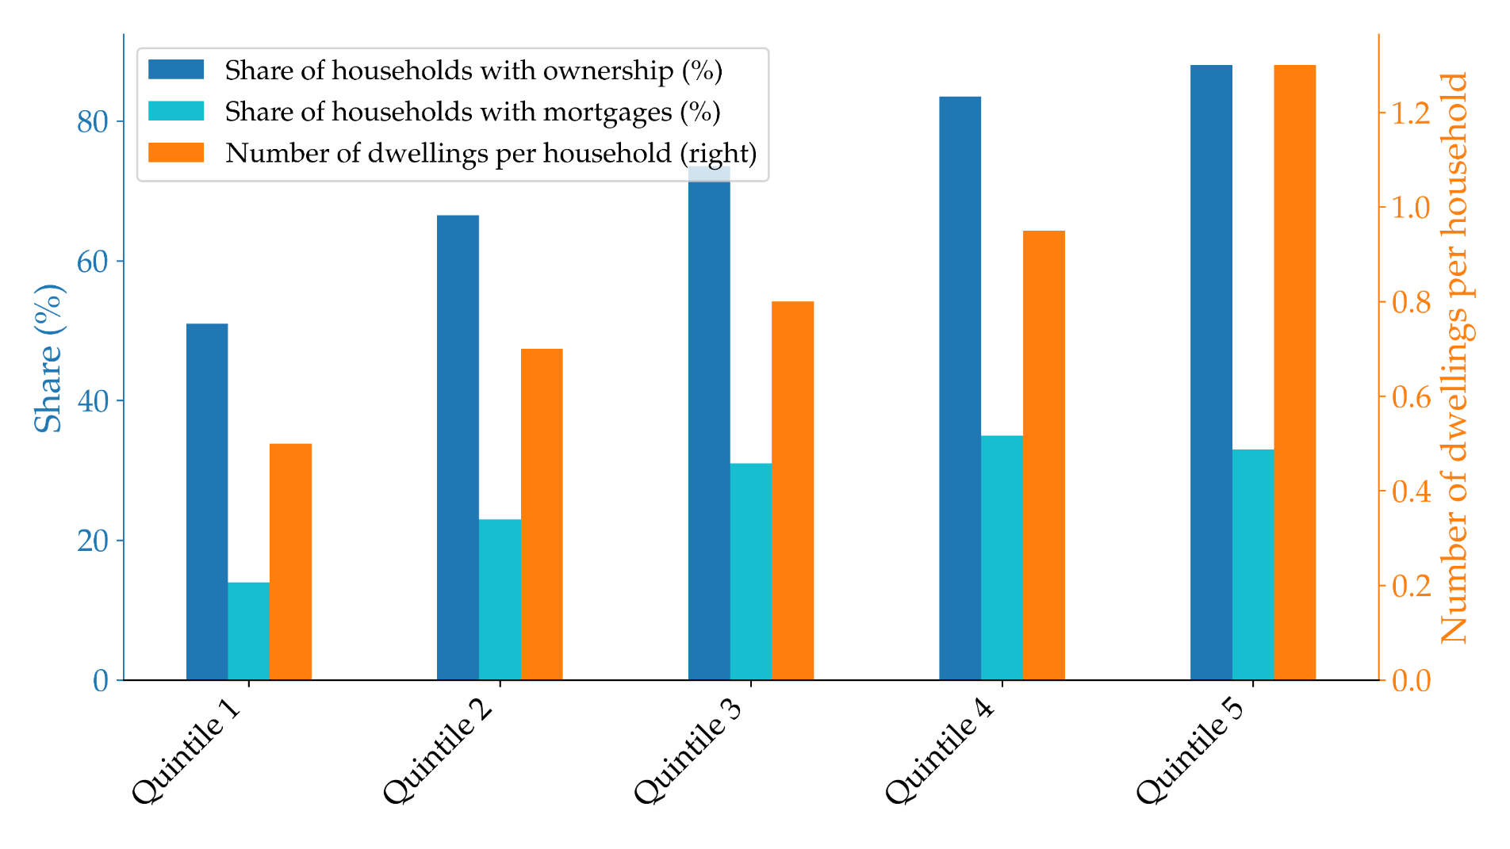
Source: Author’s Analyses based on Stein-Kapach (2019) and Kosman (2021)
The foregoing discussion highlights a key issue concerning Israel’s loan-to-value (LTV) ratio. Empirical evidence indicates that the average LTV ratio in Israel is low relative to other advanced economies (Laufer and Tzur-Ilan (2021)). In addition, the ratio has been substantially affected by macroprudential measures introduced from approximately 2010 onward (Benchimol et al. (2022)). These institutional features render Israel an especially interesting case for investigation, as they raise important questions about the influence of LTV policy on monetary transmission and housing market outcomes.
Data from OECD countries (Van-Hoenselaar Frank et al. (2021)), depicted in Fig. 2, show that countries with more permissive LTV restrictions tend to have a higher percentage of homeowners with mortgages (out of total population) on average. Additionally, as shown in Fig. 3, countries with a higher proportion of homeowners with mortgages tend to have higher mortgage leverage, which constitutes a sizable portion of household debt. The takeaway is that as leverage restrictions are relaxed, a larger proportion of households may take out mortgages and become homeowners, resulting in higher overall leverage. This evidence supports our focus on ownership and leverage responses as the primary transmission channels of LTV policy, rather than home prices.
Figure 3: Share of households with mortgages vs. mortgage leverage (with respect to GDP)  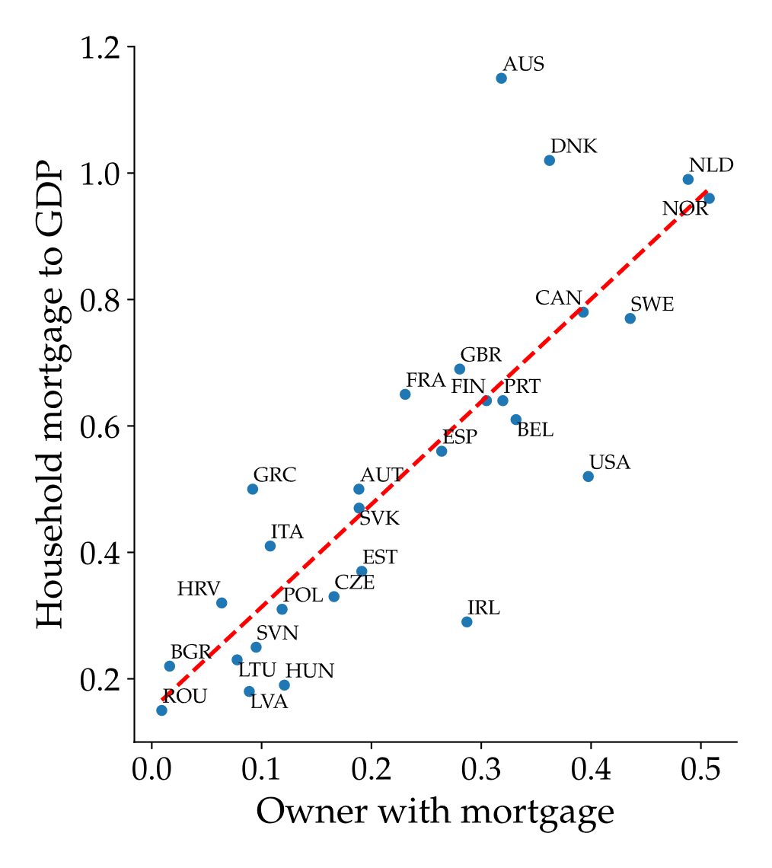 | Figure 2: LTV restriction and share of households with mortgages  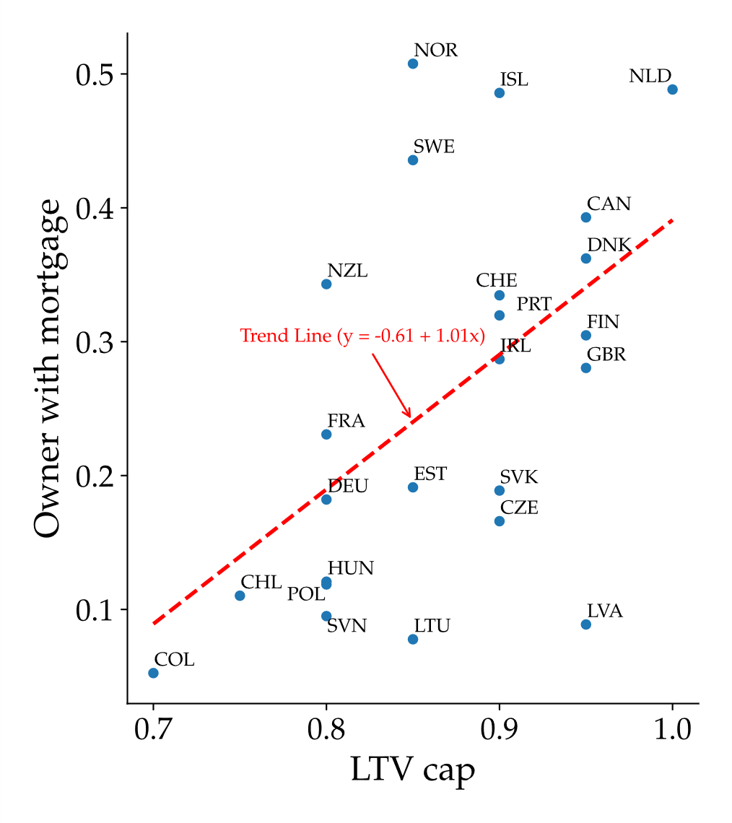
Source: Authors' Analyses. Data: OECD
Another notable fact is that there is a high degree of nominal rigidity in rental prices in Israel. Based on a sample from 2010–2015, Raz-Dror (2019) found that rent contracts are signed for at least one year, on average. Ribon and Sayag (2013) found that the average period for price changes among different components of the CPI in Israel is less than one year. This indicates that price rigidity in rent prices is higher than other components of the CPI. This finding for Israel aligns with the economic literature, which also finds a higher level of nominal price rigidity in rental prices relative to other prices (Genesove (2003); Shimizu et al. (2010); Verbrugge et al. (2017)). This evidence justifies our analytical distinction between rental price dynamics and non-housing price movements, a differentiation that has meaningful implications, most notably, the tendency for real rental prices to increase following contractionary monetary policy measures.
Taken together, these stylized facts motivate the development of a model that incorporates heterogeneous households, an explicit rental market supplied by investors, binding collateral constraints, and nominal rent rigidity. These features are essential for explaining why macroprudential policy in Israel exerts a strong influence on leverage and tenure choice, yet has only a limited effect on housing prices.

The Model
The model contains two representative household categories, lenders (patient) and borrowers (impatient), which have collateral constraints; housing retailers who provide final rental properties in the housing market; companies that produce consumer goods (excluding housing services); commercial banks functioning as financial intermediaries; and a central bank responsible for implementing monetary and macroprudential policies.
The lenders' (patient) discount factor is higher than that of the borrowers (impatient), which generate savings and debt respectively. In equilibrium, the debt of borrowers equals the savings of lenders.
Although Israel is a small open economy, we model it as a closed economy for the purposes of this analysis, given that the primary channel through which the global economy influences the domestic housing market is indirect. Specifically, while mortgage lending in Israel is conducted almost exclusively through the domestic banking sector, mortgage interest rates are influenced by global financial conditions via their impact on domestic capital market interest rates.
We assume that, in the short run, the supply of dwellings is exogenous, that is, housing supply adjusts only gradually to shocks over several years. As a result, short-term fluctuations in the housing market are driven primarily by changes in demand for both owner-occupied and rental properties across household types, while supply remains largely external and relatively inelastic.
Empirical evidence supporting this assumption comes from the lengthy construction period in Israel, which averages more than 30 months (Bank of Israel Report, 2024). When the additional time required for land marketing and planning—often exceeding two years for approvals—is considered, the total duration from the decision to expand supply to the actual increase easily surpasses five years. Furthermore, a significant portion of land designated for residential development is administered by Israeli authorities and thus not fully governed by market forces.
The model encompasses both the ownership and rental housing markets, with the two being imperfectly substitutable. Demand in these markets originates from two distinct household categories: 1. borrowers, who are constrained by LTV restriction, and 2. lenders, who are financially unconstrained and act as investors by supplying rental properties. Both household types generate demand for non-housing consumption goods and provide labor to firms.
Real estate investors offer rental houses by leasing them to renters, subject to price rigidity. Firms produce consumption goods (exclude housing) using labor (without capital) and operate in monopolistic competition subject to price rigidity. The central bank conducts monetary policy using a monetary interest rate, and macroprudential policy using LTV restrictions. In the model, there is no fiscal policy.

Households
Households' utility function includes consumption $C_{t}$ (excl. housing), housing $H_{t}$ and labor $N_{t}$. We assume the utility function of the following form similar to Sun and Tsang (2017):
$$U\left(C_{t},H_{t},N_{t}\right)=z_{t}Γ_{C}log\left(C_{t}-ζ^{c}C_{t-1}\right)+j_{t}log\left(H_{t}\right)-\frac{1}{1+ϱ}N_{t}^{1+ϱ}$$
The parameter $Γ_{C}=\frac{1-ζ^{c}}{1-βζ^{c}}$ ensures that, in the steady state, the marginal utility of consumption depends solely on the level of consumption. $ζ^{c}$, is a degree of habit in consumption, and $z_{t}$ and $j_{t}$ are preference shocks to consumption and housing, respectively.
In this paper, we set aside individual household-level behavior and instead model a representative household for each of the two types in the economy—lenders and borrowers—both of whom obtain shelter services through a combination of homeownership and participation in the rental market.
We define a housing bundle that consists of ownership, $h_{o,t}$, and rent, $h_{r,t}$:
$$H\left(h_{o,t},h_{r,t}\right)={\left[γh_{o,t}^{\frac{ε-1}{ε}}+\left(1-γ\right)h_{r,t}^{\frac{ε-1}{ε}}\right]}^{\frac{ε}{ε-1}},$$
where $ε>1$ is the intratemporal elasticity of substitution between renting and owning, and $γ$, $0<γ<1$ is the relative weight assigned to ownership. If renting and owning were perfect substitutes, the elasticity would be infinite ($ε→∞$). In our framework, we assume that renting and owning are close substitutes but not perfect substitutes, which is a very plausible assumption given real-world housing market conditions.
Habit formation in consumption is incorporated into the model, reflecting its well-documented empirical relevance both internationally and in Israel (see, e.g., Argov et al. (2012)). Although we do not explicitly model habit formation in housing, as in Sun and Tsang (2017), the optimization problem for the two household types implicitly generates smooth housing dynamics. This arises because the marginal utility from both ownership and renting depends directly on the marginal utility of consumption, which is smoothed by habit formation.

Borrowers (impatient households)
Impatient households that take on long-term debt (as in Alpanda and Zubairy (2017)):
$$B_{t}^{'}=\left(1-Υ\right)B_{t-1}^{'}+{B_{t}^{'}}^{New} (1)$$
where $B_{t}^{'}$ is a stock of long-term debt, $B_{t-1}^{'}$ is a long-term debt from the previous period, and ${B_{t}^{'}}^{New}$ is a new debt. $Υ$ represents the fixed rate at which debt principal is repaid each period. In the steady-state (SS) this ratio also represents the share of new debt in the total stock of debt.
Our new debt issuance mechanism closely follows Alpanda and Zubairy (2017), with one modification described below. Equation (2) represents the supply of new debt from commercial banks, which is subject to a time-varying regulatory Loan-to-Value (${LTV}_{t})$ limit. In general, Equation (2) is expressed as an inequality. In our model, however, we assume that it always holds with equality. This assumption is justified for the following reason: the new debt constraint in Equation (2) is already binding in the steady state. In the policy analysis presented in Section 6, we introduce two shocks—monetary policy and an LTV shock—that further tighten the constraint.
$${B_{t}^{'}}^{New}≤ LTV_{t}q_{t}\left(h_{o,t}^{'} -h_{o,t-1}^{'}\right) + κ\left(LTV_{t}q_{t}h_{o,t-1}^{'}-\left(1-Υ\right)B_{t-1}^{'}\right) \left(2\right)$$
where $q_{t}$ is the real price of one housing unit; $h_{o,t}^{'}$ is housing acquired this period (so $∆h_{o,t}^{'}$measures the upgrade size);$κ$ presents the proportion of existing home net equity that is used for a new credit.
The first term captures the borrowing constraint for housing improvers, which is subject to the LTV constraint. They are homeowners who sell their existing property to purchase a new home, often one that is larger or more desirable. The second term allows housing improvers to refinance up to the regulatory limit on their previous-period housing stock, scaled by $κ$. In simpler terms, it means that housing improvers with positive net equity at the beginning of period t can borrow beyond the debt limit typically associated with home upgrades. The time-varying regulatory $LTV_{t}$​ governs all components of new debt issuance and evolves exogenously with macroprudential policy (see Section 4).
Equation (2) adapts the framework of Alpanda and Zubairy (2017) to address two main limitations. First, in their model, when the depreciation rate is set to zero—as in our case—the steady-state stock of debt becomes independent of the LTV constraint. Second, their formulation permits borrowers who have recently taken out loans within the LTV limit to immediately expand their debt by leveraging their own net capital. To resolve these issues, we discount the value of existing housing by the LTV ratio, as reflected in the final term of Equation (2).
From Equations (1) and (2), we can derive the amount of debt in steady state:
$$B^{'}=\frac{κ}{Υ+κ\left(1-Υ\right)}{LTVqh}_{o}^{'}$$
The steady-state amount of new borrowing is then:
$${B^{'}}^{New}=\frac{Υκ}{Υ+κ\left(1-Υ\right)}{LTVqh}_{o}^{'}$$
It is straightforward to observe that under the assumption that $Υ=1 and κ$=1, we obtain the following steady-state condition of one-period debt:
$$B^{'}={B^{'}}^{New}=LTV⋅qh_{o}^{'}$$
The budget constraint is expressed in real terms, meaning that it is in terms of consumption (excluding housing) ($P_{t}^{c}$):
$$C_{t}^{'}+q_{t}h_{o,t}^{'}+r_{t}h_{r,t}^{'}+\left(R_{t-1}^{L}-1+Υ\right)B_{t-1}^{'}={B_{t}^{'}}^{New}+q_{t}h_{o,t-1}^{'}+w_{t}^{'}N_{t}^{'} (3)$$
where on the left side: $C_{t}^{'}$ is consumption (excl. housing), $q_{t}h_{o,t}^{'}$ is the expenditure on dwellings purchased for ownership, $r_{t}h_{r,t}^{'}$ is the expenditure on rental services ($r_{t}$ is the real price of rental services and $h_{r,t}^{'}$ is the amount of rental services), $\left(R_{t-1}^{L}-1+Υ\right)B_{t-1}^{'}$ is the payment on debt from the previous period, and $R_{t-1}^{L}$ is the gross real interest rate on mortgages. We neglect transaction cost of purchased or sold dwellings, as well as their depreciation.
On the right side: ${B_{t}^{'}}^{New}$is the amount of new (real) debt, $q_{t}h_{o,t-1}^{'}$ is the value of dwellings purchased for ownership in period t-1 and then sold in period t, and $w_{t}^{'}N_{t}^{'}$ is income from labor. We also assume that the borrowers do not receive any dividends, because they do not own any firms. We also assume that there are no taxes because there is no government in the model.
We consider two types of mortgage interest rates in our model, both indexed to the Consumer Price Index (CPI). The first is a fixed-rate mortgage, while the second is a variable-rate mortgage that moves one-to-one with the real central bank policy rate. The following section provides a detailed explanation of each type.
The first type: fixed-rate mortgage
In this case, which serves as our main benchmark, debt issued in previous periods is unaffected by current or future changes in the policy rate, as its interest rate is fixed at the time of issuance.
When a borrower takes out a new mortgage in period t, the interest rate on that loan is $R_{t}+\text{ω}$, where $R_{t}$ denotes the (gross) short-term real central bank policy rate and $\text{ω}$ is a positive constant spread. Consequently, the average mortgage interest rate on the total stock of debt in period t is given by:
$$R_{t}^{L}=\frac{B_{t}^{'New}}{B_{t}^{'}}\left(R_{t}+\text{ω}\right)+\left(1-\frac{B_{t}^{'New}}{B_{t}^{'}}\right)R_{t-1}^{L}$$
where $\frac{B_{t}^{'New}}{B_{t}^{'}}$ represents the (time-varying) share of newly issued debt in the total outstanding debt, and $1-\frac{B_{t}^{'New}}{B_{t}^{'}}$ is the (time-varying) share of previously issued debt.
For example, suppose a borrower obtains a loan at a 5% interest rate and does not take on additional debt thereafter. The interest rate on the outstanding debt will remain fixed at 5%, irrespective of subsequent changes in the central bank’s policy rate. However, once new debt is issued in the future, the effective interest rate on the total outstanding debt becomes a weighted average of the interest rate on the newly issued debt and that on the existing stock of debt.
For the purpose of simplifying the model, we assume that borrowers do not internalize, in their optimization problem, the effect of new debt issuance on the average mortgage interest rate. In other words, once borrowers determine the amount of new debt according to the first-order condition specified below, the level of new debt in the above equation for $R_{t}^{L}$ is treated as predetermined.
The second type: variable-rate mortgage
In this specification, the mortgage interest rate is defined to move one-to-one with the real central bank rate. This can be viewed as a special case of the fixed-rate setup discussed earlier, obtained under the technical condition that the adjustment parameter is always equal to one $(\frac{B_{t}^{'New}}{B_{t}^{'}}=1$).
$$R_{t}^{L}=R_{t}+\text{ω}$$
Economically, this case closely approximates the so‑called Prime interest rate, which is linked to the nominal Bank of Israel policy rate and is also applied to long‑term debt. A key distinction in our model, however, is that the short‑term interest rate is indexed to the CPI, whereas the Prime rate used in practice is not.
The first-order conditions characterizing borrowers’ optimization are invariant to the selected mortgage track. These conditions are presented below, and a detailed derivation is provided in the Technical Appendix (supplementary material can be found here). All variables with subscript t+1 represent the expected values for period t+1, conditional on information available at time t.
The first-order conditions with respect to $C_{t}^{'},h_{o,t}^{'}, h_{r,t}^{'},B_{t},N_{t}^{'}$ are respectively (where $ϑ=1/ϵ$):
$$λ_{t}^{'}=Γ_{c}^{'}\left(\frac{z_{t}^{'}}{C_{t}^{'}-ζ^{c}C_{t-1}^{'}}-β^{'}ζ^{c}\frac{z_{t+1}^{'}}{C_{t+1}^{'}-ζ^{c}C_{t}^{'}}\right)$$
$j_{t}^{'}\frac{γ^{'}{h_{o,t}^{'}}^{-ϑ}}{γ^{'}{h_{o,t}^{'}}^{1-ϑ}+\left(1-γ^{'}\right){h_{r,t}^{'}}^{1-ϑ}}=\left(λ_{t}^{'}- μ_{t}^{'}{LTV}_{t}\right)q_{t}-β^{'}\left(λ_{t+1}^{'}{+μ}_{t+1}^{'}{LTV}_{t+1}\left(1-κ\right)\right)q_{t+1}$
$$j_{t}^{'}\frac{\left(1-γ^{'}\right){h_{r,t}^{'}}^{-ϑ}}{γ^{'}{h_{o,t}^{'}}^{1-ϑ}+\left(1-γ^{'}\right){h_{r,t}^{'}}^{1-ϑ}}=λ_{t}^{​^{'}}r_{t}$$
$$μ_{t}^{'}=λ_{t}^{​^{'}}-β^{'}\left(λ_{t+1}^{​^{'}}R_{t}^{L}+μ_{t+1}^{'}\left(1-Υ\right)\left(1-κ\right)\right)$$
$${N_{t}^{'}}^{ϱ}=λ_{t}^{​^{'}}w_{t}^{'}$$

Lenders (Unconstrained households)
Lenders function in dual roles: as consumers and as investors. As consumers, they demand goods, rental services, and home ownership; they supply labor; and they value leisure. As investors, they buy properties as investments and rent them to renters. Notably, investors do not gain direct utility from investment properties, viewing them instead as a financial tool.
The budget constraint of lenders (in real terms of $P_{t}^{c}):$
$$C_{t}+q_{t}\left(h_{o,t}+h_{inv,t}\right)+r_{t}h_{r,t}+R_{t-1}B_{t-1}= B_{t}+q_{t}\left(h_{o,t-1}+h_{inv,t-1}\right)+p_{t}^{m}h_{inv,t}+w_{t}N_{t}+Div_{t}, \left(5\right)$$
where $h_{o,t}$ represents the quantity of houses purchased for ownership, and $h_{inv,t}$ represents the quantity of houses purchased for investment purposes (with all investors being identical). Investors lease out $h_{inv,t}$ dwellings to retailers as an intermediate good at a nominal price $P_{t}^{m}$ ($P_{t}^{m}=p_{t}^{m}P_{t}^{c})$ at the start of period $t$, and reclaim the dwellings at the end of period $t$. Therefore, only investors are subject to capital gains or losses when reselling in period t+1. It is important to recognize that $r_{t}$ signifies the real price of rental services in the economy, which typically differs from $p_{t}^{m}$, since $p_{t}^{m}$ is the price of the intermediate housing good for retailers. Lenders receive dividends from three sources: firms producing consumer goods, commercial banks, and retailers of dwellings.
The first-order conditions for the lenders with respect to $C_{t}, h_{o,t}, h_{r,t},B_{t}, N_{t}, h_{inv,t}$ are respectively (see supplementary material):
$$λ_{t}=Γ_{c}\left(\frac{z_{t}}{C_{t}-ζ^{c}C_{t-1}}-βζ^{c}\frac{z_{t+1}}{C_{t+1}-ζ^{c}C_{t}}\right)$$
$$j_{t}\frac{γh_{o,t}^{​^{-ϑ}}}{γh_{o,t}^{​^{1-ϑ}}+\left(1-γ\right)h_{r,t}^{​^{1-ϑ}}}=λ_{t}q_{t}-βλ_{t+1}q_{t+1}$$
$$j_{t}\frac{\left(1-γ\right)h_{r,t}^{​^{-ϑ}}}{γh_{o,t}^{​^{1-ϑ}}+\left(1-γ\right)h_{r,t}^{​^{1-ϑ}}}=λ_{t}r_{t}$$
$$λ_{t}=βλ_{t+1}R_{t}$$
$$N_{t}^{ϱ}=λ_{t}w_{t}$$
$$q_{t}=E_{t}\sum_{i=0}^{∞}{s}df_{t,t+i}⋅p_{t+i}^{m}$$
where the stochastic discount factor of the lenders defined as $sdf_{t,t+i}=β^{i}\frac{λ_{t+i}}{λ_{t}}$.
In equilibrium, the home price is determined by the present value of current and expected future payoffs that households obtain from dwelling retailers, subject to the transversality condition, which rules out non-fundamental (bubble) solutions. That is, we assume that: $\lim_{T→∞}{E_{t}\left\{{sdf}_{t,t+T}⋅q_{t+T}\right\}}=0$.
The pricing condition is typically used to link home prices to rental prices in the economy. In our model, however, it is determined by the price of intermediate rental dwellings leased by retailers (see Section 4.3). The divergence between these two prices stems from rent price rigidity and the presence of monopolistic competition (see Section 4.3).
Based on the lender’s first-order conditions with respect to $h_{o,t}$ and $h_{r,t}$ (see above), the pricing formula can be expressed in terms of rental prices:
$$q_{t}=E_{t}\left\{\sum_{i=0}^{∞}{{sdf}_{t,t+i}\frac{U_{h_{o},t+i}}{U_{h_{r},t+i}}r_{t+i}}\right\}$$
where $\frac{U_{h_{o},t+i}}{U_{h_{r},t+i}}$ denotes the marginal utility ratio of lenders, which arises here due to the CES assumption in the utility function and the rent market structure. In the conventional formulation found in the literature—namely, the user cost approach—this marginal utility ratio does not appear. If there is perfect substitutability between renting and owning ($ε→∞$), and a rented dwelling is equivalent to an owned dwelling in the CES utility function ($γ=0.5$), then the ratio equals 1, and the standard pricing equation is recovered. In this respect, our study advances the conventional framework in the literature by incorporating investor preferences—represented by lenders in our model—into the determination of home prices. This approach departs from the standard view in which home prices are driven solely by the price of dwellings, thereby highlighting the additional role of investor behavior in housing market dynamics.

Retailers
The objective of this section is to generate nominal rigidity in rental prices, a phenomenon observed in the Israeli market as shown by Raz-Dror (2019). This rigidity is characterized by the significantly lower volatility of rental prices than of home prices. A comparison between Raz-Dror (2019) and Ribon and Sayag (2013) indicates that rental prices exhibit greater nominal rigidity than consumer goods prices. This phenomenon is not exclusive to Israel. It is also observed globally (see Sun and Tsang (2017), Genesove (2003), Shimizu et al. (2010), and Verbrugge et al. (2017)). To that end, we introduce a model of monopolistic competition in the rental market with price rigidity.
Retailers lease dwellings from investors for one period at a nominal price $P_{t}^{m}$, and the dwellings are then used as intermediate rental properties. The final product of rental dwellings in the economy, $Y_{t}^{rent},$ is a composite of a continuum of mass unity of differentiated rental dwellings that uses intermediate rental dwellings from investors as the sole input (that is, $h_{inv,t}\left(j\right)=Y_{f,t}$, where $Y_{f,t}$ is the amount of dwellings of retailer $f$, and$h_{inv,t}\left(j\right)$ is the intermediate rental dwellings of investor $j$). The final product of $Y_{t}^{rent}$ for rental dwellings is:
$$Y_{t}^{rent}={\left[\int_{0}^{1}{{\left(Y_{f,t}\right)}^{\frac{η_{r}-1}{η_{r}}}}df\right]}^{\frac{η_{r}}{η_{r}-1}}$$
where $η_{r}$ is the elasticity of substitution between differentiated rental dwellings.
Demand for differentiated retail dwelling $f$ is given:
$$Y_{f,t}={\left(\frac{P_{f,t}^{rent}}{P_{t}^{rent}}\right)}^{-η_{r}}Y_{t}^{rent}$$
where the (nominal) price of $Y_{t}^{rent}$ is given as:
$$P_{t}^{rent}={\left[\int_{0}^{1}{{\left(P_{f,t}^{rent}\right)}^{1-η_{r}}}df\right]}^{\frac{1}{1-η_{r}}}$$
Differentiated retail firms face price rigidity à la Rotemberg (1982), leading to a Philips curve of rent prices.
We start with the expected profit function of each retailer, to be maximized:
$$\max{E_{t}\sum_{i=0}^{∞}{{sdf}_{t,t+i}\left[\frac{P_{f,t+i}^{rent}}{P_{t+i}^{rent}}Y_{f,t+i}-\frac{P_{t+i}^{m}}{P_{t+i}^{rent}}Y_{f,t+i}-\frac{Θ}{2}{\left(\frac{P_{f,t+i}^{rent}}{P_{f,t+i-1}^{rent}}-{{(π}^{rent})}^{1-ϕ}{\left(\frac{P_{t+i-1}^{rent}}{P_{t+i-2}^{rent}}\right)}^{ϕ}\right)}^{2} Y_{t+i}^{rent}\right]}}$$
where $π^{rent}$ is the steady state inflation rate of rental services, $ϕ$ is the degree of indexation to past inflation of rental services and $Θ$ defines the cost associated with changing price. The stochastic discount factor of the lenders define above (owners of retailer's firm).
The first-order condition with regard to price $P_{f,t}^{rent}$ yields a nonlinear Philips curve for nominal rental prices (see the Technical Appendix in the supplementary material, here):
$$\frac{p_{t}^{m}}{r_{t}}=\frac{η_{r}-1}{η_{r}}+\frac{Θ}{η_{r}}π_{t}^{rent}\left(π_{t}^{rent}-{\left(π^{rent}\right)}^{1-ϕ}{\left(π_{t-1}^{rent}\right)}^{ϕ}\right)-sdf_{t,t+1}\frac{Θ}{η_{r}}π_{t+1}^{rent}\frac{Y_{t+1}^{rent}}{Y_{t}^{rent}}\left(π_{t+1}^{rent}-{\left(π^{rent}\right)}^{1-ϕ}{\left(π_{t}^{rent}\right)}^{ϕ}\right) \left(5\right)$$
where $π_{t}^{rent}=\frac{r_{t}}{r_{t-1}}π_{t}^{c}.$
In the steady state, the final (real) price of rental services ($r$) is higher than the intermediate (real) rent price ($p^{m}$) by a markup of ($r=\frac{η_{r}}{η_{r}-1}p^{m}$). Retailers' dividends, in real terms, are transferred to the lenders:
$$Div_{t}^{retail}=r_{t}Y_{t}^{rent}-p_{t}^{m}Y_{t}^{rent}-\frac{Θ}{2}{\left(π_{t}^{rent}-{\left(π^{rent}\right)}^{1-ϕ}{\left(π_{t-1}^{rent}\right)}^{ϕ}\right)}^{2}r_{t}Y_{t}^{rent}$$
where $Y_{t}^{rent}=h_{inv,t}$ (see proof in the Technical Appendix in the supplementary material here).
Proposition 1:
A higher loan-to-value (LTV) ratio—indicative of looser macroprudential policy—raises the ownership-to-rent ratio among borrowers in the steady state, while leaving that of lenders unaffected.
Proof: see in the appendix , here.

Firms
There is a continuum of monopolistically competitive firms indexed by $z∈\left[0,1\right].$ Each firm manufactures a differentiated intermediate good with a linear production function without capital,
$Y_{t}\left(z\right)=A_{t}{\overset{⃐}{N}}_{t}\left(z\right)$,
where the aggregate labor input of the firm is a Cobb-Douglas composite of the agents’ labor, ${\overset{⃐}{N}}_{t}\left(z\right)={\left(N_{t}\left(z\right)\right)}^{τ}{\left(N_{t}^{'}\left(z\right)\right)}^{1-τ}$. The share of each type is assumed to be identical to the share in the population, $τ$, which generates constant income shares (see Benigno et al. (2020) and Sun and Tsang (2017)).
The differentiated good firms sell their products in a monopolistic competition to a composite firm, producing the aggregate domestic good:
$$Y_{t}={\left(\int_{0}^{1}{Y_{t}{\left(z\right)}^{\frac{η_{t}-1}{η_{t}}}dz}\right)}^{\frac{η_{t}}{η_{t}-1}},$$
where $η_{t}$ is the (time-varying) elasticity of substitution between the differentiated goods, thus serving as a "mark-up shock" to inflation $π_{t}$. The shock $log\left(η_{t}\right)$ follows $AR\left(1\right)$ process.
The aggregate good $Y_{t}$ is then sold in perfect competition at the price of $P_{t}^{c}=$ ${\left(\int_{0}^{1}{P_{t}^{c}{\left(z\right)}^{1-η_{t}}dz}\right)}^{\frac{1}{1-η_{t}}}$ and is used for private consumption.
Minimizing production costs by the composite firm implies the following demand functions for the differentiated goods:
$Y_{t}\left(z\right)={\left[\frac{P_{t}^{c}\left(z\right)}{P_{t}^{c}}\right]}^{-η_{t}}Y_{t}$.
We assume nominal price rigidities à la Rotemberg (1982). Each firm $z$ seeks to maximize its expected profits, and the discounting factor of profits depends on the ownership of the firms, which is assumed to belong to the lenders. This assumption is in line with Guerrieri and Iacoviello (2017).
The expected profits, expressed in real terms of consumption goods:
$$maxE_{t}\sum_{i=0}^{∞}{s}df_{t,t+i}x_{t+i}\left(z\right),$$
where $x_{t}\left(z\right)$ is the real profit of firm $z$ defined below:$$x_{t}\left(z\right)=\frac{P_{t}^{c}\left(z\right)}{P_{t}^{c}}Y_{t}\left(z\right)-w_{t}N_{t}\left(z\right)-w_{t}^{'}N_{t}^{'}\left(z\right)-\frac{χ}{2}{\left(\frac{P_{t}^{c}\left(z\right)}{P_{t-1}^{c}\left(z\right)}-{\left(π\right)}^{1-ϖ}{\left(\frac{P_{t-1}^{c}}{P_{t-2}^{c}}\right)}^{ϖ}\right)}^{2}Y_{t}$$
and $sdf_{t,t+i}=β^{i}\frac{λ_{t+i}}{λ_{t}}$ is a stochastic discount factor of the lenders (owners of the firms).$π$ is the steady-state inflation rate (excl. rentals), $ϖ$ is the degree of indexation to past inflation (excl. rent) and $χ$ defines the cost associated with changing the price and is the source for price rigidity. The expressions $w_{t}N_{t}\left(z\right) and w_{t}^{'}N_{t}^{'}\left(z\right)$ represent the real income of two distinct types of workers.
The first-order conditions with regard to price $P_{t}^{c}\left(z\right)$ yield the Philips curve:
$$Γ_{t}=\frac{η_{t}-1}{η_{t}}+\frac{χ}{η_{t}}π_{t}^{c}\left(π_{t}^{c}-{\left(π\right)}^{​^{1-ϖ}}{\left(π_{t-1}^{c}\right)}^{ϖ}\right)-sdf_{t,t+1}\frac{χ}{η_{t}}π_{t+1}^{c}\frac{Y_{t+1}}{Y_{t}}\left(π_{t+1}^{c}-{\left(π\right)}^{​^{1-ϖ}}{\left(π_{t}^{c}\right)}^{ϖ}\right)$$
where $sdf_{t,t+1}=\frac{βλ_{t+1}}{λ_{t}}$ is the stochastic discount factor of the lenders, and $Γ_{t}$ is a marginal cost.
The first-order conditions with regard to $N_{t}\left(z\right)$ and $N_{t}^{'}\left(z\right)$ yields (see the Technical Appendix in the supplementary materials for details, here):
$$Γ_{t}=\frac{w_{t}}{τY_{t}}N_{t}=\frac{w_{t}^{'}}{\left(1-τ\right)Y_{t}}N_{t}^{'}$$
Dividends are transferred to the lenders:
$$Div_{t}=Y_{t}-w_{t}N_{t}-w_{t}^{'}N_{t}^{'}-\frac{χ}{2}{\left(π_{t}^{c}-{\left(π\right)}^{1-ϖ}{\left(π_{t-1}^{c}\right)}^{ϖ}\right)}^{2}Y_{t}$$

Commercial Banks (intermediates)
Commercial banks act as intermediaries, accepting deposits from lenders and extending loans to borrowers. The banks place these deposits with the central bank, earning the announced interest rate (see Section 4.7).
Their budget constraint is given by:
$$R_{t-1}B_{t-1}^{'}+{R_{t-1}^{L}B}_{t-1}^{'}=B_{t}^{'}+{R_{t-1}B}_{t-1}^{'}+Div_{t}^{b}$$
where the left-hand side represents income from deposits at the central bank and from loans to borrowers, while the right-hand side represents interest payments to lenders and deposits at the central bank.
We define profits as:
$${Div_{t}^{b}=R_{t-1}B}_{t-1}^{'}-B_{t}^{'}+(R_{t-1}^{L}-{R_{t-1})B}_{t-1}^{'}$$
Profits of commercial banks in period t are transferred to lenders, under the assumption that lenders are the sole owners of the commercial banks.

Monetary policy
The central bank’s monetary policy follows a Taylor-type rule:
$$r_{t}^{CB}=ρr_{t-1}^{CB}+\left(1-ρ\right)\left(r^{CB}+θ_{1}\left(π_{t}-π\right)+θ_{2}Δy_{t}\right)+ε_{t}^{CB}$$
where $r_{t}^{CB}$ is a nominal interest rate of the central bank,$π_{t}={δπ}_{t}^{r}+{\left(1-δ\right)π}_{t}^{C}$ is the CPI inflation, calculated as the weighted average of the inflation of rental dwellings and the inflation of CPI (excl. rental dwellings) (with $δ$ being the weight of rental dwellings in the CPI); $Δy_{t}$ is the growth rate of GDP relative to the growth rate in the steady state; and $ε_{t}^{CB}$ is a monetary shock.
The implementation of monetary policy in the model is characterized by the following mechanism:
$$B_{t}^{S}=R_{t-1}^{S}B_{t-1}^{S}+{TR}_{t},$$
where $R_{t}^{S}=R_{t}=r_{t}^{CB}-π_{t+1}$ and $B_{t}^{S}=-B_{t}=B_{t}^{'}$.
In this framework, the central bank supplies deposits in the amount demanded by commercial banks and pays interest on these deposits exactly at the announced policy rate. Any resulting profits or losses of the central bank are transferred eventually to the lenders.

Market clearing
Aggregate consumption, defined as the sum of consumption by lenders and borrowers, is equal to total output net of adjustment costs:
$$C_{t}^{'}+C_{t}=Y_{t}\left(1-\frac{χ}{2}{\left(π_{t}^{c}-{\left(π\right)}^{1-ϖ}{\left(π_{t-1}^{c}\right)}^{ϖ}\right)}^{2}\right)-\frac{Θ}{2}{\left(π_{t}^{rent}-{\left(π^{rent}\right)}^{1-ϕ}{\left(π_{t-1}^{rent}\right)}^{ϕ}\right)}^{2}r_{t}Y_{t}^{rent}$$
The total number of dwellings acquired for investment by the lenders matches the supply of the final rental dwelling product.
$$h_{inv,t}=h_{r,t}+h_{r,t}^{'}=Y_{t}^{rent}$$
The total number of dwellings in the economy, available for both rent and ownership, is constant.
$$h_{o,t}+h_{o,t}^{'}+h_{r,t}+h_{r,t}^{'}=h$$
Total savings are equal to total debt.
$$B_{t}+B_{t}^{'}=0$$
As outlined in Sun and Tsang (2017), the model is specified at each household’s type aggregate level. For instance, $B_{t}=\int_{τ}{b_{t}}=τb_{t}$, where $b_{t}$ represents the "per household" level; this approach similarly applies to other variables. The proportion of each type within the population influences the economy through their respective labor contributions to production.

Calibration
We calibrate our model parameters to align with the Israeli economy's distinct features (Table 1). We begin with the habit formation parameter in consumption, a standard feature in empirical models for Israel that, while not critical to housing market mechanisms, improves the precision of the quantitative analysis. The degree of habit formation parameter for consumption$ζ^{c}$ is set at 0.5 for all households, a value that falls between the 0.62 from Argov et al. (2012) and the 0.1 from Ilek and Rozenshtrom (2018), (IL&R in Table 1). The disutility from labor parameter $θ$ is set at 2.5, consistent with Ilek and Rozenshtrom (2018). The relative preference of housing, $j_{t}$, set in steady state to $j=1$, while we test for robustness in the appendix (here) the case of $j=0.12$ as in Iacoviello and Neri (2010) and Sun and Tsang (2017). The elasticity of substitution between differentiated consumption goods ($η=6$) is set to imply a steady state markup of 20%, consistent with Ilek and Rozenshtrom (2018). We apply the same elasticity value of 6 for the substitution between differentiated rental goods. This assumption suggests that firms have identical market power in both markets under monopolistic competition.
We assume a high elasticity of substitution between renting and owning (set at $ε=10$) in the housing services aggregator function for both household types. We then adjust parameters $γ=0.499$and $γ^{'}=0.652$ to align with the observed ownership-to-rent ratios of 6 for lenders and 1.6 for borrowers. It is important to note that the lenders' ownership-to-rent ratio in the model is also influenced by the 20% markup in the rental market, while the borrowers' ratio is affected by the steady state LTV ratio (see Section 4.5).
The two parameters—the share of constrained households (borrowers or impatient households) in the economy and their corresponding LTV ratio—are calibrated to reflect that, in reality, debt spans long periods. We set the share of constrained households (1-$τ)$ at 31.2%, based on Cohen and Ilek (2024). The corresponding effective LTV ratio is set at 66%, as calculated by the same study. Below, we explain this calibration.
Veteran debt holders, who are far from the debt limit, are unaffected by changes in the LTV ratios, unless seeking new debt or refinancing, so they are not classified as financially constrained. In contrast, households near the debt limit face difficulties in obtaining additional credit and are classified as financially constrained. We calibrate the parameters of the model accordingly, based on a long-term survey (Cohen and Ilek (2024)). In practice, the model is calibrated so that debt limit affects about 31.2% of Israel's population. This group consists of two sub-groups:
1. Households that are unable to purchase a home due to insufficient equity (approximately 25% of the population). For them the effective LTV limit is around 75%.
2. Homeowners with existing mortgages who remain financially constrained (about 7% of the population). For them, the effective LTV limit is about 50% if they wish to increase home-backed debt.
The effective LTV in the model is a weighted average of the limits for these two groups.
We set the repayment rate of debt principal at 5% per period. This rate is calibrated to match the steady-state share of new debt in the total stock of debt (as detailed in Section 4.1.1). This calibration aligns with empirical observations, where the average ratio of new mortgage value to total housing debt value is approximately 5%.
Due to the lack of specific indicators for Israel, we rely on values from international literature to calibrate certain parameters. Specifically, we set the ratio of existing home net equity that is used for new loans ($κ$) to 0.0172. This calibration is based on the findings of Alpanda and Zubairy (2017), who conducted a study on housing in the United States.
Lenders (patient households) have a discount factor $β=0.99$, while borrowers (impatient households) have a discount factor $β^{'}=0.975$. These values have a tiny impact on dynamics but ensure that impatient households are sufficiently close to the borrowing limit, creating a strong enough impatience motive. This allows for accurate linearization around a steady state with a binding borrowing limit (Iacoviello (2005); Iacoviello and Neri (2010)).
Borrowers encounter a fixed mortgage interest rate spread$\text{ω}$ of 1.5% annually (0.375% quarterly), aligned with the average mortgage rate spread in Israel.
The CPI inflation (excluding rent) indexation parameter $ϖ$ is set at 0.3, which is between the 0.37 in Argov et al. (2012) and the zero in Ilek and Rozenshtrom (2018). We also apply the same indexation degree to nominal rent prices, $ϕ=0.3$. The price adjustment cost parameter for differentiated consumption goods firms $χ$, which affects the level of nominal rigidity in price setting, is set at 95, matching the value obtained in Ilek and Rozenshtrom (2018). The price adjustment cost parameter for rental services firms $Θ$ is set at 311, based on stylized facts in Israeli rental market documented by Raz-Dror (2019), indicating greater nominal rigidity in rental goods prices relative to consumption goods prices. This is consistent with empirical evidence from Raz-Dror (2019) and Ribon and Sayag (2013).
The inflation gap parameter $θ_{1}$ in the monetary policy rule is set at 2, implying a central bank's strong response to inflation deviations from its target, in line with the Taylor principle. This parameter is chosen to be between the 2.5 obtained in Argov et al. (2012) and the 1.5 from Ilek and Rozenshtrom (2018). The central bank's response to output growth $θ_{2}$ is set at 0.02, suggesting a more moderate response to output changes. The interest rate inertia parameter $ρ$ is set at 0.75, reflecting significant smoothing in the interest rate. This inertia parameter aligns with Ilek and Rozenshtrom (2018) and is similar to Argov et al. (2012).
Table 1: Calibration summary
Parameter | Description | Value | Reference
$$ζ^{c}$$ | Habit in consumption for both HH | 0.5 | Ilek and Rozenshtrom (2018), Argov et al. (2012)
β | Discount factor of lenders | 0.99 | Literature
β' | Discount factor of borrowers | 0.975 | Literature
$$\text{ω}$$ | Interest rate spread (in annual terms) | 1.5% | Ilek and Cohen (2023)
$$γ$$ | Proportion of ownership in the housing bundle for lenders | 0.499 | Authors’ calculations
$γ$' | Proportion of ownership in the housing bundle for borrowers | 0.652 | Authors’ calculations
$$ϵ$$ | Intratemporal elasticity of substitution between rent and ownership for both HH | 10 | Authors’ calculations
1-$τ$ | Share of constrained households | 31.2% | Cohen and Ilek (2024)
$$Υ$$ | Repayment rate of debt principal | 5% | Data
$$κ$$ | Ratio of existing home net equity used for a new credit | 0.0172 | Alpanda and Zubairy (2017)
$$\text{LTV}$$ | Loan-to-Value ratio in SS | 66% | Cohen and Ilek (2024)
$$η$$ | Elasticity of substitution between intermediate consumption goods | 6 | IL&R
$$η_{r}$$ | Elasticity of substitution between intermediate rental dwellings | 6 | Authors’ calculations
$$θ$$ | Curvature of utility with regard to labor for both HH | 2.5 | IL&R
$ϖ$, $ϕ$ | Degree of inflation indexation of consumption and rental prices | 0.3 | Argov et al. (2012) and authors’ considerations
$$χ$$ | Parameter of consumption price adjustment in cost function | 95 | IL&R
$$Θ$$ | Parameter of rent price adjustment in cost function | 311 | Authors’ calculations
$$θ_{1}$$ | Reaction of CB policy rule to inflation gap | 2 | IL&R and Argov et al. (2012)
$$θ_{2}$$ | Reaction if CB policy rule to output growth | 0.02 | IL&R and Argov et al. (2012)
$$ρ$$ | Degree of smoothing in the CB interest rate rule | 0.75 | IL&R and Argov et al. (2012)
$$δ$$ | Weight of rent in the CPI | 25% | Data
$$π$$ | Inflation target | 2% | Official BOI target

Policy Analysis
In this section, we analyze the impact of monetary and macroprudential policies on the housing market.
In the following policy analysis, we assume the LTV constraint is always binding under both monetary and macroprudential tightening policies. First, we calibrate the model to provide a strong incentive for impatient agents to borrow. Specifically, their discount factor ensures that impatient households are close to the borrowing limit, allowing for accurate linearization around a steady state with a binding borrowing limit (Iacoviello (2005); Iacoviello and Neri (2010); Sun and Tsang (2017)). Second, the LTV constraint is already binding in the steady state, even before these policies are implemented, and the shocks we analyze will further tighten the constraint. Our calibration of the LTV ratio in the steady state is 66% and it is derived from the Israeli data, ensuring that it is binding (see Section 5 and Cohen and Ilek (2024). We calibrate the share of borrowers to be 31.2% of the population, representing households for whom the borrowing constraint is binding or nearly binding, as detailed in Section 5 and Cohen and Ilek (2024).
We conducted robustness tests on our results under different degrees of substitution between ownership and renting, as described in the appendix (supplementary material can be found here).

Impact of monetary policy on the housing market
The responses to a monetary policy (MP) shock, as depicted in Fig. 4 (blue line, representing the baseline case of fixed-rate mortgages), are consistent with the conventional New-Keynesian model. Following a contractionary monetary policy shock of 1 p.p. (in annualized terms) the real interest rate increases, resulting in a simultaneous decline in real activity and inflation.
It is important to note that the increase in the real interest rate induces an intertemporal substitution effect (consistent with the Euler equation) among all households (both lenders and borrowers), resulting in a decrease in the demand for consumption ($C, C^{'}$) and housing rental services ($h_{r}, h_{r}^{'}$ ).
In addition, the investors’ (unconstrained households) demand for rental property investment, $h_{inv}$, is decreasing. As a result, the total number of rented housing units ($h_{r} + h_{r}^{'}$) must also decrease by the same amount, since the only housing supply available for rent is $h_{inv}$ (see Eq. 6 in Section 4.4). Moreover, a decrease in the supply of rental housing leads to a higher real price of rent, $r$.
Furthermore, the housing market experiences a significant decline in housing prices as valuations adjust to higher interest rates. The increase in interest rates also leads to a corresponding rise in mortgage rates on new loans, displaying an almost one-to-one relationship (see Section 4.1.1). However, the effective mortgage rate on the outstanding stock of mortgages increases only marginally, reflecting the gradual adjustment of existing long-term contracts (as demonstrated in Section 6.3 below).
Mortgages therefore become more expensive, which pushes borrowers (financially constrained households) to reduce their new debt burden and, consequently, to reduce their expenses and their home ownership. This makes the collateral constraint tighter and results in borrowers deleveraging their debt to meet the LTV constraint, further pushing down their expenses, and thus reducing ownership, rental, and consumption demand. Stock of debt decreases gradually, as a result of the cumulative decreasing of new debt.
Notably, the rent to home price ratio ($r/q$), which represents the return on dwellings, increases, aligning with the higher interest rate.
Interestingly, lenders (unconstrained households) take advantage of the lower home prices and increase their home ownership, $h_{o}$. This is the only segment of the housing market that increases and clears the market.
As discussed, to meet the LTV constraint, borrowers decrease their home ownership, which could potentially result in increased demand for rentals (substitution effect between ownership and renting). However, this does not happen immediately but is delayed by several quarters.
Two main factors discourage demand for rental housing services: (a) a general reduction in demand due to high real interest rates and the debt deleveraging process, and (b) higher real rent prices (supported by low general inflation, as a relative price effect). It is essential to emphasize that households may reduce both home ownership and renting, for instance by downsizing from a 4-room apartment to a 3-room apartment.
Compared to the relevant literature in Israel, our findings align qualitatively with much of the existing research. Nagar and Segal (2014) find that a 1 percentage point increase in the monetary interest rate leads to a 6.5 percent decline in nominal home prices over a two-year period. Similarly, Yakhin and Gamrasni (2021) report that a 1 percentage point rise in short-term real interest rates results in a 2 percent decrease in real home prices over a one-year period. In our model, a comparable measure produces a decline of approximately 1.2 (2.4) percent in real terms and 3.3 (6.6) percent in nominal terms over a one-year (two-year) period.
Figure 4: Response to a 1 p.p. MP shock, under a baseline LTV restriction of 66% (blue line) and under a tight LTV cap of 56% (orange dashed line), both under fixed-rate mortgages
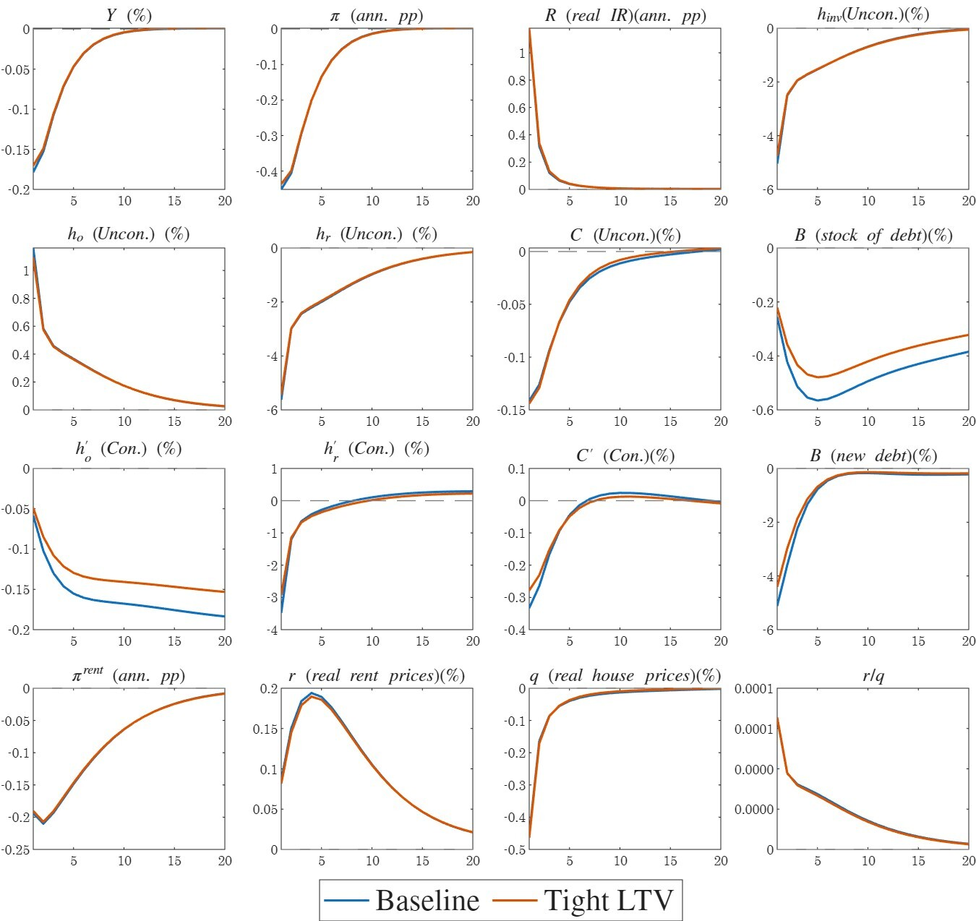
Notes: Variables are expressed as deviations from their steady state values and include: output, inflation, real central bank interest rate, investment in dwellings, ownership by unconstrained households, renting by unconstrained households, consumption by unconstrained households, stock of debt, ownership by constrained households, renting by constrained households, consumption by constrained households, new debt, nominal and real rent prices, real home prices and rent-to-home price ratio. The y-axes represent the percent deviation of each variable from its steady state in annualized terms, except for inflation and interest rates, which are shown as percentage point deviations.

The effectiveness of monetary policy under different levels of macroprudential policy tightness
An interesting question is whether monetary policy’s effectiveness in achieving price stability and supporting real activity is affected by the tightness of macroprudential policy. This question is directly related to the debate on the coordination of monetary and macroprudential policies (see, e.g., Malovaná et al. (2023)). To investigate this question, we conduct an experiment by introducing a monetary policy shock under two different regulations: (a) a baseline LTV ratio of 66% in the steady-state (as analyzed above) and (b) a tighter LTV ratio of 56% in the steady-state. The latter represents a policy aimed at maintaining lower leverage in the economy, thereby reducing the severity of financial distress.
Fig. 4 displays the impulses under both scenarios (baseline and tight LTV cap), and it appears that the impulse dynamics of inflation and output are almost identical in both cases. Thus, we conclude that macroprudential policy, in the form of LTV limits, does not change the effectiveness of monetary policy.
These results are consistent with Funke et al. (2018) (Section 4.4.4), despite notable differences in model specifications and housing market assumptions, and with Cozzi et al. (2021) (Fig. 12), although they considered the leverage ratio of banks rather than households.
Fig. 4 also shows that there is almost no difference in the reaction of unconstrained households (lenders) to the two levels of the LTV cap. This is true of both home prices and rent prices.
Constrained households (borrowers) respond differently to changes in the loan-to-value (LTV) cap (see Figure 4). Under a tighter LTV cap, the steady-state debt stock is lower—specifically, about 24% lower, as discussed later. This lower initial level of indebtedness reduces the sensitivity of borrowers to interest rate increases. When macroprudential policy is tight (LTV cap of 56%), interest payments remain relatively manageable. In contrast, with a higher LTV cap (66%), borrowers enter with greater leverage, and the resulting rise in interest rates can trigger substantial deleveraging. Consequently, under the tighter LTV cap, constrained households experience a milder decline in consumption, a smaller reduction in homeownership, and less pronounced deleveraging compared to the scenario with a higher LTV cap.
In addition to differences in debt levels (the intensive margin), a lower LTV cap may also reduce the share of borrowers (the extensive margin), as mortgages become less affordable. Using Israeli data, we estimate the corresponding decline in the share of borrowers (see Cohen and Ilek (2024)) and find a reduction of approximately 4 percentage points. However, incorporating this effect does not materially change the impulse responses. The only meaningfully affected equation is that of labor composition (see Section 2.4). We therefore conclude that the overall contribution—though minimal—originates primarily from differences in initial debt levels, as previously described.
We conjecture that the primary reason for the limited sensitivity of output (which largely corresponds to the sum of non-housing consumption by the two household types), inflation, and other key variables to monetary policy across different LTV ratios lies in the separability of the utility function between consumption and housing. This separability implies that the marginal utility of non-housing consumption is not directly influenced by the amount of housing consumed, whether through ownership or rent. For borrowers, this feature is particularly important: following a positive monetary policy shock, their housing demand varies substantially across LTV ratios (see Figure 4). If the utility function were non-separable, changes in housing demand would have translated into more pronounced adjustments in non-housing consumption.
The limited sensitivity of monetary policy effectiveness to different LTV ratios in the steady state may stem from the model’s linearity, which is based on first-order Taylor approximation. To assess this possibility, we re-solve the model using a second-order Taylor approximation and find that the result remains robust.

Monetary Policy Effectiveness under Fixed-Rate and Variable-Rate Mortgage Regimes
In the previous section, we analyzed the impact of different LTV caps on the effectiveness of monetary policy. We now try to examine how monetary policy effectiveness differs under fixed-rate and variable-rate mortgage structures. This analysis is important because limiting the share of variable-rate mortgages serves as an additional macroprudential policy tool that, beyond its standard objectives (e.g., reducing default risk and strengthening the resilience of the banking system, as discussed in Section 2), may also affect the effectiveness of monetary policy.
Figure 5 presents the effects of monetary policy under two distinct scenarios: one in which all mortgages carry a fixed interest rate, and another in which all mortgages have a variable interest rate. Both cases assume identical loan-to-value ratios and maturities. This comparative analysis aims to elucidate how the transmission mechanism varies between these scenarios. Furthermore, it considers potential outcomes in practical settings when adjustments are made to the proportion of variable rate mortgages held by typical households, as referenced in the introduction (Section 1).
To begin with, the variation in mortgage interest rate types does not significantly alter the transmission of monetary policy to the broader economy. Aggregate activity ($Y$) and inflation ($π$) respond in a similar manner regardless of the mortgage structure. In other words, the model suggests that reducing the share of variable-rate mortgages does not diminish the central bank’s effectiveness in achieving its primary objectives.
The similarity in the response of real activity across the two mortgage interest rate structures arises from the comparable initial reduction in consumption by both household types under each case (blue line versus orange line for each type). Subsequently, however, the lower consumption of borrowers under the variable interest rate scenario is offset by higher consumption among lenders, resulting in a similar overall level of output.
However, this distinction becomes particularly important when examining the housing market. As expected, changes in monetary policy are transmitted to mortgage interest rates much more strongly in the case of variable-rate mortgages than in fixed-rate products. Consequently, higher borrowing costs reduce the demand for home ownership among constrained households—an effect that is also reflected in substantial debt deleveraging—which, in turn, negatively affects their overall consumption levels. Despite the pronounced debt deleveraging observed in the case of variable-rate mortgages, the response of housing prices remains quite similar (see Figure 5). This outcome arises because housing prices are not directly influenced by borrowers’ debt levels but are instead determined in the market for unconstrained investors (see Section 4.2).
Figure 5: Response to a 1 p.p. MP shock, under a Fixed-Rate Mortgage (blue line) and under a Variable-Rate Mortgage (orange dashed line)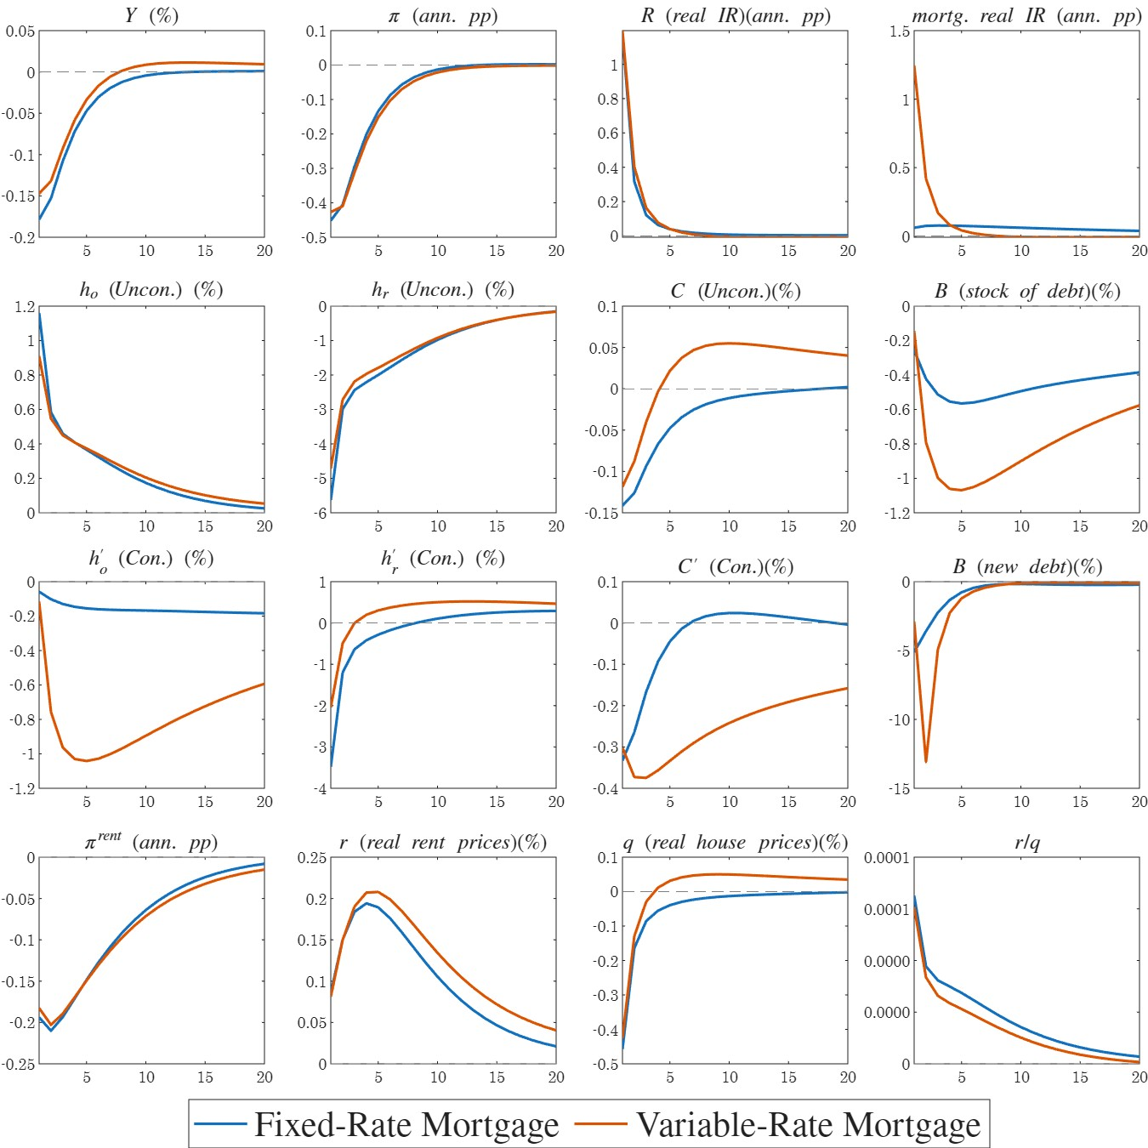
Notes: Variables are expressed as deviations from their steady state values and include: output, inflation, real central bank interest rate, mortgage real interest rate, ownership by unconstrained households, renting by unconstrained households, consumption by unconstrained households, stock of debt, ownership by constrained households, renting by constrained households, consumption by constrained households, new debt, nominal and real rent prices, real home prices and rent-to-home price ratio. The y-axes represent the percent deviation of each variable from its steady state in annualized terms, except for inflation and interest rates, which are shown as percentage point deviations.

The Effect of LTV Ratio on Home Prices
The primary objective of macroprudential policy is to lessen the risk of future financial crises by controlling the level of debt in the economy. An intriguing question is whether such policy also influences home prices? Research findings vary, suggesting that the impact of macroprudential policy on home prices may depend on a country's specific housing market structure, making it difficult to draw definitive conclusions. Here, we examine the impact of macroprudential policy in the housing market using our model.

Short term effect of permanent LTV shock
The LTV ratio shock demonstrates the impact of macroprudential policy that either tightens or loosens household borrowing capacity. Given the infrequency of macroprudential policy measures, we assume that the shock to the LTV ratio is (almost) permanent, approximated by a remarkably high inertia. More specifically, we simulate a scenario where macroprudential policy lowers the maximum LTV ratio from 66% to 56% (almost) permanently. The share of borrowers is an exogenous parameter in the model, while in reality the LTV ratio shock may change the lender-borrower composition. Thus, we present here only the intensive borrowing margin.
Figure 6 displays the impulse responses of the main variables to a permanent reduction in the loan-to-value (LTV) cap by 10 percentage points. It is evident that a tighter macroprudential (MP) policy leads to substantial deleveraging: new debt initially declines by about 70%, while outstanding debt falls by roughly 5%.
To understand the mechanism driving this result, we present again the equation describing the evolution of new debt.
$$B{'ₜ}^{New} ≤ LTV_{t}qₜ\left(h_{o,t}^{'} -h_{o,t-1}^{'}\right)+ κ\left(LTV_{t}qₜh_{o,t-1}^{'} -\left(1-Υ\right)B_{t-1}^{'}\right)$$
The significant deleveraging occurs for two main reasons: (1) a lower LTV cap directly reduces new borrowing, leading to a lower level of allowable new debt even when the price and quantity of owner‑occupied housing are fixed (the first term); and (2) the lower LTV cap generates negative net equity—after adjustment for the reduced LTV—forcing borrowers to deleverage (the second term). These two factors are further intensified as the decline in borrowers’ home ownership leads to even stronger deleveraging.
However, as illustrated in Fig. 6, despite the substantial deleveraging, real house prices decline only marginally. A 10 percentage point tightening of the LTV regulation leads to a reduction of no more than 0.25% in home prices.
Our model-based result—that home prices react only weakly to a lower LTV cap—aligns with Cerutti et al. (2017) and Buitron and Denis (2014). Cerutti et al. (2017) find that reducing the maximum LTV ratio has an insignificant, slightly negative effect on home prices in advanced economies, while Buitron and Denis (2014) report no evidence that macroprudential policies in Israel have restrained home prices.
Several studies employing DSGE models have examined the impact of changes in loan-to-value (LTV) ratios on housing prices. These studies generally find that a permanent reduction in the LTV cap leads to an immediate decline in home prices, although the magnitude of the effect varies across studies between 0.5% and 20%.
We hypothesize that this difference stems from two main factors: first, the absence of a rental market in those models, which typically serves as a close substitute for home ownership; and second, the distinctive features of Israel’s rental housing market, particularly the dominant role played by investors (as discussed in Sections 2 and 3). We now explain our key finding that, despite a significant reduction in the LTV cap, the effect on home prices remains minimal.
As borrowers reduce home ownership, downward pressure on housing prices emerges. In models with ownership only, this leads to a significant price decline. However, when a rental market is included, an offsetting channel appears. Given the high substitutability between owning and renting, borrowers shift to renting, as reflected in rising rents and declining ownership (see Figure 6). The increased rental demand encourages investors to expand housing purchases, raising housing investment by over 3%. This occurs because returns on housing rise relative to deposit interest rates. Thus, two opposing forces largely offset each other: borrowers selling homes and moving to rentals, pushing prices down, and investors buying properties to meet higher rental demand, pushing prices up.
We conducted a robustness test to examine the weak response of housing prices under a low degree of substitution between ownership and renting. The result remains largely unchanged (see appendix in supplementary material, here), even though the substitution effect on housing prices is much weaker than in the baseline case, as it is offset by a more accommodative monetary policy stance.
To verify that the mechanisms in the rental market are the main source of this result, we eliminated the rental market in the model by setting the ownership share ($γ$) in the housing composite $H\left(h_{o,t},h_{r,t}\right)$ close to one and reducing the elasticity of substitution between ownership and renting ($ε$) close to one. We find that under this calibration, the decline in housing prices is twice stronger than in the benchmark case. When in addition we reduce the share of investors in the economy, the reduction in the home prices is……
Figure 6: Effects of a macroprudential policy tightening that lowers the loan-to-value (LTV) cap from 66% to 56%.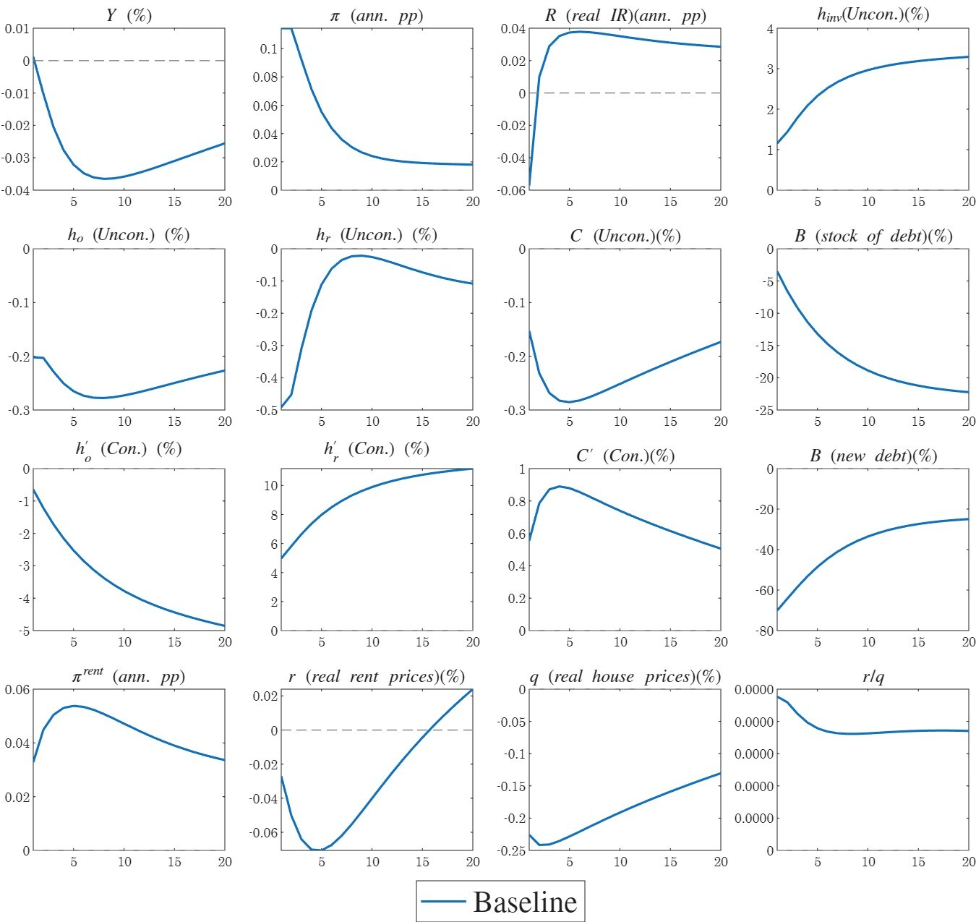
Notes: Variables are expressed as deviations from their steady state values and include: output, inflation, real central bank interest rate, investment in dwellings, ownership by unconstrained households, renting by unconstrained households, consumption by unconstrained households, stock of debt, ownership by constrained households, renting by constrained households, consumption by constrained households, new debt, nominal and real rent prices, real home prices and rent-to-home price ratio. The y-axes present the percent deviation of each variable from its steady state in annualized terms, except for inflation and interest rates, which are shown as percentage point deviations.

Long-term effect of LTV shock
In Section 6.4.1, we examined the short‑term dynamics of the main variables following the LTV shock. We now turn to the long‑run implications of this reduction for the steady‑state equilibrium.
In Table 2, we compare two steady states of the economy: the baseline calibration with an LTV cap of 66%, and a scenario with tighter macroprudential policy featuring an LTV cap of 56%. We interpret modification of the LTV limit as emphasizing a structural shift in the economy rather than a dynamic policy action. We examine how a permanent decline in the LTV cap affects the ratio of new debt to GDP and the composition between ownership and renting for two household types in the new steady state. However, we do not assess the impact of this permanent decline on the overall welfare of the economy, nor do we provide recommendations for the optimal LTV ratio.
In the steady state, the LTV ratio has no impact on the relative price of rent to ownership (see the Technical Appendix, here). Consequently, any changes in the ownership‑to‑rent ratio and other related variables reflect non‑price adjustments.
As expected, a stricter LTV (Loan-to-Value) restriction leads to a significant 24% decline in the ratio of new mortgages to GDP in the new steady state. Consequently, the renter-occupied housing rate among borrowers increases by 6 percentage points. This outcome is consistent with the negative relationship between the renter-occupied housing rate and the LTV ratio, as demonstrated in Proposition 1 of Section 4.3.
The renter-occupied housing rate among lenders remains unchanged in the steady state (14.3%), as it is determined only by their preferences and a markup in the housing market (see Proposition 1 in Section 4.3.). Overall, the renter-occupied housing rate in the economy increases from 17.2% to 17.9%, but this effect is solely via borrowers.
Table 2's outcomes presume that LTV ratio changes do not affect the share of borrowers. While in practice, LTV changes might alter the proportion of borrowers (constrained households), our model does not account for an endogenous shift between the two groups (lenders to borrowers or vice-versa). Such a transition would also imply a change in preferences for lenders and borrowers, given their differing initial discount factors ($β$).
The final two columns of Table 2 present outcomes under an alternative scenario, where tighter macroprudential policy increases the fraction of constrained households from 31.2% to 35%. This assumption is based on external calibration from Cohen and Ilek (2024). The results demonstrate only minor deviations from the original scenario, despite the increase in the fraction of the constrained households.
Table 2: Comparison of Steady‑State Outcomes under Different LTV Caps: Debt‑to‑GDP Ratio and Renter‑Occupied Housing Rate
 | Baseline | Tight LTV | Change | Tight LTV* | Change*
Share of constrained households, $1-τ$ | 31.2% | 31.2% | - | 35% | 3.8 p.p
$LTV$ limit | 66% | 56% | -10 p.p | 56% | -10 p.p
New debt to GDP ratio$\frac{B^{'NEW}}{Y}$ |  |  | -24% |  | -14%
Rent ratio of lenders $\frac{h_{r}}{h_{r}+h_{o}}$ | 14.3% | 14.3% | - | 14.3% | -
Rent ratio of borrowers $\frac{{h^{'}}_{r}}{{h^{'}}_{r}+{h^{'}}_{o}}$ | 38.4% | 44.4% | 6 p.p | 44.4% | 6 p.p
Rent ratio total  $$\frac{h_{r}+{h^{'}}_{r}}{h}$$ | 17.2% | 17.9% | 0. 7 p.p | 18.4% | 1.2 p.p

Conclusions
The effectiveness of monetary and macroprudential policies is a key concern for central banks. Our model of the Israeli economy indicates that implementing macroprudential measures—such as lowering the loan‑to‑value (LTV) cap or restricting the share of time‑varying interest‑rate mortgages—does not significantly hinder the central bank’s ability to achieve its primary objectives of price stability and supporting real economic activity. However, these policies do generate distributional effects arising from household heterogeneity and also influence the magnitude of deleveraging.
In particular, we find that the effectiveness of monetary policy in influencing home prices is only marginally affected by macroprudential measures such as a lower LTV cap or restrictions on the share of time‑varying interest‑rate mortgages. This finding is consistent with the relatively weak response of home prices to a standalone LTV shock.
This outcome contrasts with much of the existing DSGE literature, which typically finds that a lower LTV cap leads to a substantial decline in housing prices. We attribute this difference to the absence of a rental market in those models and to distinctive features of Israel’s rental housing market, particularly the dominant role of investors.
Overall, our findings provide important insights for policymakers. They highlight a nuanced reality: while macroprudential tools such as LTV restrictions can effectively enhance financial stability, their impact on home prices may be less straightforward than initially assumed.
Finally, we believe that our research not only deepens the understanding of Israel’s housing market dynamics but also offers broader implications for other economies implementing similar macroprudential frameworks.

Reference
Alpanda, Sami, and Sarah Zubairy, “Addressing Household Indebtedness: Monetary, Fiscal or Macroprudential Policy?,” European Economic Review, 92 (2017), 47–73.
Aoki, Kosuke, James Proudman, and Gertjan Vlieghe, “House Prices, Consumption, and Monetary Policy: a Financial Accelerator Approach,” Journal of Financial Intermediation, (2004), 22.
Argov, Eyal, Emanuel Barnea, Alon Binyamini, Eliezer Borenstein, David Elkayam, and Irit Rozenshtrom, “MOISE: A DSGE Model for the Israeli Economy,” Discussion Paper Series, (2012) (Bank of Israel Research Department).
Bekiros, Stelios, Rachatar Nilavongse, and Gazi Salah Uddin, “Expectation-driven house prices and debt defaults: The effectiveness of monetary and macroprudential policies,” Journal of Financial Stability, 49 (2020), 100760.
Benchimol, Jonathan, Inon Gamrasni, Michael Kahn, Sigal Ribon, Yossi Saadon, Noam Ben-Ze’ev, Asaf Segal, and Yitzchak Shizgal, “The interaction between domestic monetary policy and macroprudential policy in Israel,” Economic Modelling, 112 (2022), 105872.
Benigno, Pierpaolo, Gauti B. Eggertsson, and Federica Romei, “Dynamic Debt Deleveraging and Optimal Monetary Policy,” American Economic Journal: Macroeconomics, 12 (2020), 310–350.
Bosshardt, Joshua, Marco Di Maggio, Ali Kakhbod, and Amir Kermani, “The Credit Supply Channel of Monetary Policy Tightening and its Distributional Impacts,” Working Paper Series, Working Paper, (2023) (National Bureau of Economic Research).
Bruneau, Gabriel, Ian Christensen, and Césaire Meh, “Housing market dynamics and macroprudential policies,” Canadian Journal of Economics, 51 (2018), 864–900.
Buitron, Carolina Osorio, and Stephanie Denis, “The Housing Market in Israel,” IMF Country Report, (2014) (International Monetary Fund).
Cairó, Isabel, and Jae Sim, “Monetary policy and financial stability,” Journal of Economic Dynamics and Control, 157 (2023), 104764.
Cerutti, Eugenio, Stijn Claessens, and Luc Laeven, “The use and effectiveness of macroprudential policies: New evidence,” Journal of Financial Stability, 28 (2017), 203–224.
Cohen, Nimrod, and Alex Ilek, “An estimate of the share of financially constrained households in Israel (Hebrew),” Unpublished Memo, (2024) (Bank of Israel).
Cozzi, Guido, Matthieu Darracq Paries, Peter Karadi, Jenny Körner, Christoffer Kok, Falk Mazelis, Kalin Nikolov, Elena Rancoita, Alejandro Van Der Ghote, and Julien Weber, “Macroprudential Policy Measures: Macroeconomic Impact and Interaction with Monetary Policy,” ECB Working Paper Series, (2021).
Drehmann, Mathias, Claudio E. V. Borio, and Kostas Tsatsaronis, “Characterising the Financial Cycle: Don’t Lose Sight of the Medium Term!,” BIS Working Papers, (2012) (Bank for International Settlements).
Funke, Michael, Robert Kirkby, and Petar Mihaylovski, “House prices and macroprudential policy in an estimated DSGE model of New Zealand,” Journal of Macroeconomics, 56 (2018), 152–171.
Genesove, David, “The Nominal Rigidity of Apartment Rents,” The Review of Economics and Statistics, 85 (2003), 844–853.
Guerrieri, Luca, and Matteo Iacoviello, “Collateral constraints and macroeconomic asymmetries,” Journal of Monetary Economics, 90 (2017), 28–49.
Iacoviello, Matteo, “House Prices, Borrowing Constraints, and Monetary Policy in the Business Cycle,” American Economic Review, 95 (2005), 739–764.
Iacoviello, Matteo, and Stefano Neri, “Housing Market Spillovers: Evidence from an Estimated DSGE Model,” American Economic Journal: Macroeconomics, 2 (2010), 125–164.
Ilek, Alex, and Nimrod Cohen, “A Semi-Structural Model with Household Debt for Israel,” Discussion Paper Series, (2023) (Bank of Israel Research Department).
Ilek, Alex, and Irit Rozenshtrom, “The term premium in a small open economy: A micro-founded approach,” International Review of Economics & Finance, 57 (2018), 333–352.
Ireland, Peter N., “Changes in the Federal Reserve’s Inflation Target: Causes and Consequences,” Journal of Money, Credit and Banking, 39 (2007), 1851–1882.
Kosman, Liran, “Housing Ownership Data by Deciles in Israel,” (2021) (The Knesset Research and Information Center, Israel).
Laufer, Steven, and Nitzan Tzur-Ilan, “The effect of LTV-based risk weights on house prices: Evidence from an Israeli macroprudential policy,” Journal of Urban Economics, 124 (2021), 103349.
Lee, Junhee, and Joonhyuk Song, “Housing and business cycles in Korea: A multi-sector Bayesian DSGE approach,” Economic Modelling, 45 (2015), 99–108.
Malovaná, Simona, Martin Hodula, Zuzana Gric, and Josef Bajzík, “Macroprudential policy in central banks: Integrated or separate? Survey among academics and central bankers,” Journal of Financial Stability, 65 (2023), 101107.
Nagar, Weitzman, and Guy Segal, “What Explains the Developments in Home Prices and Rents in Israel between 1999 and 2010?,” Israel Economic Review, 12 (2014), 115–161.
Poterba, James M., “Tax Subsidies to Owner-Occupied Housing: An Asset-Market Approach,” The Quarterly Journal of Economics, 99 (1984), 729.
Quint, Dominic, and Pau Rabanal, “Monetary and Macroprudential Policy in an Estimated DSGE Model of the Euro Area,” International Journal of Central Banking, 10 (2014).
Raz-Dror, Ofer, “The changes in rent in israel during the years of the housing crisis 2008–2015,” Israel Economic Review, 17 (2019).
Ribon, Sigal, “The Interaction between Macroprudential and Monetary Policies and the Housing Market – A VAR Examination for Israel,” Discussion Paper Series, (2023) (Bank of Israel Research Department).
Ribon, Sigal, and Doron Sayag, “Price Setting Behavior in Israel An Empirical Analysis Using Microdata,” Discussion Paper Series, (2013) (Research Department Bank of Israel).
Rotemberg, Julio J., “Monopolistic Price Adjustment and Aggregate Output,” The Review of Economic Studies, 49 (1982), 517–531.
Shimizu, Chihiro, Kiyohiko G. Nishimura, and Tsutomu Watanabe, “Residential rents and price rigidity: Micro structure and macro consequences,” Journal of the Japanese and International Economies, 24 (2010), 282–299.
Stein-Kapach, Nardit, “Ownership of Financial Assets by Households Findings from the Longitudinal Survey 2018 (Hebrew only),” (2019) (Central Bureau of Statistics).
Sun, Xiaojin, and Kwok Ping Tsang, “What Drives the Owner-Occupied and Rental Housing Markets? Evidence from an Estimated DSGE Model,” Journal of Money, Credit and Banking, 49 (2017), 443–468.
Svensson, Lars E O, “A Simple Frictionless Model of User Cost and User-Cost-to-Income and User-Cost-to-Rent Ratios,” Unpublished manuscript, (2022) (Stockholm School of Economics).
Van-Hoenselaar Frank, Cournède Boris, De Pace Federica, and Ziemann Volker, “Mortgage finance across OECD countries,” OECD Economics Department Working Papers, (2021) (Paris, OECD).
Verbrugge, Randal, Alan Dorfman, William Johnson, Fred Marsh III, Robert Poole, and Owen Shoemaker, “Determinants of Differential Rent Changes: Mean Reversion versus the Usual Suspects,” Real Estate Economics, 45 (2017), 591–627.
Yakhin, Yossi, and Inon Gamrasni, “The Housing Market in Israel: Long-Run Equilibrium and Short-Run Dynamics,” Discussion Paper Series, (2021) (Bank of Israel Research Department).

We are grateful to Yossi Yakhin for his insightful discussion and valuable comments, which greatly contributed to improving this paper. We also thank Oren Levintal for his discussion, and Adi Brender, Eliezer Borenstein, Alon Benyamini, Yoav Friedman, Sigal Ribon, and the other participants in the Bank of Israel Research Department seminar for their helpful feedback and suggestions.
Alex Ilek – Research Department, Bank of Israel. Email: alexei.ilek@boi.org.il
Nimrod Cohen– Research Department, Bank of Israel. Email: nimrod.cohen@boi.org.il
Yaakov Chen-Zion – Research Department, Bank of Israel. Email: yaakov.chen-zion@boi.org.il
Ribon (2023) represented macroprudential (MP) measures with a dummy variable assuming permanence, but this variable encompassed all MP measures, not only those targeting the housing market.
These results contradict the findings of Quint and Rabanal (2014); Bekiros et al. (2020); Bosshardt et al. (2023); Cairó and Sim (2023), who found that macroprudential policies can complement monetary policy and vice versa.
As income increases, the share of households with a mortgage rises—a robust phenomenon observed worldwide.
The user cost approach compares the cost of renting with the alternative cost of owner‑occupied housing (see, for example, Poterba (1984); Svensson (2022)). The basic assumption underlying this approach is perfect substitutability between rental and owner‑occupied housing.
Similarly to Ireland (2007) and Ilek and Rozenshtrom (2018).
Similar to the assumption of indexation to past inflation in the Calvo price rigidity setting. See for example, Ireland (2007) and Ilek and Rozenshtrom (2018).
For convenience, we use $B^{'}$ to denote both the deposits of commercial banks at the central bank and the deposits of lenders at commercial banks, applying the clearing condition $B_{t}^{'}+B_{t}=0.$
Until 2024, the general-purpose loan limit backed by a home was 50%, but during "Operation Swords of Iron," it was temporarily raised to 70% (up to 200,000 ILS). For calibration, we use the 50% value.
The calculation of the parameter $Θ$ is available from the authors upon request.
This document is available upon request
Similar to the approach in Alpanda and Zubairy (2017) footnote 34, and Funke et al. (2018).
When scaling all results to a 10 percentage point permanent reduction in the LTV ratio cap, the estimated immediate decrease in home prices is approximately 20% in Funke et al. (2018), 1.2% in Bruneau et al. (2018), and 0.5% in Lee and Song (2015).

