Appendix for:
Assessing the Impact of Monetary and Macroprudential Policies on Israelis Housing Market: A DSGE Model Approach
Alex Ilek, Nimrod Cohen and Yaakov Chen-Zion
10.3.2026

Proof of Proposition 1
We begin with the lenders and restate the Phillips curve for rental prices (see Eq. (5) in Section 4.3):
$$\frac{p_{t}^{m}}{r_{t}}=\frac{η_{r}-1}{η_{r}}+\frac{Θ}{η_{r}}π_{t}^{rent}\left(π_{t}^{rent}-{\left(π\right)}^{1-ϕ}{\left(π_{t-1}^{rent}\right)}^{ϕ}\right)-sdf_{t,t+1}\frac{Θ}{η_{r}}π_{t+1}^{rent}\frac{Y_{t+1}^{rent}}{Y_{t}^{rent}}\left(π_{t+1}^{rent}-{\left(π\right)}^{1-ϕ}{\left(π_{t}^{rent}\right)}^{ϕ}\right)$$
In the steady state we obtain:
$$r=Fp^{m},$$
where $F=\frac{η_{r}}{η_{r}-1}$ is a markup.
From the first-order conditions of the lenders (Section 4.2)
$$\frac{h_{o}}{h_{r}}={\left(\frac{1-γ}{γ}\left[\frac{q}{r}-sdf\frac{q}{r}\right]\right)}^{-ε}$$
After substituting $r=Fp^{m}$, we obtain:
$$\frac{h_{o,t}}{h_{r,t}}={\left(\frac{1-γ}{γ}\frac{1}{F}\left[\frac{q}{p^{m}}-sdf\frac{q}{p^{m}}\right]\right)}^{-ε}$$
From Eq. (f) in Section 4.2, we have:
$$\frac{q}{p^{m}}-sdf\frac{q}{p^{m}}=1$$
Consequently, in the steady state, the ownership-to-rent ratio for lenders depends solely on underlying preferences and the markup prevailing in the rental market.
$$\frac{h_{o,t}}{h_{r,t}}=\frac{h_{o}}{h_{r}}={\left(\frac{γ}{1-γ}F\right)}^{ε}.$$
Next, we turn to the ownership-to-rent ratio for borrowers. From second and third equations in Section 4.1.1, we derive the ownership–to-rent ratio of the borrowers in the steady state (see the Technical Appendix for details of the derivation):
$$\frac{h_{o}^{'}}{h_{r}^{'}}={\left[\frac{1-γ^{'}}{γ^{'}}\frac{q}{r}θ\right]}^{-ε},$$
where $θ=1-β'$+LTV($β^{'}-β^{'}κ-1)\frac{μ'}{λ'}$, and $\frac{q}{r}=\frac{\frac{η_{r}-1}{η_{r}}}{1-β}$ represents the price-to-rent ratio in the SS, and $\frac{μ'}{λ'}=\frac{1-β'R^{L}}{1-β^{'}\left(1-κ\right)(1-Υ)}$ represents the Lagrangian multiplier ratio associated with borrowers in the steady state.
Thus
$$\frac{h_{o}^{'}}{h_{r}^{'}}={\left[\left(\frac{1-γ^{'}}{γ^{'}}\right)\left(\frac{\frac{η_{r}-1}{η_{r}}}{1-β}\right) \left\{1-β'+LTV(β^{'}-β^{'}κ-1)\frac{1-β'R^{L}}{1-β^{'}\left(1-κ\right)(1-Υ)}\right\}\right]}^{-ε}$$
Taking derivative w.r.t. LTV yields (none of the terms in the expression depend on LTV)
$$\frac{∂\left(\frac{h_{o}^{'}}{h_{r}^{'}}\right)}{∂LTV}=\frac{-ε\left(\frac{1-γ^{'}}{γ^{'}}\right)\left(\frac{\frac{η_{r}-1}{η_{r}}}{1-β}\right)(β^{'}-β^{'}κ-1)\frac{1-β'R^{L}}{1-β^{'}\left(1-κ\right)(1-Υ)}}{{\left[\left(\frac{1-γ^{'}}{γ^{'}}\right)\left(\frac{\frac{η_{r}-1}{η_{r}}}{1-β}\right) \left\{1-β'+LTV(β^{'}-β^{'}κ-1)\frac{1-β'R^{L}}{1-β^{'}\left(1-κ\right)(1-Υ)}\right\}\right]}^{1+ε}}$$
It is straightforward to see that $\frac{∂\left(\frac{h_{o}^{'}}{h_{r}^{'}}\right)}{∂LTV}>0$, since all terms in the expression are positive, except for $β^{'}-β^{'}κ-1<0$ and the negative sign of $-ε$ in the numerator. Their product is positive, resulting in a positive overall derivative.

Changing the housing preference weight (j)

Here, we examine the effect of the housing preference weight $j$ in the utility function (see Section 4.1). Since there is no estimate for Israel, we test the case of $j=0.12$ as in Iacoviello and Neri (2010) and Sun and Tsang (2017), while our baseline is $j=1$. Under the MP shock (Figure A.3), the response of most variables is similar to the baseline case. The most notable change is that borrowers increase rental demand and reduce ownership demand more prominently. This is because lower $j$ reduces significantly the marginal utility from ownership and for rent
Under the LTV shock (Figure A.4), we observe only slightly different qualitative responses than under the benchmark, with generally faster and stronger reactions.
Figure A.3: Response to a 1 p.p. monetary policy shock, for j=1 (blue line) and for j=0.12 (orange line)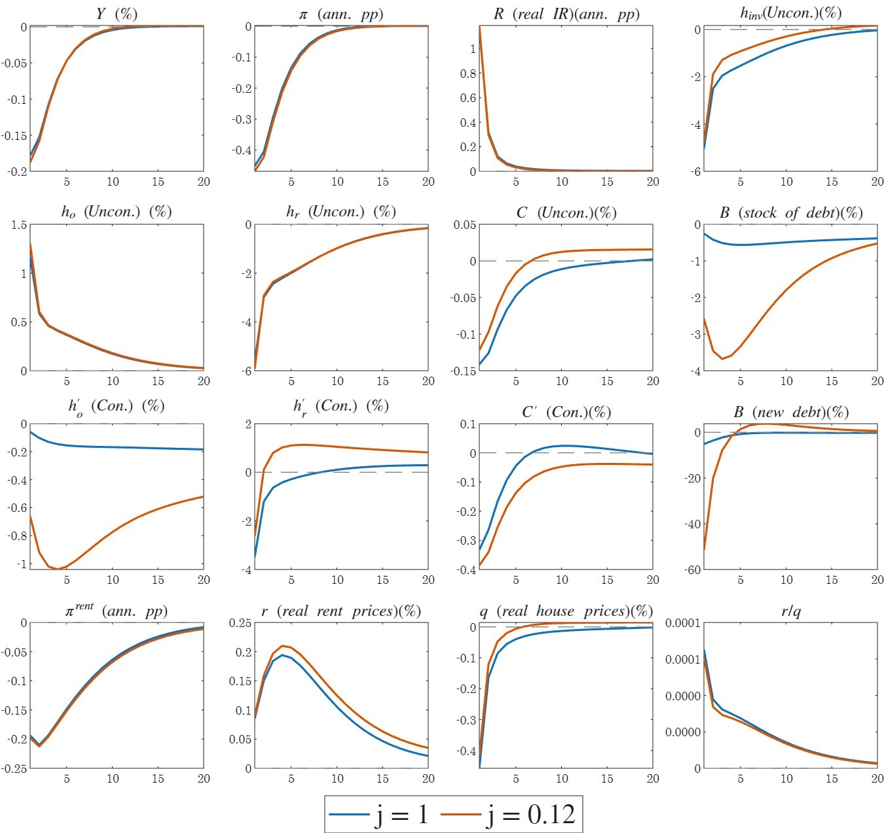
Notes: Variables (in deviation from their steady state): output, inflation, real central bank interest rate, investment in dwellings, ownership by unconstrained households, renting by unconstrained households, consumption by unconstrained households, stock of debt, ownership by constrained households, renting by constrained households, consumption by constrained households, new debt, nominal and real rent prices, real home prices and rent-to-home price ratio. The y-axes present the percent deviation of each variable from its steady state in annualized terms, except for inflation and interest rates, which are shown as percentage point deviations.

Figure A.4: Response to a LTV shock of 10 p.p., for j=1 (blue line) and for j=0.12 (orange line)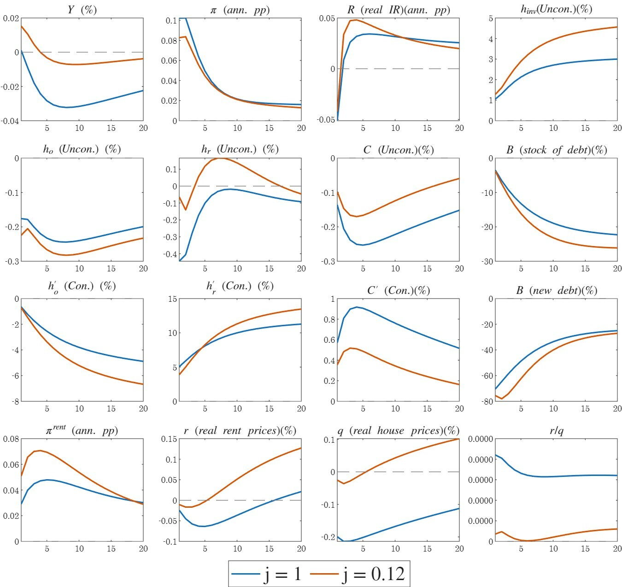
Notes: Variables (in deviation from their steady state): output, inflation, real central bank interest rate, investment in dwellings, ownership by unconstrained households, renting by unconstrained households, consumption by unconstrained households, stock of debt, ownership by constrained households, renting by constrained households, consumption by constrained households, new debt, nominal and real rent prices, real home prices and rent-to-home price ratio. The y-axes presents the percent deviation of each variable from its steady state in annualized terms, except for inflation and interest rates, which are shown as percentage point deviations.

