**Michael Cohen**

**INFO 451 Final Exam**

**Question A:**

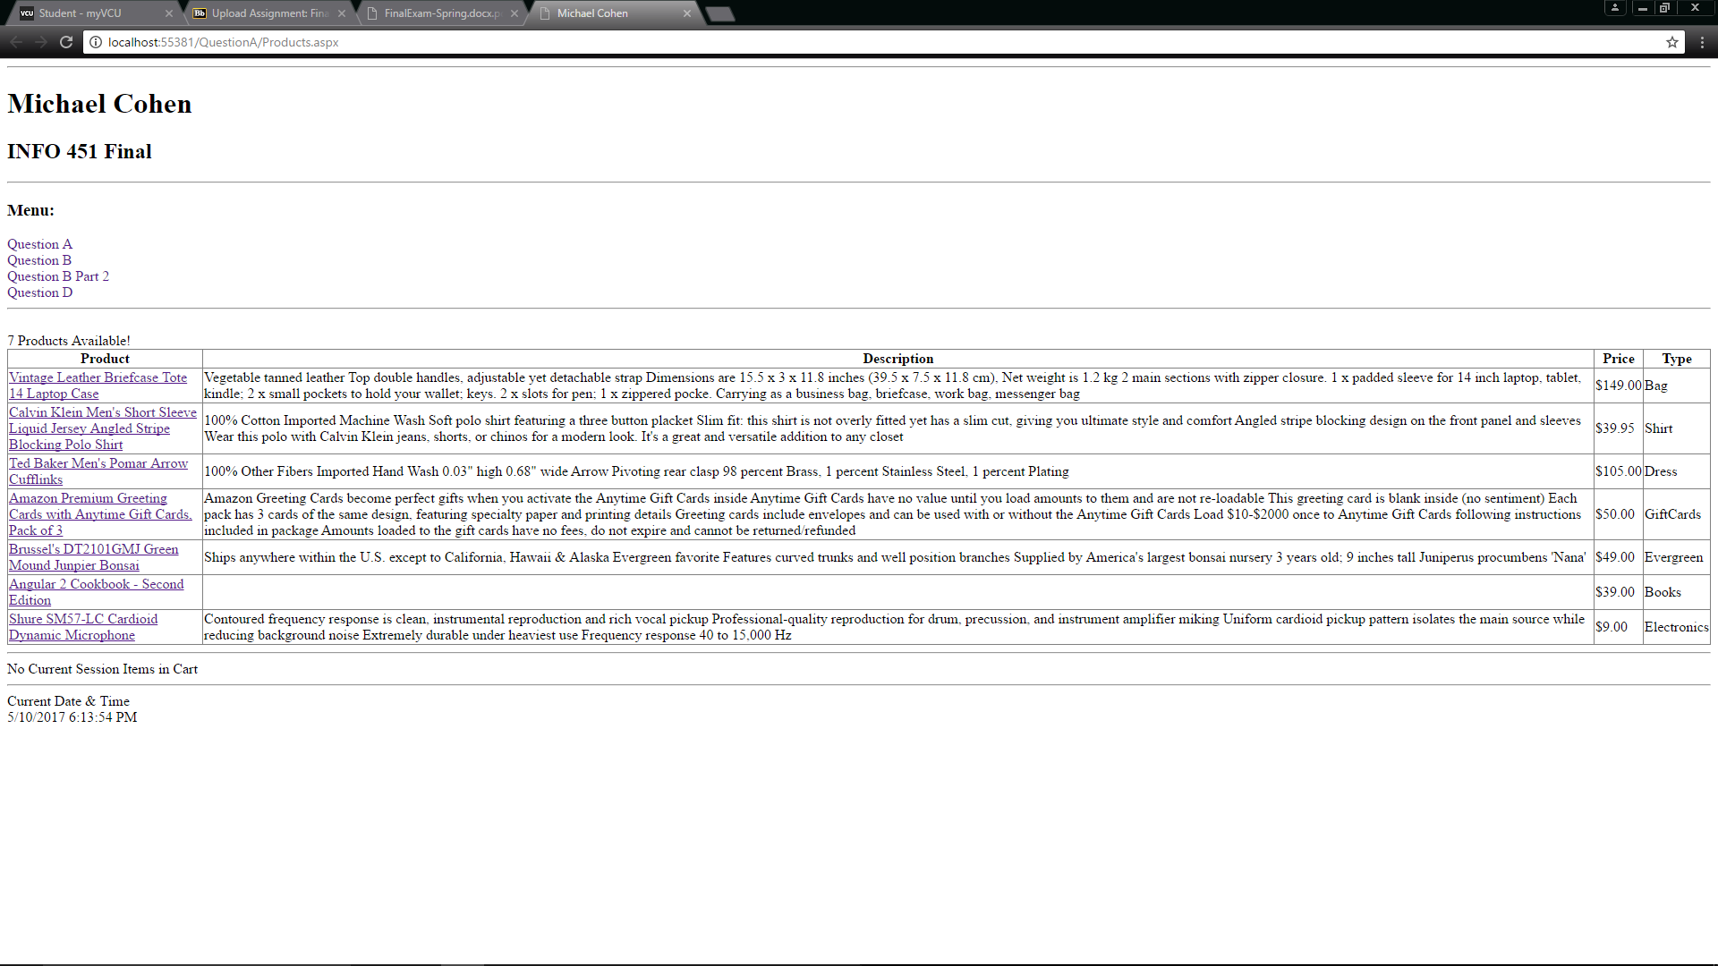 **When Clicking on one of the Product hyperlinks:**

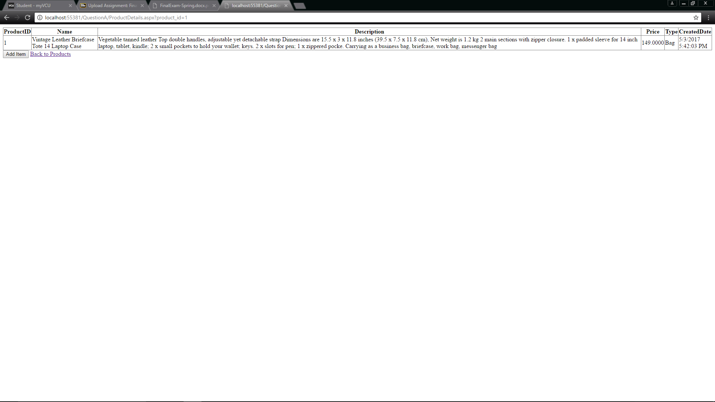

**After Adding an Item to the “Cart”:**

Indicated by ‘1 Items in Cart’

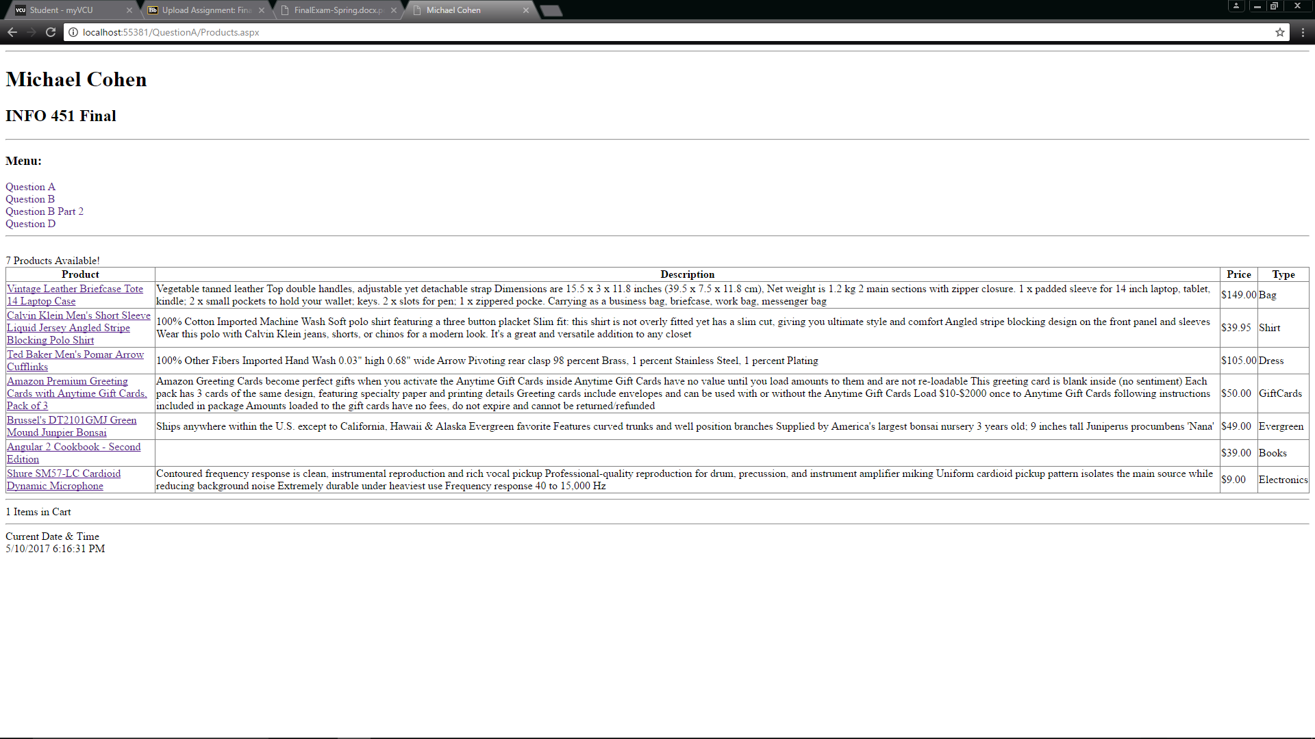

**After Adding 4 items to the “Cart”**

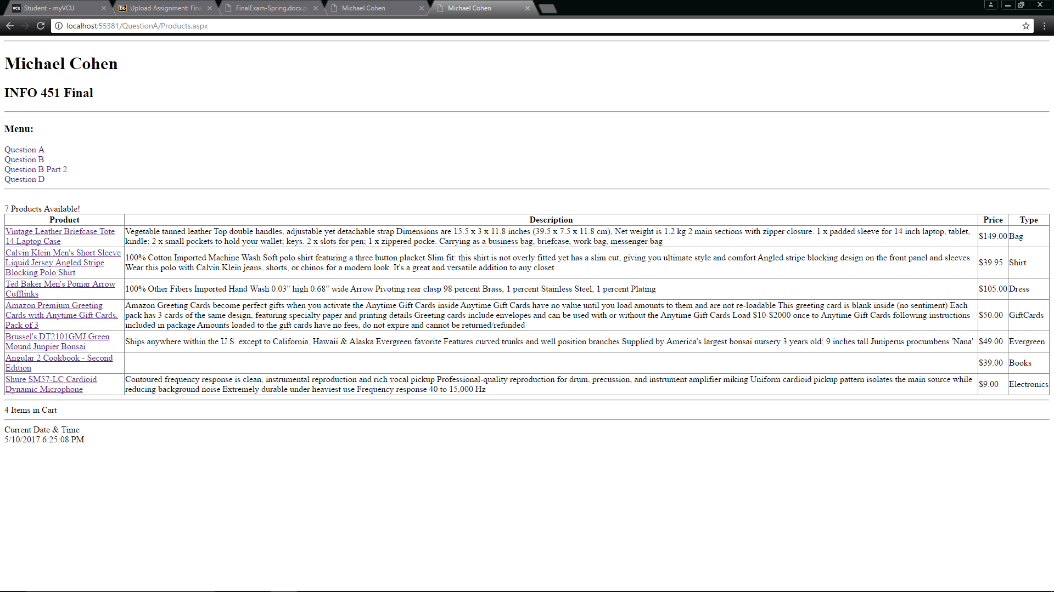

**Question B:**

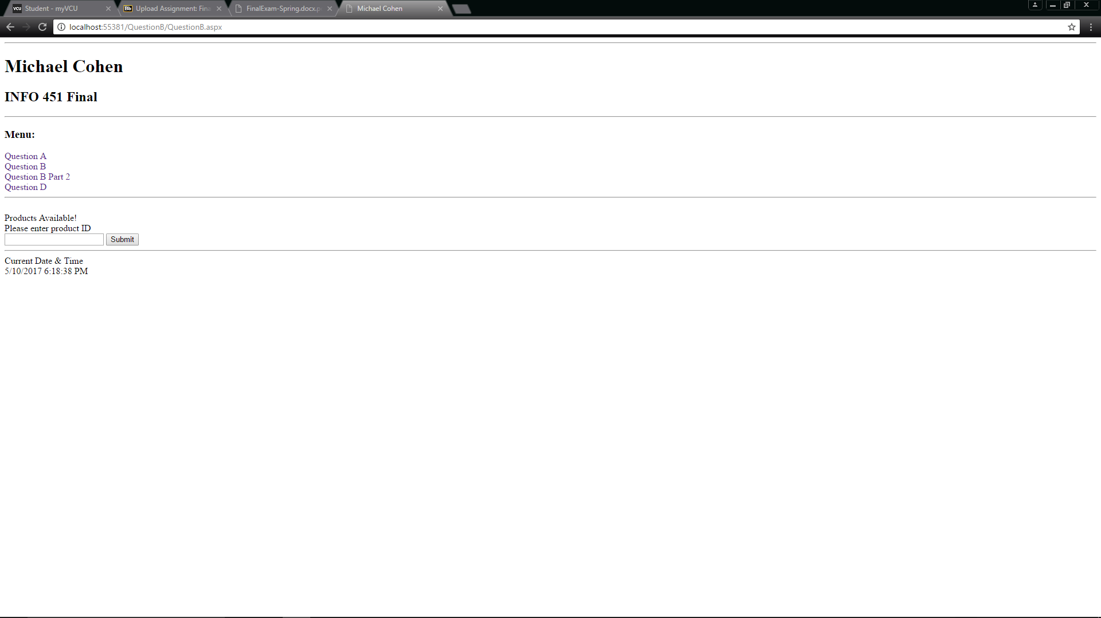

**Typing in product_id as ‘1’:**

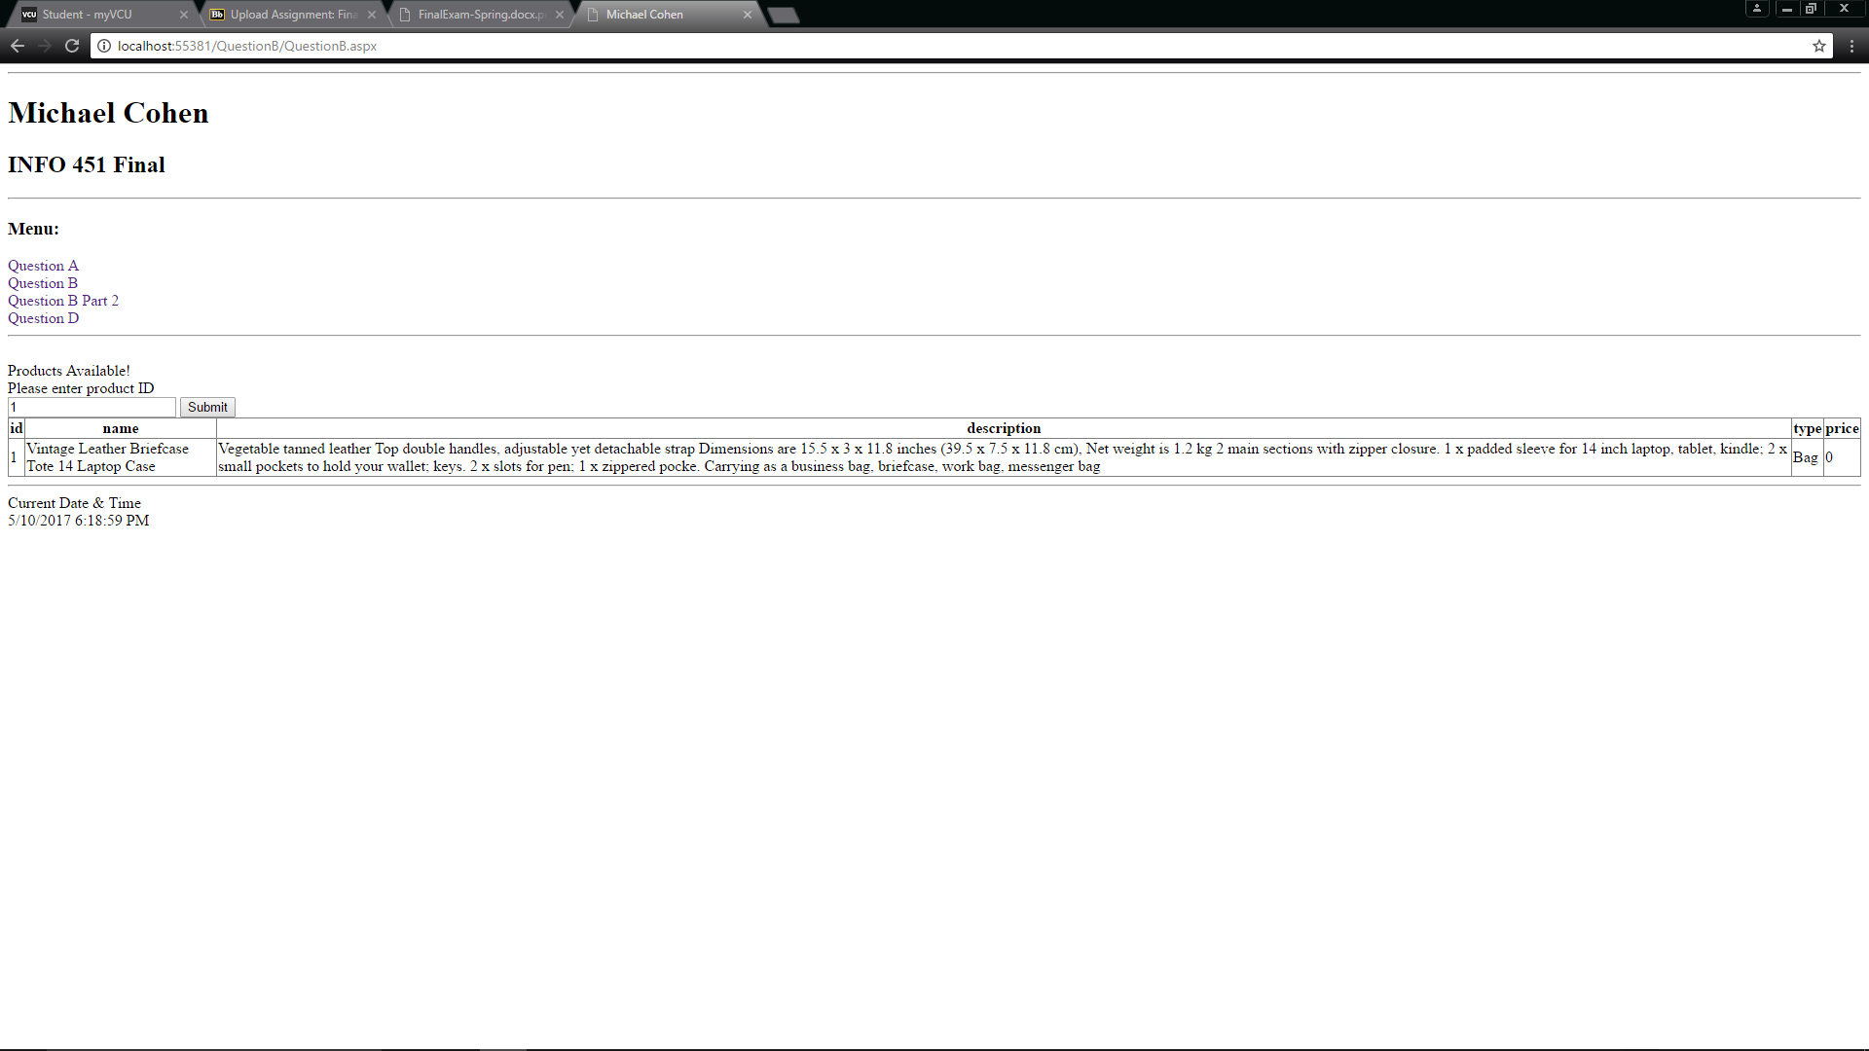

**Typing in product_id as ‘2’:**

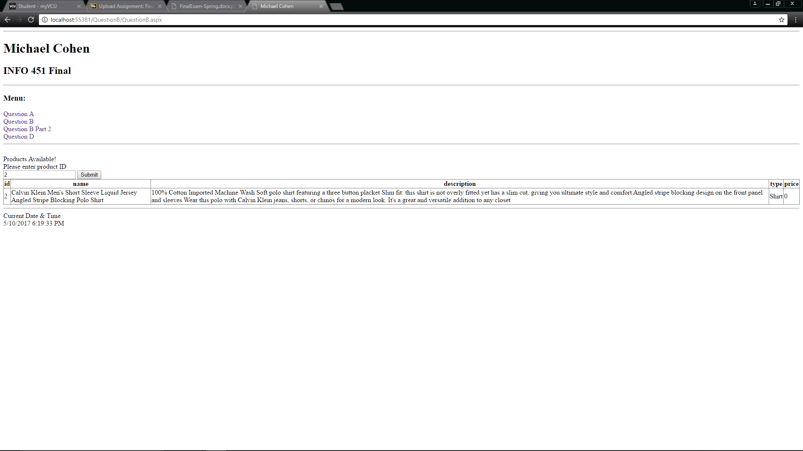

**Typing in product_id as ‘7’:**

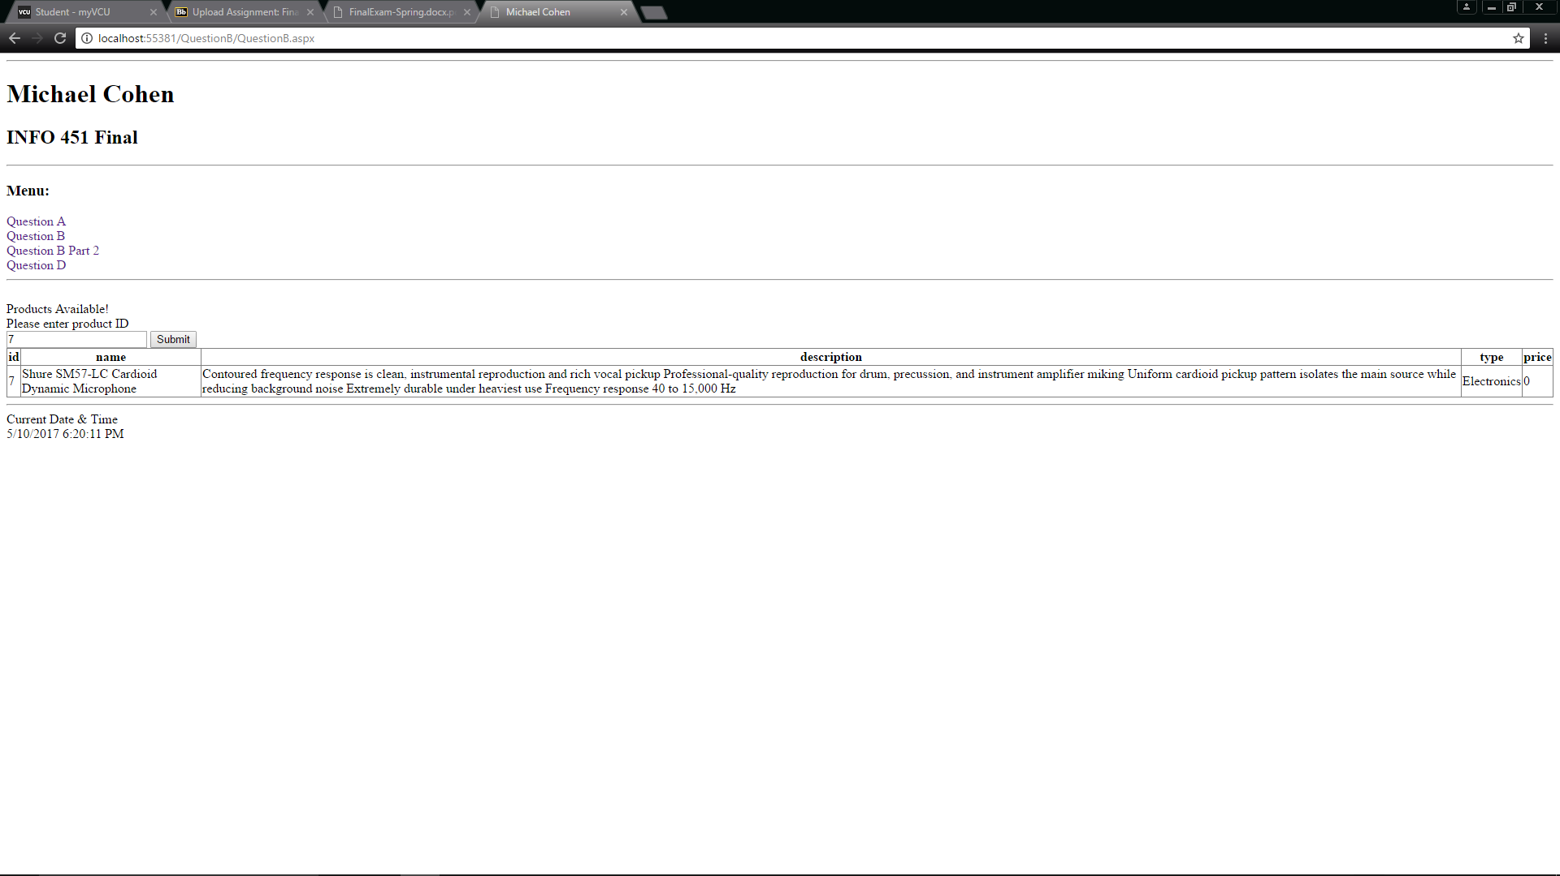

**I couldn’t get the error message to properly display, so I deleted the contents and left it as it.**

**Question B Part 2: (will also Link the QuestionB&D.doc) in doc folder**

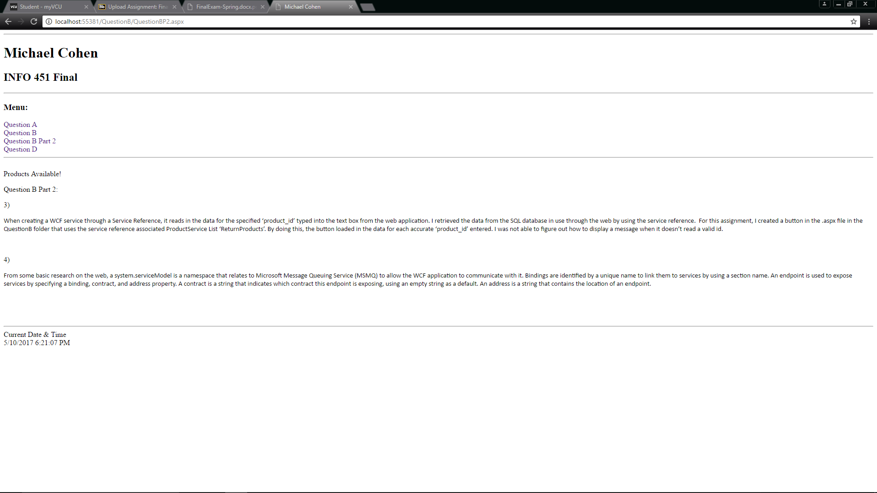

**Question D: (will also Link the QuestionB&D.doc) in doc folder**

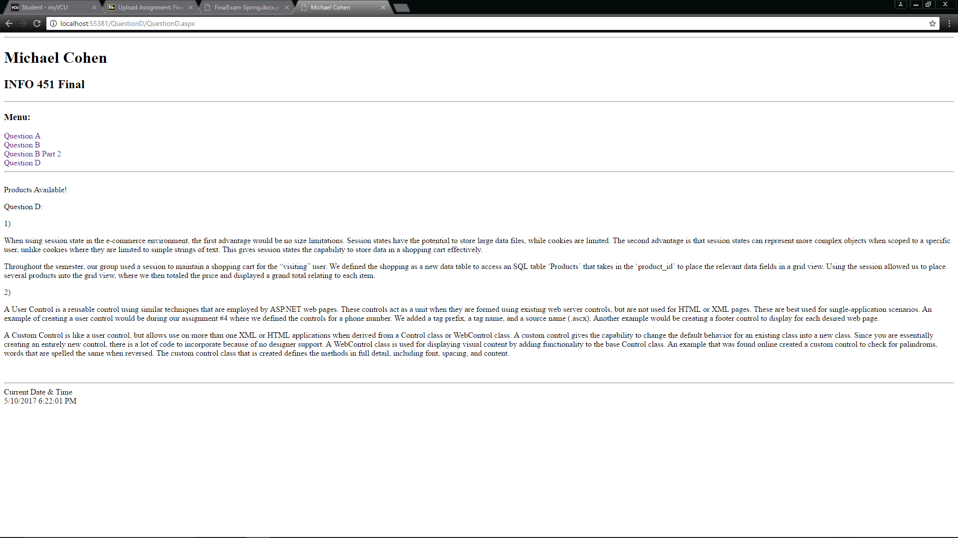

**Question E:**

Master Page:

The Master Page can be seen throughout the other screen shots, but here is there layout through the design window in visual studios.

