Category | Task | Change
Audio Changes | For all tasks | Randomize stimuli within each order (A, B, C, D)  This means: if Order A has stimuli 1, 2 3, 4, and 5, then we’d love a random number generator to pick the stimulus presentation order. For example, a rand num generator would order the files as follows: 4, 1, 2, 5, 3  This should be different for every kid in order A so we don’t want the same random number sequence for each kid in a condition
Audio Changes | For all tasks | (1) Insert beeping sound after the stimulus to alert the participant that it’s their turn to repeat the stimulus (I.e., an auditory cue), (2) add this into the training examples as well. Audio file located here: <insert link to Auditory_Cue.mp3>
Audio Changes | For all tasks | We would like a variety of encouraging phrases after each trial, so kids don’t get bored with the feedback, these can be randomized in the presentation (I.e., “Excellent!” “You got this!” “Good job space cadet!”) The 6-8 files are located here: <insert link>
Audio Changes | Task 2: Navigate the Spaceship | - Add a good/bad training example that is spoken (in addition to the sung one that’s there already)  - We have economized the wording in this task overall, we can replace audio (if you show us how) or you are welcome to do so (audio filenames are identical and located here <shortened audio files>  - After the task is done, insert whoosh sound as the spaceship lands on Planet Stardust < link to Spaceship_Takeoff_Landing.wav)
 | End Screen | - Insert congratulations sound: <insert link End_Screen_Congrats.mp3>  - Insert llama sound: <insert link Llama_Sound.mp3>
Visual Changes | Introduction Screen | - On the ‘StarMap’ (photo below), place a visual of Lucky the Llama on the purple planet to make it clear to the participants where he is in space  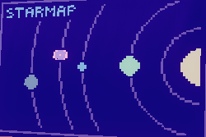  - This map should show up before leaving the space station and when returning home to be consistent with the goal of the mission
Visual Changes |  | 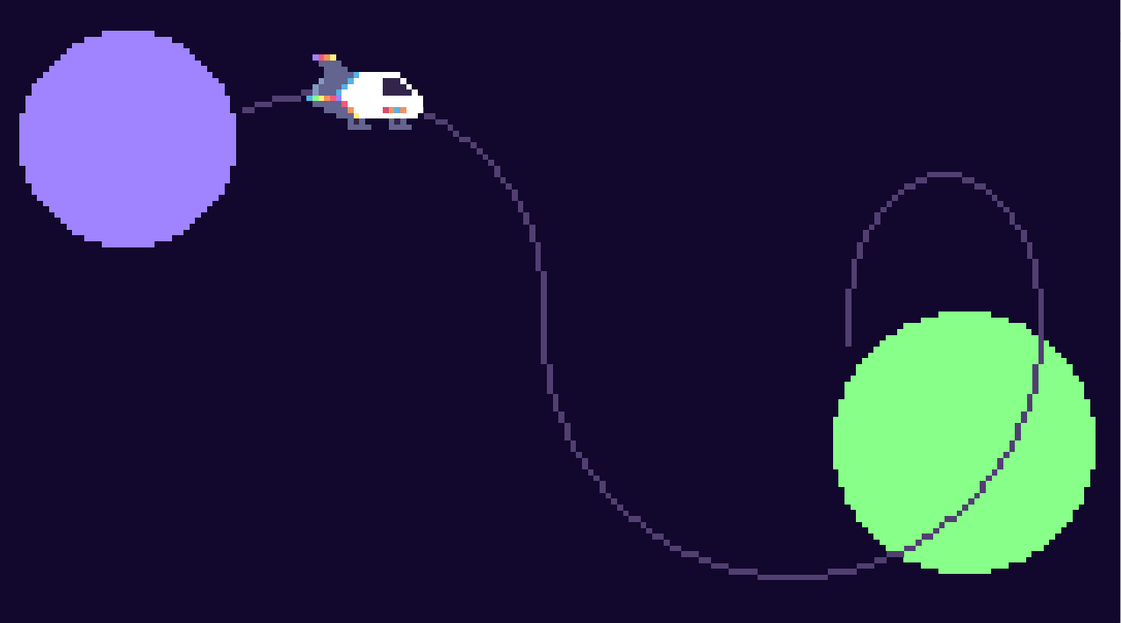
Visual Changes | Task 1: Light Up the Sky | - Use all 3 screen to demonstrate the elements of the training trials  - Left screen: computer face (“first, the computer will say...”)  - Middle screen: record frame (“then your job is to repeat...”)  - Right screen: planet map w/Lucky (e.g., see lower photo below “...to bring lucky back...”  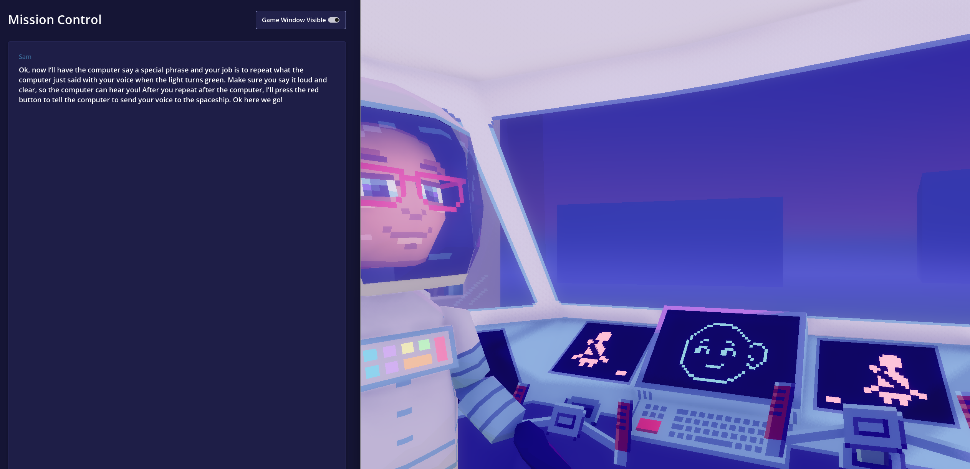  - Visual feedback after each trial to reward/encourage progress  - Ideal: One star appears in the sky after each “successful” trial  - Alternative: a cluster of stars appears after every 3 “successful” trials
Visual Changes | Task 2: Navigate the Spaceship | - Make Planet Stardust more visible (currently it is too dark on our monitors and blends into the night sky)  - Visual feedback after each trial to reward/encourage progress  - Ideal: Planet appears bigger after each trial  - Alternative: a progress bar at the bottom of the screen appears and increases after each trial  - Good/bad example  - On screen, show computer face for stimuli and full body character to represent the astronaut
Visual Changes | Task 3: Alien Encounter | - Make alien super cute (e.g., plump, smooth, head attached) & have him move to appear on the screen - see example below:    - Lucky the Llama a little cuter, too – smiling, bigger eyes, name tag?
Visual Changes | For all tasks | As we discussed, the sonic visualizer should not appear for stimulus presentation, only for participant repetitions (i.e., show the computer face only for stimuli & sonic visualizer only for participant repetitions)

