**Philippine Copyright 2024**

by the Authors’ Names

and the

Polytechnic University of the Philippines

All rights reserved. Portions of this manuscript may be reproduced with proper referencing and due acknowledgment of the author.

**VILLA SALUD CATERING RESERVATION AND BOOKING SYSTEM**

A Capstone Project

Presented to the Faculty of the College of Computer and Information Sciences

Polytechnic University of the Philippines

Sta. Mesa, Manila

In Partial Fulfilment of the Requirements for the Degree

Bachelor of Science in Information Technology

.

**Armedilla, Alliyah Samantha D.**

**Gasta, Marc Oliver L.**

**Rosario, Angelica G.**

**Santos, Akisha Gelsey L.**

**January 2025**

**APPROVAL SHEET**

This capstone project **TITLE OF CAPSTONE PROJECT (IN ALL CAPS AND IN BOLD FACE)** prepared and submitted by NAME OF RESEARCHERS (FN MI LN; Alphabetical Order) in partial fulfilment of the requirements for the degree, BACHELOR OF SCIENCE IN INFORMATION TECHNOLOGY has been:

Recommended for Approval and Acceptance

Date:

___________________________ ________________

**Mr. John Dustin D. Santos, MIT**

Faculty in-Charge

___________________________ ________________

**Mr. John Dustin D. Santos, MIT**

Adviser (omit if same as FIC or none)

Approved by the Capstone Project Defense Panel:

___________________________ ________________

**Assoc. Prof. Name, MSIT**

Chair

___________________________ ________________

**Asst. Prof. Name, MIS**

___________________________ ________________

**Prof. Name, DIT**

Accepted for the Department of Information Technology:

___________________________ ________________

**Asst. Prof. Lydinar D. Dastas, MSCS**

Chairperson

Accepted for the College of Computer and Information Sciences:

___________________________ ________________

**Prof. Benilda Eleonor V. Comendador, DIT**

Dean

**ACKNOWLEDGMENTS**

*SAMPLE ONLY. YOU MAY CREATE YOUR OWN*

The researchers would like to express their sincerest gratitude to their advisor, _______ [Advisor Name], for their invaluable guidance and support throughout their master’s program. Their expertise and encouragement helped the researchers to complete this research and write this thesis.

They would also like to thank _______ [Name] and _______ [Name] for serving on their thesis committee and providing helpful feedback and suggestions.

**CERTIFICATION OF ORIGINALITY**

This is to certify that the research work presented in this capstone project, COMPLETE TITLE OF THE CAPSTONE PROJECT for the degree Bachelor of Science in Information Technology at the Polytechnic University of the Philippines embodies the result of original and scholarly work carried out by the undersigned. This capstone project does not contain words or ideas taken from published sources or written works that have been accepted as basis for the award of a degree from any other higher education institution, except where proper referencing and acknowledgement were made.

|  |  |
| --- | --- |
|  | (Wet Signature)  **NAME OF RESEARCHERS**  Researchers  _________________________  Date Signed (date, month, year) |

**ABSTRACT**

Title : Title of Capstone Project

Researcher : LN, FN MI

Degree : Bachelor of Science in Information Technology

Institution : Polytechnic University of the Philippines

Year : 2024

Adviser : Name of Adviser

(Note: Abstract should be double-spaced, and not more than 250 words)

Keywords : At least five (5) keywords must be given (To include “Polytechnic University of the Philippines”)

**EXECUTIVE SUMMARY**

SAMPLE ONLY. The project is about scheduling and monitoring truck bodies in production. The main problem stems from late delivery of finished units due to factors that comprises it. The main objective of the study is to develop a system that will improve the current manual process regarding their monitoring and scheduling of the stages of works that is done and delays of the units that must be delivered on time. The plant manager and the admin will manage this system, which has the capability of creating job order/s, assign work order/s, update and monitor stage and status of the current job order. The system will generate reports and display status.

The Truck Body Production Scheduling and Monitoring System consists of 5 users, the plant manager, agent, admin officer, production head, and the quality assurance. The plant manager and the admin officer has the capability of monitoring everything that is happening in the production. They can also add/create/update job orders. The agent is capable only for adding job order. The production head is in charge of updating production stages and statuses, and manage reports. The quality assurance is responsible for inspecting the final product and must ensure that it observes the quality standards.

The project team was able to gather data needed through the help of previews research documents/ projects. The team also conducted client interviews and consultations to adviser and faculty-in-charge for proper guidance in the project development. Moreover, the project team constructed survey questionnaires to be answered by the target users of the project. As a result of that, the team gathered essential response that is valuable in improving the project or in conducting revisions.

Based on the overall result of the survey, the system meets the clients’ needs and give them a useful system that helps their job more productive and more organized. This will give more focus on the innovation of the system. However, there are some things that can be improved for similar projects in the future.

**Table of Contents**

|  |  |  |  |  |  |  |  |
| --- | --- | --- | --- | --- | --- | --- | --- |
|  | |  | | | | **Page** | |
| **Title Page** | | | | | | i | |
| **Certification and Approval Sheet** | | | | | | ii | |
| **Acknowledgments** | | | | | | iii | |
| **Certification of Originality** | | | | | | iv | |
| **Abstract** | | | | | | v | |
| **Executive Summary** | | | | | |  | |
| **Table of Contents** | | | | | |  | |
| **List of Tables** | | | | | |  | |
| **List of Figures** | | | | | |  | |
| **CHAPTER 1 – INTRODUCTION** | | | | | |  | |
| **1.1** | | **Project Context** | | | | 1 | |
| **1.2** | | **Technical Background** | | | | 3 | |
| 1.2.1 | | | Equipment/Hardware | | |  | |
| 1.2.2 | | | Software | | |  | |
| 1.2.3 | | | Peopleware/Manpower | | |  | |
| 1.2.4 | | | Network Infrastructure/Architecture | | |  | |
| 1.2.5 | | | Storage, Backup and Recovery Procedure | | |  | |
| 1.2.6 | | | Security Procedures | | |  | |
| 1.2.7 | | | Policies and Procedures | | |  | |
| **1.3** | | **Problem Analysis** | | | |  | |
| 1.3.1 | | | Fishbone Diagram | | |  | |
| 1.3.2 | | | Problem and Solution Statement | | |  | |
| 1.3.3 | | | Problem-Requirements Matrix | | |  | |
| **1.4** | | **Purpose and Description** | | | |  | |
| **1.5** | | **Specific Objectives** | | | |  | |
| **1.6** | | **Scope and Limitations** | | | |  | |
| **CHAPTER 2 – review of related literature, Studies, and systems** | | | | | | | |
|  | Topic 1 | | | |  | |
| **chapter 3 – methodology** | | | | | |  | |
| **3.1** | | **Requirements Analysis** | | | |  | |
| 3.1.1 | | | Requirements – Features Matrix | | |  | |
| 3.1.2 | | | Use Case Diagram | | |  | |
| 3.1.3 | | | Use Case Report | | |  | |
| **3.2** | | **Design Specifications** | | | |  | |
| 3.2.1 | | | Activity Diagram | | |  | |
| 3.2.2 | | | GUI Design | | |  | |
| 3.2.3 | | | Database Schema | | |  | |
| 3.2.4 | | | Data Dictionary | | |  | |
| **3.3** | | **Development Methodology** | | | |  | |
| 3.3.1 | | | Process Model | | |  | |
| 3.3.2 | | | Development Tools | | |  | |
| **3.4** | | **Test Methodology/Procedures** | | | |  | |
| **3.5** | | **System Requirements** | | | |  | |
| **3.6** | | **Quality Plan** | | | |  | |
| **3.7** | | **Evaluation Plan** | | | |  | |
| **CHAPTER 4 – RESULTS AND DISCUSSION** | | | | | |  | |
| **CHAPTER 5 – SUMMARY OF FINDINGS, CONCLUSION AND RECOMMENDATION** | | | | | | | |
| **REFERENCES** | | | | | |  | |
| **APPENDICES** | | | | | |  | |
| Appendix A | | | | Data Gathering Instrument | |  | |
| Appendix B | | | | Client Forms and Reports | |  | |
| Appendix C | | | | Evaluation Tools, Test Documents and Test Results | |  | |
| Appendix D | | | | User’s Manual | |  | |
| Appendix E | | | | Sample Generated Outputs | |  | |
| Appendix F | | | | Certification of Originality Check/Turnitin Results | |  | |
| Appendix G | | | | Certification of Editing | |  | |
| Appendix H | | | | Implementation Report | |  | |
| Appendix I | | | | Capstone Project Revision Matrices | |  | |
| Appendix J | | | | Ethics Clearance and Terminal Report | |  | |
| Appendix K | | | | Biographical Statements | |  | |

**LIST OF TABLES**

|  |  |  |
| --- | --- | --- |
| **Table No.** | **Description** | **Page** |
| 1 | Manage reservation | 11 |
| 2  3  4  5  6  7  8  9  10  11  12  13 | Handle inquiries  Email confirmation  Book reservation  View reservation  Cancel/Reschedule reservation  Receive notification  Admin table  Parton table  Reservation table  Inquiries table  Payment table  Development tools used | 14  15  15  16  17  18  31  31  32  33  34  38 |

**LIST OF FIGURES**

|  |  |  |
| --- | --- | --- |
| **Figure No.** | **Description** | **Page** |
| 1 | Fishbone Diagram | 4 |
| 2  3  4  5  6  7  8  9  10  11  12  13  14  15  16  17  18  19  20  21 | Admin side use case report  Patron side use case report  Check availability; patron side activity diagram  Book reservation activity diagram  Modify reservation activity diagram  View reservation summary activity diagram  Check availability; admin side activity diagram  Manage reservation activity diagram  Respond to inquiries activity diagram  GUI: Landing page  GUI: Admin account creation  GUI: Admin log in  GUI: Inquiry page  GUI: Dates page  GUI: Homepage  GUI: View reservation (Patron side)  GUI: Create reservation  GUI: Initial inquiry questions  Database schema  Agile methodology chart | 12  12  19  20  20  21  22  23  24  25  25  26  26  27  27  28  28  29  30  35 |

**Chapter 1**

**INTRODUCTION**

* 1. **PROJECT CONTEXT**

Villa Salud is a popular reception hall, known for hosting various events such as weddings, birthdays, baptisms, and kiddie parties. With its welcoming atmosphere and dedicated staff, Villa Salud is a favorite venue for people celebrating special moments. Residing from a main road in Taguig. Its location is one of its strengths as it is easy to locate and to remember. For more than 20 years, Villa Salud has been offering services to a lot of people. Villa Salud, starting from scratch and in the era of manual transactions and still surviving up to now where modernization rules anywhere, Villa Salud is in need to catch up with the time and the trends happening right now. Villa Salud uses manual processes to handle important tasks like reservations, menu packages, and scheduling. This method is time-consuming and increases the chances of mistakes or miscommunication between staff and clients. For example, double bookings can happen when reservations aren’t properly tracked, causing frustration for customers. Also, managing menu choices manually can lead to delays and confusion, affecting the overall guest experience.

To address these issues, this research proposes creating a Catering Reservation and Booking System specifically for Villa Salud. The goal of the system is to improve the management of catering services by automating important tasks. By using this system, Villa Salud can improve its operations, allowing staff to focus on delivering great service. By using a system designed for its specific needs, Villa Salud can improve customer satisfaction with faster responses and more accurate service.

Applying technology to daily lives can make things easier, as it provides more options for easier process and transaction. One of technology’s main purposes is to provide help, automation, make daily living easier and operations faster. Using technology and using it to your advantage will give a great deal and help in the long run. Allowing you to ease off with the processes and make your operations run smoothly. Villa Salud may just be a small-time events place but using a simple and easy system can cause a lot of help for them to compete with bigger and higher known competitors. It can also give an edge to them having a system that people or their target market will appreciate making positive feedback on their business.

**1.2 FRAMEWORK**

**1.2.1 Theoretical Framework**

**1.2.2 Conceptual Framework**

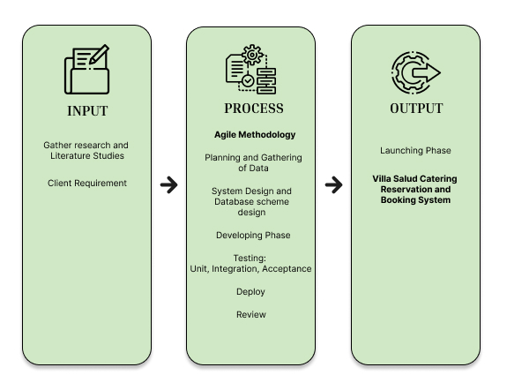

The researchers used the Input-Output Process (IPO) Model to conceptualize all the variables within the system. Based on the information and client requirements, the researchers will analyze, design, and develop the Villa Salud Catering Reservation and Booking System during the process, this represents the system development phase.

The system development follows the Agile Methodology, beginning with planning and data gathering to understand the needs of Villa Salud. This will include designing a systematic database schema in the system design phase, thus ensuring that the flow of information is appropriate. In the development phase, core functionalities will be implemented and tested in several stages, for instance unit testing, integration testing, and acceptance testing, in order to ascertain system reliability. The tested system will then be deployed for real-world usage and put under review based on its performance.

The output of this process is a fully functional and automated catering reservation and booking system for Villa Salud. This system will improve the event reservations, make the scheduling process efficient, and ensure that the overall customer experience is enhanced. It will also give a better way of organizing bookings by the management so that manual workload and errors are reduced.

**1.3 PROBLEM ANALYSIS**

**1.3.1 Statement of the Problem**

In the catering industry, operational efficiency and client trust are essential to success. Villa Salud is currently experiencing several challenges that need to be addressed, such as inconsistent records, loss of backup data, and delays in processing inquiries. These issues can cause confusion among staff and customers, hinder service delivery, and ultimately damage the reputation of Villa Salud as a reliable catering service. This requires solving the issues to allow proper functioning and boost customer satisfaction.

Problems encountered:

1. Inconsistency of Record. Inconsistency of records in the Villa Salud can create serious problems. When client inquiries, event details, and menu choices are not recorded correctly, it can lead to confusion for both staff and customers. For instance, there may be double reservations or insufficient food prepared if a reservation is made incorrectly or if event changes are not updated. This could let customers down and damage Villa Salud's reputation as a trustworthy caterer. Customers expect clear and accurate information about their events, and any mistakes can lead to frustration and loss of trust.
2. Loss of Backup Data. Important information including customer contracts, event schedules, and menu details could be lost in case the system malfunctions or makes an error. For example, delivery of services may be delayed if the staff members are unable to prepare for upcoming events because they do not have access to client contracts. When schedules of events get lost, the employees may not be aware of events that are lined up or specific requirements that will be needed in the event. This can bring uncertainty to the company, causing last-minute changes that may prove difficult and end up delaying or causing chaos at the event on the day it is held.
3. Delay of process. On a normal non busy day of Villa Salud we can say that they can accommodate more than five (5) inquiries and process them within the day, but with a hectic schedule or busy days it will be hard for Villa Salud to do all of it. Without the help of a system, it all can cause a delay for the processing of inquiries and other processes, thus leading to a possible confusion and, worst is loss of customer’s trust.

By that, the researchers seek to answer this following question:

1. How can record keeping be improved to ensure consistency?
2. What strategies can be implemented to prevent data loss?
3. How can the inquiry processing time be reduced?

**1.3.2 Fishbone Diagram**

Figure 1. Fishbone Diagram

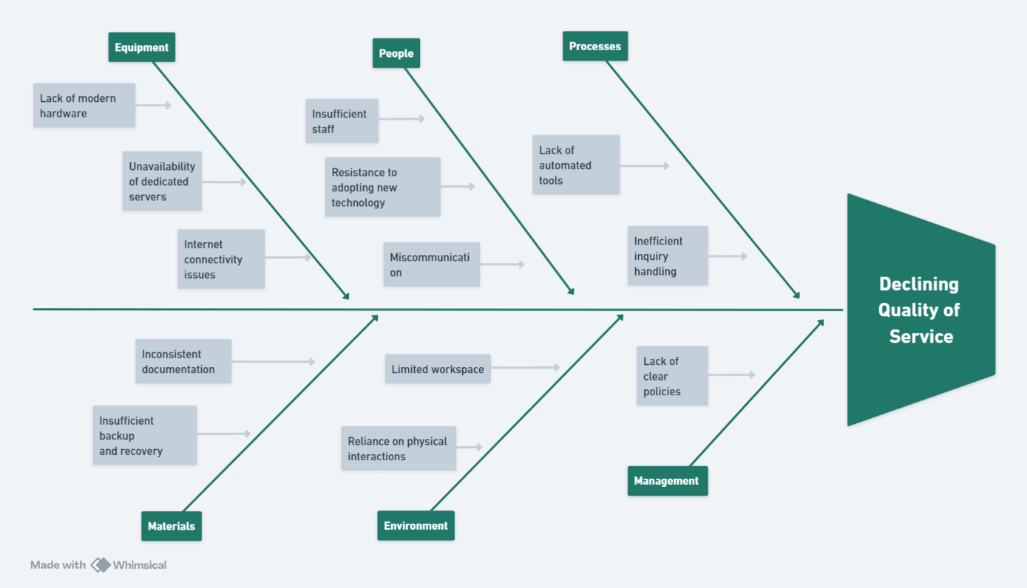

**1.5 SCOPE AND LIMITATIONS**

**1.5.1 Scope**

This study aims to develop an information system of catering service that Villa Salud offers. This system specifically aims to provide help in this area: reservation of events; organization of offered packages; automation of checking and scheduling for events; tool and feedback for reporting and summarization. With the system it can help both clients and staff of Villa Salud. On the client's side, it will be much easier for them to check and inquire for their questions and inquiries. For the staff’s side, it provides an easy but powerful tool to use to ease up their jobs, therefore providing more and greater services to the customers.

**1.5.2 Limitations**

This study aims to focus on Villa Salud catering services only. This system will be enough to be developed and studied for the amount of time we researchers have. Limited time and resources, such as money and manpower contribute to the limitations of the development of this system. Tool and knowledge is the other half of the great contributor for the limitation. Lacking knowledge of other programming languages and tools causes limitations for us developers. Data testing is limited, having just enough data provided by the owners and managers to us, which is also a cause of having not enough time.

**1.6 SIGNIFICANCE OF THE STUDY**

This study aims to develop the Villa Salud Catering Services Information System, which will serve or provide benefits to different factors and stakeholders:

Management and staff will be the first one to feel the changes about the system, as they are the first one to and will use the system. This system can reduce errors, miscommunication and misunderstanding. Offering more options to fulfill their duties faster and in a much accurate and reliable way.

Clients benefit from this study as it can make their inquiries or questions be answered or accommodated in a faster and efficient way. They benefit greatly as they are the source and the reason why Villa Salud still continues up to this day and still running their operations despite setbacks and market competitions.

Local businesses can also benefit from this study as it can be used as a guide or format on how to adopt and accept certain changes and transition, accepting and using technology to your advantage.

Future researchers can use this study for future references in making a study or system about catering service information systems or an information system in general. This also provides highlights of the importance of adopting and using technology as a tool to enhance your system and operations.

**CHAPTER 2**

**REVIEW OF RELATED LITERATURE**

1. **Event Management Systems**

It was agreed by MDPI (2022) that planning is created to aid the owner and the customers in managing and placing orders. Through the use of this system, the owner can track reservations and bookings, inquiries and payments of the customers. Data analysis resulted in the development of a set of tools and methods that have the potential to assist corporate event managers in the project risk management process. This set comprises a work breakdown structure (WBS) template, a risk breakdown structure (RBS), and a set of risk treatment and mitigation strategies for corporate events. These tools are innovative in the sense that they are based on and correspond to the phases of the event life-cycle rather than individual management domains, have not been developed in unison before, and can be utilized collectively for greater benefits

Discussed by Akshayaa Rani M (2023), technology is revolutionizing contemporary event catering, increasing productivity and visitor happiness. Data-driven menu customization is made possible by tools like CaterZen, and waste is decreased and supply chains are optimized by inventory management systems like MarketMan. Food preparation and presentation are improved by cutting-edge kitchen technologies including 3D food printing and robotic chefs. Wearable technology and mobile apps make it easier for employees to coordinate for flawless service. Digital menus and clever serving methods are examples of interactive dining technologies that enhance and customize the visitor experience. The paper emphasizes how crucial technology is to improving operational excellence and upgrading event catering. With the help of technological enhancements, it emphasizes the great help technology can give to the users thus, allowing to have better execution in terms of event management resulting in great user experience.

### **Catering And Food Service Technologies**

JETIR (2021) explored the use of online catering systems. Highlighting different kinds of catering like mobile catering, wedding catering, catering on ships and so on. The catering management system will help in maintaining the available people, resources and the timings well. It will help in solving the problems related to the catering at the events that are conducted. This catering management system will help in the smooth running of the business.

The study by Maringa and Maringa (2023) highlights the significance of ICT for competitiveness in a globalized market by examining how it improves Catering Information Systems (CIS) in Kenyan e-hotels. The study, which looks at operations across hotel star ratings, finds that important CIS components—such as food, drinks, conference, and rooming services—are heavily reliant on information flows. Automated mini-bars had the least influence, whereas recipe costing and stock control systems were the most successful ICT intervention areas. Rooming and conferencing came in second and third, respectively. The report highlights how important ICT is to streamlining hotel operations and enhancing service quality.

Akshayaa (2024) explores how digital tools revolutionize pre-event planning and enhance guest experiences, while Better Cater, Inc. (2024) discusses emerging trends like AI-driven resource management. This study emphasizes the use of technology, applying and using them as an advantage. Allowing the user to have better service to the customers.

Colleges and large-scale institutions have also embraced catering technology. IEEE (2022) examines campus catering systems designed to reduce inefficiencies during peak times. It showcases the range of use of Catering Information Systems (CIS) or any other related online services like booking and reservation services. This shows the flexibility of system. This study shows that even college campus can use this type of system and can show you great and helpful results.

### **Customer Satisfaction Through Technology**

Verana (2024) claimed that as an event planner, you know how challenging it can be to organize and run successful events. From managing budgets to coordinating schedules and communicating with attendees, many aspects must be considered. But with the increasing role of technology in event management, it has become more streamlined, efficient, and effective. In her article:Role of Technology in Event Management: A Guide for Event Planners, it has been explored how technology can support you in planning, promoting events, and executing events that leave a lasting impression on customers.

Meanwhile, ThaiJo (2024) emphasizes the role of ICT in increasing loyalty through personalized customer interactions and clear communication. With the help of technology, it prioritizes the means of making things easier as well as processes. Meaning to say, because of the use of technology it gives an edge to the users to have better experience in the system allowing to have a good results and feedback from them, also making things easier for them and making good impressions that the system brings to the customer.

### **Small Business Automation**

“How Manual Processes Are Hurting Your Business” an article developed in 2022 by Frank Tilleli. Automation encompasses a wide range of easy-to-implement digital tools and platforms that can significantly streamline and improve various business processes, particularly tedious tasks like data entry and verification. If you haven't made the move to automation, you could be hurting your company more than you realize. Manual processes have become a hindrance, putting those who use them further behind their competitors and limiting their ability to create valuable, efficient workflows.

Khwunnak et al. 's (2023) study focuses on a website that serves as a reservation system for local business owners in Nong Bua Lam Phu Walking Street. The method, which targets 170 small company owners, attempts to simplify reservations for sales spaces while improving convenience and cutting down on travel expenses. Overall quality ratings for the website were high (M=3.78, SD=0.59), and the most useful component was the user interface. Additionally, the level of satisfaction among entrepreneurs was very high (M=4.00, SD=0.69), indicating that it had been successful in increasing accessibility and efficiency for local vendors. The importance of digital technologies in assisting local companies is emphasized by this study.

The International Journal of Instruction (2022) further illustrates how algorithm-driven systems improve quality monitoring, a concept adaptable to food and service standards in catering. Having a system that focuses on making the best possible service to the customer gives you a good look and advantage as a business owner, especially nowadays that innovation and technology is a must. It is like a privilege to have that once you have it, it will give you so much edge to you competitors.

**Synthesis**   
 The reviewed literature demonstrates how digital solutions transform event management, catering services, customer satisfaction and small business operations. Each study contributes insights into how Villa Salud Catering Services can adopt automation and customer-centric technology to enhance efficiency and competitiveness. The literatures mentioned and used in this chapter was able to determine different topics and factors needed to fully enhanced and develop the system for Villa Salud. Focusing on main ideas and topic to relate for research study, we are able to determine previous studies and use it as a guide and answer questions in developing the system. This research seeks to bridge the gap in existing literature by developing a tailored platform that meets the unique needs of Villa Salud.

**CHAPTER 3**

**METHODOLOGY**

**3.1 REQUIREMENT ANALYSIS**

**3.1.1. Features Matrix**

Table 1

|  |  |  |
| --- | --- | --- |
| **Feature** | **Description** | **Requirements** |
| Inquiry Management | Allows admins to manage customer inquiries, including responding, categorizing, and converting inquiries into reservations. | Admin login, inquiry submission forms, email notification system. |
| Reservation Management | Admins can view available and reserved dates, update reservations, and avoid double bookings. | Admin dashboard, date-picker, reservation status tracker. |
| Email Confirmation | Automatically sends email confirmations to customers after inquiries or reservations. | Admin login, email server integration, confirmation templates. |
| Booking System | Patrons can select available dates, choose menu packages, and submit a reservation request. | Patron login, calendar availability checker, food package selection dropdown. |
| View Reservation | Patrons can view their reservation details, including date, time, menu, and payment status. | Patron login, database connection for reservation details. |
| Cancel/Reschedule Reservation | Patrons can cancel or reschedule their reservations through an easy-to-use interface. | Patron login, date-picker for rescheduling, reservation ID validation. |
| Receive Notifications | Patrons receive email or SMS updates about their reservations or inquiries. | Email notification system, SMS gateway (optional). |
| Admin Dashboard | Centralized dashboard for admins to manage reservations, generate reports, and check system status. | Admin login, reporting tools, summary views for reservations, inquiries, and payments. |
| Payment Processing | Tracks payment details, including type (down payment/full payment), amount, and payment date. | Payment table in the database, support for multiple payment types (ENUM: 'down', 'full'). |
| Activity Logs | Records admin and patron actions (e.g., reservations, inquiries, and payments) for tracking purposes. | Database table for activity logs, timestamp recording, admin ID/patron ID linkage. |

This table represents all the main features our system has. This explains how system works, what it means and what it’s called. This also shows the requirements needed to meet the feature or the capabilities of the system. It can also show who is involved in the feature.

**3.1.2. Use Case Diagram**

Figure 2. Admin Side

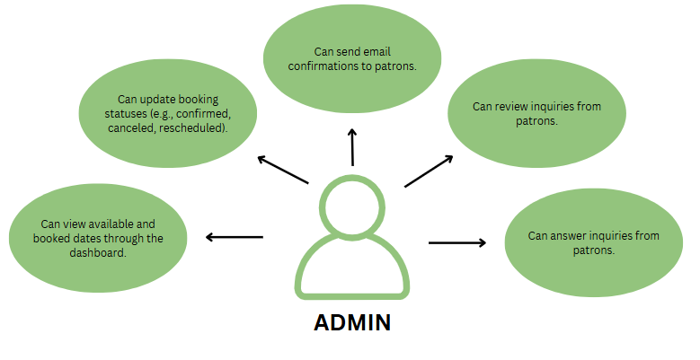

Figure 2 shows the use case diagram for the admin side of the system. This shows the interaction of the admin into the system. It shows the capabilities or the abilities of an admin into the system. It also represents the behavior of the admin towards the system.

Figure 3. Patron Side

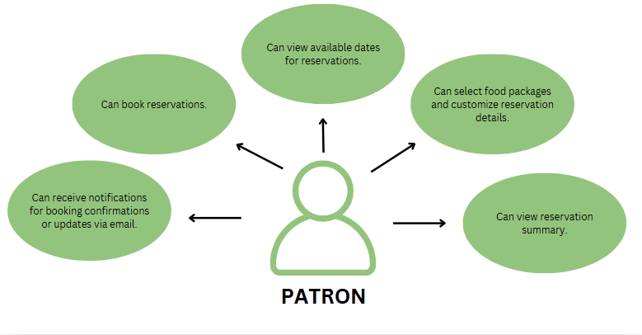

Figure 3 shows the use case diagram for patron (customer). This diagram shows the behavior, interaction and, the capabilities of the patron to the system.

**3.1.3. Use Case Report**

Table 1

|  |  |
| --- | --- |
| **Use Case Name:** | **Manage Reservations** |
| Actors | Admin |
| Description | The admin can manage customer reservations, including updating the reservation status (confirmed, canceled, rescheduled), and checking available and booked dates. |
| Preconditions | Admin must log in to the system. |
| Main Flow | 1. Admin logs into the system.  2. Admin navigates to the reservation management dashboard.  3. Admin views booked and available dates.  4. Admin updates reservation statuses as needed. |
| Alternative Flow | 1. If the reservation does not exist, the system displays an error message. |

Continuation to Table 1

|  |  |
| --- | --- |
| Postconditions | Updated reservation details are reflected in the system. |

Table 2

|  |  |
| --- | --- |
| **Use Case Name** | **Handle Inquiries** |
| Actors | Admin |
| Description | The admin can review and answer inquiries from customers. |
| Preconditions | Admin must log in to the system. |
| Main Flow | 1. Admin logs into the system. |
| 2. Admin navigates to the inquiries section. |
| 3. Admin reviews inquiries submitted by patrons. |
| 4. Admin sends responses to the inquiries. |
| Alternative Flow | 1. If there are no inquiries, the system displays a "No Inquiries Available" message. |

Continuation to Table 2

|  |  |
| --- | --- |
| Postconditions | Customer inquiries are marked as reviewed/responded to. |

Table 3

|  |  |
| --- | --- |
| **Use Case Name** | **Send Email Confirmations** |
| Actors | Admin |
| Description | The admin sends email confirmations for reservations to patrons. |
| Preconditions | Reservation details must be complete. |
| Main Flow | 1. Admin logs into the system. |
| 2. Admin selects a reservation and sends an email confirmation. |
| Postconditions | Customer inquiries are marked as reviewed/responded to. |

Table 4

|  |  |
| --- | --- |
| **Use Case Name** | **Book Reservation** |
| Actors | Patron |

Continuation to Table 4

|  |  |
| --- | --- |
| Description | The patron can book a reservation for a specific date, selecting the food package and customizing details. |
| Preconditions | The customer must access the system through the interface. |
| Main Flow | 1. Patron accesses the reservation interface. |
| 2. Patron views available dates for reservations. |
| 3. Patron selects a date, food package, and additional details. |
| 4. Patron submits the booking request. |
| Postconditions | Reservation is successfully saved in the system. |

Table 5

|  |  |
| --- | --- |
| **Use Case Name** | **View Reservation Summary** |
| Actors | Patron |

Continuation to Table 5

|  |  |
| --- | --- |
| Description | The patron can view the details of their reservation. |
| Preconditions | A reservation must exist in the system. |
| Main Flow | 1. Patron navigates to the reservation summary section. |
| 2. Patron reviews the details of their reservation. |
| Alterative Flow | If no reservation exists, the system displays a "No Reservation Found" message. |
| Postconditions | Reservation details are displayed. |

Table 6

|  |  |
| --- | --- |
| **Use Case Name** | **Cancel/Reschedule Reservation** |
| Actors | Patron |
| Description | The patron can cancel or reschedule their reservation through the system. |
| Preconditions | A reservation must exist in the system. |

Continuation to Table 6

|  |  |
| --- | --- |
| Main Flow | 1. Patron navigates to their reservation. |
| 2. Patron selects the option to cancel or reschedule the reservation. |
|  | 3. System processes the cancellation or rescheduling. |
| Postconditions | Reservation is either canceled or rescheduled, and the system updates its status. |

Table 7

|  |  |
| --- | --- |
| **Use Case Name** | **Receive Notifications** |
| Actors | Patron |
| Description | The patron receives email notifications for booking confirmations or updates. |
| Preconditions | Email address must be registered in the system. |

Continuation to Table 7

|  |  |
| --- | --- |
| Main Flow | 1. Patron submits a booking or updates a reservation. |
| 2. System sends an email notification to the patron. |
| Postconditions | Notification is successfully received by the patron. |

**3.2 DESIGN SPECIFICATIONS**

**3.2.1. Activity Diagram**

Patron’s processes. In the following figures, it will show the processes available in patron’s side. This shows systematic approach of the patron to the system. The process will be shown in a flowchart to better present and to easily understand the process.

Figure 4. Check Availability.

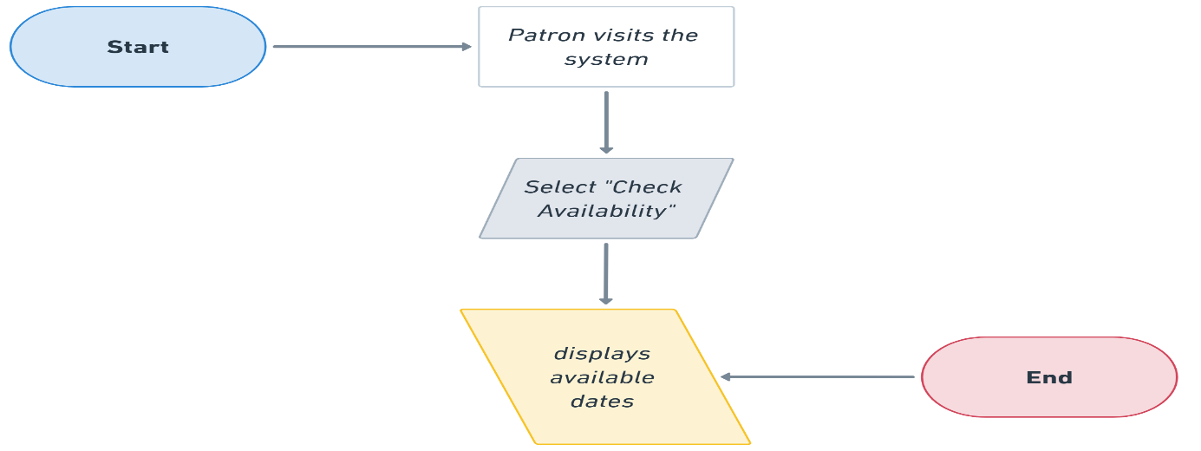

Figure 5. Book a Reservation.

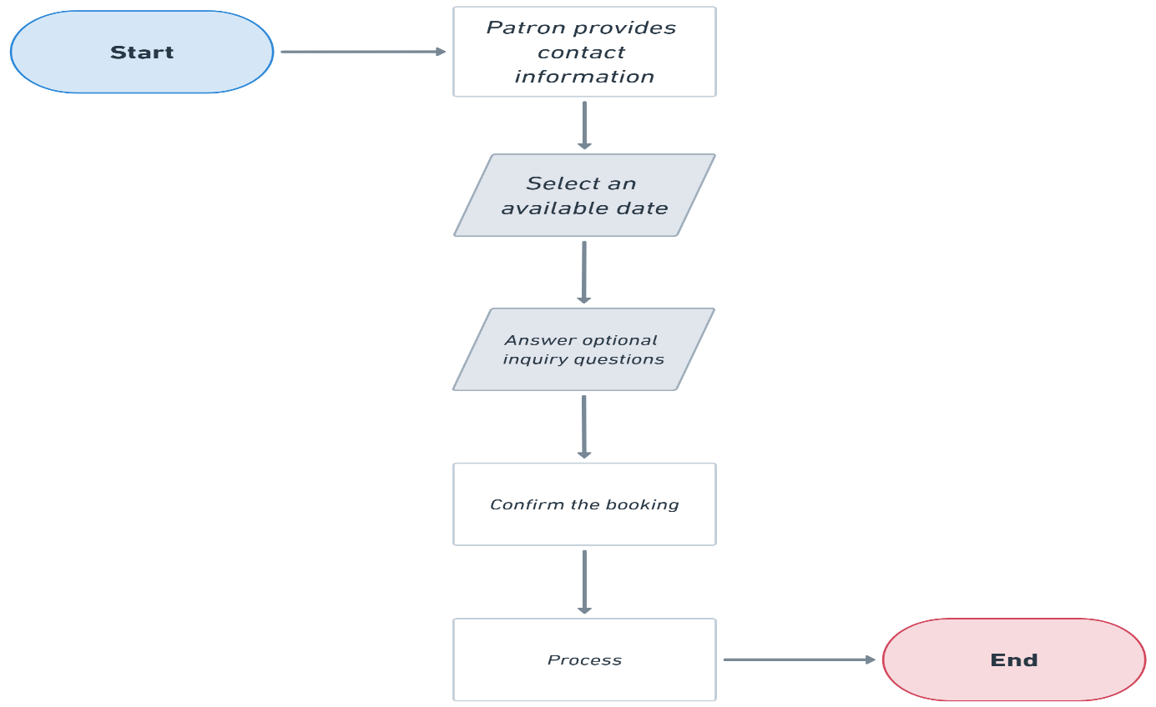

Figure 6. Modify Reservation

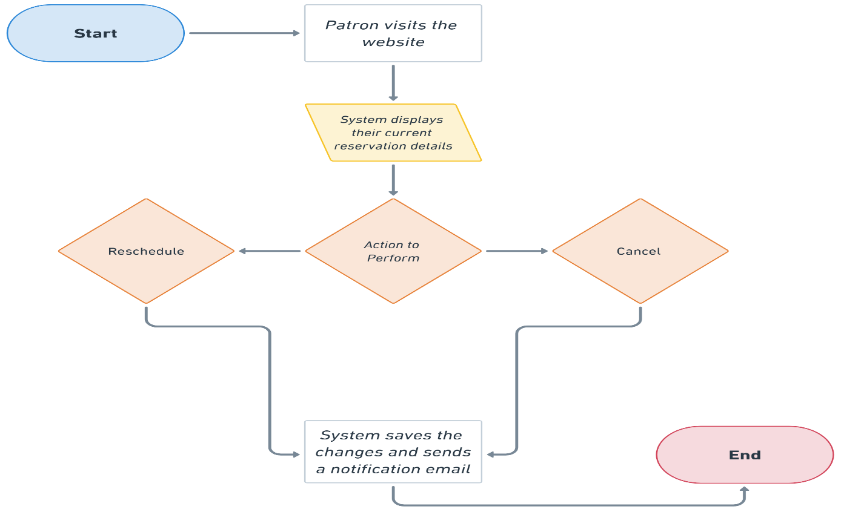

Figure 7. View Reservation Summary

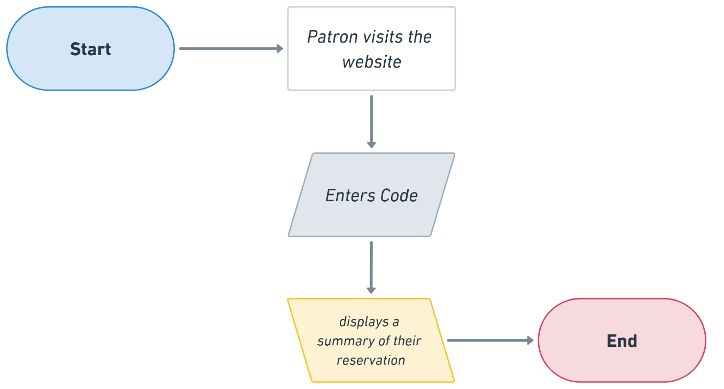

Admin’s processes. The following figure will represent the process for the admin. It will be shown in a flowchart method to easily present the systematic process of the admin in the system.

Figure 8. Check Availability

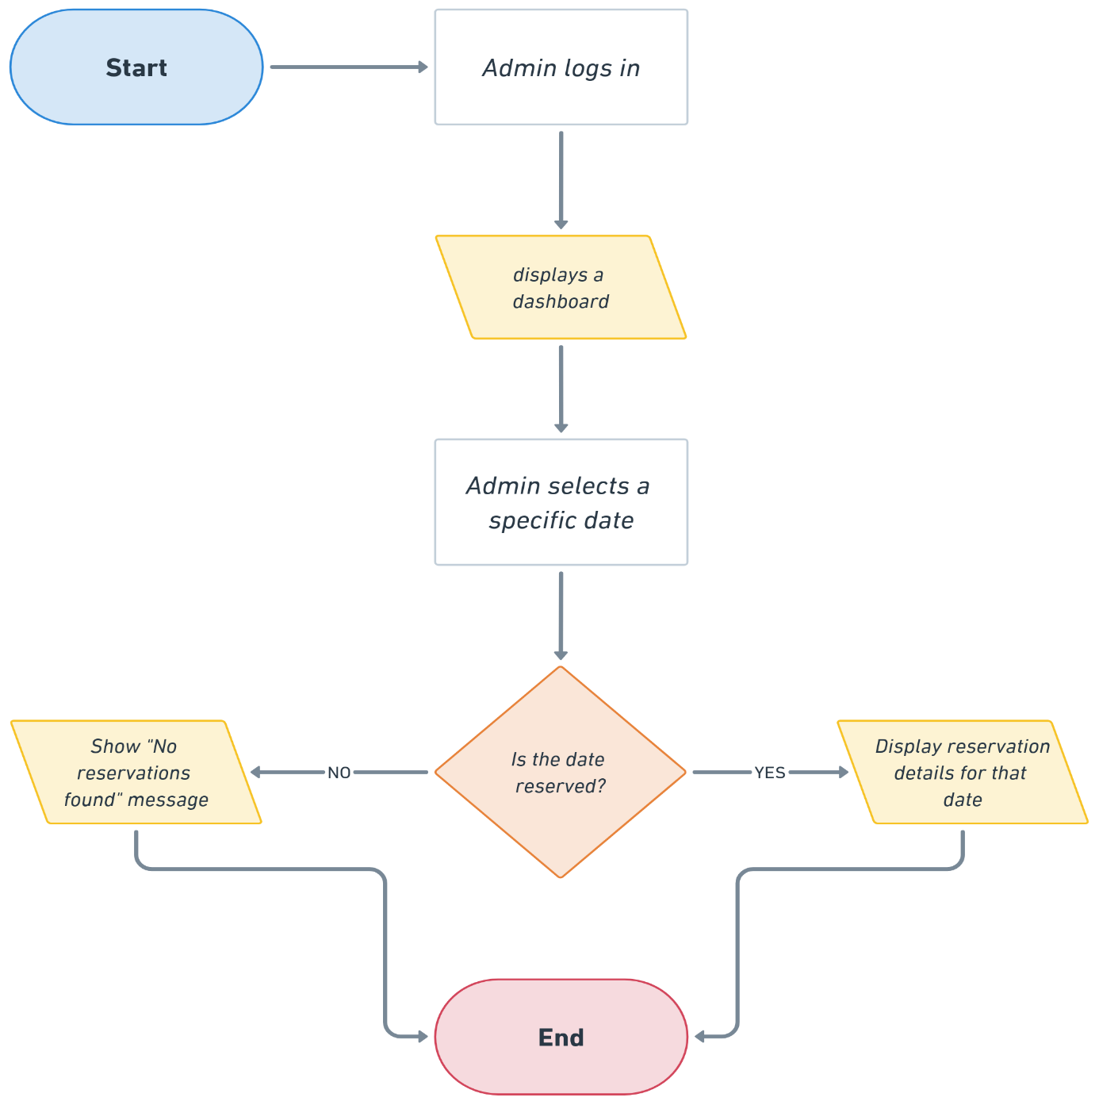

Figure 9. Manage Reservations

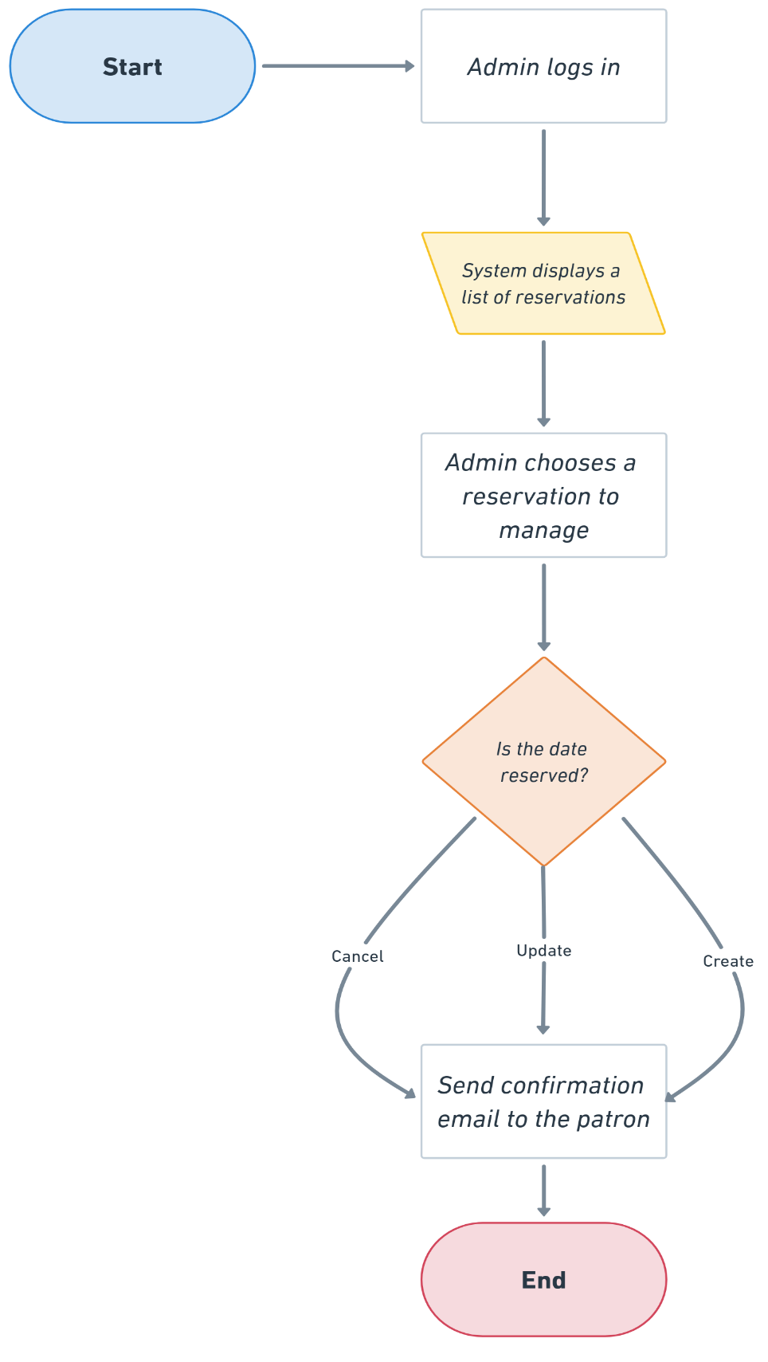

Figure 10. Respond to Inquiries

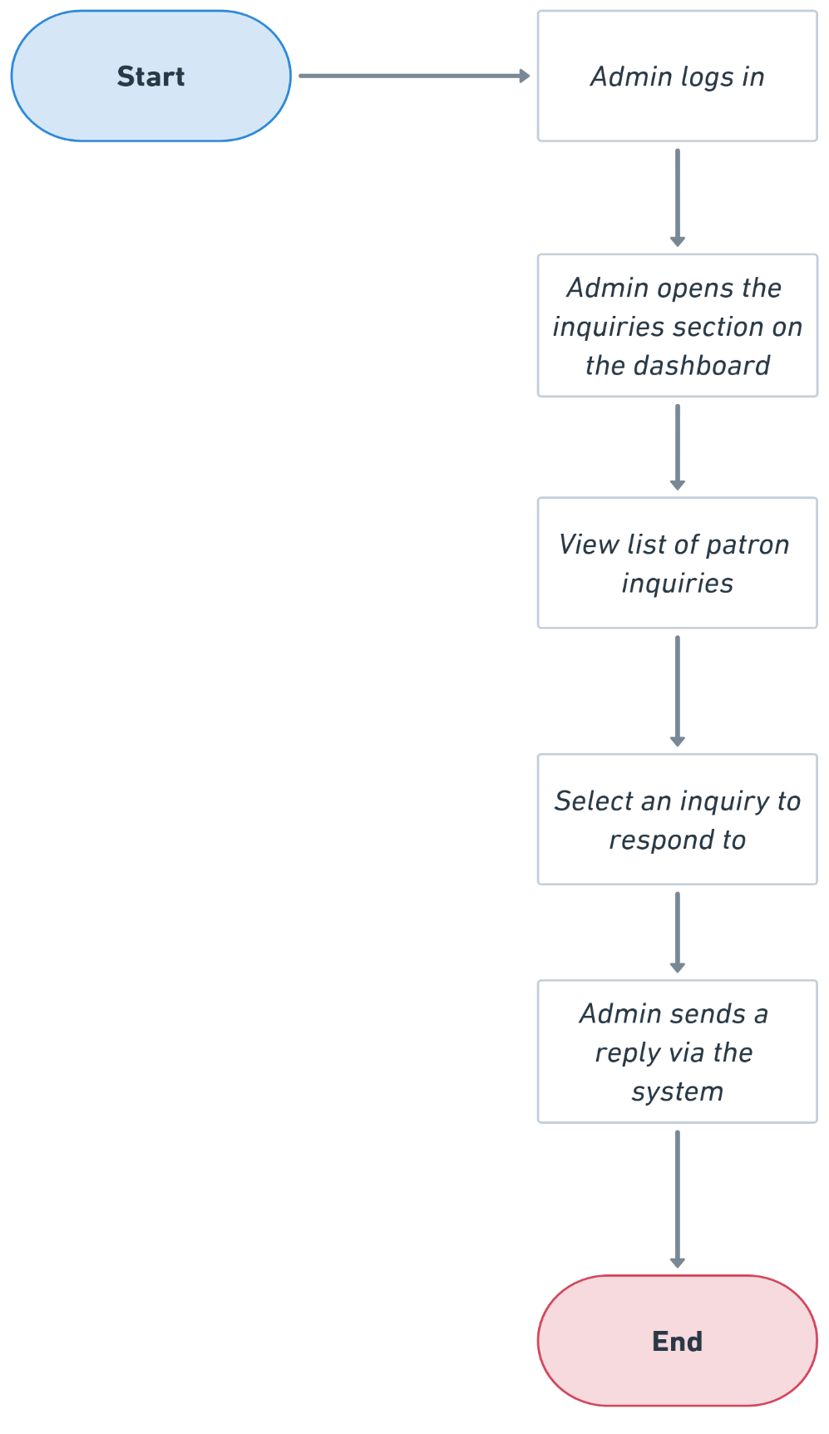

**3.2.2. GUI Design**

Figure 11. Landing Page

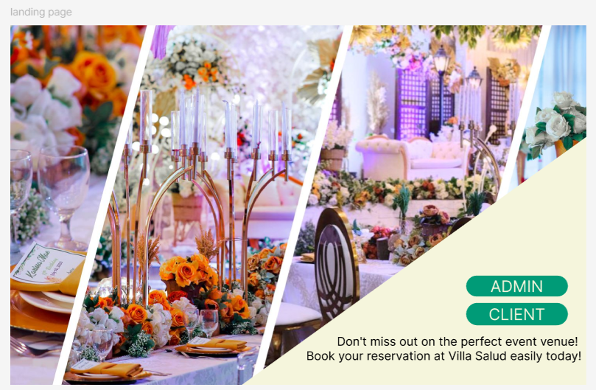

Figure 12. Admin Account Creation

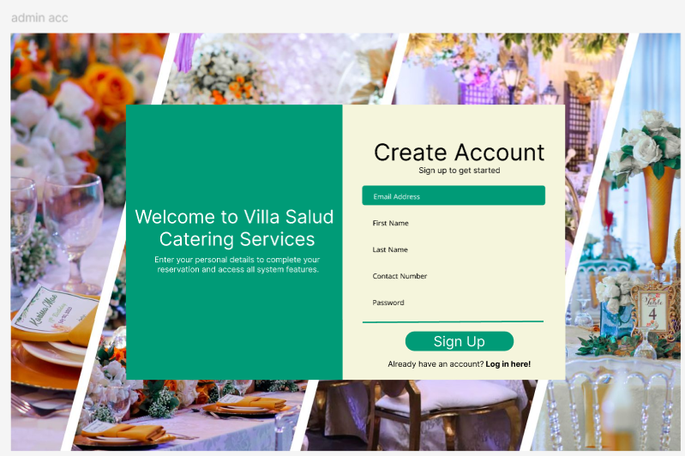

Figure 13. Admin Log in

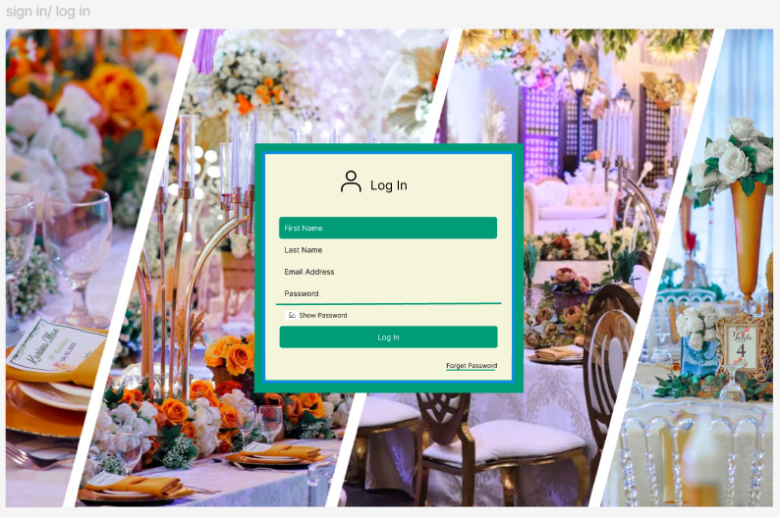

Figure 14. Inquiry Page

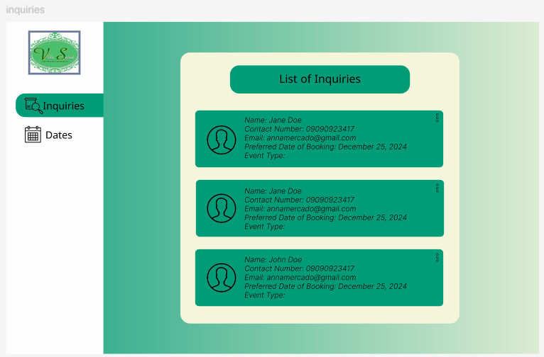

Figure 15. Dates Page

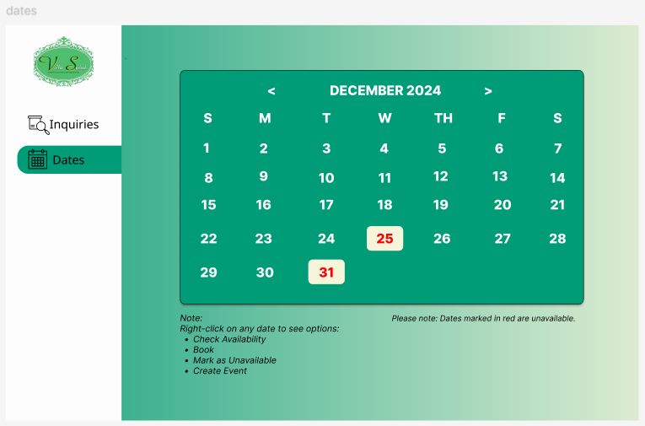

Figure 16. Patron’s Homepage

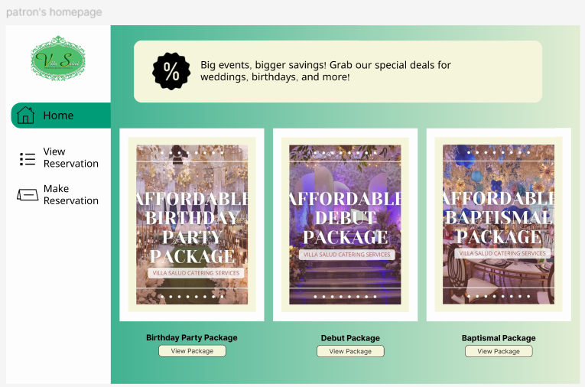

Figure 17. Patron: View Reservation

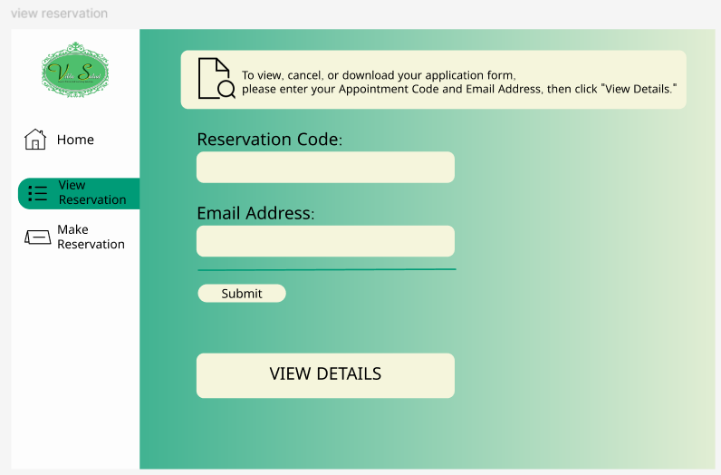

Figure 18. Creation of Reservation

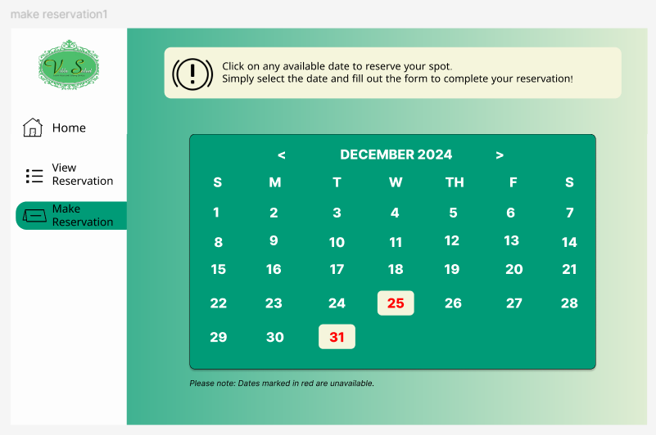

Figure 19. Initial Inquiry Questions

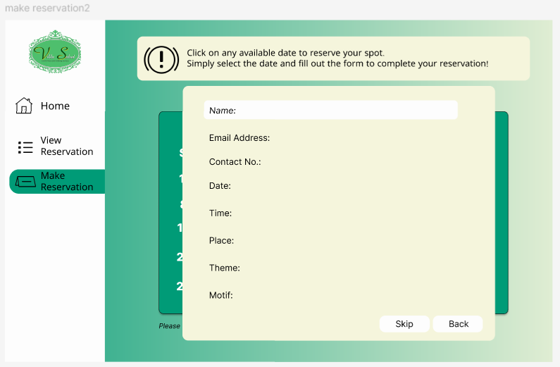

* + 1. **Database Schema**

Figure 20. Database Schema

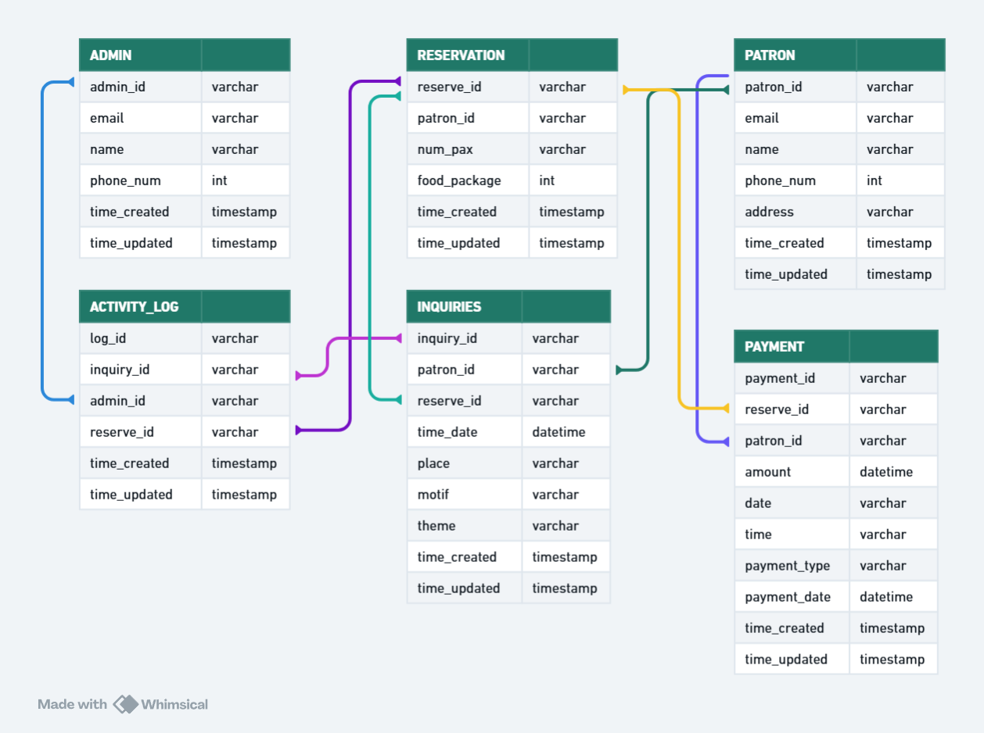

**3.2.4. Data Dictionary**

Table 8. Admin Table

|  |  |  |  |
| --- | --- | --- | --- |
| **ADMIN** | | | |
| Field Name | Data Type | Field Size | Description |
| id | INT |  | Description ID |
| admin_id | VARCHAR | 255 | Unique admin’s ID |
| email | VARCHAR | 255 | Admin’s email address |
| name | VARCHAR | 255 | Admin’s last name |
| phone_num | INT |  | Admin’s phone number |
| time_created | TIMESTAMP |  | Time for when the table has created |
| time_updated | TIMESTAMP |  | Time for when the table has been updated |

Table 9. Patron’s Table

|  |  |  |  |
| --- | --- | --- | --- |
| **PATRON (CUSTOMER)** | | | |
| Field Name | Data Type | Field Size | Description |
| id | INT |  | Description ID |
| patron_id | VARCHAR | 255 | Unique patron’s ID |

Continuation of Table 9.

|  |  |  |  |
| --- | --- | --- | --- |
| Email | VARCHAR | 255 | Patron’s email address |
| name | VARCHAR | 255 | Patron’s last name |
| address | VARCHAR | 255 | Patron’s address |
| phone_num | INT |  | Patron’s phone number |
| time_created | TIMESTAMP |  | Time for when the table has created |
| time_updated | TIMESTAMP |  | Time for when the table has been updated |

Table 10. Reservation Table

|  |  |  |  |
| --- | --- | --- | --- |
| **RESERVATION** | | | |
| Field Name | Data Type | Field Size | Description |
| id | INT |  | Description ID |
| reserve_id | VARCHAR | 255 | Unique reservation’s ID |
| patron’s id | VARCHAR | 255 | Patron’s unique id |
| num_pax | INT | 255 | Number of persons that will attend |
| food_package | ENUM |  | What type of food package the customer will avail |

Continuation of Table 10.

|  |  |  |  |
| --- | --- | --- | --- |
| time_created | TIMESTAMP |  | Time for when the table has created |
| time_updated | TIMESTAMP |  | Time for when the table has been updated |

Table 11. Inquiries Table

|  |  |  |  |
| --- | --- | --- | --- |
| **INQUIRIES** | | | |
| Field Name | Data Type | Field Size | Description |
| id | INT |  | Description ID |
| inquiry_id | VARCHAR | 255 | Unique event’s ID |
| patron_id | VARCHAR | 255 | Unique patron’s ID |
| reserve_id | VARCHAR | 255 | Unique reservation’s ID |
| time_date | VARCHAR | 255 | Time and date of the event |
| place | VARCHAR | 255 | Place of the event |
| theme | VARCHAR | 255 | The theme of the event |
| motif | VARCHAR | 255 | Motif of the event |
| time_created | TIMESTAMP |  | Time for when the table has created |
| time_updated | TIMESTAMP |  | Time for when the table has been updated |

Table 12. Payment Table

|  |  |  |  |
| --- | --- | --- | --- |
| **PAYMENT** | | | |
| Field Name | Data Type | Field Size | Description |
| id | INT |  | Description ID |
| pay_id | VARCHAR | 255 | Unique payment’s ID |
| reserve_id | VARCHAR | 255 | Unique reservation’s ID |
| patron_id | VARCHAR | 255 | Unique patron’s ID |
| amount | VARCHAR | 255 | Amount to be paid by the customer |
| date | DATE |  | Date the order payment has been issued |
| time | TIME |  | Time the order payment has been issued |
| payment_date | DATETIME |  | Date of the possible settlement of date of the customer |
| payment_type | ENUM |  | What type of payment the customer will do; full or down payment |
| time_created | TIMESTAMP |  | Time for when the table has created |
| time_updated | TIMESTAMP |  | Time for when the table has been updated |

Table 13. Activity Log Table

|  |  |  |  |
| --- | --- | --- | --- |
| ACTIVITY LOG | | | |
| Field Name | Data Type | Field Size | Description |
| log_id | VARCHAR | 255 | Unique activity log’s ID |
| inquiry_id | VARCHAR | 255 | Unique event’s ID |
| admin_id | VARCHAR | 255 | Unique admin’s ID |
| reserve_id | VARCHAR | 255 | Unique reservation’s ID |
| time_created | TIMESTAMP |  | Time for when the table has created |
| time_updated | TIMESTAMP |  | Time for when the table has been updated |

**3.3. DEVELOPMENT TOOLS**

**3.3.1. Process Model**

Figure 21. Agile Methodology

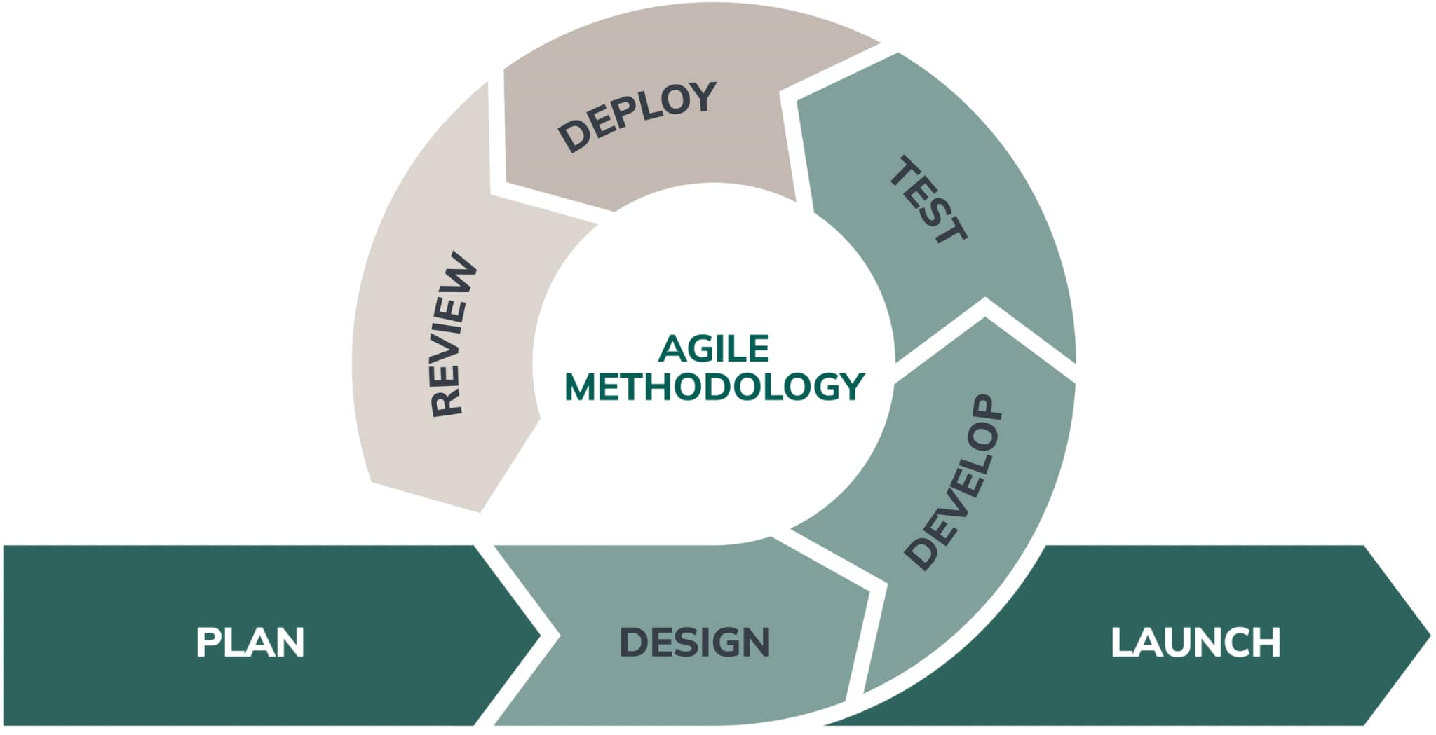

We applied the Agile methodology in developing the system because it allows us to adjust to changes in the project requirements more effectively. This approach ensures our efforts are focused and efficient while also making it easier to improve or modify the system’s design when needed. If there are updates or revisions to the design, Agile helps us track the system’s progress more effectively.

By using Agile, we adopted a flexible and collaborative approach to system development. This method allows us to handle changes smoothly, simplify updates to the system’s structure, and monitor its progress closely. With Agile principles, our goal is to create a reliable, high-quality system that automates and replaces manual processes, improving efficiency and overall service quality for Villa Salud.

**Planning**

In Agile methodology, everything begins with the Planning Phase. Here, we focused on gathering all the information needed to develop the system. We clearly defined the project’s scope and limitations, created an initial plan for implementation, and assessed how feasible and credible the project would be. To better understand what the client needed, we also conducted an interview to gather their requirements and ensure those needs would be implemented effectively in the system.

**Design**

In this phase, we created a layout based on the client’s requirements. We designed the interface to be simple and easy to use, aiming to ensure user satisfaction. To achieve this, we used a minimal color scheme, made the design responsive, and prioritized a user-friendly approach. We used Figma to visualize the system, allowing the client to see a preview of the partial outcome and provide feedback for improvements.

**Develop**

In the development stage, the developer is assigned to work on the system’s integrity, design, layout, and functionality. The developer gathers all the necessary information from the client and ensures the system is properly integrated. The features to be implemented in the system include managing catering reservations, organizing menu packages, automating scheduling, generating reports, creating announcements. When writing the code, the system's design, specs, and the customer's specific requirements are all carefully considered. By taking these aspects carefully, we will make sure that the end product satisfies the system's expectations and is in line with the planned goals.

**Test**

In the testing phase, the Quality Assurance (QA) team checks how well the system works, how it performs, and its overall design. This includes performing functionality, integrity, and unit testing. In addition to testing the system's responsiveness and design, any faults or errors are found and fixed. Before the system is fully implemented at Villa Salud, the researchers will test it with the client, a small group of users, and employees to make sure it is functional.

**Deploy**

After the testing phase, the system will be deployed and checked by the client. During this deployment stage, the client will use the system and test its functionalities and integrations to ensure everything works as expected.

**Review**

The review stage is when the client evaluates their experience using the system and provides feedback. During this stage, the client can also suggest improvements to the system’s functionalities or requirements to enhance its performance.

**Launch**

The launch stage is when the developers officially launch the system and deploy it for public use. During this stage, the system becomes fully operational and accessible to the intended users. The researchers ensure that everything is in place for the system’s smooth functioning, and it is made available for the public or the target audience to begin using.

**3.3.2. Development Tools**

Table 13. Development Tools Used

|  |  |
| --- | --- |
| Programming Languages | JavaScript, PHP |
| Supporting Tools | HTML, CSS, GITHUB |
| Relational Database Management  System | PHP, MySQL |
| Integrated Development Environment | Visual Studio Code, GitHub |
| Server | Google |
| Web Browser | Google Chrome, Microsoft Edge, Safari |

**REFERENCES**