Project1

0811562 何祁恩

1. Kid blurred-noisy.tiff

|  |  |
| --- | --- |
| (a) original | (b) Laplacian (using absolute value) |
| (c) Laplacian-sharpened | (d) Sobel-gradient |

|  |  |
| --- | --- |
| (e) smoothed gradient | (f) (e)‧(b) |
| (g) (a)+(f) | (h) power-law transformation of (g) |

|  |
| --- |
| Original histograms |
| Output histograms |

2. Fruit blurred-noisy.tiff

|  |  |
| --- | --- |
| (a) original | (b) Laplacian (using absolute value) |
| (c) Laplacian-sharpened | (d) Sobel-gradient |

|  |  |
| --- | --- |
| (e) smoothed gradient | (f) (e)‧(b) |
| (g) (a)+(f) | (h) power-law transformation of (g) |

|  |
| --- |
| Original histograms |
| Output histograms |

|  |  |  |  |  |
| --- | --- | --- | --- | --- |
| *SS* | *p*(*r*)  (kid original) | *p*(*r*)  (kid output) | *p*(*r*)  (fruit original) | *p*(*r*)  (fruit output) |
| 0 | 2.08E-06 | 2.08E-06 | 2.47E-06 | 2.47E-06 |
| 1 | 0 | 1.25E-05 | 3.70E-06 | 3.70E-06 |
| 2 | 0 | 7.92E-05 | 1.23E-06 | 1.11E-05 |
| 3 | 2.08E-06 | 3.96E-05 | 2.47E-06 | 9.88E-06 |
| 4 | 2.08E-06 | 0.000314583 | 7.41E-06 | 4.32E-05 |
| 5 | 8.33E-06 | 0.000177083 | 9.88E-06 | 0 |
| 6 | 1.25E-05 | 0.001379167 | 1.48E-05 | 3.70E-05 |
| 7 | 0 | 0.002266667 | 0 | 0.000212346 |
| 8 | 1.04E-05 | 0.001160417 | 1.48E-05 | 0.000138272 |
| 9 | 2.71E-05 | 0.004860417 | 1.36E-05 | 0 |
| 10 | 2.92E-05 | 0.002354167 | 3.70E-05 | 0.000632099 |
| 11 | 3.96E-05 | 0.009377083 | 5.56E-05 | 0.00032716 |
| 12 | 6.67E-05 | 0.003997917 | 5.68E-05 | 0 |
| 13 | 0.0001125 | 0.014875 | 0.0001 | 0.001580247 |
| 14 | 0.000135417 | 0.005777083 | 0 | 0.000753086 |
| 15 | 0 | 0.021008333 | 0.000138272 | 0.003245679 |
| 16 | 0.000177083 | 0.007804167 | 0.00017037 | 0 |
| 17 | 0.000222917 | 0.0239625 | 0.000192593 | 0.001490123 |
| 18 | 0.000258333 | 0.00845 | 0.000269136 | 0.005983951 |
| 19 | 0.000372917 | 0.025708333 | 0.00032716 | 0 |
| 20 | 0.000525 | 0.008552083 | 0.000404938 | 0.002524691 |
| 21 | 0.000614583 | 0 | 0 | 0.008741975 |
| 22 | 0.000727083 | 0.025504167 | 0.000558025 | 0 |
| 23 | 0 | 0.0079125 | 0.000617284 | 0.003385185 |
| 24 | 0.000925 | 0.022579167 | 0.000753086 | 0.011576543 |
| 25 | 0.001160417 | 0.006947917 | 0.000935802 | 0 |
| 26 | 0.001358333 | 0.019727083 | 0.001049383 | 0.004106173 |
| 27 | 0.00158125 | 0.006291667 | 0.001260494 | 0.013206173 |
| 28 | 0.001920833 | 0 | 0 | 0 |
| 29 | 0.002354167 | 0.018164583 | 0.001491358 | 0.004779012 |
| 30 | 0 | 0.006029167 | 0.001712346 | 0.014446914 |
| 31 | 0.00275 | 0.01855 | 0.001967901 | 0 |
| 32 | 0.0030375 | 0.006233333 | 0.002319753 | 0.004855556 |
| 33 | 0.00360625 | 0 | 0.002544444 | 0.015511111 |
| 34 | 0.0040125 | 0.0196375 | 0.002698765 | 0 |
| 35 | 0.00459375 | 0.006689583 | 0 | 0.005214815 |
| 36 | 0.004904167 | 0.020795833 | 0.003008642 | 0 |
| 37 | 0.005625 | 0.007108333 | 0.003337037 | 0.016795062 |
| 38 | 0 | 0 | 0.003608642 | 0.005809877 |
| 39 | 0.0060125 | 0.021545833 | 0.003925926 | 0 |
| 40 | 0.006966667 | 0.0074625 | 0.004444444 | 0.01815679 |
| 41 | 0.007720833 | 0.023060417 | 0.004744444 | 0.005985185 |
| 42 | 0.00819375 | 0 | 0 | 0 |
| 43 | 0.008979167 | 0.0080875 | 0.004940741 | 0.018709877 |
| 44 | 0.009329167 | 0.024375 | 0.005340741 | 0 |
| 45 | 0.010079167 | 0.0081375 | 0.005758025 | 0.006451852 |
| 46 | 0 | 0 | 0.005816049 | 0.019804938 |
| 47 | 0.01044375 | 0.024747917 | 0.006338272 | 0 |
| 48 | 0.01103125 | 0.008220833 | 0.006665432 | 0.006781481 |
| 49 | 0.011347917 | 0.024391667 | 0 | 0 |
| 50 | 0.0118125 | 0 | 0.006802469 | 0.020760494 |
| 51 | 0.012222917 | 0.00814375 | 0.00702716 | 0.007053086 |
| 52 | 0.0123125 | 0.0233375 | 0.007209877 | 0 |
| 53 | 0.013095833 | 0 | 0.007654321 | 0.021798765 |
| 54 | 0 | 0.007760417 | 0.007920988 | 0 |
| 55 | 0.012927083 | 0.021627083 | 0.007890123 | 0.007562963 |
| 56 | 0.013170833 | 0 | 0 | 0.02287284 |
| 57 | 0.01323125 | 0.007039583 | 0.008025926 | 0 |
| 58 | 0.013379167 | 0.020091667 | 0.00845679 | 0.007724691 |
| 59 | 0.013247917 | 0.006347917 | 0.008277778 | 0 |
| 60 | 0.01296875 | 0 | 0.008687654 | 0.023553086 |
| 61 | 0 | 0.0185 | 0.008598765 | 0.008004938 |
| 62 | 0.012777083 | 0.006114583 | 0.008971605 | 0 |
| 63 | 0.01275625 | 0 | 0 | 0.024238272 |
| 64 | 0.012733333 | 0.01770625 | 0.008828395 | 0 |
| 65 | 0.01189375 | 0.005552083 | 0.009049383 | 0.008 |
| 66 | 0.011272917 | 0 | 0.008851852 | 0 |
| 67 | 0.01109375 | 0.016979167 | 0.009239506 | 0.023835802 |
| 68 | 0.010783333 | 0.005410417 | 0.008823457 | 0.007854321 |
| 69 | 0 | 0 | 0.009165432 | 0 |
| 70 | 0.010308333 | 0.015791667 | 0 | 0.023377778 |
| 71 | 0.010091667 | 0.005320833 | 0.009164198 | 0 |
| 72 | 0.009714583 | 0 | 0.009028395 | 0.00768642 |
| 73 | 0.009195833 | 0.0154875 | 0.009262963 | 0.022869136 |
| 74 | 0.00895 | 0 | 0.009197531 | 0 |
| 75 | 0.008545833 | 0.00500625 | 0.009254321 | 0.007581481 |
| 76 | 0.008154167 | 0.014466667 | 0.00905679 | 0 |
| 77 | 0 | 0 | 0 | 0.02237037 |
| 78 | 0.007835417 | 0.004783333 | 0.009058025 | 0 |
| 79 | 0.007516667 | 0.014233333 | 0.009059259 | 0.007564198 |
| 80 | 0.00710625 | 0 | 0.00922716 | 0 |
| 81 | 0.006754167 | 0.004789583 | 0.009085185 | 0.022055556 |
| 82 | 0.006629167 | 0.01353125 | 0.009124691 | 0.007534568 |
| 83 | 0.00658125 | 0 | 0.009225926 | 0 |
| 84 | 0 | 0.004497917 | 0 | 0.022090123 |
| 85 | 0.006466667 | 0 | 0.009118519 | 0 |
| 86 | 0.006208333 | 0.013202083 | 0.008895062 | 0.007493827 |
| 87 | 0.005939583 | 0.004352083 | 0.008964198 | 0 |
| 88 | 0.006010417 | 0 | 0.008918519 | 0.022004938 |
| 89 | 0.006054167 | 0.012327083 | 0.008869136 | 0 |
| 90 | 0.005829167 | 0 | 0.008859259 | 0.007341975 |
| 91 | 0.005891667 | 0.00405625 | 0.009019753 | 0.022307407 |
| 92 | 0 | 0.011639583 | 0 | 0 |
| 93 | 0.006114583 | 0 | 0.008745679 | 0.007297531 |
| 94 | 0.006295833 | 0.003972917 | 0.008912346 | 0 |
| 95 | 0.006066667 | 0.011391667 | 0.008839506 | 0.0219 |
| 96 | 0.0062125 | 0 | 0.008911111 | 0 |
| 97 | 0.006429167 | 0.00349375 | 0.008739506 | 0.0073 |
| 98 | 0.0062 | 0 | 0.008791358 | 0 |
| 99 | 0.006335417 | 0.01031875 | 0 | 0.021695062 |
| 100 | 0 | 0 | 0.008555556 | 0.006980247 |
| 101 | 0.006529167 | 0.003258333 | 0.008632099 | 0 |
| 102 | 0.006620833 | 0.009904167 | 0.008606173 | 0.020974074 |
| 103 | 0.006716667 | 0 | 0.0085 | 0 |
| 104 | 0.006795833 | 0.003222917 | 0.008409877 | 0.007081481 |
| 105 | 0.006829167 | 0 | 0.008423457 | 0 |
| 106 | 0.00684375 | 0.009704167 | 0 | 0.020585185 |
| 107 | 0.007114583 | 0.00319375 | 0.008038272 | 0 |
| 108 | 0 | 0 | 0.008181481 | 0.006835802 |
| 109 | 0.006872917 | 0.009241667 | 0.008146914 | 0 |
| 110 | 0.006989583 | 0 | 0.007885185 | 0.020658025 |
| 111 | 0.007022917 | 0.003202083 | 0.007835802 | 0 |
| 112 | 0.007304167 | 0.009675 | 0.007775309 | 0.006774074 |
| 113 | 0.00703125 | 0 | 0 | 0.019781481 |
| 114 | 0.007079167 | 0.00315 | 0.007791358 | 0 |
| 115 | 0 | 0 | 0.00752716 | 0.006508642 |
| 116 | 0.006922917 | 0.009627083 | 0.007412346 | 0 |
| 117 | 0.00701875 | 0 | 0.007487654 | 0.018966667 |
| 118 | 0.006895833 | 0.0035125 | 0.007076543 | 0 |
| 119 | 0.006775 | 0.0101125 | 0.007277778 | 0.006258025 |
| 120 | 0.006766667 | 0 | 0 | 0 |
| 121 | 0.006841667 | 0.00335625 | 0.006961728 | 0.017432099 |
| 122 | 0.006695833 | 0 | 0.007067901 | 0 |
| 123 | 0 | 0.01015625 | 0.00675679 | 0.005592593 |
| 124 | 0.0065125 | 0 | 0.006750617 | 0 |
| 125 | 0.006135417 | 0.003210417 | 0.006661728 | 0.016254321 |
| 126 | 0.006529167 | 0 | 0.006783951 | 0 |
| 127 | 0.006125 | 0.00901875 | 0 | 0.005249383 |
| 128 | 0.005679167 | 0.002404167 | 0.006491358 | 0 |
| 129 | 0.005804167 | 0 | 0.006650617 | 0.015139506 |
| 130 | 0.005452083 | 0.006614583 | 0.006483951 | 0 |
| 131 | 0 | 0 | 0.006493827 | 0.004746914 |
| 132 | 0.005491667 | 0.001895833 | 0.006535802 | 0.013679012 |
| 133 | 0.00538125 | 0 | 0.006459259 | 0 |
| 134 | 0.005227083 | 0.005004167 | 0 | 0.004412346 |
| 135 | 0.0050625 | 0 | 0.006591358 | 0 |
| 136 | 0.004866667 | 0.001704167 | 0.006519753 | 0.012549383 |
| 137 | 0.004835417 | 0 | 0.006511111 | 0 |
| 138 | 0.004622917 | 0.004775 | 0.00654321 | 0.004016049 |
| 139 | 0 | 0.001433333 | 0.006646914 | 0 |
| 140 | 0.00460625 | 0 | 0.006520988 | 0.011724691 |
| 141 | 0.004358333 | 0.004641667 | 0 | 0 |
| 142 | 0.004335417 | 0 | 0.006512346 | 0.003797531 |
| 143 | 0.004464583 | 0.001558333 | 0.006614815 | 0 |
| 144 | 0.004064583 | 0 | 0.006659259 | 0.01084321 |
| 145 | 0.004158333 | 0.004475 | 0.006406173 | 0 |
| 146 | 0 | 0 | 0.006439506 | 0.003338272 |
| 147 | 0.00414375 | 0.001439583 | 0.006653086 | 0 |
| 148 | 0.00396875 | 0 | 0 | 0.009738272 |
| 149 | 0.00369375 | 0.004260417 | 0.006582716 | 0 |
| 150 | 0.003839583 | 0 | 0.006453086 | 0.00308642 |
| 151 | 0.003833333 | 0.001320833 | 0.006630864 | 0 |
| 152 | 0.003622917 | 0.0041375 | 0.006506173 | 0.008858025 |
| 153 | 0.003675 | 0 | 0.006566667 | 0 |
| 154 | 0 | 0.001277083 | 0.006434568 | 0.002719753 |
| 155 | 0.003635417 | 0 | 0 | 0 |
| 156 | 0.0035375 | 0.0037375 | 0.006493827 | 0.007969136 |
| 157 | 0.003497917 | 0 | 0.006325926 | 0 |
| 158 | 0.0034 | 0.001179167 | 0.006475309 | 0.002423457 |
| 159 | 0.00348125 | 0 | 0.006440741 | 0 |
| 160 | 0.003466667 | 0.003358333 | 0.00621358 | 0.006822222 |
| 161 | 0.003341667 | 0 | 0.00625679 | 0 |
| 162 | 0 | 0.00109375 | 0 | 0.002101235 |
| 163 | 0.00336875 | 0 | 0.006212346 | 0 |
| 164 | 0.003283333 | 0.002741667 | 0.006190123 | 0.005846914 |
| 165 | 0.003260417 | 0 | 0.006414815 | 0 |
| 166 | 0.003189583 | 0.00091875 | 0.006179012 | 0.001818519 |
| 167 | 0.003104167 | 0 | 0.006161728 | 0 |
| 168 | 0.003116667 | 0.002641667 | 0.006087654 | 0.004990123 |
| 169 | 0 | 0 | 0 | 0 |
| 170 | 0.0031375 | 0.00075 | 0.005855556 | 0.001559259 |
| 171 | 0.003177083 | 0 | 0.005838272 | 0 |
| 172 | 0.0031875 | 0.002127083 | 0.00557284 | 0.004233333 |
| 173 | 0.003147917 | 0 | 0.005585185 | 0 |
| 174 | 0.003072917 | 0.000702083 | 0.005524691 | 0.001359259 |
| 175 | 0.002858333 | 0 | 0.005317284 | 0 |
| 176 | 0.002777083 | 0.00168125 | 0.005191358 | 0.003538272 |
| 177 | 0 | 0 | 0 | 0 |
| 178 | 0.002910417 | 0.0005375 | 0.005018519 | 0.001061728 |
| 179 | 0.002891667 | 0 | 0.00487284 | 0 |
| 180 | 0.002866667 | 0.001302083 | 0.004701235 | 0.003039506 |
| 181 | 0.00280625 | 0 | 0.004638272 | 0 |
| 182 | 0.002852083 | 0.000375 | 0.004295062 | 0.000890123 |
| 183 | 0.002704167 | 0.001054167 | 0.004138272 | 0 |
| 184 | 0.002689583 | 0 | 0 | 0.002445679 |
| 185 | 0 | 0.000295833 | 0.004049383 | 0 |
| 186 | 0.00276875 | 0 | 0.003902469 | 0.000680247 |
| 187 | 0.002702083 | 0.000802083 | 0.003708642 | 0 |
| 188 | 0.002608333 | 0 | 0.003488889 | 0.001907407 |
| 189 | 0.002633333 | 0.000241667 | 0.003325926 | 0 |
| 190 | 0.002589583 | 0 | 0.003149383 | 0.000537037 |
| 191 | 0.002475 | 0 | 0 | 0 |
| 192 | 0.002497917 | 0.0005625 | 0.002971605 | 0.001496296 |
| 193 | 0 | 0 | 0.002848148 | 0 |
| 194 | 0.002647917 | 0.000141667 | 0.002741975 | 0.000422222 |
| 195 | 0.002620833 | 0 | 0.002525926 | 0 |
| 196 | 0.002627083 | 0.0003875 | 0.002298765 | 0.0012 |
| 197 | 0.0025375 | 0 | 0.002302469 | 0 |
| 198 | 0.002779167 | 0.0001 | 0 | 0.000318519 |
| 199 | 0.002597917 | 0 | 0.00211358 | 0 |
| 200 | 0 | 0.000277083 | 0.00202716 | 0.000853086 |
| 201 | 0.002747917 | 0 | 0.001928395 | 0 |
| 202 | 0.002729167 | 8.75E-05 | 0.00172716 | 0.000234568 |
| 203 | 0.002739583 | 0 | 0.001644444 | 0 |
| 204 | 0.003039583 | 0.00020625 | 0.001683951 | 0.000675309 |
| 205 | 0.00291875 | 0 | 0 | 0 |
| 206 | 0.002914583 | 7.92E-05 | 0.001528395 | 0.000195062 |
| 207 | 0.002845833 | 0 | 0.001293827 | 0 |
| 208 | 0 | 0.00013125 | 0.001250617 | 0.00045679 |
| 209 | 0.002954167 | 0 | 0.001092593 | 0 |
| 210 | 0.003010417 | 6.04E-05 | 0.001025926 | 0.000123457 |
| 211 | 0.00311875 | 0 | 0.001025926 | 0 |
| 212 | 0.002958333 | 8.13E-05 | 0 | 0.000322222 |
| 213 | 0.003002083 | 0 | 0.00088642 | 0 |
| 214 | 0.0031125 | 1.04E-05 | 0.000812346 | 0 |
| 215 | 0.002879167 | 0 | 0.000766667 | 8.64E-05 |
| 216 | 0 | 6.25E-05 | 0.000667901 | 0 |
| 217 | 0.003052083 | 0 | 0.000639506 | 0.000220988 |
| 218 | 0.002641667 | 2.08E-05 | 0.000593827 | 0 |
| 219 | 0.002570833 | 0 | 0 | 5.19E-05 |
| 220 | 0.002735417 | 4.79E-05 | 0.00047284 | 0 |
| 221 | 0.002502083 | 0 | 0.00047284 | 0.00012716 |
| 222 | 0.00244375 | 2.08E-06 | 0.000444444 | 0 |
| 223 | 0.0021625 | 0 | 0.000365432 | 3.58E-05 |
| 224 | 0 | 1.46E-05 | 0.000328395 | 0 |
| 225 | 0.001891667 | 0 | 0.000264198 | 0.000122222 |
| 226 | 0.002075 | 0 | 0 | 0 |
| 227 | 0.0019 | 1.04E-05 | 0.000274074 | 3.58E-05 |
| 228 | 0.001647917 | 0 | 0.000238272 | 0 |
| 229 | 0.001485417 | 1.88E-05 | 0.000183951 | 5.19E-05 |
| 230 | 0.001214583 | 0 | 0.000192593 | 0 |
| 231 | 0 | 6.25E-06 | 0.000124691 | 1.23E-05 |
| 232 | 0.001147917 | 0 | 0.000133333 | 0 |
| 233 | 0.001072917 | 1.25E-05 | 0 | 3.83E-05 |
| 234 | 0.000977083 | 0 | 9.38E-05 | 0 |
| 235 | 0.000839583 | 4.17E-06 | 9.01E-05 | 4.94E-06 |
| 236 | 0.00073125 | 0 | 7.04E-05 | 0 |
| 237 | 0.000483333 | 6.25E-06 | 7.53E-05 | 0 |
| 238 | 0.000435417 | 0 | 5.19E-05 | 3.33E-05 |
| 239 | 0 | 0 | 4.07E-05 | 0 |
| 240 | 0.000427083 | 0 | 0 | 1.23E-06 |
| 241 | 0.000272917 | 0 | 2.84E-05 | 0 |
| 242 | 0.000166667 | 4.17E-06 | 2.72E-05 | 1.11E-05 |
| 243 | 0.000191667 | 0 | 1.73E-05 | 0 |
| 244 | 0.00015625 | 0 | 2.59E-05 | 3.70E-06 |
| 245 | 0.000114583 | 0 | 8.64E-06 | 0 |
| 246 | 9.38E-05 | 0 | 9.88E-06 | 6.17E-06 |
| 247 | 0 | 0 | 0 | 0 |
| 248 | 7.50E-05 | 2.08E-06 | 6.17E-06 | 3.70E-06 |
| 249 | 2.92E-05 | 0 | 2.47E-06 | 0 |
| 250 | 2.71E-05 | 2.08E-06 | 2.47E-06 | 6.17E-06 |
| 251 | 3.54E-05 | 0 | 1.23E-06 | 0 |
| 252 | 1.46E-05 | 0 | 4.94E-06 | 0 |
| 253 | 1.04E-05 | 0 | 1.23E-06 | 0 |
| 254 | 0 | 0 | 0 | 0 |
| 255 | 4.17E-06 | 2.08E-06 | 1.23E-06 | 1.23E-06 |

3.code

Import package:

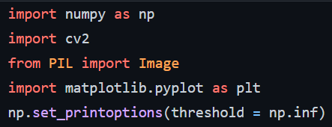

Function to save picture/constrast_stretching/plot histogram/calculate probability

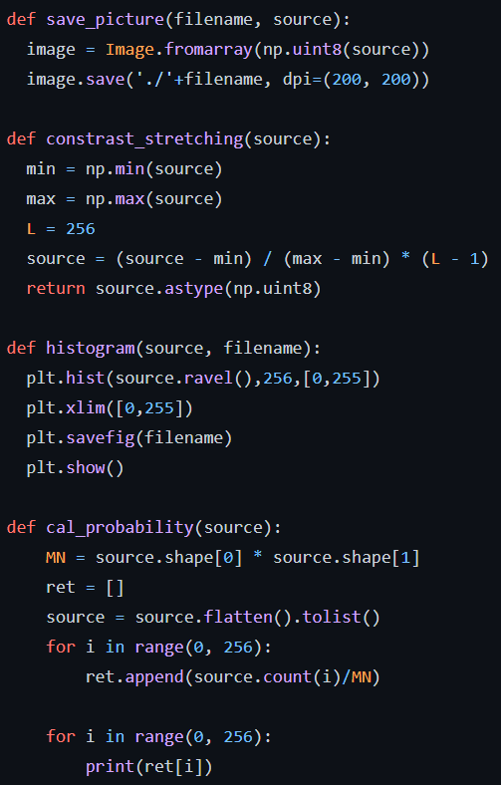

DIP main function:

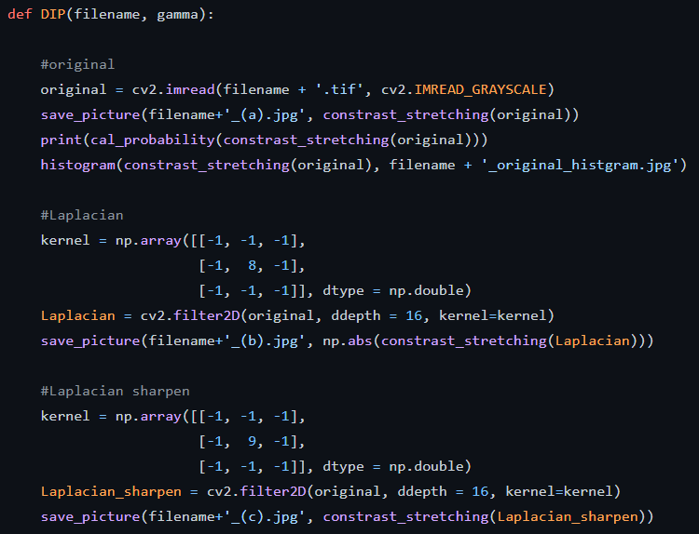

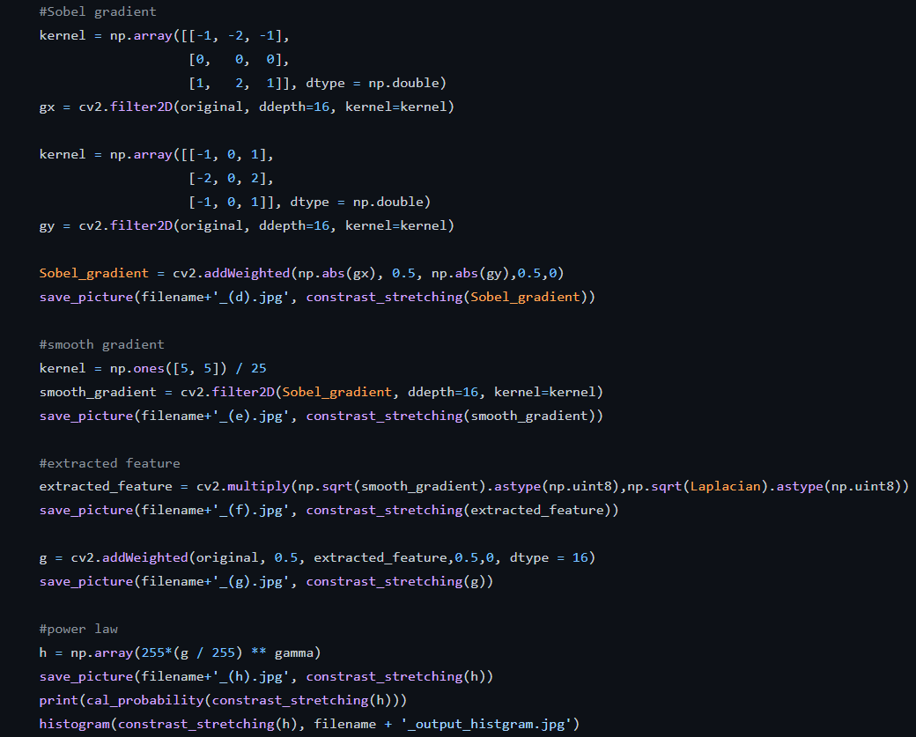

Driven code:

