Project2

0811562何祁恩

1. Source code

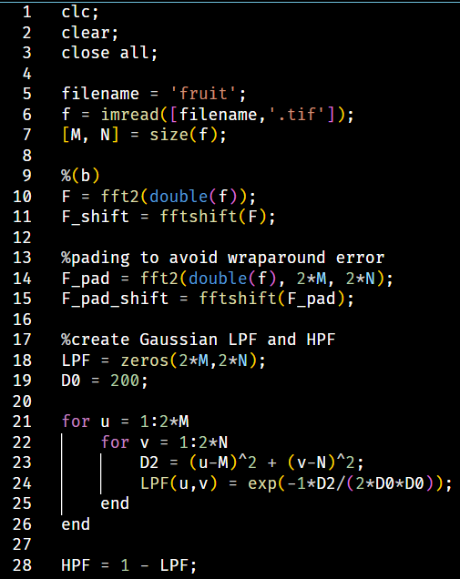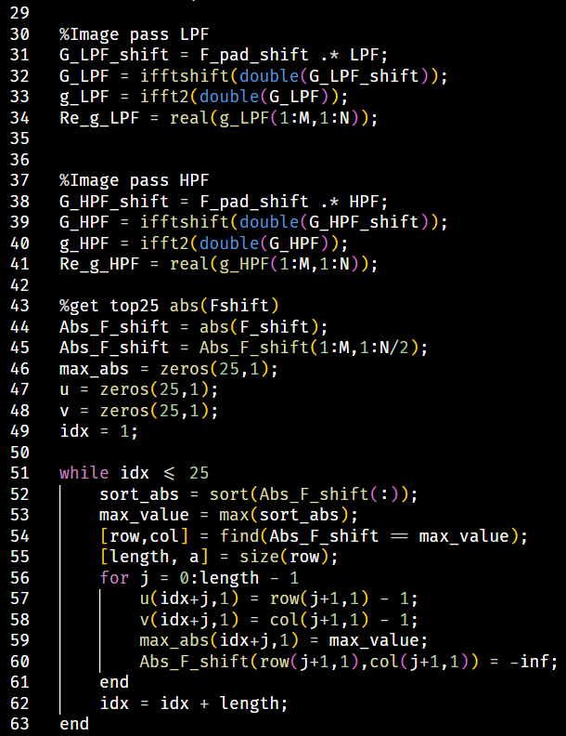

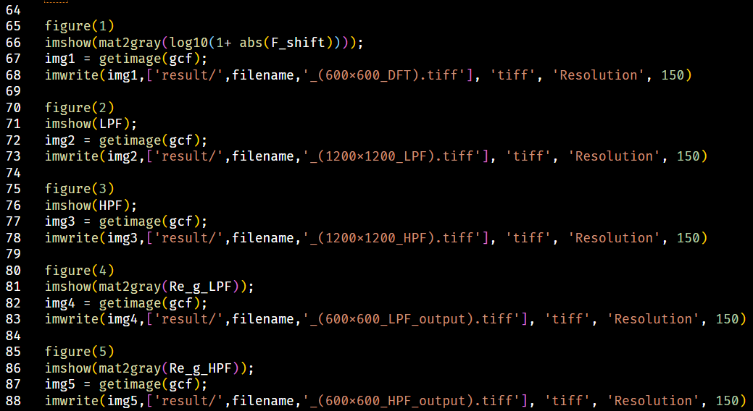

1. Fourier magnitude spectra (Log scale)
2. Kid.tif



1. Fruit.tif



1. Magnitude response of Gaussian LPF and HPF
2. LPF



1. HPF



1. Output image
2. Kid LPF output



1. Kid HPF output



1. Fruit LPF output



1. Fruit HPF output



1. Top25 DFT frequency on the left half of (b)
2. Kid

|  |  |
| --- | --- |
| u | v |
| 301 | 299 |
| 300 | 299 |
| 299 | 299 |
| 298 | 299 |
| 297 | 299 |
| 299 | 297 |
| 302 | 298 |
| 298 | 298 |
| 298 | 294 |
| 302 | 299 |
| 302 | 296 |
| 299 | 298 |
| 304 | 298 |
| 316 | 298 |
| 299 | 294 |
| 301 | 296 |
| 317 | 298 |
| 296 | 296 |
| 296 | 298 |
| 316 | 297 |
| 300 | 294 |
| 298 | 292 |
| 297 | 296 |
| 298 | 297 |
| 301 | 297 |

1. Fruit

|  |  |
| --- | --- |
| u | v |
| 300 | 299 |
| 301 | 297 |
| 300 | 298 |
| 296 | 299 |
| 303 | 297 |
| 300 | 297 |
| 299 | 299 |
| 295 | 299 |
| 302 | 297 |
| 297 | 298 |
| 301 | 294 |
| 298 | 299 |
| 300 | 295 |
| 302 | 299 |
| 304 | 299 |
| 303 | 299 |
| 296 | 294 |
| 299 | 298 |
| 303 | 298 |
| 299 | 296 |
| 296 | 296 |
| 306 | 299 |
| 297 | 296 |
| 299 | 297 |
| 302 | 295 |