Project 5

ID：0811562 name：何祁恩

(a) Source codes:

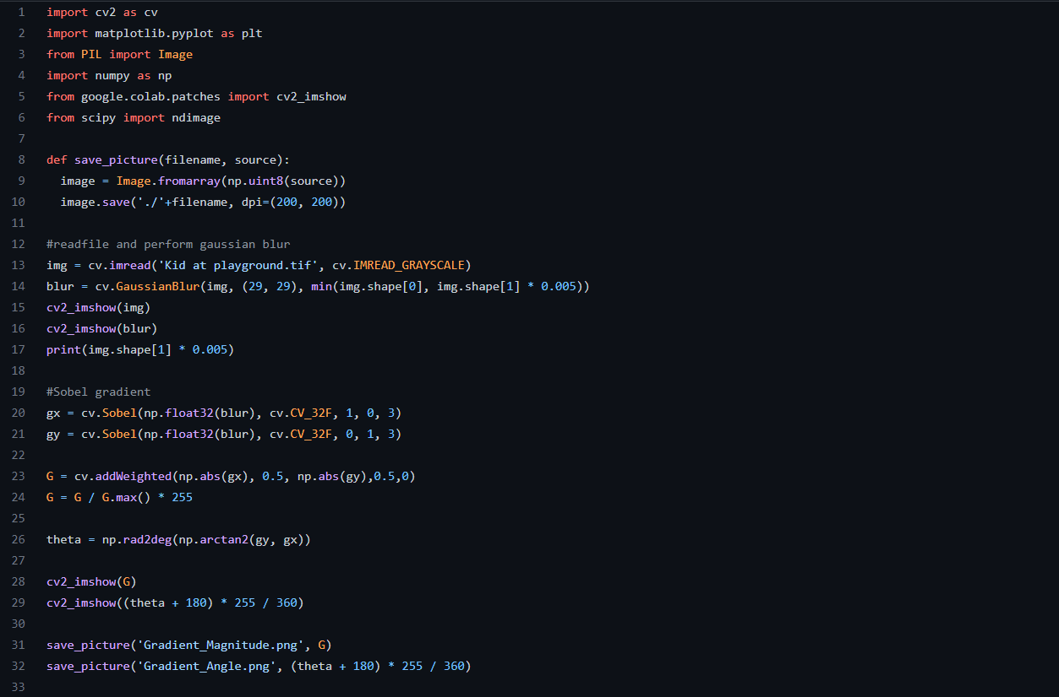

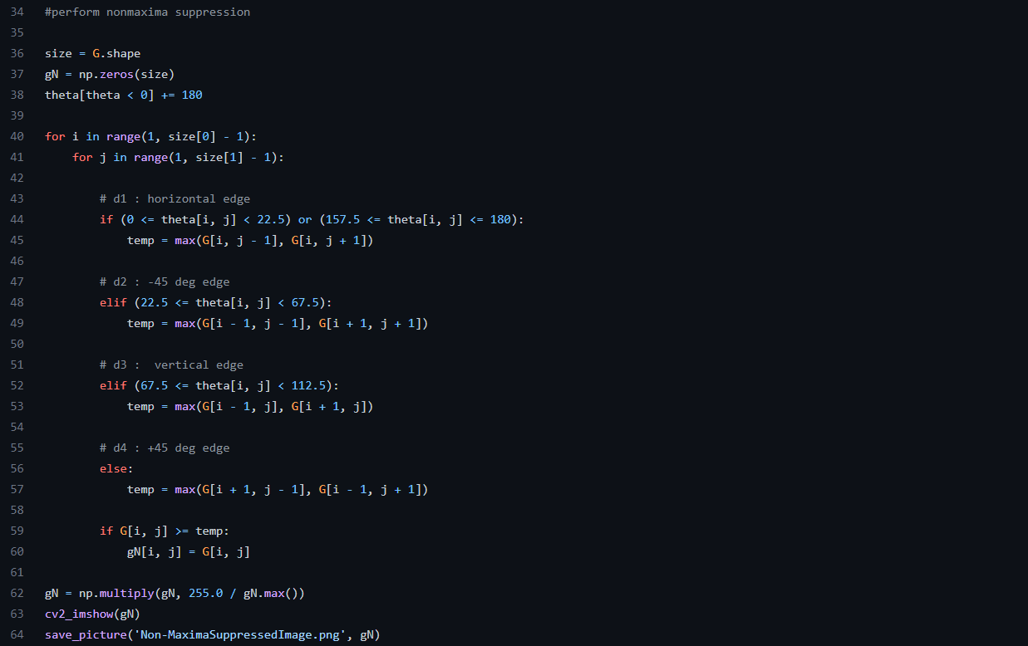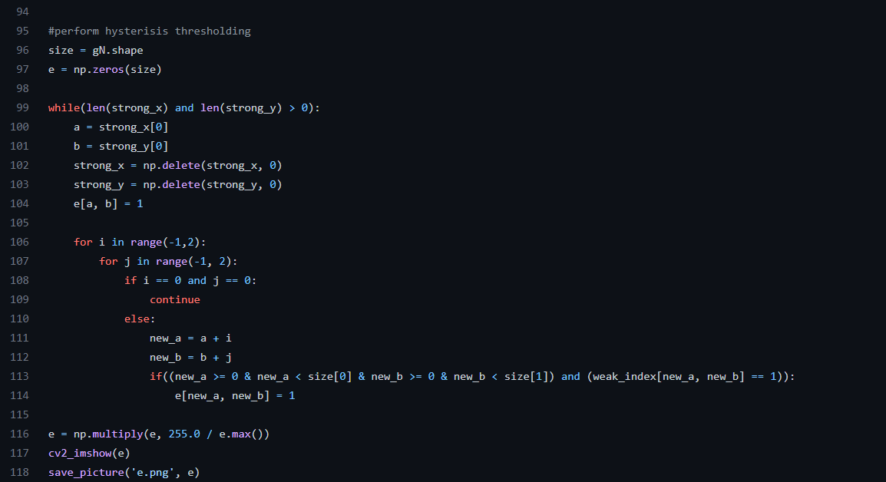

(b) Plot images of the gradient magnitude and gradient angle:

|  |  |
| --- | --- |
| magnitude | angle |

© Plot onmaximal suppressed image gN (x,y) as well as images of gNL(x,y) and gNH(x,y):

|  |  |
| --- | --- |
| gN (x,y) | gNL(x,y) |

gNH(x,y)



(d) Plot final edge map e(x,y):

