Objective: Determine exercise or not to maximize the total performance

* Brute force:. There are two options for each day: exercise or not.
* The problem is linearly ordered  dynamic programming?

dynamic programming to solve the problem:

define: performance if exercise continuously for  day

( for continuous work)

define: maximum performance if the th day rest

define: maximum performance if the Nth day work.

Base case:





(Assume index starts from 1)

Transition function:









Early return if work continuously can’t improve the performance.

Flow chart:

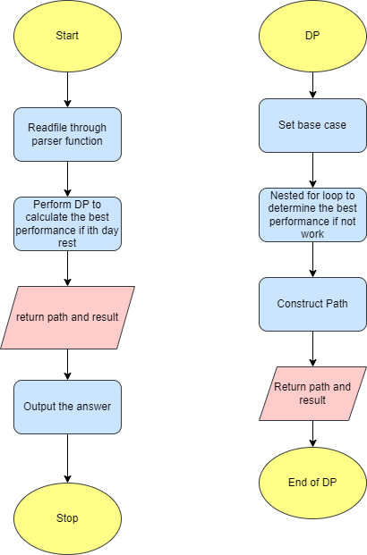

Time complexity analysis:

Read file: 

Bottom-up dynamic programming for memorization: 

Backtracking the solution path: 

Output answer: 

Therefore, the overall time complexity is 