Algorithm Lab2 MST

Flow chart:

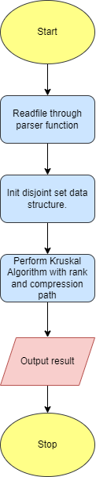

Time Complexity Analysis:

define N = # of vertex, complete graph # of edge = 

Parser: 

Kruskal Algorithm on the complete graph with rank and path compression:

Sort edge: 

Loop in Kruskal perform  on find set and union on disjoint set.

Total time complexity 