演算法lab3 0811562 何祁恩

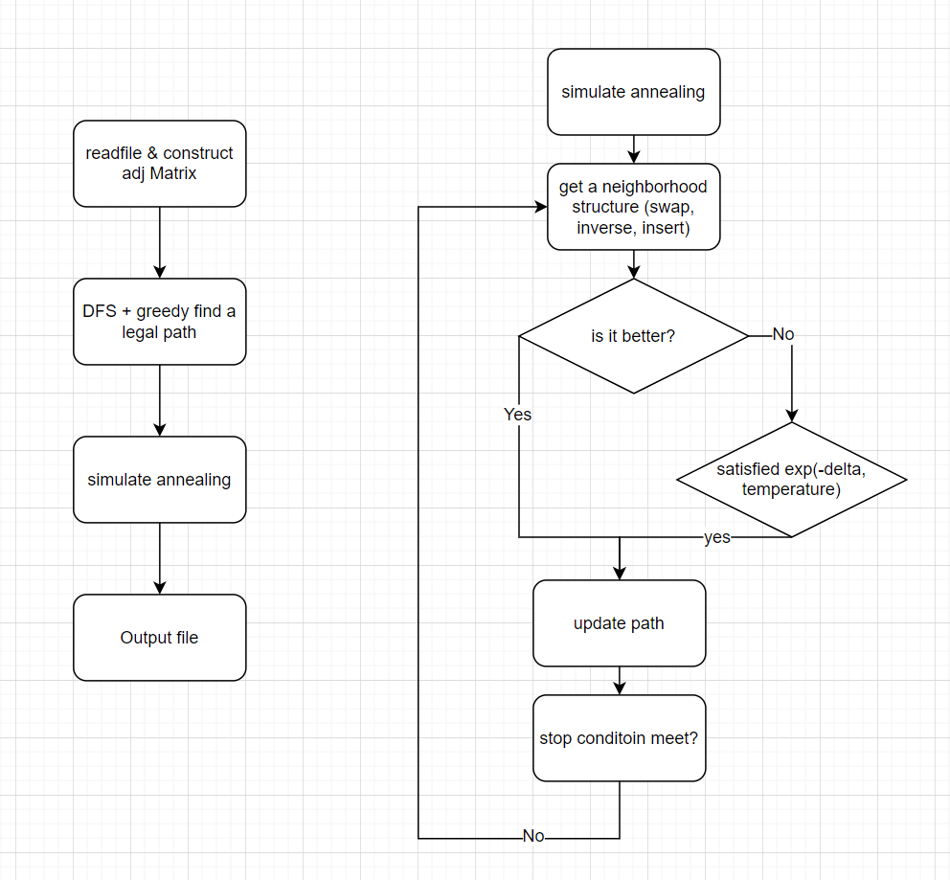

Readfile: O(n^2)

DFS+greedy: O(n + m)

Simulate annealing: heuristic, just keep doing when time’s up