How to flash ESP-01 without FTDI cable
Using Wemos D1 Mini
Assumption: The reader already knows how to use Arduino IDE, has some basic electronics, and knows how to use breadboard and dupont jumper wires.
A. Setup the IDE
1. Install Arduino IDE
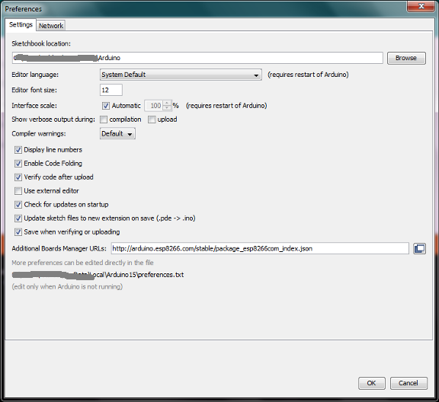
- Add ESP8266 Board Manager

- Detailed instructions at <TODO>

B. Setup Arduino IDE to flash ESP-01
- Select Board as "Generic ESP8266 Module".
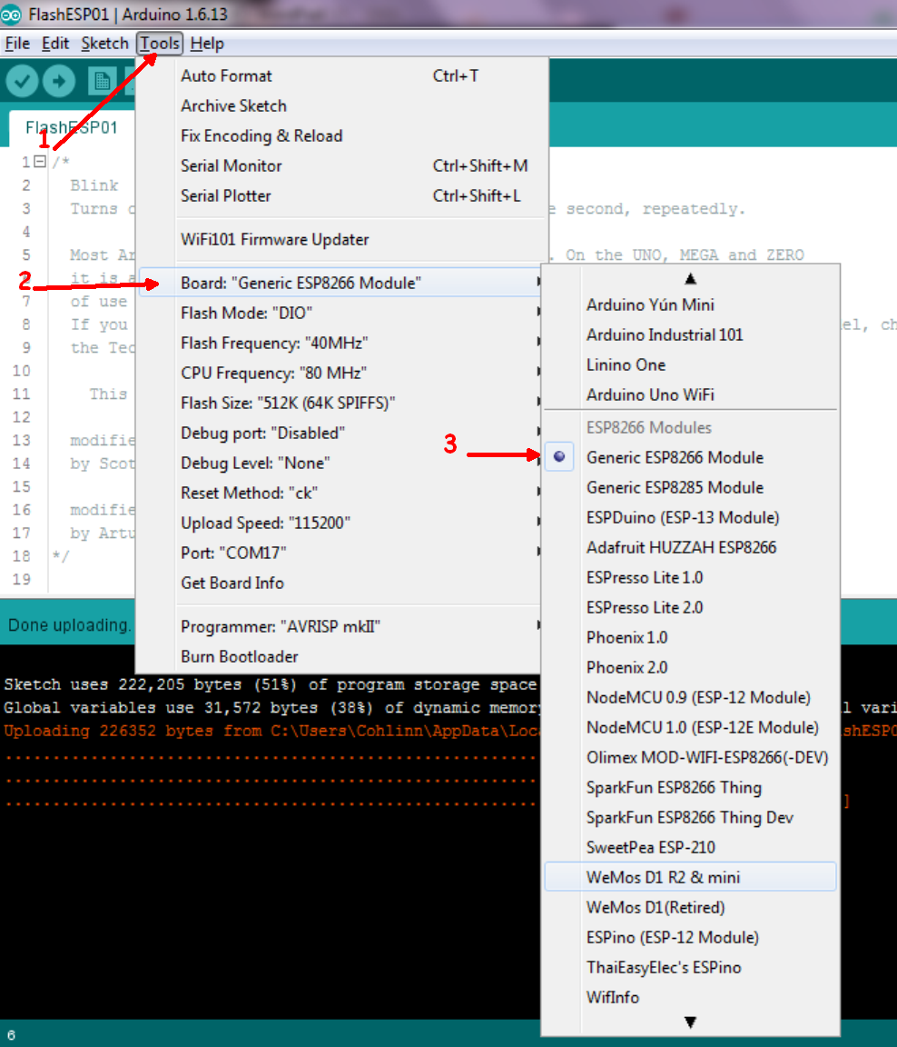
- Select the flash size. If in doubt, pick the 512K (64K SPIFFS).
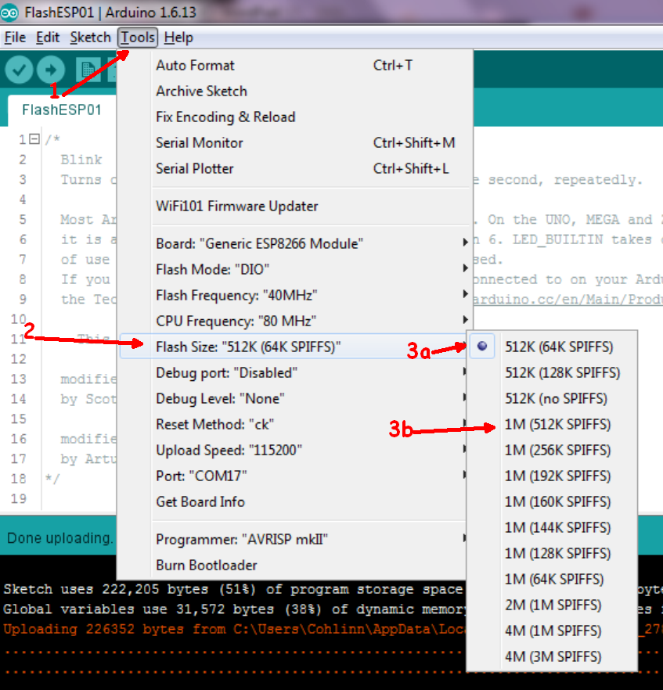
Note that there are different versions of ESP-01.
In general, the blue pcbs has 512KB memory (3a), and the black pcbs has 1 MB memory(3b). If in doubt, use the lower option 512KB . The black pcbs version can be flashed with the lower setting, you just would not get its full potential.

- Set the upload speed to 115200.
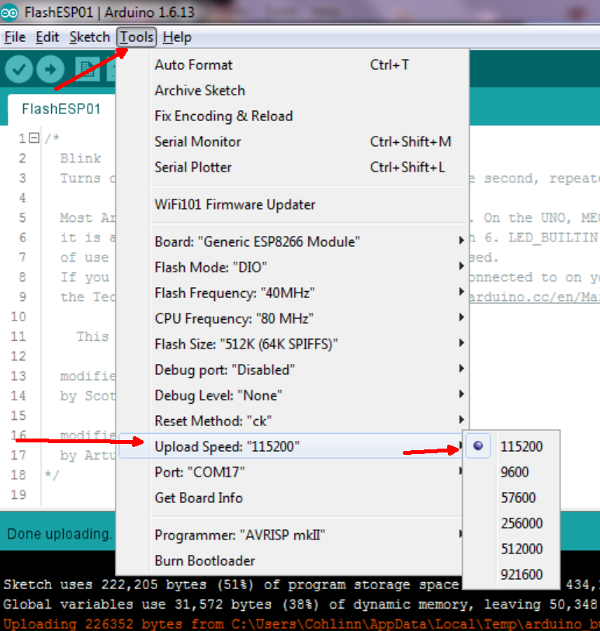
- Pick the COM port (USB port)
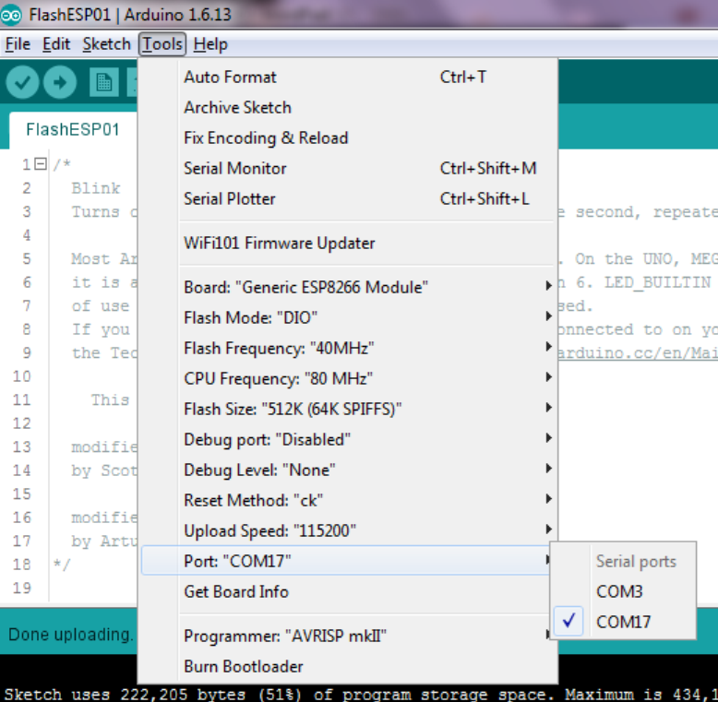
C. Wire up ESP-01 to Wemos
- How to connect the ESP8266 and Arduino
We wire up a circuit to convert the Wemos D1 mini into an USB-to-Serial converter which we then use to flash the ESP8266 with the new firmware. This is the ESP-01 pinout:
- ESP8266-01 pinout
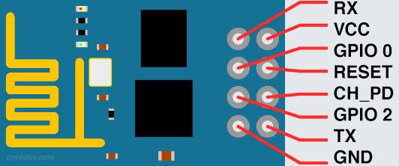
- Wiring scheme:
Wemos D1 mini | ESP8266
RX | RX
TX | TX
GND | GND
GND | GPIO 0
3.3V | VCC
3.3V | CH_PD
Reset | Reset

- Connect the Wemos to the computer with USB cable.

- Load the code and flash

Credits and References
This idea started when a few ESP-01 came into my possession. At that time, I had several Wemos boards and had been working with them for a few months.
What I did not have was FTDI cables and Arduino Uno. Most tutorials to flash an ESP-01 involved an FTDI cable. There was one that uses Arduino Uno. And this project was based on that tutorial.
Since I was using Wemos as a miniaturised Uno with WIFI capabilities, I thought the concept behind the tutorial (use the built in FTDI in the Wemos) would work.
It was actually simpler than using an Uno. And one difference is that I used the Wemos' RESET pin to also control the ESP-01 RESET pin.
https://cordobo.com/2300-flash-esp8266-01-with-arduino-uno/
The ESP-01's pin configurations make it difficult to use on a breadboard. I built my own adapter using male and female headers and a variable board. But you don't really need it.
You can just use female headers to connect from breadboard to the ESP-01. The wires get rather messy, but it works.

