### **Team Members**

Brian Moores, Greg Dorleus, Joshua Cohn

### **Topic**

COVID-19 has had a material impact on the US economy, however certain sectors have been impacted less and, in some cases, may have grown during the pandemic. By comparing several sectors of the US economy comprised of stocks listed on the S&P 500 over a two-year period (2018 through 2020) we will present a dashboard of visualizations that will answer the question of impact on performance due to COVID-19.

### **Sample Dashboard view with possible visualizations we are thinking of:**

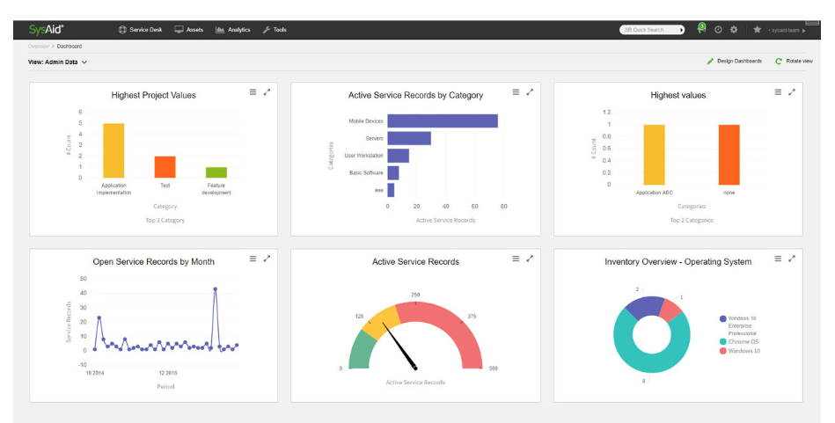

### **Data Collection:**

Tickers representative of market sectors from the S&P500 on Barchart.com.