Apache (PHP) Server Implementation

# Proposed Infrastructure

## Problem

Many small businesses have their own homemade infrastructure that is set up much like the diagram shown on the next page. A lot of current companies will charge amounts that are well out of the rage of the small business for establishing an alert system in their home solution. Also, a lot of alert systems are not even hosted on site but instead in the company’s own datacenter. This can lead to more complications and a lot of money paid out to the companies.

## Current Solutions

* + On Site Hosting
    - Alert Companies charge insane amounts of money to implement their own services in the small business infrastructure. In order for them to do this, the small business must have a certain number of employees to even apply.
  + Remote Hosting
    - Alert Companies host the alert system in their own datacenter. However, this can lead to complications and the need of a full staff, response on phone, support etc. This leads to expense monthly charges and also they do not guarantee fast emergency responses as they could be hosted in a different state entirely.

## Proposed solution

This proposed server infrastructure will be hosted in the internal network of the small business, but unlike the current solutions will be affordable and easy to implement. It will not require a certain threshold of people to apply for it. This will allow the small companies to be able to manage the alert system in their own way (but still ensure functionality), and still guarantee the fast responsiveness and of having it on site. The service will be ready at any point in time and can respond to responses whenever an authorized request comes in. This infrastructure hopes to allow small businesses to have a simple, fast, and affordable solution.

# Users/Administrators of Apache PHP Server

* Employees
  + Interface to the server through the mobile application
  + Receive Lockdown Responses
* Response Administrators
  + Can edit/add/update Employee information
  + Receive detailed information on emergency
* Local Emergency Response Authority
  + Will receive a message containing the needed information
  + They will choose the course of action they were trained on
* Server Administrators
  + Will be able to update/change SQL tables, maintenance on the server, and choose the local emergency response authority.

# Basic Concept

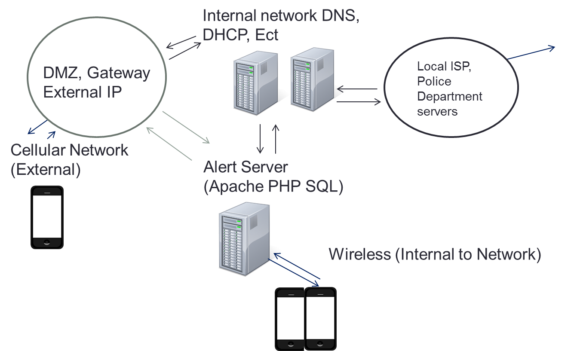

# Features

## Apache PHP Server Features

* + Service
    - Server will be able to implement basic PHP and SQL functionality
    - This server will provide a constant “resting” service that will respond to requests immediately.
  + Interface with Android
    - In order to interface with android, the server will be accepting HTTP POST requests and other forms of requests from the user’s android phone. This will allow the server to receive messages from both internal and external requests.
  + Interface with Emergency Authority
    - The server will be able to send a message/alert to the community 911 emergency response, or other chosen emergency authority, with all of the information obtained from the alert message of the android app. Also, all of the designated response administrators of the application will be contacted. Essentially, this means if the small business has designated security personnel, the app will contact that person immediately of the emergency in addition to the 911 emergency responses.
  + Lockdown message to Employees in Danger
    - After an employee has signified a danger in the work place, all other employees will receive a calm, detailed message on how to properly respond to the situation. For example, if an employee sends an emergency response of a live shooter, all employees will be notified to of the proper response of locking their office, or any other doors and entering a lockdown.
  + Implement Login Functionality
    - In order to improve security, identification of false reports, and fast responses we are looking at a pre-authorize option. When a phone connects to the server, via internal network or external (cellular), it will log in to the apache server through a check with a database. If the user is indeed authorized, every time that person comes to work he/she will be not have to log in everyday but instead will be ready to go from day to day. This solution would be able to manage the employees outside of the internal network (Cellular) if we implement a log-in setting option where the user can login via the GUI of the phone and the phone can use that info on each time the app is started.
  + Disclaimer
    - Un-authorized phones, tablets, and laptops should not be able to send an emergency message. However, this response system is not designed to be hard to use and take five or more minutes to formulate a response. Therefore we would like to make this response system semi-secure to deter bots and basic attacks. If a false report has been filed the user and phone from the false report will be investigated by the local law enforcement and subject to the full extent of the law, as calling in false emergency responses is highly illegal.

## SQL Server Features (Subject to needs of Small Business)

* + Tables
    - EmployeeLogin
      * EmployeeUserName
      * EmployeePassword
    - ResponseAdminLogin
      * ResponseAdminUserName
      * ResponseAdminPassword
    - Employee Information (Used for Response Messages, Subject to expansion)
      * EmployeeUserName
      * EmployeeOfficeNumber
      * EmployeeCellularNumber
      * EmployeeStatus
    - EmergancyContact
      * EmergancyContactName
      * EmergancyContactPhone
      * EmergancyContactEmail
      * EmergancyContactLocation

## DNS, DHCP, Basic Infrastructure

* + The basic Infrastructure of a business (Mail, DNS, DHCP, and Networking) should already be implemented in the work place. Most commonly, these are homemade systems that have been in place with the business for a long time.
  + In the event of the small business not having a proper set up, we can refer them to a designated IT counseling or other service to help get the business up and running for the proper infrastructure needed for a response system.