Let’s start from the discrete definition of the SR2009 model in their SM, section 2. Let’s ignore controlling variables and error terms throughout. The original formula has subscripts i, for location, and t, for year. We will also drop those since we’ll need to dissect time inside a year.

eq. 1

Here, Y is the log yield and h means heat, a certain temperature level. They confusingly used T for something else in their definitions. g(h) is the impact function they are trying to estimate, which will be piecewise linear on h in our case, but more on that later. The function is “the cumulative distribution function of heat”. The other document I sent, SR2006, defines it a little better in the context of our eq 1: “Using Φ(h) as the cumulative distribution of time with temperatures less than or equal to h, the time temperatures fall in a 1deg heat interval (h, h + 1] becomes Φ(h + 1) − Φ(h)”.

So the term within brackets essentially means the total time temperatures fall within the 1deg interval starting in h. The g(h+0.5) is merely centering the impact function in the middle of that temperature interval. We will need to define Φ a little more in depth and will be carrying the h argument around a lot, so let’s just assume their intervals were centered on the actual h instead. This is of course not exactly of what they did but we are shifting everything by a mere half degree. Our working equation will then look like:

eq. 2

Now, let’s define the term in brackets in a more tractable way, retaining the meaning of being the “time temperatures fall in a 1deg heat interval”, now centered on h. This will be easier if we consider we are evaluating this on a discrete interval of time dt, in days. The value of dt we are actually using is 0.01 days. So, at a certain time t, the time temperatures fall in an interval centered around h will depend of the temperature variation with time T(t) will be:

eq. 3

The total time temperatures fall in a 1deg heat interval centered in h will be the sum of θ over all time steps in a certain growing season GS:

eq. 4

So, our eq. 2 becomes:

eq. 5

Now, let’s look into the piecewise specification of g(h).

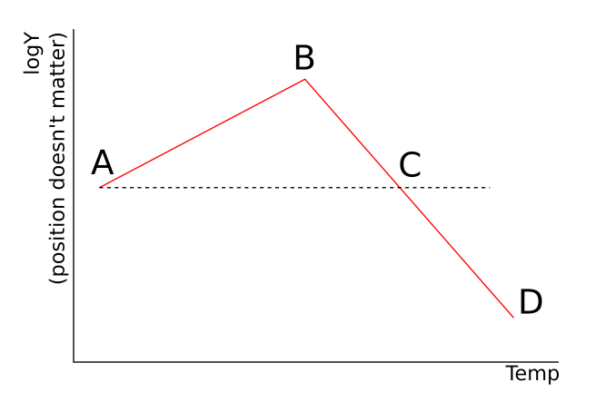

We will ignore any flat parts before or after these points for the moment

So, in a piecewise portion between T1 and T2, g(h) is a simple slope and intercept funcion of h. Note that this is only evaluated for h above K:

Eq. 6

If we have both values of β_{1,} namely β_{R} in the rising part from A-B and β_{F} in the falling part from B-D, we can infer expressions for each segment

Segment AB

Y(A) = 0, so:

Substituting Eq.6:

Eq 7

Segment BC

Y(C) = 0, so:

Substituting Eq.6:

Eq 8

Segment CD

Again, Y(C) = 0, so:

Substituting Eq.6:

Eq 9

General equation

Combining the equations for the segments we have:

The terms for BC and CD are essentially the same, except that in BC (h-C) is always negative and in CD (h-C) is always positive. Aggregating:

Alternative form without considering point C

Segment BD

General equation

GDD and EDD equations

General equation, GDD/EDD form

