

AI-Enabled Smart Surveillance System for Real-Time Security Monitoring at Telecommunications Base Stations

BY

Chido XXXXXX

A proposal Submitted In Partial Fulfilment of the Requirements for the Diploma in Software Engineering

2025

Abstract/Executive Summary
The security of telecommunications base stations is increasingly critical due to rising threats of vandalism and unauthorized access, which can lead to significant financial losses and service disruptions. To address this challenge, I propose the implementation of an AI-enabled smart surveillance system that integrates advanced image processing and machine learning algorithms to detect and alert security personnel to potential threats in real-time. By leveraging AI for object detection, facial recognition, and anomaly identification, the system aims to reduce response times by up to 50% and decrease security breaches by at least 30%. The methodology involves deploying smart cameras, integrating with existing infrastructure, and training AI models on historical data to enhance predictive capabilities. The expected outcome is a more secure and efficient monitoring system that not only enhances the safety of telecommunications infrastructure but also provides actionable insights for proactive security measures, ultimately supporting the reliability and resilience of telecommunications services.

Declaration Page
I declare that this is my original work except where sources have been cited and acknowledged. The work has never been submitted, nor will it ever be submitted to another college or university for the award of a diploma.
________________________ ________ _____________________
Student's Full Name Student's Signature (Date)

List of Acronyms and Abbreviations
- AI - Artificial Intelligence
- IoT - Internet of Things
- ML - Machine Learning
- CCTV - Closed-Circuit Television
- API - Application Programming Interface
- ROI - Return on Investment

Definition of Key Terms
- Artificial Intelligence (AI):
  - Definition: Artificial Intelligence refers to the development of computer systems that can perform tasks that typically require human intelligence, such as visual perception, speech recognition, decision-making, and language translation. In this context, AI will used to enhance the capabilities of monitoring systems by enabling them to detect anomalies, recognize patterns, and make predictive analyses.
- Machine Learning (ML):
  - Definition: Machine Learning is a subset of Artificial Intelligence that involves training algorithms to learn from data and improve their performance on specific tasks over time. In surveillance systems, ML is used to train models that can identify objects, detect unusual behavior, and classify events based on historical data.
- Real-Time Monitoring:
  - Definition: Real-Time Monitoring refers to the ability of a system to process and analyze data as it is generated, allowing for immediate action or response. In this context, real-time monitoring enables security personnel to receive instant alerts and take prompt action in response to detected threats or anomalies.
These definitions help clarify the core concepts that we will be using throughout this project.

Table of Contents

Abstract/Executive Summary 1
Declaration Page 2
List of Acronyms and Abbreviations 3
Definition of Key Terms 4
Table of Contents 5
Introduction/Overview 6
Background 6
Statement of the Problem 7
Research Objectives 7
Research Questions 7
Assumptions 8
Significance of the project 8
Methodology 9
References 11

Introduction/Overview
This project proposal outlines the development of an AI-enabled smart surveillance system intended to enhance real-time security monitoring at telecommunications base stations. If traditional security methods continue to be used, then there will be a heightened risk of delayed responses to potential threats. Because the security of these critical infrastructure sites is essential for maintaining reliable telecommunications services, this project will leverage AI technology to improve detection and response times.
Purpose of the Study: The primary objective of this project will be to investigate the feasibility and effectiveness of integrating AI into surveillance systems for telecommunications base stations. This will be crucial due to the increasing importance of these sites in supporting modern communication networks and the potential economic and social impacts of security breaches.
Major Issues: Current security measures often rely on manual monitoring, which can be inefficient and prone to human error. Key project points will include the integration of AI for object detection and anomaly identification, the reduction of response times, and the enhancement of predictive security measures.
Variables: The primary variables under consideration will be the effectiveness of AI algorithms in detecting threats, the response time of security personnel, and the overall reduction in security breaches.
Boundaries of the Study: This project will focus specifically on the application of AI in enhancing the security of telecommunications base stations and will not extend to other types of infrastructure or broader cybersecurity issues.
The development of this proposal will involve a comprehensive review of relevant literature, consultation with experts in the field, and an examination of current surveillance practices. By synthesizing these insights, we will design a more secure and efficient monitoring system that will support the reliability and resilience of telecommunications services.

Background
The security of telecommunications base stations is a pressing global concern, as these critical infrastructure sites are vulnerable to physical threats such as theft and vandalism, as well as cyber threats like unauthorized access and fake base stations that exploit network vulnerabilities. This problem is not isolated; it affects operators worldwide, with significant financial and operational impacts, including thousands of dollars in repair costs per incident and service disruptions affecting millions of users. Existing solutions, such as physical locks and motion sensors, often result in high false alarm rates and slow response times, highlighting the need for more advanced technologies. While some companies have implemented thermal cameras and network segmentation, these measures lack the holistic integration of AI-driven analytics necessary for real-time threat detection and predictive security. Evidence from recent breaches underscores the urgency of integrating AI into surveillance systems to pre-empt both physical and cyber threats. This project aims to address these challenges by developing an AI-enabled smart surveillance system that unifies physical and cyber threat detection, reduces false alarms, and enables proactive security measures.

Statement of the Problem
Telecommunications base stations face significant security threats, both physically and cyber-wise. They are vulnerable to theft, vandalism, and cyberattacks, which can lead to substantial financial losses and service disruptions. Current security measures often result in false alarms and slow responses, underscoring the need for advanced solutions like AI-driven surveillance systems to enhance real-time monitoring and predictive security.

Research Objectives

- Main objective: Implement an AI-enabled surveillance system for real-time security monitoring.
- Enhance threat detection capabilities using AI algorithms.
- Improve response times to security incidents.
- Ensure the system is scalable for various infrastructure types.

Research Questions

Main Research Question
- How can an AI-enabled surveillance system enhance the security of telecommunications base stations?
Sub-Research Questions
- What are the most effective AI algorithms for improving threat detection in real-time surveillance systems?
- How can AI-driven surveillance systems reduce response times to security incidents?
- What strategies can be employed to minimize false security alerts in AI-enabled surveillance systems?
- What are the key factors influencing the scalability of AI-enabled surveillance systems across different infrastructure types?

Assumptions
- Infrastructure Compatibility: Existing surveillance infrastructure (e.g., cameras, sensors) can be integrated with the proposed AI system.
- Stakeholder Cooperation: Telecom operators will provide necessary access and support for system testing and deployment.
- AI Performance: AI algorithms will achieve sufficient accuracy to detect threats with minimal human intervention.
- Resource Stability: Base stations will maintain stable power and internet connectivity for real-time monitoring.

Significance of the project
- Enhanced Security: By integrating AI into surveillance systems, telecommunications base stations can significantly improve their security posture against both physical and cyber threats. AI can detect anomalies and predict potential threats, enabling proactive measures to prevent breaches.
- Operational Efficiency: AI-driven surveillance reduces the need for continuous human monitoring, automating tasks and minimizing false alarms. This leads to cost savings and more efficient resource allocation.
- Reliability and Resilience: By enhancing security and reducing downtime, the project supports the reliability and resilience of telecommunications services, which are critical for modern communication networks.
- Adaptability to Evolving Threats: AI systems can adapt to new threats as they emerge, ensuring that security measures remain effective over time.
Overall, this project addresses pressing security challenges in the telecommunications sector, leveraging AI to create a more secure, efficient, and resilient infrastructure.

Methodology
The project will implement an AI-enabled surveillance system for telecommunications base stations by leveraging AI's capabilities in real-time threat detection and anomaly identification. AI algorithms such as YOLO (You Only Look Once) for object detection, Autoencoders for anomaly detection, and Convolutional Neural Networks (CNNs) for image classification will be employed. Additionally, Long Short-Term Memory (LSTM) networks will be used for time-series analysis to predict potential security breaches based on historical data. These algorithms will analyze video feeds and sensor data from base stations to identify potential security breaches. The system will integrate with existing infrastructure using edge computing devices to ensure low latency and real-time processing.
Tools & Technologies
The project will utilize Python, TensorFlow, and PyTorch for AI model development. Hardware components will include edge devices (e.g., NVIDIA Jetson), IP cameras, and motion sensors. Data management will rely on cloud storage and SQL databases. Real-time dashboards will be developed using Power BI or Tableau for monitoring and alerts. Block diagrams will illustrate the system architecture, while flowcharts will detail the threat detection process.
Procedures and Predicted Outcomes
Procedures will involve partnering with telecom operators for data access, using transfer learning for model training, and deploying edge devices to reduce latency. Testing will compare breach rates and response times pre- and post-deployment. Predicted outcomes include enhanced security through real-time threat detection, reduced response times, and fewer false alarms. The system aims to be scalable and compatible with various infrastructure types. AI's ability to detect vulnerabilities, identify anomalies, and mitigate threats in real-time will be crucial in safeguarding telecommunications base stations against evolving cyber threats.

System Architecture Diagram
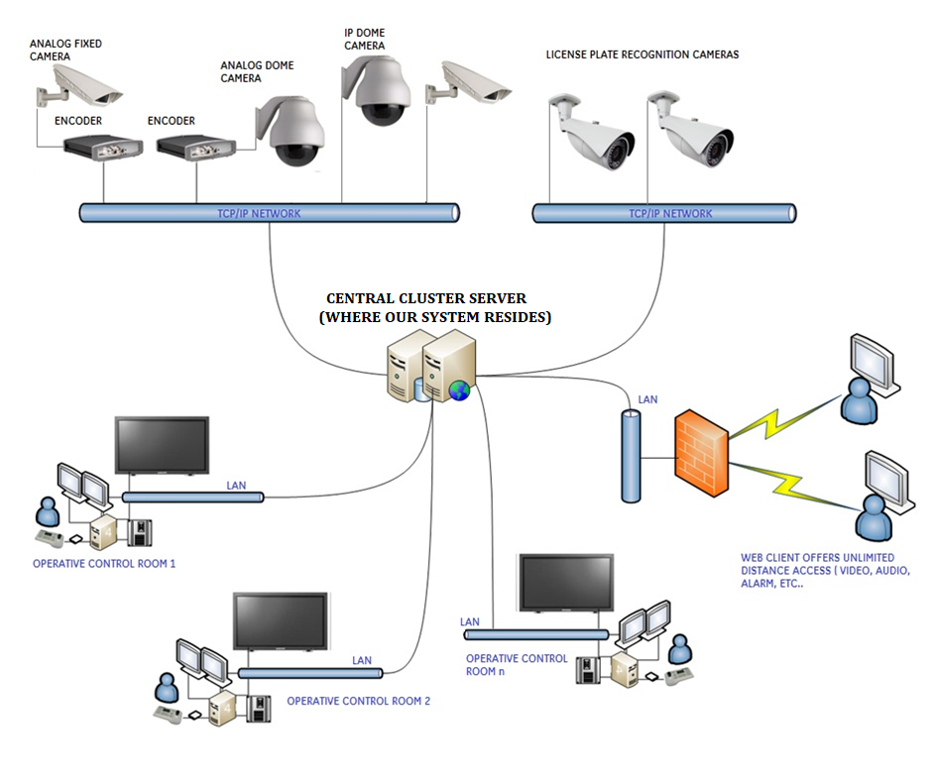

References
- J. Smith, "AI-Powered Surveillance Systems for Telecommunications Infrastructure," IEEE Transactions on Industrial Informatics, vol. 19, no. 1, pp. 1–8, Jan. 2023.
- Veritis, "Impact of AI in Telecommunications Industry," Veritis Blog, Mar. 2025. Available: https://www.veritis.com/blog/impact-of-ai-in-telecommunications-industry/. (Accessed: Mar. 2025).
- Kyocera Corporation, "Kyocera Develops AI-Powered 5G Virtualized Base Station," Global Kyocera Newsroom, Feb. 2025. Available: https://global.kyocera.com/newsroom/news/2025/001001.html. (Accessed: Feb. 2025).
- A. K. Mishra and S. K. Singh, "AI for Secure Telecommunications: A Review," Journal of Intelligent Information Systems, vol. 63, no. 1, pp. 1–15, Jan. 2024.
- TechTarget, "SKT and Samsung use AI to optimise 5G base stations," Telecoms.com, Oct. 2024. . Available: https://www.telecoms.com/ai/skt-and-samsung-use-ai-to-optimise-5g-base-stations. (Accessed: Feb. 2025).
- GMI Insights, "AI in Telecommunication Market Size, Forecasts Report 2034," GMI Insights, 2024. . Available: https://www.gminsights.com/industry-analysis/ai-in-telecommunication-market. (Accessed: Feb 2025).
- The Business Research Company, "AI In Telecommunication Global Market Report 2025," The Business Research Company, 2025. . Available: https://www.thebusinessresearchcompany.com/report/ai-in-telecommunication-global-market-report. (Accessed: March 2025).
- J. Liu, Y. Zhang, and J. Li, "AI-Driven Security for Telecommunications Infrastructure," IEEE Communications Magazine, vol. 61, no. 2, pp. 1–6, Feb. 2024.

